Supplementary Information
Drug target prediction through deep learning functional representation of gene signatures
Chen et al.

Supplementary Notes
Supplementary Note 1: Gene signature embeddings derived from other gene embedding methods
Gene signature embeddings were also derived from other gene embedding methods, including OPA2Vec¹, Gene2vec², and clusDCA³, to compare with FRoGS.
OPA2Vec applies the word2vec⁴ model to jointly generate embeddings for genes and GO terms. For this, it first generates sentences from GO annotations and GO metadata to form a corpus, in which genes and GO terms are treated as words. The PubMed⁵ abstracts are used as a corpus by OPA2Vec for pretraining. Using OPA2Vec’s gene embeddings, an input gene set can be represented by averaging embeddings of individual genes in the set, denoted as ‘OPA2Vec Gene’. For completeness, we also generate gene set embeddings using OPA2Vec’s GO embeddings, by first adding up embeddings of GO terms associated with each gene as the gene embedding and then averaging gene embeddings in the set, denoted as ‘OPA2Vec GO’. The gene and GO embeddings used for comparison were generated using the provided code and data in the OPA2Vec GitHub repository (https://github.com/bio-ontology-research-group/opa2vec).
Gene2vec generates gene embeddings from transcriptome-wide gene co-expression networks derived from large-scale Gene Expression Omnibus datasets. It uses a Skip-Gram model to learn gene embeddings from highly co-expressed gene pairs. The pretrained gene embeddings obtained from the Gene2vec GitHub repository (https://github.com/jingcheng-du/Gene2vec) were used for comparison.
clusDCA generates embeddings of GO terms by running random walks on the directed acyclic graph structures of GO hierarchies and then applying matrix factorization. The provided code and data from the clusDCA GitHub repository (https://github.com/wangshenguiuc/clusDCA) were used to generate the clusDCA GO embedding. Gene embeddings of Gene2vec and GO embeddings of clusDCA were used to generate gene signature embeddings using the same methods as described above.
Supplementary Note 2: The influence of data sampling strategy on model performance
Zhong et al.⁶ recently published a Siamese spectral-based graph convolutional network (SSGCN) model by leveraging the protein-protein interaction network contained in transcriptional signatures. With 123 drugs and the top 100 predicted candidates, SSGCN showed a much-improved target recall of 0.71-0.84 compared to 0.15 using CMap⁶. For SSGCN model training, positive compound-target pairs were based on the Broad Institute’s compound annotation⁷, where known compound targets were highly concentrated in functional categories related to kinase signaling and cancer-related processes (Fig. S2). In contrast, negative compound-target pairs in the dataset were generated by pairing compounds of known targets with genes randomly selected from the whole genome, where no functional enrichment should be expected. Therefore, gene members of highly enriched pathways such as oncogenic kinases occurred much more frequently in the positive pairs than in the negative pairs of both training and test datasets. Compound-target predictions should conceptually be solely based on the interaction terms between compound features and target features (in the forms of shRNA/cDNA signatures); however, the strong association between targets and the positive outcome inherited from the described sampling strategy raises the concern that a model might make good predictions heavily relying on target features alone and is therefore biased towards targets frequently appeared in the positive pairs of training data, which could have resulted in an overestimated model performance but not generalizable in real applications.
To investigate this possibility, we retrained our FRoGS based deep learning model using the same data split tactic as used in SSGCN and following its data generation strategy. Using the SSGCN’s evaluation strategy, our new model achieved a high top-30 accuracy of 0.59 and a top-100 accuracy of 0.80, which is higher than the reported performance of SSGCN and the other methods compared in its original publication (Fig. S3). Compared to Model L’s recall of 0.36, the significant boost in model recall here was purely due to the difference in how the negative training dataset was constructed. We then randomly permuted the gene identity in the query compound gene signatures, i.e., erased biological information within the query compound signatures. We expected the new model to completely fail, as any predictions would have to be based on the shRNA/cDNA gene signatures alone, given the input compound signature was nonsense. Surprisingly, the new model still achieved a high top-30 accuracy of 0.46 compared to 0.008 of random predictions (Fig. S3). This suggests the training set constructed by SSGCN lowered the barrier for the prediction challenge, which might have resulted in a model paying an inappropriate amount of attention to target signature input alone and thus potentially will not generalize well for real applications. In our Model L training, each target occurred in equal frequency in both our positive and negative datasets, therefore, our model had to make predictions relying solely on compound-target interactions. In addition, considering 123 drugs were used in SSGCN compared to 1438 compounds used in our recall benchmark, the different evaluation datasets might partly explain the significantly higher performance of CMap method (16%) quoted in Zhong et al. compared to the 9.6% we observed⁶. Incorporating all the above observations, we believe the prediction of compound targets based on transcriptional signatures remains an important unsolved challenge and some reported successes in the literature warrant further evaluation.
Supplementary Note 3: Co-target probability based on structure similarities
Madhukar et al. previously demonstrated that structure similarity $s(c, c^{'})$ between a query c and a reference $c^{'}$ served as the strongest evidence for compound target prediction according to the structure-activity relationship (SAR)⁸. A Model S_{SAR} was derived based on an in-house medicinal chemistry activity database, where it mapped s, measured by ECFP fingerprints⁹, into a probability of the compound pair being co-active within the same biological assay. According to Model S_{SAR}, compound pairs with s ≥ 0.64 have ≥0.8 probability to be co-active in the same assay. However, as we are not interested in predicting targets for compounds that are structurally similar to known reference structures, Model S_{SAR} offers little value in predicting novel targets. Therefore, Model S_{SAR} is not used for target prediction in our study, but only serves to validate predictions generated by other models.
Supplementary Note 4: Construction of the pQSAR-based model
Pharmacological activities are useful for target prediction in the knowledge-based approach⁸, relying on the guilt-by-association (GBA) principle, which assumes compound pairs sharing similar activity patterns across a large assay panel tend to interact with the same targets or perturb the same underlying pathway¹⁰. Our company, Novartis International AG, has accumulated a large proprietary compound activity matrix consisting of 6 million chemical structures and more than 12,000 biological assays (see Methods), where assays cover a diverse collection of gene targets including kinases, proteases, transcription regulators, G-protein-coupled receptors, nuclear hormone receptors, ion channels, and other common drug targets. Martin et al. demonstrated the missing elements in this matrix could be imputed effectively with a profile-quantitative structure-activity relationship (pQSAR) algorithm, where the Pearson r² between experimental pIC₅₀ values and their predictions were above 0.3 for 72% of the assays¹¹. This pharmacological activity matrix, hereafter referred to as the pQSAR dataset, enabled us to train an LR-based Model pQSAR, also abbreviated as Model Q, to map the correlation coefficient between a Broad compound pair’s activity profile, q, into their probability of sharing the same target. The compound pair included a query compound c and a reference compound $c^{'}$ of a known target g, therefore, Model Q predicted the probability of a (c, g) association through $q(c, c^{'})$. Many previous activity-based studies were based on the NCI₆₀ growth inhibition screen dataset¹², our test results showed a similar LR model only based on NCI₆₀ achieved a weak Matthews correlation coefficient (MCC)¹³ of 0.04 and a recall of 0.16, while Model Q based on the much larger pQSAR matrix offered a significant advantage with an MCC of 0.33 and a recall of 0.70. This outcome was expected as pQSAR matrix covered significantly larger chemical and biological space, therefore, activity correlations across 4420 assays (1003 unique gene targets) should have been a much stronger predictor for co-targeting than those across 60 NCI cancer cell lines. The performance metric of all models tested in this study are provided in Table S1.
Supplementary Note 5: Transcriptional, pharmacological, and structural data types are orthogonal
Fig. S4a suggests Model L does not rely on structure similarity information (r² = 0.00). Fig. S4b illustrates there exists a correlation between q and s, especially for s ≥ 0.35. We compute q in the pQSAR data source only for compound pairs with s < 0.35, therefore, limiting the correlation to a lower r² value of 0.10. Based on our analysis using in-house data, a similarity threshold of 0.35 corresponds to a weak 55% probability of preserving the structure-activity relationship (SAR) (Supplementary Note 3). Scatter plots in Fig. S4c confirmed the previous study that gene signature evidence r and activity correlation q do not linearly correlate with each other.
As none of Model L, Model Q, and Model LQ (the combined model described in Supplementary Note 7) introduced in this study relied on structure similarity evidence, structure similarity can be used as an independent validation for model predictions. This also suggests the performance of these three models is expected to be generalizable for future applications unto orphan compounds. Note that compound pairs with s ≥ 0.35 were ignored when they were used as inputs for Model Q and Model LQ for the purpose of target prediction; however, when we use Model Q in the context of validating and annotating predictions from Model L and Model LQ, we consider all compound pairs regardless of their s values and we call such a model as Model Best_Q.
Supplementary Note 6: The complementary roles of Model L and Model pQSAR
While Model Q outperforms Model L, which is consistent with previous findings^{8,14} (Fig. S5a), the two models likely have their own strength depending on the target biological context. The overlap of compounds and gene targets predictable by Model L and Model Q separately are shown in Fig. S5b and Fig. S5c, respectively. Only predictions for the top 5% target candidates and with a probability higher than 0.8 were retained for Model L. Since the L1000 r scores originated from normalized rank scores, 0.8 probability score translates to top 1%; the more stringent threshold partially explains the relatively smaller gene counts associated with Model L compared to Model Q. Enrichment analyses were carried out with Metascape¹⁵ on the known targets recalled by either models, which suggested both models are capable of recovering targets involved in a broad range of pathways and biological processes (Fig. S5d, Fig. S6a). More importantly, Model L predicts targets that are not recoverable by the Model Q (Fig. S5e, Fig. S6b). These model-specific pathways tend to have less significant p-values than those observed when both models provide similar predictions (Fig. S5d, Fig. S6a). Likely, each approach possesses a unique advantage inherent within the data sources, such as transcriptional response for Model L and enrichment of target classes covered by in-house assays and focused compound screening libraries used for Model Q.
Supplementary Note 7: Choose logistic regression for Model LQ
In this study, we adopted logistic regression models to convert features learned from a single or multiple data sources into a compound-target association probability score. Madhukar et al. combined multiple lines of evidence using a naive Bayesian model by assuming underlying features were independent of each other⁸. The logistic regression model can also be viewed as a general form of the Naive Bayesian model. On one hand, LR models translate a missing value into a 0.5 probability suggesting neither a favorable nor unfavorable outcome, which is equivalent to multiply an odd ratio of one in the Naive Bayesian model. On the other hand, logistic regression does not require features to be independent, it instead can model feature dependency to a certain extent. This is conceptually assuring, even though we do not observe significant correlation between L1000 and pQSAR datasets (Fig. S4c).
For the standard Naive Bayesian model LQ^{NB}, the probability is modeled based on the multiplication of odd ratios:
$p^{LQ}= \frac{1}{1+exp⁡\left\{-\frac{p^{L}}{{1-p}^{L}}∙\frac{p^{Q}}{1-p^{Q}}\right\}}$,
where $p^{L}$ and $p^{Q}$ are probabilities from Model L and Model Q, respectively. We also tested a modified model LQ^{NB clip}, where odd ratios less than one are ignored:
$p^{LQ clip}= \frac{1}{1+exp⁡\left\{-\max\left(1, \frac{p^{L}}{{1-p}^{L}}\right)∙\max\left(1,\frac{p^{Q}}{1-p^{Q}}\right)\right\}}$.
Model LQ archived a recall of 0.74, surpassing both naive Bayesian models with recall of 0.67 for LQ^{NB} and 0.69 for LQ^{NB clip} (Fig. S8, Table S1). This suggests there remain residual dependencies between r and q, despite their negligible linear correlation coefficient.
Supplementary Note 8: Tests of viable options of combining Model L and Model pQSAR
We tested another non-linear model XGBoost¹⁶, as it has become the method of choice by many Kaggle (https://www.kaggle.com) winning teams. The recall rate of XGBoost based on five-fold cross-validation (CV) is at par with Model LQ. Compared to Model LQ with only three parameters, XGBoost is a tree- ensemble model that requires many more model parameters. With only 2340 positive samples in the training set, independent XGBoost CV model inferences have Pearson r² of 0.9 (Fig. S9a) compared to 1.0 in the case of LR (Fig. S9b). The smaller training set also explains why with weight parameters being positively defined, LR models can guarantee compound-target pairs with higher similarity feature scores must produce higher probability output, such desirable biological interpretability is not guaranteed within more complex models such as XGBoost.

Supplementary Figures
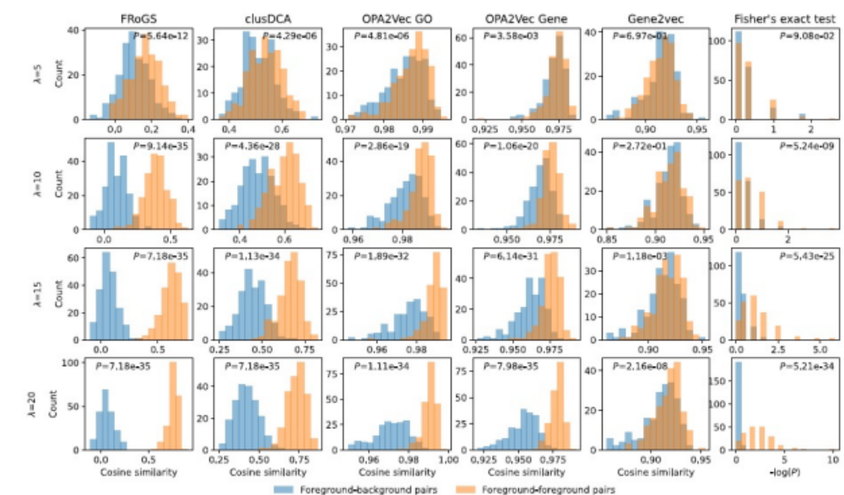
Fig. S1 Distributions of distance between two kinds of gene set pairs for different methods using pathway R-HSA-5576891 (Cardiac conduction) as an example. Algorithms attempt to distinguish pairs of foreground gene set signatures (orange) from pairs of foreground-background signatures (blue). Each row represents simulation results conducted using foreground gene sets sampled under a particular λ. Each column contains results obtained under the corresponding algorithms. When fewer pathway genes were seeded ($λ=5$, the first row), the Fisher’s exact test (the last column in Fig. S1) failed to distinguish ($S_{fg}$, $S_{fg}^{'}$) pairs from ($S_{fg}$, $S_{bg})$ pairs (p = 0.09), explaining the difficulty of the current gene identity-based algorithm in extracting weak molecular causal signals. FRoGS embedding (the first column in Fig. 1c), on the other hand, distinguished the two distributions with a p-value of 5.6×10⁻¹². As $λ$ increased, the two distributions became more readily distinguishable under stronger pathway signals, and FRoGS demonstrated the best separation among all methods under comparison.

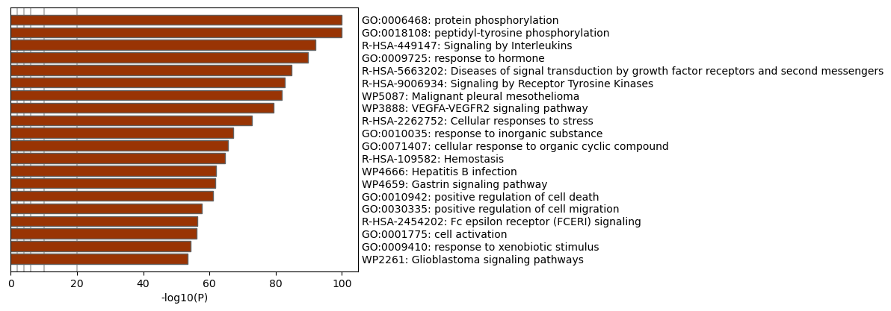Fig. S2 Known targets show strong functional bias. Known targets based on Broad annotations⁷ are highly enriched in kinase signaling and cancer-related processes according to Metascape enrichment analysis¹⁵.

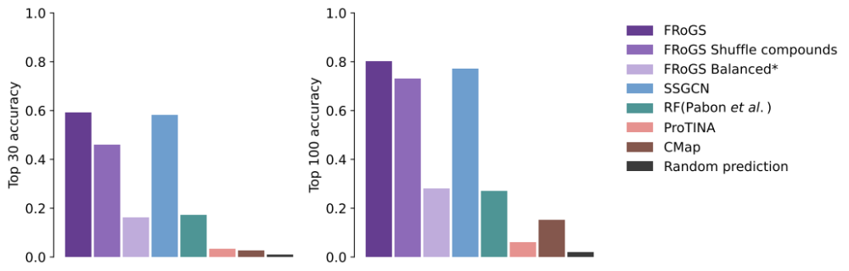
Fig. S3 Performance comparison with other state-of-the-art compound-target prediction methods based on the SSGCN¹¹ dataset. The performance of FRoGS was trained on the SSGCN dataset. The performance of FRoGS Shuffle compounds was obtained by shuffling the query compound gene signatures in the input of FRoGS. * marks the stringent data generation strategy that requires a 1:1 ratio of positive compounds to negative compounds paired with each target, which is different from the one used in SSGCN. The performance of SSGCN⁶, RF (Pabon et al.)¹⁷, ProTINA¹⁸, CMap¹⁹, and random prediction was obtained from the original publication of SSGCN. The dramatic increase in performance of our FRoGS model using SSGCN imbalanced training dataset (from 3rd bar to the 1st bar from the left) suggests the high performance of SSGCN might be partially explained by the bias introduced in the training and could limit model generalization.

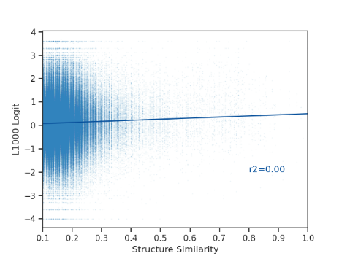 | 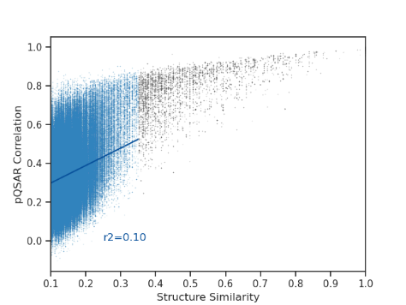 | 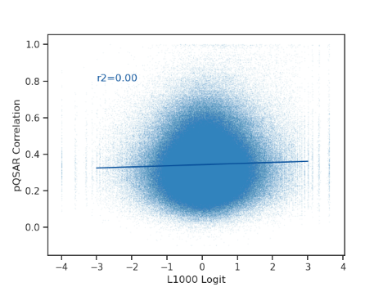
a | b | c
Fig. S4 Correlation among L1000 logit score (1 - r)/r, pQSAR correlation coefficient q, and query-reference structural similarity score s. a L1000 logit and structure similarity score s are independent. c pQSAR similarity q and structure similarity s have a marginal correlation of r² = 0.10, when we only compute q for pairs with s ≤ 0.35. c L1000 and pQSAR features are independent.

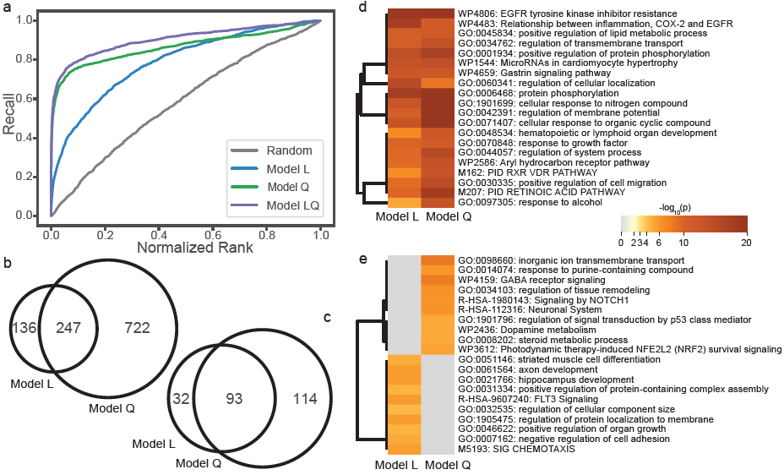
Fig. S5 Comparison between Model L and Model Q. a Recall-rank plot for all models. b Venn diagram of compounds with known targets recallable with high probability (p ≥ 0.8) by Model L and Model Q. c Venn diagram of known targets recallable with high probability (p ≥ 0.8) by Model L and Model Q. d Top 20 commonly enriched biological process clusters based on known targets in b. e Top 20 specifically enriched biological process clusters based on known targets recalled by Model L and Model Q.

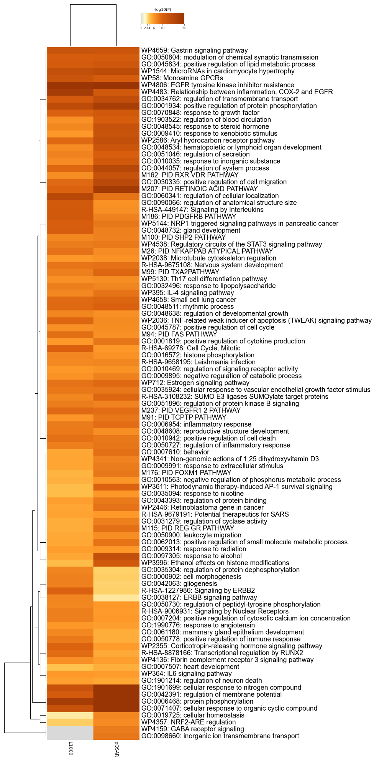
a
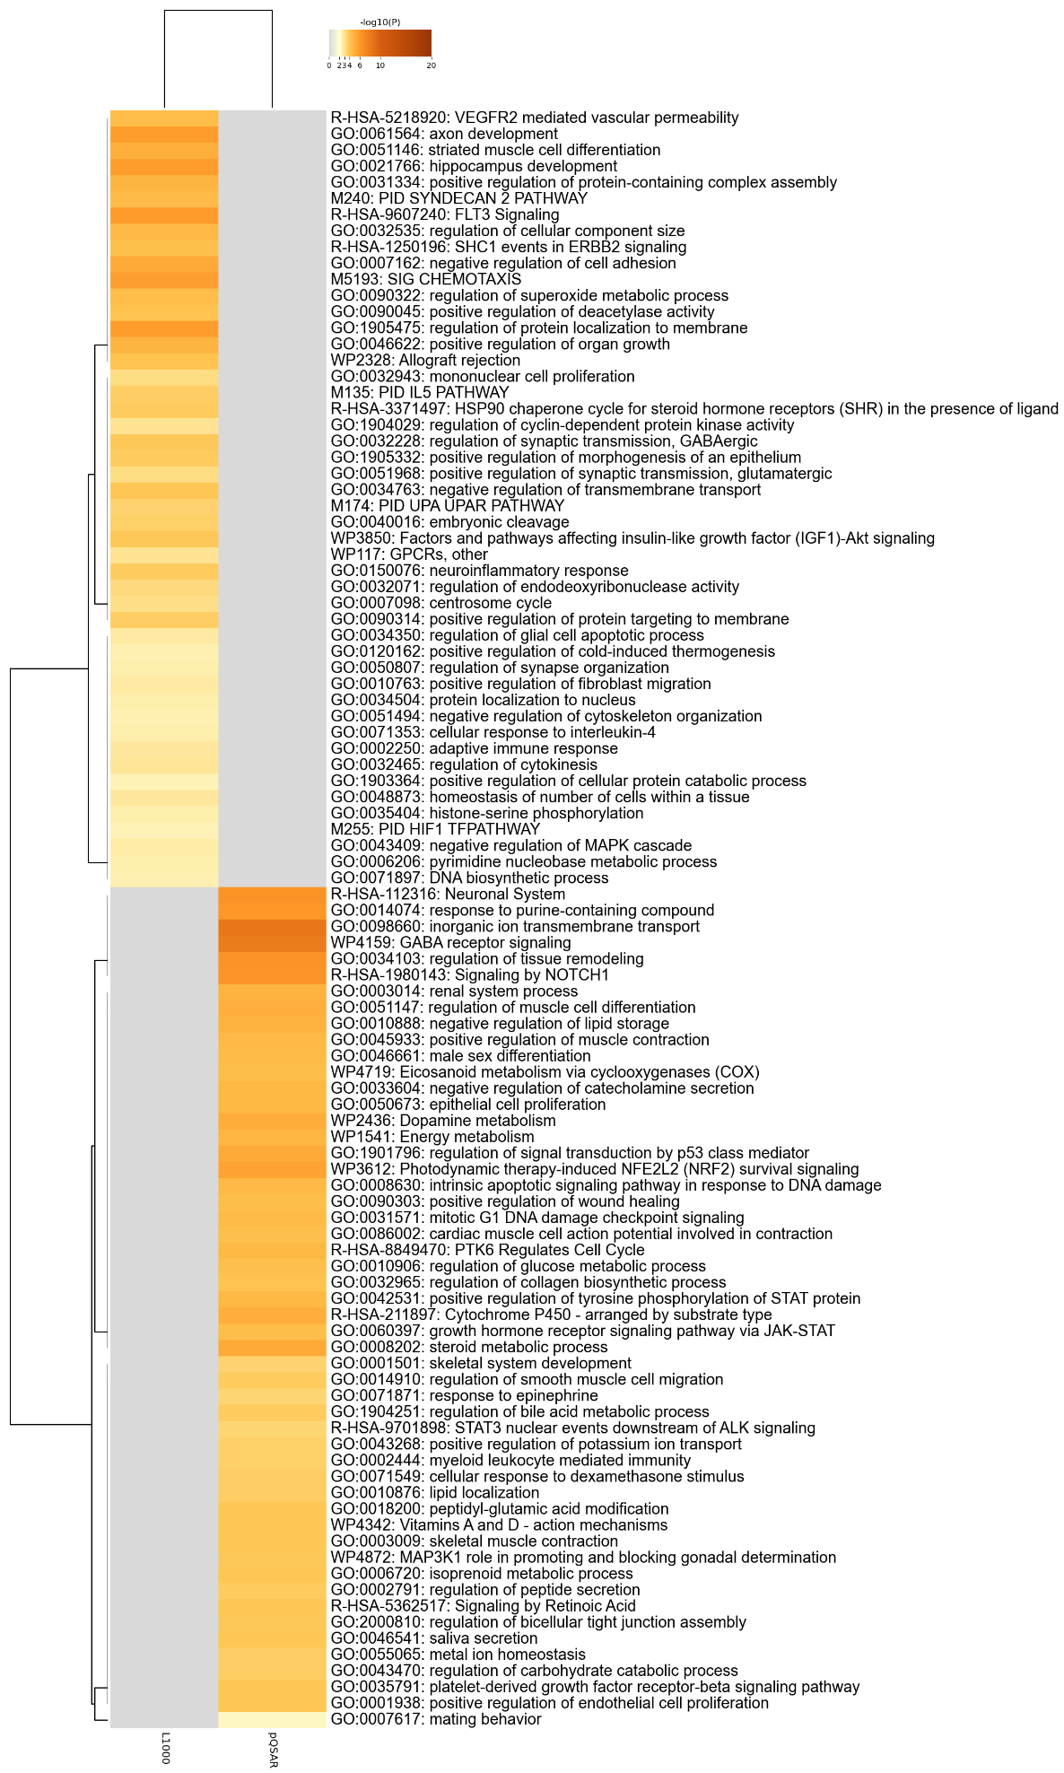
b
Fig. S6 Top 100 enriched processes identified by Metascape¹⁵ based on known targets recalled by Model L and Model Q. a Metascape enrichment analysis results prioritized by commonly enriched processes. b Metascape enrichment analysis results prioritized by specifically enriched processes.
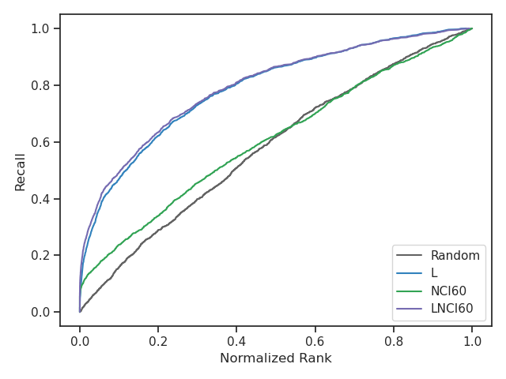
Fig. S7 Comparison of Model L, Model NCI₆₀, and Model L+NCI₆₀ (LNCI60).

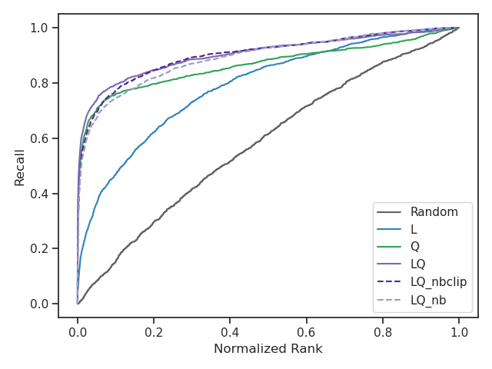
Fig. S8 Comparison between logistic regression Model LQ and Naive Bayesian models LQ^{NB} and
LQ^{NBclip}.

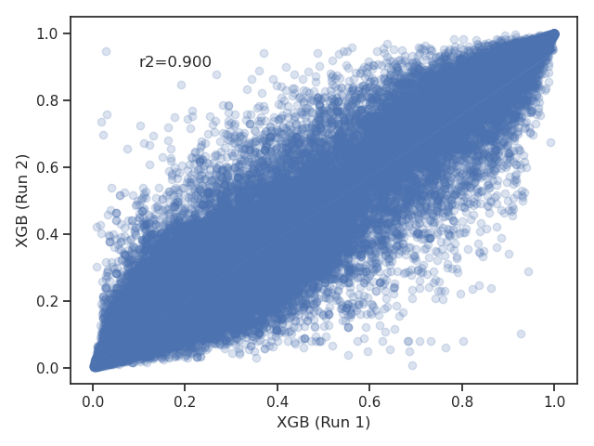 | 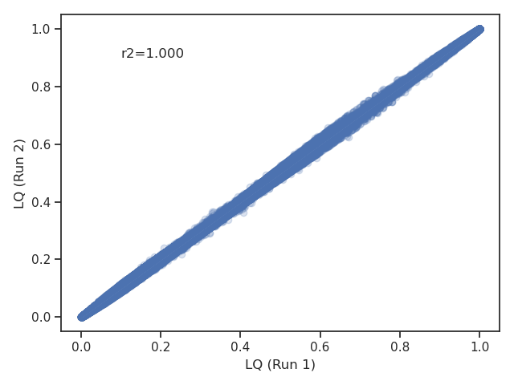
a | b
Fig. S9 Prediction correlation between two independent cross-validation model inferences. The predictions were collected from the leave-out fold predicted with a model trained based on the other four folds. a Results from two XGBoost models. b Results from two logistic regression LQ models.

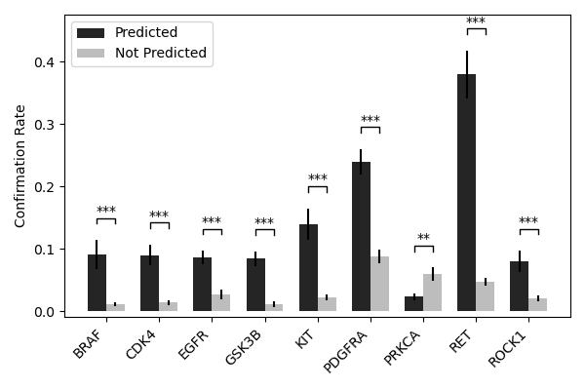
Fig. S10 Comparison of dose-response confirmation rates between compounds predicted to bind to corresponding kinases (black) versus those not predicted (gray). The differences show the precisions, TP/(TP + FP), of our kinase inhibitor predictions are significantly higher than false omission rate, FN/(FN+TN). The separation is clear in 8 out of 9 assays tested except PRKCA.
Reference
1. Smaili, F. Z., Gao, X. & Hoehndorf, R. OPA2Vec: combining formal and informal content of biomedical ontologies to improve similarity-based prediction. Bioinformatics 35, 2133–2140 (2019).
2. Du, J. et al. Gene2vec: distributed representation of genes based on co-expression. BMC Genomics 20, 82 (2019).
3. Wang, S., Cho, H., Zhai, C., Berger, B. & Peng, J. Exploiting ontology graph for predicting sparsely annotated gene function. Bioinformatics 31, i357-64 (2015).
4. Mikolov, T., Sutskever, I., Chen, K., Corrado, G. S. & Dean, J. Distributed representations of words and phrases and their compositionality. Adv Neural Inf Process Syst 26, (2013).
5. Canese, K. & Weis, S. PubMed: The Bibliographic Database. The NCBI handbook 2, (2013).
6. Zhong, F. et al. Drug target inference by mining transcriptional data using a novel graph convolutional network framework. Protein Cell 13, 281–301 (2022).
7. Corsello, S. M. et al. The Drug Repurposing Hub: a next-generation drug library and information resource. Nat Med 23, 405–408 (2017).
8. Madhukar, N. S. et al. A Bayesian machine learning approach for drug target identification using diverse data types. Nat Commun 10, 5221 (2019).
9. Rogers, D. & Hahn, M. Extended-connectivity fingerprints. J Chem Inf Model 50, 742–54 (2010).
10. Cheng, T., Li, Q., Wang, Y. & Bryant, S. H. Identifying compound-target associations by combining bioactivity profile similarity search and public databases mining. J Chem Inf Model 51, 2440–8 (2011).
11. Martin, E. J. et al. All-Assay-Max2 pQSAR: Activity Predictions as Accurate as Four-Concentration IC50s for 8558 Novartis Assays. J Chem Inf Model 59, 4450–4459 (2019).
12. Shoemaker, R. H. The NCI60 human tumour cell line anticancer drug screen. Nat Rev Cancer 6, 813–23 (2006).
13. Matthews, B. W. Comparison of the predicted and observed secondary structure of T4 phage lysozyme. Biochim Biophys Acta 405, 442–51 (1975).
14. Wang, W., Yang, S. & Li, J. Drug target predictions based on heterogeneous graph inference. Pac Symp Biocomput 53–64 (2013).
15. Zhou, Y. et al. Metascape provides a biologist-oriented resource for the analysis of systems-level datasets. Nat Commun 10, 1523 (2019).
16. Chen, T. & Guestrin, C. XGBoost: A Scalable Tree Boosting System. Proceedings of the 22nd ACM SIGKDD International Conference on Knowledge Discovery and Data Mining doi:10.1145/2939672.
17. Pabon, N. A. et al. Predicting protein targets for drug-like compounds using transcriptomics. PLoS Comput Biol 14, e1006651 (2018).
18. Noh, H., Shoemaker, J. E. & Gunawan, R. Network perturbation analysis of gene transcriptional profiles reveals protein targets and mechanism of action of drugs and influenza A viral infection. Nucleic Acids Res 46, e34 (2018).
19. Lamb, J. et al. The Connectivity Map: using gene-expression signatures to connect small molecules, genes, and disease. Science 313, 1929–35 (2006).

