Supplementary Table 1. Drug likeliness properties
Phytocompound | cLogP | LogS | Molecular Weight | TPSA | Drug Score | Lipinski drug likeness | No of violations
7-Hydroxyfrullanolide | 1.98 | -2.73 | 248.32 g/mol | 46.53 Å² | 0.27 | -9.12 | 0
5-hydroxy-7-methoxy-6-C-glycosylflavone | 0.26 | -3.22 | 430.40 g/mol | 134.9 Å² | 0.24 | -3.59 | 0
Terpineol | 2.34 | -2.19 | 154.25 g/mol | 20.23 Å² | 0.28 | -7.41 | 0
Germacrene D | 5.96 | -3.55 | 204.35 g/mol | 0.00 Å² | 0.28 | -10.29 | 1
Astragalin | -0.09 | -2.49 | 448.38 g/mol | 186.3 Å² | 0.42 | -2.68 | 2
Isoquercetin | -0.35 | -2.19 | 464.38 g/mol | 206.6 Å² | 0.43 | -2.17 | 2
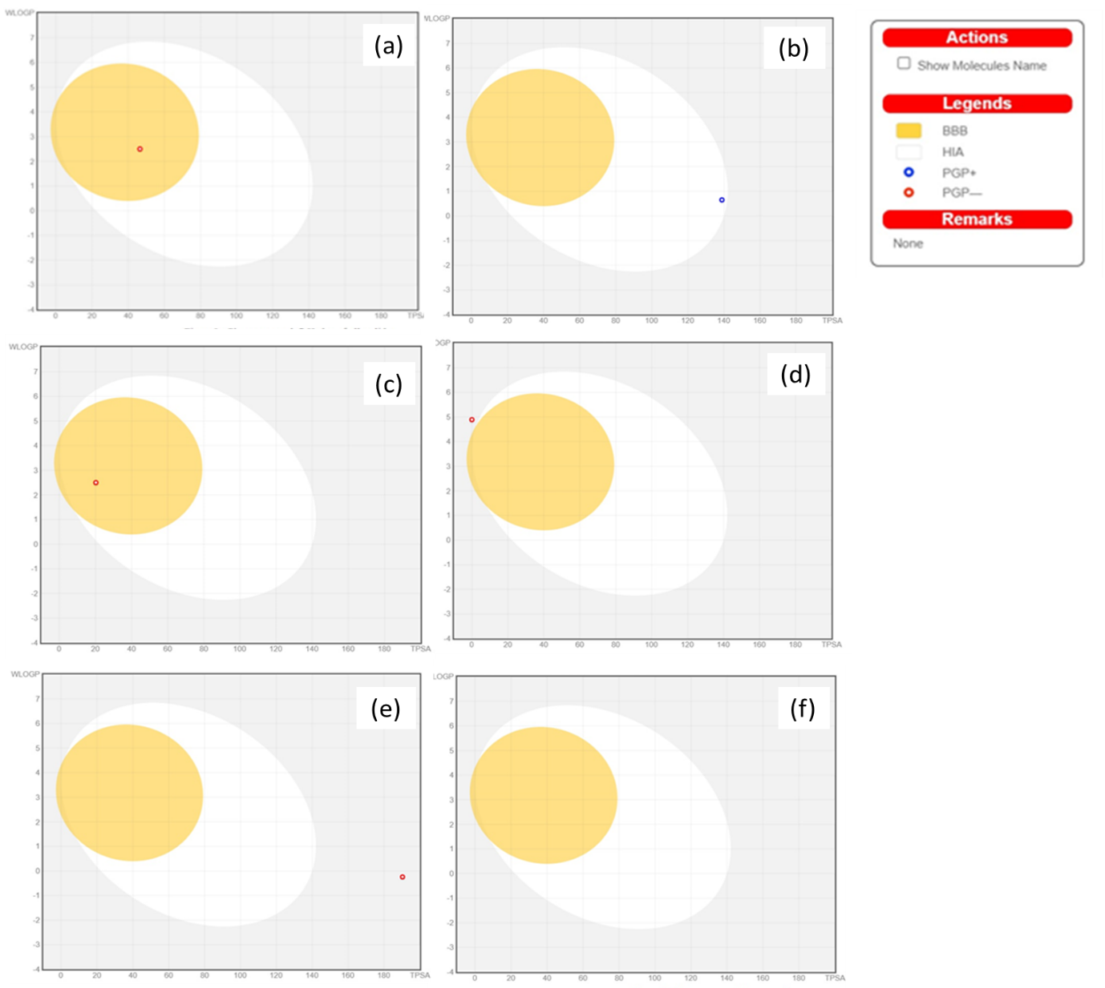
Supplementary Figure 1. Predictive Model Brain Or IntestinaL EstimateD permeation method (Boiled-egg). The BOILED-egg plots depicted that all the binders were capable of absorption into the human gastrointestinal tracts [(a) - 7-Hydroxyfrullanolide, (b) - 5-hydroxy-7-methoxy-6-C-glycosylflavone, (c) – Terpineol, (d) – Germacrene D, (e)- Astragalin, (f) – Isoquercetin]
Supplementary Table 2. ADME properties of phytocompounds
 | 7-Hydroxyfrullanolide | 5-hydroxy-7-methoxy-6-C-glycosylflavone | Terpineol | Germacrene D | Astragalin | Isoquercetin
Eye irritation | + | - | + | + | - | -
Reproductive toxicity | + | + | - | - | + | +
Respiratory toxicity | + | + | - | - | + | +
skin sensitisation | - | - | + | + | - | -
Blood Brain Barrier | + | - | + | + | - | -
Biodegradation | - | - | + | + | - | -

