SUPPLEMENTARY
Supplementary Figures
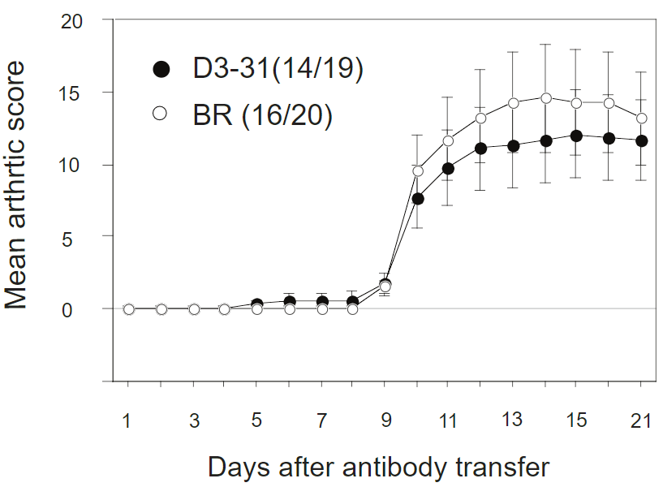
Supplementary figure S1: D3-31 mice are not protected from T cell-independent collagen type II antibody-induced arthritis (CAIA). D3-31 mice are shown in black and BR mice in white. Data is summarized as mean (SEM). Incidence and total number of mice are indicated in parenthesis.
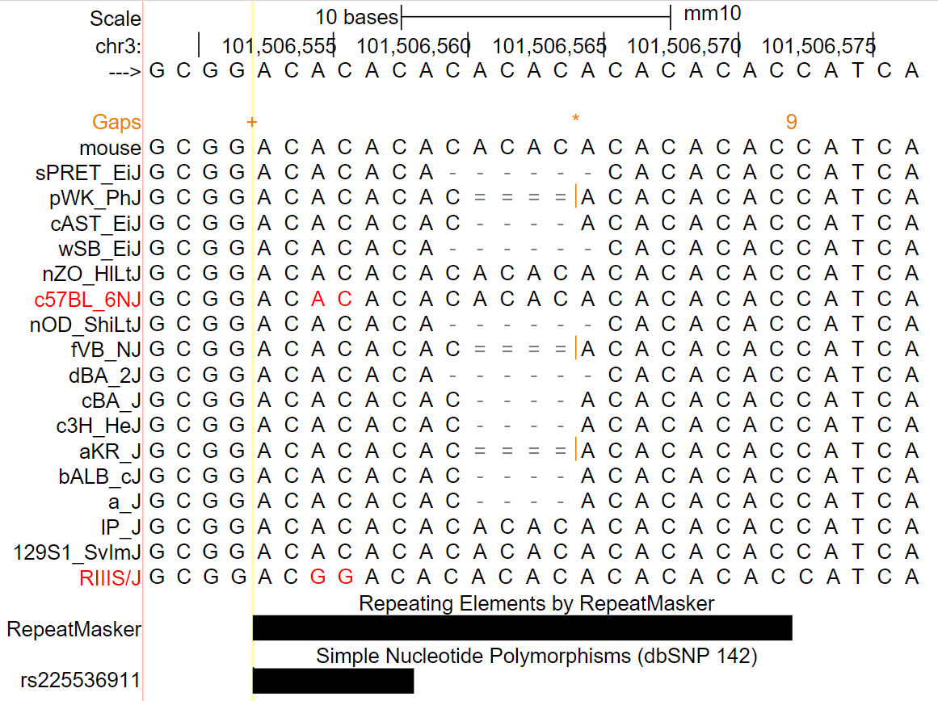
Supplementary figure S2: SNP478 lies within a highly polymorphic CA(n) simple repeat. Sequences of common mouse inbred strains around SNP478 according to ²⁰ are shown. +, start of AC repeat; 9, end of AC repeat; single line, aligned strain has no bases in the gap region; double line, aligned strain has one or more unalignable bases in the gap region.
Supplementary Methods
Supplementary Table 1: List of primers used for genotyping.
Target |  | Sequence 5'-3' | Application
D3mit75 | F | CCTGCCCTCCTTCTACCAG | genotyping
 | R | GCTTAGTGGTTCCTATTGAAGTCA
D3mf54 | F | TTGTGTCTTGGCCCCTTGTT | genotyping
 | R | GCTCCTAGGTGAGGCTTGAGAA
D3mf46 | F | TCCCCCAAGCATGAGAAAAC | genotyping
 | R | TGGTAGCGCTTTTATTTATTCCC
D3KV1/HRM424 | F | AAGACAGGTCCCAGAACCCT | genotyping
 | R | TCAGCTCTCTTCTTGACCACAC
D3mf96 | F | CCCAGAGGCTCCTCCCTAT | genotyping
 | R | TCACTCTTGGTTTCGAGGAGA
D3mf52 | F | CATACATTCAGGCAAAACACTCA | genotyping
 | R | TGACAGCTACGGTGTACTCACAT
D3mf2/AA1 | F | CCGATCTGATGGAGACATTTTTT | genotyping
 | R | TTCTGCTGGGGTGAGATTCA
D3mf31 | F | ATGTGGCTCAATGAGAACAGCT | genotyping
 | R | CCAAAAAATGGGATACCACAATG
D3mit102 | F | GGCTCGCTGGTTGGTTTTAC | genotyping
 | R | GGGCTCCTACATGCATGAAT
D3mit77 | F | TCCTGCTGACACCACCAAG | genotyping
 | R | AGCACCTACATTTTCCGCAA
D3mf43 | F | GTGGGGAGGTATGGGATGA | genotyping
 | R | GGCTCGAACCCATGACATA

Supplementary Table 2: List of primers used for gene expression.
Target |  | Sequence 5'-3' | Application
NHLH2 | F | CCACAAGCCCTTTGAGTGGG | mRNA expression
 | R | CGGTGTCTTAGCGGGTGTAT
SLC22A15 | F | GCACTTGCAGGATCGATTGG | mRNA expression
 | R | AGGAGCGGATGAAGTACCCT
CD101 | F | AGCCGGCAGCAAGAGATTTT | mRNA expression
 | R | GAAGCTGCGGGTTACCATCT
CD2 | F | CCAACCTGAACGCACCATTC | mRNA expression
 | R | AGGACAGACCTTTCTCTGGACA
ATP1A1 | F | TCGGGGCCATTCTTTGTTTC | mRNA expression
 | R | CACCCCGAGGTACAGATCAT
MAB21L3 | F | CATTAAGGTTTTGGCCCCCA | mRNA expression
 | R | GCACATTGTAGTACCGCCAG
IGSF3 | F | ATACAACTGCCGGGTGACTG | mRNA expression
 | R | AGATGCTGCTTTTGAGGGGC
VTCN1 | F | AGCTGCAGTTGCTGAACTCT | mRNA expression
 | R | CTCCGGGATTCTGTTGGACC
ACTB | F | AACCGTGAAAAGATGACCCAGAT | mRNA expression
 | R | GTCCATCAGAATGCCTGTGGTA

Supplementary Table 3: List of primers used for ChIP-qCPR.
Target |  | Sequence 5'-3' | Application
D3KV1 1 | F | GTTCTGGCCCCAGATTGTCA | ChIP-qPCR
 | R | GGTTGTGCTCCTTCCTGGAG
D3KV1 2 | F | AAAGATGTGCATCTCCGCCT | ChIP-qPCR
 | R | GGGACCTGTCTTTCAGGCTC
D3KV1 3 | F | ATTGGCAGTGGTGTAGCAGG | ChIP-qPCR
 | R | GACAATCTGGGGCCAGAACA
gene dessert | F | AGCTCTGCCATGAGAACACA | ChIP-qPCR (neg ctrl)
 | R | TGTCCATGCCCTTCTGACAA
gene dessert | F | TCCTCAAGACCAACTGCCAC | ChIP-qPCR (neg ctrl)
 | R | GTTGCCTGTTACCACTACTGC
CSF2RA 1 | F | GACCTCCGCTAAAGTCCCAG | ChIP-qPCR (pos ctrl)
 | R | TACCGCTTGTGGTCGAACTC
CSF2RA 2 | F | TGTCCTCATAGACTGGGGCA | ChIP-qPCR (pos ctrl)
 | R | GGTACGCTGCTCTGTCATGT

