Supplementary Information
Large-scale Analysis of Small Molecule-RNA Interactions using Multiplexed RNA Structure Libraries
Ryosuke Nagasawa,^{a,b,‡} Kazumitsu Onizuka,^{a,b,c,‡,}* Kaoru R. Komatsu,^{d,‡} Emi Miyashita,^{d} Hirotaka Murase,ª Kanna Ojima,^{a,b} Shunya Ishikawa,^{a,b} Mamiko Ozawa,ª Hirohide Saito,^{d,}* and Fumi Nagatsugi ^{a,b,}*
ª Institute of Multidisciplinary Research for Advanced Materials, Tohoku University, 2-1-1 Katahira, Aoba-ku, Sendai, Miyagi 980-8577, Japan.
^{b} Department of Chemistry, Graduate School of Science, Tohoku University, Aoba-ku, Sendai 980-8578, Japan.
^{c} Division for the Establishment of Frontier Sciences of Organization for Advanced Studies, Tohoku University, Aoba-ku, Sendai, Miyagi 980-8577, Japan.
^{d} Center for iPS Cell Research and Application (CiRA), Kyoto University, 53 Kawahara-cho, Shogoin, Sakyoku, Kyoto, 606-8507, Japan.

Table of Contents
Experimental procedures (Schemes S1-S5) S2-S13
Figure S1. HPLC profiles of biotin conjugation of G-clamp-N₃ S14
Figure S2. HPLC profiles of biotin conjugation of TO derivatives S14
Figure S3. Evaluation of the relationship between the number of multiple Gs and the affinity ranking of G-clamp S15
Figure S4. Fluorescence titrations to determine K_{D} values of G-clamp-N₃ S16-S21
Figure S5. Minimum free energy structures calculated by RNAfold S22
Table S1. The correlation between Z-score and K_{D} value for G-clamp S23
Figure S6. Molecular modeling structure of mir-4520-1 and mir-548ba S24
Figure S7. Kernel density estimation of TO derivatives and G-clamp Z-scores S25
Figure S8. Fluorescence titrations to compare K_{D} values for a hsa-mir-4437 loop with mir-4437-mut
S26
Figure S9. Fluorescence titrations to determine K_{D} values of TO-N₃ S27
Figure S10. Fluorescence titrations to determine K_{D} values of TO-3-N₃ S28
Figure S11. Fluorescence titrations to determine K_{D} values of TO-PRO-1 S29
Figure S12. Fluorescence titrations to determine K_{D} values of TO-PRO-3 S30
Figure S13. Minimum free energy structures for the assay with TO derivatives S31
Table S2. The correlation between Z-scores and KD values for TO-N₃ and TO-3-N₃ RNA binding
Table S3. The correlation between Z-scores and KD values for TO-PRO-1 RNA binding S32
Table S4. The correlation between Z-scores and KD values for TO-PRO-3 RNA binding S33
Figure S14. Normalized fluorescences in FID assay S34
Figure S15. Fluorescence titrations to determine K_{D} values of baicalein S35
Figure S16. Fluorescence titrations to determine K_{D} values of myricetin S35
Figure S17. Fluorescence titrations to determine K_{D} values of chelerythrine chloride S36
Figure S18. The precisions of FID assay S36
Figure S19. The pH dependency of fluorescence intensity of chelerythrine chloride S37
Figure S20. Fluorescence titrations to determine K_{D} values of AS 602801 S37
NMR data S38-S49

Experimental Procedures
Material and methods
General chemicals were purchased from FUJIFILM Wako Pure Chemical, the Tokyo Chemical Industry, Kanto Chemical or Aldrich. Target RNAs were purchased from JBioS (Japan). ¹H NMR spectra (400, 500, and 600 MHz) were recorded using Bruker AVANCE III 400, 500, and 600 spectrometers, respectively. ¹³C NMR spectra (125 and 151 MHz) were recorded using Bruker AVANCE III 500 and 600 spectrometers, respectively. High-resolution electrospray mass analysis was performed using a Bruker MicrOTOF-Q II. HPLC purification was performed with a JASCO HPLC System (PU-2089Plus, UV-2075Plus, and CO-2065Plus) using a reverse-phase C₁₈ column (COSMOSIL 5C₁₈-AR-II, Nacalai Tesque, 4.6×250 mm for analysis or 10×250 mm for ligand purification).

Synthesis of G-clamp-N₃
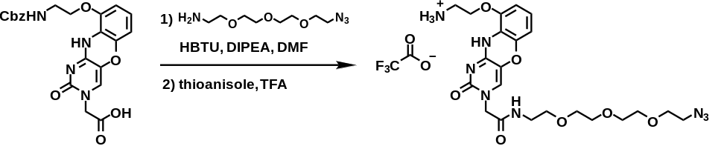

G-clamp-N₃
G-clamp-COOH
Scheme S1

To a solution of G-clamp-COOH (100 mg, 0.22 mmol) in DMF (3.4 mL), HBTU (126 mg, 0.33 mmol), DIPEA (224 µL, 1.32 mmol), and 11-azido-3,6,9-trioxaundecan-1-amine (65 μL, 0.33 mmol) were added, and the reaction mixture was stirred at room temperature overnight. The reaction mixture was diluted with DCM, and then washed with saturated aqueous NaHCO₃ and brine. The organic layer was separated and dried over Na₂SO₄, filtered, and evaporated. The residue was purified by column chromatography (CHCl₃: MeOH = 30:1) to afford Cbz-protected G-clamp-N₃ as a yellow solid (122 mg, 85%).

To a solution of the above compound (10 mg, 0.015 mmol) in TFA (200 µL), thioanisole (43 µL, 0.38 mmol) was added, and the mixture was stirred at room temperature overnight. TFA was completely removed in vacuo, and the resulting residue was dissolved in MeOH, washed with Hexane and evaporated. The crude product was purified by reverse phased HPLC with C-18 column (Nacalai Tesque: COSMOSIL 5C₁₈-AR-II, 10 × 250 mm) by a liner gradient of 0-40%/30 min acetonitrile in 0.1% TFA buffer at a flow rate of 4 mL/min at 40 ºC, and monitored by UV detection at λ = 254 nm, to afford G-clamp-N₃ as a yellow solid (11.6 µmol, 74%). The concentration of G-clamp-N₃ was determined by quantitative ¹H-NMR using maleic acid as an internal standard. ¹H-NMR (400 MHz, DMSO-d₆) δ 3.22-3.27 (m, 4H), 3.38-3.44 (m, 4H), 3.50-3.57 (m, 8H), 3.59 (t, J = 4.8 Hz, 2H), 4.16 (t, J = 4.8 Hz, 2H), 4.26 (s, 2H), 6.51 (d, J = 8.0 Hz, 1H), 6.67 (d, J = 8.0 Hz, 1H), 6.84 (t, J = 8.0 Hz, 1H), 7.45 (s, 1H), 8.03 (brs, 3H), 8.20 (t, J = 5.4 Hz, 1H), 9.82 (brs, 1H). ¹³C-NMR (151 MHz, DMSO-d₆) δ 42.3, 50.2, 50.8, 65.1, 69.2, 69.4, 69.79, 69.87, 69.95, 69.98 107.2, 108.7, 116.0, 118.1, 123.4, 125.7, 130.0, 142.5, 145.7, 154.3, 158.2, 167.4. ESI-HRMS (m/z): [M+H]⁺ calcd for C₂₂H₃₁N₈O₇⁺, 519.2310; found 519.2334.

Synthesis of TO-N₃
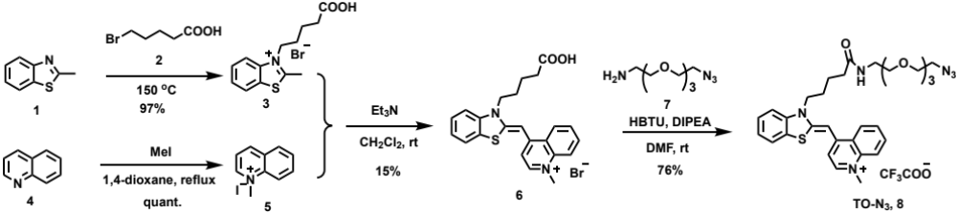

Scheme S2
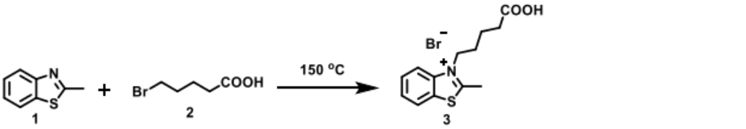
Synthesis of compound 3

Compound 1 (2.98 g, 20.0 mmol) and compound 2 (5.41 g, 29.9 mmol) were mixed neat at 150 °C for 23 h. After the mixture was cooled to room temperature, Et₂O (10 mL) was added. The mixture was washed with Et₂O (30 mL) to provide compound 3 (7.61 g, 97% yield) as a brown solid. The yield was calculated by ¹H-NMR analysis because the crude contained byproduct which is HBr salt of compound 1 (compound 3: HBr salt of compound 1 = 1 : 0.28). ESI-HRMS (m/z): [M-Br⁻]⁺ calcd for C₁₃H₁₆NO₂S⁺, 250.0896, found 250.0889.

Synthesis of compound 5

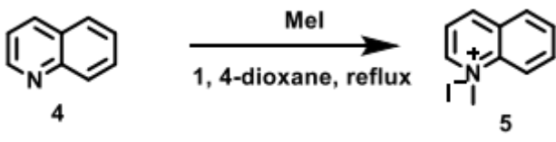
To a solution of quinoline 4 (1.13 g, 8.72 mmol) in 1,4-dioxane (15 mL), MeI (2.3 g, 16 mmol) was added dropwise and refluxed for 22 h. The mixture was cooled to room temperature before filtration. The mixture was washed with Et₂O (3 mL×3) and hexane (3 mL×3) to afford compound 5 (2.27 g, quant) as a yellow solid. ¹H-NMR (400 MHz, DMSO-d₆) δ 4.64 (s, 3H), 8.08 (dt, J = 1.2, 6.0 Hz, 1H), 8.17 (dd, J = 5.6, 8.4 Hz, 1H), 8.30 (dt, J = 1.6, 7.2 Hz, 1H), 8.48 (dd, J = 1.2, 8.0 Hz, 1H), 8.52 (dd, J = 0.8, 8.8 Hz, 1H), 9.28 (d, J = 8.4 Hz, 1H), 9.50 (dd, J = 0.8, 5.8Hz, 1H).

Synthesis of compound 6
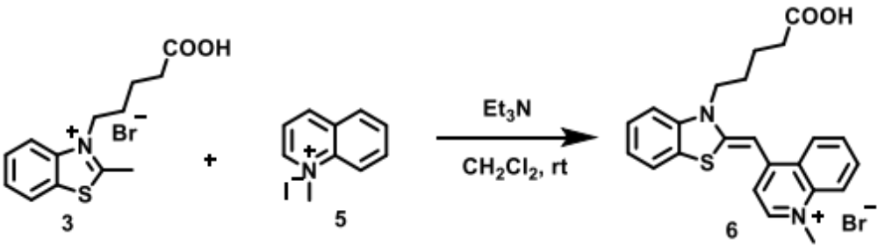

To a solution of compound 3 (0.195 g, 0.590 mmol), compound 5 (0.162 g, 0.635 mmol) in CH₂Cl₂ (5.6 mL) and Et₃N (0.62 g, 6.1 mmol) were added and the mixture was stirred at room temperature for 18 h. The mixture was evaporated under reduced pressure, filtrated with acetone (20 mL) and dried under reduced pressure. Then, the mixture was filtrated with H₂O (10 mL) and dried under reduced pressure. The mixture was dissolved in MeOH (10 mL) and solid residues were filtrated out. The filtrate was evaporated under reduced pressure. The residue was purified by reprecipitation with MeOH (2 mL) and Et₂O (20 mL) and filtrated to afford compound 6 (42.7 mg, 15% yield) as a red solid. ¹H-NMR (400 MHz, DMSO-d₆) δ 1.69 (m, 2H), 1.77 (m, 2H), 2.28 (t, J = 6.8 Hz, 2H), 4.13 (s, 3H), 4.56 (t, J = 7.6 Hz, 2H), 6.89 (s, 1H), 7.32 (d, J = 6.8 Hz, 1H), 7.39 (t, J = 7.6 Hz, 1H), 7.58 (t, J = 8.0 Hz, 1H), 7.72 (d, J = 8.4 Hz, 1H), 7.76 (td, J = 1.6, 7.2 Hz, 1H), 7.97 (m, 3H), 8.56 (d, J = 7.2 Hz, 1H), 8.76 (d, J = 8.4 Hz, 1H).

Synthesis of compound 8
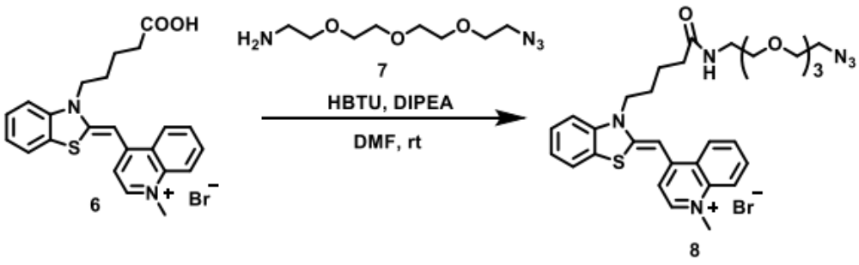
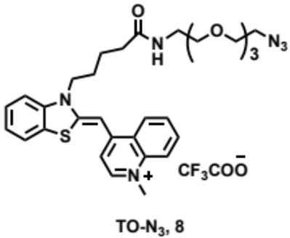

To a solution of compound 6 (9.7 mg, 21 μmol) in DMF (0.40 mL), DIPEA (16 mg, 0.12 mmol) and HBTU (14 mg, 36 μmol) were added first, then compound 7 (11 mg, 50 μmol) was added, and the mixture was stirred at room temperature for 20 h. The mixture was evaporated under reduced pressure and filtrated with DMSO (1.2 mL). The filtrate was purified by reverse phased HPLC to provide compound 8 (10.7 μmol, 76% yield) as a red solid. The concentration of TO-N₃ was determined by quantitative ¹H-NMR using maleic acid as an internal standard. HPLC conditions: A: 0.1% TFA in distilled water, B: 0.1% TFA in MeCN; B: 0%→60% (～20 min) → 100% (～25 min). Flow rate = 4 mL/min; Temp. = 28.8 °C; UV = 254 nm, C-18 column (Nacalai tesque : COSMOSIL 5C18-AR-II, 10×250 mm). ¹H-NMR (600 MHz, DMSO-d₆) δ 1.72 (m, 2H), 1.79 (m, 2H), 2.18 (t, J = 7.2 Hz, 2H), 3.16 (m, 2H), 3.30-3.57 (m, 14H),4.19 (s, 3H), 4.63 (t, J = 7.8 Hz, 2H), 6.96 (s, 1H), 7.42 (dt, J = 1.2, 6.6 Hz, 2H), 7.61 (tt, J = 1.2, 5.2 Hz, 1H), 7.80 (m, 2H), 7.88 (t, J = 5.4 Hz, 1H), 8.06 (m, 3H), 8.63 (d, J = 7.2 Hz, 1H), 8.81 (d, J = 7.8 Hz, 1H). ¹³C-NMR (151 MHz, DMSO-d₆) δ 22.3, 26.3, 34.6, 38.4, 42.4, 45.5, 49.9, 69.1, 69.2, 69.5, 69.6, 69.7, 69.7, 87.5, 108.0, 112.9, 118.3, 122.9, 123.8, 124.1, 124.5, 125.6, 127.0, 128.2, 133.2, 138.1, 140.0, 145.1, 148.9, 159.3, 171.9. ESI-HRMS (m/z): [M-CF₃COO⁻]⁺ calcd for C₃₁H₃₉N₆O₄S⁺ , 591.2748, found 591.2748.

Synthesis of TO-3-N₃
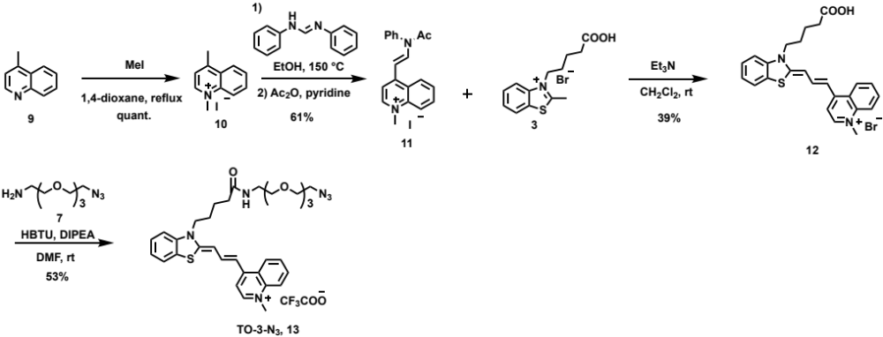

Scheme S3

Synthesis of compound 10
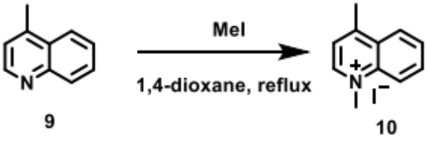

To a solution of 4-methylquinoline 9 (1.08 g, 7.58 mmol) in 1,4-dioxane (13 mL), MeI (2.1 g, 14.4 mmol) was added dropwise and refluxed for 19 h. The mixture was cooled to room temperature before filtration with Et₂O (5 mL). The mixture was washed with Et₂O (3 mL×3) and hexane (3 mL×3) to provide compound 10 (2.20 g, quant) as a yellow solid. ¹H-NMR (400 MHz, DMSO-d₆) δ 3.00 (s, 3H), 4.57 (s, 3H), 8.06 (m, 2H), 8.27 (dt, J = 2.0, 6.8 Hz, 1H), 8.48 (d, J = 8.8 Hz, 1H), 8.53 (dd, J = 1.0, 8.8 Hz, 1H), 9.34 (d, J = 6.0 Hz, 1H).

Synthesis of compound 11
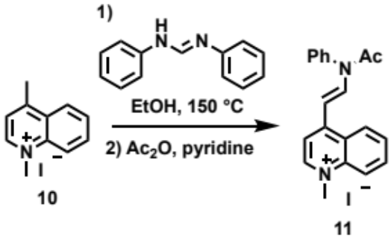

To a solution of compound 10 (0.518 g, 1.82 mmol) in EtOH (3.0 mL), diphenylformamidine (0.694 g, 3.54 mmol) was added and the mixture was stirred at 150 °C for 40 min. The mixture was cooled to room temperature and filtrated with EtOH (20 mL) to afford enamine intermediate (1.00 g). Pyridine (5.6 mL) and Ac₂O (1.8 g, 18 mmol) were added to the intermediate and the mixture was stirred at room temperature for 18 h. The mixture was diluted with AcOEt (28 mL), filtrated with AcOEt (30 mL) and dried under reduced pressure. To the residue, CH₂Cl₂ (10 mL) was added and stirred at room temperature for 40 min to be dissolved. Solid residues in the solution were filtrated out and the filtrate was evaporated under reduced pressure. The residue was purified by reprecipitation with CH₂Cl₂ (0.5 mL) and Et₂O (8.4 mL) and filtration with Et₂O (40 mL) to afford compound 11 (0.476 g, 61% yield) as a pale green solid. ¹H-NMR (400 MHz, DMSO-d₆) δ 2.07 (s, 3H), 4.46 (s, 3H), 6.04 (d, J = 14 Hz, 1H), 7.73 (d, J = 8.4 Hz, 2H), 7.69 (m, 3H), 7.89 (m, 2H), 8.17 (dt, J = 2.0, 6.8 Hz, 1H), 8.35 (d, J = 8.8 Hz, 1H), 8.36 (d, J = 6.8 Hz, 1H), 8.90 (d, J = 13.6 Hz, 1H), 9.14 (d, J = 6.8 Hz, 1H).

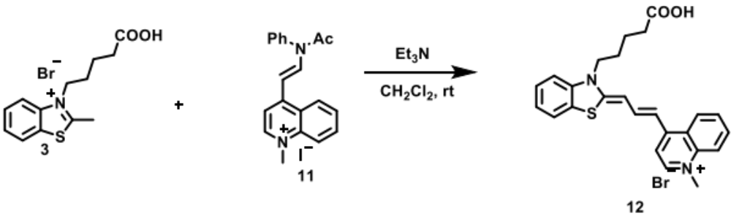
Synthesis of compound 12

To a solution of compound 3 (0.103 g, 0.313 mmol), compound 11 (0.132 g, 0.306 mmol) in CH₂Cl₂ (1.0 mL) and Et₃N (147 mg, 6.1 mmol) were added and stirred at room temperature for 16 h. The mixture was evaporated under reduced pressure, filtrated with CH₂Cl₂ (6 mL), washed with acetone (20 mL) and dried under reduced pressure to provide compound 12 (61.6 mg, 39% yield) as a green-purple solid. ¹H-NMR(400 MHz, DMSO-d₆) δ1.64 (m, 2H), 1.72 (m, 2H), 2.20 (t, J = 6.4 Hz, 2H), 4.11 (s, 3H), 4.21 (t, J = 7.2 Hz, 2H), 6.51 (d, J = 12 Hz, 1H), 7.11 (d, J = 13.6 Hz, 1H), 7.27 (t, J = 7.6 Hz, 1H), 7.42 (t, J = 8.0 Hz, 1H), 7.55 (d, J = 8.4 Hz, 1H), 7.71 (m, 1H), 7.82 (t, J = 7.2, 2H), 7.96 (m, 2H), 8.11 (t, J = 12.4 Hz, 1H), 8.36 (d, J = 6.8 Hz, 1H), 8.46 (d, J = 8.8 Hz, 1H).

Synthesis of compound 13
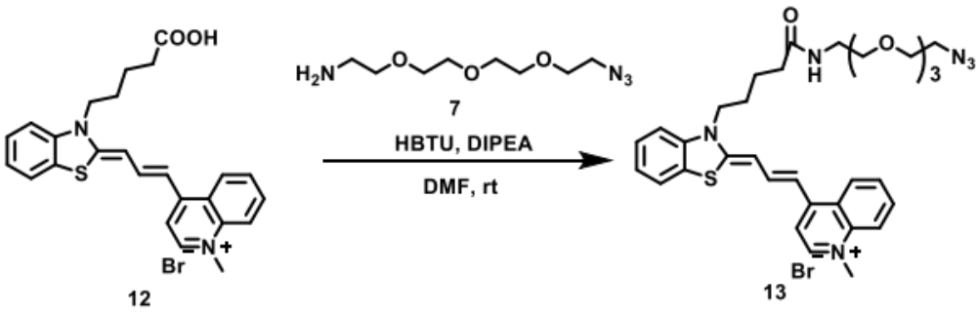
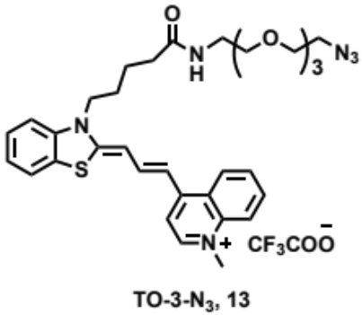

To a solution of compound 12 (10.2 mg, 20.5 μmol) in DMF (0.60 mL), DIPEA (16 mg, 0.13 mmol) and HBTU (12.3 mg, 32.4 μmol) were added first, then compound 7 (11 mg, 50 μmol) was added and stirred at room temperature for 21 h. Then, HBTU (6.5 mg, 17.1 μmol) and compound 7 (11 mg, 50 μmol) were added to the mixture and the mixture was stirred for further 21 h. The mixture was evaporated under reduced pressure and filtrated with DMSO (1.2 mL). The filtrate was purified by reverse phased HPLC to provide compound 13 (10.9 μmol, 53% yield) as a blue solid. The concentration of TO-3-N₃ was determined by quantitative ¹H-NMR using maleic acid as an internal standard. HPLC conditions: A: 0.1% TFA in distilled water, B: 0.1% TFA in MeCN; B: 0% → 60% (～20 min)→100%(～25 min). Flow rate = 4 mL/ min; Temp. = 26.6 °C; UV = 254 nm, C-18 column (Nacalai Tesque: COSMOSIL 5C18-AR-II, 10×250 mm). ¹H-NMR (600 MHz, DMSO-d₆) δ 1.66 (m, 4H), 2.18 (t, J = 4.4 Hz, 2H), 3.18 (m, 2H), 3.35-3.57 (m, 14H), 4.13 (s, 3H), 4.23 (t, J = 7.2 Hz, 2H), 6.50 (d, J = 12.6 Hz, 1H), 7.13 (d, J = 13.2 Hz, 1H), 7.30 (dt, J = 0.6, 7.5 Hz, 1H), 7.48 (dt, J = 0.6, 7.2 Hz, 1H), 7.58 (d, J = 8.4 Hz, 1H), 7.73 (dt, J = 1.8, 6.6 Hz, 1H), 7.86 (d, J = 7.8, 2H), 7.92 (t, J = 5.4 Hz, 1H), 7.99 (m, 2H), 8.14 (t, J = 12.6 Hz, 1H), 8.41 (d, J = 6.6 Hz, 1H), 8.47 (d, J = 8.4 Hz, 1H). ¹³C-NMR (151 MHz, DMSO-d₆) δ 22.4, 26.6, 34.8, 38.5, 42.3, 45.4, 50.1, 69.2, 69.3, 69.6, 69.7, 69.8, 69.8, 98.4, 109.5, 109.7, 112.5, 118.2, 122.7, 124.1, 124.2, 124.8, 125.0, 126.9, 127.7, 133.5, 139.0, 141.5, 143.4, 143.9, 150.6, 160.8, 171.9. ESI-HRMS (m/z): [M-CF₃COO⁻]⁺ calcd for C₃₃H₄₁N₆O₄S⁺, 617.2905, found 617.2907.

Synthesis of TO-N₃-2
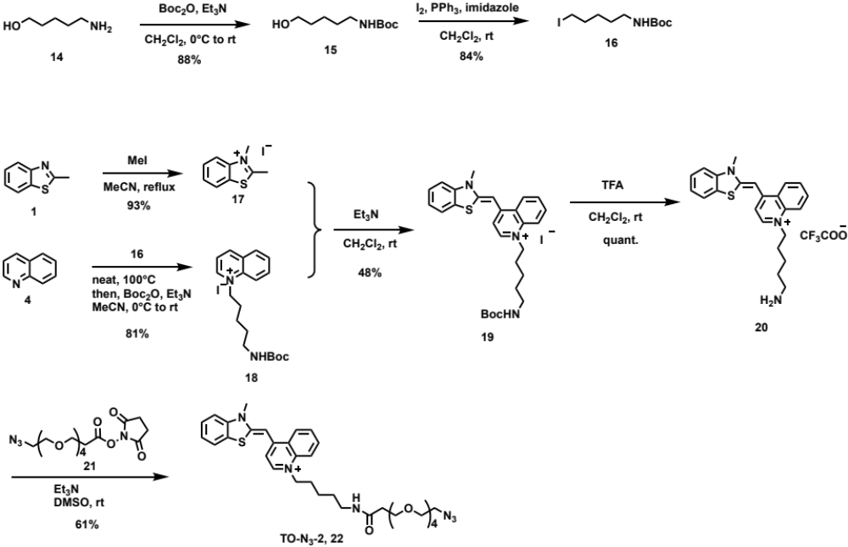

Scheme S4

Synthesis of compound 15

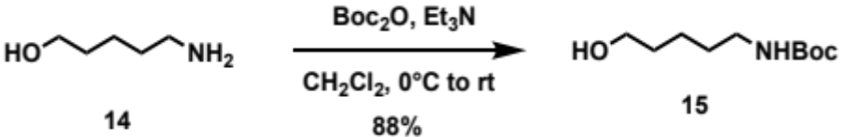
To a solution of 5-amino-1-pentanol 14 (1.01 g, 9.75 mmol) in CH₂Cl₂ (19 mL), Et₃N (1.1 g, 11 mmol) was added and cooled to 0 °C, then Boc₂O (2.4 g, 11 mmol) was added and stirred. After 6 min, the temperature of the mixture was raised to room temperature and stirred for 20 h. H₂O (50 mL) and CHCl₃ (50 mL) were added to the mixture, the organic and aqueous layers were separated, then the aqueous layer was extracted with CHCl₃ (30 mL×3). The organic layers were combined and dried over Na₂SO₄. The solution was filtered and concentrated under reduced pressure. The residue (3.48 g) was purified by column chromatography (hexane/AcOEt = 2/1 to 1/1 to 1/2) to afford compound 15 as a colourless oil (1.74 g, 88% yield). ¹H-NMR (500 MHz, CDCl₃) δ 1.39 (m, 2H), 1.43 (s, 9H), 1.51 (quintet, J = 7.3 Hz, 2H), 1.59 (quintet, J = 7.0 Hz, 2H), 3.12 (q, J = 6.3 Hz, 2H), 3.64 (t, J = 6.5 Hz, 2H), 4.55 (brs, 1H). ESI-HRMS (m/z): [M+H]⁺ calcd for C₁₀H₂₂NO₃⁺ , 204.1594, found 204.1578.

Synthesis of compound 16
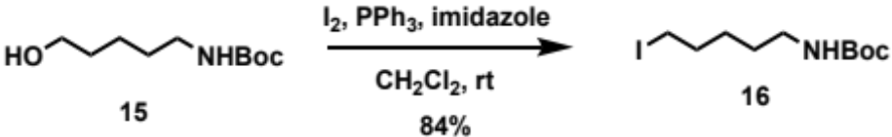

To a solution of I₂ (2.62 g, 10.3 mmol) in CH₂Cl₂ (7.0 mL), PPh₃ (3.38 g, 12.9 mmol) and imidazole (0.877 g, 12.9 mmol) were added at 0 °C. A solution of compound 15 (1.74 g, 8.56 mmol) in CH₂Cl₂ (10 mL) was added to the mixture and then warmed to room temperature and stirred for 15 h. Sat. Na₂S₂O₃ aq. (50 mL) and CH₂Cl₂ (50 mL) were added to the mixture, the organic and aqueous layers were separated, then the aqueous layer was extracted with CH₂Cl₂ (50 mL). The organic layers were combined and washed with sat. Na₂S₂O₃ aq. (50 mL) and brine (50 mL), then dried over Na₂SO₄. The solution was filtered and evaporated under reduced pressure. The residue (6.41 g) was purified by column chromatography (hexane/Et₂O = 8/1 to 4/1) to afford compound 16 as a colourless oil (2.26 g, 84% yield). ¹H-NMR (400 MHz, CDCl₃) δ 1.41 (m, 2H), 1.44 (s, 9H), 1.49 (m, 2H), 1.84 (quintet, J = 7.2 Hz, 2H), 3.12 (q, J = 6.3 Hz, 2H), 3.18 (t, J = 7.0 Hz, 2H), 4.52 (brs, 1H). ESI-HRMS (m/z): [M+Na]⁺ calcd for C₁₀H₂₀INNaO₂⁺, 336.0421, found 336.0423.

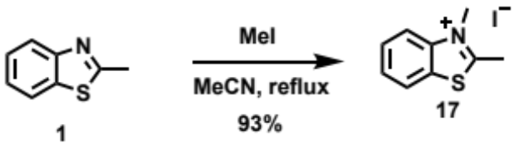
Synthesis of compound 17

To a solution of 2-methylbenzothiazole 1 (0.504 g, 3.38 mmol) in MeCN (12 mL), MeI (1.0 g, 7.3 mmol) was added and the mixture was refluxed for 23 h. Further MeI (0.91 g, 6.4 mmol) was added to the mixture and refluxed for 17 h. After the mixture was cooled to room temperature, the solid was filtrated and washed with AcOEt (30 mL) to afford compound 17 as a white solid (0.914 g, 93% yield). ¹H-NMR (500 MHz,DMSO-d₆) δ 3.17 (s, 3H), 4.20 (s, 3H), 7.81 (dt, J = 0.8, 7.8 Hz, 1H), 7.90 (dt, J = 1.2, 8.0 Hz, 2H), 8.29 (d, J = 8.5 Hz, 1H), 8.44 (d, J = 7.5 Hz, 1H). ESI-HRMS (m/z): [M-I]⁺ calcd for C₉H₁₀NS⁺, 164.0528, found 164.0534.

Synthesis of compound 18
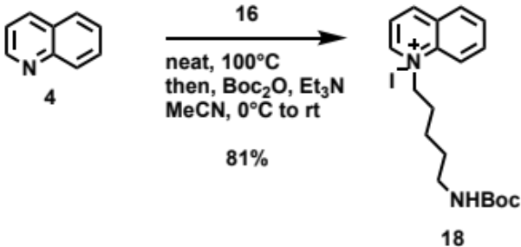

Compound 16 (2.10 g, 6.71 mmol) and quinoline 4 (0.75 g, 5.8 mmol) were added to a round flask, and the mixture was stirred for 4 h at 100 °C. After the mixture was cooled to room temperature, MeCN (13 mL) and Et₃N (0.58 g, 5.7 mmol) were added to the mixture, and it was cooled to 0 °C. Boc₂O (1.2 g, 5.7 mmol) was added to the stirred solution at 0 °C. After 10 min, the temperature of the solution was raised to room temperature and stirred for 17 h. The mixture was evaporated under reduced pressure and filtrated with Et₂O (30 mL). The solid was dissolved in DCM/MeOH = 9/1 (50 mL). The DCM/MeOH washes were evaporated and dried to afford compound 18 as a red solid (2.44 g, 81% yield). The yield was determined by ¹H-NMR analysis because T.M. contained byproduct. The compound 18 was used in the next reaction without further purification. ESI-HRMS (m/z): [M-I]⁺ calcd for C₁₉H₂₇N₂O₂⁺ , 315.2067, found 315.2075.

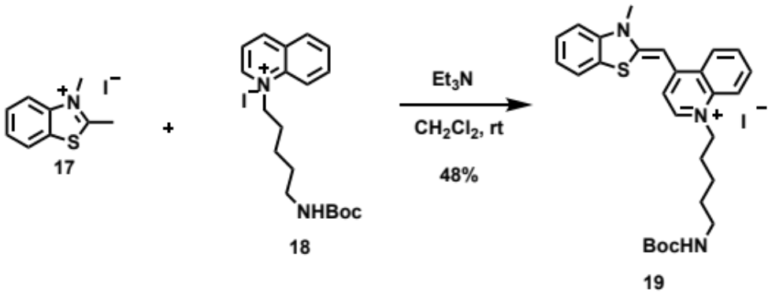
Synthesis of compound 19

To a solution of compound 18 (2.60 mmol) and compound 17 (0.897 g, 3.08 mmol) in CH₂Cl₂ (29 mL), Et₃N (3.2 g, 31 mmol) was added and stirred for 17 h at room temperature. The mixture was evaporated under reduced pressure, filtrated and washed with Et₂O (60 mL) and H₂O (30 mL). The solid was dissolved in DCM/MeOH = 20/1 (100 mL) and filtrated. The DCM/MeOH washes were evaporated and dried to afford compound 19 as a red solid (1.48 mmol, 48% yield). The yield was determined by ¹H-NMR analysis because T.M. contained by-product. The compound 19 was used in the next reaction without further purification. ESI-HRMS (m/z): [M-I]⁺ calcd for C₂₈H₃₄N₃O₂S⁺, 476.2366, found 476.2369.

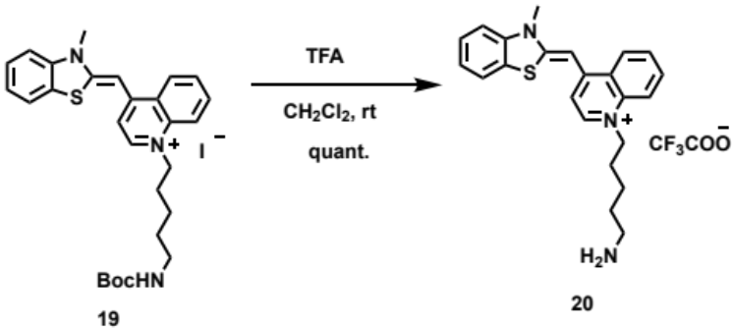
Synthesis of compound 20

To a solution of compound 19 (48.5 μmol) in CH₂Cl₂ (67 μL), TFA (0.60 mL) was added and the mixture was stirred for 3.5 h at room temperature. The mixture was evaporated under reduced pressure to afford compound 20 (quant) as a red solid. The compound 20 was used in the next reaction without further purification.

Synthesis of compound 22
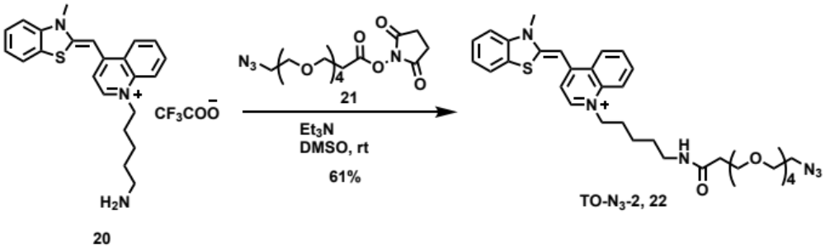

To a solution of compound 20 (15.3 μmol) in DMSO (925 μL), a solution of Azido-PEG₄-NHS-Ester 21 (6.54 mg, 16.8 μmol) in DMSO (17 μL) and Et₃N (1.76 mg, 17.4 μmol) were added and stirred for 3 d at room temperature. DMSO (200 μL) was added to the mixture, and it was filtrated and purified by reverse phased HPLC to afford compound 22 as a red solid (61% yield). The concentration of TO-N₃-2 was determined by quantitative ¹H-NMR using maleic acid as an internal standard. HPLC conditions: A: 0.1% TFA in distilled water, B: 0.1% TFA in MeCN; B: 0% → 60% (～15 min) → 100% (～20 min). Flow rate = 4 mL/min; Temp. = 35.0 °C; UV = 254 nm, C-18 column (Nacalai Tesque : COSMOSIL 5C18-AR-II, 10×250 mm). ¹H-NMR (600 MHz, DMSO-d₆) δ 1.34 (quintet, J = 7.5 Hz, 2H), 1.45 (quintet, J = 7.1 Hz, 2H), 1.86 (quintet, J = 7.7 Hz, 2H), 2.27 (t, J = 6.6 Hz, 2H), 3.04 (q, J = 6.6 Hz, 2H), 3.37 (t, J = 5.1 Hz, 2H), 3.5-3.6 (m, 16H), 4.02 (s, 3H), 4.58 (t, J = 7.2 Hz, 2H), 6.93 (s, 1H), 7.37 (d, J = 7.2 Hz, 1H), 7.42 (dt, J = 0.9, 7.5 Hz, 1H), 7.62 (dt, J = 1.2, 7.8 Hz, 1H),7.76 (dt, J = 0.9, 7.5 Hz, 1H), 7.79 (d, J = 8.4 Hz, 1H), 7.81 (t, J = 5.4 Hz, 1H), 7.99 (dt, J = 1.4, 7.8 Hz, 1H), 8.05 (dd, J = 0.9, 8.4 Hz, 1H), 8.14 (d, J = 9.0 Hz, 1H), 8.61 (d, J = 7.2 Hz, 1H), 8.80 (dd, J = 0.6, 9.0 Hz, 1H). ¹³C-NMR (151 MHz, DMSO-d₆) δ 23.7, 28.9, 29.1, 34.3, 36.6, 38.5, 40.5, 50.4, 54.6, 67.3, 69.7, 69.9, 70.1, 70.2, 70.2, 70.2, 88.5, 108.3, 113.5, 118.6, 123.3, 124.3, 124.7, 125.0, 126.3, 127.2, 128.6, 133.7, 137.5, 140.9, 144.8, 149.0, 160.5, 170.3. ESI-HRMS (m/z): [M-CF₃COO]⁺ calcd for C₃₄H₄₅N₆O₅S⁺, 649.3167, found 649.3185.

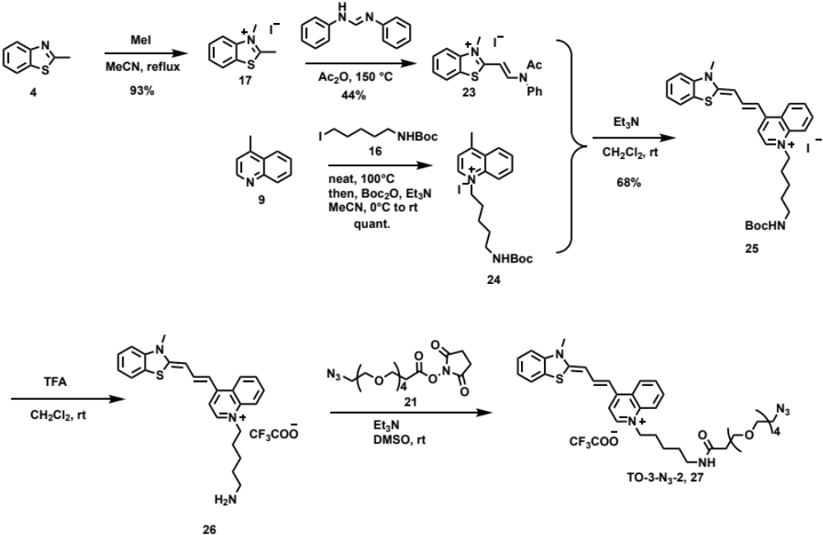
Synthesis of TO-3-N₃-2

Scheme S5

Synthesis of compound 23
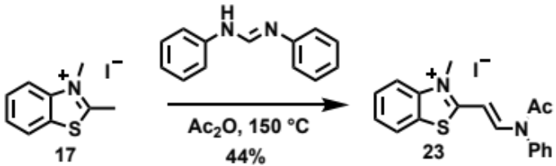

To compound 17 (0.510 g, 1.75 mmol), diphenylformamidine (0.683 g, 3.48 mmol) and Ac₂O (3.5 mL) were added and stirred at 150 °C for 1.5 h. The mixture was cooled to room temperature before Et₂O (30 mL) was added. The mixture was decantated with Et₂O (10 mL×2) and AcOEt (10 mL×2). The mixture was filtrated with AcOEt (10 mL) to afford compound 23 (0.336 g, 44% yield) as a red solid.
¹H-NMR (400 MHz, DMSO-d₆) δ 2.06 (s, 3H), 3.88 (3H, s), 5.69 (d, J = 14 Hz, 1H), 7.53 (m, 2H), 7.69 (m, 3H), 7.72 (dd, J = 1.2, 8.0 Hz, 1H), 7.79 (dt, J = 1.2, 7.2 Hz, 1H), 8.10 (d, J = 8.4 Hz, 1H), 8.31 (dd, J = 0.8, 8.0 Hz, 1H), 8.80 (d, J = 14 Hz, 1H). ESI-HRMS (m/z): [M-I]⁺ calcd for C₁₈H₁₇N₂OS⁺, 309.1056, found 309.1069.

Synthesis of compound 24
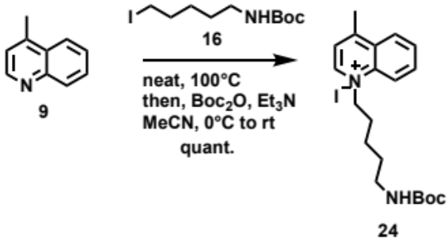

Compound 16 (0.509 g, 1.63 mmol) and lepidine 9 (0.22 g, 1.5 mmol) were added to a round flask. The mixture was stirred for 3.5 h at 100 °C. After the mixture was cooled to room temperature, MeCN (3.2 mL) was added and further cooled to 0 °C. Boc₂O (0.17 g, 0.78 mmol) was added to the stirred solution at 0 °C. After 12 min, the temperature of the solution was raised to room temperature and stirred for 22 h. The mixture was evaporated under reduced pressure and MeCN (1 mL) was added. The solution was decantated with Et₂O (10 mL) and evaporated under reduced pressure. The decantation process was performed 3 times in the end to obtain compound 24 (0.943 g, quant. yield) as an orange solid. The yield was determined by ¹H-NMR analysis because T.M. contained byproduct. The compound 24 was used in the next reaction without further purification. ESI-HRMS (m/z): [M-I]⁺ calcd for C₂₀H₂₉N₂O₂⁺, 329.2224, found 329.2248.

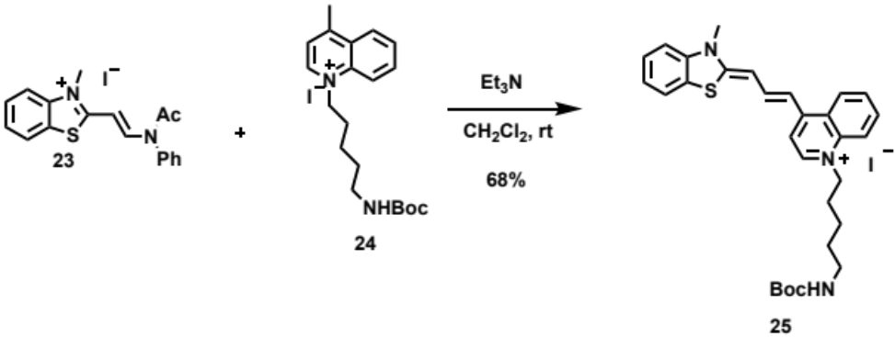
Synthesis of compound 25

To a solution of compound 24 (0.281 mmol) and compound 23 (0.113 g, 0.259 mmol) in CH₂Cl₂ (5.0 mL), Et₃N (0.23 g, 2.3 mmol) was added and stirred for 21 h at room temperature. The mixture was evaporated under reduced pressure to obtain crude (0.285 g). The crude was purified by column chromatography (hexane/CHCl₃ = 1/1 then only CHCl₃ then CHCl₃/MeOH = 40/1 to 20/1 to 10/1) to afford compound 25 (0.111 g, 68% yield) as a dark green solid. ¹H-NMR (600 MHz, DMSO-d₆) δ 1.32 (m, 2H), 1.35 (s, 9H), 1.41 (quintet, J = 7.2 Hz, 2H), 1.82 (quintet, J = 7.2 Hz, 2H), 2.90 (q, J = 6.4 Hz, 2H), 3.74 (s, 3H), 4.53 (m, 2H), 6.49 (d, J = 12 Hz, 1H), 6.78 (t, J = 5.7 Hz, 1H), 7.10 (d, J = 13.2 Hz, 1H), 7.31 (dt, J = 1.2, 6.6 Hz, 1H), 7.49 (dt, J = 1.2, 7.2 Hz, 1H), 7.58 (t, J = 8.4 Hz, 1H), 7.70 (t, J = 7.2 Hz, 1H), 7.84 (dd, J = 1.8, 7.2 Hz, 1H), 7.88 (d, J = 7.8 Hz, 1H), 7.94 (dt, J = 1.2, 7.2 Hz, 1H), 8.07 (d, J = 9.0 Hz, 1H), 8.15 (t, J = 12.9 Hz, 1H), 8.39 (d, J = 7.2 Hz, 1H), 8.46 (d, J = 9.0 Hz, 1H). ¹³C-NMR (151 MHz, DMSO-d₆) δ 23.2, 28.3, 28.5, 29.1, 32.9, 54.0, 77.4, 98.8, 109.3, 109.6, 112.5, 118.0, 122.5, 124.2, 124.2, 124.6, 125.2, 126.7, 127.6, 133.4, 137.9, 142.0, 142.5, 143.8, 150.3, 155.6, 161.6. ESI-HRMS (m/z): [M-I]⁺ calcd for C₃₀H₃₆N₃O₂S⁺, 502.2523, found 502.2542.

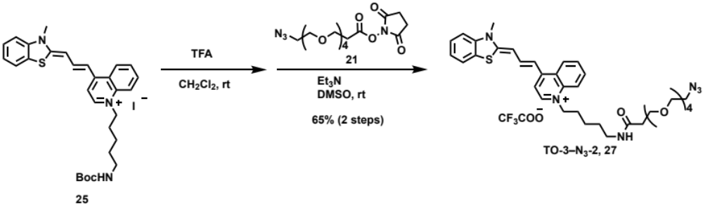
Synthesis of compound 27

To a solution of compound 25 (13.8 mg, 22.0 μmol) in CH₂Cl₂ (26 μL), TFA (0.25 mL) was added and stirred for 2 h at room temperature. The mixture was evaporated under reduced pressure to obtain the intermediate. To the intermediate in DMSO (1.2 mL), a solution of Azido-PEG₄-NHS-Ester 21 (9.39 mg, 24.2 μmol) in DMSO (0.20 mL) and Et₃N (6.2 mg, 61 μmol) were added and stirred for 2 d at room temperature. To the mixture, DMSO (800 μL) was added, and the mixture was filtrated and purified by reverse phased HPLC to afford compound 27 as a blue solid (65% yield in 2 steps). The concentration of TO-3-N₃-2 was determined by quantitative ¹H-NMR using maleic acid as an internal standard. HPLC conditions; A: 0.1% TFA in distilled water, B: 0.1% TFA in MeCN; B: 0% → 60% (～15 min) → 100% (～20 min) → 100%(～25 min). Flow rate = 4 mL/min; Temp. = 35.0 °C; UV = 254 nm, C-18 column (Nacalai Tesque: COSMOSIL 5C18-AR-II, 10×250 mm). ¹H-NMR (600 MHz, DMSO-d₆) δ 1.32 (m, 2H), 1.43 (quintet, J = 7.2 Hz, 2H), 1.82 (quintet, J = 7.7 Hz, 2H), 2.27 (t, J = 6.6 Hz, 2H), 3.03 (q, J = 6.0 Hz, 2H), 3.36 (t, J = 4.8 Hz, 2H), 3.45-3.58 (m, 16H), 3.72 (s, 3H), 4.51 (t, J = 7.5 Hz, 2H), 6.47 (d, J = 12.6 Hz, 1H), 7.08 (d, J = 13.2 Hz, 1H), 7.30 (dt, J = 0.9, 7.8 Hz, 1H), 7.48 (dt, J = 0.8, 7.5 Hz, 1H), 7.56 (d, J = 8.4 Hz, 1H), 7.69 (dt, J = 0.6, 7.2 Hz, 1H), 7.81 (brs, 1H), 7.82 (d, J = 7.2 Hz, 1H), 7.86 (dd, J = 1.2, 7.8 Hz, 1H), 7.94 (dt, J = 1.2, 7.8 Hz, 1H), 8.05 (d, J = 9.0 Hz, 1H), 8.14 (dt, J = 1.2, 12.9 Hz, 1H), 8.36 (d, J = 7.2 Hz, 1H), 8.45 (dd, J = 1.2, 7.8 Hz, 1H). ¹³C-NMR (151 MHz, DMSO-d₆) δ 23.3, 28.5, 28.7, 32.9, 36.2, 38.1, 50.0, 54.0, 66.9, 69.3, 69.6, 69.7, 69.8, 69.8, 69.9, 98.9, 109.3, 109.6, 112.6, 115.8, 117.8, 118.0, 122.6, 124.2, 124.3, 124.7, 125.2, 126.8, 127.7, 133.4, 137.9, 142.0, 142.5, 143.9, 150.4, 157.9, 158.1, 161.7, 163.1, 170.0. ESI-HRMS (m/z): [M-CF₃COO]⁺ calcd for C₃₆H₄₇N₆O₅S⁺, 675.3323, found 675.3340.

Biotin modification of G-clamp-N₃ by SPAAC
To a solution of DBCO-SS-biotin in DMSO (Argutus Medical Ltd., 10 mM, 50 μL), a solution of G-clamp-N₃ in DMSO (10 mM, 50 μL) was added, and the mixture (5 mM, 100 μL) was incubated at 37 °C. After 30 min, the mixture was analyzed by reverse phased HPLC with C-18 column (Nacalai Tesque: COSMOSIL 5C₁₈-AR-II, 4.6 × 250 mm) by a liner gradient of 10-100%/20 min acetonitrile in 0.1% TFA buffer at a flow rate of 1 mL/min at 40 °C, and monitored by UV detection at λ = 254 nm (Figure S1). The mixture was used without any purification. G-clamp-biotin: ESI-HRMS (m/z): [M+H]⁺ calcd for C₆₄H₈₇N₁₄O₁₅S₃⁺, 1387.5632; found 1387.5620.

Biotin modification of TO-N₃, TO-N₃-2, TO-3-N₃, and TO-3-N₃-2 by SPAAC
To a solution of DBCO-biotin in DMSO (9 mM, 1 μL), a solution of TO-N₃, TO-N₃-2, TO-3-N₃, or TO-3-N₃-2 in DMSO (10 mM, 1 μL) was added, and the mixture (4.5 and 5 mM, 2 μL) was incubated at 37 °C. After 30 min, the mixture was analyzed by reverse phased HPLC with C-18 column (Nacalai Tesque: COSMOSIL 5C₁₈-AR-II, 4.6 × 250 mm) by a liner gradient of 10-100%/20 min acetonitrile in 0.1% TFA buffer at a flow rate of 1 mL/min at 40 °C and monitored by UV detection at λ = 254 nm (Fig. S2). The mixture was used without any purification. TO-biotin: ESI-HRMS (m/z): [M+2H]²⁺ calcd for C₇₀H₉₁N₁₁O₁₂S₂²⁺, 670.8142; found 670.8142, TO-3-bitotin: ESI-HRMS (m/z): [M+2H]²⁺ calcd for C₇₂H₉₃N₁₁O₁₂S₂²⁺, 683.8218; found 683.8220, TO-biotin-2: ESI-HRMS (m/z): [M+2H]²⁺ calcd for C₇₃H₉₇N₁₁O₁₃S₂²⁺, 699.8349; found 699.8357, TO-3-biotin-2: ESI-HRMS (m/z): [M+2H]²⁺ calcd for C₇₅H₉₉N₁₁O₁₃S₂²⁺, 712.8427; found 712.8439.

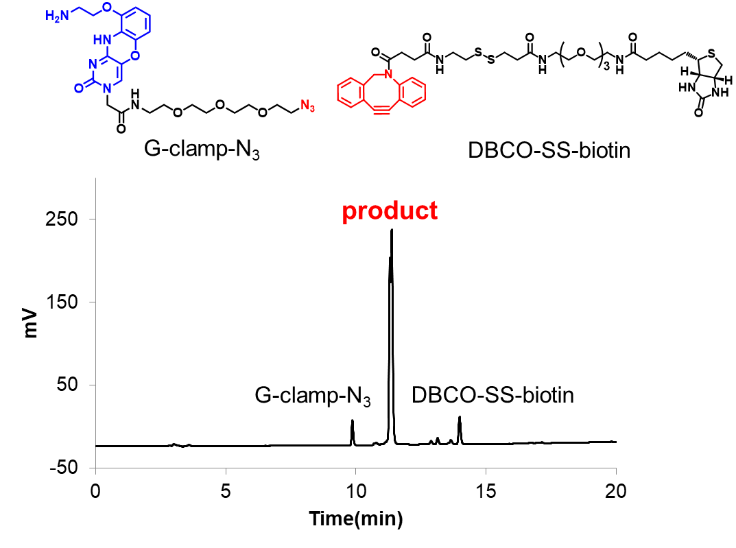

Figure S1. HPLC profiles of biotin conjugation of G-clamp-N₃ by strain-promoted azide-alkyne cycloaddition (SPAAC).

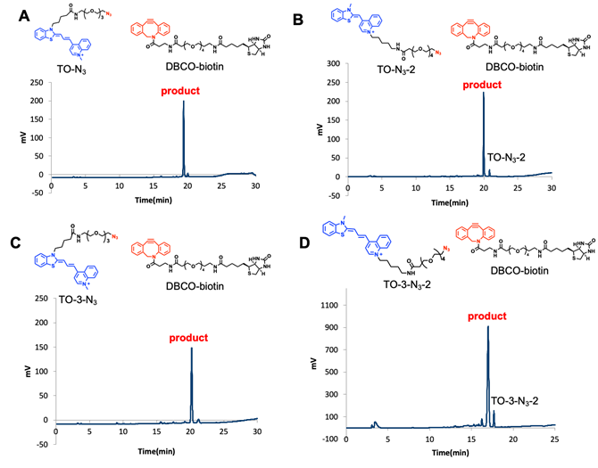
Figure S2. HPLC profiles of biotin conjugation of TO derivatives by strain-promoted azide-alkyne cycloaddition (SPAAC). The reactions of (A) TO-N₃, (B) TO-N₃-2, (C) TO-3-N₃-1, and (D) TO-3-N₃-2.

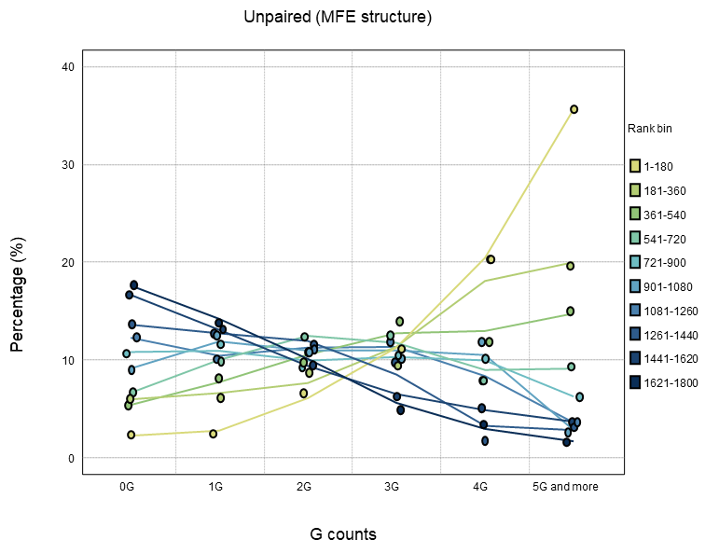
Figure S3. Evaluation of the relationship between the number of multiple Gs and the affinity ranking of G-clamp to human pre-miRNA (n = 1800) in library-1. MFE (minimum free energy) structures calculated by RNAfold were used to count G in unpaired nucleotide (ssRNA). The X-axis shows bins determined by the number of Gs in each secondary structure; the Y-axis shows the number of RNA motifs in each bin of G counts as a percentage.

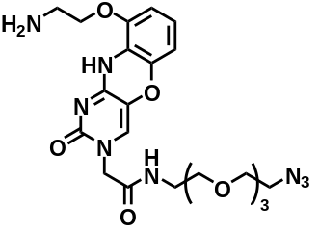
Figure S4. Fluorescence titrations to determine the apparent dissociation constants (K_{Dapp}) of G-clamp-N₃. Fluorescence titration spectra were measured using G-clamp-N₃ (0.01 μM for hsa-mir-4520-1, its mutG2A, and hsa-mir-6847, or 0.1 μM for other RNAs) upon addition of RNA (0-21 µM) in phosphate buffer (pH 7.0). The representative data and K_{Dapp} values are shown.

G-clamp-N₃

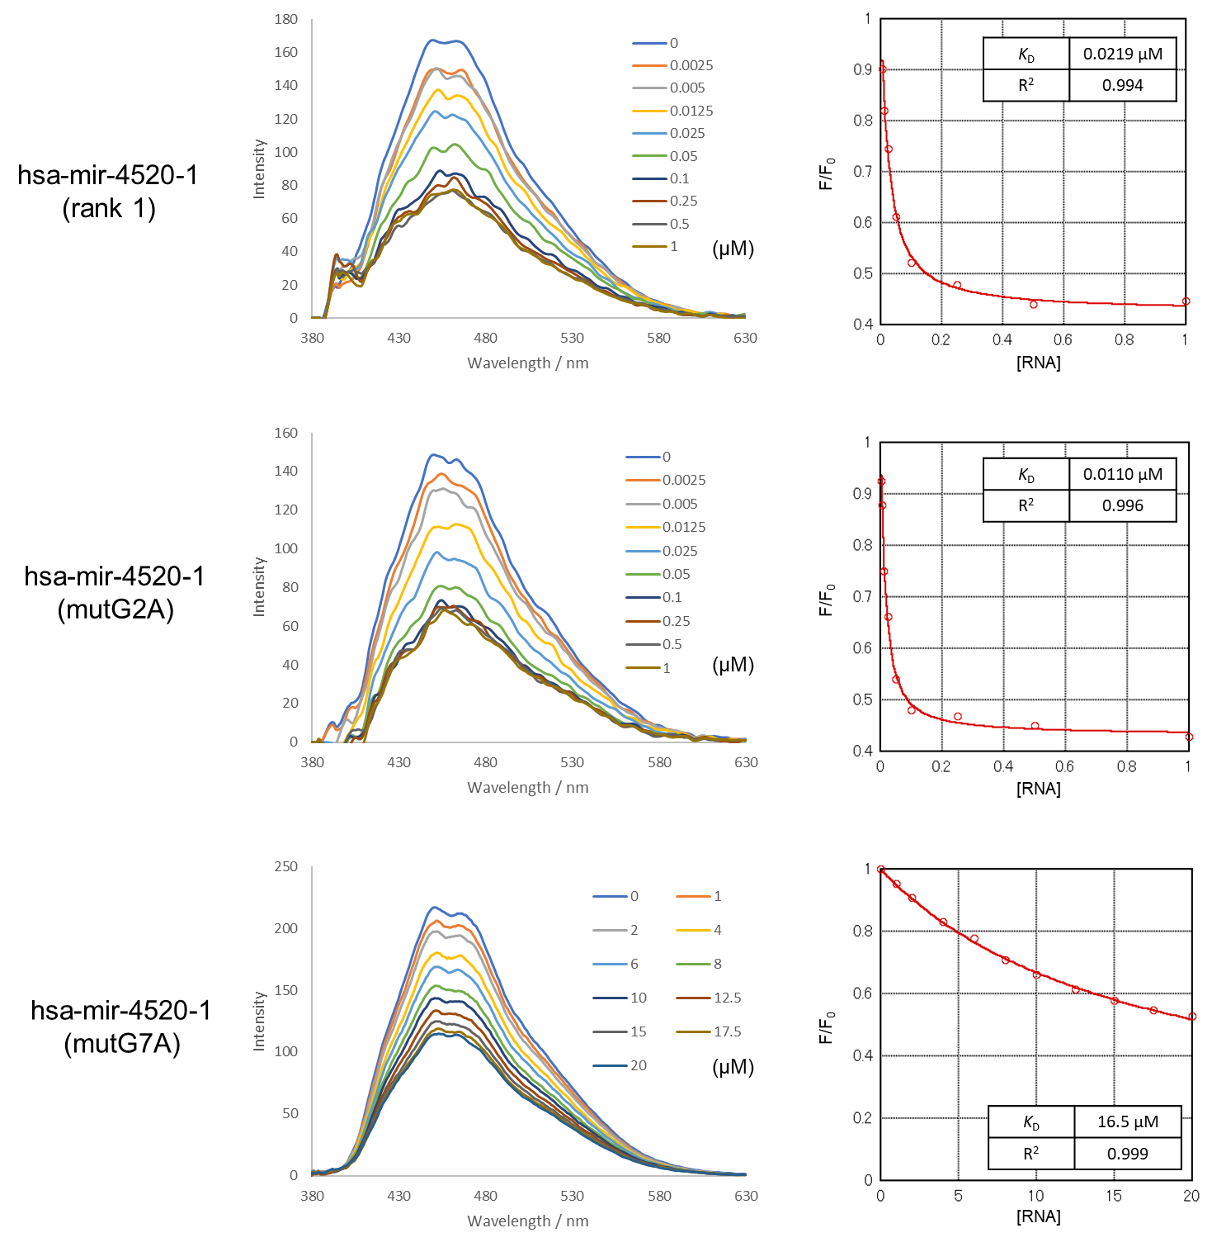

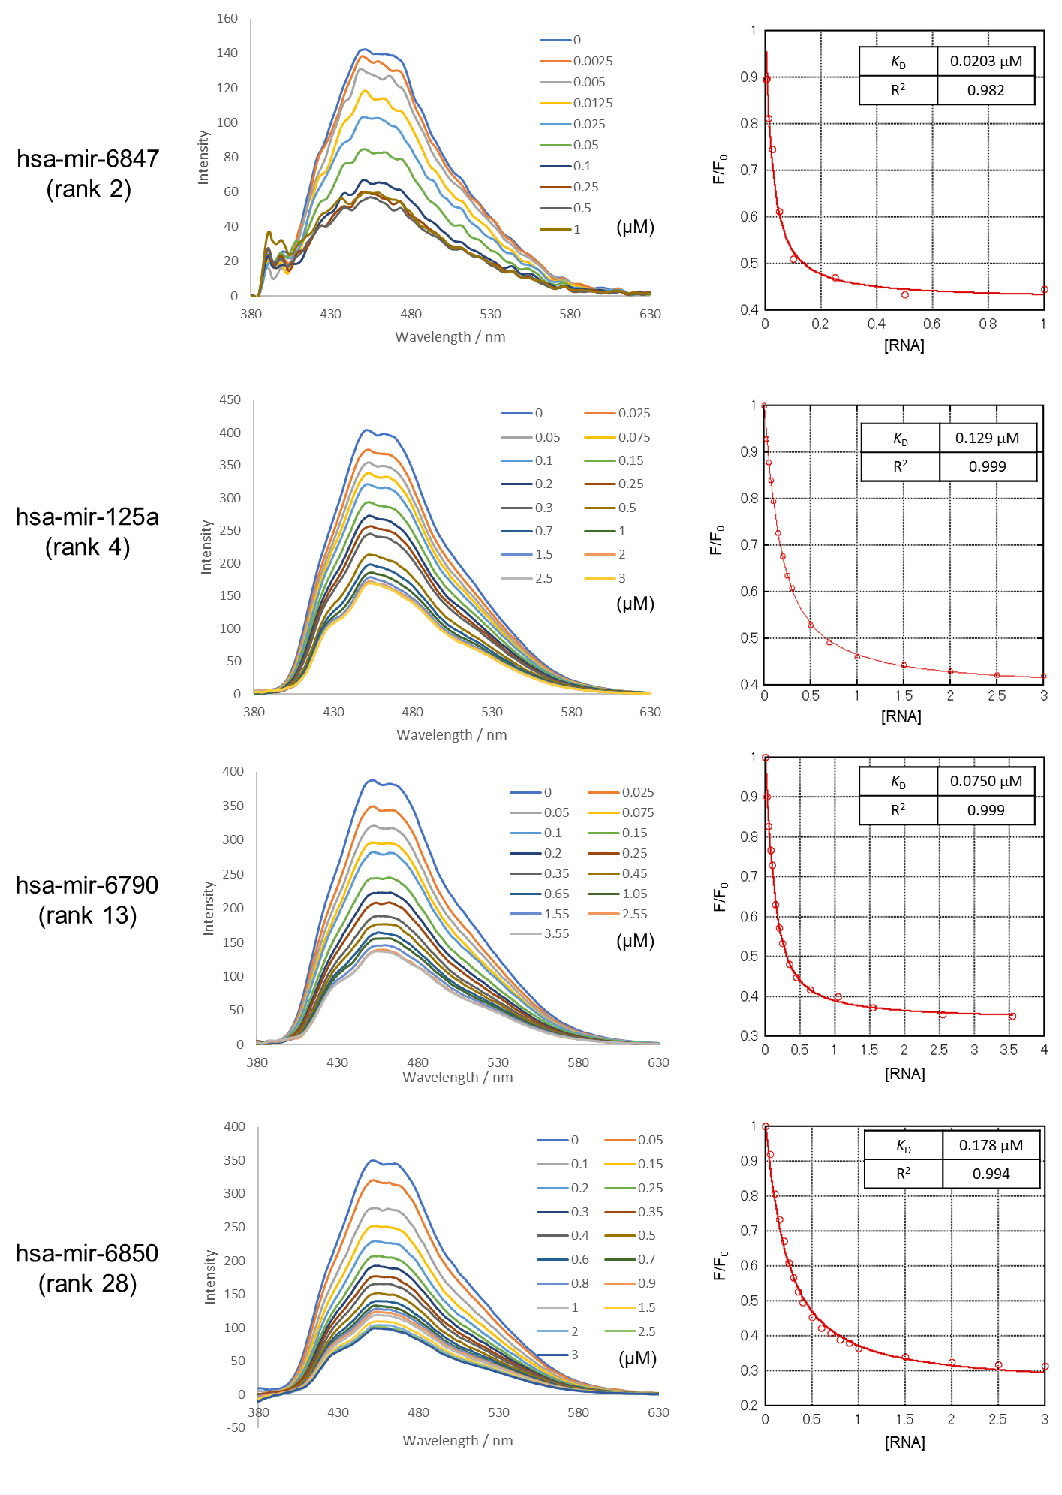

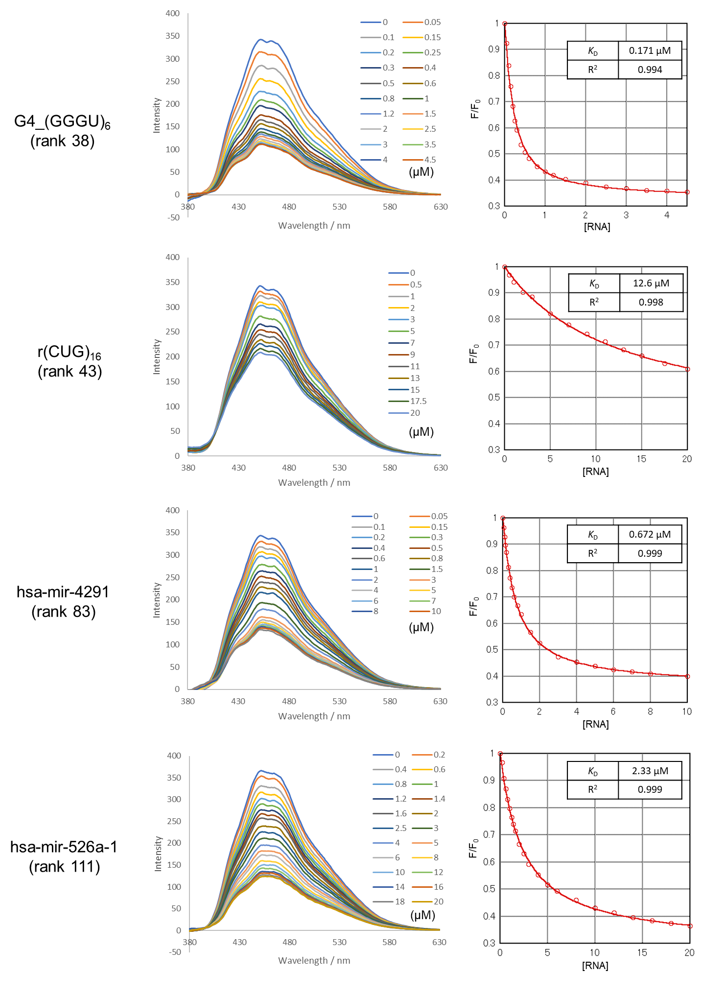

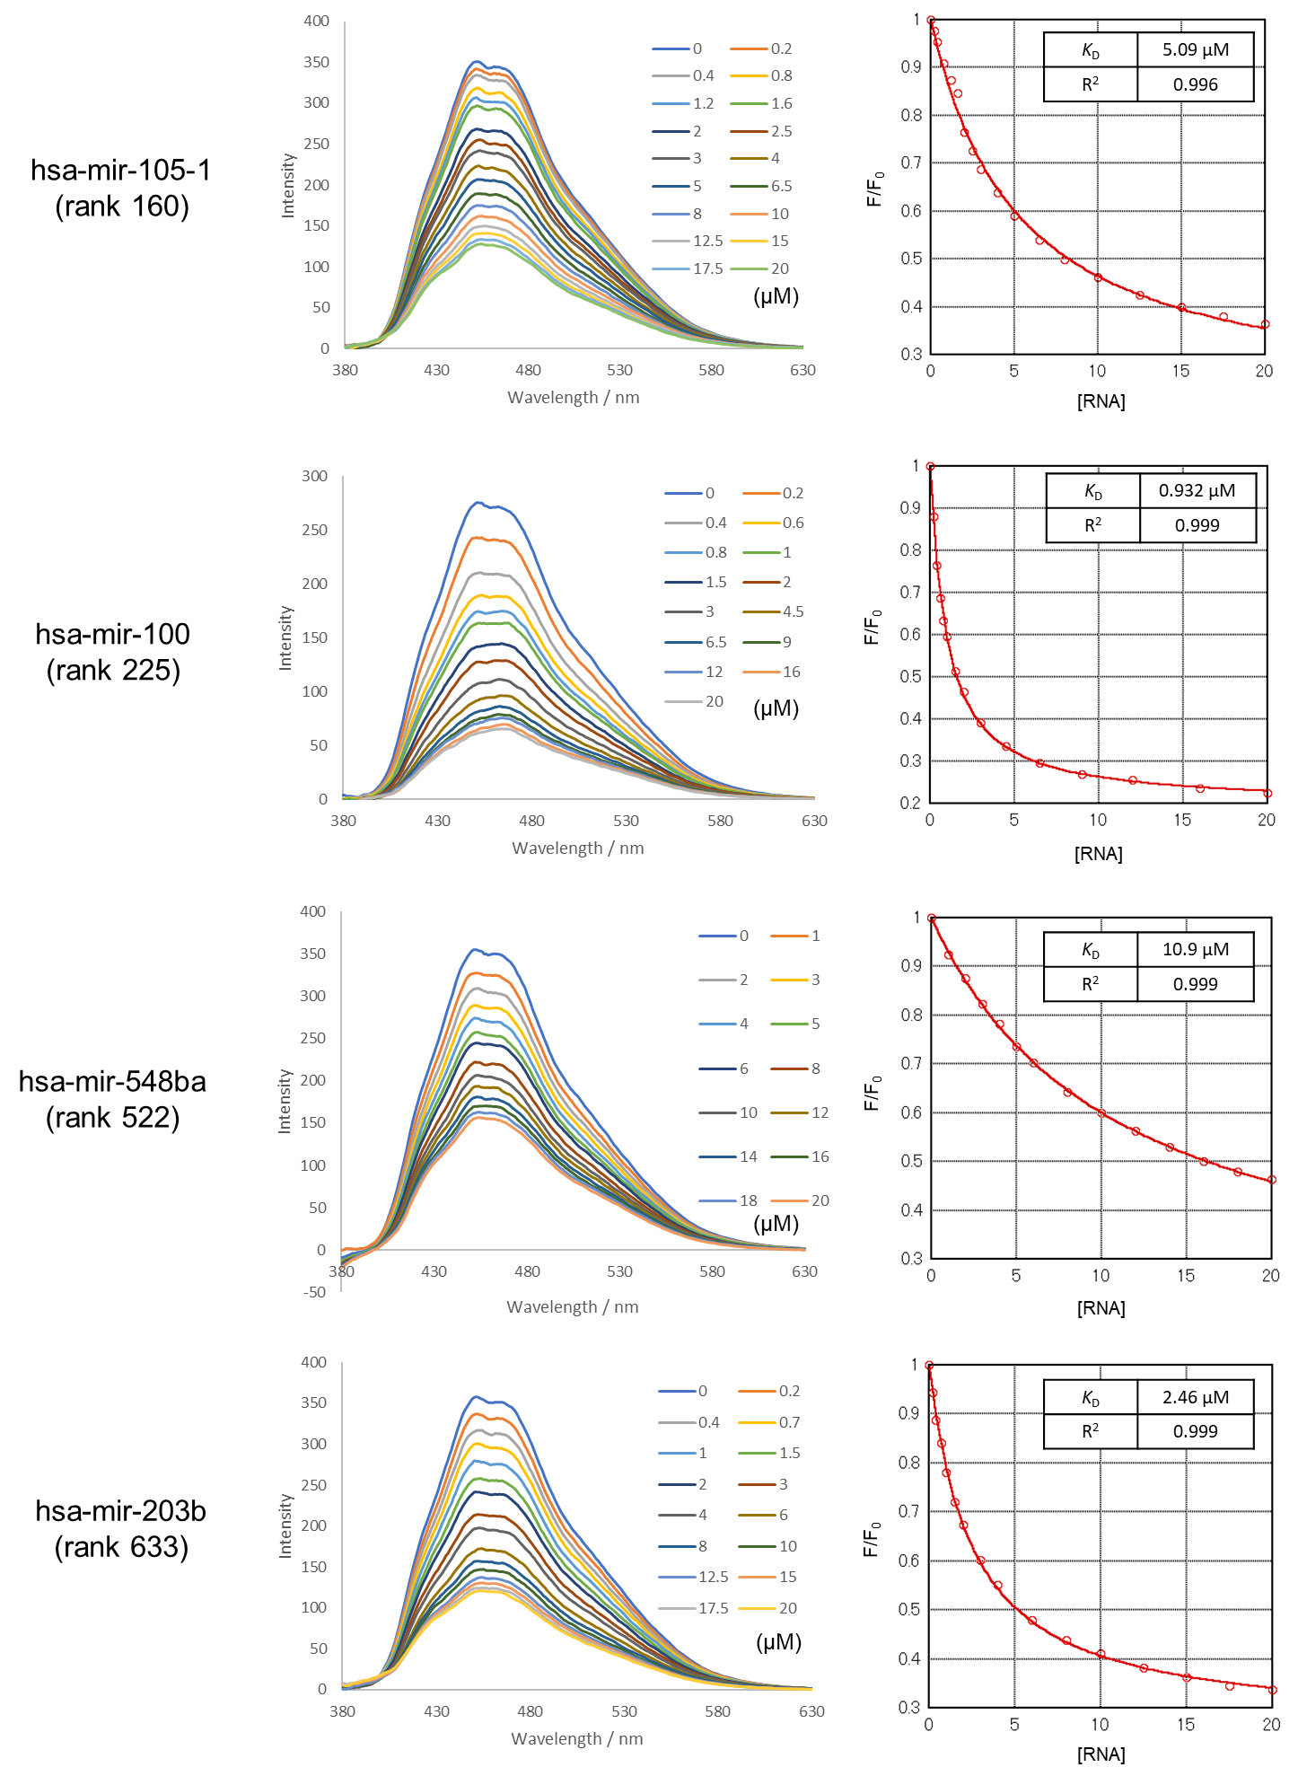

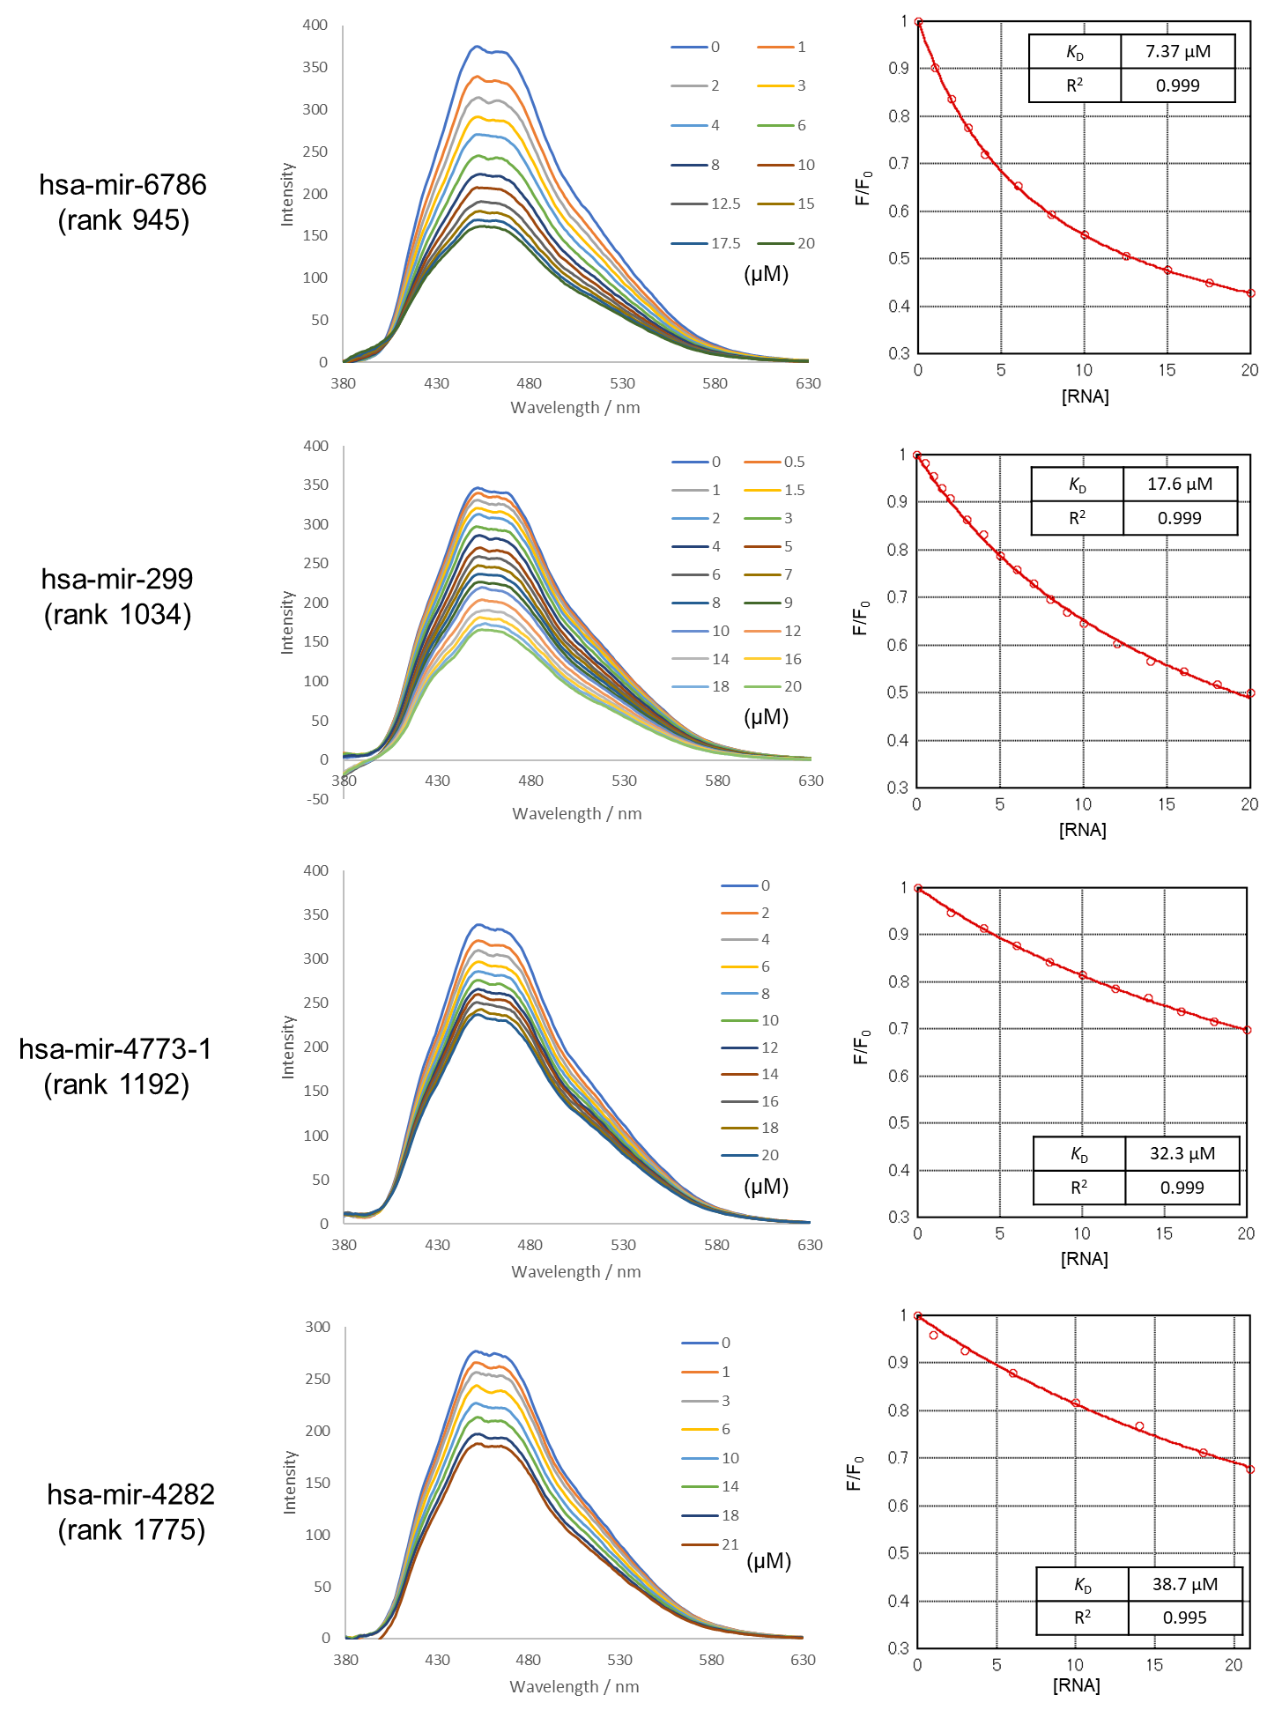

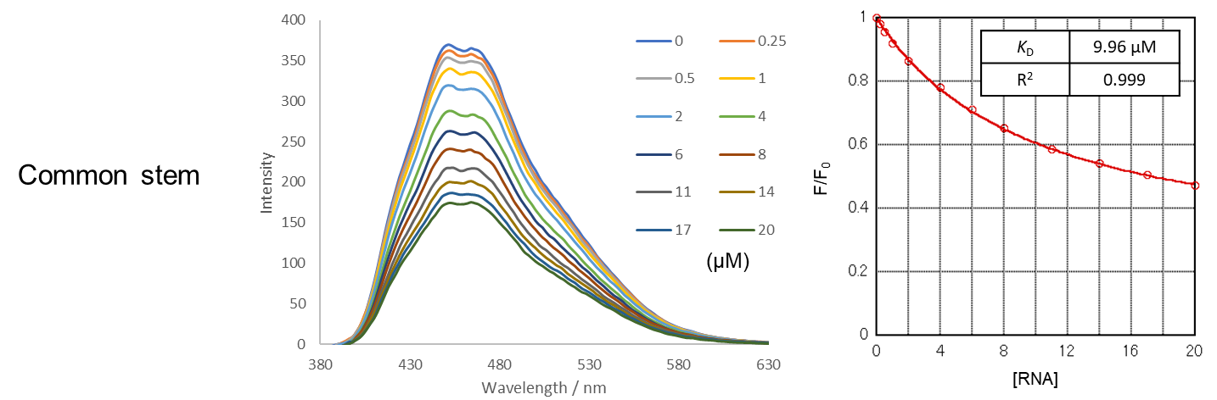

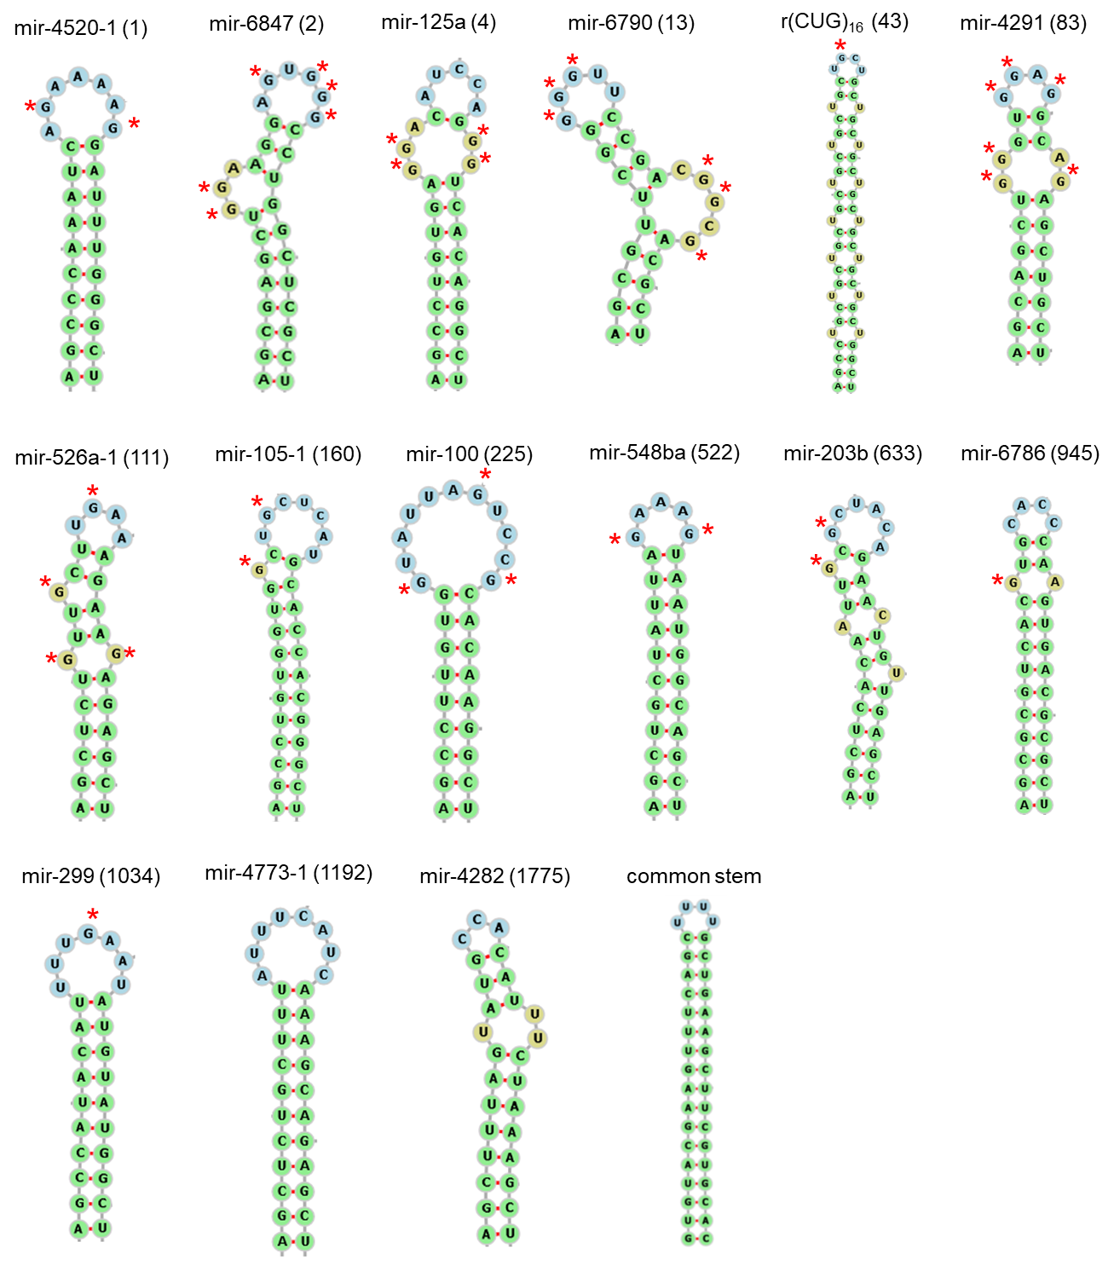

Figure S5. Minimum free energy structures calculated by RNAfold. The red asterisks (*) indicate the unpaired G base.

Table S1. The correlation between Z-scores and K_{Dapp} values for G-clamp RNA binding.
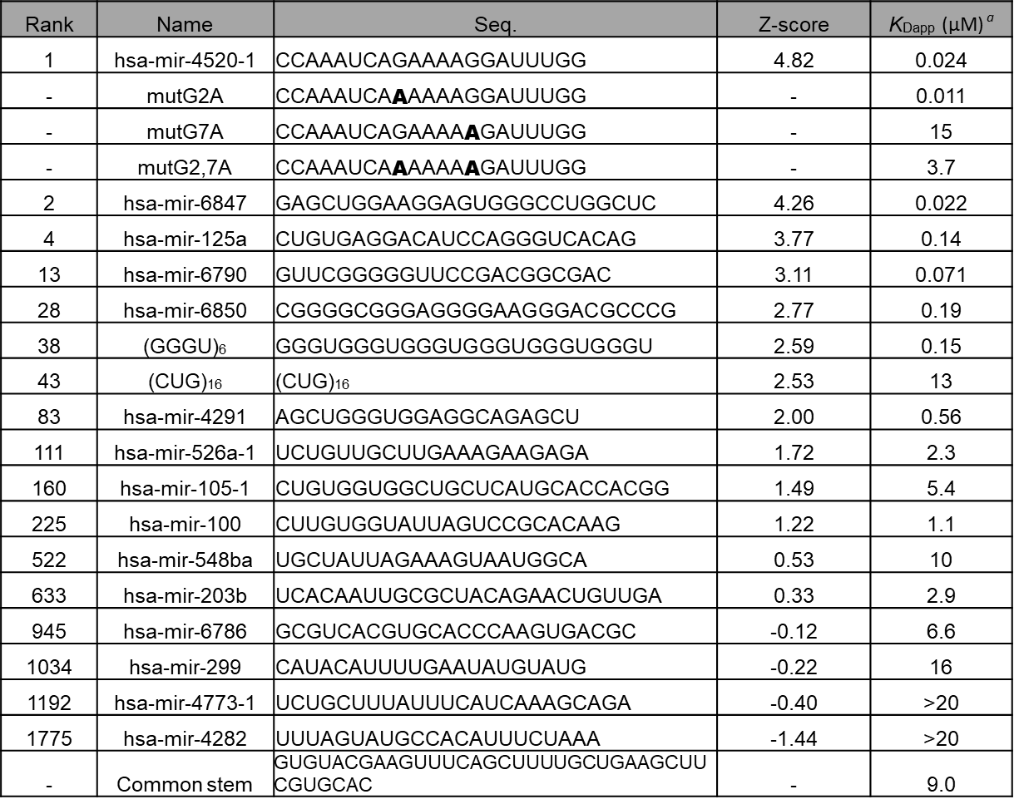

a) Mean data from two independent experiments are shown.

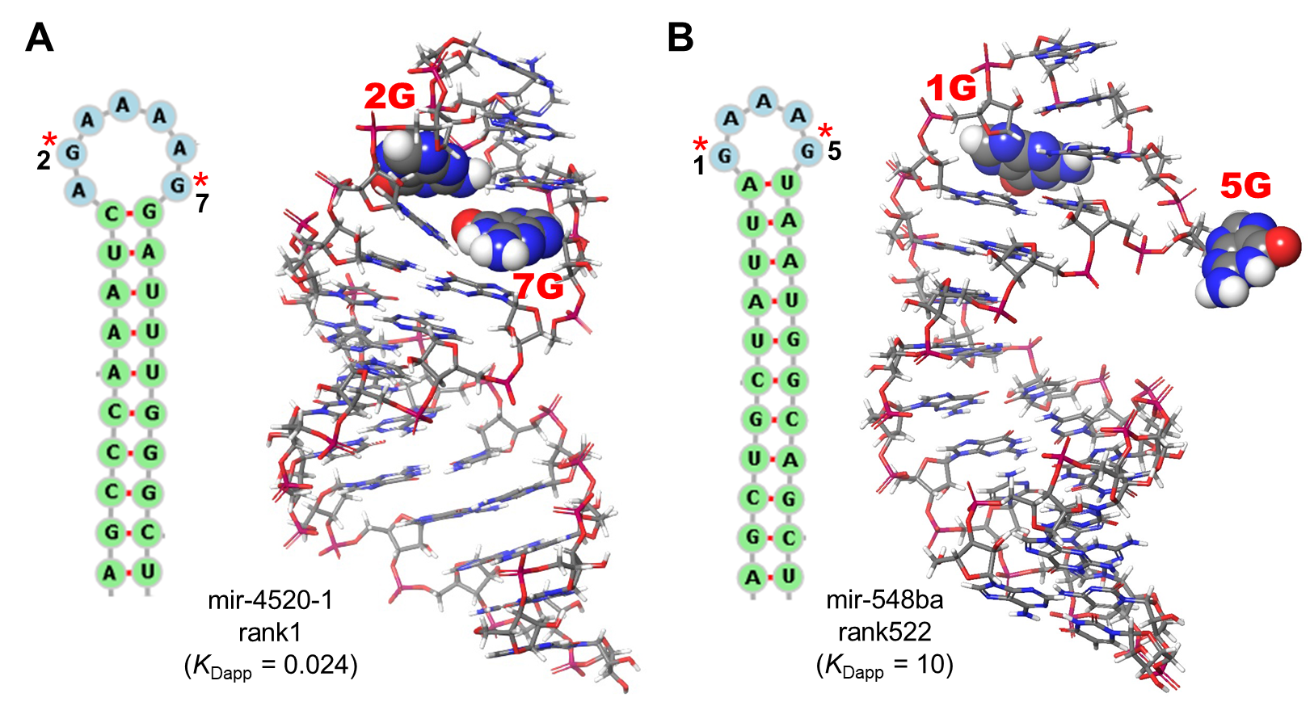
Figure S6. Molecular modeling structure of (A) mir-4520-1 and (B) mir-548ba. The complex structure was modeled by RNAComposer and MacroModel. Red asterisks (*) and CPK models indicate the G base in single-stranded regions.

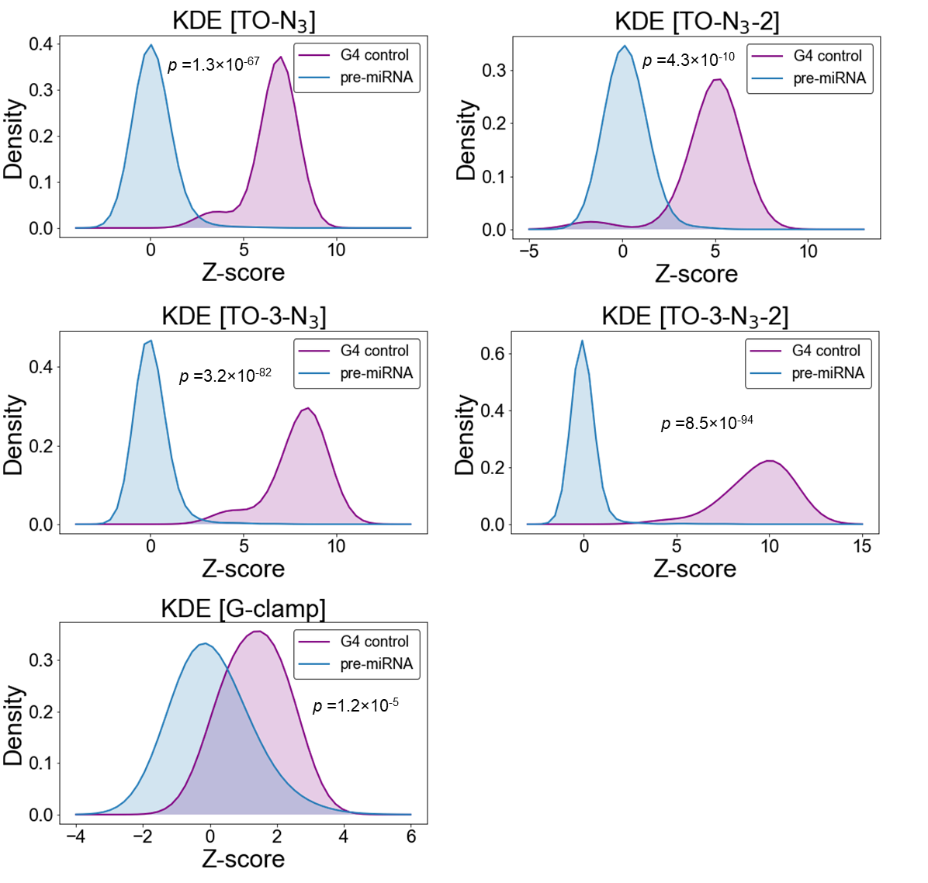
Figure S7. Kernel density estimation of TO derivatives and G-clamp Z-scores. The p-values were determined by two-tailed Brunner–Munzel test.

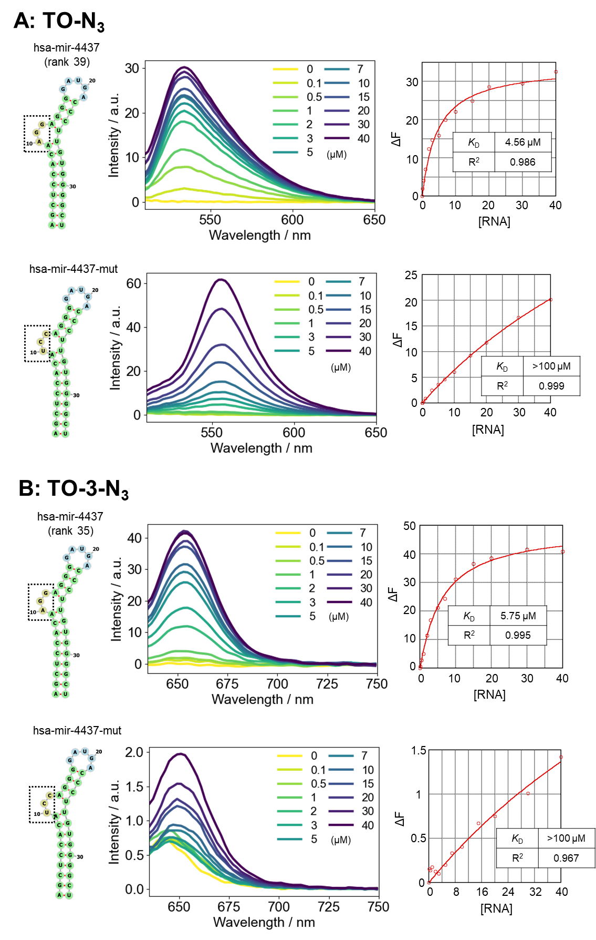
Figure S8. Fluorescence titrations to compare the K_{Dapp} values for a hsa-mir-4437 loop with mir-4437-mut (AGG to UCC). Fluorescence titration spectra were measured using (A) TO-N₃ (0.1 μM) or (B) TO-3-N₃ (1 μM) upon addition of RNA (0-40 µM) in phosphate buffer (pH 7.0). Conditions: λex: 501 nm, λem: 530 nm for TO-N₃ and λex: 623 nm, λem: 655 nm for TO-3-N₃. The representative data and K_{Dapp} values are shown.

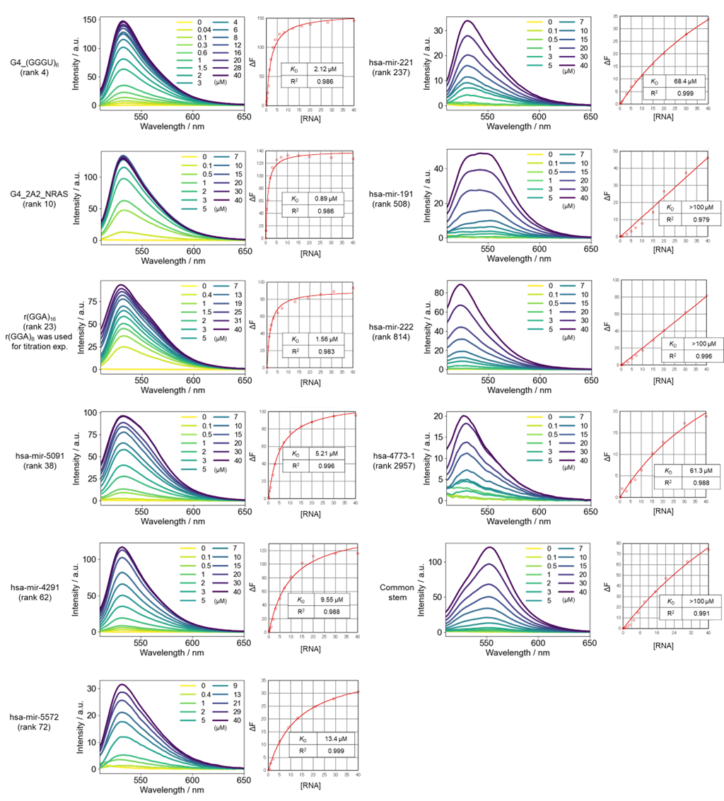
Figure S9. Fluorescence titrations to determine the apparent dissociation constants (K_{Dapp}) of TO-N₃. Fluorescence titration spectra were measured using TO-N₃ (0.1 μM) upon addition of RNA (0-40 µM) in phosphate buffer (pH 7.0). Conditions: λex: 501 nm, λem: 530 nm. The representative data and K_{Dapp} values are shown.

TO-N₃

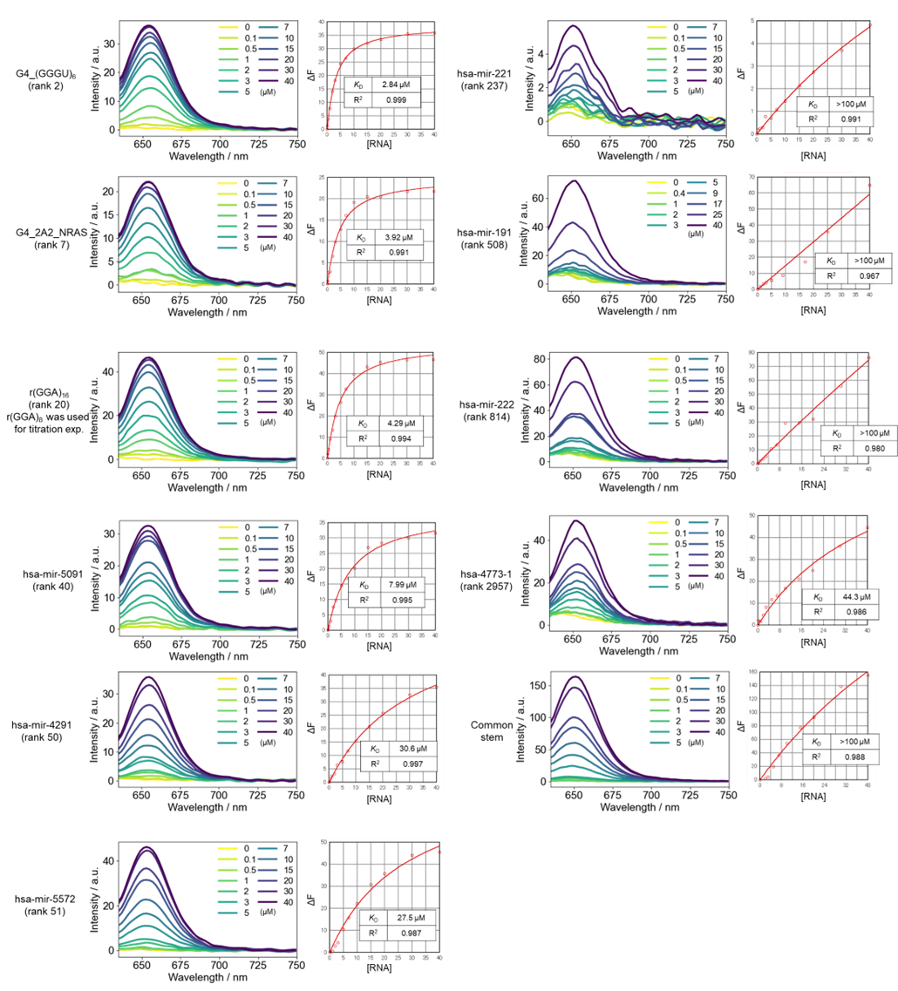
Figure S10. Fluorescence titrations to determine the apparent dissociation constants (K_{Dapp}) of TO-3-N₃. Fluorescence titration spectra were measured using TO-3-N₃ (1 μM) upon addition of RNA (0-40 µM) in phosphate buffer (pH 7.0). Conditions: λex: 623 nm, λem: 655 nm. The representative data and K_{Dapp} values are shown.

TO-3-N₃

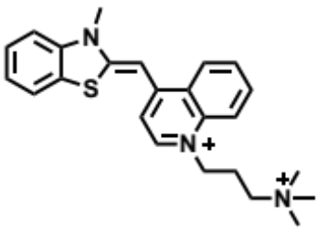
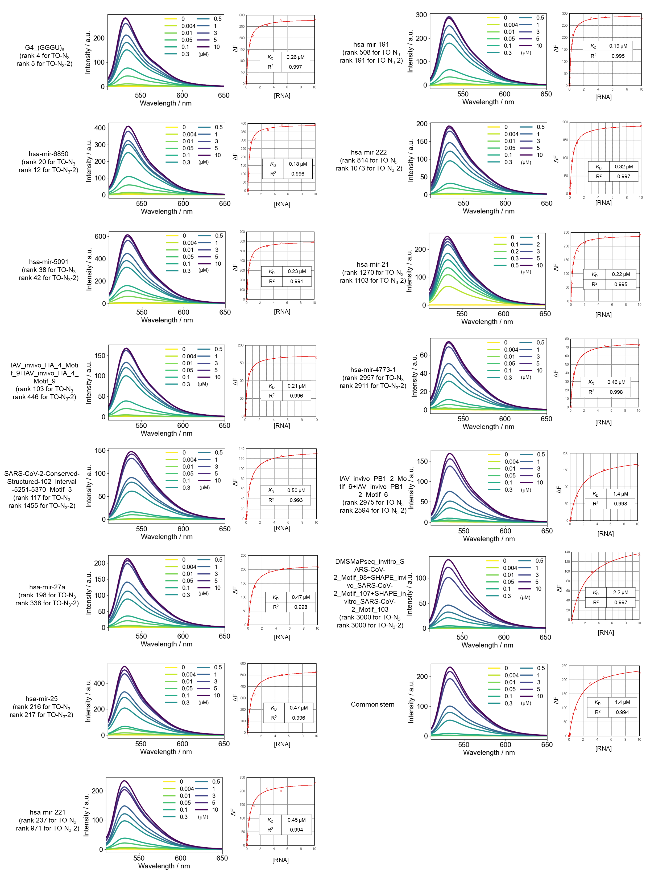
TO-PRO-1
Figure S11. Fluorescence titrations to determine the apparent dissociation constants (K_{Dapp}) of TO-PRO-1. Fluorescence titration spectra were measured using TO-PRO-1 (0.1 μM) upon addition of RNA (0-10 µM) in phosphate buffer (pH 7.0). Conditions: λex: 501 nm, λem: 530 nm. The representative data and K_{Dapp} values are shown.

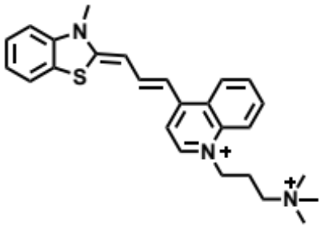
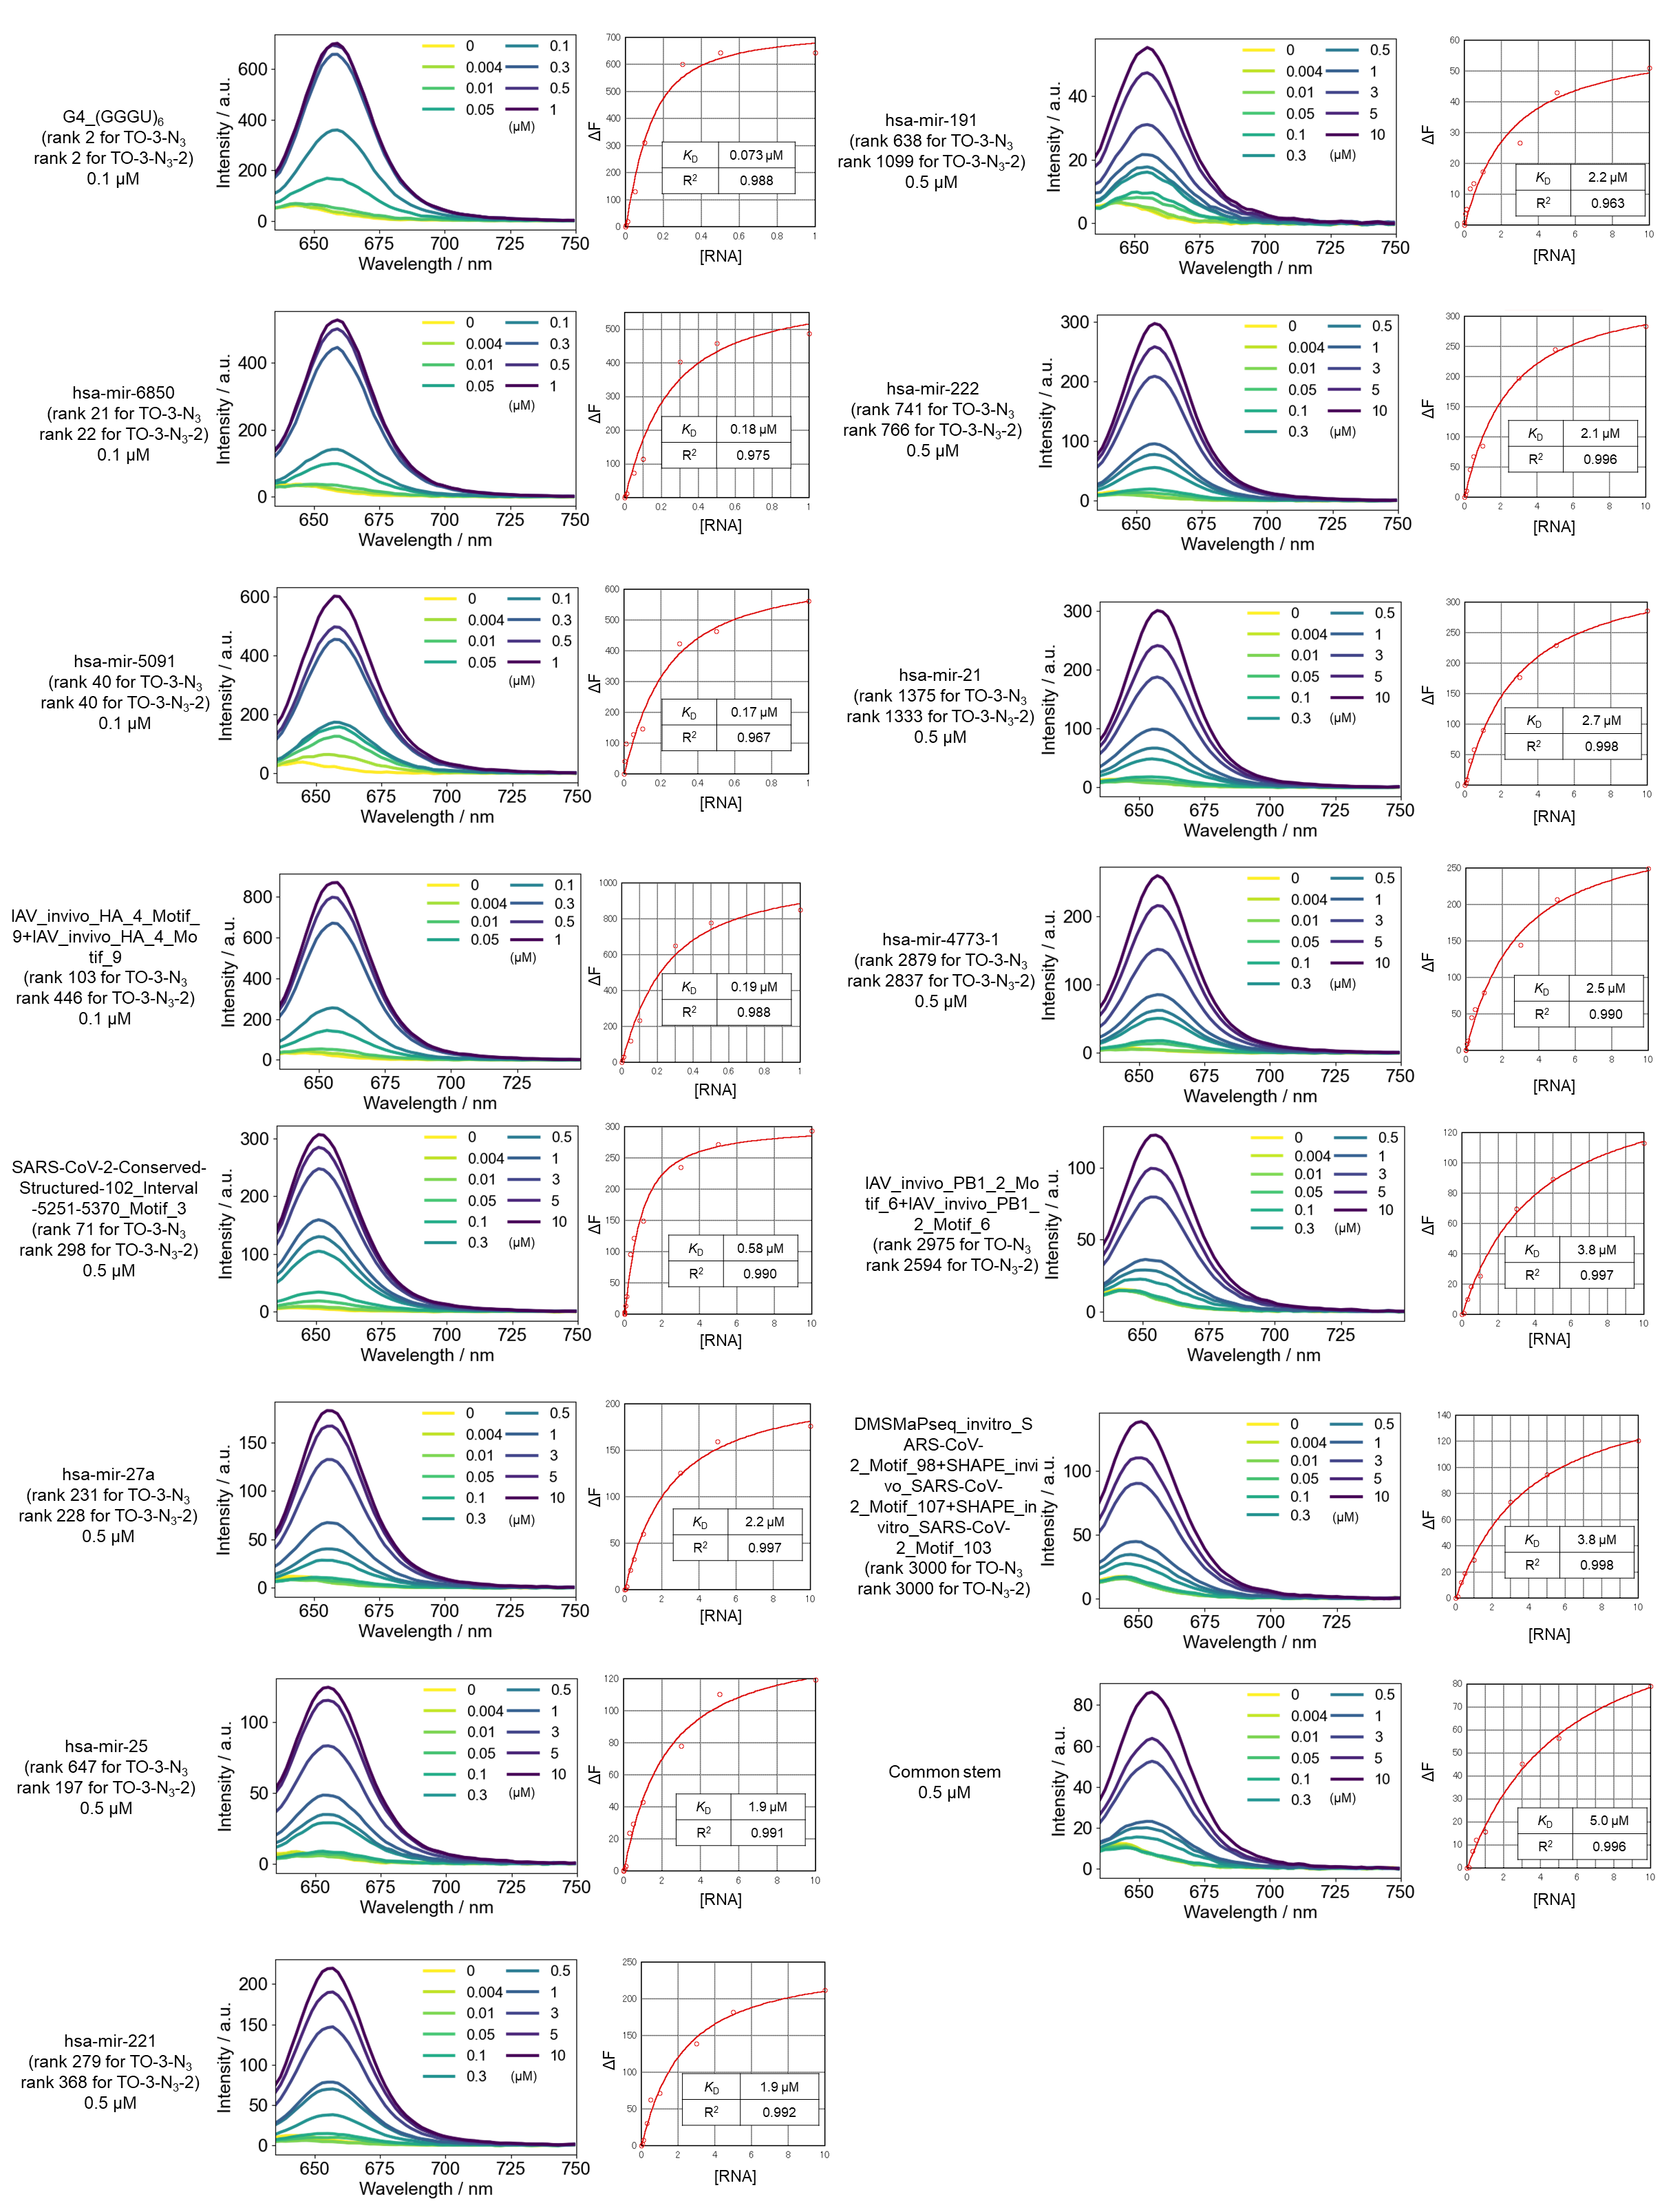
Figure S12. Fluorescence titrations to determine the apparent dissociation constants (K_{Dapp}) of TO-PRO-3. Fluorescence titration spectra were measured using TO-PRO-3 (0.1 μM for G4_r(GGGU)6, hsa-mir-6850 and hsa-mir-5091, or 0.5 μM for the others) upon addition of RNA (0-1 μM for G4_r(GGGU)6, hsa-mir-6850 and hsa-mir-5091, or 0-10 μM for the others) in phosphate buffer (pH 7.0). Conditions: λex: 623 nm, λem: 655 nm. The representative data and K_{Dapp} values are shown.

TO-PRO-3

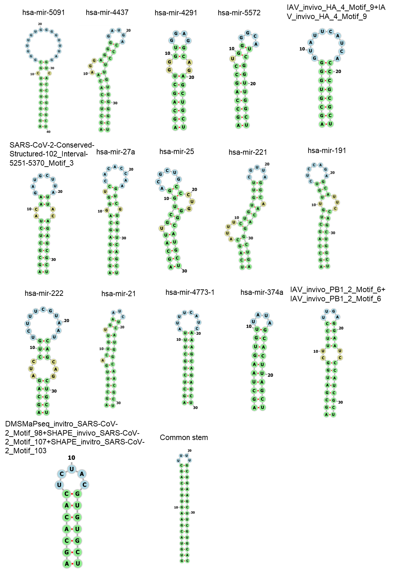
Figure S13. Minimum free energy structures calculated by RNAfold for the assay with TO derivatives.

Table S2. The correlation between Z-scores and K_{Dapp} values for TO-N₃ and TO-3-N₃ RNA binding.

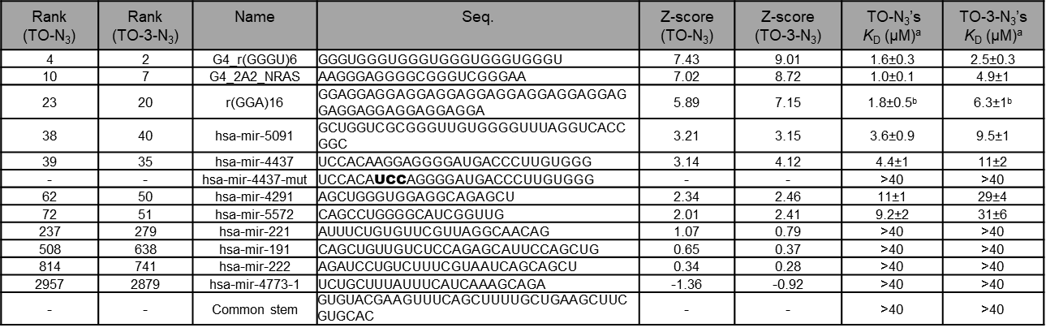
a) Data are mean±standard error from three independent experiments.
b) r(GGA)₈ was used instead of r(GGA)₁₆.

Table S3. The correlation between Z-scores and K_{Dapp} values for TO-PRO-1 RNA binding.

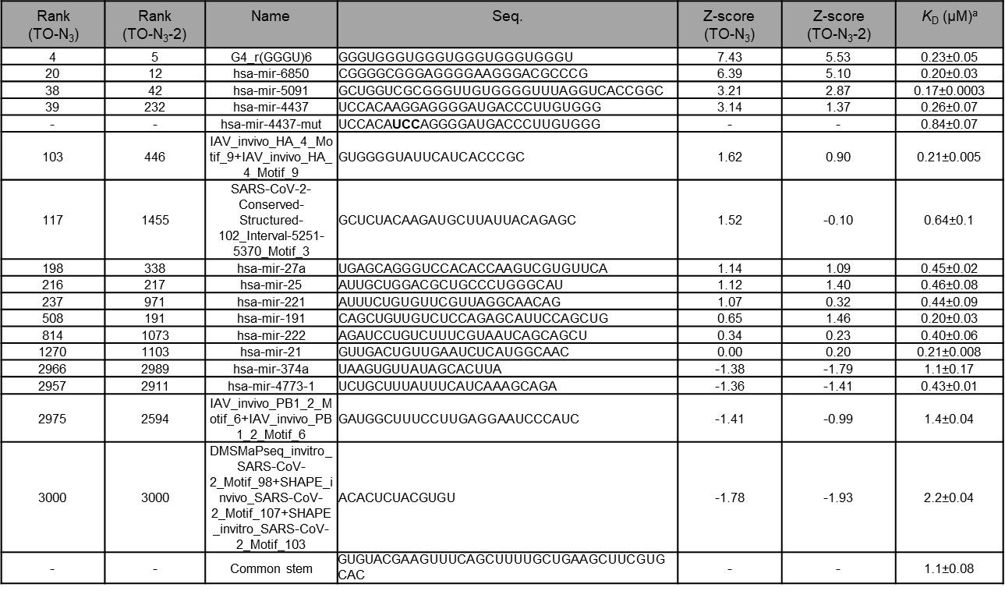
a) Data are mean±standard error from three independent experiments.

Table S4. The correlation between Z-scores and K_{Dapp} values for TO-PRO-3 RNA binding.

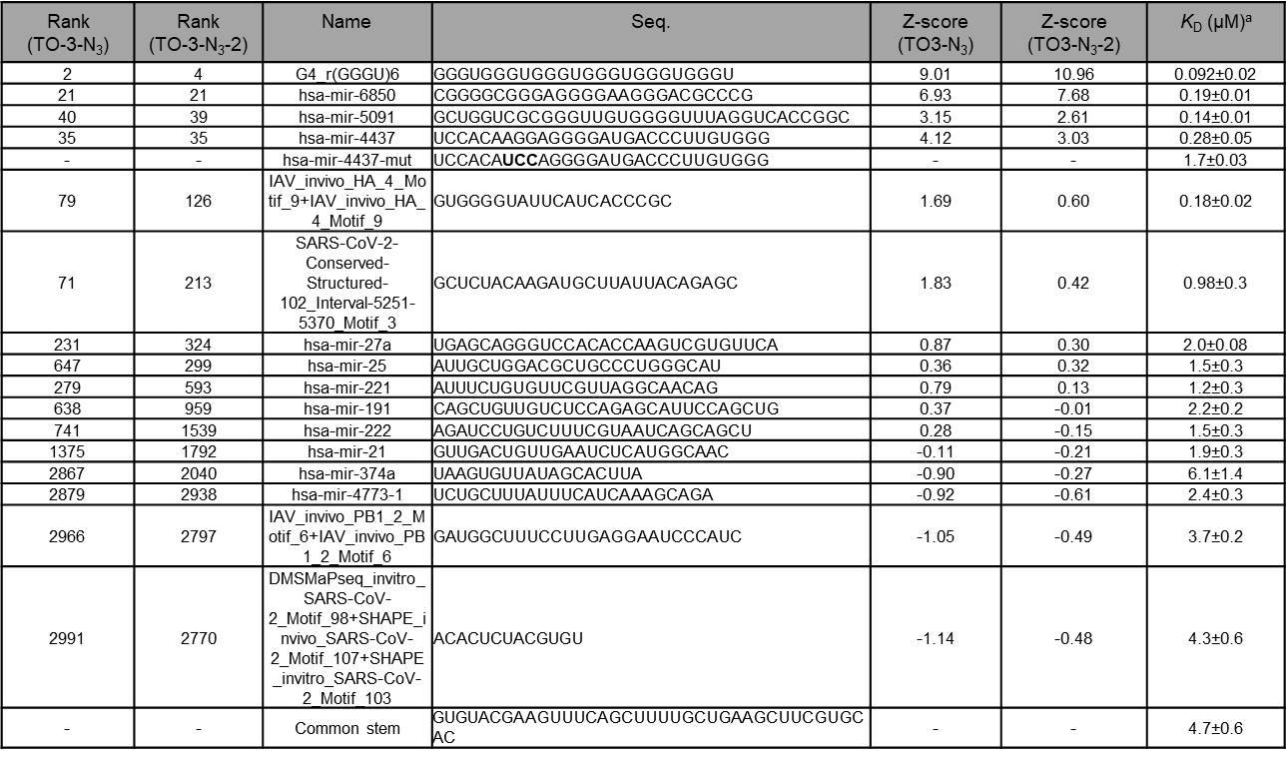
a) Data are mean±standard error from three independent experiments.

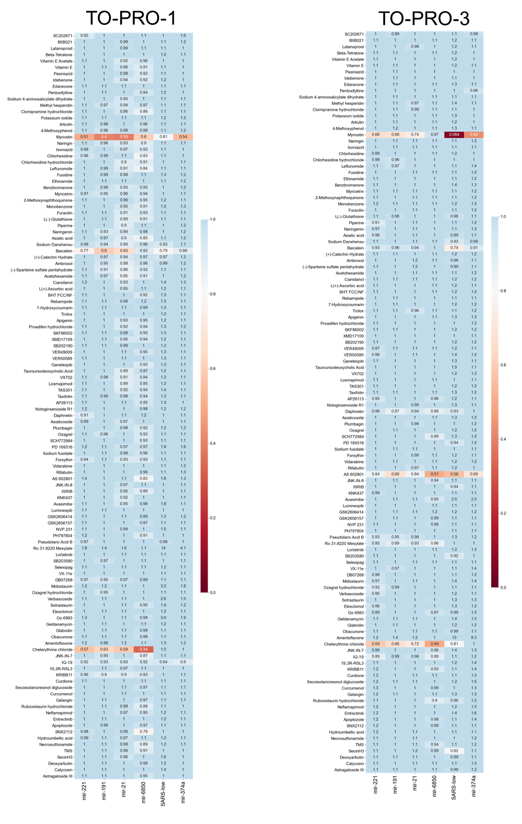
Figure S14. Normalized fluorescences in FID assay using TO-PRO-1 (left) and TO-PRO-3 (right). The data are mean from two independent experiments.

baicalein
Figure S15. Fluorescence titrations to determine the apparent dissociation constants (K_{Dapp}) of baicalein. Fluorescence titration spectra were measured using baicalein (5 or 10 μM) upon addition of RNA (0-40 µM) in phosphate buffer (pH 7.0). Conditions: λex: 315 nm, λem: 404 nm. The representative data and K_{Dapp} values are shown.

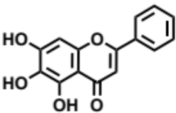

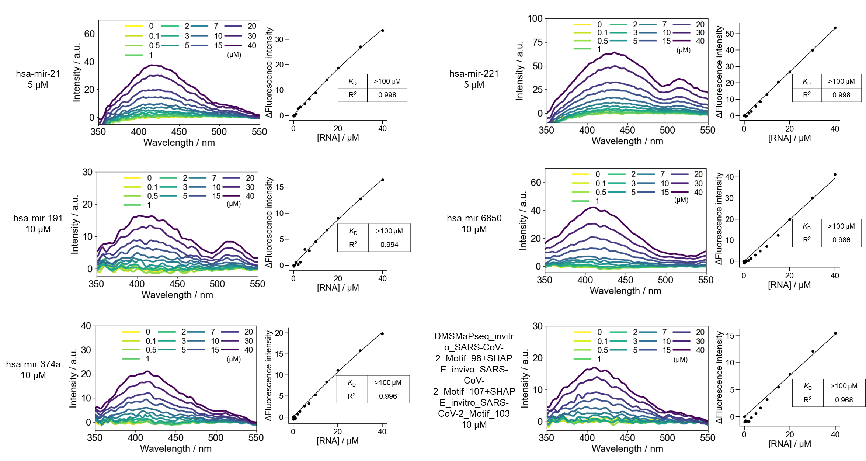

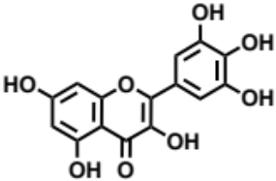
myricetin
Figure S16. Fluorescence titrations to determine the apparent dissociation constants (K_{Dapp}) of myricetin. Fluorescence titration spectra were measured using myricetin (1 or 5 μM) upon addition of RNA (0-40 µM) in phosphate buffer (pH 7.0). Conditions: λex: 376 nm, λem: 542 nm. The representative data and K_{Dapp} values are shown.

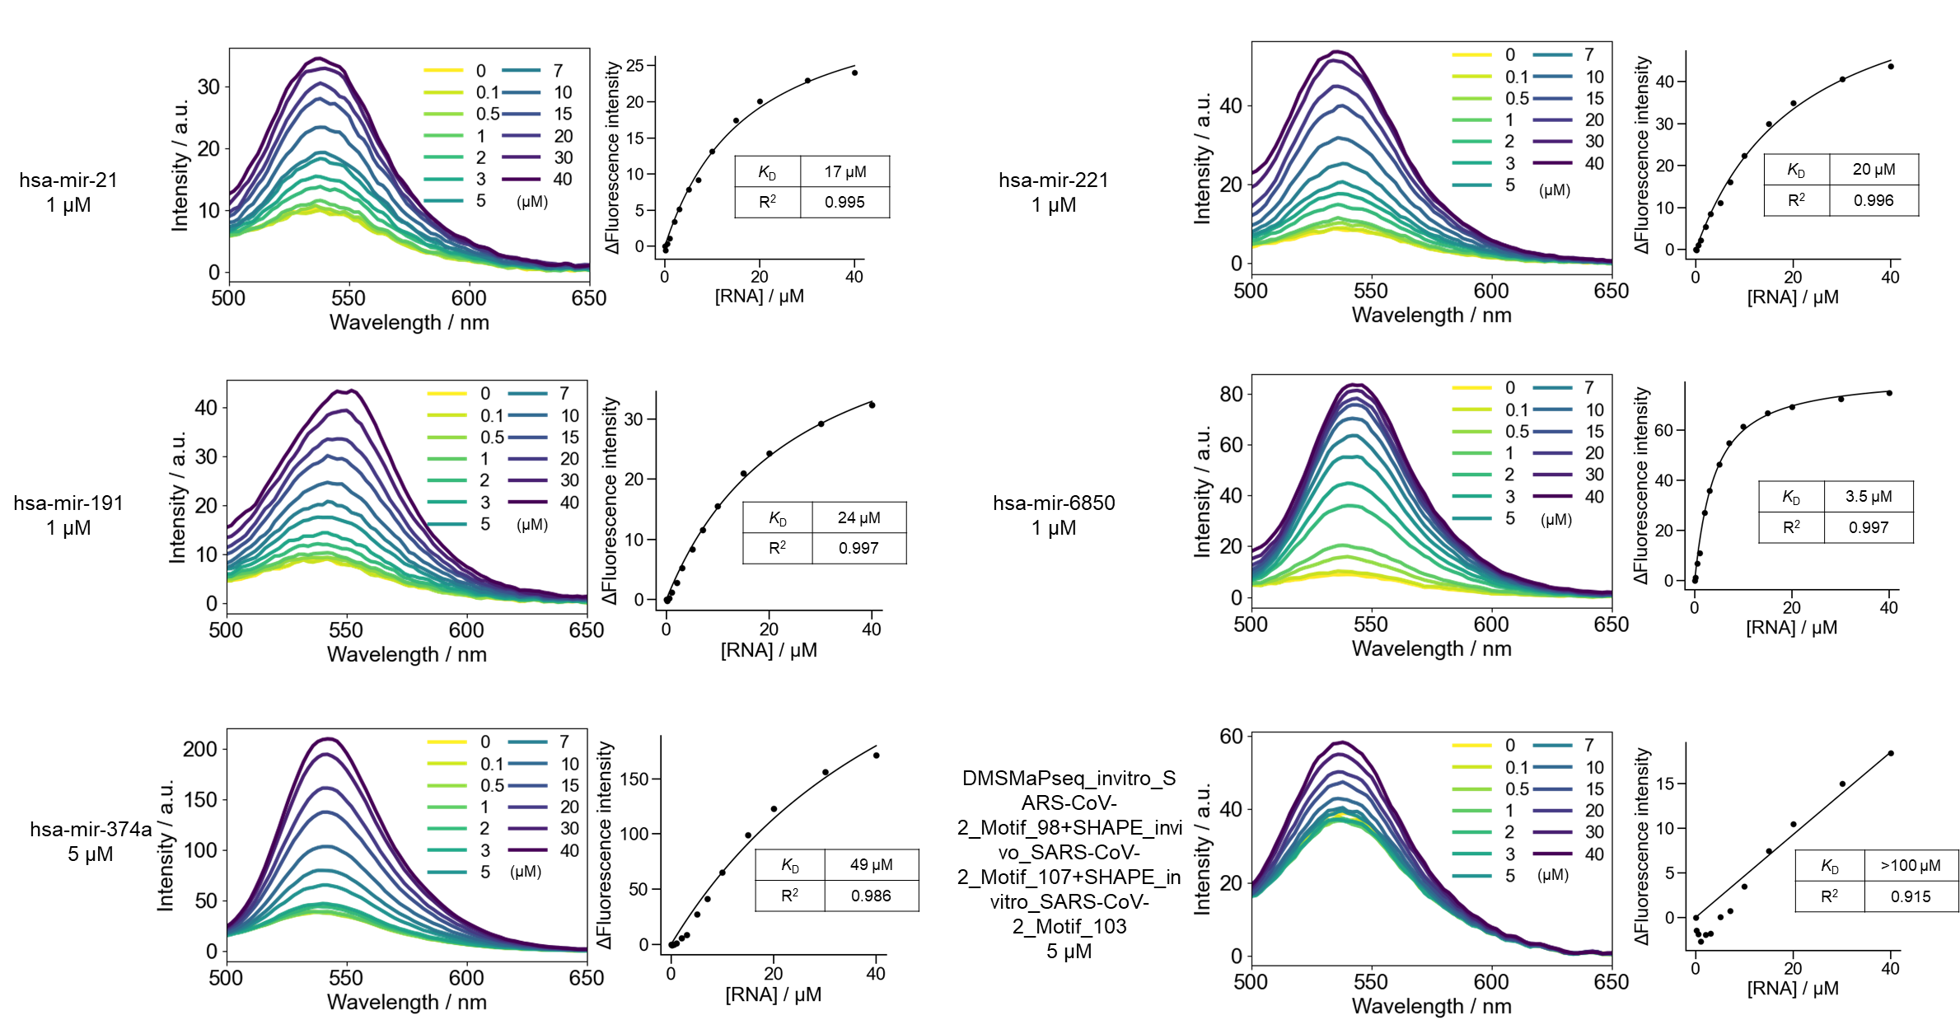
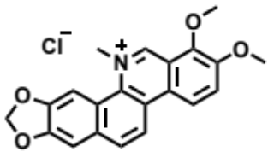
Figure S17. Fluorescence titrations to determine the apparent dissociation constants (K_{Dapp}) of chelerythrine chloride. Fluorescence titration spectra were measured using chelerythrine (1 μM) upon addition of RNA (0-40 µM) in phosphate buffer (pH 7.0). Conditions: λex: 320 nm, λem: 414 nm. The representative data and K_{Dapp} values are shown.

chelerythrine
chloride

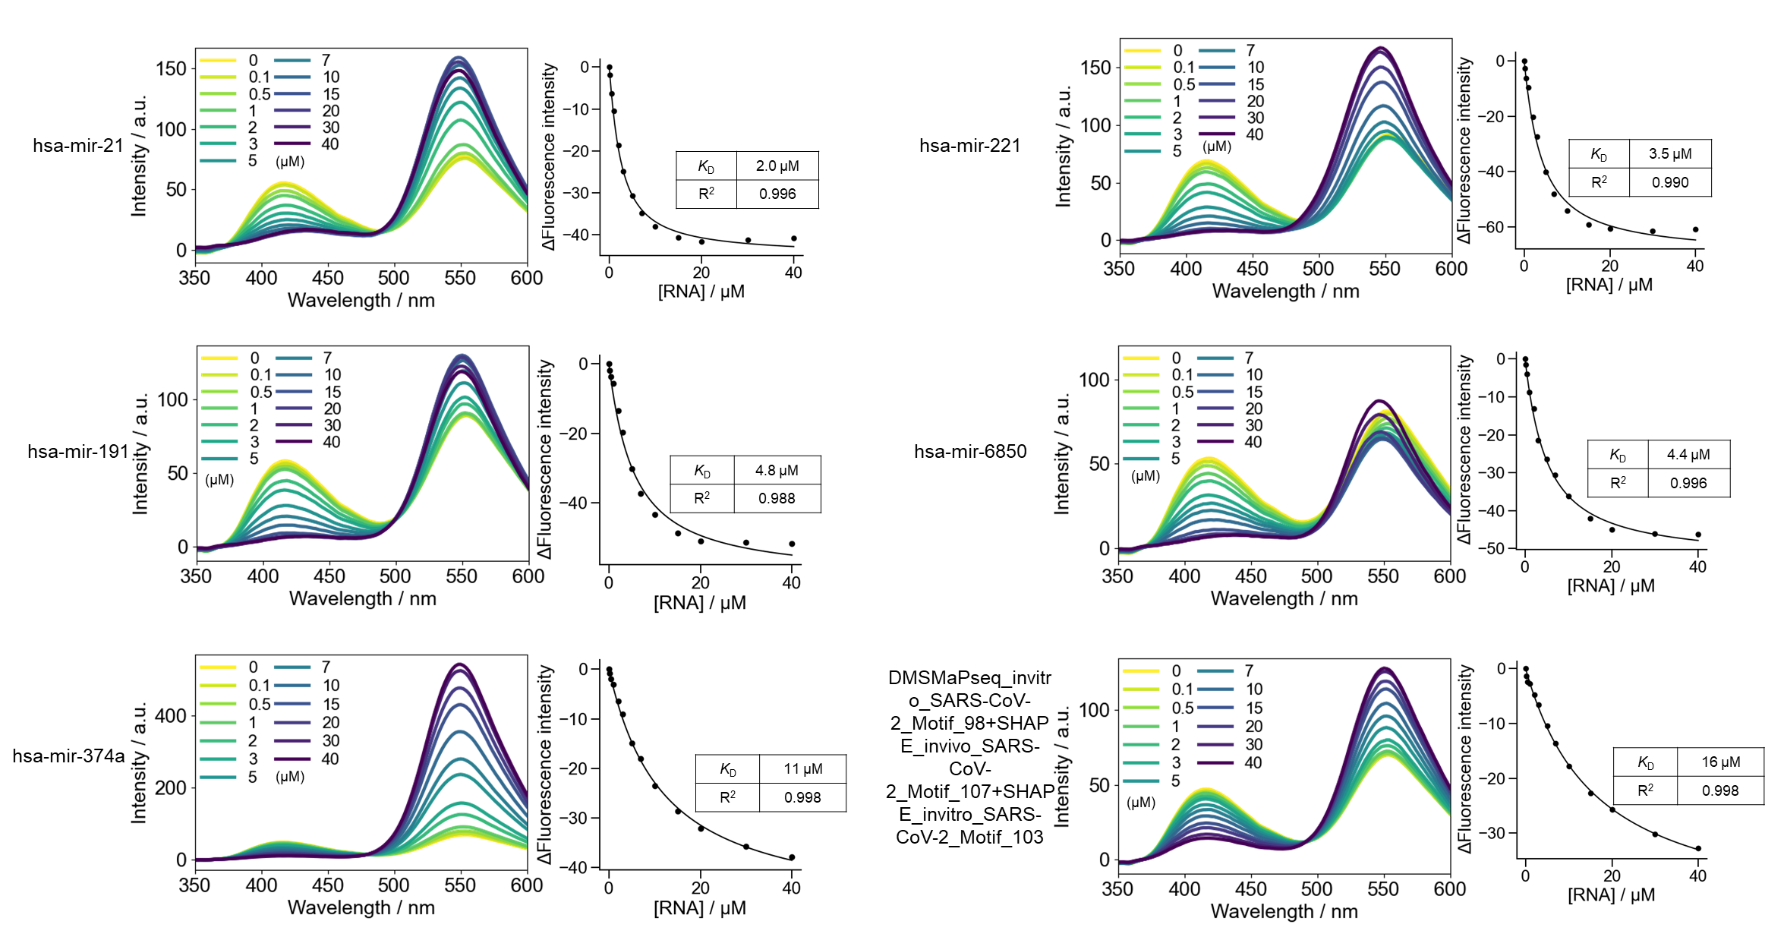

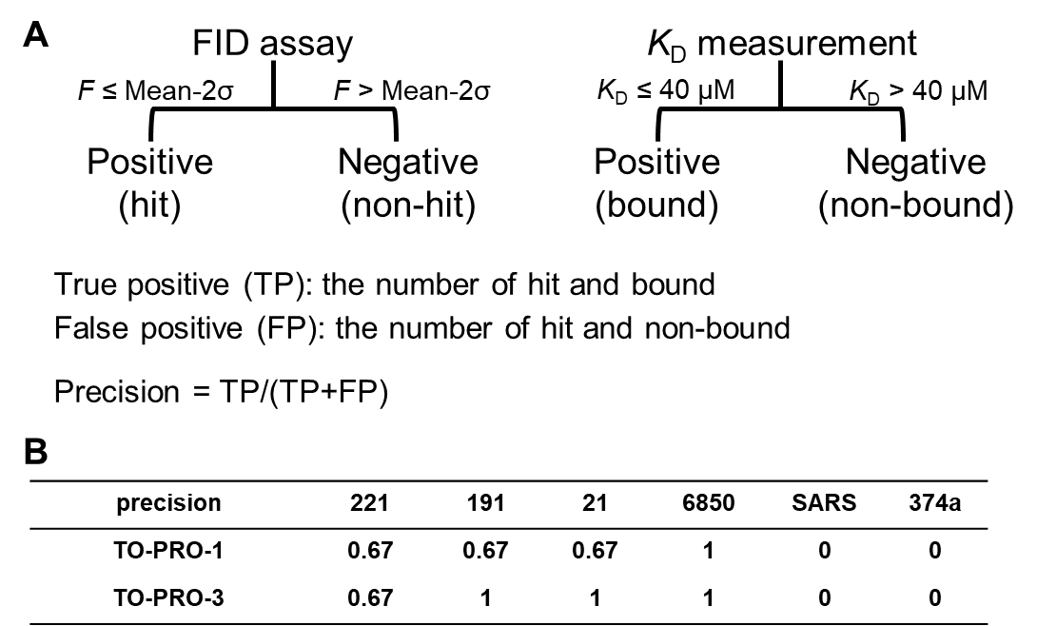

Figure S18. The precisions of FID assay. (A) Definition of true positive, false positive and precision. F denotes fluorescence intensity in FID assay and σ denotes standard division. (B) The precisions of FID assay using TO-PRO-1 and TO-PRO-3 across the investigated RNAs.

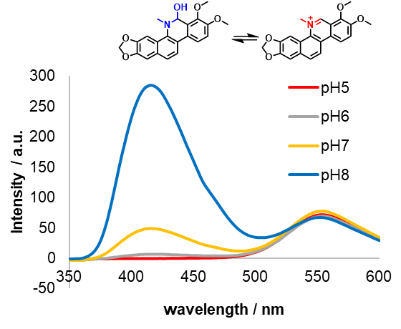
Figure S19. The pH dependency of fluorescence intensity of chelerythrine chloride. Fluorescence titration spectra were measured using chelerythrine chloride (1 μM) in phosphate buffer (pH 7.0). Conditions: λex: 320 nm.

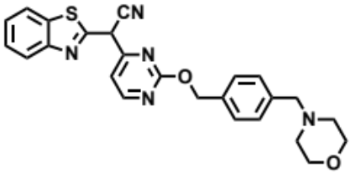
Figure S20. Fluorescence titrations to determine the apparent dissociation constants (K_{Dapp}) of AS 602801. Fluorescence titration spectra were measured using AS 602801 (1 μM) upon addition of RNA (0-40 µM) in phosphate buffer (pH 7.0). Conditions: λex: 372 nm, λem: 432 nm. The representative data and K_{Dapp} values are shown.

AS 602801

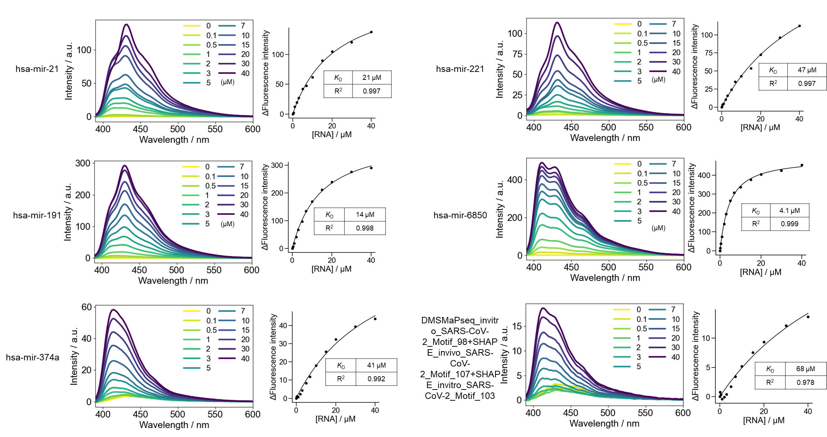

NMR Data
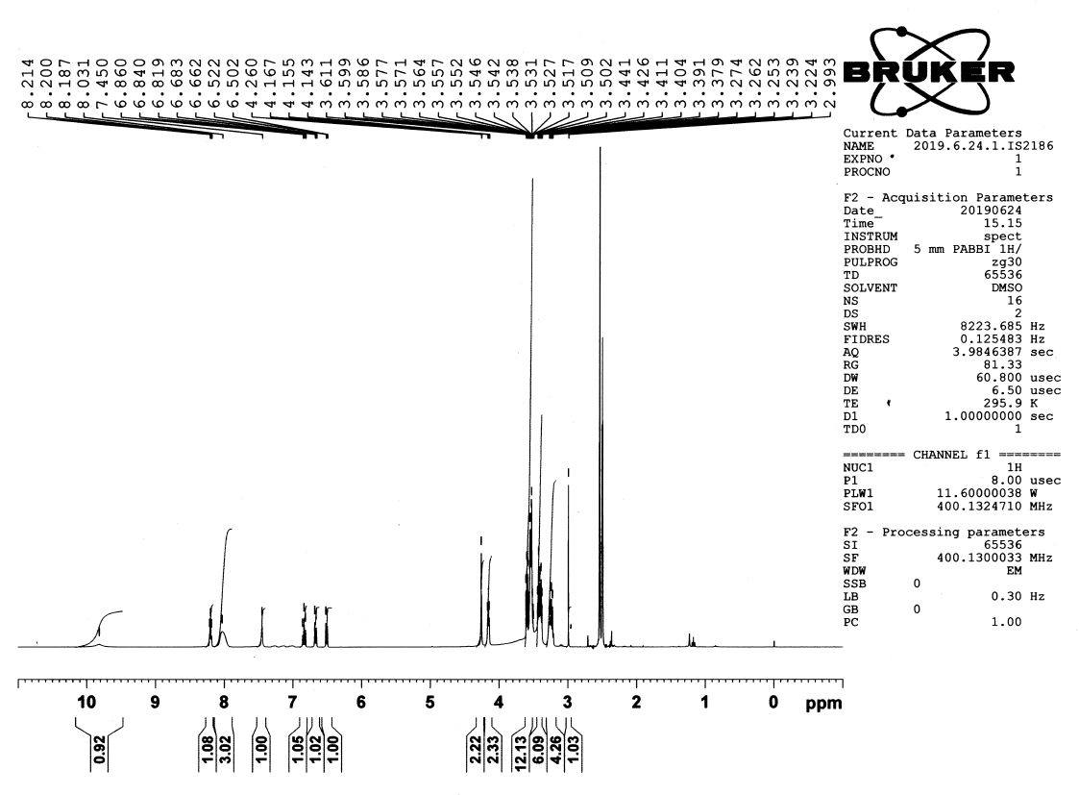
G-clamp-N₃, ¹H NMR (400 MHz, DMSO-d₆)

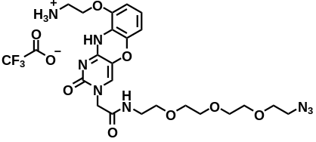

G-clamp-N₃, ¹³C NMR (151 MHz, DMSO-d₆)
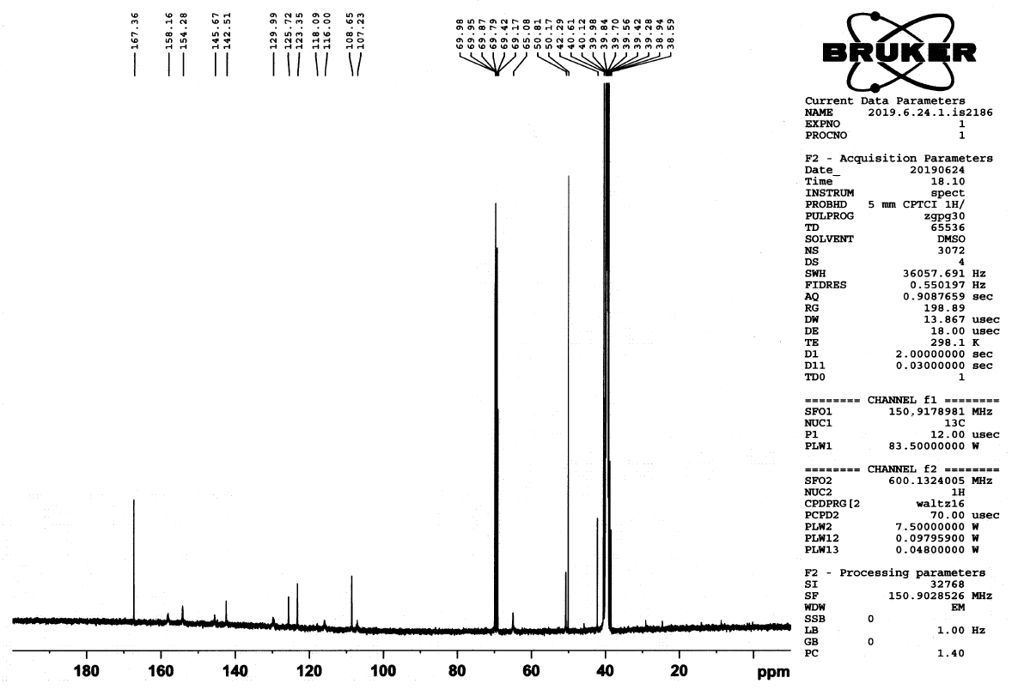

Compound 5, ¹H-NMR (400 MHz, DMSO-d₆)
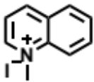
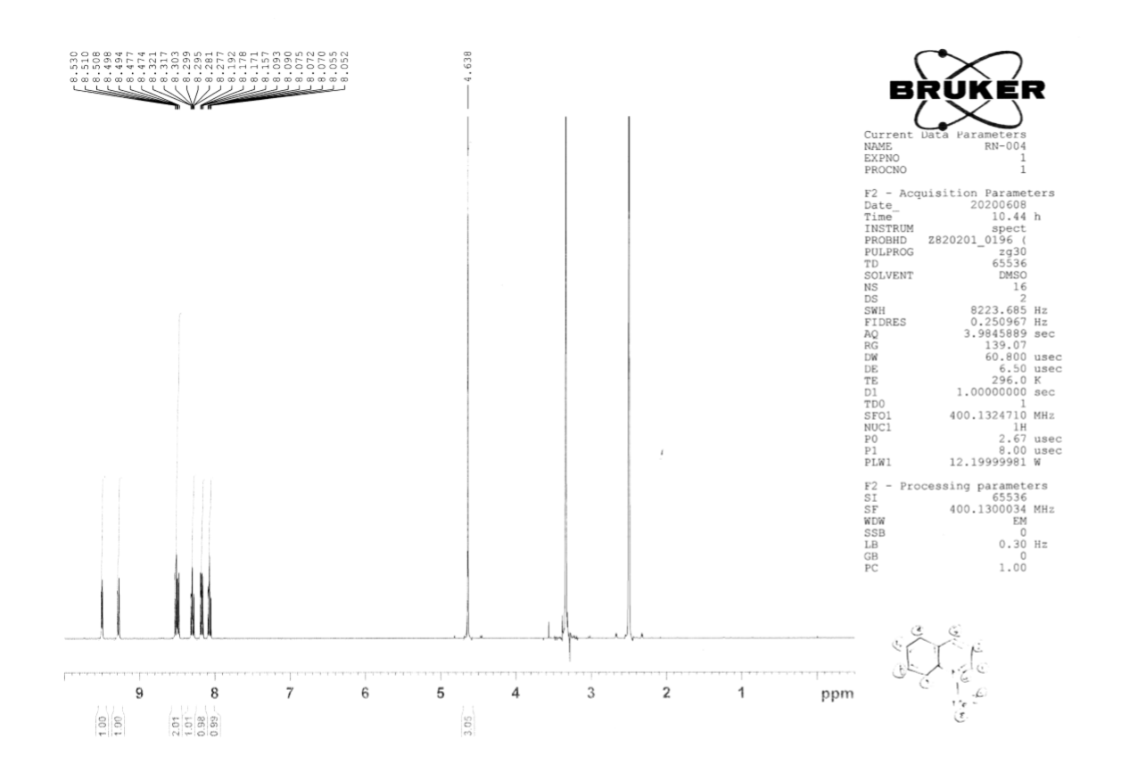

Compound 6, ¹H-NMR (400 MHz, DMSO-d₆)
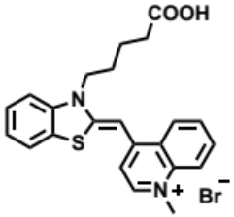
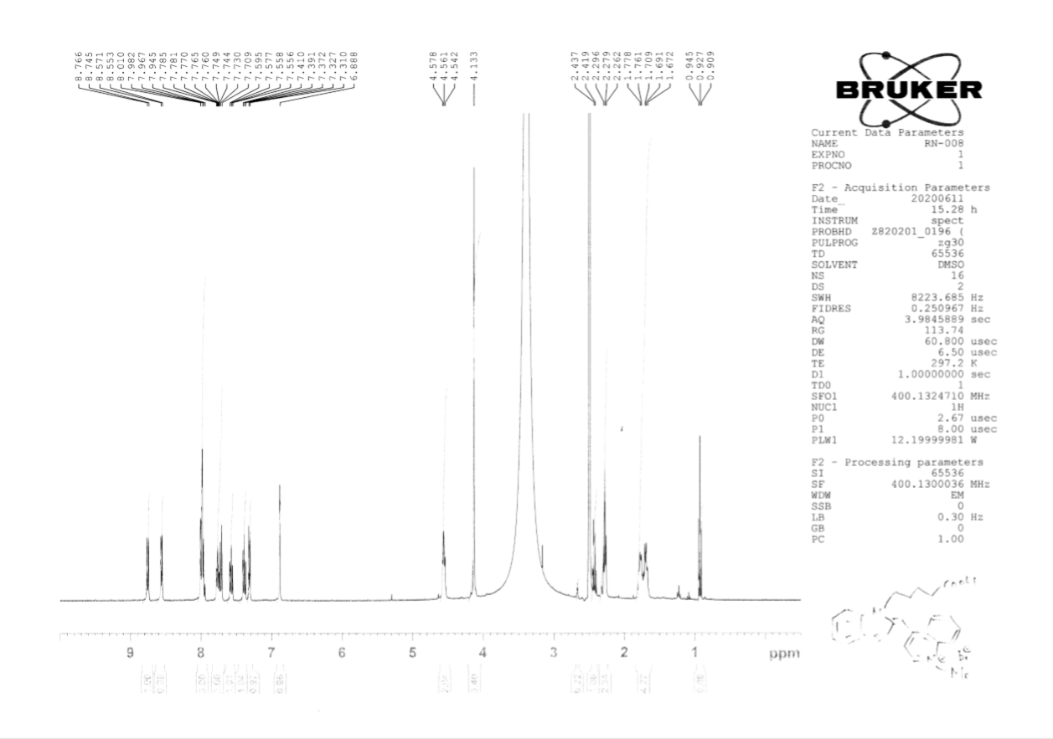

TO-N₃, ¹H-NMR (600 MHz, DMSO-d₆)
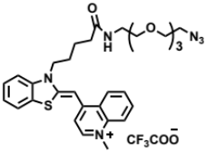
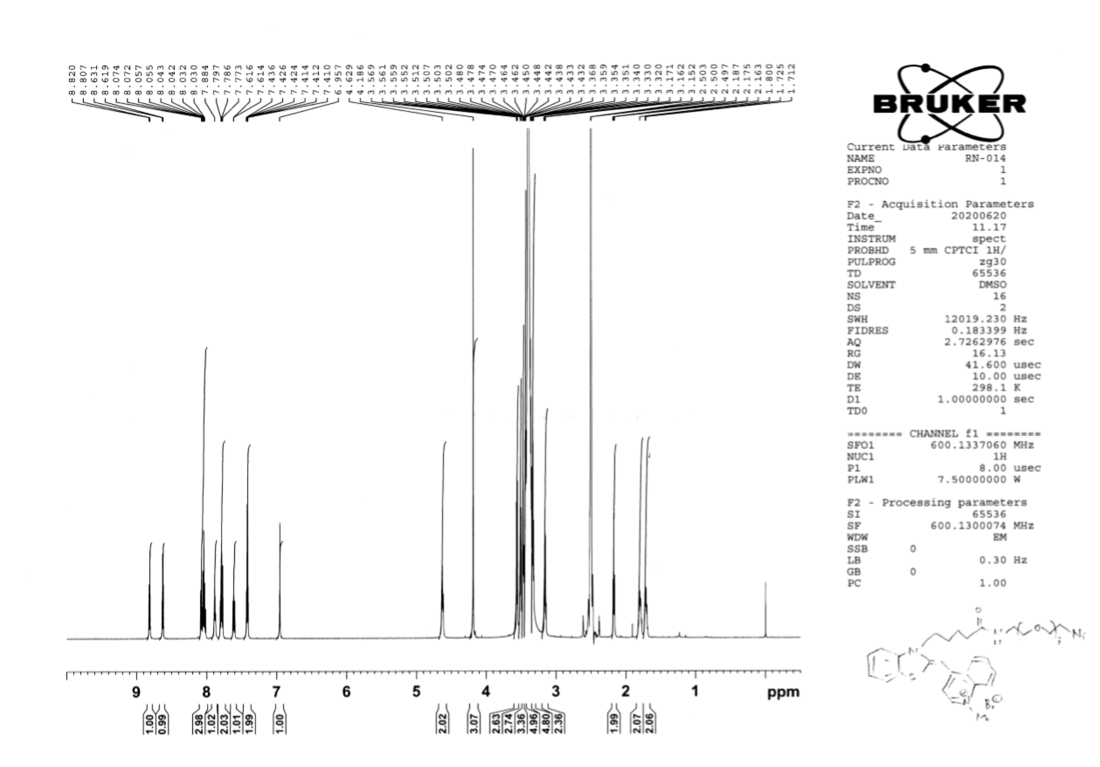

TO-N₃, ¹³C-NMR (151 MHz, DMSO-d₆)
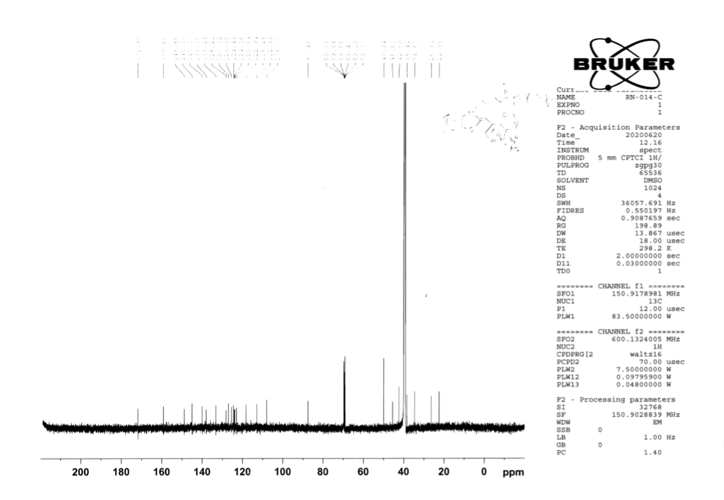

Compound 10, ¹H-NMR (400 MHz, DMSO-d₆)
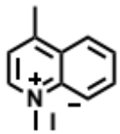
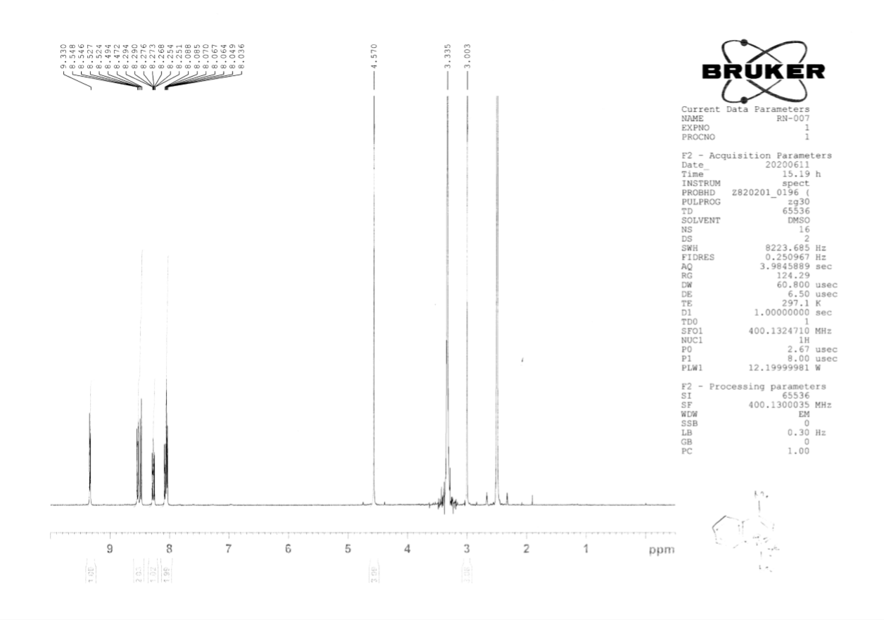

Compound 11, ¹H-NMR (400 MHz, DMSO-d₆)
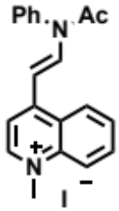
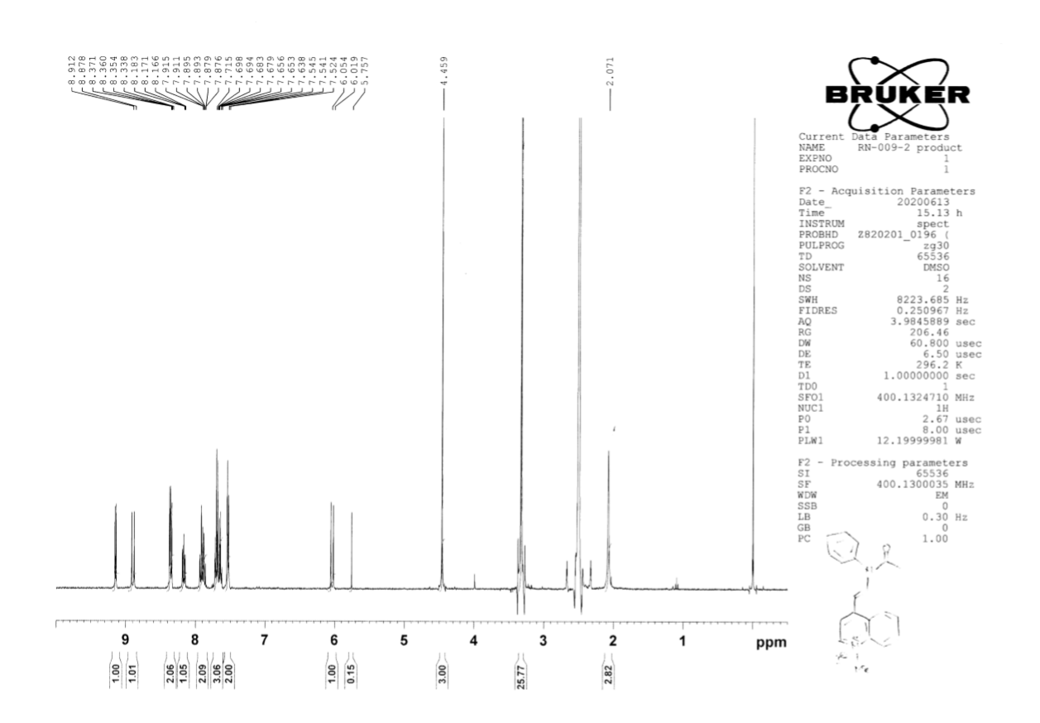

Compound 12, ¹H-NMR (400 MHz, DMSO-d₆)
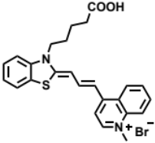
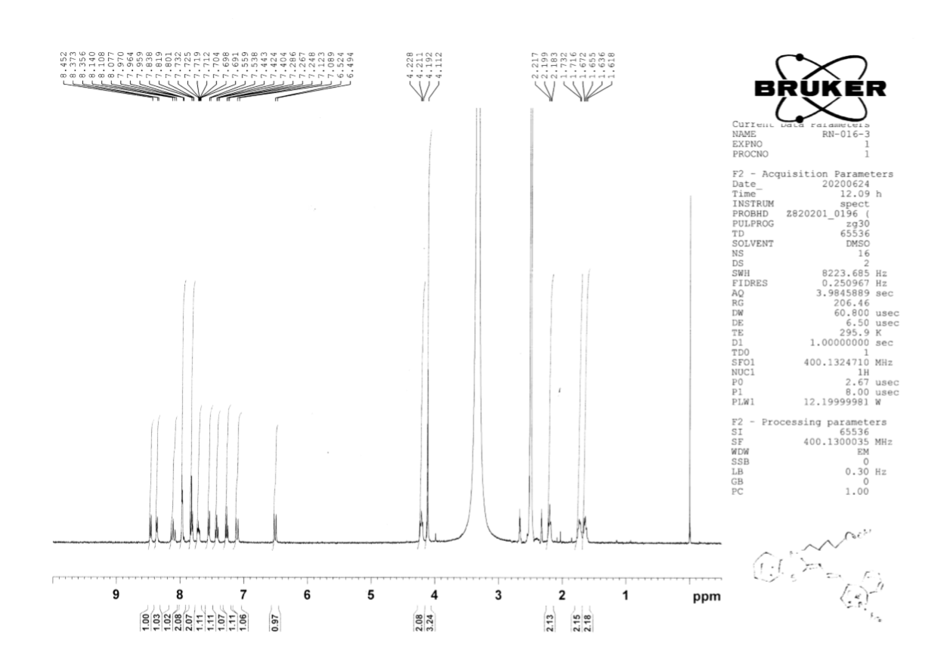

TO-3-N₃, ¹H-NMR (600 MHz, DMSO-d₆)
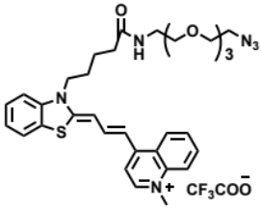
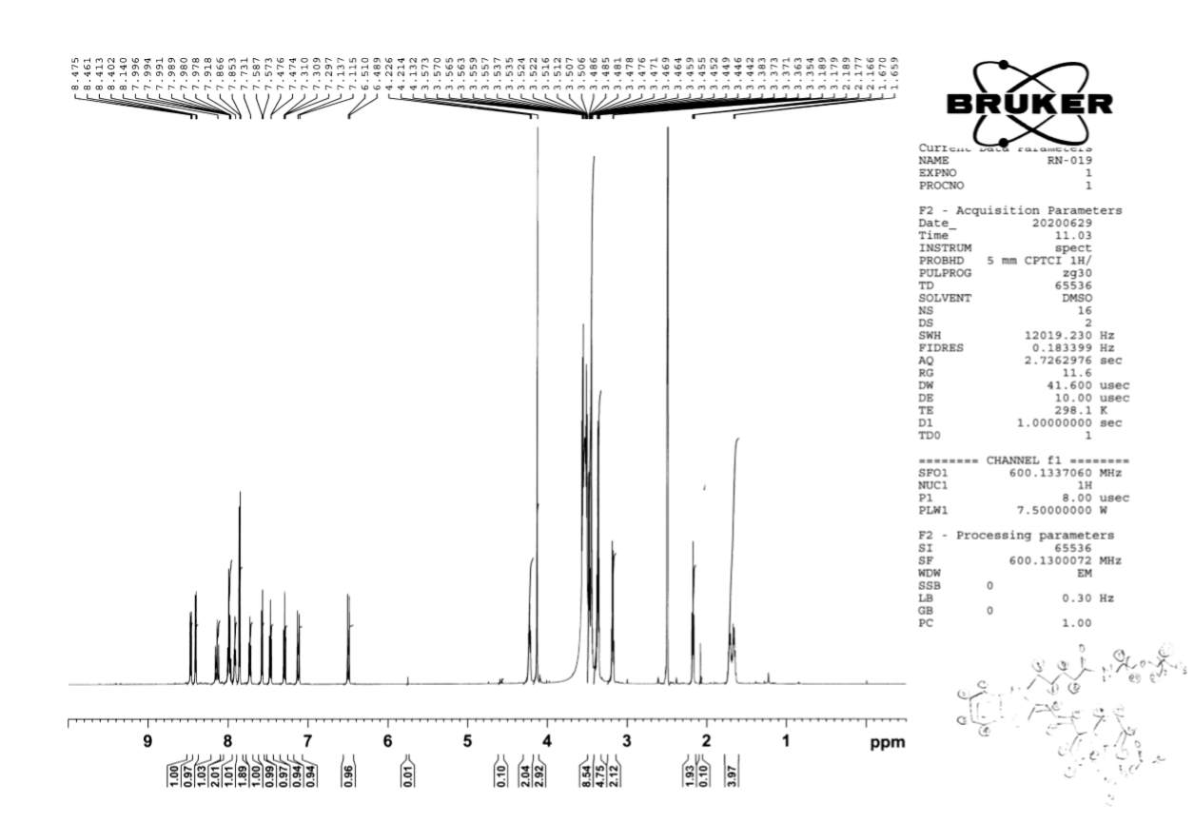

TO-3-N₃, ¹³C-NMR (151 MHz, DMSO-d₆)
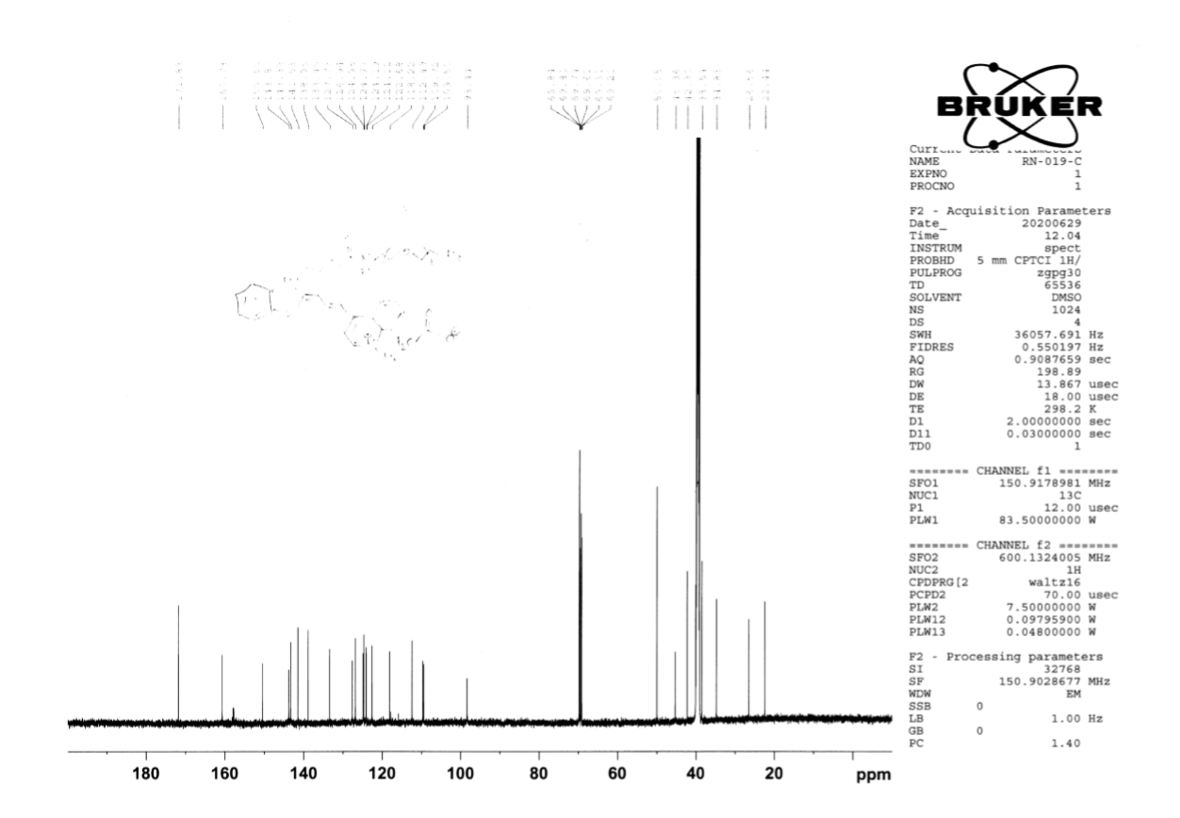

Compound 15, ¹H-NMR (500 MHz, CDCl₃)

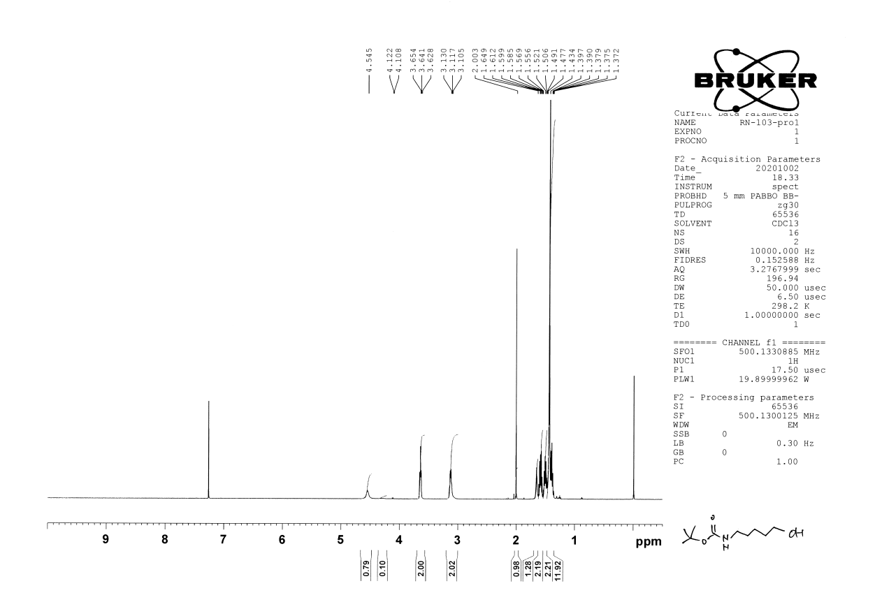

Compound 16, ¹H-NMR (400 MHz, CDCl₃)

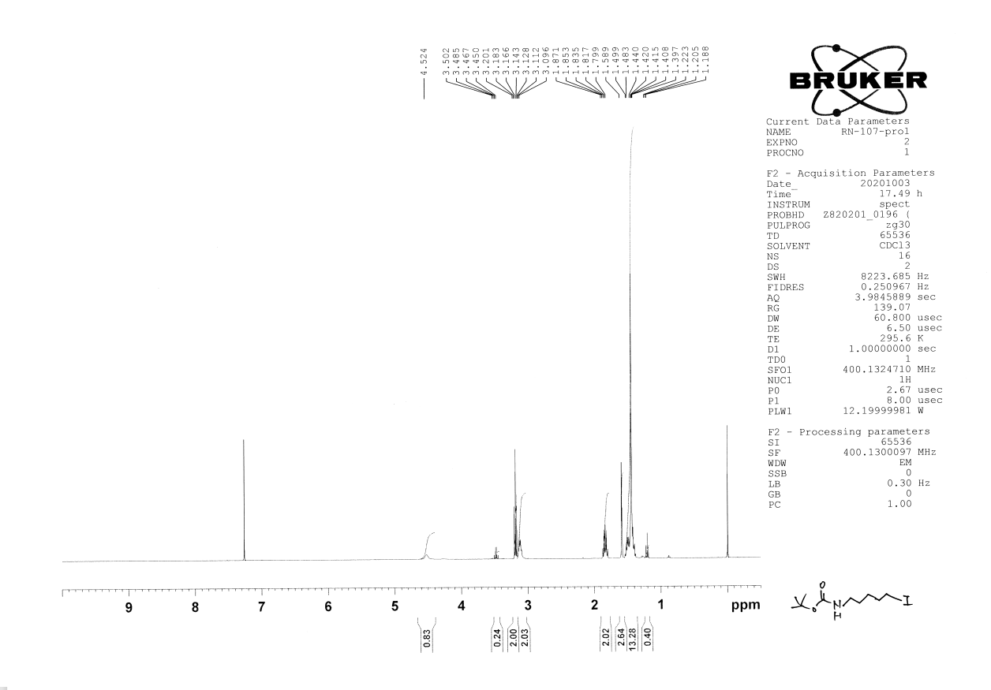

Compound 17, ¹H-NMR (500 MHz,DMSO-d₆)
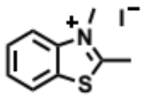
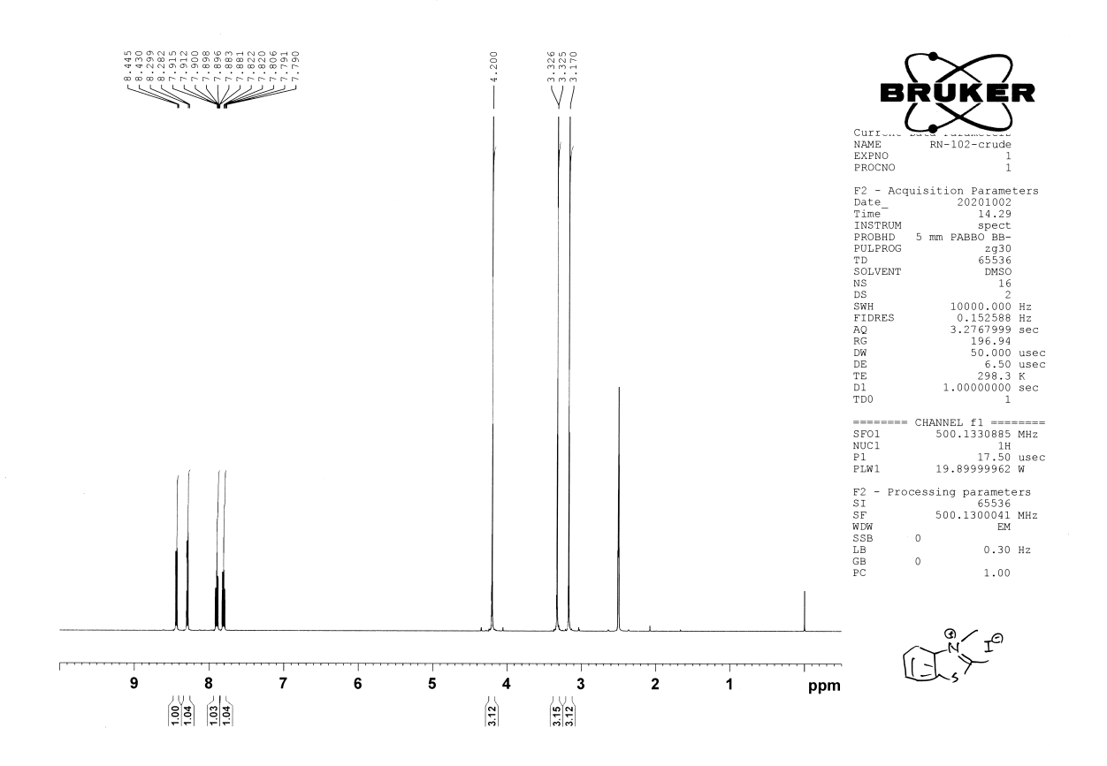

TO-N₃-2, ¹H-NMR (600 MHz, DMSO-d₆)
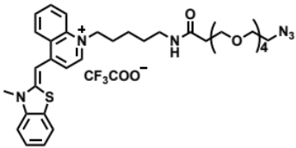
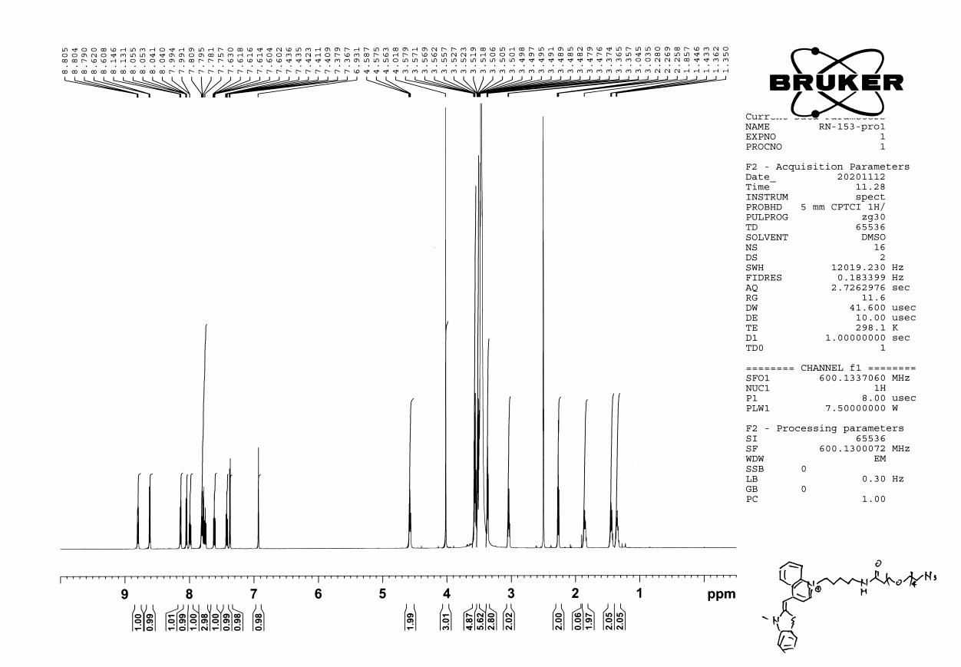

TO-N₃-2, ¹³C-NMR (151 MHz, DMSO-d₆)
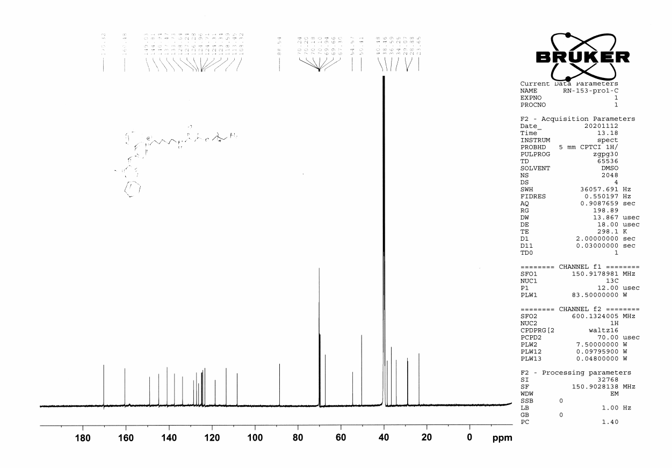

Compound 23, ¹H-NMR (400 MHz, DMSO-d₆)

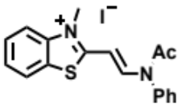
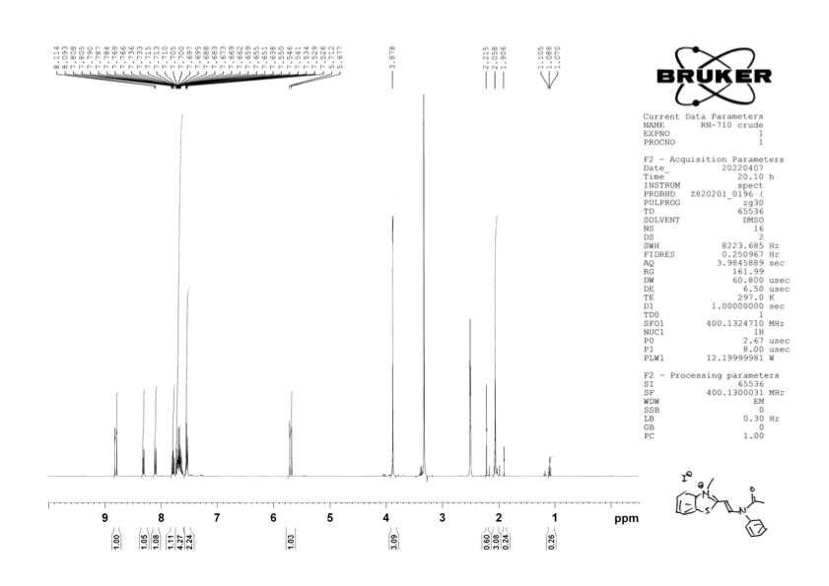

Compound 25, ¹H-NMR (600 MHz, DMSO-d₆)
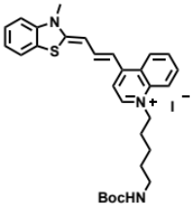
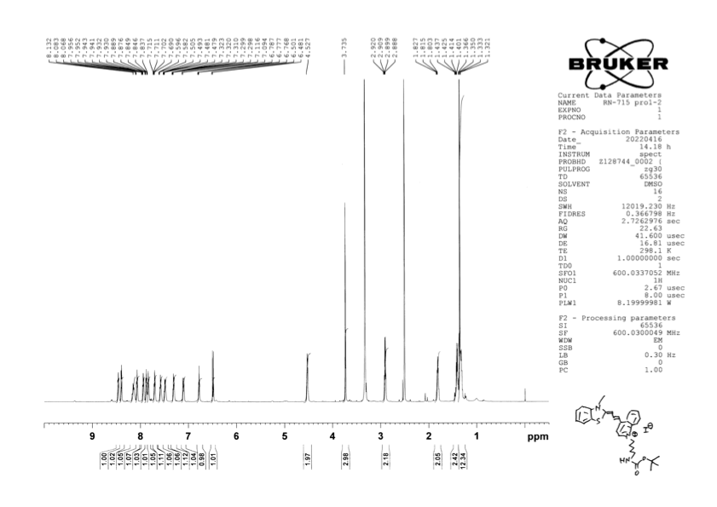

Compound 25, ¹³C-NMR (151 MHz, DMSO-d₆)
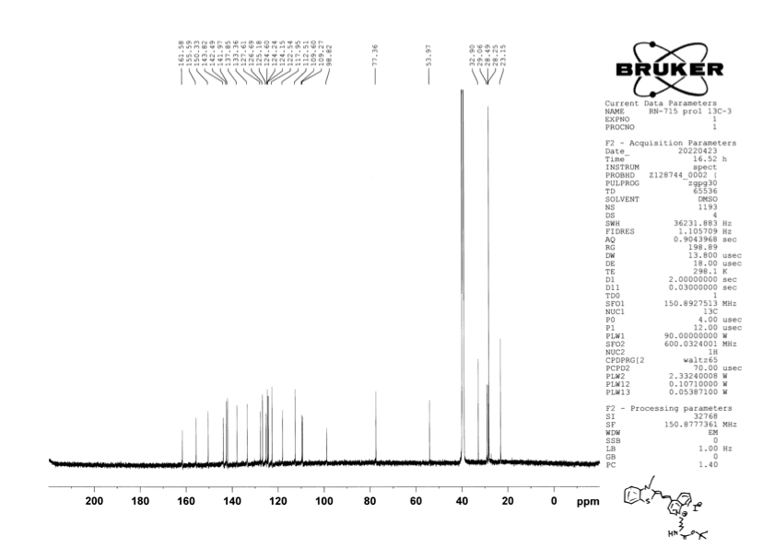

TO-3-N₃-2, ¹H-NMR (600 MHz, DMSO-d₆)
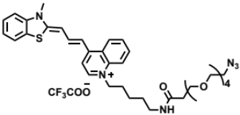
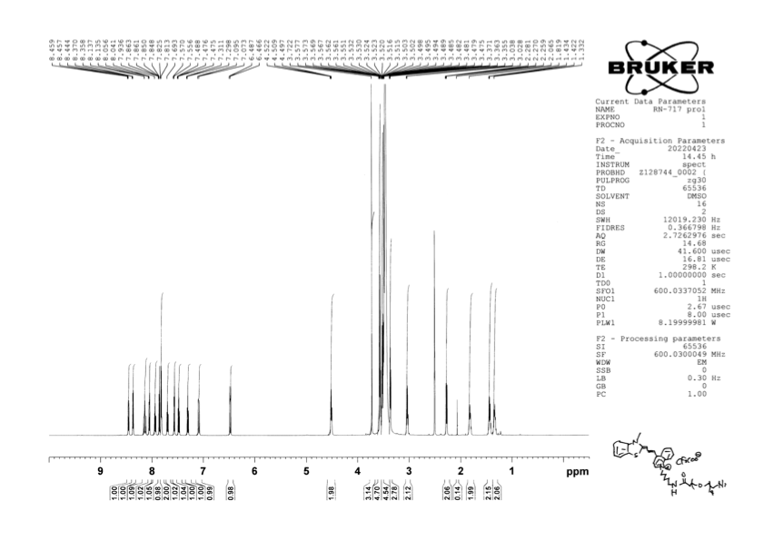

TO-3-N₃-2, ¹³C-NMR (151 MHz, DMSO-d₆)
