Supporting Information for
Peroxidase-like Fe⁰@FeMn-NC for the efficient degradation of 4-CP: Critical role of Fe⁰
Xinxin Lv ^{a, b}, Huilai Liu ^{a, b}, Zhihao Li ^{a, b}, Minshu Cui ª, Kangping Cui ª, Zhengliang Dai ^{c}, Bei Wang ^{c}, Xing Chen ^{a, b}

a. Key Laboratory of Nanominerals and Pollution Control of Higher Education Institutes, School of Resources and Environmental Engineering, Hefei University of Technology, Hefei 230009, P. R. China;
b. Key Lab of Aerospace Structural Parts Forming Technology and Equipment of Anhui Province, Institute of Industry and Equipment Technology, Hefei University of Technology, Hefei, 230009, P. R. China;
c. Anqing Changhong Chemical Co., Ltd., Anqing, 246002, P. R. China

Table of contents
Figure S1. SEM images of (a) NC-900, (b) Fe-NC, and (c) Mn-NC.
Figure S2. XPS spectra of (a) Survey; (b) C 1s; (c) N 1s; (d) O 1s for Fe⁰@FeMn-NC.
Figure S3. Steady-state kinetic assay of NC-900 nano-enzyme. (a) Time-dependent absorption changes at 652 nm in the presence of different concentrations of H₂O₂; (b) The velocities were measured with different H₂O₂ concentrations; (c) Double reciprocal plots between velocity and H₂O₂ concentration.
Figure S4. Steady-state kinetic assay of Fe-NC nano-enzyme. (a) Time-dependent absorption changes at 652 nm in the presence of different concentrations of H₂O₂; (b) The velocities were measured with different H₂O₂ concentrations; (c) Double reciprocal plots between velocity and H₂O₂ concentration.
Figure S5. Steady-state kinetic assay of Mn-NC nano-enzyme. (a) Time-dependent absorption changes at 652 nm in the presence of different concentrations of H₂O₂; (b) The velocities were measured with different H₂O₂ concentrations; (c) Double reciprocal plots between velocity and H₂O₂ concentration.
Figure S6. Comparison of the kinetic parameters K_{m} and V_{max} of various nano-enzymes when hydrogen peroxide was used as a substrate in this study and the literature reports.
Figure S7. Effect of NBA, AA, and FFA on the degradation of 4-CP in the Fe⁰@FeMn-NC/H₂O₂ system.
Figure S8. Mass spectrum of by-products in the degradation of 4-CP.
Figure S9. Main degradation processes of 4-CP and its intermediates.
Figure S10. Degradation rates of 4-CP and TOC in five cycles.
Table S1. Specific surface area, pore volume and pore width of different samples.
Table S2. Comparison of kinetic parameters with other catalysts using H₂O₂ as substrate.
Table S3. Changes in indicators before and after the reaction of raw water in a chemical plant workshop.
References

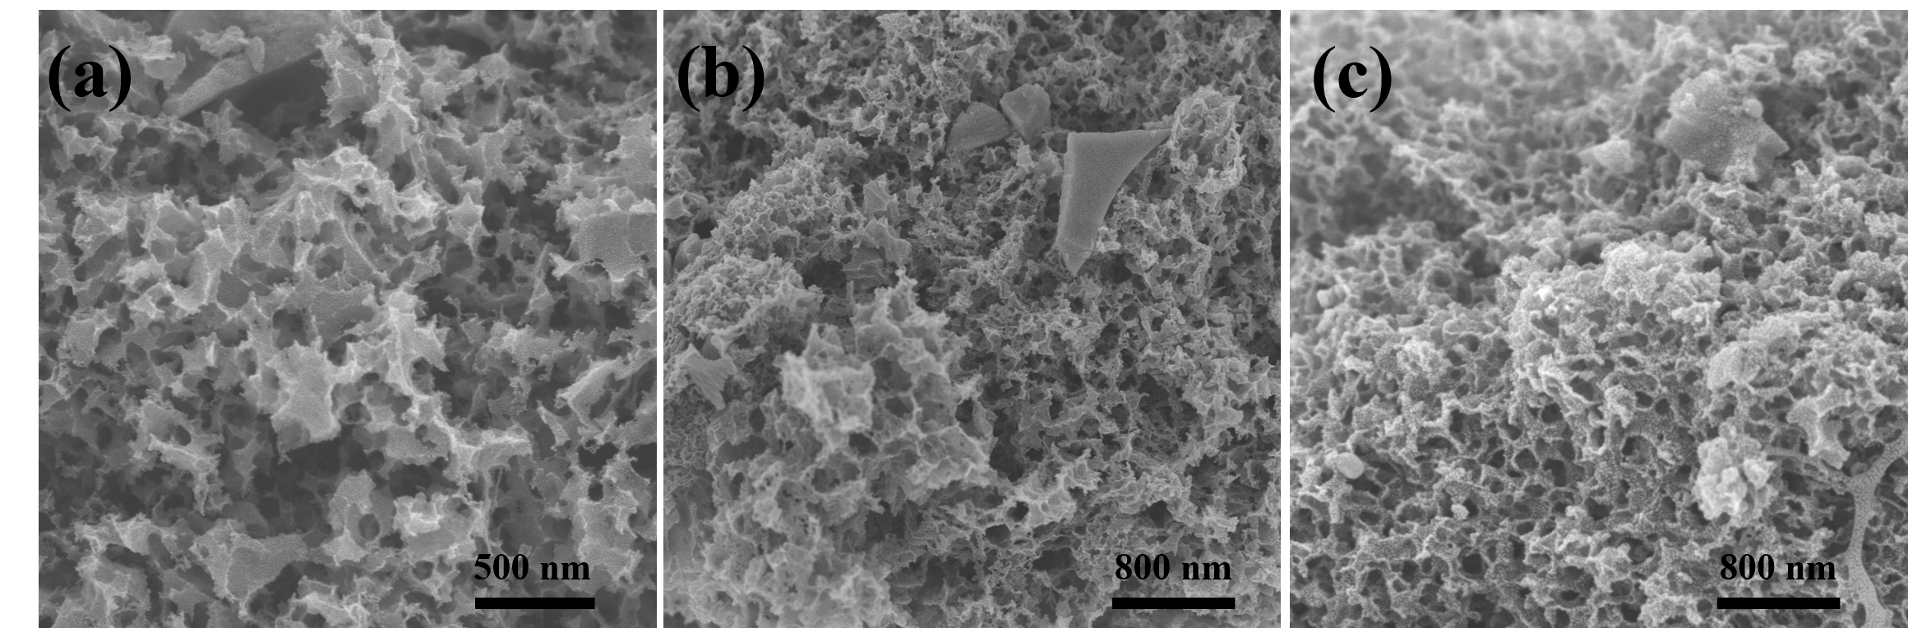
Figure S1. SEM images of (a) NC-900, (b) Fe-NC, and (c) Mn-NC.

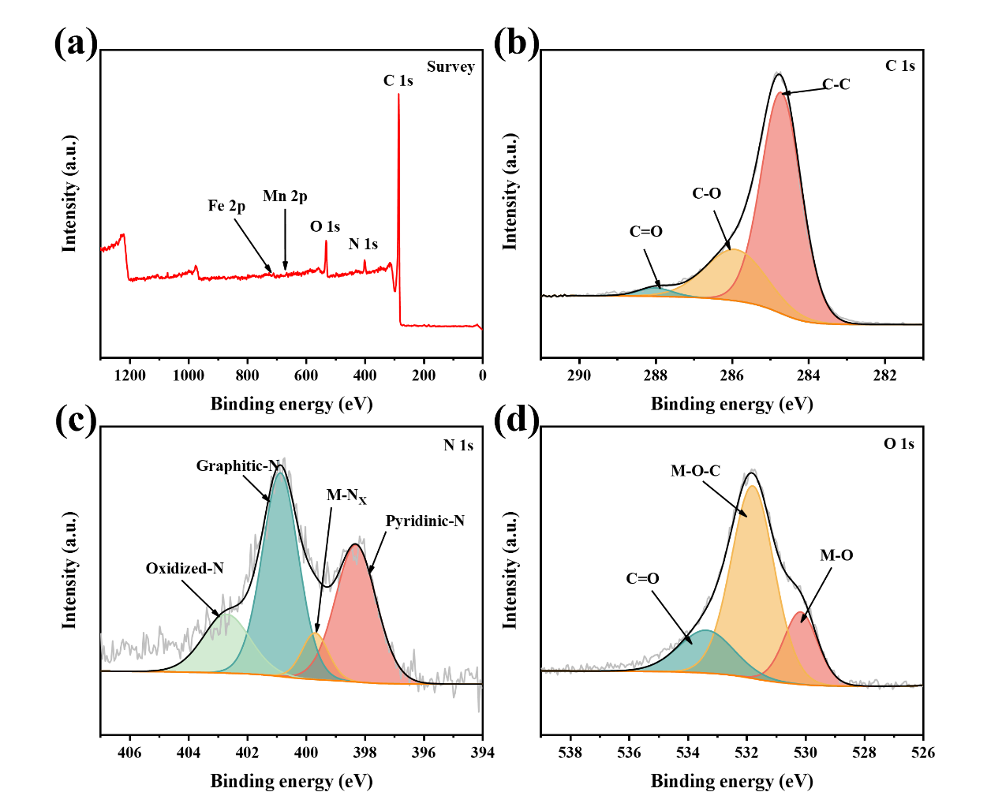
Figure S2. XPS spectra of (a) Survey; (b) C 1s; (c) N 1s; (d) O 1s for Fe⁰@FeMn-NC.

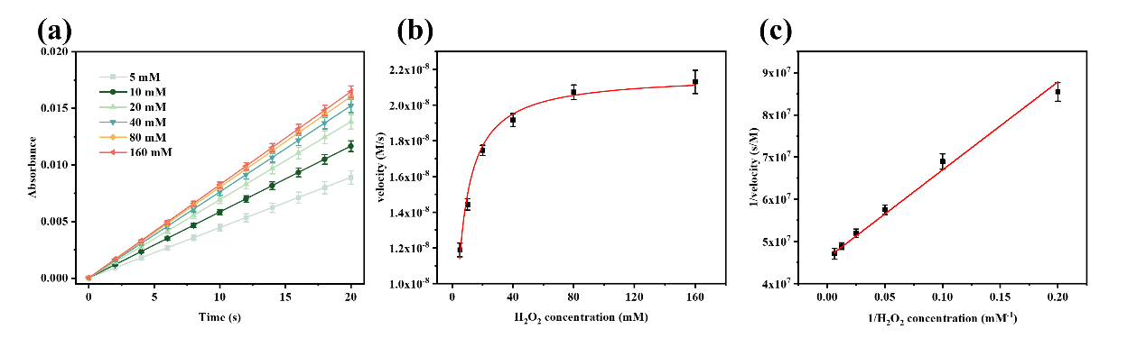
Figure S3. Steady-state kinetic assay of NC-900 nano-enzyme. (a) Time-dependent absorption changes at 652 nm in the presence of different concentrations of H₂O₂; (b) The velocities were measured with different H₂O₂ concentrations; (c) Double reciprocal plots between velocity and H₂O₂ concentration.

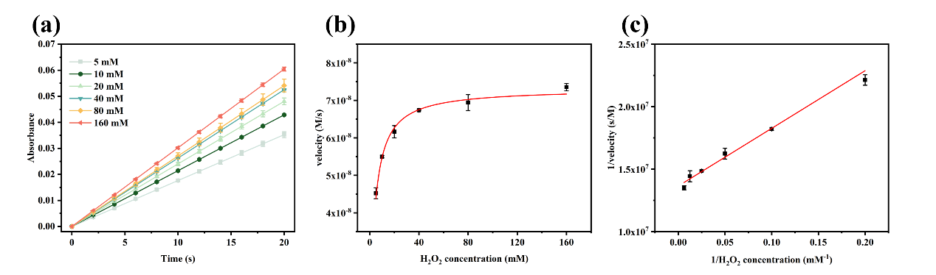
Figure S4. Steady-state kinetic assay of Fe-NC nano-enzyme. (a) Time-dependent absorption changes at 652 nm in the presence of different concentrations of H₂O₂; (b) The velocities were measured with different H₂O₂ concentrations; (c) Double reciprocal plots between velocity and H₂O₂ concentration.

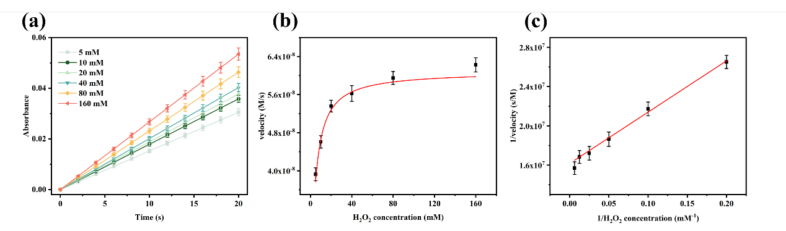
Figure S5. Steady-state kinetic assay of Mn-NC nano-enzyme. (a) Time-dependent absorption changes at 652 nm in the presence of different concentrations of H₂O₂; (b) The velocities were measured with different H₂O₂ concentrations; (c) Double reciprocal plots between velocity and H₂O₂ concentration.

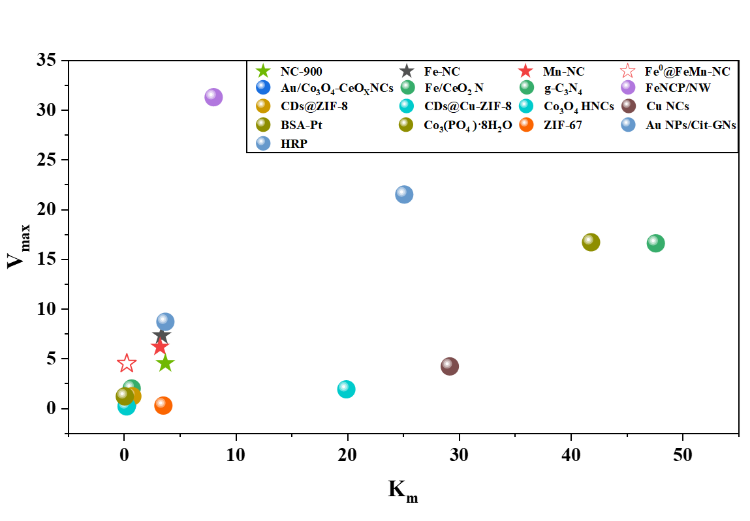
Figure S6. Comparison of the kinetic parameters K_{m} and V_{max} of various nano-enzymes when hydrogen peroxide was used as a substrate in this study and the literature reports (Chen et al., 2014; Ding et al., 2023; Gao et al., 2007; Hu et al., 2013; Jampaiah et al., 2016; Li et al., 2015; Liu et al., 2018; Peng et al., 2022; Wang, H. et al., 2021; Wang et al., 2018; Wang et al., 2019; Wang, Y. et al., 2021; Wang, Y.F. et al., 2021).

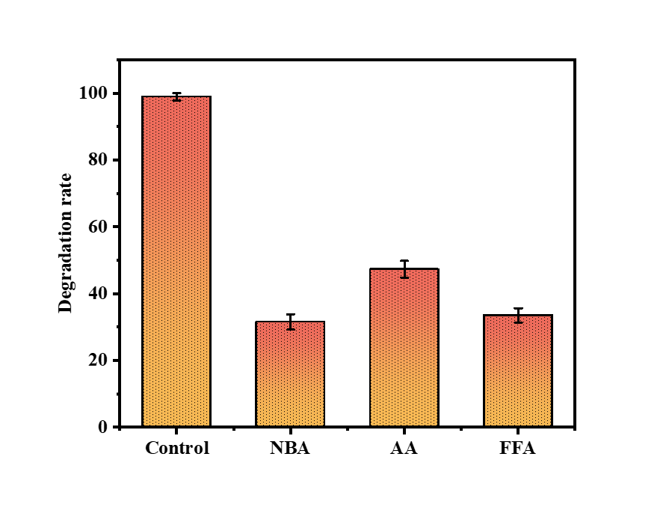
Figure S7. Effect of NBA, AA, and FFA on the degradation of 4-CP in the Fe⁰@FeMn-NC/H₂O₂ system.

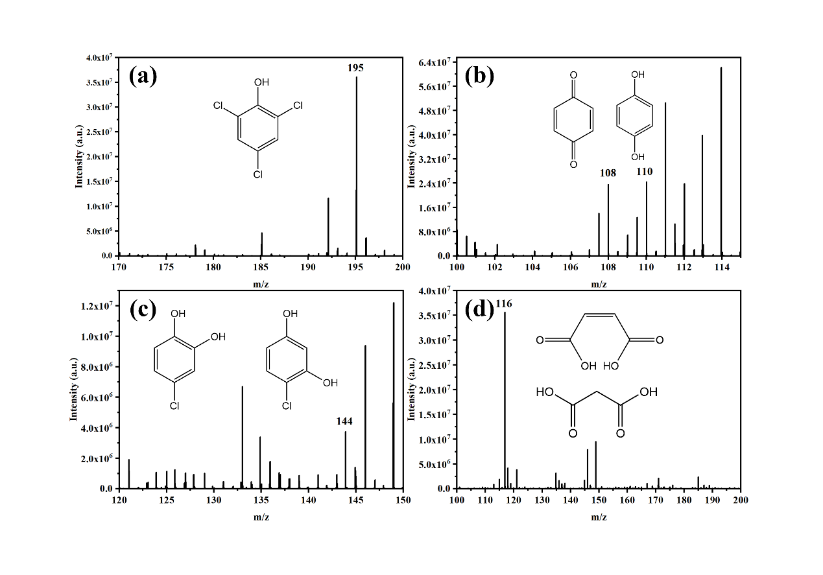
Figure S8. Mass spectrum of by-products in the degradation of 4-CP.

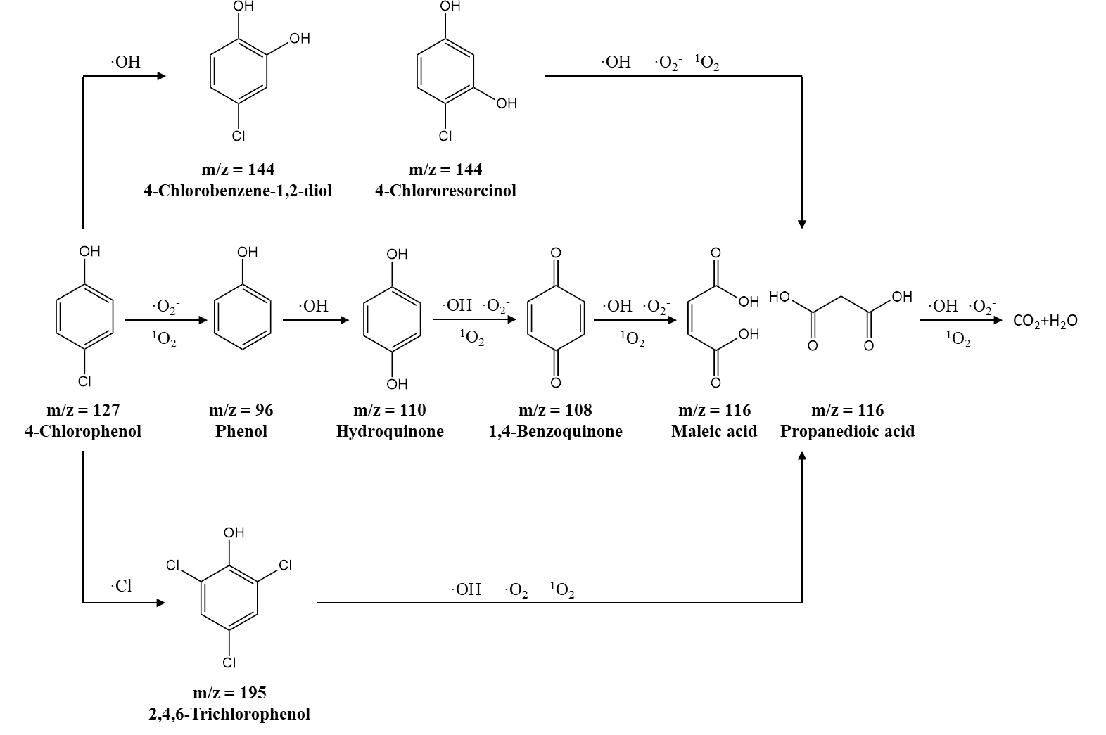
Figure S9. Main degradation processes of 4-CP and its intermediates.

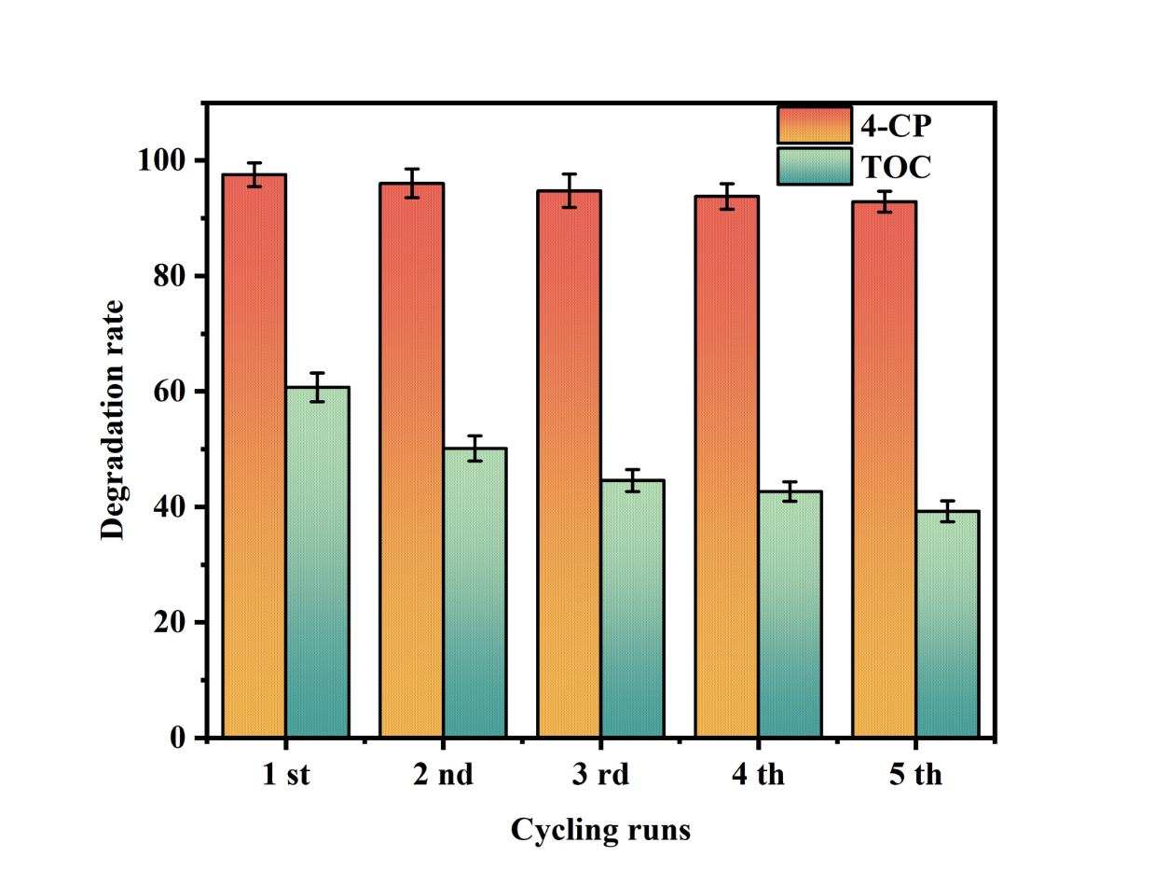
Figure S10. Degradation rates of 4-CP and TOC in five cycles.

Table S1. Specific surface area, pore volume, and pore width of different samples.
Catalysts | Surface area (m² g⁻¹) | Pore volume (cm³ g⁻¹) | Pore width (Å)
NC-900 | 1097.847 | 0.556 | 5.67
Fe-NC | 648.315 | 0.289 | 5.93
Mn-NC | 641.372 | 0.282 | 5.94
Fe⁰@FeMn-NC | 657.721 | 0.295 | 5.90

Table S2. Comparison of kinetic parameters with other catalysts using H₂O₂ as substrate.
Catalysts | K_{m} (mM) | V_{max} (10⁻⁸ M/s) | Ref.
NC-900 | 4.53 | 2.17 | This Work
Fe-NC | 3.38 | 7.33 | This Work
Mn-NC | 3.23 | 6.18 | This Work
Fe⁰@FeMn-NC | 0.25 | 4.5 | This Work
Au/Co₃O₄-CeO_{X}NCs | 0.2724 | 0.3898 | (Liu et al., 2018)
Fe/CeO₂ NRs | 47.6 | 16.6 | (Jampaiah et al., 2016)
g-C₃N₄ | 0.682 | 2.0 | (Wang et al., 2019)
FeNCP/NW | 8.02 | 31.28 | (Ding et al., 2023)
CDs@ZIF-8 | 0.737 | 1.22 | (Wang, Y. et al., 2021)
CDs@Cu-ZIF-8 | 0.232 | 0.2 | (Wang, Y.F. et al., 2021)
Co₃O₄ HNCs | 19.9 | 1.92 | (Wang, H. et al., 2021)
Cu NCs | 29.16 | 4.22 | (Hu et al., 2013)
BSA-Pt | 41.8 | 16.7 | (Li et al., 2015)
Co₃(PO₄)·8H₂O | 0.073 | 1.2 | (Peng et al., 2022)
ZIF-67 | 3.52 | 0.28 | (Wang et al., 2018)
Au NPs/Cit-GNs | 25.08 | 21.5 | (Chen et al., 2014)
HRP | 3.7 | 8.71 | (Gao et al., 2007)

Table S3. Changes in indicators before and after the reaction of raw water in a chemical plant workshop.
 | pH | Turbidity  (NTU) | COD  (mg/L) | 4-CP  (mg/L) | 4-NP  (mg/L) | BPA  (mg/L) | PCM  (mg/L) | Phenol  (mg/L)
before | 9.5 | 1872 | 2023 | 24.97 | 38.71 | 13.25 | 9.32 | 43.71
after | 4.0 | 563 | 876 | 2.38 | 4.76 | 1.92 | 2.10 | 2.63

References
Chen, X.M., Tian, X.T., Su, B.Y., Huang, Z.Y., Chen, X., Oyama, M., 2014. Au nanoparticles on citrate-functionalized graphene nanosheets with a high peroxidase-like performance. Dalton Transactions 43(20), 7449-7454. https://doi.org/10.1039/c3dt53316f.
Ding, S.C., Barr, J.A., Lyu, Z., Zhang, F.Y., Wang, M.Y., Tieu, P., Li, X., Engelhard, M.H., Feng, Z.X., Beckman, S.P., Pan, X.Q., Li, J.C., Du, D., Lin, Y.H., 2023. Effect of Phosphorus Modulation in Iron Single-Atom Catalysts for Peroxidase Mimicking. Advanced Materials. https://doi.org/10.1002/adma.202209633.
Gao, L.Z., Zhuang, J., Nie, L., Zhang, J.B., Zhang, Y., Gu, N., Wang, T.H., Feng, J., Yang, D.L., Perrett, S., Yan, X., 2007. Intrinsic peroxidase-like activity of ferromagnetic nanoparticles. Nature Nanotechnology. 2(9), 577-583. https://doi.org/10.1038/nnano.2007.260.
Hu, L., Yuan, Y., Zhang, L., Zhao, J., Majeed, S., Xu, G., 2013. Copper nanoclusters as peroxidase mimetics and their applications to H₂O₂ and glucose detection. Analytica Chimica Acta 762, 83-86. https://doi.org/10.1016/j.aca.2012.11.056.
Jampaiah, D., Srinivasa Reddy, T., Kandjani, A.E., Selvakannan, P.R., Sabri, Y.M., Coyle, V.E., Shukla, R., Bhargava, S.K., 2016. Fe-doped CeO₂ nanorods for enhanced peroxidase-like activity and their application towards glucose detection. Journal of Materials Chemistry B 4(22), 3874-3885. https://doi.org/10.1039/c6tb00422a.
Li, W., Chen, B., Zhang, H., Sun, Y., Wang, J., Zhang, J., Fu, Y., 2015. BSA-stabilized Pt nanozyme for peroxidase mimetics and its application on colorimetric detection of mercury(II) ions. Biosensors & Bioelectronics 66, 251-258. https://doi.org/10.1016/j.bios.2014.11.032.
Liu, H., Ding, Y.N., Yang, B.C., Liu, Z.X., Liu, Q.Y., Zhang, X., 2018. Colorimetric and ultrasensitive detection of H₂O₂ based on Au/Co₃O₄-CeO_{x} nanocomposites with enhanced peroxidase-like performance. Sensors and Actuators B-Chemical 271, 336-345. https://doi.org/10.1016/j.snb.2018.05.108.
Peng, L.J., Zhou, H.Y., Zhang, C.Y., Yang, F.Q., 2022. Study on the peroxidase-like activity of cobalt phosphate and its application in colorimetric detection of hydrogen peroxide. Colloids and Surfaces A-Physicochemical and Engineering Aspects 647. https://doi.org/10.1016/j.colsurfa.2022.129031.
Wang, H., Fu, W., Chen, Y., Xue, F., Shan, G., 2021. ZIF-67-derived Co₃O₄ hollow nanocage with efficient peroxidase mimicking characteristic for sensitive colorimetric biosensing of dopamine. Spectrochimica Acta Part A: Molecular and Biomolecular Spectroscopy 246, 119006. https://doi.org/https://doi.org/10.1016/j.saa.2020.119006.
Wang, S., Xu, D., Ma, L., Qiu, J., Wang, X., Dong, Q., Zhang, Q., Pan, J., Liu, Q., 2018. Ultrathin ZIF-67 nanosheets as a colorimetric biosensing platform for peroxidase-like catalysis. Analytical & Bioanalytical Chemistry(No.27), 7145-7152.
Wang, Y., Liu, R.L., Chen, G.N., Wang, L., Yu, P., Shu, H., Bashir, K., Fu, Q., 2019. Hemin-porous g-C₃N₄ hybrid nanosheets as an efficient peroxidase mimic for colorimetric and visual determination of glucose. Microchim. Acta 186(7), 10. https://doi.org/10.1007/s00604-019-3564-9.
Wang, Y., Liu, X., Wang, M., Wang, X., Ma, W., Li, J., 2021. Facile synthesis of CDs@ZIF-8 nanocomposites as excellent peroxidase mimics for colorimetric detection of H₂O₂ and glutathione. Sensors and Actuators B: Chemical 329, 129115. https://doi.org/https://doi.org/10.1016/j.snb.2020.129115.
Wang, Y.F., Wang, M.K., Wang, X.X., Ma, W.N., Liu, J.X., Li, J.Y., 2021. Designed synthesis of CD@Cu-ZIF-8 composites as excellent peroxidase mimics for assaying glutathione. Materials Chemistry Frontiers 5(16), 6125-6132. https://doi.org/10.1039/d1qm00702e.

Dr. Xing Chen Institute of Industry and Equipment Technology, Hefei University of Technology, Hefei, 230009, P. R. China Email: xingchen@hfut.edu.cn

