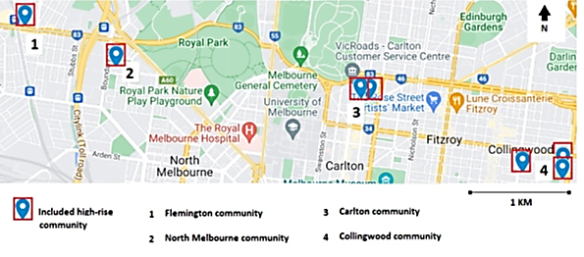
Supplementary Figure 2. Locations of the high rise estates included in this evaluation, Melbourne, Victoria, Australia

