Supplementary material
Influence of climate variability on change in storage of overexploited aquifers in a semi-arid region
Juan Manuel Navarro Céspedes ^{a,b}, Jesús Horacio Hernández Anguiano ^{c,*}, Pedro Camilo Alcántara Concepción ^{c}, Christian Dominguez Sarmiento ^{d}, Jorge Luis Morales Martínez ^{e,f}, Peter S. K. Knappett ^{g}, Miguel Angel Acosta Reyes ª, Yanmei Li ^{h}, Viridiana Piña González ª, Xiaoxiao Zha ª

ª Doctoral Program of Science and Technology of Water, University of Guanajuato, Guanajuato, Gto. 36000, Mexico
^{b} Department of Mathematics, Universidad Central “Marta Abreu” de las Villas, Santa Clara, Villa Clara, 54830, Cuba
^{c} Department of Geomatics and Hydraulics Engineering, University of Guanajuato, Guanajuato, Gto. 36000, México
^{d} Instituto de Ciencias de la Atmósfera y Cambio Climático, Universidad Nacional Autónoma de México, México City, 04510, México
^{e} Department of Civil Engineering, University of Guanajuato, Guanajuato, Gto. 36000, México
^{f} Universidad Virtual del Estado de Guanajuato. Purísima de Bustos, Gto. 36400, México
^{g} Department of Geology and Geophysics, Texas A&M University, College Station, TX, 778432, United States
^{h} Department of Mining, Metallurgy and Geology, University of Guanajuato, Guanajuato, Gto. 36020, México

* Corresponding author
E-mail addresses:
jm.navarrocespedes@ugto.mx (Juan Manuel Navarro Céspedes), https://orcid.org/0000-0001-5420-4509
horacio.hernandez@ugto.mx (Jesús Horacio Hernández Anguiano), https://orcid.org/0000-0001-5433-0986
camilo.alcantara@ugto.mx (Pedro Camilo Alcántara Concepción),
dosach@atmosfera.unam.mx (Christian Dominguez Sarmiento), https://orcid.org/0000-0002-2787-052X
jorge.morales@cimat.mx (Jorge Luis Morales Martinez), https://orcid.org/0000-0002-8327-6699
mukta@geo.tamu.edu (Peter S.K. Knappett),
ma.acostareyes@ugto.mx (Miguel Angel Acosta Reyes),
yanmeili@ugto.mx (Yanmei Li), https://orcid.org/0000-0001-6988-6776
v.pinagonzalez@ugto.mx (Viridiana Piña González),
x.zha@ugto.mx (Xiaoxiao Zha).
Wavelet coherence analysis
The wavelet coherence (WTC) analysis closely resembles that of a traditional correlation coefficient but between two CWTs, where this method uncovers locally phase locked behavior, but the more desirable features of the WTC come at the price of being slightly less localized in time frequency space (Grinsted et al. 2004).

Climate indices vs climatological variables and EVI
Climate indices vs SPI6 analysis is showed in Fig. S1: Band 1 – 2 semesters, here the coherence relationships between these variables is intermittent in all aquifers and showed a rapid varying phase, suggesting a not clear physical relationship between these variables at this band; Band 4-8 semesters during 2008 - 2012, here the in-phase coherence relations are present in all indices for all aquifers, this suggest that when ONI-PNA-CAR signals are combined then a significative positive correlation appears with the occurrence of strong droughts and wet periods with a frequency of 2 – 4 years.

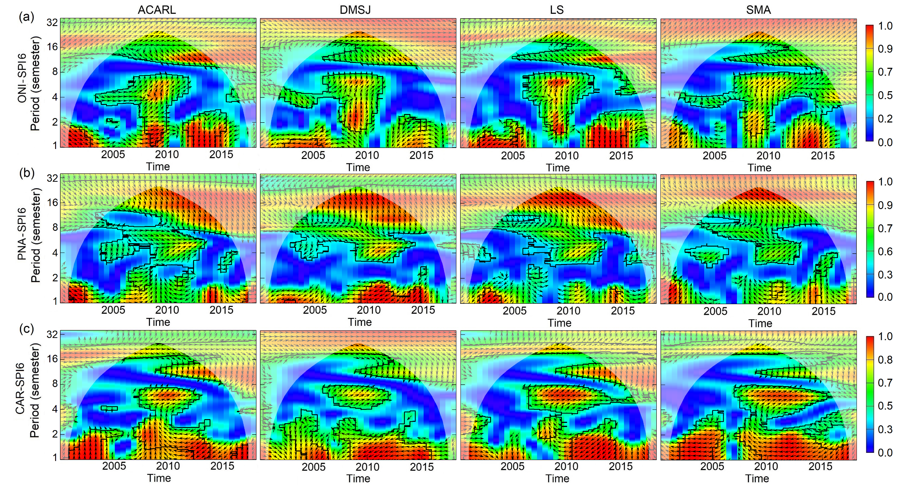
Fig. S1 Wavelet coherence between (a) ONI, (b) PNA, (c) CAR and SPI6 from 2000 to 2017 in aquifers of CARL. The cone of influence excludes areas of edge effects. Black contour lines indicate 95% confidence intervals. Arrows indicate the leading/lagging time series.

ONI vs PP Fig. S2a: here the in-phase coherence relations are dominant at intermittent highest power with intra-annual to inter-annual scales (0.5-1 years; 2-4 years, and 4-8 years). But it is important to note that in XWT analysis these periodicities were not significative.
PNA vs PP Fig. S2b: here the in-phase coherence relations are dominant with highest power at band of 1-2 semesters and intermittent periodicities at 4-8 semesters, with a dominant transition phase (-$π$/2) at periodicities of 8-16 semesters.
CAR vs PP Fig. S2c: here the rapid varying phase lag, with intermittent periodicities at band 1-2 semesters, suggest that the physical relationship between these variables at this band is not clear, except for the band 4-8 semesters during 2008 – 2012 where in-phase coherence relations are significative.

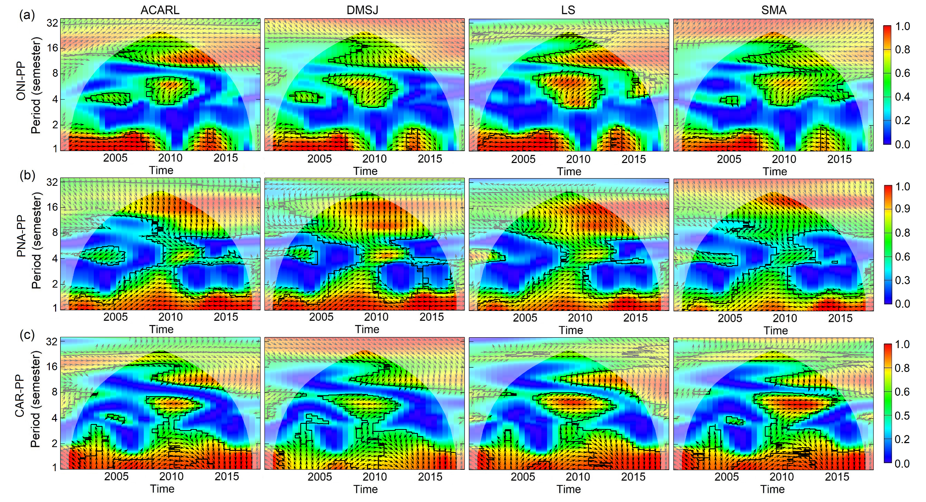
Fig. S2 Wavelet coherence between (a) ONI, (b) PNA, (c) CAR and precipitation (PP) from 2000 to 2017 in aquifers of CARL. The cone of influence excludes areas of edge effects. Black contour lines indicate 95% confidence intervals. Arrows indicate the leading/lagging time series.

In the WTC spectra of climate indices vs Max_Temp, figure not included, from the analysis is possible to mention that relationships between these variables are mostly in anti-phase with intermittent periodicities at 1-2 semesters band. Nevertheless, the rapidly varying phase lag suggest that the physical relationship between these variables is unclear, except for the band of 4-8 semesters during 2008 – 2012 where out-phase coherence relations are present on all indices for all aquifers, it suggest a negative correlation during 2008-2012 between climate indices and the maximum temperature in all aquifers.
The results of the WTC between climate indices and EVI and the results of the WTC between climate indices and minimum temperature do not differ from the results of the WTC between climate indices and PP. That is why these results were not presented.

Precipitation vs groundwater change in storage
An important assumption of this research is that precipitation has an important indirect influence over the groundwater change in storage through irrigation from agriculture, and it is supported by the results showed in Fig. S3, where in-phase coherence relations are dominant at band of 1-2 semesters between PP and ΔGS. However, this assumption is not supported in Fig. S3 for ACARL aquifer at inter-annual scale, where the rapidly varying phase lag and the intermittency of significant coherence power suggest that the link between PP and ΔGS is unclear. Although, the presence of the Sierra of Guanajuato in ACARL, which generates a higher rainfall regime and an important source of lateral recharge in ACARL, seems to be a factor of greater relevance in the evolution ΔGS than groundwater extraction for irrigation.

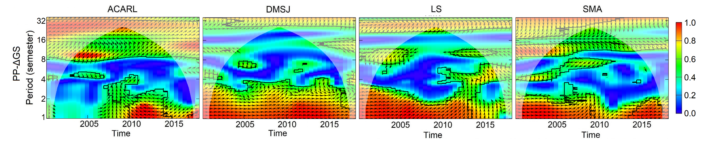
Fig. S3 Wavelet coherence between precipitation (PP) and groundwater change in storage (ΔGS) from 2000 to 2017 in aquifers of CARL. The cone of influence excludes areas of edge effects. Black contour lines indicate 95% confidence intervals. Arrows indicate the leading/lagging time series.

Spearman’s rank correlation
Spearman's correlation analysis between climate indices and the variables SPI6, PP, Max_Temp, Min_Temp, EVI and ΔGS confirms some of the cross-wavelet analysis results (see Table S1). Where, PNA index is in good agreement with the climate variability in high and low frequency oscillations. There is a significant relationship $(p<0.05)$ between the SPI6 index and climate indices ONI-PNA-CAR in all aquifers (except PNA in SMA aquifer). Precipitation is representative of the variables EVI and Min_Temp, so these can be omitted in a frequency analysis. CAR index has significative influence over the Max_Temp, suggesting it could be related with an increase of humidity in the region of analysis principally at intra-annual scales.
Table S1 Spearman’s correlation coefficients between SPI6, precipitation (PP), maximum and minimum temperature (Max_Temp, Min_Temp), EVI, ΔGS and climate indices in aquifers of CARL. Significant coefficients are highlighted in bold. Values in parenthesis indicate the lag time in semester
Aquifer | Variable | ONI | PNA | CAR
ACARL | SPI6 | 0.51(1); -0.34(15);  -0.46(16) | 0.63(10) | 0.37(1)
ACARL | PP | -0.16(16) | 0.39(10) | -0.17(5)
ACARL | Max_Temp | 0.40(14) | 0.37(2) | -0.37(16)
ACARL | Min_Temp | -0.13(9) | -0.40(3); 0.37(10); -0.33(13) | -0.29(15)
ACARL | EVI | 0.18(4) | -0.38(5) | 0.23(10)
ACARL | ΔGS | -0.24(16) | 0.37(1) | -0.22(8)
DMSJ | SPI6 | 0.56(1); -0.34(6) | -0.48(2) | 0.46(1)
DMSJ | PP | 0.16(1) | -0.35(3); -0.37(5); -0.34(7); 0.39(10) | -0.19(5)
DMSJ | Max_Temp | 0.36(3) | 0.36(2); 0.38(14) | 0.44(2); 0.43(14); 0.49(15)
DMSJ | Min_Temp | 0.28(2) | -0.34(3); -0.37(5); -0.40 (7); 0.33(10); 0.37(14) | 0.24(2)
DMSJ | EVI | -0.17(7) | -0.39(5); 0.34(10) | 0.22(2)
DMSJ | ΔGS | 0.18(7) | 0.32 (6) | -0.20(5)
LS | SPI6 | 0.56(1); -0.40(15); -0.49(16) | 0.33 (10) | 0.40(1)
LS | PP | -0.20(16) | -0.34(3); -0.36(5); 0.40(10) | -0.18(5)
LS | Max_Temp | 0.31(3) | 0.44 (14) | 0.48(14); 0.44(15)
LS | Min_Temp | 0.22(2) | -0.37(3); 0.33(5); -0.37(7); 0.37(10); 0.40(14) | 0.17(10)
LS | EVI | 0.16(2) | -0.38(5) | 0.22(8)
LS | ΔGS | -0.24(10) | -0.32(9) | -0.30(10)
SMA | SPI6 | 0.52 (1); -0.40 (15); -0.49(16) | -0.216(6) | 0.46(1); -0.35(14)
SMA | PP | -0.21(9) | -0.35(5); 0.36(10) | -0.18(13)
SMA | Max_Temp | 0.31(3) | 0.42(2); 0.33(11); 0.40(14) | 0.40(2); 0.45(12); 0.48(13); 0.50(14); 0.44(15)
SMA | Min_Temp | 0.24(2) | 0.33(2); -0.33(3); -0.33(7); 0.41(14) | 0.24(2)
SMA | EVI | -0.18(7) | -0.42(5) | -0.17(5)
SMA | ΔGS | 0.28(16) | -0.28(13) | -0.32(13)

REFERENCES
Grinsted A, Moore JC, Jevrejeva S (2004) Application of the cross wavelet transform and wavelet coherence to geophysical time series. Nonlinear processes in geophysics 11(5/6): 561-566. https://doi.org/10.5194/npg-11-561-2004

