A facile synthesis of bridged polycyclic compounds consisting of chromeno-oxazocine-quinolin skeletons:
Eight-Membered-Ring constructions via tandem dinucleophilic addition of 4-hydroxycoumarin to 1,10-phenanthrolin-1-ium Salts
Mohammad Hosein Sayahi,¹* Ahmad Habbibi,² Ali Moazzam,³ Samanesadat Hosseini,⁴ Bagher Larijani,³ Mehdi Adib,² Saeed Bahadorikhalili⁵, Mohammad Mahdavi³*
¹ Department of Chemistry, Payame Noor University, Tehran, Iran
² School of Chemistry, College of Science, University of Tehran, PO Box 14155-6455, Tehran, Iran.
³ Endocrinology and Metabolism Research Center, Endocrinology and Metabolism Clinical Sciences Institute, Tehran University of Medical Sciences, Tehran, Iran.
⁴ Shahid Beheshti University of Medical Sciences, Tehran, Iran
⁵ Department of Electronic Engineering, Universitat Rovira I Virgili, 43007, Tarragona, Spain
Corresponding author: sayahymh@pnu.ac.ir (M.H. Sayahi), momahdavi@sina.tums.ac.ir (M. Mahdavi)

rac-16-benzyl-15,16-dihydro-7H,8H-7,15-methanochromeno[3',4':7,8][1,3]oxazocino[5,4-h]quinolin-8-one (4a)
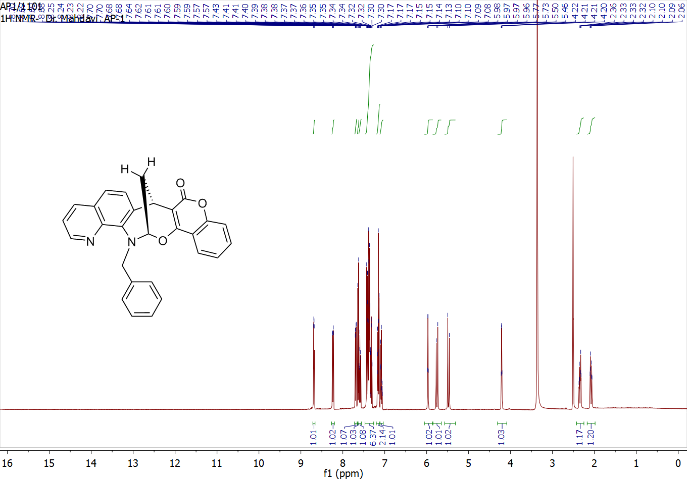
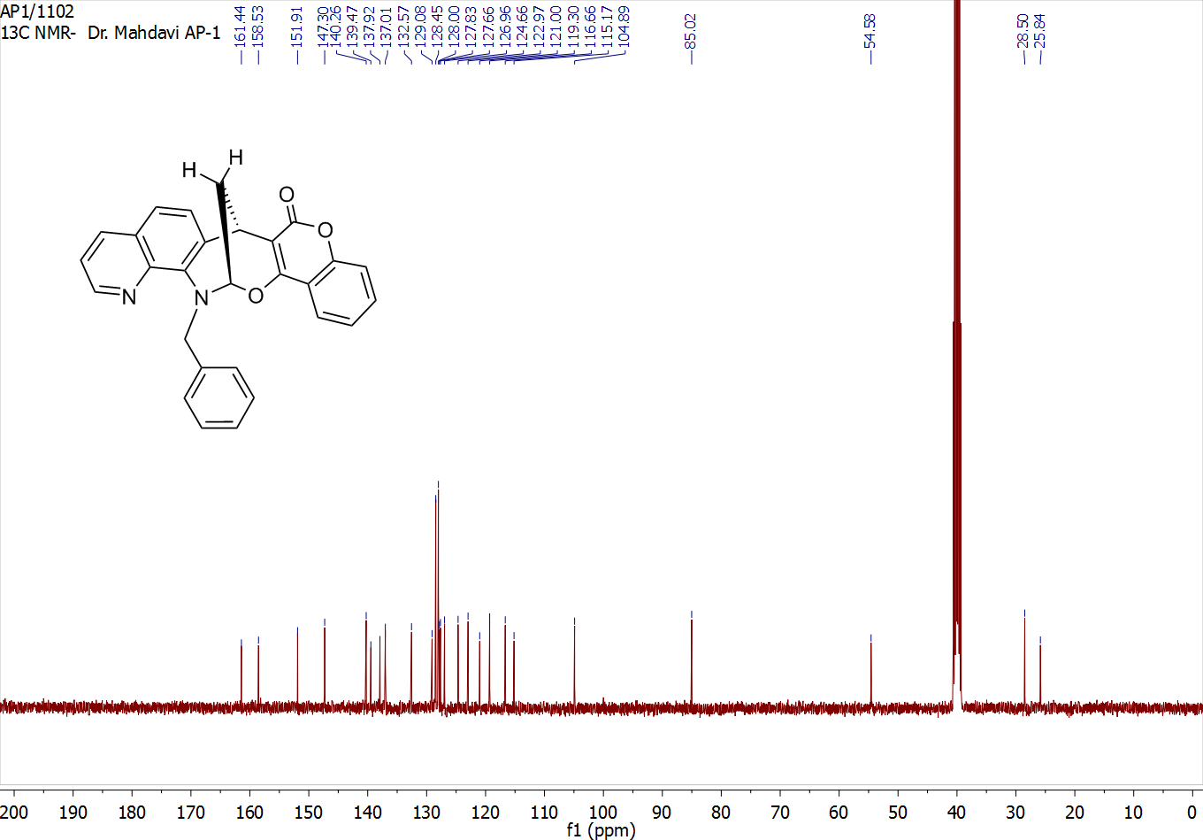

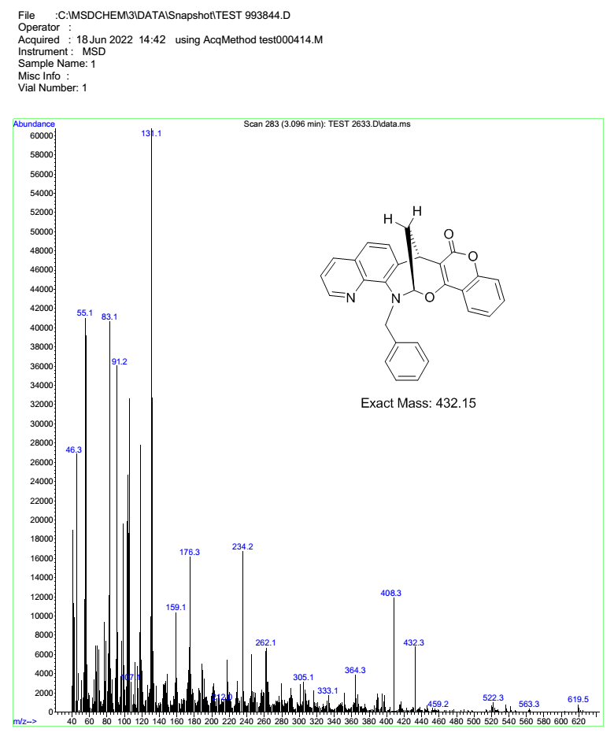

rac-16-(4-bromobenzyl)-15,16-dihydro-7H,8H-7,15-methanochromeno[3',4':7,8][1,3]oxazocino[5,4-h]quinolin-8-one (4b)
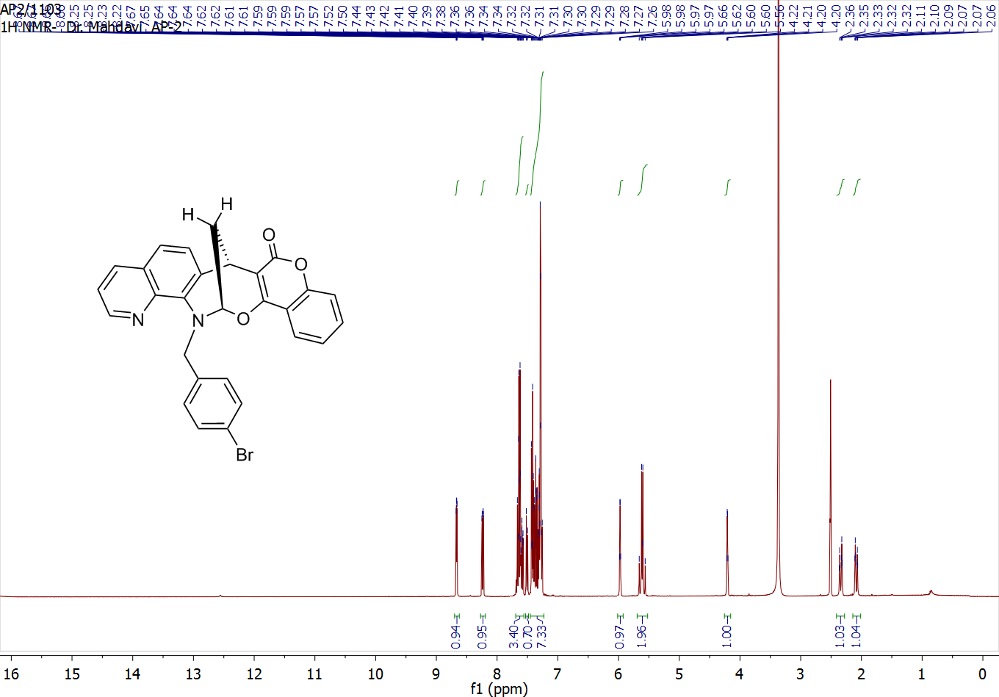
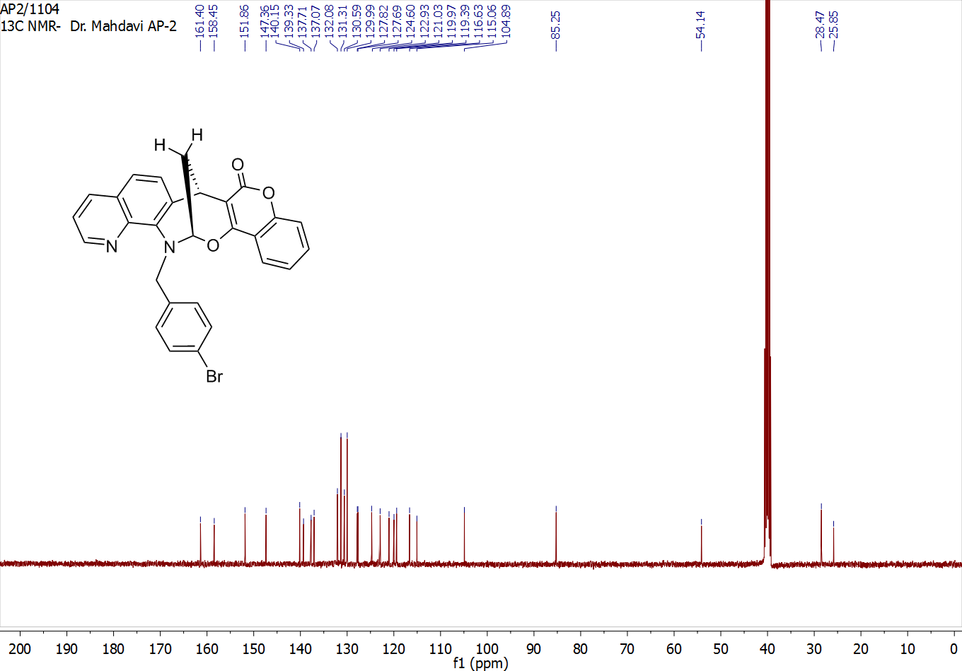
rac-16-(4-chlorobenzyl)-15,16-dihydro-7H,8H-7,15-methanochromeno[3',4':7,8][1,3]oxazocino[5,4-h]quinolin-8-one (4c)
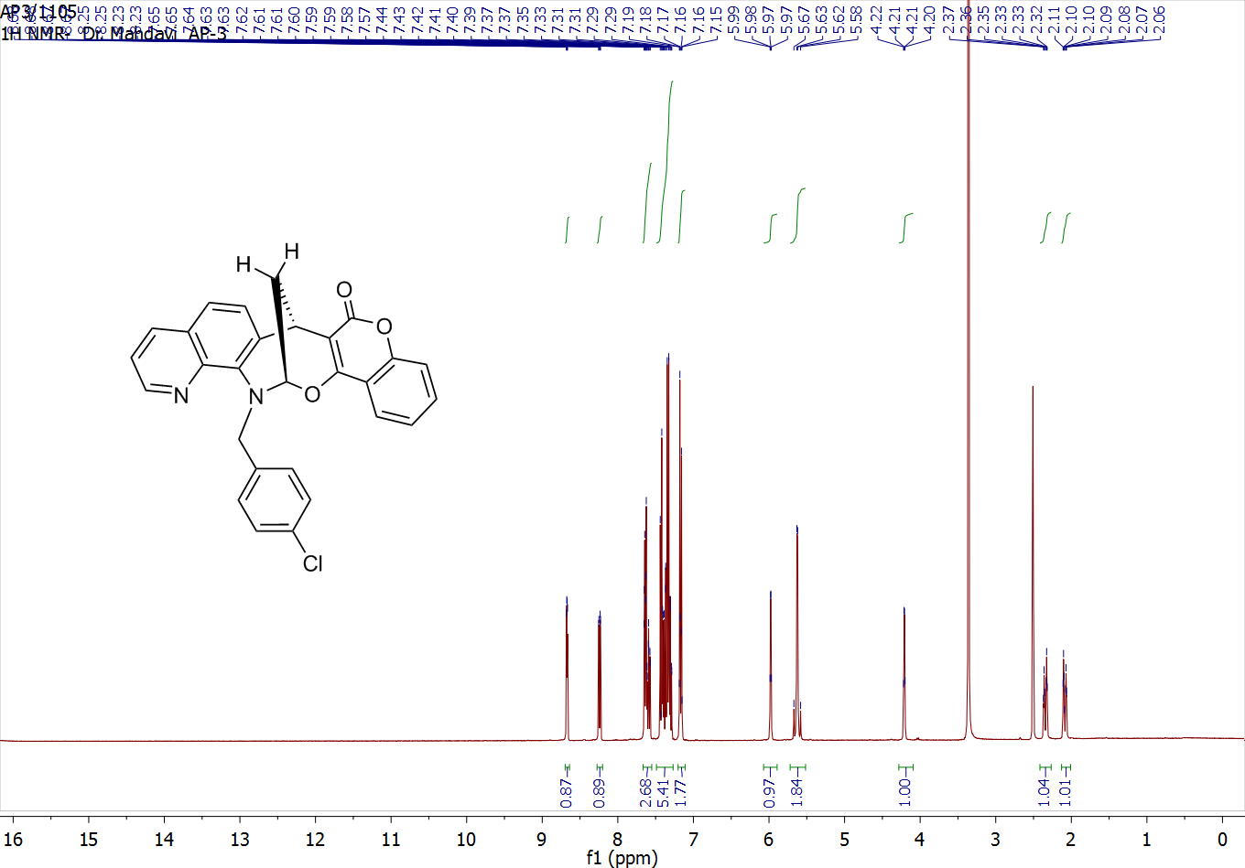
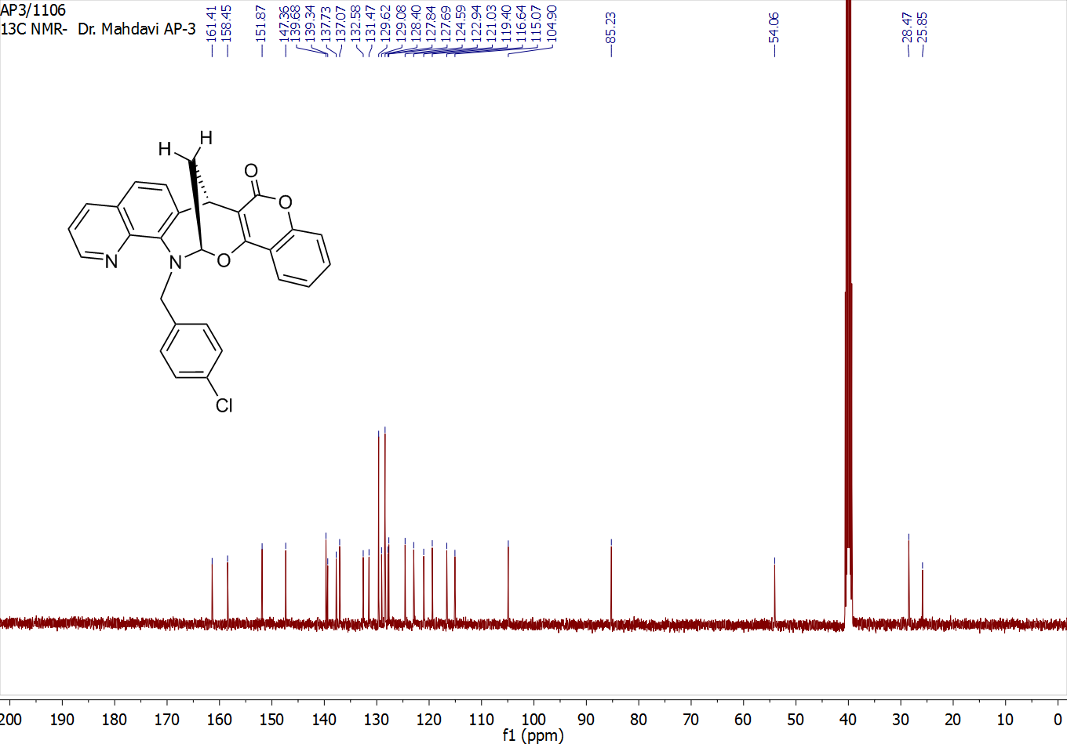
rac-16-(3-chlorobenzyl)-15,16-dihydro-7H,8H-7,15-methanochromeno[3',4':7,8][1,3]oxazocino[5,4-h]quinolin-8-one (4d)
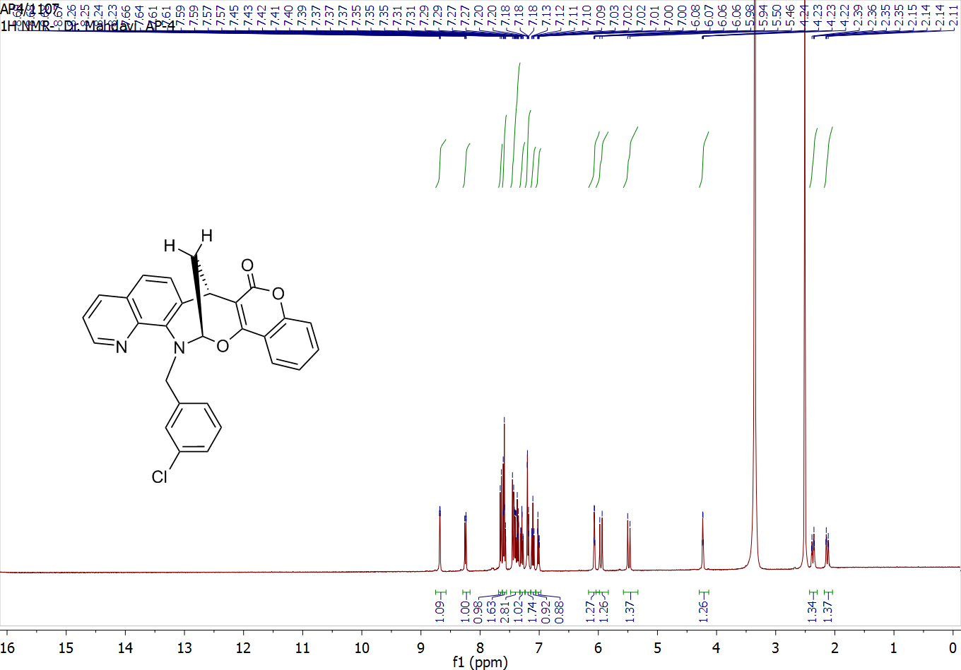
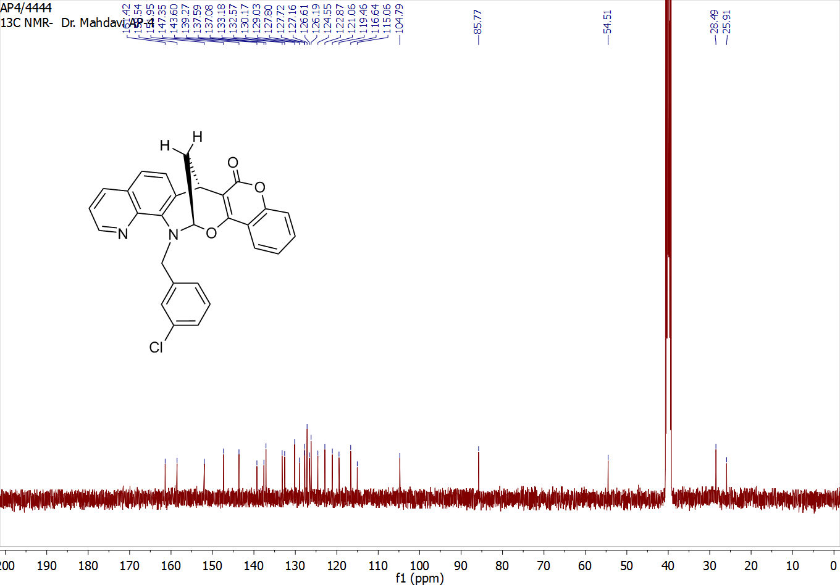
rac-16-(2-bromobenzyl)-15,16-dihydro-7H,8H-7,15-methanochromeno[3',4':7,8][1,3]oxazocino[5,4-h]quinolin-8-one (4e)
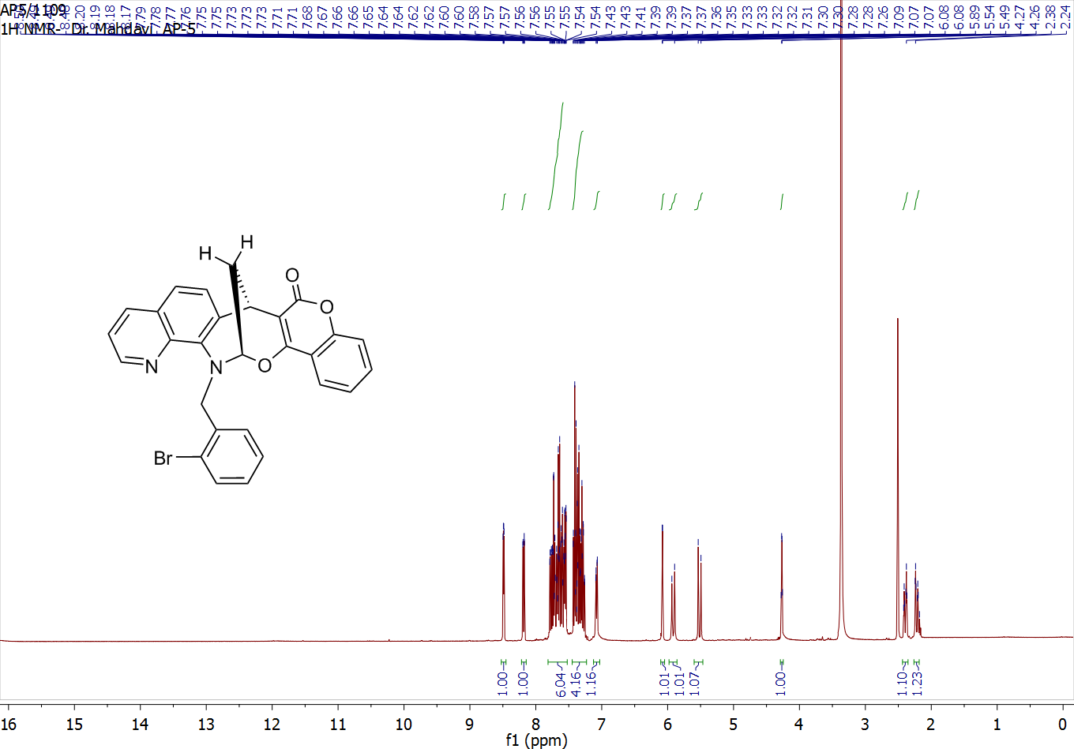
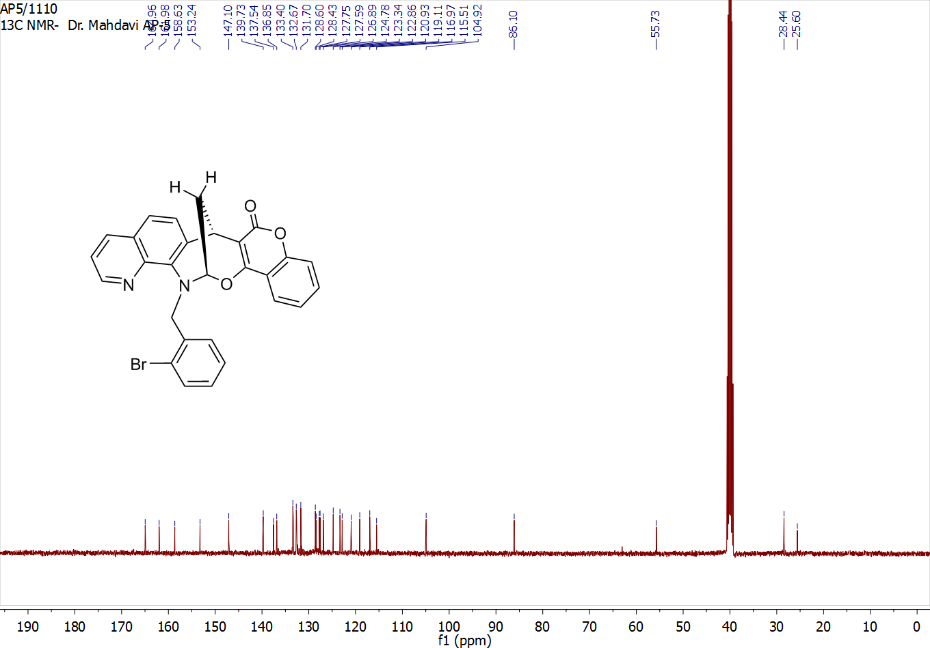
rac-16-(2-chlorobenzyl)-15,16-dihydro-7H,8H-7,15-methanochromeno[3',4':7,8][1,3]oxazocino[5,4-h]quinolin-8-one (4f)
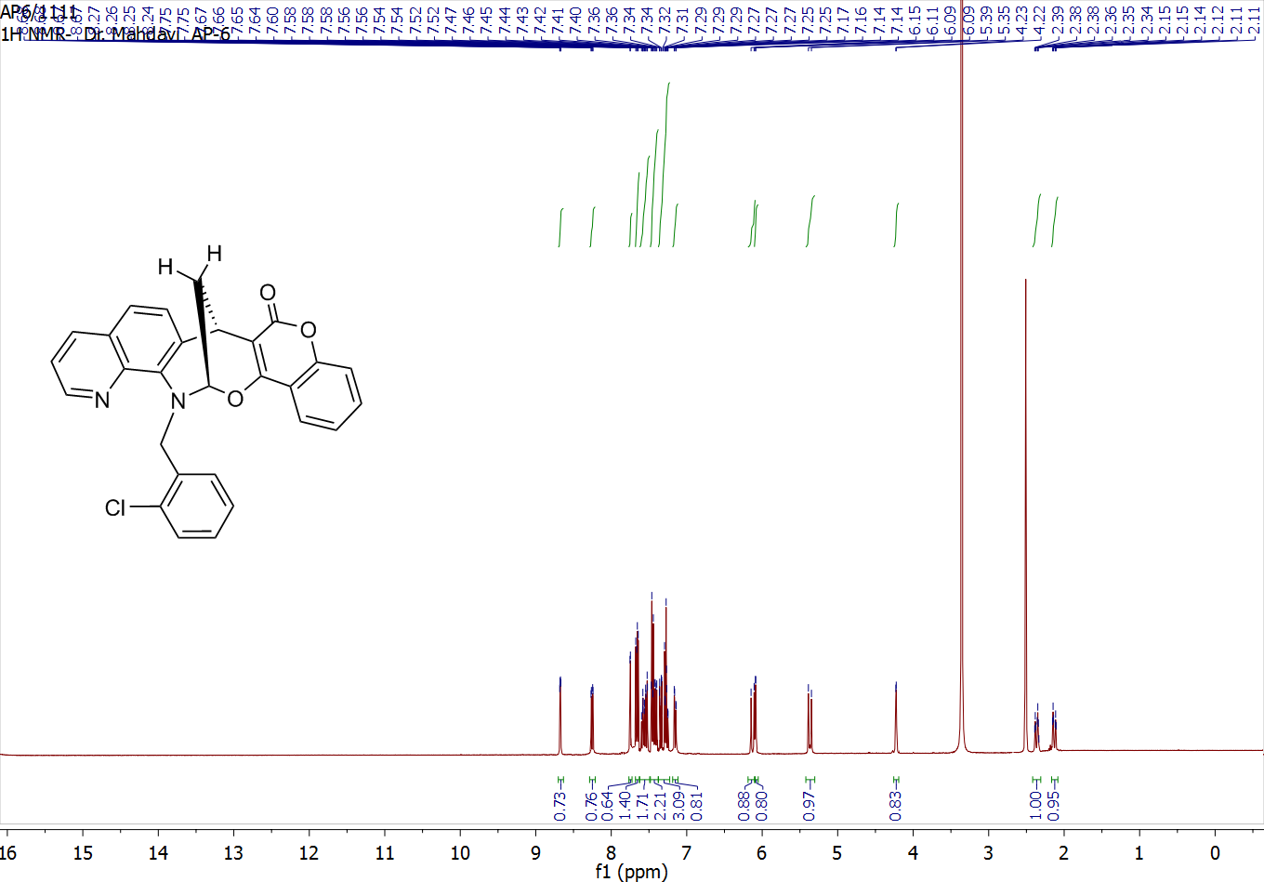
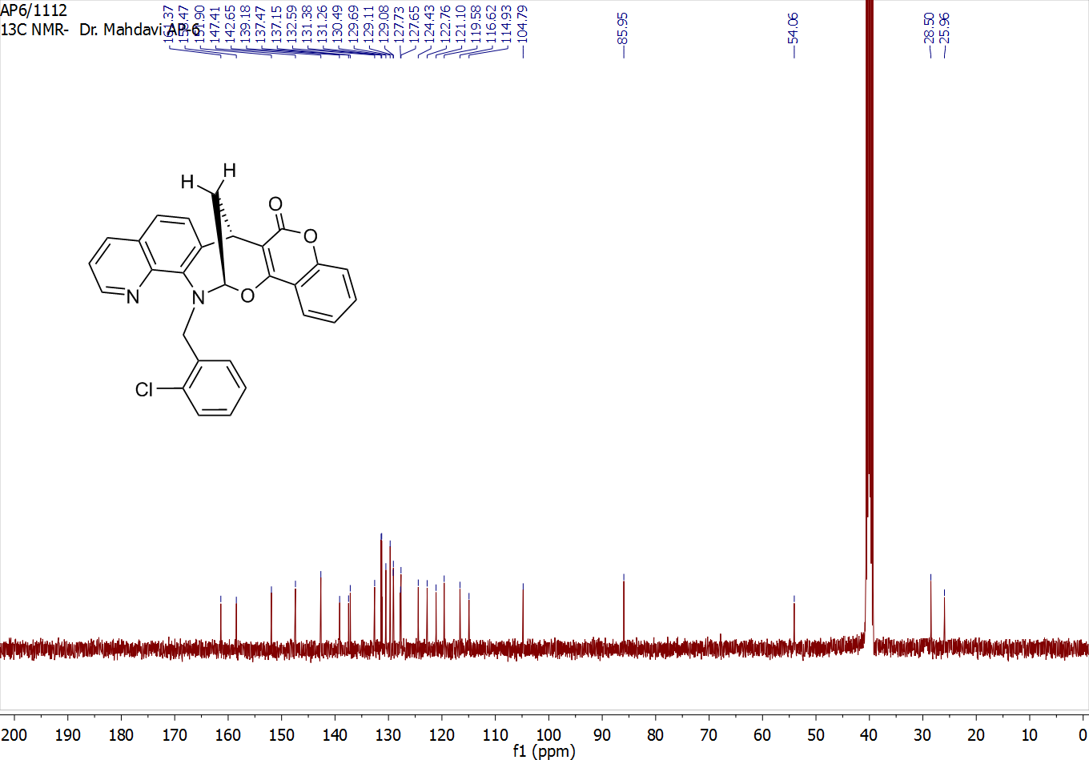
rac-16-(2,3-dichlorobenzyl)-15,16-dihydro-7H,8H-7,15-methanochromeno[3',4':7,8][1,3]oxazocino[5,4-h]quinolin-8-one (4g)
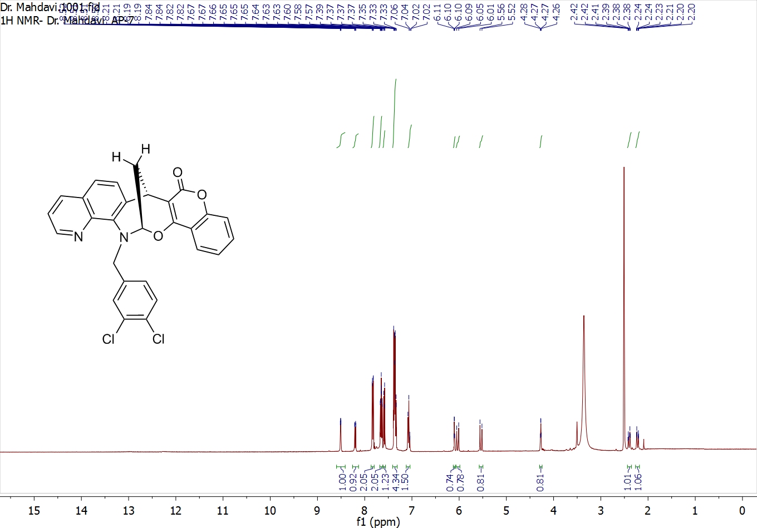
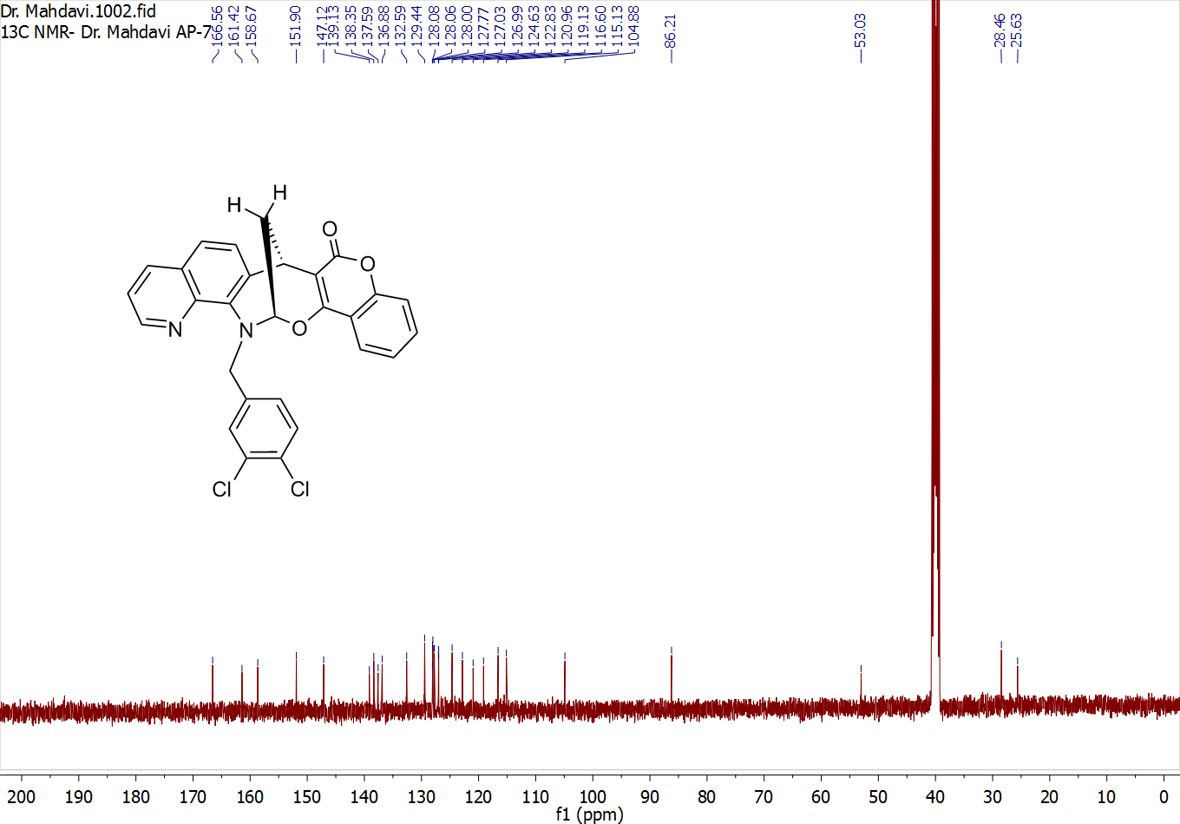
rac-16-(4-fluorobenzyl)-15,16-dihydro-7H,8H-7,15-methanochromeno[3',4':7,8][1,3]oxazocino[5,4-h]quinolin-8-one (4h)
