Supplementary files

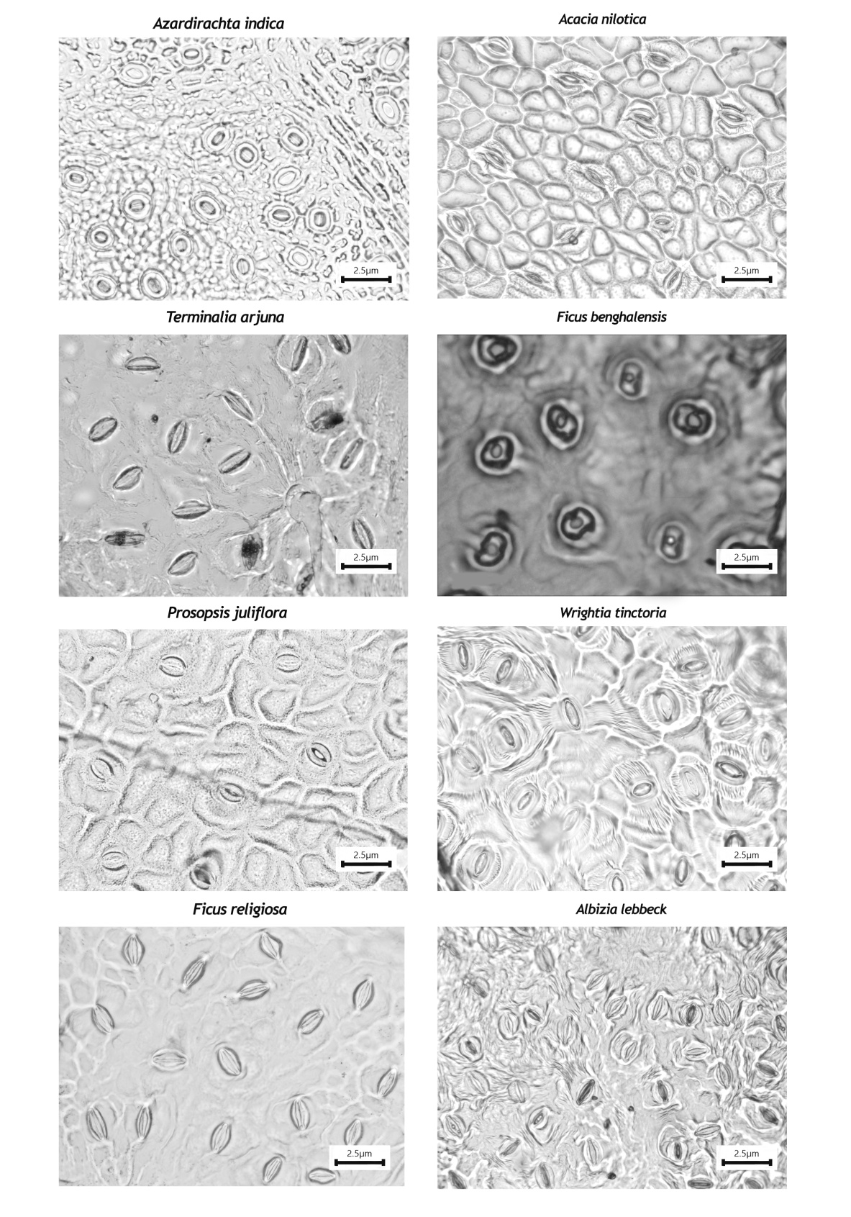
Fig. S 1 | Stomatal micrographs (40 x magnification) of selected eight tree species depicting the stomatal morphology and density

Construction of Structural Equation Model
A conceptual meat model (Fig S1) was constructed all the using 11 experimental variables (pn: Photosynthesis, sd: Stomatal Density, GS: Stomatal Conductance, Temp: Temperature, intraco2: Leaf Intracellular CO2, Amco2: Ambient Carbon Dioxide, sm: Soil moisture, sn: Soil nitrogen, rubisco: Ribulose-1,5-bisphosphate carboxylase/oxygenase, chla: Total Chlorophyll, toc: Total Organic Carbon). It was hypothesized that exogenous variables does influence the endogenous variable. The rationale behind each hypothesized path between the endogenous and exogenous variable are briefed in Table S1. SEMs for selected species was fitted using the lavaan package (Rosseel, 2012). Significance and goodness of fit of the SEMs were tested using multiple model fit validation indices: i) the robust model chi-square (χ2) with a non-significant p-value (p > 0.05) indicating that the model-implied covariance matrix equals the observed covariance matrix, ii) Comparative Fit Index (CFI), (best fit at CFI > 0.95), iii) Robust root Mean Square Error of Approximation (RMSEA) (best fit at RMSEA < 0.05), and iv) Standardized Root Mean squared Residual (SRMR) (best fit at SRMR < 0.08). The model with the complete best fit was arrived for tree species. Each path in the final model was assessed for standardized coefficients, significant contribution, and explained variance (R2) per response variable were calculated.

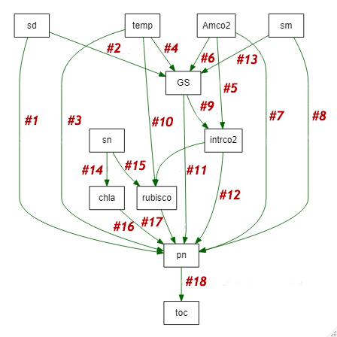
pn: Photosynthesis, sd: Stomatal Density, GS: Stomatal Conductance, Temp: Temperature, intraco2: Leaf Intracellular CO2, Amco2: Ambient Carbon Dioxide, sm: Soil moisture, sn: Soil nitrogen, rubisco: Ribulose-1,5-bisphosphate carboxylase/oxygenase, chla: Total Chlorophyll, toc: Total Organic Carbon.
Fig S 2. | Meta Model - the rationale behind each path of carbon fixing functional trait is given in Table. S 1

Path  # | Pathway | Described underlying mechanism behind hypothesized relationship | Reference
1 | pn ~ sd | Photosynthesis increase with stomatal density | (Xu and Zhou, 2008)
2 | GS ~ sd | Stomatal conductance increased with Stomatal density | (Xu and Zhou, 2008)
3 | pn ~ temp | Photosynthesis ceases with increase in temperature | (Li et al., 2023)
4 | GS ~ temp | Stomatal conductance increases against temperature | (Feng et al., 2023)
5 | intraco2 ~  Amco2 | Significant increase in Ambient CO2 caused increase in intracellular CO2 | (Grunstra and Van Auken, 2023)
6 | GS ~ Amco2 | Increasing Ambient CO2 drastically increase stomatal conductance | (De Souza, 2023)
7 | pn ~ Amco2 | Current trends (2023) Ambient CO2 does enhance photosynthesis | (Yang et al., 2023)
8 | pn ~sm | High Soil moisture leads to increase in Photosynthesis rate | (Yu et al., 2023)
9 | intraco2 ~ GS | Higher stomatal conductance leads increased intracellular co2 levels | (De Souza, 2023)
10 | rubisco ~  temp | Increased temperature delimits rubisco | (Scafaro et al., 2023)
11 | pn ~ GS | Photosynthesis increase with stomatal conductance | (Qi et al., 2023)
12 | pn ~ intraco2 | Increase in intracellular co2 rises photosynthesis | (Jahan et al., 2023)
13 | GS ~ sm | A linear relation was observed between Stomatal conductance and soil moisture | (Qi et al., 2023)
14 | chla ~ sn | Leaf chlorophyll increase with soil nitrogen content | (WU et al., 2023)
15 | rubisco ~ sn | Soil nitrogen significantly correlated with rubisco | (X.-Q. Wang et al., 2023)
16 | pn ~ chla | Chlorophyll and photosynthesis are positively corellated | (Mao et al., 2023)
17 | pn ~ rubisco | RuBisCO and photosynthesis are positively correlated | (Qu et al., 2023)
18 | toc ~ pn | Total organic carbon increases with an increase in Photosynthesis | (Y. Wang et al., 2023)

Table S 1 | Rationale behind each hypothesized path in the Meta model Path

Model validation for the selected tree species
- Azardirachta indica

Model Test User Model:

Test statistic 3.112
Degrees of freedom 26
P-value (Chi-square) 0.015

Model Test Baseline Model:

Test statistic 58.086
Degrees of freedom 45
P-value 0.091

User Model versus Baseline Model:

Comparative Fit Index (CFI) 0.957
Tucker-Lewis Index (TLI) 0.959

Root Mean Square Error of Approximation:

RMSEA 0.074
90 Percent confidence interval - lower 0.000
90 Percent confidence interval - upper 0.142
P-value H_0: RMSEA <= 0.050 0.291
P-value H_0: RMSEA >= 0.080 0.082

Standardized Root Mean Square Residual:

SRMR 0.077

Parameter Estimates:

Standard errors Standard
Information Expected
Information saturated (h1) model Structured

Regressions:
Estimate Std.Err z-value P(>|z|) Std.lv Std.all
chla ~
sn 0.067 0.003 2.510 0.029 -0.027 -0.210
rubisco ~
sn 0.015 0.002 0.044 0.965 0.000 0.006
pn ~
sd -0.013 0.002 1.741 0.082 0.003 0.227
rubisco 0.465 0.253 -1.920 0.055 -0.485 -0.263
chla 0.683 0.286 -0.464 0.642 -0.133 -0.060
temp 0.077 0.476 1.695 0.090 0.807 0.760
intraco2 -0.054 0.007 -0.653 0.513 -0.004 -0.093
sm 0.275 0.420 0.440 0.660 0.185 0.259
Amco2 -0.032 0.086 0.691 0.490 0.060 0.485
GS ~
Amco2 0.070 0.005 0.863 0.388 0.004 0.647
intrco2 ~
Amco2 -0.018 0.364 -1.019 0.308 -0.371 -0.138
rubisco ~
temp 0.015 0.077 0.053 0.958 0.004 0.007
intrco2 -0.022 0.003 -2.653 0.008 -0.009 -0.353
toc ~
pn 0.738 0.653 0.264 0.792 0.173 0.037
GS ~
temp 0.109 0.027 -0.344 0.731 -0.009 -0.166
sd 0.211 0.000 0.144 0.885 0.000 0.020
pn ~
GS 2.861 2.626 0.967 0.334 2.538 0.132
GS ~
sm -0.015 0.023 -1.084 0.279 -0.025 -0.680
intrco2 ~
GS 3.963 56.556 2.192 0.028 23.963 0.298

Variances:
Estimate Std.Err z-value P(>|z|) Std.lv Std.all
.chla 0.255 0.051 5.000 0.000 0.255 0.956
.rubisco 0.339 0.068 5.000 0.000 0.339 0.876
.pn 1.081 0.216 5.000 0.000 1.081 0.820
.GS 0.003 0.001 5.000 0.000 0.003 0.955
.intrco2 382.105 2.421 5.000 0.000 2.105 0.904
.toc 8.081 5.616 5.000 0.000 8.081 0.999

R-Square:
Estimate
chla 0.644
rubisco 0.424
pn 0.280
GS 0.445
intrco2 0.096
toc 0.441

- Albizia Lebbeck

Model Test User Model:

Test statistic 17.393
Degrees of freedom 26
P-value (Chi-square) 0.897

Model Test Baseline Model:

Test statistic 52.240
Degrees of freedom 45
P-value 0.213

User Model versus Baseline Model:

Comparative Fit Index (CFI) 1.000
Tucker-Lewis Index (TLI) 3.058

Root Mean Square Error of Approximation:

RMSEA 0.000
90 Percent confidence interval - lower 0.000
90 Percent confidence interval - upper 0.050
P-value H_0: RMSEA <= 0.050 0.949
P-value H_0: RMSEA >= 0.080 0.015

Standardized Root Mean Square Residual:

SRMR 0.057

Parameter Estimates:

Standard errors Standard
Information Expected
Information saturated (h1) model Structured

Regressions:
Estimate Std.Err z-value P(>|z|) Std.lv Std.all
chla ~
sn 0.139 0.006 -1.650 0.099 -0.009 -0.227
rubisco ~
sn 0.090 0.006 -1.594 0.111 -0.010 -0.218
pn ~
sd -0.980 0.003 -0.060 0.952 -0.000 -0.007
rubisco 0.192 0.137 1.401 0.161 0.192 0.168
chla 0.239 0.147 1.627 0.104 0.239 0.192
temp 0.197 0.086 2.301 0.021 0.197 0.277
intraco2 -2.990 0.004 -0.032 0.975 -0.000 -0.004
sm 0.609 0.256 -2.379 0.017 -0.609 -1.275
Amco2 0.127 0.044 2.883 0.004 0.127 1.542
GS ~
Amco2 0.060 0.001 0.243 0.808 0.000 0.147
intraco2 ~
Amco2 0.552 0.338 1.634 0.102 0.552 0.231
rubisco ~
temp 0.041 0.085 0.479 0.632 0.041 0.066
intraco2 0.055 0.004 1.143 0.253 0.005 0.155
toc ~
pn 0.973 0.562 1.571 0.116 0.883 0.217
GS ~
temp 0.124 0.003 1.454 0.146 0.004 0.195
sd 0.620 0.000 0.149 0.882 0.000 0.020
pn ~
GS 8.270 4.633 1.785 0.074 8.270 0.222
GS ~
sm 0.010 0.008 0.659 0.510 0.005 0.400
intraco2 ~
GS 3.660 1.063 0.738 0.461 0.540 0.104

Variances:
Estimate Std.Err z-value P(>|z|) Std.lv Std.all
.chla 0.360 0.072 5.000 0.000 0.360 0.948
.rubisco 0.415 0.083 5.000 0.000 0.415 0.921
.pn 0.407 0.081 5.000 0.000 0.407 0.689
.GS 0.000 0.000 5.000 0.000 0.000 0.899
.intraco2 408.888 93.778 5.000 0.000 408.888 0.947
.toc 9.333 1.867 5.000 0.000 9.333 0.953

R-Square:
Estimate
chla 0.252
rubisco 0.179
pn 0.311
GS 0.101
intraco2 0.053
toc 0.747

- Ficus Benghalensis

Model Test User Model:

Test statistic 6.437
Degrees of freedom 26
P-value (Chi-square) 0.439

Model Test Baseline Model:

Test statistic 41.903
Degrees of freedom 45
P-value 0.604

User Model versus Baseline Model:

Comparative Fit Index (CFI) 0.970
Tucker-Lewis Index (TLI) 0.944

Root Mean Square Error of Approximation:

RMSEA 0.018
90 Percent confidence interval - lower 0.000
90 Percent confidence interval - upper 0.114
P-value RMSEA <= 0.05 0.011

Standardized Root Mean Square Residual:

SRMR 0.077

Parameter Estimates:

Standard errors Standard
Information Expected
Information saturated (h1) model Structured

Regressions:
Estimate Std.Err z-value P(>|z|) Std.lv Std.all
chla ~
sn 0.093 0.005 -0.679 0.007 -0.003 -0.096
rubisco ~
sn 0.062 0.010 -0.161 0.002 -0.002 -0.023
pn ~
sd -0.015 0.001 -0.996 0.009 -0.001 -0.132
rubisco 0.261 0.142 -1.837 0.006 -0.261 -0.228
chla 0.021 0.276 0.066 0.007 0.018 0.008
temp 0.332 0.140 2.363 0.008 0.332 0.309
intraco2 -0.014 0.005 0.806 0.000 0.004 0.100
sm 0.147 0.411 -0.357 0.001 -0.147 -0.204
Amco2 0.034 0.071 0.473 0.006 0.034 0.270
GS ~
Amco2 0.011 0.001 -1.167 0.003 -0.001 -0.721
intraco2 ~
Amco2 -0.143 0.442 -0.324 0.006 -0.143 -0.046
rubisco ~
temp -0.016 0.134 -0.044 0.005 -0.006 -0.006
intraco2 0.080 0.005 -0.029 0.007 -0.000 -0.004
toc ~
pn 0.372 0.568 0.250 0.002 0.142 0.035
GS ~
temp 0.022 0.002 0.793 0.008 0.002 0.113
sd 0.010 0.000 0.994 0.000 0.000 0.143
pn ~
GS 1.524 8.156 1.981 0.048 6.154 0.256
GS ~
sm 0.010 0.007 1.193 0.003 0.008 0.735
intraco2 ~
GS 7.124 4.316 -0.138 0.040 0.944 -0.019

Variances:
Estimate Std.Err z-value P(>|z|) Std.lv Std.all
.chla 0.269 0.054 5.000 0.000 0.269 0.991
.rubisco 1.029 0.206 5.000 0.000 1.029 0.999
.pn 1.035 0.207 5.000 0.000 1.035 0.770
.GS 0.000 0.000 5.000 0.000 0.000 0.925
.intraco2 446.251 169.250 5.000 0.000 846.251 0.998
.toc 21.669 4.334 5.000 0.000 21.669 0.999

R-Square:
Estimate
chla 0.609
rubisco 0.101
pn 0.230
GS 0.275
intraco2 0.602
toc 0.658

- Ficus religiosa

Model Test User Model:

Test statistic 2.182
Degrees of freedom 26
P-value (Chi-square) 0.679

Model Test Baseline Model:

Test statistic 8.648
Degrees of freedom 45
P-value 0.328

User Model versus Baseline Model:

Comparative Fit Index (CFI) 0.982
Tucker-Lewis Index (TLI) 0.911

Loglikelihood and Information Criteria:

Loglikelihood user model (H0) -522.353
Loglikelihood unrestricted model (H1) -511.262

Akaike (AIC) 1094.706
Bayesian (BIC) 1142.506
Sample-size adjusted Bayesian (SABIC) 1064.036

Root Mean Square Error of Approximation:

RMSEA 0.000
90 Percent confidence interval - lower 0.000
90 Percent confidence interval - upper 0.091
P-value H_0: RMSEA <= 0.050 0.806
P-value H_0: RMSEA >= 0.080 0.079

Standardized Root Mean Square Residual:

SRMR 0.075

Parameter Estimates:

Standard errors Standard
Information Expected
Information saturated (h1) model Structured

Regressions:
Estimate Std.Err z-value P(>|z|) Std.lv Std.all
chla ~
sn 0.082 0.006 -0.364 0.016 -0.002 -0.051
rubisco ~
sn 0.061 0.006 0.406 0.085 0.002 0.058
pn ~
sd -0.061 0.003 0.251 0.002 0.001 0.031
rubisco 0.587 0.285 2.060 0.039 0.587 0.237
chla 0.396 0.254 1.557 0.019 0.396 0.179
temp 0.246 0.164 -1.497 0.034 -0.246 -0.179
intraco2 -0.093 0.003 0.943 0.046 0.003 0.110
sm 1.744 0.484 -3.606 0.000 -1.744 -1.894
Amco2 0.286 0.083 3.435 0.001 0.286 1.800
GS ~
Amco2 0.019 0.002 -0.042 0.066 -0.000 -0.026
intraco2 ~
Amco2 0.476 0.800 -0.596 0.051 -0.476 -0.083
rubisco ~
temp 0.020 0.079 0.249 0.003 0.020 0.035
intraco2 -0.051 0.002 -0.160 0.073 -0.000 -0.023
toc ~
pn 0.277 1.005 -0.275 0.083 -0.277 -0.039
GS ~
temp 1.652 0.003 -0.404 0.086 -0.001 -0.057
sd 0.112 0.000 1.537 0.024 0.000 0.221
pn ~
GS 0.131 6.724 0.816 0.014 5.488 0.098
GS ~
sm -0.121 0.010 0.156 0.076 0.002 0.098
intraco2 ~
GS 0.110 0.941 1.125 0.061 316.021 0.157

Variances:
Estimate Std.Err z-value P(>|z|) Std.lv Std.all
.chla 0.451 0.090 5.000 0.000 0.451 0.997
.rubisco 0.358 0.072 5.000 0.000 0.358 0.995
.pn 1.458 0.292 5.000 0.000 1.458 0.664
.GS 0.001 0.000 5.000 0.000 0.001 0.939
.intraco2 411.525 553.305 5.000 0.000 407.525 0.970
.toc 41.067 22.213 5.000 0.000 11.067 0.998

R-Square:
Estimate
chla 0.713
rubisco 0.205
pn 0.336
GS 0.461
intraco2 0.630
toc 0.402

- Prosopis juliflora
Model Test User Model:

Test statistic 6.512
Degrees of freedom 26
P-value (Chi-square) 0.093

Model Test Baseline Model:

Test statistic 1192.958
Degrees of freedom 45
P-value 0.000

User Model versus Baseline Model:

Comparative Fit Index (CFI) 0.960
Tucker-Lewis Index (TLI) 0.958

Root Mean Square Error of Approximation:

RMSEA 0.003
90 Percent confidence interval - lower 0.002
90 Percent confidence interval - upper 0.109
P-value RMSEA <= 0.05 0.110

Standardized Root Mean Square Residual:

SRMR 0.012

Parameter Estimates:

Standard errors Standard
Information Expected
Information saturated (h1) model Structured

Regressions:
Estimate Std.Err z-value P(>|z|) Std.lv Std.all
chla ~
sn 0.119 0.004 30.180 0.000 0.109 0.974
rubisco ~
sn 0.027 0.014 1.216 0.024 0.017 0.395
pn ~
sd 0.059 0.051 -0.947 0.043 -0.049 -0.083
rubisco 0.392 0.187 2.103 0.035 0.392 0.079
chla 0.243 0.138 1.762 0.018 0.243 0.126
temp 0.270 0.185 1.443 0.049 0.267 0.117
intraco2 0.074 0.028 -2.612 0.009 -0.074 -0.304
sm 0.198 0.146 1.283 0.000 0.188 0.122
Amco2 0.163 0.046 3.506 0.000 0.163 0.614
GS ~
Amco2 0.011 0.001 -6.583 0.000 -0.009 -0.652
intraco2 ~
Amco2 1.652 0.164 -6.131 0.000 -1.006 -0.916
rubisco ~
temp -0.349 0.115 -3.036 0.002 -0.349 -0.754
intraco2 0.026 0.014 -1.836 0.066 -0.026 -0.522
toc ~
pn 1.221 0.050 45.832 0.000 2.281 0.988
GS ~
temp 0.028 0.008 3.391 0.001 0.028 0.227
sd 0.009 0.002 -2.010 0.044 -0.005 -0.152
pn ~
GS 3.732 2.655 1.406 0.060 3.732 0.204
GS ~
sm -0.023 0.007 -3.243 0.001 -0.023 -0.273
intraco2 ~
GS 0.558 11.327 0.485 0.027 5.498 0.072

Variances:
Estimate Std.Err z-value P(>|z|) Std.lv Std.all
.chla 0.085 0.017 5.000 0.000 0.085 0.052
.rubisco 0.058 0.012 5.000 0.000 0.058 0.230
.pn 0.101 0.020 5.000 0.000 0.101 0.016
.GS 0.000 0.000 5.000 0.000 0.000 0.016
.intraco2 372.622 0.524 5.000 0.000 372.62 0.025
.toc 0.758 0.152 5.000 0.000 0.758 0.023

R-Square:
Estimate
chla 0.548
rubisco 0.370
pn 0.684
GS 0.784
intraco2 0.675
toc 0.177

- Terminalia arjuna

Model Test User Model:

Test statistic 3.512
Degrees of freedom 26
P-value (Chi-square) 0.043
siginifies model fits the data or data fits the model

Model Test Baseline Model:

Test statistic 1592.958
Degrees of freedom 43
P-value 0.000

User Model versus Baseline Model:

Comparative Fit Index (CFI) 0.950
Tucker-Lewis Index (TLI) 0.938

Root Mean Square Error of Approximation:

RMSEA 0.007
90 Percent confidence interval - lower 0.044
90 Percent confidence interval - upper 0.123
P-value RMSEA <= 0.05 0.123

Standardized Root Mean Square Residual:

SRMR 0.035

Parameter Estimates:

Standard errors Standard
Information Expected
Information saturated (h1) model Structured

Regressions:
Estimate Std.Err z-value P(>|z|) Std.lv Std.all
chla ~
sn 0.119 0.004 30.180 0.000 0.409 0.974
rubisco ~
sn 0.010 0.014 -2.216 0.014 -0.117 -0.295
pn ~
sd 0.039 0.551 -1.847 0.003 -0.049 -0.383
rubisco 0.124 0.137 3.103 0.055 0.292 0.279
chla 0.040 0.128 3.462 0.068 0.243 0.526
temp 0.340 0.285 2.423 0.049 0.467 0.517
intraco2 0.116 0.028 -2.632 0.029 -0.174 -0.104
sm 0.231 0.346 1.283 0.010 0.288 0.122
Amco2 0.094 0.546 3.506 0.000 0.163 0.614
GS ~
Amco2 0.021 0.001 -6.583 0.011 -0.009 -0.552
intraco2 ~
Amco2 1.656 0.164 -6.131 0.001 -1.306 -0.516
rubisco ~
temp 0.299 0.115 -3.036 0.001 -0.449 -0.854
intraco2 0.046 0.014 -1.836 0.056 -0.026 -0.222
toc ~
pn 0.261 0.050 45.832 0.000 2.481 0.188
GS ~
temp 0.038 0.008 3.391 0.002 0.128 0.227
sd 0.192 0.002 -2.010 0.042 -0.005 -0.152
pn ~
GS 0.321 2.655 1.406 0.032 1.132 0.204
GS ~
sm -0.081 0.007 -3.243 0.043 -0.123 -0.273
intraco2 ~
GS 5.231 11.327 0.485 0.011 5.298 0.072

Variances:
Estimate Std.Err z-value P(>|z|) Std.lv Std.all
.chla 0.023 0.027 5.000 0.000 0.085 0.052
.rubisco 0.011 0.012 5.000 0.000 0.058 0.230
.pn 0.154 0.021 5.000 0.000 0.101 0.016
.GS 0.046 0.022 5.000 0.000 0.000 0.016
.intraco2 1.124 0.312 5.000 0.000 2.622 0.025
.toc 0.248 0.552 5.000 0.000 0.758 0.023

R-Square:
Estimate
chla 0.248
rubisco 0.570
pn 0.284
GS 0.584
intraco2 0.212
toc 0.347

- Wrighthia tictoria
Model Test User Model:

Test statistic 0.487
Degrees of freedom 26
P-value (Chi-square) 0.768

Model Test Baseline Model:

Test statistic 38.734
Degrees of freedom 45
P-value 0.733

User Model versus Baseline Model:

Comparative Fit Index (CFI) 0.980
Tucker-Lewis Index (TLI) 0.923

Root Mean Square Error of Approximation:

RMSEA 0.000
90 Percent confidence interval - lower 0.000
90 Percent confidence interval - upper 0.079
P-value H_0: RMSEA <= 0.050 0.870
P-value H_0: RMSEA >= 0.080 0.048

Standardized Root Mean Square Residual:

SRMR 0.068

Parameter Estimates:

Standard errors Standard
Information Expected
Information saturated (h1) model Structured

Regressions:
Estimate Std.Err z-value P(>|z|) Std.lv Std.all
chla ~
sn 0.321 0.009 -0.195 0.046 -0.002 -0.028
rubisco ~
sn 0.145 0.010 -1.456 0.045 -0.015 -0.194
pn ~
sd 0.163 0.001 -0.210 0.034 -0.000 -0.029
rubisco 0.165 0.121 1.363 0.073 0.165 0.190
chla 0.022 0.136 0.164 0.070 0.022 0.022
temp 0.081 0.129 -0.316 0.052 -0.041 -0.043
intraco2 0.593 0.013 -1.748 0.080 -0.023 -0.247
sm 0.211 0.390 -1.537 0.024 -0.599 -0.954
Amco2 0.092 0.067 1.375 0.069 0.092 0.851
GS ~
Amco2 0.092 0.001 1.526 0.027 0.002 0.944
intraco2 ~
Amco2 0.442 0.161 -1.174 0.040 -0.189 -0.164
rubisco ~
temp 0.028 0.144 0.198 0.043 0.028 0.026
intraco2 0.031 0.014 2.187 0.029 0.031 0.290
toc ~
pn 1.288 0.637 -1.519 0.029 -0.968 -0.210
GS ~
temp 0.023 0.003 0.082 0.034 0.000 0.012
sd 0.111 0.000 -0.773 0.039 -0.000 -0.109
pn ~
GS 0.631 6.365 -0.204 0.038 -1.298 -0.028
GS ~
sm -0.014 0.008 -1.626 0.004 -0.014 -1.005
intraco2 ~
GS 1.223 68.278 -0.127 0.099 -8.693 -0.018

Variances:
Estimate Std.Err z-value P(>|z|) Std.lv Std.all
.chla 0.982 0.196 5.000 0.000 0.982 0.999
.rubisco 1.189 0.238 5.000 0.000 1.189 0.876
.pn 0.909 0.182 5.000 0.000 0.909 0.888
.GS 0.000 0.000 5.000 0.000 0.000 0.931
.intraco2 402.207 10.441 5.000 0.000 402.207 0.973
.toc 20.775 4.155 5.000 0.000 20.775 0.956

R-Square:
Estimate
chla 0.511
rubisco 0.624
pn 0.612
GS 0.069
intraco2 0.127
toc 0.544

- Acacia nilotica
Model Test User Model:

Test statistic 62.723
Degrees of freedom 26
P-value (Chi-square) 0.000

Model Test Baseline Model:

Test statistic 1.550
Degrees of freedom 45
P-value 0.230

User Model versus Baseline Model:

Comparative Fit Index (CFI) 0.981
Tucker-Lewis Index (TLI) 0.903

Root Mean Square Error of Approximation:

RMSEA 0.007
90 Percent confidence interval - lower 0.381
90 Percent confidence interval - upper 0.474
P-value H_0: RMSEA <= 0.050 0.000
P-value H_0: RMSEA >= 0.080 0.010

Standardized Root Mean Square Residual:

SRMR 0.029

Parameter Estimates:

Standard errors Standard
Information Expected
Information saturated (h1) model Structured

Regressions:
Estimate Std.Err z-value P(>|z|) Std.lv Std.all
chla ~
sn 0.781 0.005 0.873 0.013 0.004 0.123
rubisco ~
sn 0.334 0.001 25.357 0.000 0.014 0.538
pn ~
sd -0.042 0.016 -1.561 0.019 -0.025 -0.235
rubisco 0.019 2.221 2.710 0.007 6.019 0.731
chla 0.249 0.317 -1.547 0.022 -0.491 -0.081
temp 0.020 0.163 0.120 0.004 0.020 0.006
intraco2 0.112 0.031 5.618 0.000 0.174 1.287
sm 0.611 0.484 -0.629 0.029 -0.304 -0.149
Amco2 0.132 0.083 0.196 0.044 0.016 0.046
GS ~
Amco2 0.091 0.001 -0.071 0.044 -0.000 -0.045
intraco2 ~
Amco2 0.529 0.369 0.462 0.044 0.170 0.066
rubisco ~
temp -0.062 0.008 -1.165 0.044 -0.009 -0.025
intraco2 0.142 0.000 -9.006 0.000 -0.014 -0.827
toc ~
pn 1.216 0.262 -2.081 0.037 -0.546 -0.282
GS ~
temp 0.122 0.002 -1.220 0.022 -0.002 -0.171
sd 0.063 0.000 0.294 0.068 0.000 0.041
pn ~
GS 0.750 2.242 -1.420 0.056 7.380 0.076
GS ~
sm 0.001 0.006 -0.141 0.088 -0.001 -0.089
intraco2 ~
GS 1.600 240.170 0.528 0.098 126.805 0.075

Variances:
Estimate Std.Err z-value P(>|z|) Std.lv Std.all
.chla 0.290 0.058 5.000 0.000 0.290 0.985
.rubisco 0.004 0.001 5.000 0.000 0.004 0.022
.pn 1.460 0.292 5.000 0.000 1.460 0.135
.GS 0.000 0.000 5.000 0.000 0.000 0.955
.intraco2 383.059 116.612 5.000 0.000 383.059 0.991
.toc 37.146 7.429 5.000 0.000 37.146 0.920

R-Square:
Estimate
chla 0.015
rubisco 0.978
pn 0.865
GS 0.045
intraco2 0.009
toc 0.580

Mapping of Soil erosion using RUSLE technique
The study used the Revised Universal Soil Loss Equation (RUSLE) in conjunction with ArcGIS Pro and ArcGIS 10.3 to map soil loss. For estimating the soil erosion all the datasets were terminated using raster analysis. The factors were having the same projected coordinates system (WGS1984/UTM 44N). Five factors were considered for soil loss estimation: rainfall erosivity, soil erodibility, slope steepness and length, crop management factor, and support practice for the RUSLE model. Datasets were prepared at varying resolutions. The factors varied spatially and temporally, dependent on other factors. Asters DEM at 15m resolution, ESRI land cover sentinel-2 dataset, FAO/ UNESCO soil map and CHRS Persiann with resolution of 0.25° x 0.25° were used to compute the factors in ArcGIS Pro and ArcGIS 10.3. This method is based on quantitative analysis using the analytical tools of ArcGIS to assess the statistical properties of rainfall, Digital Elevation Model (DEM) and estimating the soil erosion. All the datasets were fused integrated with remote sensing and GIS to model the Revised Universal Soil Loss Equation (RUSLE). RUSLE model is commonly used for sheet and rill erosion which influence land use pattern.
A = R*LS*P*C*K (1)
A is the average of soil loss, R is the rainfall erosivity factor [MJ mm ha⁻¹ h⁻¹ year⁻¹)]; K is the soil erodibility factor [t ha h ha⁻¹MJ⁻¹ mm⁻¹)]; L is the slope length factor; S is the slope steepness factor; C is the cover and management factor and P is the conservation support-practices factor. The above equation is used to estimate the average soil loss for a long period of time. This equation is calculated in ArcGIS 10.3 using Map algebra to prepare the soil loss map. The other research works has proved that these parameters (R, K, S, C, L and P) of the RUSLE model can be attained but validating those sources is the vital part in the result. So, Accuracy assessment was attempted to check the accuracy of the map and reduce the error; thus, Kappa index, user accuracy, producer accuracy and overall accuracy indices were used to validate the final result of soil erosion.
Data type | Source | Description
Soil map | FAO | Soil profile
Land use land cover | ESRI Land cover | Land cover using sentinel -2
Rainfall | CHRS | Persiann
Terrain | Aster DEM | Topographic map

Table S 2. Types of data utilized in the current study and their respective description sources.
R- Factor Rainfall Erosivity
R factor quantifies the effect of the rain droplets impact on soil regime; the kinetic energy of rain drop consequently forms sheet and cause rill erosion. The R – factor is usually expressed in units of MJ/mm/ha/h⁻¹/yr⁻¹ which shows the amount of energy per unit area time possible for soil erosion; higher the rainfall erosivity greater the probability for soil erosion. In the current study across the study area, the highest rainfall recorded in the year 2022 ranged 880 mm and 286 mm. The highest rainfall was recorded in the north eastern part (Ariyalur) of the study area; with mean of 349.3 mm. The rainfall gradually decreased from north eastern to south western area. Dindigul, Pudukkottai and Tiruchirappalli recorded moderate and below moderate rainfall which denotes that there is less possibilities of soil to be eroded. Ariyalur and Perambalur has high rainfall erosivity that accelerate the erosion of the soil.
R = 0.562 *P -8.12 (2)
Where, R is the rainfall erosivity (MJ/mm/ha/hr⁻¹/yr⁻¹) and P is the mean Annual Rainfall (mm) 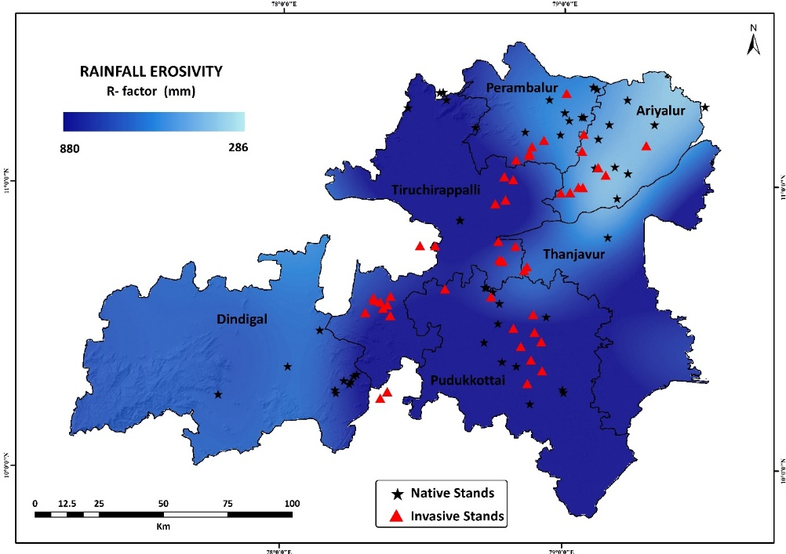
Fig. S 3. Rainfall Erosivity in the study region at Central Districts of TamilNadu

K Factor Soil erodibility
Soil erodibility factor (K) determines a surface material or soil's vulnerability to erosion, sediment transportability, and runoff rate, measured under standard conditions using a unit plot with a 9% gradient and 22.6 meters length, tilled up and down the hill and maintained in continuous fallow is influenced by soil texture, profile structure, organic matter content, and permeability (Kim, 2006). Its values range from 0.01 for stable soils to 0.70 for fragile soils (Chen et al., 2008), indicating the rate of soil loss based on the rainfall erosivity (R) index. In a study by (Behera et al., 2023) focusing on the Chilika watershed, they established a relationship between organic matter and soil texture to employ the soil erodibility factor. The current study used the following equation, developed by (Williams et al., 1996) for the determination of soil erodibility factor (K).
K_{RUSLE} = K_{w} = F_{csand} * F_{cl-si} * F_{orgc} * F_{hisand} (3)
^{F}_{csand} is the factor that lowers the K indicator in soil with high coarse sand content and higher for soil with little sand.
^{F}_{Ci-Si is} the low soil erodibility factor for the soil with high clay- to -slit- ratios.
F_{orgnc} reduce thew K value in soil with high organic content
F_{hisand} Lowers the K content of soil with extremely high sand content
F_{csand} = (0.2+0.3*exp [-0.256*m_{s}*(1-m_{silt} ÷ 100)]) (1)
F_{cl-si} = (m_{silt} ÷ m_{c} + m_{silt})^{0.3} (2)
F_{orgc} = (1-0.25*orgc ÷ orgc + exp [3.72-2.95*orgc]) (3)
F_{hisand} = [ 1- 0.7*(1-m_{silt} ÷ 100) ÷ (1-m_{silt} ÷ 100) +exp [-5.51+22.9*(1-m_{silt} ÷ 100)] ] (4)
M_{s} is the sand fraction content (0.05-2.00mm diameter) [%]
M_{slit} is the slit fraction content (0.002 – 0.05 mm diameter) [%]
M_{c} is the clay fraction content (<0.002 mm diameter) [%]
orgC is the organic carbon (SOC) content [%]

Soil unit symbol | sand % topsoil | silt % topsoil | clay % topsoil | OC % topsoil | F_{csand} | F_{cl-si} | F_{orgc} | F_{hisand} | K- Factor
LC | 64.3 | 12.2 | 23.5 | 0.63 | 0.2 | 0.724615 | 0.997717 | 0.983034 | 0.142139
VP | 25.1 | 12.2 | 62.7 | 0.68 | 0.201064 | 0.580181 | 0.997206 | 0.999995 | 0.116327
I | 58.9 | 16.2 | 24.9 | 0.97 | 0.200001 | 0.756314 | 0.992542 | 0.994235 | 0.14927
JE | 70.8 | 12.8 | 16.5 | 1.15 | 0.2 | 0.780015 | 0.988398 | 0.942194 | 0.14528
AP | 57 | 15.6 | 27.1 | 1.09 | 0.200001 | 0.73928 | 0.989839 | 0.996086 | 0.145782
LO | 76 | 9.9 | 14.1 | 0.41 | 0.2 | 0.766703 | 0.999175 | 0.86298 | 0.132221
ND | 38.9 | 17.6 | 43.6 | 1.57 | 0.200082 | 0.688063 | 0.979618 | 0.999911 | 0.134851
VC | 22.4 | 24.5 | 53 | 0.69 | 0.203952 | 0.707879 | 0.997095 | 0.999997 | 0.143954
RD | 82.1 | 6.7 | 11.3 | 0.27 | 0.2 | 0.743431 | 0.999634 | 0.703729 | 0.104596
AH | 31.3 | 24.8 | 43.8 | 3.34 | 0.200725 | 0.73695 | 0.974417 | 0.999983 | 0.144137
Soil Symbol | Abbreviation
C | Chromic Luvisols
VP | Pellic Vertisols
I | Inceptisol
JE | Eutric Fluvisols
AP | Plinthic Acrisols
LO | Orthic Luvisols
ND | Dystric Nitosols
VC | Chromic Vertisols
RD | Dystric Regosols
AH | Humic Acrisols
Table. S 3. Percentage of top soil and k factor

Table S 4. Soil types and abbreviations
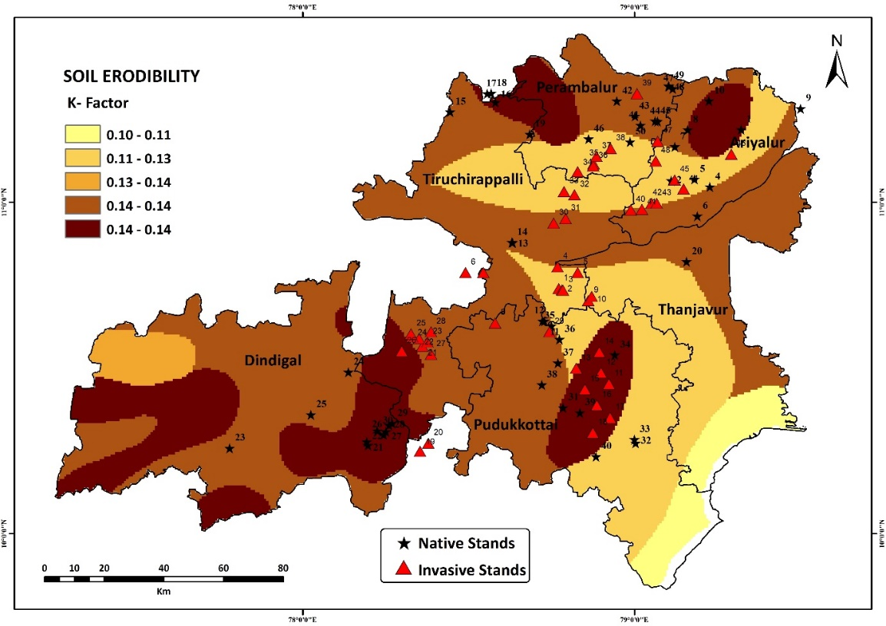

Fig S 4. Soil Erodibility across the study region in central districts of Tamil Nadu

Topographic or Slope Length/Steepness Factor (LS)
Topography is one the most important factor in RUSLE model to determine the soil erosion. Slope length is the distance from the origin of overland flow along its path to location of concentrated flow or deposition. Topographic factor is the elements that influence the soil erosion through slope length and steepness slope length and soil erosion are positively correlated. LS factor is a combination of fill; flow accumulation; flow direction and slope contribute area per contour. In the current study 80% of the study area is a low undulated terrain; in the northern and western parts Small Mountain contributes to the overall steepness of the study area. Therefore, it is concluded that the study shows a very low steepness and length results in decline in soil loss over the area. LS factor for the present study was derived by slope and flow accumulation (Kamaludin et al., 2013) as follows:
LS=pow [(Flow accumulation)*cell size/22.13]0.4*pow[sin(slope*0.01745/0.0896]1.3 (4)

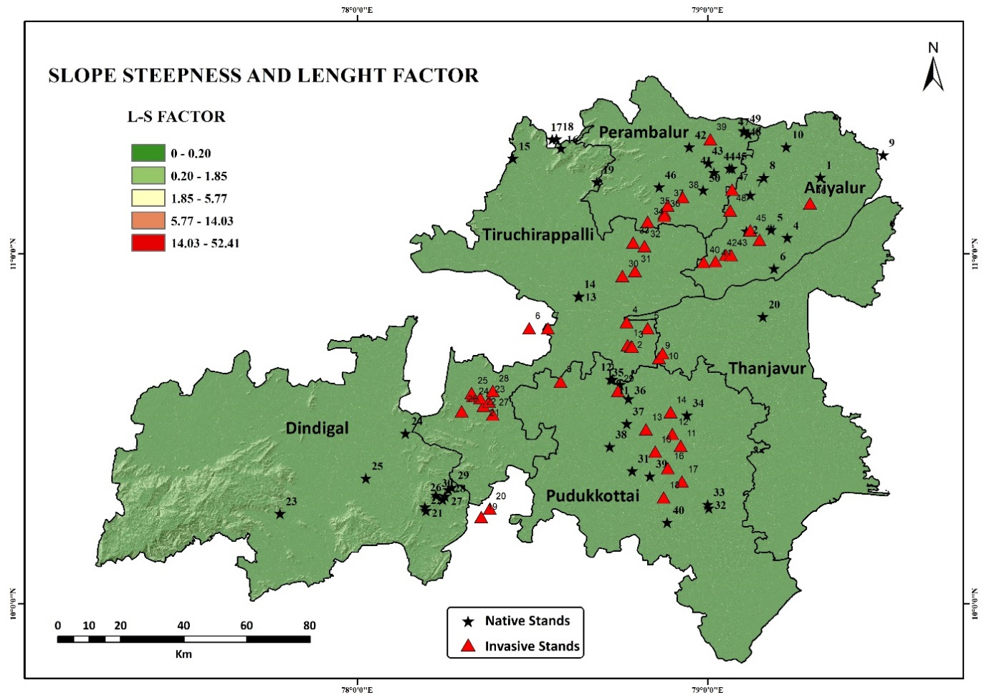
Fig S 5. Slope steepness and length map of Central Districts of TamilNadu

C – factor cover management
It is to be noted that when there is loss of vegetation or uncovered vegetation there is chance to prevent soil erosion The C-factor plays a crucial role in crop management, but unfortunately, its value is unavailable for most Indian crops. To overcome this limitation, (Karaburun, 2010) calculated C-factor values, which were then utilized to assess the impact of management and cropping patterns on soil erosion rates and amounts in India's agricultural lands. Vegetation type and its quality, as well as management practices, significantly influence soil erosion in any region (Holdsworth and Morgan, 2005; Mohammad and Adam, 2010)
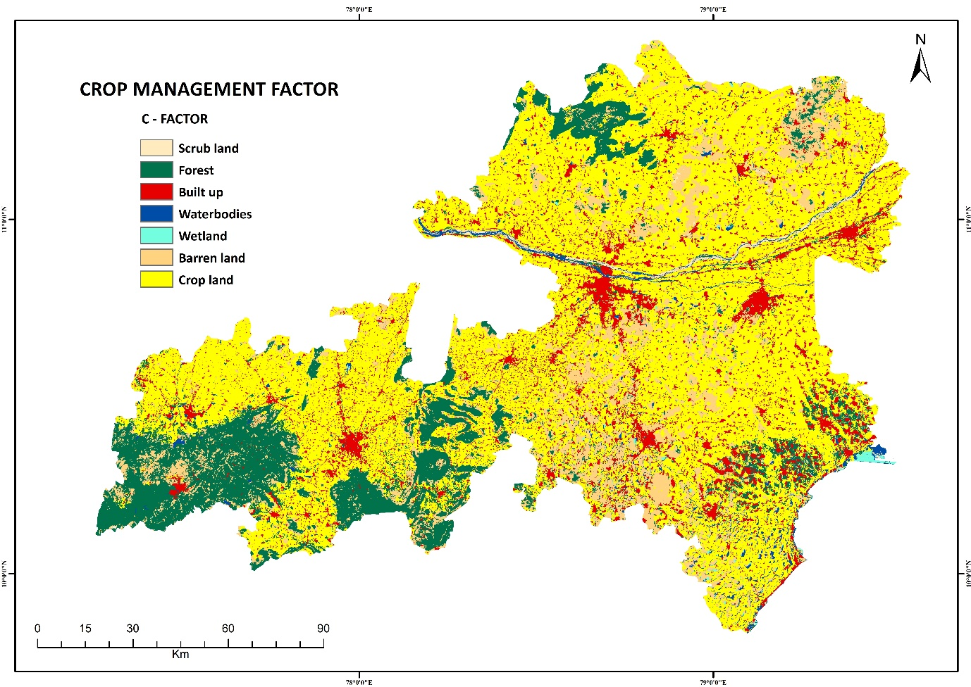
Fig. S 6. Land use Land cover map of central districts of TamilNadu
LULC class | C- factor value | Sources
Settlement | 0.09 | (Singh et al., 2023)
Barren land | 0.50 | (Singh et al., 2023)
Forest | 0.003 | (Singh et al., 2023)
Water bodies | 0.28 | (Singh et al., 2023)
Wetland | 0.28 | (Singh et al., 2023)
Cropland | 0.63 | (Singh et al., 2023)
Scrubland | 0.001 | (Singh et al., 2023)

Table. S 5. Crop management factor values for different land use.

LULC | Area (Sq.km) | Area (%)
Water Bodies | 469.11 | 2.09
Forest | 3150.68 | 14.5
Flooded vegetation | 9.70 | 0.22
Crop | 13688.58 | 61.07
Built up | 2325.34 | 10.37
Grass land | 105.20 | 0.46
Barren land | 2574.64 | 11.29

Table. S 6. Land Use Land Cover area and its proportions across the study region (2022)

P – Factor support practise factor
P -factor is manmade which is implemented on the top soil factored for top soil erosion through water. P factor is associated with contouring, strip cropping, terracing and other activities by which its land can be managed and to stop soil erosion. P value was assessed using land use land cover which was adopted by (Larson et al., 1997)due to high influence of land use land cover in the study area (Sinshaw et al., 2021). As the effectiveness of erosion control practise can vary depending on land management practise and local conditions. The value of P factor in range id 0 to 1, where 0 is represented complete vegetation cover and high effect of soil erosion and 1 represents bare soil no soil erosion control practise. The P factor attribute results the overall management of the area through various measurement were taken to implement land management practices. The P factor was generated on the basis of land use types. The P value was given accordingly to each land use classes (Table S6).

LULC class | P – factor value | Sources
Settlement | 1.0 | (Singh et al., 2023)
Barren land | 1.0 | (Singh et al., 2023)
Forest | 0.8 (0.4)
Water bodies | 1.0 | (Singh et al., 2023)
Wetland | 1.0 | (Singh et al., 2023)
Cropland | 0.5 (0.7)
Scrubland | 1.0 | (Singh et al., 2023)

Table. S 7. Support Practice factor

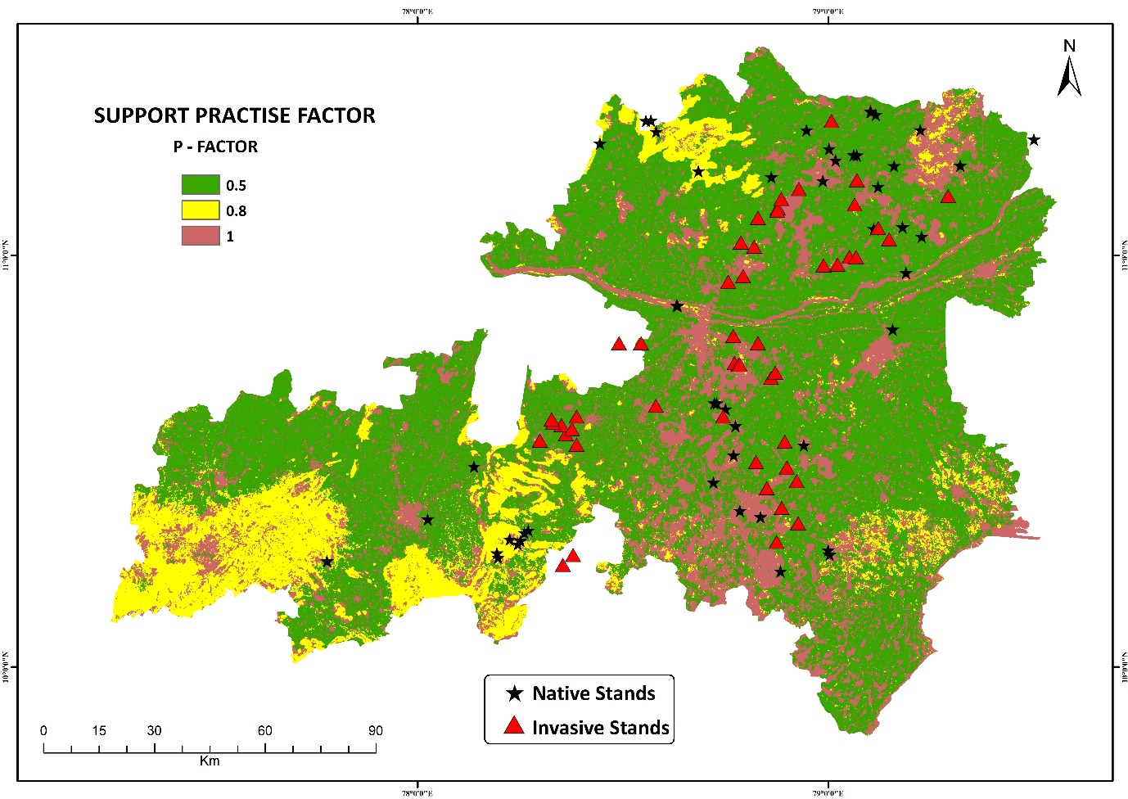
Fig. S 7. Conservation support practice factor map in central districts of TamilNadu.

Category | K factor | R factor | LS factor | C factor | P factor
Maximum | 0.14 | 880 | 52.14 | 0.63 | 1.0
Mean | 0.13 | 406 | 0.02 | 0.4 | 0.6
Minimum | 0.10 | 286 | 0.0 | 0.001 | 0.5
Table. S 9. Statistical analysis of RUSLE model factors

Soil loss estimation
All across the study area soil erosion observed to be very high in montane regions but in plains soil erosion was recorded to be very generally low; very high erosion rate was encountered in the montane region about 84.26 ton/ha/year. In Invasive Stands mean soil loss/erosion was estimated to be 4.52 ± 2.55 ton/ha/year in contrast soil erosion under Native Stands were 33.5 ± 13.4 ton/ha/year which is high comparatively to Invasive Stands. Low soil erosion in Invasive Stands might be attributed to the very high depositional rate and Soil Organic Carbon enrichment trait of Prosopis juliflora; in specific organic exudates from roots tends creates a high adhesive humus layer which intern holds the soil and prevent erosion. Though the bulk densities of the under canopy soil of Invasive stands were low compared to Native Stands, in spite soil erosion rates were observed to be low in Invasive Stands across the study region. In montane region existence of Native Stands tends to decrease the soil erosion and increase the land stability in multiple folds, but in open montane areas very high erosion rate was observed due to the slope and high rainfall.
Soil erosion classes | Soil loss  (ton / ha / year) | Area (ha) | Area (%)
Very low | 0.30 - 6.60 | 15,69,120 | 72
Low | 6.60 - 9.90 | 2,68,992 | 12
Moderate | 9.90 - 16.5 | 2,01,744 | 9
High | 16.5 - 33.0 | 89,664 | 4
Very high | 33.0 - 84.2 | 67,248 | 3

Table. S 10. Soil erosion proportions across the study area.

Class name | Reference total | Classified total | Number correct | Percent accuracy |  | Over all accuracy (%) | Kappa coefficient  (%)
 |  |  |  | Producer accuracy (%) | User accuracy (%) | Over all accuracy (%) | Kappa coefficient  (%)
Water bodies | 16 | 13 | 3 | 100 | 91.25 | 91.76 | 92.21
Forests | 67 | 56 | 11 | 82.3 | 93.5 | 91.76 | 92.21
Flooded vegetation | 03 | 03 | 0 | 89 | 100 | 91.76 | 92.21
Crop land | 52 | 47 | 5 | 94.12 | 90.3 | 91.76 | 92.21
Built up | 47 | 43 | 4 | 97.7 | 91.4 | 91.76 | 92.21
Barren land | 58 | 42 | 16 | 89.5 | 82.1 | 91.76 | 92.21
Total | 243 | 204 | 39 |  |  | 91.76 | 92.21

Table. S 11. Kappa coefficient validating RUSLE model Accuracy totals for LULC across the study area

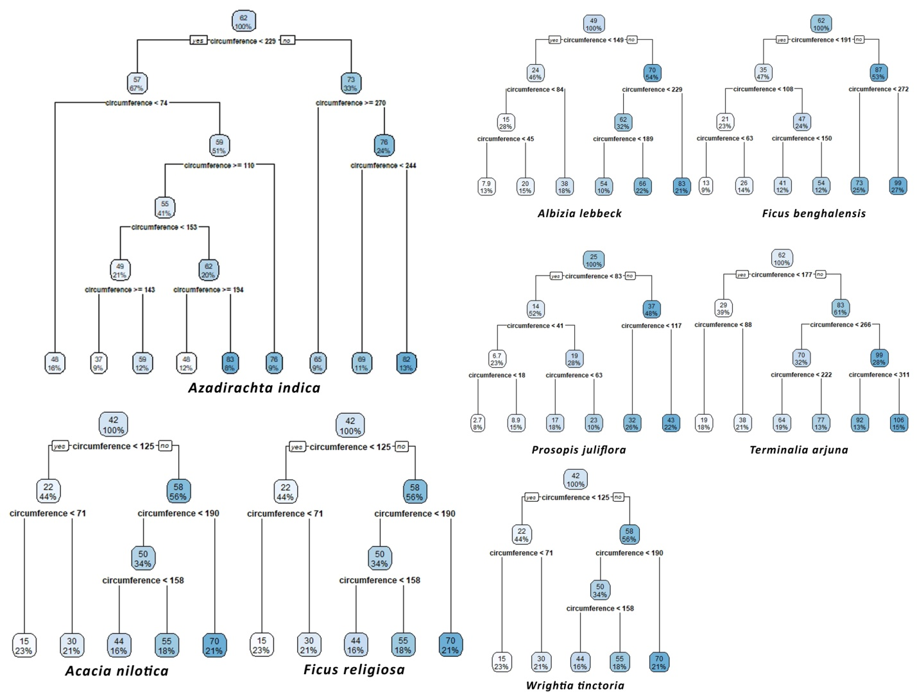

Fig. S 8 | Decision trees testing, classifying the age of selected trees in variation across the study area with an increase in stem circumference (cm).

Reference:
De Souza, A.P., 2023. Dynamic responses of carbon assimilation and stomatal conductance in the future climate. J. Exp. Bot. 74, 2790–2793.
Feng, X., Liu, R., Li, C., Zhang, H., Slot, M., 2023. Contrasting responses of two C4 desert shrubs to drought but consistent decoupling of photosynthesis and stomatal conductance at high temperature. Environ. Exp. Bot. 209, 105295.
Grunstra, M.B., Van Auken, O.W., 2023. Comparative Gas Exchange of Ulmus crassifolia (Cedar Elm, Ulmaceae) and Ungnadia speciosa (Mexican Buckey, Sapindaceae) at Ambient and Elevated Levels of Light, CO2 and Temperature. Am. J. Plant Sci. 14, 691–709.
Jahan, E., Sharwood, R.E., Tissue, D.T., 2023. Effects of leaf age during drought and recovery on photosynthesis, mesophyll conductance and leaf anatomy in wheat leaves. Front. Plant Sci. 14, 1091418.
Li, G., Wu, C., Chen, Y., Huang, C., Zhao, Y., Wang, Y., Ma, M., Ding, Z., Yu, P., Tang, X., 2023. Increasing temperature regulates the advance of peak photosynthesis timing in the boreal ecosystem. Sci. Total Environ. 882, 163587.
Mao, L., Song, Q., Li, M., Liu, X., Shi, Z., Chen, F., Chen, G., Zheng, H., Zhu, X.-G., 2023. Decreasing photosystem antenna size by inhibiting chlorophyll synthesis: A double-edged sword for photosynthetic efficiency. Crop Environ. 2, 46–58.
Qi, Y., Zhang, Q., Hu, S., Wang, R., Wang, H., Zhang, K., Zhao, H., Zhao, F., Chen, F., Yang, Y., 2023. Applicability of stomatal conductance models comparison for persistent water stress processes of spring maize in water resources limited environmental zone. Agric. Water Manag. 277, 108090.
Qu, Y., Mueller-Cajar, O., Yamori, W., 2023. Improving plant heat tolerance through modification of Rubisco activase in C3 plants to secure crop yield and food security in a future warming world. J. Exp. Bot. 74, 591–599.
Scafaro, A.P., Posch, B.C., Evans, J.R., Farquhar, G.D., Atkin, O.K., 2023. Rubisco deactivation and chloroplast electron transport rates co-limit photosynthesis above optimal leaf temperature in terrestrial plants. Nat. Commun. 14, 2820.
Wang, X.-Q., Sun, H., Zeng, Z.-L., Huang, W., 2023. Within-branch photosynthetic gradients are more related to the coordinated investments of nitrogen and water than leaf mass per area. Plant Physiol. Biochem. 198, 107681.
Wang, Y., Wu, F., Li, X., Li, C., Zhao, Y., Gao, Y., Liu, J., 2023. Effects of plants and soil microorganisms on organic carbon and the relationship between carbon and nitrogen in constructed wetlands. Environ. Sci. Pollut. Res. 30, 62249–62261.
WU, G., CHEN, X., ZANG, Y., Ying, Y.E., QIAN, X., ZHANG, W., ZHANG, H., LIU, L., ZHANG, Z., WANG, Z., 2023. An optimized strategy of nitrogen-split application based on the leaf positional differences in chlorophyll meter readings. J. Integr. Agric.
Xu, Z., Zhou, G., 2008. Responses of leaf stomatal density to water status and its relationship with photosynthesis in a grass. J. Exp. Bot. 59, 3317–3325.
Yang, K., Huang, Y., Yang, J., Yu, L., Hu, Z., Sun, W., Zhang, Q., 2023. The determiner of photosynthetic acclimation induced by biochemical limitation under elevated CO2 in japonica rice. J. Plant Physiol. 280, 153889.
Yu, T., Jiapaer, G., Long, G., Li, X., Jing, J., Liu, Y., De Maeyer, P., Van de Voorde, T., 2023. Interannual and seasonal relationships between photosynthesis and summer soil moisture in the Ili River basin, Xinjiang, 2000–2018. Sci. Total Environ. 856, 159191.

