Supplementary materials

Appendix 1: Summary statistics for patent filing
- Table S1
Appendix 2: All changepoint and event timelines
- Figures S1-S6
Appendix 3: All manual topic model graphs
- Figures S7-S12
Appendix 4: Manual topic keywords
- Table S2

Appendix 1: Summary statistics for patent filing
Table S1: Patent filing trends for six taxa between 1970 and 2020, scraped from the Google Patents database
Taxa | Median monthly patents 01-1988 to  01-1989 | Median monthly patent 06-2019 to 06-2020 | Total patents 01-1970 to 06-2020 | First patent filed | Maximum patents per month | Month with maximum patents | Changepoint month | Mean change % 1988-2020
Bear | 0 | 5 | 1718 | 01-1977 | 34 | 2015-12 | 1992-03 | 115
Caterpillar fungus | 0 | 46 | 14754 | 08-1978 | 485 | 2015-12 | 1992-08 | 143
Horseshoe crab | 0 | 2 | 1209 | 05-1970 | 13 | 2017-09 | 1987-08 | 102
Pangolin | 0 | 8 | 6907 | 03-1984 | 150 | 2013-12 | 1995-08 | 130
Rhinoceros | 0 | 1 | 526 | 07-1988 | 53 | 2013-01 | 2008-03 | 149
Sturgeon | 0 | 8 | 2194 | 02-1971 | 117 | 2016-04 | 2003-04 | 129
Global (all patenting activity) | 127,233 | 406,270 | 118,393,322 | - | 688,747 | 2017-12 | - | 104
Patents from China | 0 | 327,456 |  | - | 559,551 | 2019-12 | - | -

Appendix 2: Changepoint and event timelines
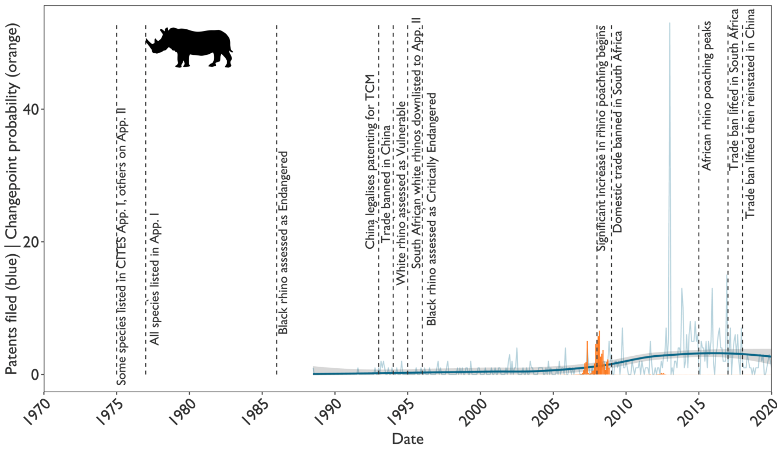 Figure S1. Changepoint and trends in patent filing for rhino-related innovations between 1970 and 2020, overlaid with a timeline of key rhino trade and conservation events.
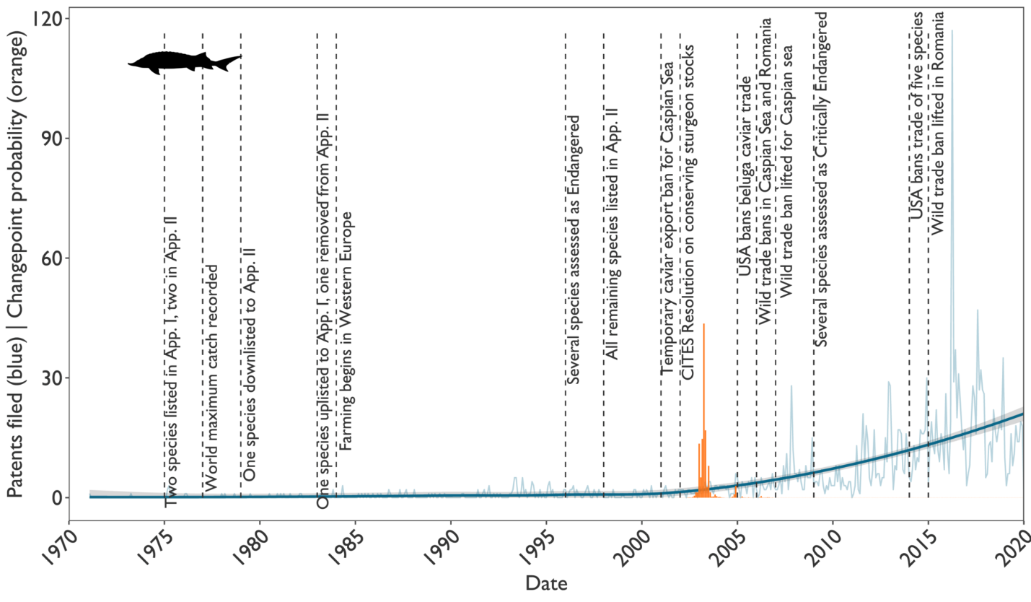 Figure S2. Changepoint and trends in patent filing for sturgeon-related innovations between 1970 and 2020, overlaid with a timeline of key sturgeon trade and conservation events.
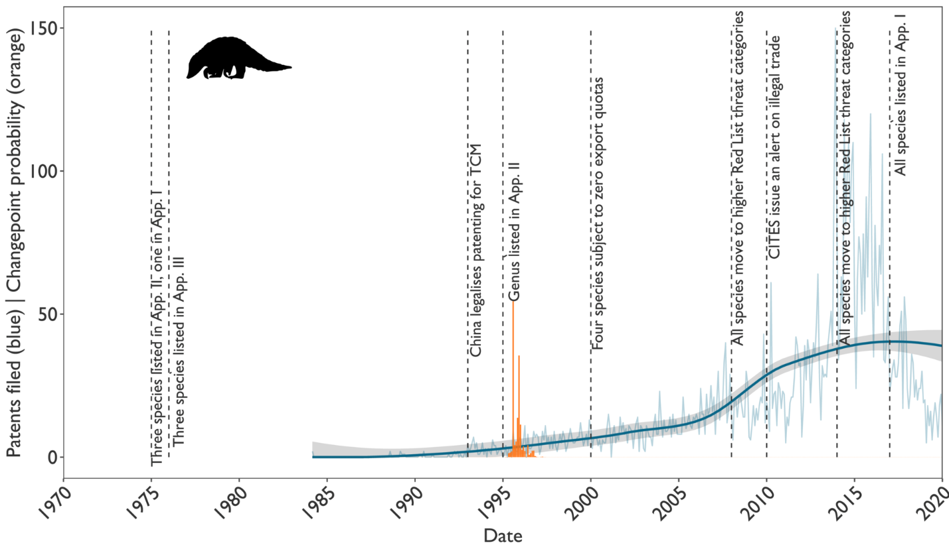 Figure S3. Changepoint and trends in patent filing for pangolin-related innovations between 1970 and 2020, overlaid with a timeline of key pangolin trade and conservation events
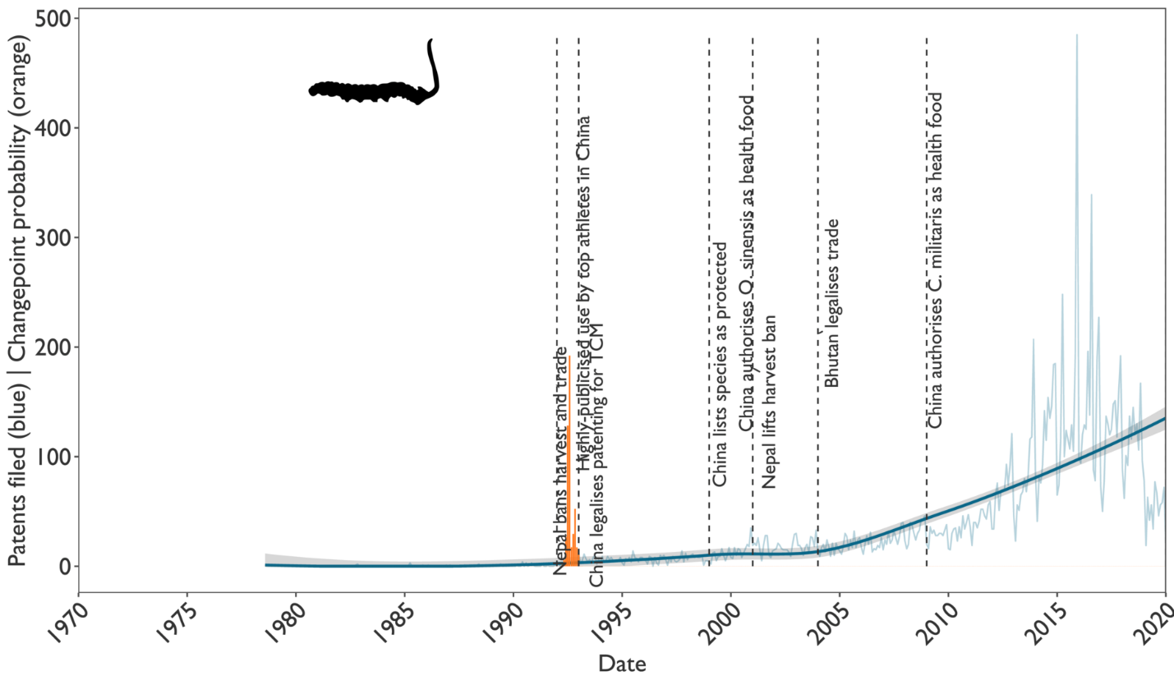 Figure S4. Changepoint and trends in patent filing for caterpillar fungus-related innovations between 1970 and 2020, overlaid with a timeline of key caterpillar fungus trade and conservation events

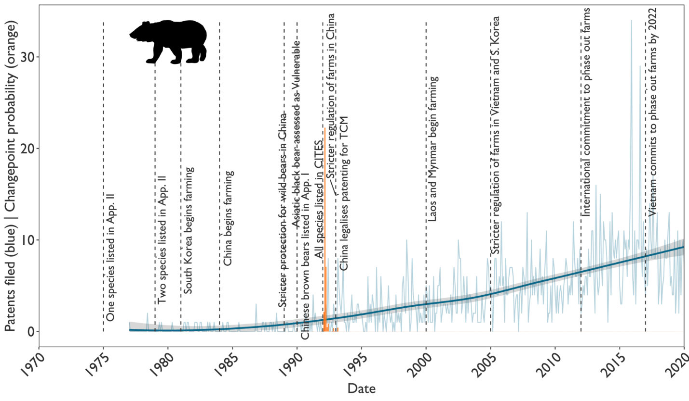 Figure S5. Changepoint and trends in patent filing for bear-related innovations between 1970 and 2020, overlaid with a timeline of key bear trade and conservation events
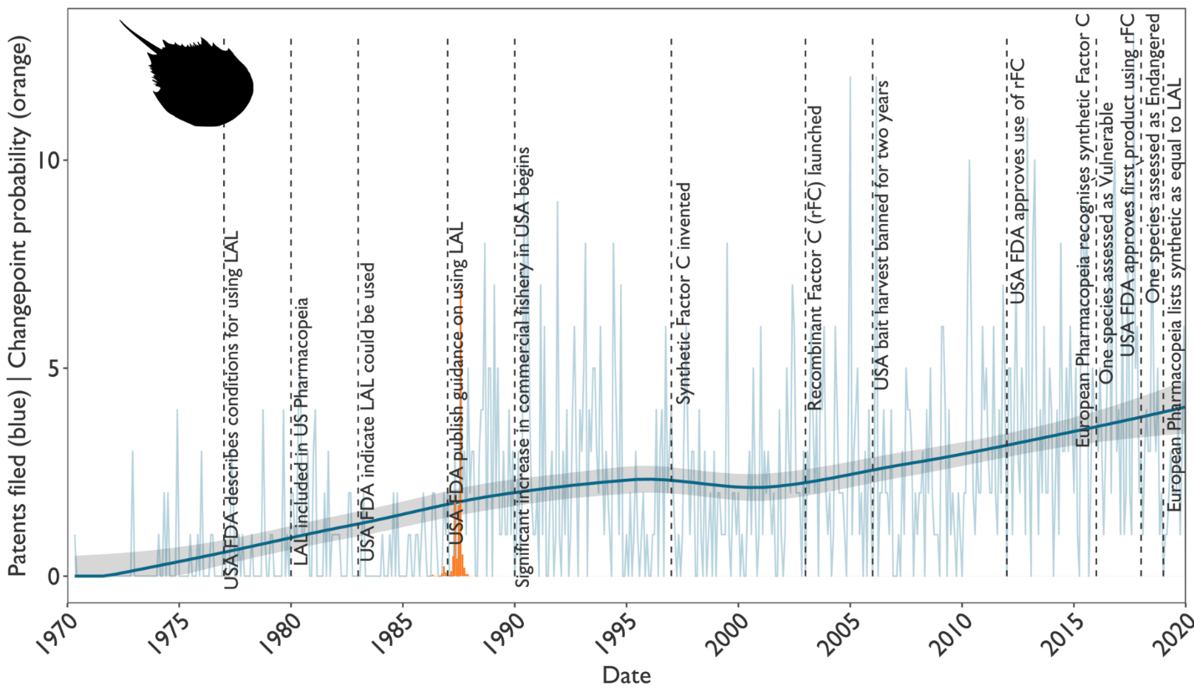 Figure S6. Changepoint and trends in patent filing for horseshoe crab-related innovations between 1970 and 2020, overlaid with a timeline of key horseshoe crab trade and conservation events

Appendix 3: Manual topic model graphs
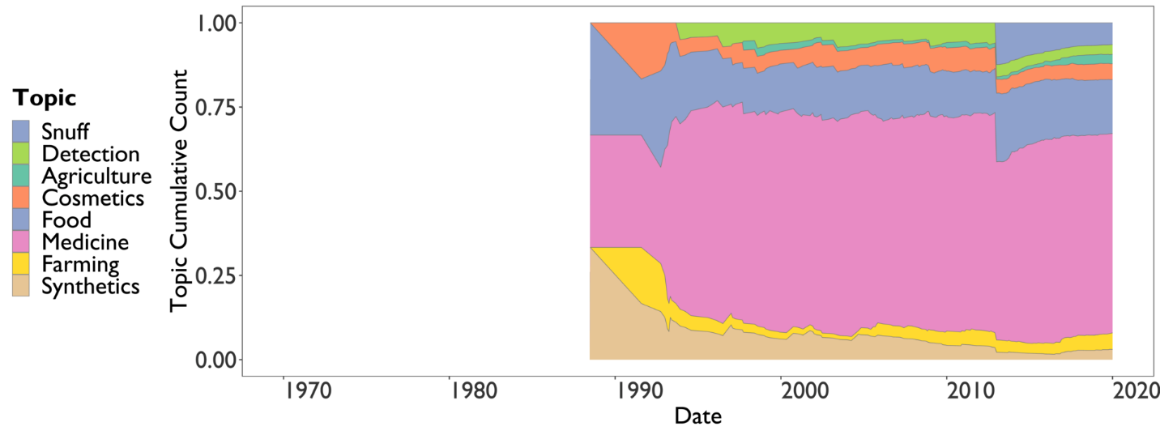 Figure S7. Manual topic model graph showing trends in topics for rhino-related patents between 1970 and 2020
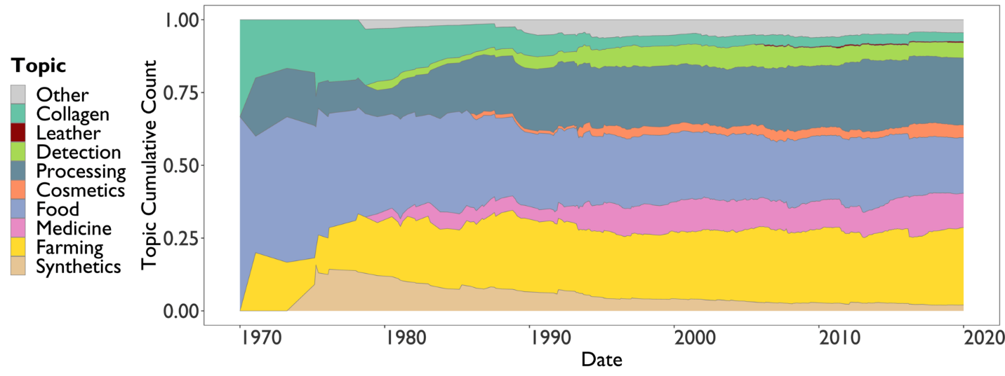 Figure S8 Manual topic model graph showing trends in topics for sturgeon-related patents between 1970 and 2020
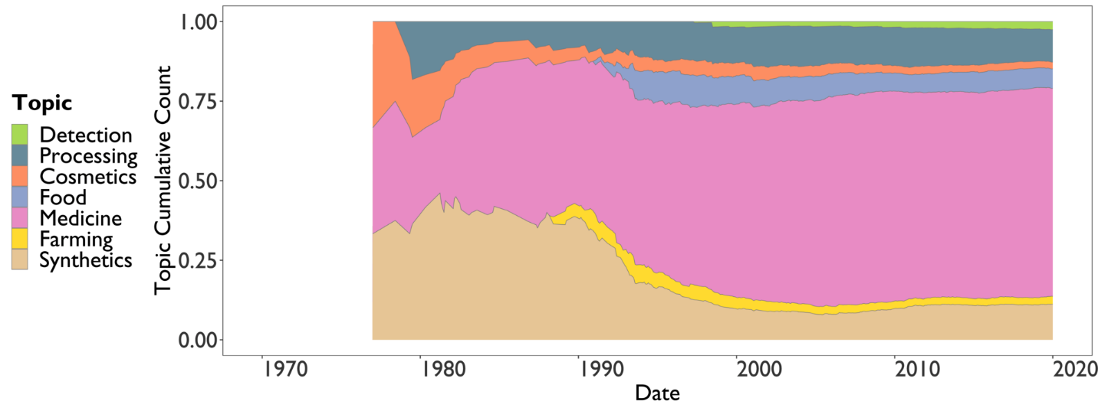Figure S9 Manual topic model graph showing trends in topics for pangolin-related patents between 1970 and 2020
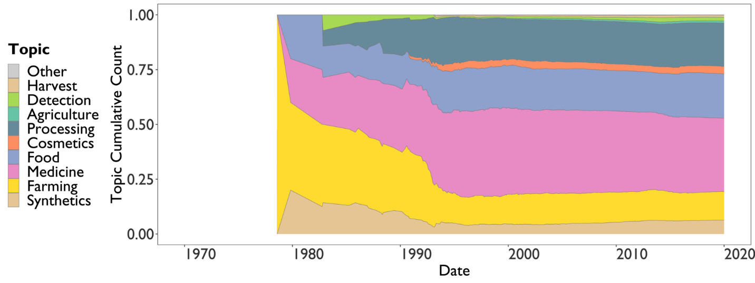Figure S10 Manual topic model graph showing trends in topics for caterpillar fungus-related patents between 1970 and 2020

Figure S11 Manual topic model graph showing trends in topics for bear-related patents between 1970 and 2020

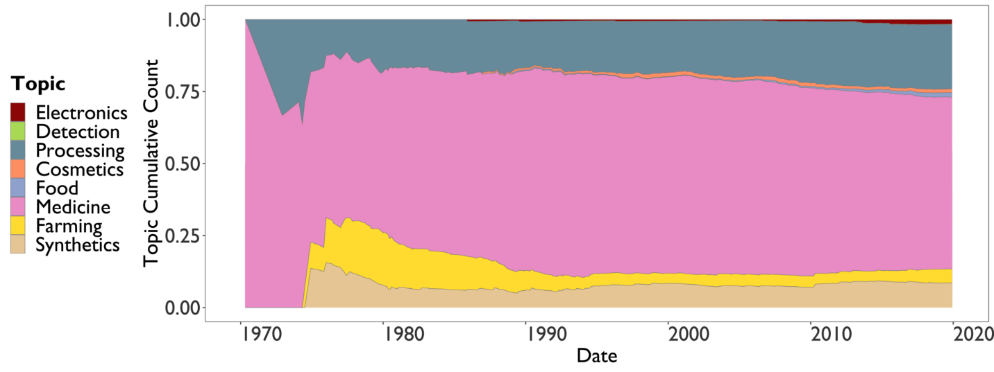 Figure S12 Manual topic model graph showing trends in topics for horseshoe crab-related patents between 1970 and 2020

Appendix 4. Manual topic keywords
Table S2. Manual keywords used to label different taxa-topic combinations in patent data scraped from the Google patent database
Taxa | Topic | Keywords
cordyceps | agriculture | "feed add*", "pig feed", "cow feed", "chicken feed", "duck feed", poultry, "sheep feed", "livestock feed", "fish feed", "animal feed", "feed for fowl*", "hen feed", fertili(s|z)er, fodder, pesticide, insecticid*, "animal reproduction"
pangolin | agriculture | mink, "sheep feed", "pig feed", "sow feed", "cow feed", fodder, fertili(s|z)er, swine, "dairy cow", "milk cow", "feed add*", "livestock feed", "fish feed", "animal feed", "chicken feed", "duck feed", poultry, "feed for fowl*", "hen feed", pesticide, insecticid*, fungicide
rhinoceros | agriculture | "soilless culture", fungicide, mink, "sheep feed", "pig feed", "sow feed", "cow feed", fodder, fertili(s|z)er, swine, "dairy cow", "milk cow", "feed add*", "livestock feed", "fish feed", "animal feed", "chicken feed", "duck feed", poultry, "feed for fowl*", "hen feed"
sturgeon | biotechnology | "cell line", biotech*
sturgeon | catching | catching, fishnet, fishing
cordyceps | cigarette | cigarette
sturgeon | collagen | collagen, gelatin, isinglass, chondroitin, cartilage
sturgeon | cosmetics | cosmetic*, skincare, "skin care", facial, beaut*, "face cream", "eye cream", wrinkle*, moisturi(z|s)*, toothpaste, "hair cream", shampoo, "anti aging", soap, mask, "oral hygiene", slimming, "hair growth", 化妆, 免疫, 牙膏, "skin preparation", "weight loss ", 화장품, "hair thickener"
pangolin | cosmetics | cosmetic*, skincare, "skin care", facial, beaut*, "face cream", "eye cream", wrinkle*, moisturi(z|s)*, toothpaste, "hair cream", shampoo, "anti aging", soap, mask, "oral hygiene", slimming, "hair growth", 化妆, 免疫, 牙膏, "skin preparation", "weight loss ", 화장품, "hair thickener"
bear | cosmetics | cosmetic*, skincare, "skin care", facial, beaut*, "face cream", "eye cream", wrinkle*, moisturi(z|s)*, toothpaste, "hair cream", shampoo, "anti aging", soap, mask, "oral hygiene", slimming, "hair growth", 化妆, 免疫, 牙膏, "skin preparation", "weight loss ", 화장품, "hair thickener"
horseshoe_crab | cosmetics | cosmetic*, skincare, "skin care", facial, beaut*, "face cream", "eye cream", wrinkle*, moisturi(z|s)*, toothpaste, "hair cream", shampoo, "anti aging", soap, mask, "oral hygiene", slimming, "hair growth", 化妆, 免疫, 牙膏, "skin preparation", "weight loss ", 화장품, "hair thickener"
cordyceps | cosmetics | cosmetic*, skincare, "skin care", facial, beaut*, "face cream", "eye cream", wrinkle*, moisturi(z|s)*, toothpaste, "hair cream", shampoo, "anti aging", soap, mask, "oral hygiene", slimming, "hair growth", 化妆, 免疫, 牙膏, "skin preparation", "weight loss ", 화장품, "hair thickener"
rhinoceros | cosmetics | cosmetic*, skincare, "skin care", facial, beaut*, "face cream", "eye cream", wrinkle*, moisturi(z|s)* , toothpaste, "hair cream", shampoo, "anti aging", soap, mask, "oral hygiene", slimming, "hair growth", 化妆, 免疫, 牙膏, "skin preparation", "weight loss ", 화장품, "hair thickener"
bear | detection | detect*, identification, molecular, germplasm, barcoding, differentiat*, 引物探针, fingerprint, 检测
cordyceps | detection | detect*, identification, gene, molecular, germplasm, barcoding, differentiat*, 引物探针, fingerprint, 检测
pangolin | detection | detect*, identification, gene, molecular, germplasm, barcoding, differentiat*, 引物, fingerprint, 检测
rhinoceros | detection | detect*, identification, gene, molecular, germplasm, barcoding, differentiat*, 引物, fingerprint, 检测
horseshoe_crab | detection | "species identification", fingerprint, primer (omit the word 'detection' as endotoxin detection is the main function of LAL)
sturgeon | detection | detect*, identification, barcoding, gene, genetic, molecular, germplasm, assay, differentiat*
horseshoe_crab | electronics | electrode*, capacitor, semiconductor
bear | farming | farm*, feed*, breed*, enclosure, cultivat*, drainage, "extracting bile"
pangolin | farming | enclosure, cultivat*, cage, breed*, "cub feed", "pangolin feed", "manis feed", "pangolin breeding", "breeding pangolin", "special feed", "feed for adult manis"
cordyceps | farming | farm*, cultivat*, cultur*, breed*, propagat*, larva*, inoculat*, host, incub*, grow*, planting, spawn, spore, pupa*, "fruit body"
horseshoe_crab | farming | farm, feed*, breed*, cultivat*, aquaculture, incub*, hatch*, culturing, larva*
rhinoceros | farming | farm*, feed*, breed*, enclosure, cultivat*, scraping, "artificial breeding"
sturgeon | farming | feed*, aquaculture, farm*, breed*, cultivat*, fatten*, hatch*, fishpond, pond, "parent fish", domesticat*, rear*, inseminat*, incubat*, larva*, pisciculture, reservoir, forage, "sturgeon sperm", cage, "water tank", fertili(s|z)ation, fertili(s|z)ed, reproduction, bred, pool aquaculture, fishery, broodstock, spawn*, "sturgeon fry", "medicine for sturgeon", "treating sturgeon", agriculture, "disease of sturgeon*", fishfarm*, veterinary, artificial, "sturgeon viral", "sturgeon respiratory", "sturgeon bacterial", "sturgeon food", cultur*, inspection, "fish industry", "sturgeon syringe"
pangolin | food | meat, food, coffee, tea, biscuit*, cookie*, sausage, hamburger, bacon, sauce*, soup*, wine, drink*, porridge, candy, "fruit juice", "food industry", delicious, edible, 咖啡, 茶, 饮料, 营养
sturgeon | food | caviar, "sturgeon eggs", roes?, "fish egg*", "sturgeon flesh", "fried sturgeon", sauce*, fillet*, meat, soup*, floss, canned, "food industry", "food product*", "food processing", delicious, edible, nutritious, "sturgeon extract", candy, nutritive, sausage, hamburger, bacon, wine, drink*, porridge, 咖啡, 茶, 饮料, 营养
cordyceps | food | drink*, wine, food, soup*, sauce*, biscuit*, porridge, tea, coffee, milk, "fruit juice", cake*, candy, beverage*, noodle*, delicious, nutri*, edible, sausage*, bacon, hamburger*, flavor*, taste*, 음료, 차, 맛, 饮料, 营养, 咖啡, 茶
bear | food | "bear meat", "bear paw food", coffee, tea, biscuit*, cookie*, sausage, hamburger, bacon, sauce*, soup*, wine, drink*, porridge, "fruit juice", "food industry", "food production", beverage, nutri*, 咖啡, 茶, delicious, edible, 饮料, 营养
rhinoceros | food | meat, food, coffee, tea, biscuit*, cookie*, sausage, hamburger, bacon, sauce*, soup*, wine, drink*, porridge, candy, "fruit juice", "food industry", delicious, edible, 咖啡, 茶, 饮料, 营养
horseshoe_crab | food | meat, food
cordyceps | harvest | digging, collecting, picking, collection, excavating
sturgeon | leather | leather
bear | medicine | "for treating", "to treat", treatment, medic*, pharmac*, decoct*, health, drugs?, symptom*, sick*, pain, ointment, plasters?, pills?, therap*, syndrome, curative, detoxi*, heal*, capsule*, immun*, tablet*, wine, cardiovascular, disease*, nourishing, invigorating tonify*, disorder, patient*, illness, "dietary supplement", granule*, incense, inflamm*, injection*, cancer, tumour, tumor, eye*, liver, gallstone, hangover, "oral preparation", childbirth, *fatigue, 病, 保健, 医, 药, 酒, 治疗, 膏, 症状, 愈, 炎症
pangolin | medicine | "for treating", "to treat", treatment, medic*, pharmac*, decoct*, health, drugs?, symptom*, sick*, pain, ointment, plasters?, pills?, therap*, syndrome, curative, detoxi*, heal*, capsule*, immun*, tablet*, wine, cardiovascular, disease*, nourishing, invigorating tonify*, disorder, patient*, illness, "dietary supplement", granule*, incense, inflamm*, injection*, cancer, tumour, tumor, hangover, lactat*, nursing, "oral preparation", childbirth, *fatigue, 病, 保健, 医, 药, 酒, 治疗, 膏, 症状, 愈, 炎症
pangolin | cancer | cancer, tumour, tumor
rhinoceros | medicine | "for treating", "to treat", treatment, medic*, pharmac*, decoct*, health, drugs?, symptom*, sick*, pain, ointment, plasters?, pills?, therap*, syndrome, curative, detoxi*, heal*, capsule*, immun*, tablet*, wine, cardiovascular, disease*, nourishing, invigorating, tonify*, disorder, patient*, illness*, granule*, "dietary supplement", incense, inflamm*, injection*, cancer, tumour, tumor, "rhinoceros glue", "oral preparation", hangover, childbirth, *fatigue, 病, 保健, 医, 药, 酒, 治疗, 膏, 症状, 愈, 炎症, 약
cordyceps | medicine | "for treating", "to treat", treatment, medic*, pharmac*, decoct*, health, drugs?, symptom*, sick*, pain, ointment, plasters?, pills?, therap*, syndrome, curative, detoxi*, heal*, capsule*, immun*, tablet*, wine, cardiovascular, disease*, nourishing, invigorating, tonify*, disorder, patient*, illness*, granule*, "dietary supplement", incense, inflamm*, injection*, cancer, tumour, tumor, nursing, antibacterial, childbirth, *fatigue, peptide, "lipid lowering".病, 保健, 医, 药, 酒, 治疗, 膏, 症状, 愈, 炎症, 薬, 약, 건강, 암, 치료
horseshoe_crab | medicine | "for treating", "to treat", treatment, medic*, pharmac*, decoct*, health, endotoxin, symptom*, curative, drugs?, biosensor, therap*, detoxi*, nourishing, invigorating, tonify*, immun*, endotoxin*, microb*, patient, illness, "dietary supplement", amebocyte, amoebocyte, amebosite, inflamm*, diagnos*, disease, biomedic*, fever, cancer, tumour, tumor, detect*, antibacterial, pyrogen*, lipopolysaccharide*, hemocyte, tachyplesin, polypeptide*, "gram negative", "gram positive", "limulus reagent", "limulus test", Perivitelline, toxin*, lectin*, childbirth, *fatigue, 病, 保健, 医, 药, 酒, 治疗, 膏, 症状, 愈, 炎症
sturgeon | medicine | "pseudosciaenae seu Acipenser", "chinese medic*", "western medic", "fish glue", "swimming bladder", plasters?, decoct*, therap*, curative, ointment, symptom*, tablets?, "air bladder", "swim bladder", maw, tea, wine, beverage, nourishing, invigorating, tonify*, pharmac*, patient, "health care", "dietary supplement", capsules?, "protein peptide*", disorder*, childbirth, fatigue, 保健
cordyceps | processing | extract*, processing, packag*, purifi*, drying, "store method", storage, bottle, cleaning, packing, crushing, grinding, powdering, cutter, cutting, box, bag, wrapping, "Production system", preserv*, separati*, concentrate, filtration, device, equipment, Encapsulation
pangolin | processing | processing, "production method"
bear | processing | extract*, processing, packaging, purifi*, "drawing bile"
sturgeon | processing | extract*, processing, packaging, purifi*, transport*, storing, extracti*, drying, freez*, filter, filtr*, preserv*
horseshoe_crab | processing | extract*, measuring, apparatus, filtration, filter, device*, manufacturing, container, platform
sturgeon | research_conservation | tagging, marking, monitoring, "fish ladder", sampling, , ecology, conservation, behavior, ichthyology, habitat
pangolin | research_conservation | research, sampling, tagging, monitoring, marking, tracking, ecology, conservation, behavior
rhinoceros | snuff | snuff, tobacco
bear | synthetics | artificial*, synthe*, biotransform*, bio-transform*, bioengineer*, culturing, "producing ursodeoxycholic acid", "preparing ursodeoxycholic acid", bioconversion, bioengineered, recombinant, "preparing high purity ursodeoxycholic", 人工熊胆, "cholic acid", chenodeoxycholic, "fowl bile", 合成
pangolin | synthetics | artificial*, synthe*, biotransform*, bio-transform*, bioengineer*, cultured, substitute, bioengineered, recombinant, 合成
rhinoceros | synthetics | artificial*, synthe*, biotransform*, bio-transform*, bioengineer*, cultured, substitute, bioengineered, recombinant, 合成
cordyceps | synthetics | synthe*, biotransform*, bio-transform*, bioengineer*, recombinant, ferment*, 合成
horseshoe_crab | synthetics | rfc, rCrFC, synthe*, recombinant, biotransform*, bio-transform*, bioengineer*, "genetic engineer*", clone*, 合成
sturgeon | synthetics | synthe*, biotransformed, bio-transformed, cultured, bioengineered, recombinant, transgenic, 合成

