Supporting information
A FLUORESCENT CHEMOSENSOR FOR DETECTION pH AND Cu²⁺ ION BASE ON 7-((2-AMINOETHYL)AMINO)-5-BROMO-6-HYDROXY-1-METHYLQUINOLIN-1-IUM-3-SULFONATE: EXPERIMENTAL AND DFT CALCULATION

Mai Phuong Chi¹, Ngo Tuan Cuong¹, Nguyen Thi Hai², Le Thi Hong Hai^{1*}
¹Chemistry Faculty, Hanoi National University of Education, Hanoi, Vietnam
²Faculty of Natural Sciences and Technology, Tay Bac University, Son La, Vietnam
Corresponding authors: hailth@hnue.edu.vn

I. IR and 1H NMR spectra of QEt
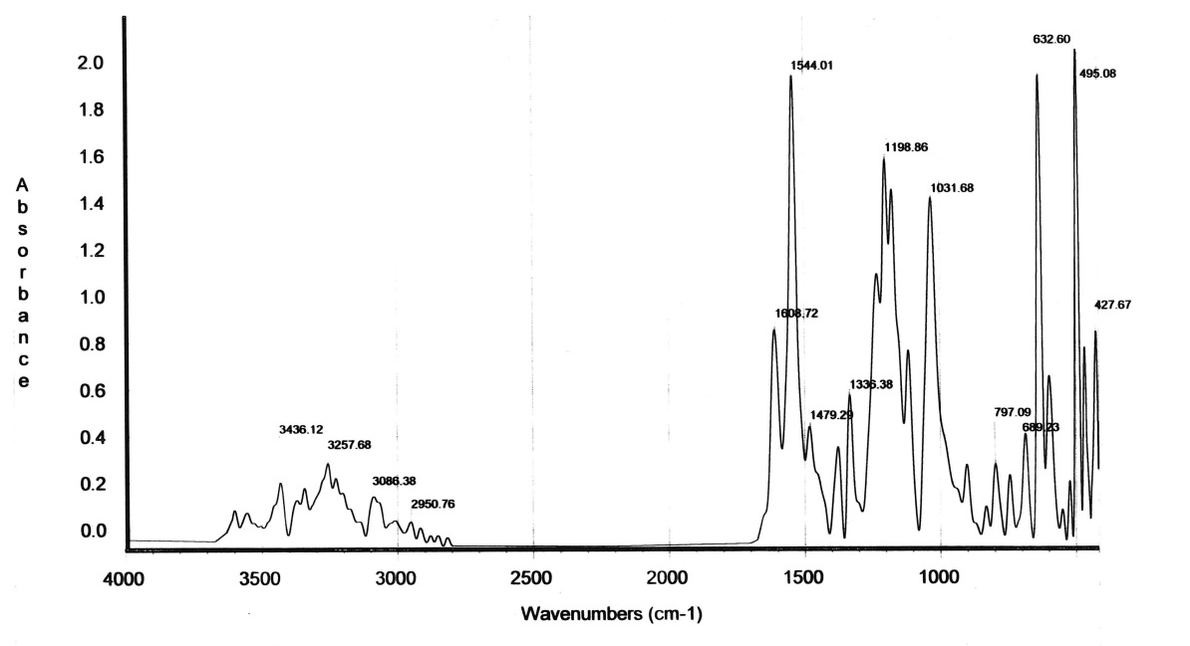

Fig S1. IR spectrum of QEt.
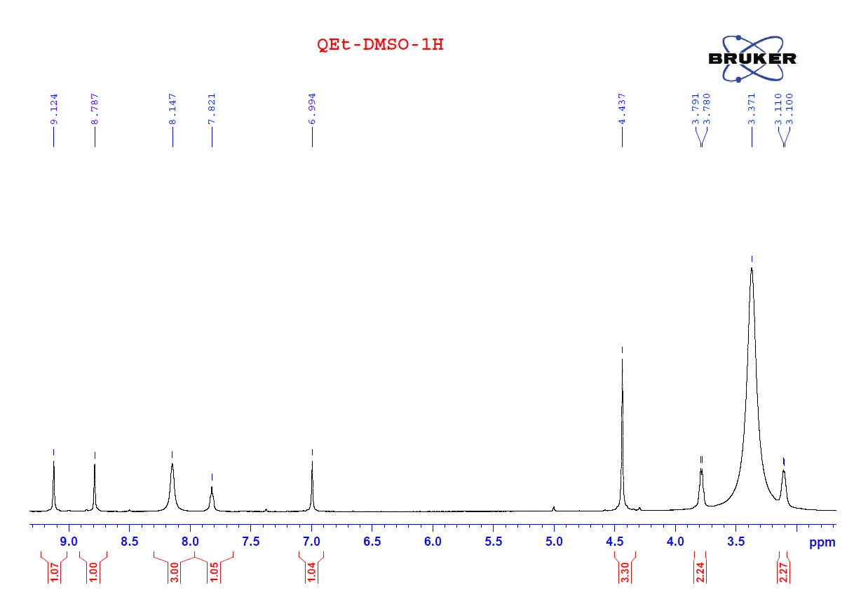
Fig S2. ¹H NMR spectrum of QEt in DMSO.

II. Cartesian coordinates of compounds QEt-0H, QEt-1H, QEt-2H and QEt-3H
QEt-0H
C -1.88672300 -2.09815300 0.00319700
C 0.20607600 -0.99261100 0.00002100
C -0.46285200 0.25982000 -0.02536600
C -1.86050800 0.27862700 -0.04098300
C -2.56966900 -0.89850500 -0.02450000
H 2.09669800 -2.02272000 -0.06639600
H -2.40989400 -3.04344200 0.00174700
C 1.60375900 -1.06591000 -0.02572300
C 0.34083700 1.43787100 -0.02233800
H -2.39065600 1.22100600 -0.07762900
C 1.70093500 1.36475500 -0.01137100
C 2.35475100 0.08803300 -0.06141100
S -4.37254100 -0.90851200 0.00381600
O -4.73727000 -2.20015100 -0.60632500
C 4.48241400 -1.13560700 -0.11404400
H 4.32867500 -1.68897500 -1.04800800
H 4.13765200 -1.76250500 0.70982700
O 2.44546200 2.49035300 0.00450200
H 3.26463300 2.36237200 0.50334900
O -4.76000400 0.27085100 -0.78890100
N -0.55601900 -2.14245300 0.01768000
Br -0.46621400 3.14544800 0.01528100
C 0.10472400 -3.45782200 0.04676100
H 0.69915000 -3.59197100 -0.85416700
H 0.73549300 -3.53132200 0.92958100
H -0.65845000 -4.22690600 0.08894800
O -4.73612600 -0.80654200 1.42956100
H 6.49087300 -2.72192900 0.78953900
H 6.68928300 -2.56127800 -0.83682800
H 7.75729300 -1.86434600 0.19543500
C 5.95450800 -0.81297500 0.08045200
H 6.13158900 -0.33338800 1.04009800
H 6.34124500 -0.17560700 -0.71281200
N 6.76707700 -2.06883900 0.05464000
H 4.01940200 0.66070800 0.76568800
H 3.97822400 0.65137700 -0.98110400
N 3.72621800 0.10175300 -0.09832100

QEt-1H
C -1.86366200 -2.09815200 0.00258100
C 0.22767500 -0.98984400 0.00200300
C -0.44288400 0.26171700 -0.02326200
C -1.84054900 0.27868600 -0.04016500
C -2.54816800 -0.89939100 -0.02503900
H 2.11971800 -2.01741400 -0.06326900
H -2.38558200 -3.04413100 0.00008500
C 1.62547700 -1.06128000 -0.02248700
C 0.35924400 1.44082700 -0.01878900
H -2.37190800 1.22038500 -0.07674400
C 1.71942600 1.36950200 -0.00660300
C 2.37497600 0.09367500 -0.05679300
S -4.35105000 -0.91179800 0.00159800
O -4.71350500 -2.20355500 -0.60964700
C 4.50430300 -1.12712100 -0.10817700
H 4.35216200 -1.68013600 -1.04261100
H 4.15960600 -1.75496300 0.71500200
O 2.46245000 2.49607300 0.01062900
H 3.28132600 2.36887800 0.51016000
O -4.73933700 0.26752300 -0.79077900
N -0.53291500 -2.14070200 0.01827300
Br -0.45009900 3.14731300 0.01909300
C 0.12953900 -3.45521400 0.04718700
H 0.72497700 -3.58804200 -0.85326800
H 0.75958600 -3.52840500 0.93054900
H -0.63265600 -4.22533100 0.08821000
O -4.71609200 -0.81115600 1.42706500
H 6.51401800 -2.71132400 0.79632900
H 6.71372400 -2.54944500 -0.82975700
H 7.77985400 -1.85171500 0.20391000
C 5.97578800 -0.80265900 0.08787700
H 6.15134400 -0.32340900 1.04797100
H 6.36241700 -0.16431000 -0.70464900
N 6.79004000 -2.05743300 0.06207500
N 3.74645700 0.10922900 -0.09242200
H 4.14148000 0.84896500 -0.65936500

QEt-2H
C 1.88306000 -2.10654900 -0.01238400
C -0.22934300 -1.01477800 -0.00914500
C 0.42722900 0.26278800 -0.00821200
C 1.81899600 0.27619900 -0.00734600
C 2.54258500 -0.90588000 -0.00833800
H -2.12136700 -2.05528900 -0.00022200
H 2.40914400 -3.04857800 -0.01653400
C -1.62819100 -1.09595800 -0.00540700
C -0.38648600 1.42820000 -0.00612800
H 2.34292900 1.22275400 -0.00647600
C -1.77795200 1.41173900 -0.00484500
C -2.38249600 0.05855400 -0.00734100
S 4.33816000 -0.87908500 0.00798200
O 4.73997700 -2.29908200 -0.04987900
C -4.54923100 -1.10076400 0.04135400
H -4.36305600 -1.65588300 0.96818200
H -4.30135100 -1.76503400 -0.79318400
O -2.55747000 2.40241700 0.00082700
O 4.70685000 -0.21187500 1.27346300
N 0.53951500 -2.14939900 -0.01340900
Br 0.43590100 3.14861100 0.00036300
C -0.11048400 -3.46624500 -0.02036500
H -0.72331000 -3.58342200 0.87121400
H -0.72853000 -3.57095300 -0.90989900
H 0.65687400 -4.23276300 -0.02797600
O 4.72782700 -0.10331500 -1.18714900
H -6.67734300 -2.57861200 -0.73753700
H -6.74072700 -2.44333600 0.90212800
H -7.86098200 -1.68869700 -0.02975400
C -6.01308200 -0.70775900 -0.03987800
H -6.24519200 -0.20699200 -0.97722700
H -6.30839800 -0.06797500 0.78942100
N -6.87133100 -1.93135900 0.02801900
N -3.72435900 0.07840800 -0.00996000
H -4.11764500 1.01276300 0.02498900

QEt-3H
C 1.88161200 -2.09660800 -0.01336500
C -0.25046200 -1.03678500 -0.01206200
C 0.39064700 0.25167100 -0.00658800
C 1.77946000 0.28527200 -0.00390300
C 2.52222900 -0.88812100 -0.00665900
H -2.12842000 -2.10235700 -0.01580400
H 2.42055000 -3.03132500 -0.01745300
C -1.64504400 -1.13815600 -0.01295600
C -0.44180800 1.40518900 -0.00357800
H 2.28988400 1.23914100 0.00002400
C -1.83212900 1.37044900 -0.00445900
C -2.42138900 0.00707400 -0.00949300
S 4.31552100 -0.83141200 0.00898600
O 4.74374600 -2.24450300 -0.03635300
C -4.58666500 -1.18342200 -0.00982300
H -4.37642800 -1.78441900 0.88309900
H -4.35691900 -1.80635000 -0.87994300
O -2.62329200 2.35189200 -0.00070700
O 4.67471900 -0.14639100 1.26823500
N 0.53671100 -2.15947600 -0.01639500
Br 0.35875700 3.13750300 0.00419200
C -0.09345900 -3.48481000 -0.02441900
H -0.70834600 -3.61043000 0.86481400
H -0.70773400 -3.59995700 -0.91547700
H 0.68482900 -4.24039500 -0.02858900
O 4.69416100 -0.05974500 -1.19299500
H -6.86093300 -2.42546700 0.92925900
H -7.84500300 -1.79047700 -0.19659700
C -6.05894300 -0.80628900 -0.03755000
H -6.27715200 -0.27585300 -0.96728500
H -6.27202500 -0.11444600 0.78838800
N -6.87739400 -2.01513700 0.00184600
N -3.75595300 0.00078900 -0.00971700
H -4.16965300 0.92628600 -0.00136900

