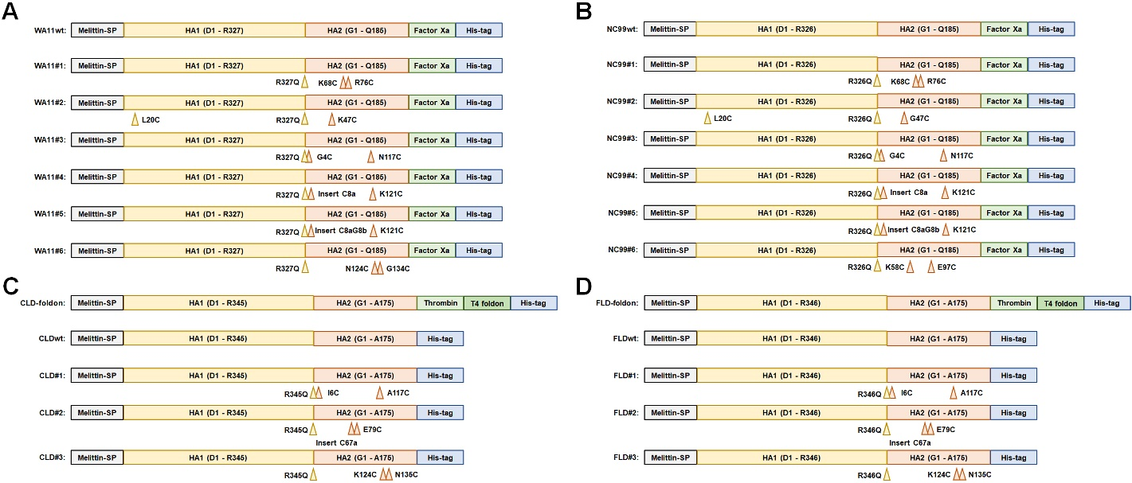
Figure S1. Schematic diagrams depict the construct design strategies and mutation sites of recombinant HA ectodomains from strains of (A) WA11, (B) NC99, (C) CLD, and (D) FLD.

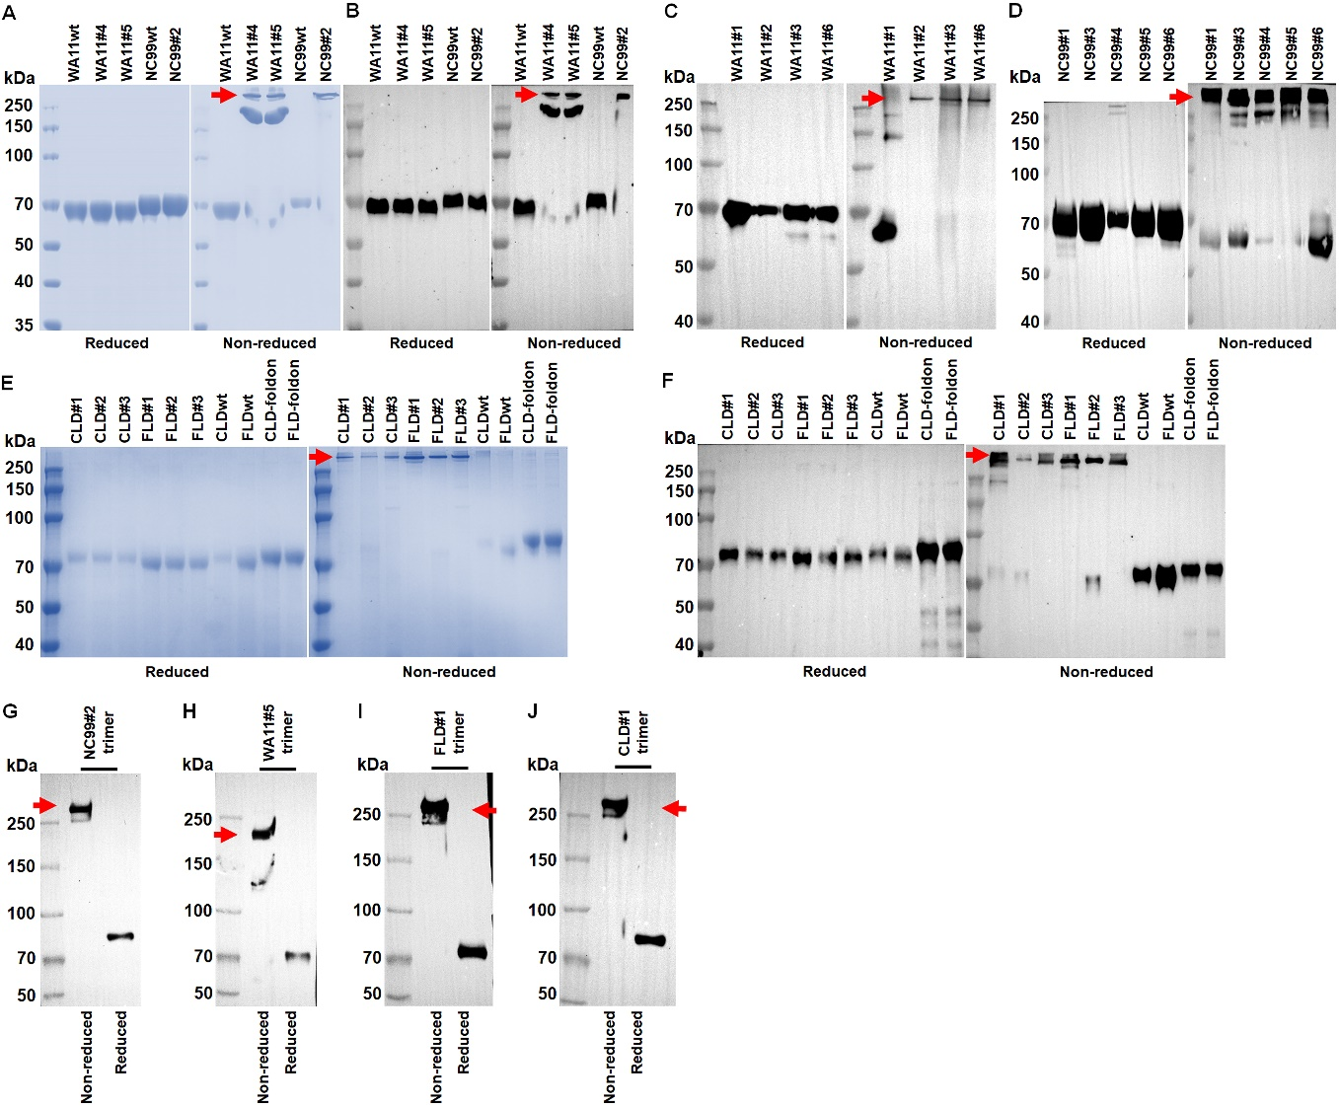
Figure S2. Characterizations of recombinant HA proteins. (A - D) Coomassie brilliant blue staining and western blot analysis of the reduced and non-reduced samples of recombinant HA proteins from strains of WA11 and NC99 by using 12% polyacrylamide gels. (E - F) Coomassie brilliant blue staining and western blot analysis of the reduced and non-reduced samples of recombinant HA proteins from strains of CLD and FLD by using 12% polyacrylamide gels. Western blot analysis of the reduced and non-reduced samples of (G) NC99#2 H1 trimer, (H) WA11#5 H1 trimer, (I) FLD#1 HA trimer, and (J) CLD#1 HA trimer by using 8% polyacrylamide gels. The red arrows indicate the protein bands containing HA trimer molecules.
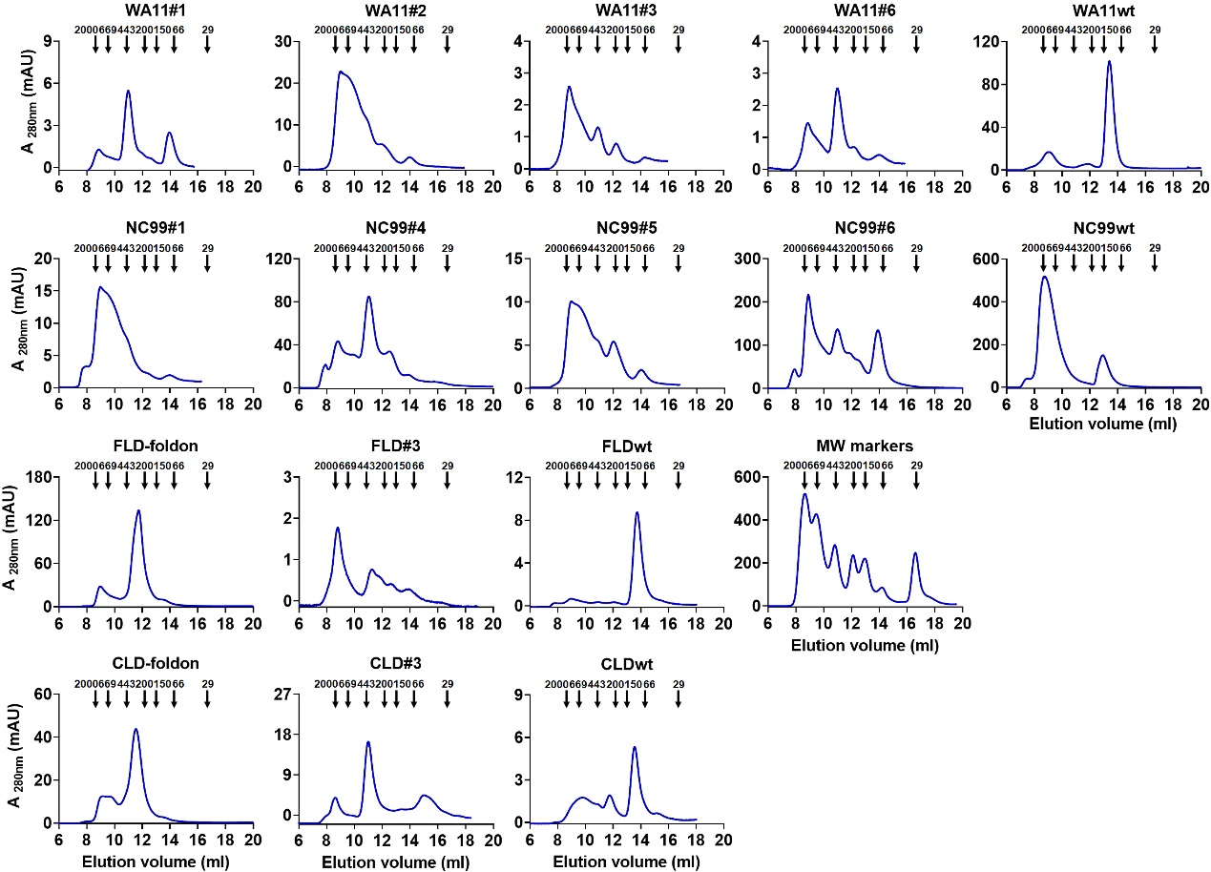
Figure S3. SEC analysis of the affinity-purified recombinant HA proteins.

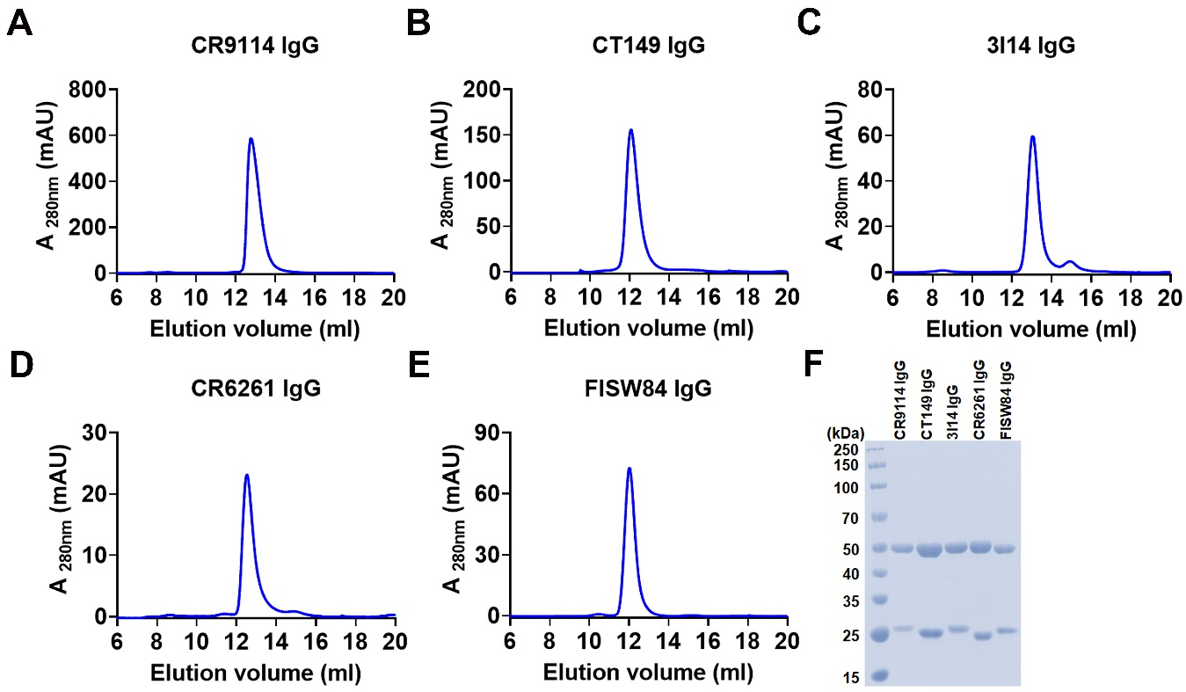
Figure S4. Characterizations of HA stem-specific human IgG1 mAbs. The expressed recombinant human IgG1 mAbs including (A) CR9114, (B) CT149, (C) 3I14, (D) CR6261, and (E) FISW84 were affinity-purified by using protein A resin beads and further checked and purified by using SEC column. (F) Dithiothreitol-reduced recombinant mAb protein samples were separated by using SDS-PAGE and the polyacrylamide gels were stained with Coomassie brilliant blue solution.

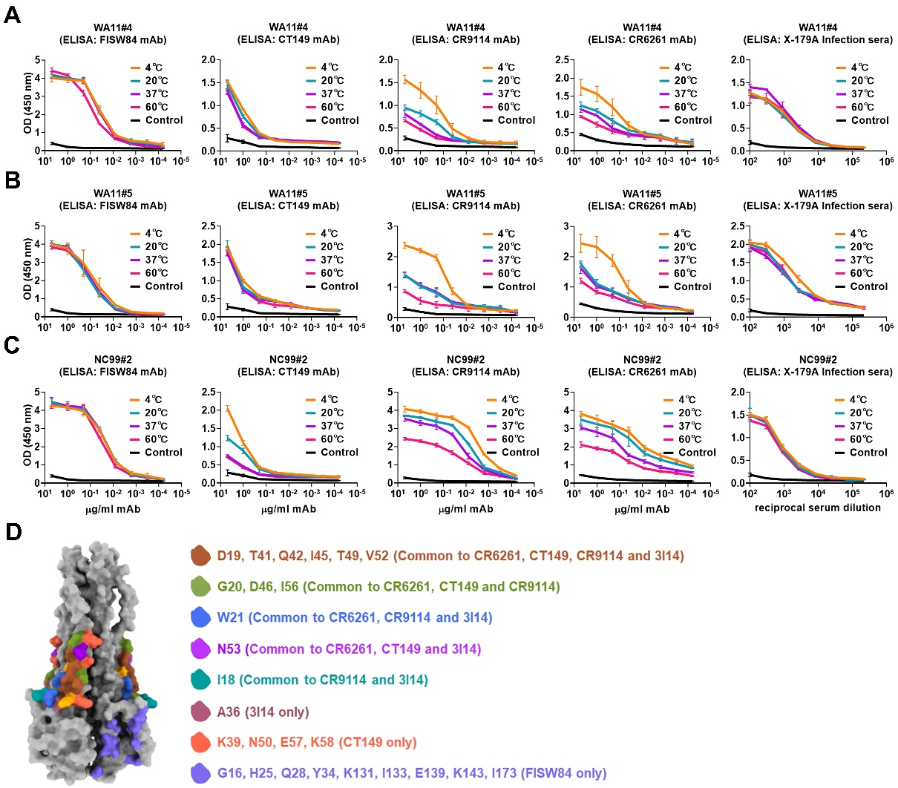
Figure S5. Thermostability analysis of disulfide bond-stabilized recombinant HA proteins by using ELISA. Recombinant H1 proteins of (A) WA11#4, (B) WA11#5, and (C) NC99#2 in sterile PBS were heat-treated at 4 °C, 20 °C, or 37 °C for 36 h, 60 °C for 30 min, before coating the 96-well immunoplates, coating immunoplates with the irrelevant protein BSA was used as the negative control for mAb binding. Thereafter the serially diluted HA stem-specific mAb FISW84, CT149, CR9114, or CR6261 was used for binding antigens, the incubation of X-179A-specific mice hyperimmune sera was used as the positive control for binding antigens. (D) Mapping the mAb footprints of CR6261, CT149, CR9114, 3I14, and FISW84, in a structure model of NC99 H1 stem that was generated by deleting the head domain in a model of complete NC99 H1 ectodomain. The sets of specific sites recognized by mAbs were listed next to the structure image. Data are presented as mean ± SD (n = 3).
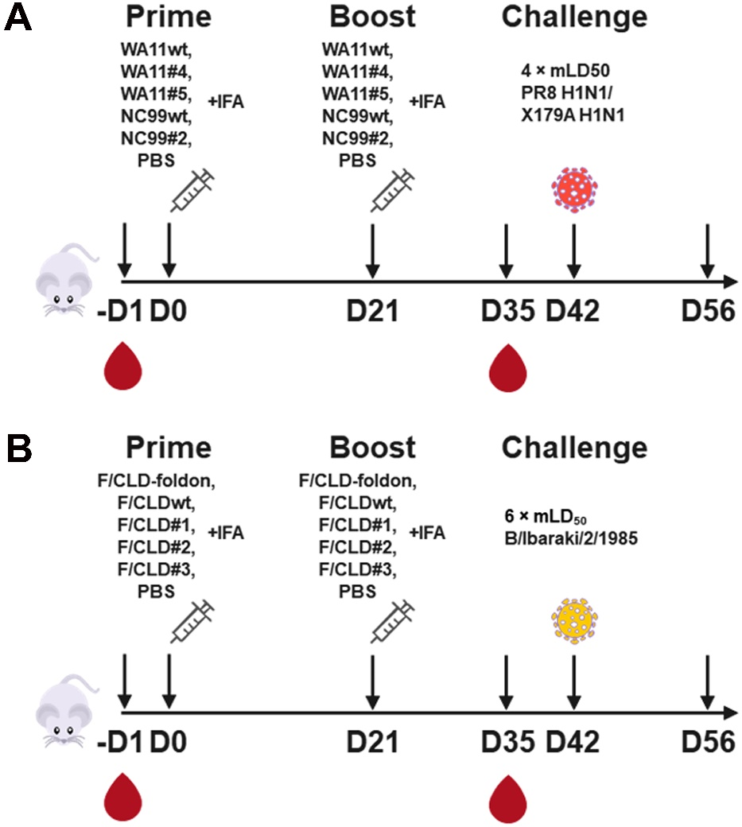
Figure S6. The immunization and viral challenge experiment regimens. Six to eight-week-old female BALB/c mice were intraperitoneally immunized twice with adjuvanted (A) recombinant H1 proteins or (B) influenza B HA proteins at a three-week interval. Three weeks post the boost immunizations at the 42nd day, the mice were intranasally infected with lethal doses of 4 × mLD₅₀ PR8, X-179A, or 6 × mLD₅₀ Iba85 viruses, and thereafter the body weight changes and survival rates were recorded in the following 14 days. One day before the prime immunization and two weeks after the boost immunizations, mice were bled for serological studies.

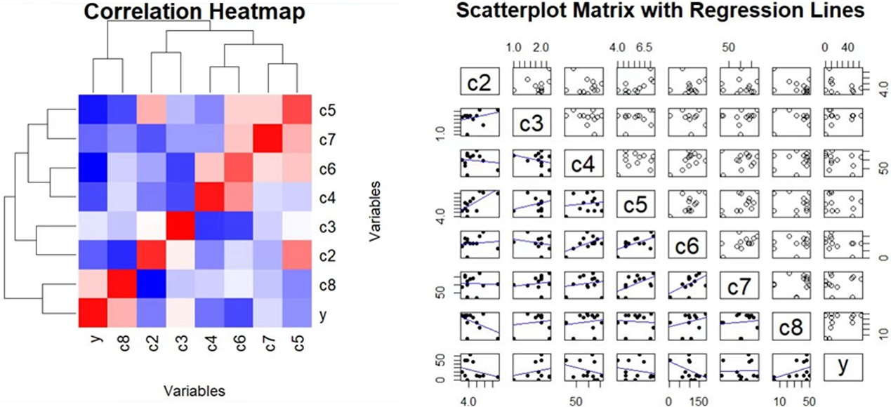
Figure S7. Regression modeling analysis. (A) Heatmap for the correlation between predictor and response variable in the disulfide bond model using H1 data; (B) Scatterplot for the correlation between predictor and response variable in the disulfide bond model using H1 data.

