Supplementary materials

Identification of EGR4 as a prospective target for inhibiting tumor cell proliferation and a novel biomarker in colorectal cancer
Bangting Wang¹*, Shijie Zhang¹*, Haiyang Wang¹, Yuwen Tao¹, Jiankun Wang¹, Mujie Ye¹, Zhining Fan¹, Yan Wang^{1#}, Li Liu^{1#}

¹Digestive Endoscopy Department, The First Affiliated Hospital with Nanjing Medical University and Jiangsu Province Hospital, Nanjing, Jiangsu, China.

*Bangting wang and Shijie Zhang contributed to this work.
#Corresponding author:
Li Liu email: kit9178@sina.com
Yan Wang email: wy_797@126.com

Keywords: EGR4, colorectal cancer, proliferation, NF-κB signaling, biomarker.

Short title: EGR4 as an original biomarker in CRC.

Figure S1. The expression of EGR4 in pan-cancer. (A) EGR4 expression in pan-cancer and adjacent normal tissue in the TCGA database. (B) The expression of EGR4 in different tumor and tumor-adjacent tissues based on UALCAN database.

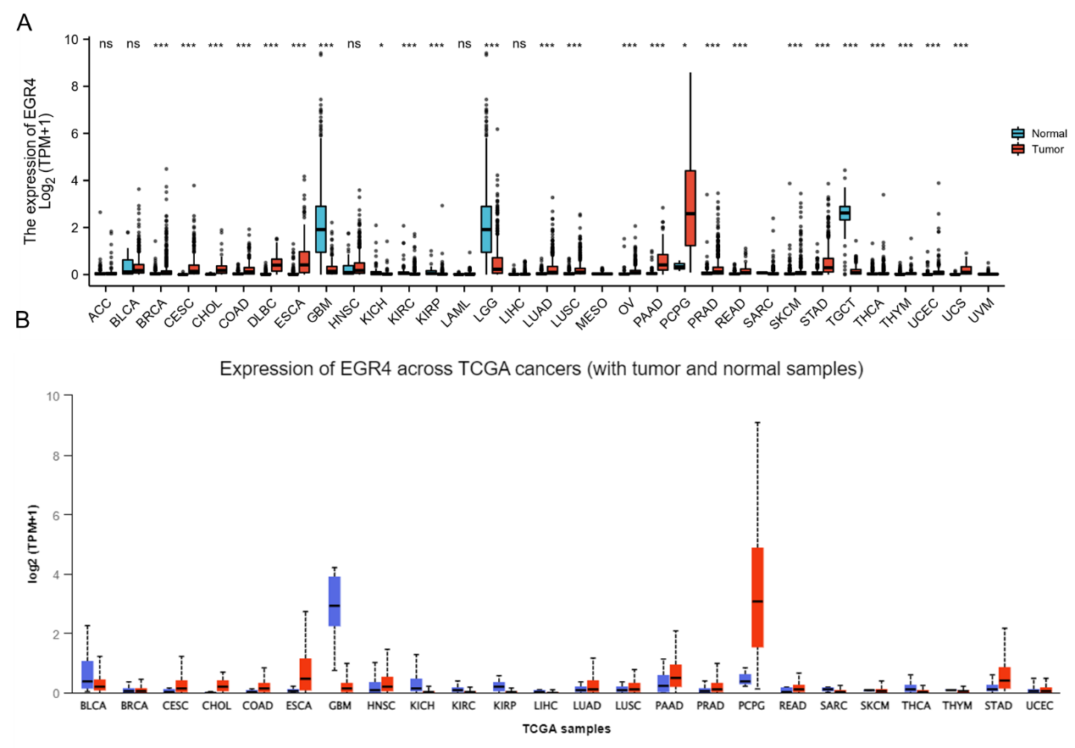

Figure S2. The expression of EGR4 in COAD and READ. (A-B) EGR4 expression was higher in COAD and READ than in the normal tissues in UALCAN. (C-D) The promoter methylation of EGR4 in CRC was lower than normal tissues. (E) Nomogram to predict the CRC survival possibility among 1 year, 3 years and 5 years. * indicates p-value < 0.05. READ, rectal adenocarcinoma; COAD, colon adenocarcinoma.

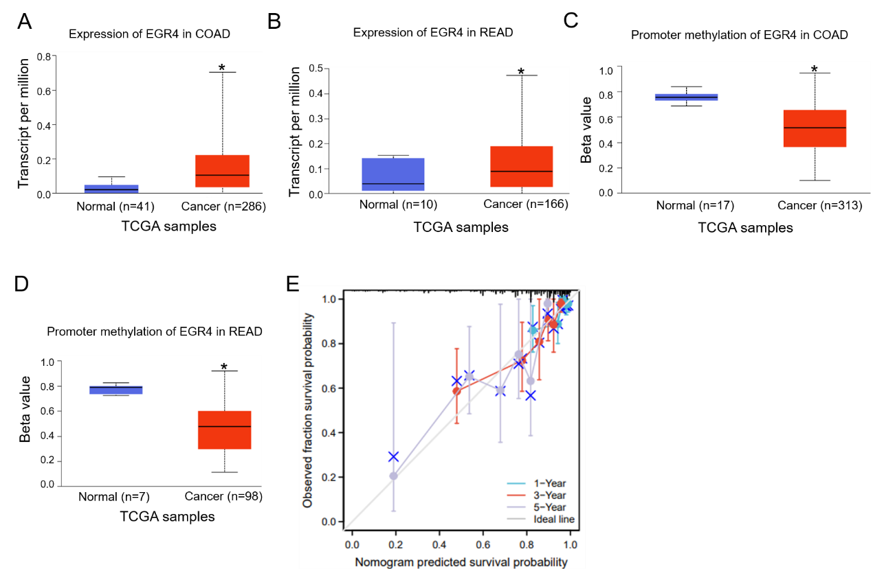

Figure S3. The genetic alterations of EGR. (A) Alterations summary of EGR4 in TCGA CRC datasets. (B-D) Summary of EGR4 structural variant, mutations, and copy-number alterations. CRC, colorectal cancer.

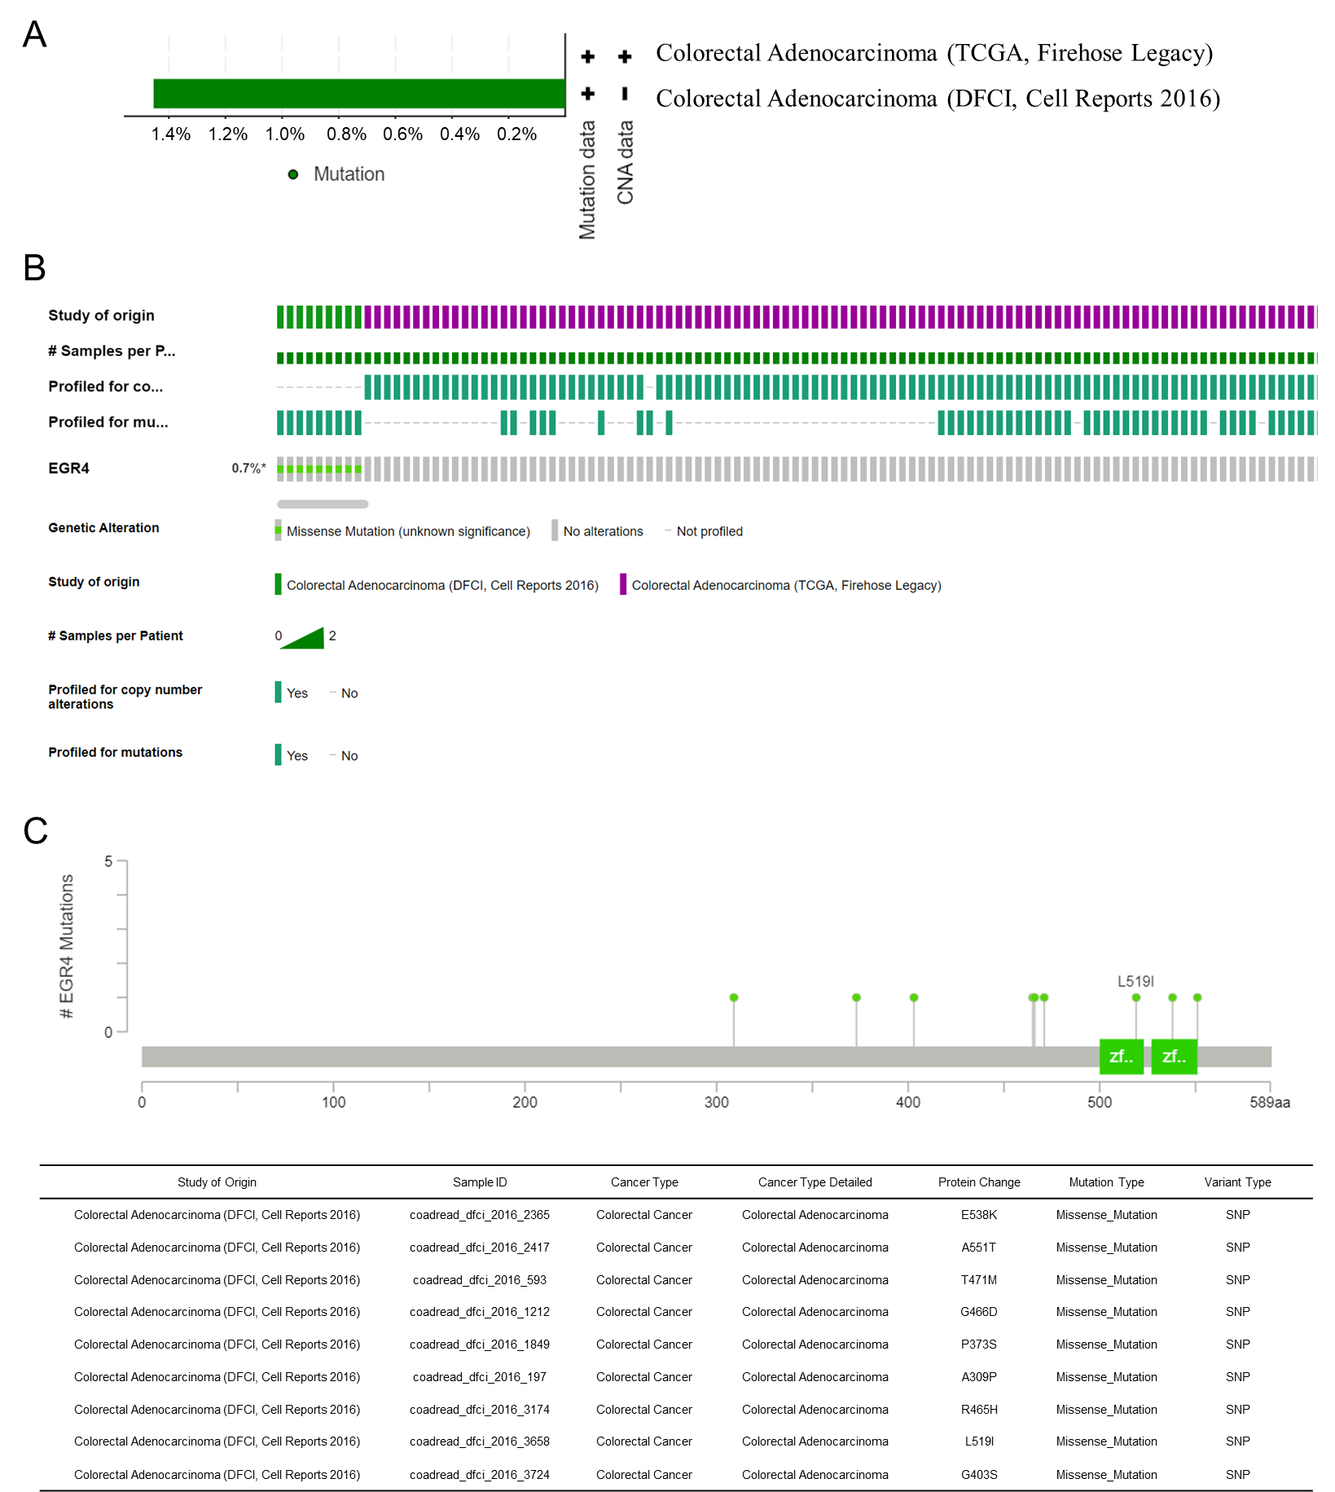

Figure S4. Relationship between somatic copy number alterations (SCNA) and immune infiltration abundance based on EGR4 expression in COAD and READ. READ, rectal adenocarcinoma; COAD, colon adenocarcinoma.
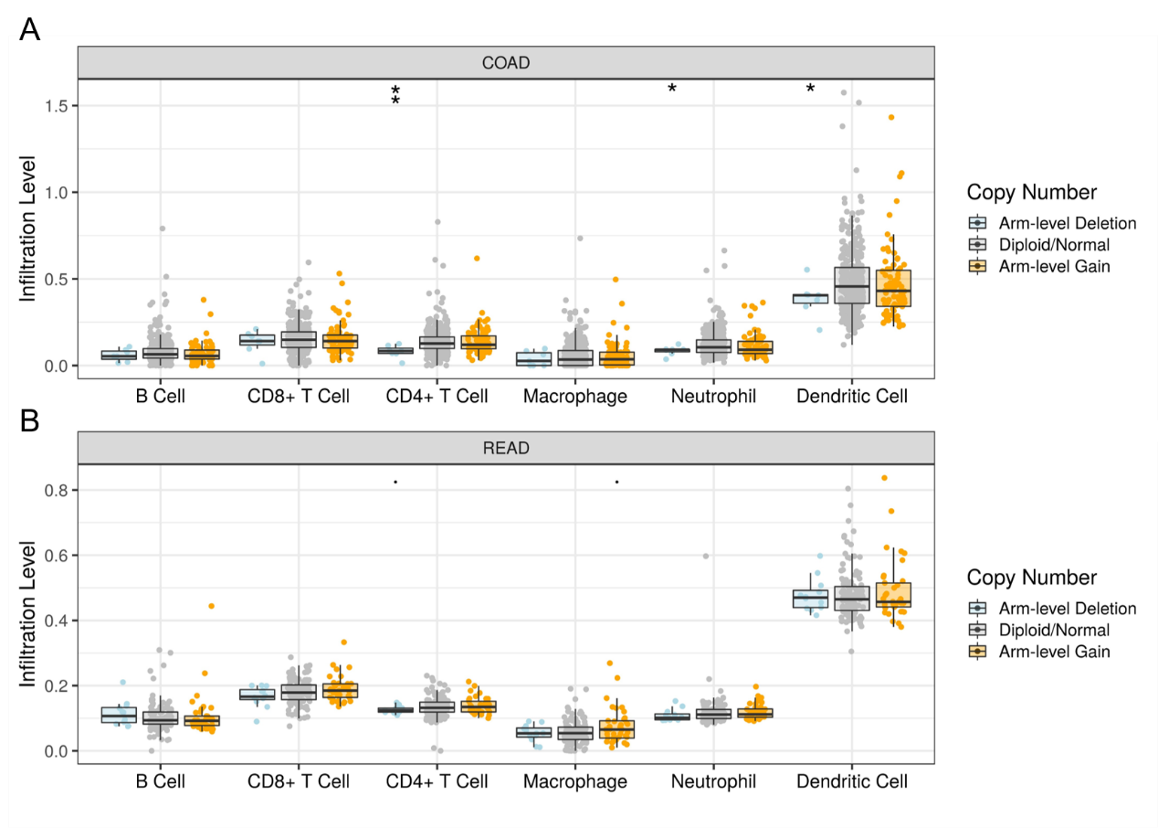

Figure S5. Relationship between EGR4 expression and immune infiltration in COAD and READ through TIMER.

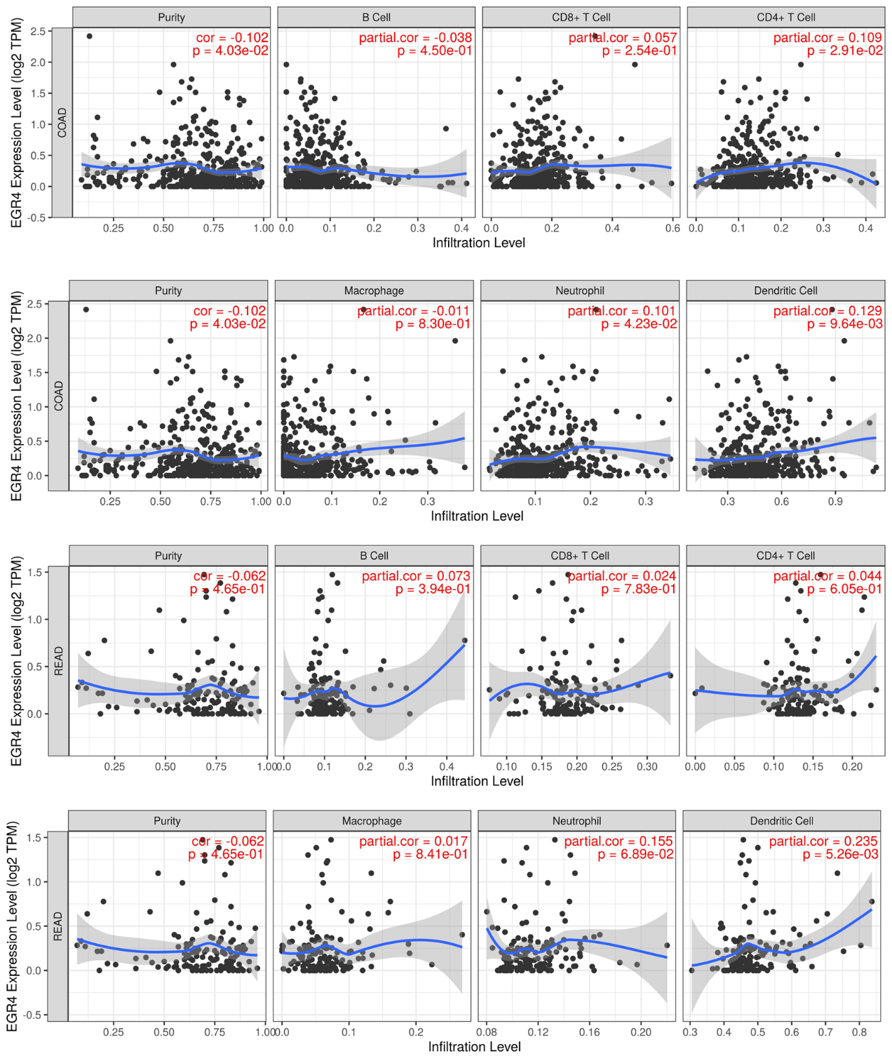

Figure S6. Association between EGR4, clinical characteristics and prognosis. (A) The bar graph showed EGR4 expression in N0 and N1-2. N: node. (B) Expression of EGR4 in different tumor stages (TI-IV). (C-D) The relationship between gender, age and OS in CRC patients. NS, none significance.

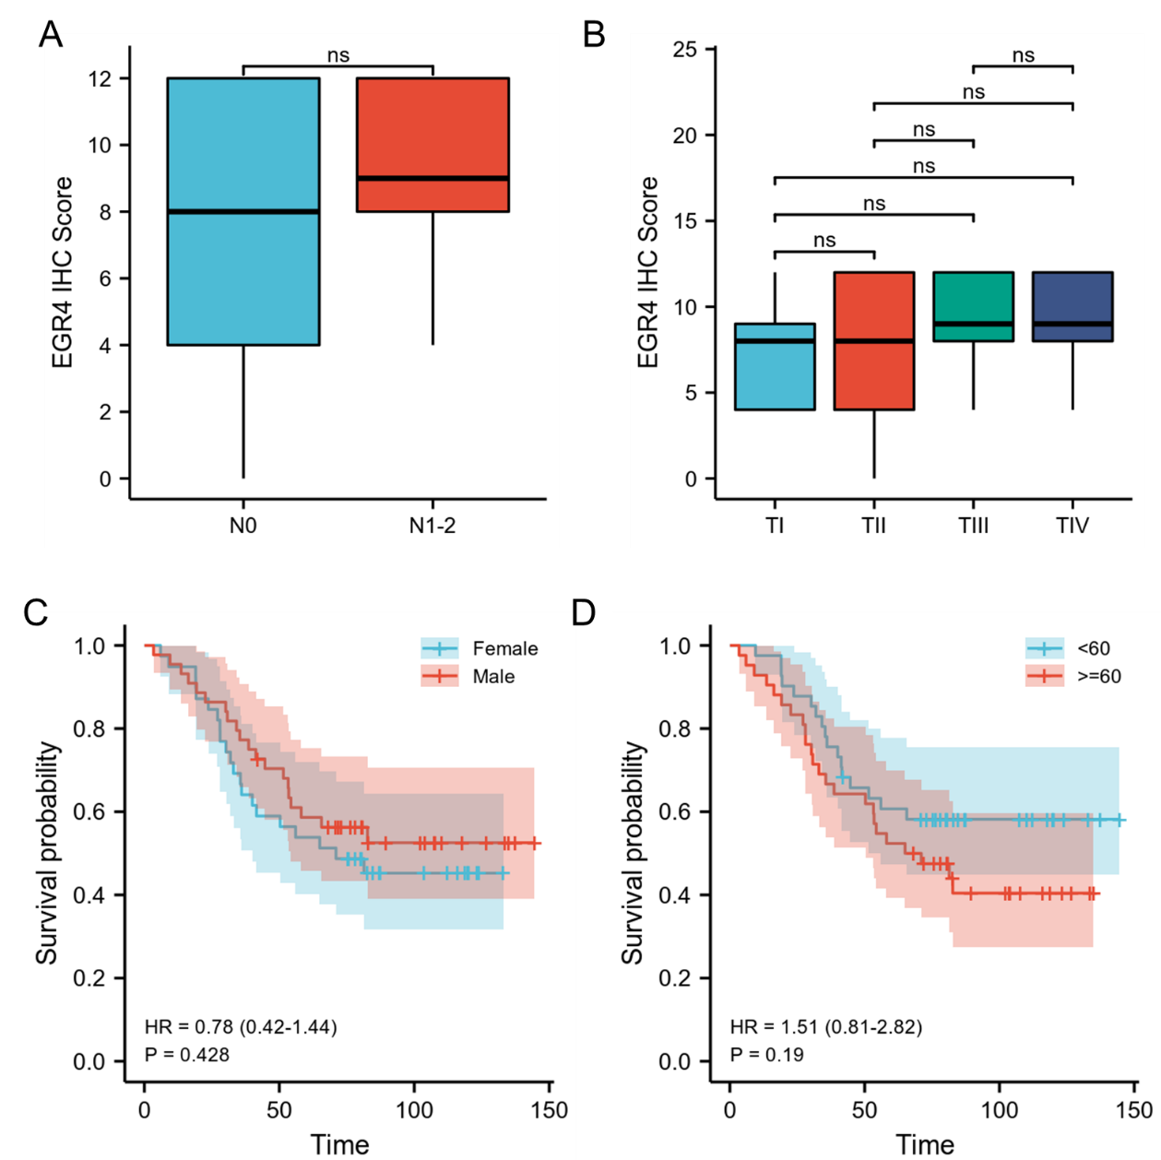

Table S1. The sequence of Primers.

Gene | Sequence
TNFa-F | CCTCTCTCTAATCAGCCCTCTG
TNFa-R | GAGGACCTGGGAGTAGATGAG
RELA-F | ATGTGGAGATCATTGAGCAGC
RELA-R | CCTGGTCCTGTGTAGCCATT
GAPDH-F | TTCACCACCATGGAGAAGGC
GAPDH-R | GGCATGGACTGTGGTCATGAG
EGR4-F | TCGTCAAGTCCACTGAAGGC
EGR4-R | GGAAGCAGGAGTCGGCTAAG

Table S2. The sequence of siRNA.

Sample | Sequence
siControl | sense 5'-UUCUCCGAACGUGUCACGUTT-3'
 | antisense 5'-ACGUGACACGUUCGGAGAATT-3'
siEGR4-1 | sense 5'-GCUUCUUCAUUCAGGCAGUTT-3'
 | antisense 5'-ACUGCCUGAAUGAAGAAGCTT-3'
 | sense 5'-GAGCAAGAGAUGGGUUUAUTT-3'
siEGR4-2 | antisense 5'-AUAAACCCAUCUCUUGCUCTT-3'

