SUPPLEMENTAL FIGURE 1: CAUSAL DIRECTED ACYCLIC GRAPH
Causal directed acyclic graph on potential confounders of pain catastrophizing

Supplemental table 1. Questions and questionnaires of PRACTICE study.

Abbreviations:
NRS: numerating rating scale
SF-36: RAND 36-item Short Form Survey
EQ-5D-5L: Euroqol-5D-5L

SUPPLEMENTAL TABLE 2: SPECIFICATION OF REGRESSION MODELS USED FOR MULTIPLE IMPUTATION WITH THE MICE PACKAGE IN R
Abbreviations:
V: variable used to correct data imputation
logreg: Logistic regression
norm: Bayesian linear regression
pass: Passive imputation (weight / length²)
pmm: Predictive mean matching
polyreg: Polytomous regression

SUPPLEMENTAL TABLE 3: BASELINE CHARACTERISTICS OF PATIENTS WITH AND WITHOUT MISSING DATA
Comparison between baseline characteristics of patients with and without missing data on PCS.
NRS: Verbal Numeric Rating Scale, NRS90: Numeric Rating Scale at day 90, PCS: Pain Catastrophizing Scale, n: Number of samples, IQR: Interquartile range, SD: Standard deviation
*p<0.05, **p<0.01, ***p<0.001, based on student's t-tests, Wilcoxon-Mann-Whitney tests, and ^{c} chi-squared tests
Low level of education: primary school, Pre-vocational secondary education, Secondary vocational education level 1 Or completion of the first three years of Senior general secondary education or Pre-university education
Intermediate level of education: graduation on senior general secondary education, pre-university education, secondary vocational education level 2-4
High level of education: Graduation at least university of applied sciences
Supplemental figure 1: Causal directed acyclic graph

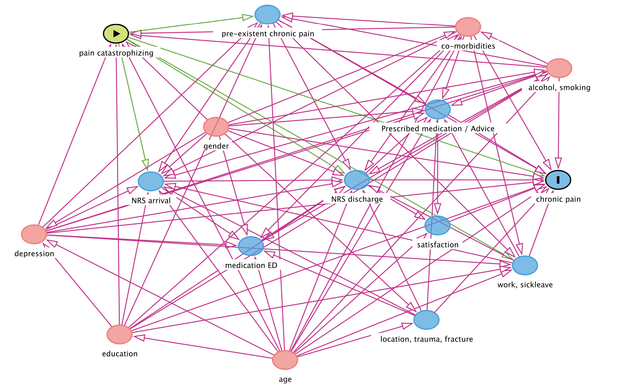
Supplemental table 1. Questions and questionnaires of PRACTICE study.

Day | NRS of pain | Patient characteristics | EQ-5D-5L | SF-36
ED-visit (0) | √ | √
1 - 6 | √ | √
7 | √ |  | √
90 | √ |  | √ | √
180 | √ |  | √ | √

Supplemental Table 2: Specification of regression models used for multiple imputation with the mice package in R
 |  |  | Covariates used for imputation
Imputed variables | Number of missings,  n (%) | Method | Age | Location | Trauma | Fracture | Satisfaction | Depression+Treatment | Depression | Depression treatment | Relationship | Chronic pain | Average alcohol | Alcohol | Education | Work+Sick leave | Work | Sick leave | Smoking | PCS | NRS0 | NRS90 | Pain chronification | Sex | PCS.Age | PCS.Sex | PCS.Depression | PCS.Deprtreatment
Age | 16 (0.8) | norm |  | v | v |  | v | v |  |  | v | v | v | v | v | v |  |  | v | v | v | v | v | v |  | v | v | v
Location | 7 (0.4) | logreg | v |  | v |  | v |  |  |  | v | v | v | v | v | v |  |  | v | v | v | v | v | v | v | v | v | v
Trauma | 628 (33.1) | logreg | v | v |  | v | v | v |  |  | v | v | v | v | v | v |  |  | v | v | v | v | v | v | v | v | v | v
Fracture | 6 (0.3) | logreg | v | v | v |  | v | v |  |  | v | v | v | v | v | v |  |  | v | v | v | v | v | v | v | v | v | v
Satisfaction with care received | 882 (46.5) | pmm | v | v | v | v |  | v |  |  | v | v | v | v | v | v |  |  | v |  | v | v | v | v | v | v | v | v
Depression+Treatment | 751 (39.6) | polyreg | v | v | v | v | v |  |  |  | v | v | v | v | v | v |  |  | v | v | v | v | v | v | v | v
Depression | 751 (39.6) | pass | v | v | v | v | v | v |  |  | v | v | v | v | v | v |  |  | v | v | v | v | v | v | v | v
Depression treatment | 751 (39.6) | pass | v | v | v | v | v | v |  |  | v | v | v | v | v | v |  |  | v | v | v | v | v | v | v | v
Relationship | 744 (39.2) | logreg | v | v | v | v | v | v |  |  |  | v | v | v | v | v |  |  | v | v | v | v | v | v | v | v | v | v
Chronic pain | 795 (41.9) | logreg | v | v | v | v | v | v |  |  | v |  | v | v | v | v |  |  | v | v | v | v | v | v | v | v | v | v
Average alcohol | 784 (41.4) | pmm | v | v | v | v | v | v |  |  | v | v |  |  | v | v |  |  | v | v | v | v | v | v | v | v | v | v
Alcohol | 784 (41.4) | pass | v | v | v | v | v | v |  |  | v | v | v |  | v | v |  |  | v | v | v | v | v | v | v | v | v | v
Education | 822 (43.4) | polyreg | v | v | v | v | v | v |  |  | v | v | v | v |  | v |  |  | v | v | v | v | v | v | v | v | v | v
Work+Sick leave | 819 (43.2) | polyreg | v | v | v | v | v | v |  |  | v | v | v | v | v |  |  |  | v | v | v | v | v | v | v | v | v | v
Work | 819 (43.2) | pass | v | v | v | v | v | v |  |  | v | v | v | v | v | v |  |  | v | v | v | v | v | v | v | v | v | v
Sick leave | 819 (43.2) | pass | v | v | v | v | v | v |  |  | v | v | v | v | v | v |  |  | v | v | v | v | v | v | v | v | v | v
Smoking | 887 (46.8) | logreg | v | v | v | v | v | v |  |  | v | v | v | v | v | v |  |  |  | v | v | v | v | v | v | v | v | v
PCS | 943 (48.3) | pmm | v | v | v | v | v | v |  |  | v | v | v | v | v | v |  |  | v |  | v | v | v | v
NRS0 | 5 (0.3) | pmm | v | v | v | v | v | v |  |  | v | v | v | v | v | v |  |  | v | v |  | v | v | v | v | v | v | v
NRS90 | 1,077 (56.8) | pmm | v | v | v | v | v | v |  |  | v | v | v | v | v | v |  |  | v | v | v |  |  | v | v | v | v | v
Pain chronification | 1,077 (56.8) | pass | v | v | v | v | v | v |  |  | v | v | v | v | v | v |  |  | v | v | v | v |  | v | v | v | v | v
Sex | 6 (0.3) | logreg | v | v | v | v | v | v |  |  | v | v | v | v | v | v |  |  | v | v | v | v | v |  | v |  | v | v
PCS.Age | 899 (47.4) | pass | v | v | v | v | v | v |  |  | v | v | v | v | v | v |  |  | v | v | v | v | v | v |  | v | v | v
PCS.Sex | 893 (47.1) | pass | v | v | v | v | v | v |  |  | v | v | v | v | v | v |  |  | v | v | v | v | v | v | v |  | v | v
PCS.Depression | 900 (47.5) | pass | v | v | v | v | v | v |  |  | v | v | v | v | v | v |  |  | v | v | v | v | v | v | v | v |  | v
PCS.Deprtreatment | 900 (47.5) | pass | v | v | v | v | v | v |  |  | v | v | v | v | v | v |  |  | v | v | v | v | v | v | v | v | v

Supplemental table 3: Baseline characteristics of patients with and without missing data
Study variables | PCS complete | PCS missing | P-value
Male, n (%) | 472 (46.9) | 501 (56.1) | <0.001***
Age, median (IQR) | 47 (31 - 59) | 43 (27 - 58) | 0.001**
mean (SD) | 45.9 (16.8) | 43.6 (17.6) | 0.005**
[n] | [1001] | [889]
NRS0, median (IQR) | 5.0 (3 - 7) | 5.0 (3 - 7) | 0.361
mean (SD) | 4.9 (2.6) | 5.0 (2.6) | 0.363
[n] | [1009] | [892]
Location, n (%)
Abdomen | 58 (5.8) | 59 (6.6) | 0.445
Upper extremities | 495 (49.2) | 437 (49.0) | 0.926
Cervical spine | 20 (2.0) | 23 (2.6) | 0.392
Head | 77 (7.7) | 93 (10.4) | 0.036*
Lower extremities | 368 (36.6) | 289 (32.4) | 0.056
Thorax | 63 (6.3) | 72 (8.1) | 0.129
Thoracic and lumbar spine | 31 (3.1) | 29 (3.3) | 0.833
Trauma, n (%) | 605 (87.8) | 493 (83.7) | 0.037*
Fracture, n (%) | 581 (57.7) | 405 (45.4) | <0.001***
Satisfaction with care received, median (IQR) | 8 (7 - 9) | 8 (7 - 8) | 0.033*
mean (SD) | 7.7 (1.6) | 7.4 (2.0) | 0.033*
[n] | [854] | [164]
Depression, n (%) | 194 (19.4) | 25 (16.8) | 0.430
Treatment, n (%) | 54 (27.8) | 7 (28.0) | 0.987
Relationship | 705 (70.0) | 94 (63.1) | 0.103
Chronic pain in other location, n (%) | 231 (23.3) | 21 (18.6) | 0.232
Alcohol consumption, n (%) | 487 (48.6) | 53 (46.5) | 0.670
Consumption per week, median (IQR) | 0 (0 - 1) | 0 (0 - 1) | 0.669
mean (SD) | 0.5 (0.5) | 0.5 (0.5) | 0.670
[n] | [1002] | [114]
Education
None | 14 (1.4) | 0 (0.0) | <0.001***
Low | 23 (2.3) | 5 (6.6) | 0.144
Intermediate | 546 (54.5) | 38 (50.0) | 0.455
High | 419 (41.8) | 33 (43.4) | 0.787
Employment | 775 (77.1) | 55 (72.4) | 0.376
Sickleave | 385 (49.7) | 16 (29.1) | 0.002**
Smoking, n (%) | 158 (16.0) | 5 (18.5) | 0.744

