Table 2: Differing reactivity of BTNX and DanceSafe FTS in street drug samples spiked with fentanyl analogs
Spiked compound | Standard solution |  | Cocaine |  |  | Heroin
Spiked compound | DS | BTNX | FTS images | DS | BTNX | FTS images | DS | BTNX
Water | neg | neg | 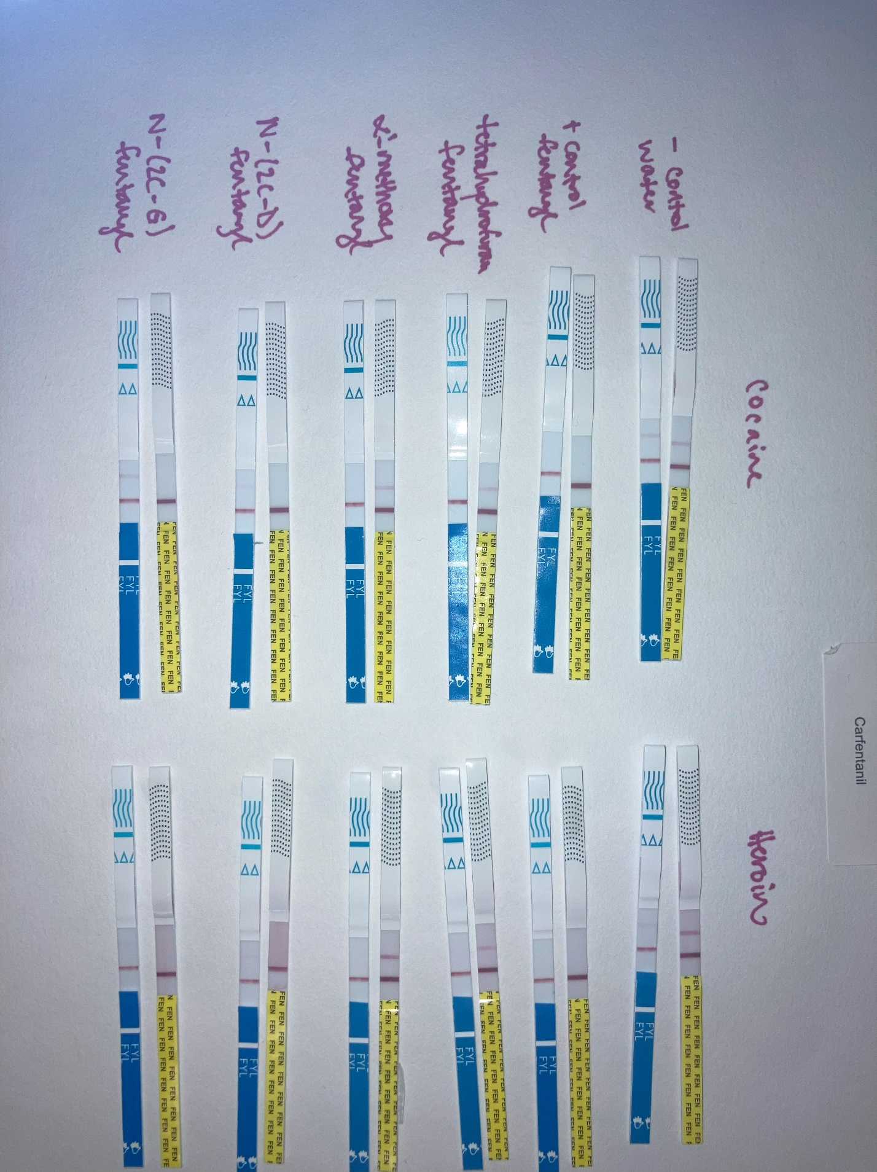 | neg | neg | 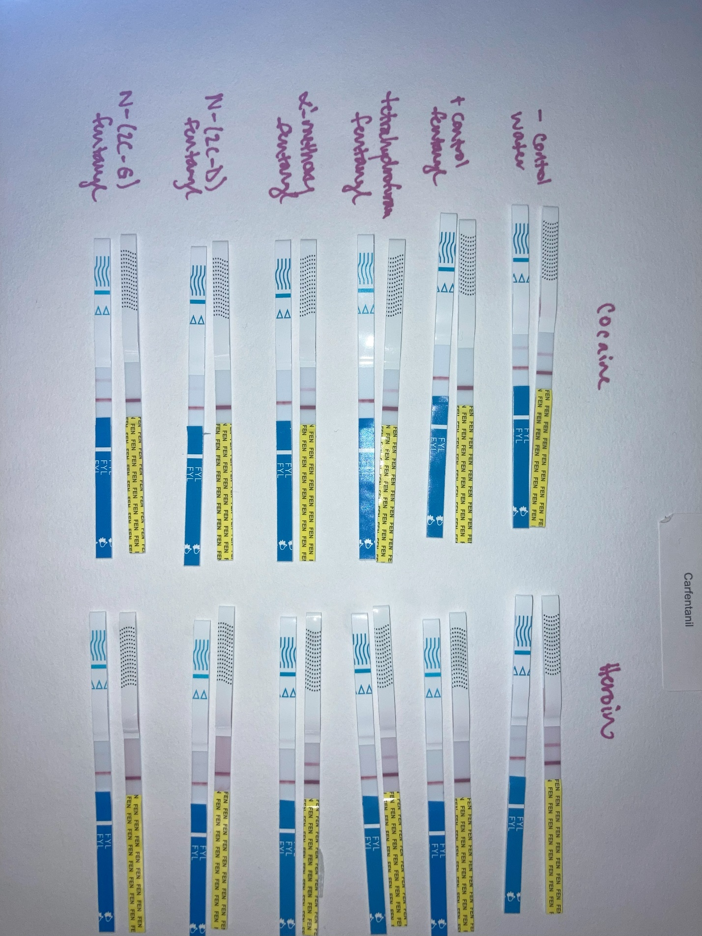 | neg | neg
Fentanyl | pos | pos |  | pos | pos |  | pos | pos
Tetrahydrofuran fentanyl | neg | pos |  | neg | pos | 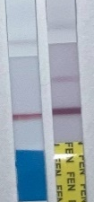 | neg | pos
α’- methoxy fentanyl | neg | pos |  | neg | pos |  | neg | pos
N-(2C-D) fentanyl | pos | neg |  | pos | neg |  | pos | neg*
N-(2C-G) fentanyl | pos | neg |  | pos | neg |  | pos | neg*
N-(3,4,5-TMA) fentanyl | pos | neg | 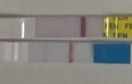 | pos | neg | 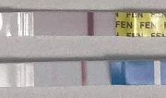 | pos | neg

