Supplemental Figure
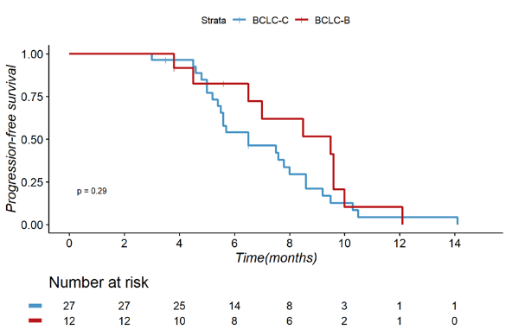 | 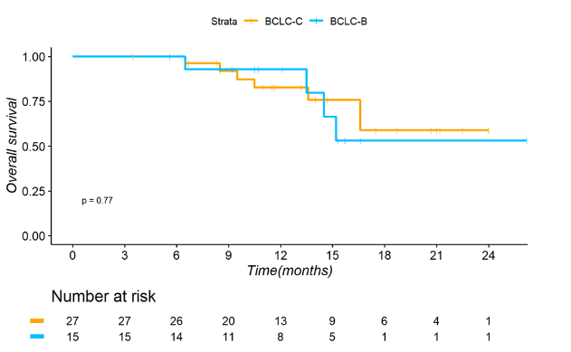
Supplementary Figure 1
Kaplan-Meier analyses of progression-free survival and overall survival according to BCLC stage (B and C) in the patients receiving dual therapy of PD-1 inhibitor and TACE
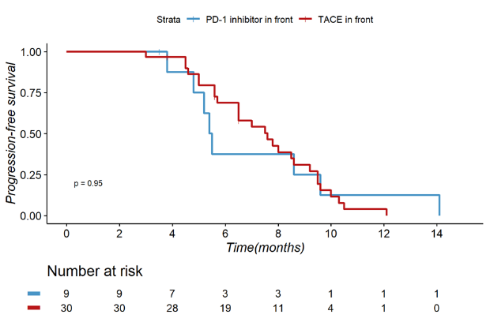 | 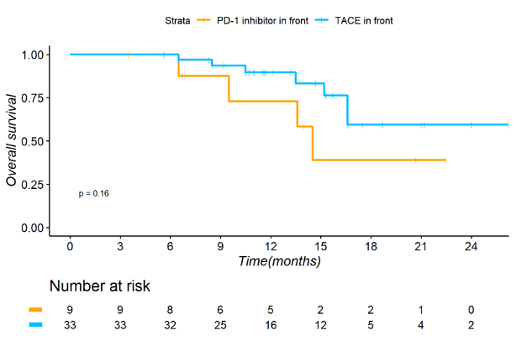
Supplementary Figure 2
Kaplan-Meier analyses of progression-free survival and overall survival according to the sequence of use of PD-1 inhibitor and TACE (TACE in front and PD-1 inhibitor in front) in the patients receiving dual therapy of PD-1 inhibitor and TACE
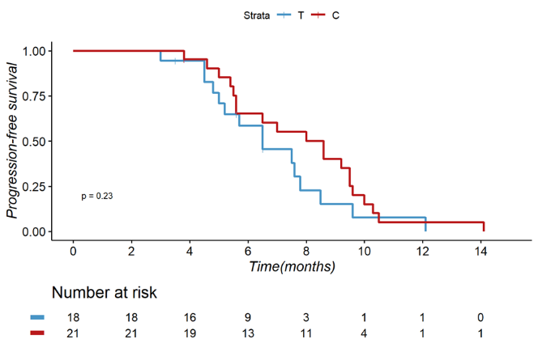 | 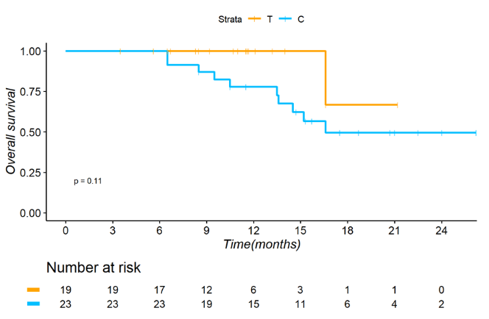
Supplementary Figure 3
Kaplan-Meier analyses of progression-free survival and overall survival according to different PD-1 inhibitors (Tislelizumab and Camrelizumab) in the patients receiving dual therapy of PD-1 inhibitor and TACE
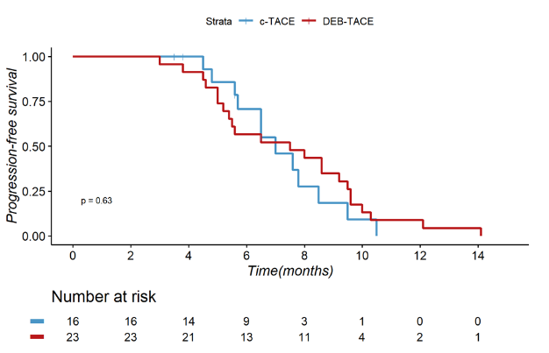 | 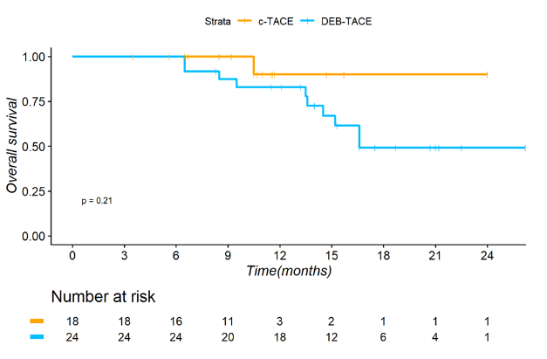
Supplementary Figure 4
Kaplan-Meier analyses of progression-free survival and overall survival according to different TACE types (c-TACE and DEB-TACE) in the patients receiving dual therapy of PD-1 inhibitor and TACE
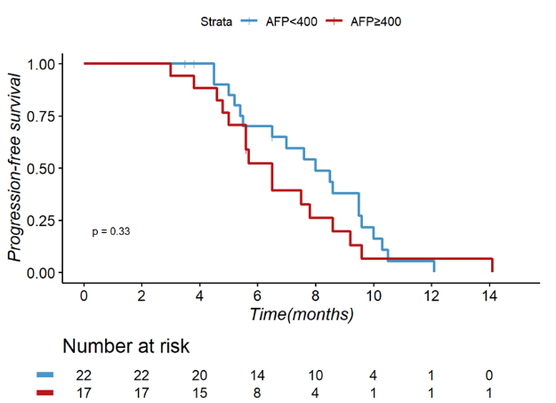 | 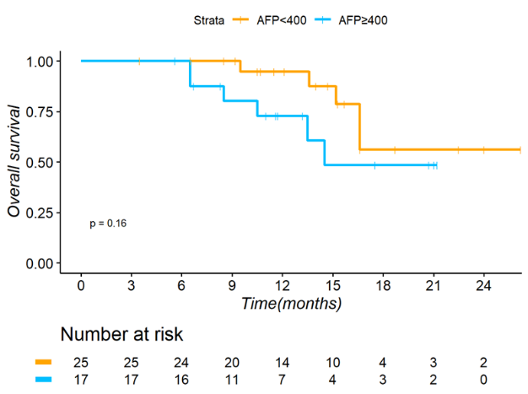
Supplementary Figure 5
Kaplan-Meier analyses of progression-free survival and overall survival according to AFP(AFP＜400ng/ml and AFP≥400ng/ml) in the patients receiving dual therapy of PD-1 inhibitor and TACE

