Supporting Information for
Boron nitride whiskers and nano alumina synergistically enhancing the vertical thermal conductivity of epoxy-cellulose aerogel nanocomposites
Zhaoyang Li,^{1,2} Duo Pan,^{1,*} Ziyuan Han,¹ D. Jaya Prasanna Kumar,³ Juanna Ren,^{4,7} Hua Hou,⁴ Zeinhom M. El-Bahy,⁵ Gaber A. M. Mersal,⁶ Ben Bin Xu,⁷ Yongzhi Liu,¹ Chuntai Liu,¹ and Mohamed M. Ibrahim⁶
¹ Key Laboratory of Materials Processing and Mold (Zhengzhou University), Ministry of Education; National Engineering Research Center for Advanced Polymer Processing Technology, Zhengzhou University, Zhengzhou, 450002, China

² Shangqiu Normal University, Shangqiu, 476000, China
³ Department of Chemical Engineering, Ramaiah Institute of Technology, Bengaluru-560054, India
⁴ College of Materials Science and Engineering, Taiyuan University of Science and Technology, Taiyuan, 030024, China
⁵ Department of Chemistry, Faculty of Science, Al-Azhar University, Nasr City 11884, Cairo, Egypt
⁶ Department of Chemistry, College of Science, Taif University, P.O. Box 11099, Taif 21944, Saudi Arabia.
⁷ Mechanical and Construction Engineering, Faculty of Engineering and Environment, Northumbria University, Newcastle Upon Tyne, NE1 8ST, UK

* Corresponding author: panduonerc@zzu.edu.cn (D. Pan)
Fig. S1 Preparation flow diagram of BNWK@Al₂O₃/CA/EP composite

Fig. S2 Compression stress relaxation fitting curves of (a) CA, (b) BNWK/CA and (c-f) BNWK@Al₂O₃/CA with different quality ratios (BNWK/Al₂O₃) of 1:1, 1:3, 1:5 and 1:7
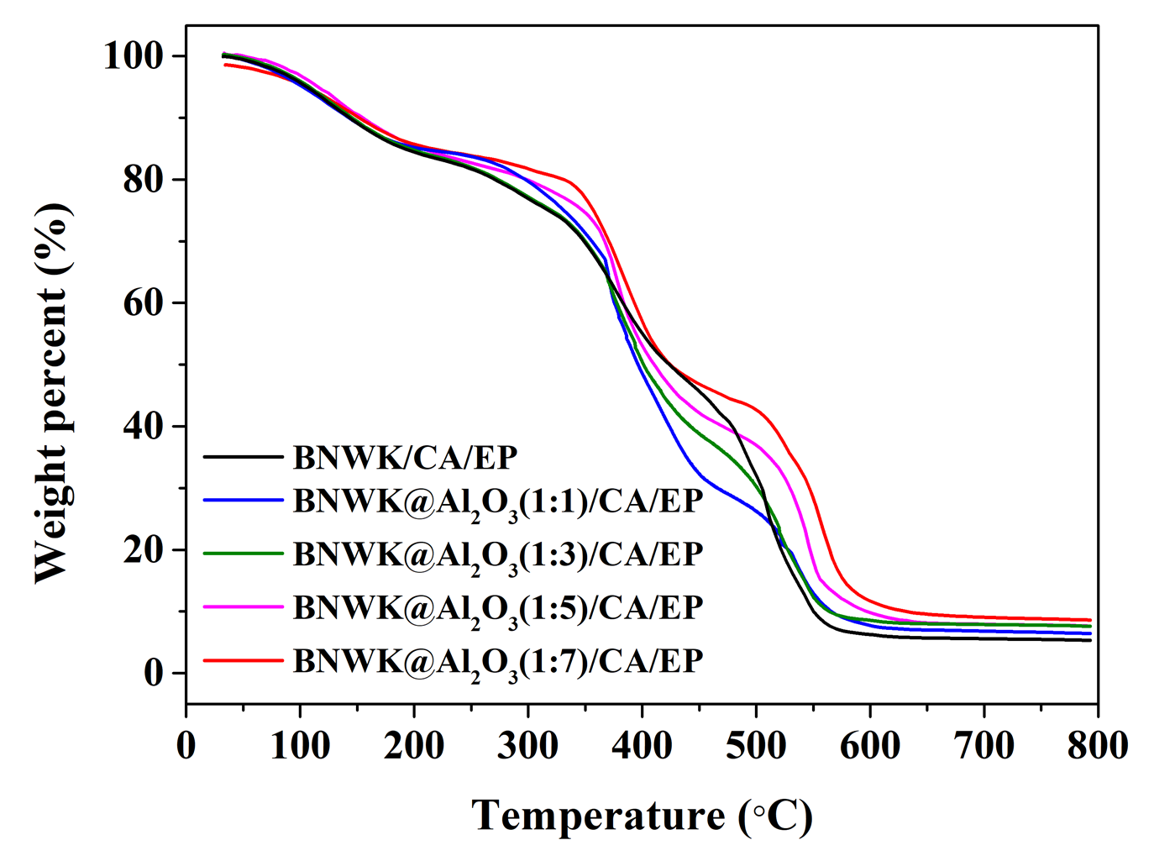
Fig. S3 TGA curve of BNWK/CA/EP and BNWK@Al₂O₃/CA/EP with different quality ratios (BNWK/Al₂O₃) of 1:1, 1:3, 1:5 and 1:7

Effective Medium Theory (EMT)
EMT is used to fit the relationship between the interface thermal resistance from filler/matrix and the thermal conductivity as shown in Equation (S1):
$K_{c}=K_{m}+\frac{aφ_{f}K_{m}}{3\left(a+\frac{R_{itr}K_{f}}{L}\right)}$ (S1)
where K_{c}, K_{f} and K_{m} are the thermal conductivity of composite, filler and matrix, respectively. To simplify the calculation, φ_{f} is replaced by the mass of the filler, R_{itr} is the interfacial thermal resistance at filler/matrix interface, L and a are the average diameter length and diameter-thickness ratio of filler, respectively.
This work mainly studies the thermally conductive performance of different composites with different architectures in the vertical direction, so the spatial structure can be simplified into a two-dimensional model. With the help of transient finite element method and all system models adopt the same loading sub-step. The governing equation is follows:[1]
$ρC_{p}\frac{∂T}{∂t}=\frac{∂}{∂x}\left(k\frac{∂T}{∂x}\right)+\frac{∂}{∂y}\left(k\frac{∂T}{∂y}\right)$ (S2)
Initial conditions:
${\left.T\right|}_{t=0}=T_{0}$ (S3)
Temperature boundary conditions:
${\left.T\right|}_{Γ}=T_{1}$ (S4)
Heat flux boundary conditions:
${\left.-k\frac{∂T}{∂n}\right|}_{Γ}=q$ (S5)
where ρ stands for density, C_{p} represents specific heat and k stands for thermal conductivity.[2] Combining the heat conduction mechanism of Fig. 7a, the total heat flow can be calculated by numerical integration at the bottom of the applied temperature according to the Fourier equation:[3]
$k=\frac{q}{{∆T}/{∆x}}$ (S6)
where q is the heat flow density, $∆$T and $∆$x are the temperature gradient and the distance between the two sides of the model.

1. Hatami M, Ghasemi S (2021) Thermophoresis and Brownian diffusion of nanoparticles around a vertical cone in a porous media by Galerkin finite element method (GFEM). Case Stud Therm Eng 28:101627 https://doi.org/10.1016/j.csite.2021.101627
2. Gupta US, Dhamarikar M, Dharkar A, Tiwari S, Namdeo R (2020) Study on the effects of fibre volume percentage on banana-reinforced epoxy composite by finite element method. Adv Compos Hybrid Mater 3:530-540 https://doi.org/10.1007/s42114-020-00179-9
3. Zhang C, Guo Z (2019) Discrete unified gas kinetic scheme for multiscale heat transfer with arbitrary temperature difference. Int J Heat Mass Transfer 134:1127-1136. https://doi.org/10.1016/j.ijheatmasstransfer.2019.02.056

