Supplementary Information
Solution-processed efficient organic upconversion device for direct NIR imaging

Shilong Dong¹, Yi Zhang^{1,2}, Zehong Wang¹, Zichun Zhou¹, Lei Zhu¹, Hongliang Zhong¹, Feng Liu¹, and Xuesong Jiang¹*

1. School of Chemistry & Chemical Engineering, Frontiers Science Center for Transformative Molecules, State Key Laboratory for Metal Matrix Composite Materials, Shanghai Jiao Tong University, Shanghai 200240, China
2. Key Laboratory of Green and Precise Synthetic Chemistry and Applications, Ministry of Education, Department of Chemistry, Huaibei Normal University, Huaibei 235000, China
*Corresponding author: Xuesong Jiang, Ph.D. Professor, E-mail: ponygle@sjtu.edu.cn

Materials
The synthesis of donor polymer 66-PTB, belonged to a class of narrow bandgap donor polymer, is described in reference¹ and the matched acceptor IEICO-4F was purchased from Nanjing Zhiyan Technology Co., Ltd，China. PEDOT:PSS Al 4083 was purchased from Heraeus Ltd. The electron blocking polymer Poly(9,9-dioctylfluorene-alt-N-(4-sec-butylphenyl)-diphenylamine) (TFB) and light-emitting polymer Poly(9,9-dioctylfluorene-alt-benzothiadiazole) (F8BT) were purchased from Volt-Amp optoelectronics tech, China. 2,4,6-Tris[3-(diphenylphosphinyl)phenyl]-1,3,5-triazine (PO-T2T) and 1-Chloronaphthalene (CN) were purchased from Adamas-beta®. Fluorinated nonionic surfactants FS-31 was purchased from Dupont Co., Ltd. Zinc acetate dihydrate (Zn(CH₃COO)₂·2H₂O), ethanolamine, chlorobenzene (CB), and 2-methoxyethanol were purchased from Shanghai Bide Pharmaceutical Technology Co., Ltd.
ZnO precursor solution was formed by dissolving 1000 mg of zinc acetate dihydrate (Zn(CH₃COO)₂·2H₂O) and 280 μL of ethanolamine in 10 ml of 2-methoxyethanol with stirring overnight. Modified PEDOT:PSS was formed by mixing PEDOT:PSS, isopropanol, FS-31 in various ratio and stirring overnight.
In a nitrogen-filled glovebox, the 66-PTB:IEICO-4F (1:1.5, w/w) mixture was dissolved in chlorobenzene (CB) with a donor polymer concentration of 8 mg mL⁻¹. 1-Chloronaphthalene (CN) (volume ratio 1%) was chosen as the solvent additive. TFB, F8BT, PO-T2T were dissolved in p-xylene, chlorobenzene and methanol, respectively, to prepare solutions with concentrations of 5 mg mL⁻¹, 7.5 mg mL⁻¹, 2.5 mg mL⁻¹, respectively.
All reagents were obtained from commercial sources and used as received without further purification unless otherwise specified.
Biological specimens for imaging application were purchased from Luo Yang Ji Min Co.Ltd.

Device fabrication
The s-UCD was assembled with detection unit and emission unit, with a structure of ITO/66-PTB:IEICO-4F/PEDOT:PSS/TFB/F8BT/PO-T2T/LiF/Al. The whole device was formed via solution spin-coating except evaporated electrodes. After spin-coating ZnO precursor on the cleaned ITO substrates, the substrates were transferred to a hot plate immediately for thermal annealing (180°C, 20 min). The glass samples were then transferred to the glove box and spin-coated 66-PTB:IEICO-4F (2500 RPM, and thermal annealing for 100°C, 10 min ). After that, the samples were removed from the glove box, spin-coated with modified PEDOT:PSS solution, and annealed at 80°C for 10 min in a vacuum oven. After transferred to the glove box, an electron-blocking layer was spin-coated on to the PEDOT:PSS at 3000 RPM for 60 s using a TFB solution followed by heat treatment at 120 °C for 10 min. After the deposition of the TFB layer, F8BT solution was spin- coated at 2000 RPM, followed by heat treatment at 120 °C for 10 min. The PO-T2T film was spin cast at 3000 RPM to finish the solution process. Finally, 0.9 nm LiF and 100 nm Al were sequentially deposited to form electrode. The active area was 0.06 cm² and 1 cm².
The OPD (ITO/66-PTB:IEICO-4F/PEDOT:PSS/Ag) assembly process is similar to the first half of the UCD preparation process. After spin-coated with modified PEDOT:PSS solution and annealed at 80°C for 10 min in a vacuum oven. 120 nm Ag was thermally evaporated onto the PEDOT:PSS layer as the top electrode. The active area was 0.06 cm².
The assembly process of the flexible s-UCD device is similar to that of normal s-UCD, except that the glass substrate was replaced with the ITO-PET flexible substrate, and the annealing temperature at each step was appropriately decreased. The active area was 1 cm².
The s-UCD, and OPD devices were encapsulated using UV-curable adhesives and UV lamps before testing in atmospheric environments.

Measurements and instruments
UV–vis absorption spectra were recorded on a PerkinElmer LAMBDA 750s with films on the quartz plates at room temperature. TEM and EDS in cross-sectional high-resolution TEM were carried out on a FEI Talos F200X G2 transmission electron microscope. The ultrathin sectioning of encapsulated UCDs was prepared by FIB-SEM (TESCAN ORSAY HOLDING, a.s. The Czech Republic) methods. AFM measurements were performed using a Dimension Icon AFM instrument (Bruker) in the tapping mode.

Device characterization
The current–voltage (J–V) curves of OPVs were measured with Keithley 2400 Source under the illumination of AM 1.5G irradiation (100 mW cm⁻²) using a 150 W solar simulator (DM 40S3, SAN-EI ELECTRIC, Japan) in a glove box at room temperature. During the test, an aperture with an area of 3.2 mm² is used to calibrate the device area.
The current–voltage (J–V) curves of OPD, and UCD were measured with Keithley 2400 Source in the dark and under various infrared lasers of different wavelength and power. The external quantum efficiency (EQE) measurement was conducted on a TRACQ-BASIC System using a lock-in amplifier with a monochromator and 500 W xenon lamp. A calibrated silicon detector (PRL-12, Newport, USA) with a known photo-response was utilized as a reference. Response time was measured under a background illumination provided by the NIR-LED (808 nm) light source. Pulsed light was provided by an arbitrary wave generator (AFG322C, Tektronix). The photovoltage traces were registered by the oscilloscope (AFG322C, Tektronix).
The current-voltage-luminance (J-V-L) curves and emission spectrum of s-UCDs were measured with Keithley 2400 Source, Luminance Meter (LS-160, Minolta, Japan) and Fiber Optic Spectrometer (USB-2000+, Ocean Optics, USA). NIR power was calibrated by optical power meter (PM100D, Thorlab, USA) before J-V-L and p-p efficiency test. Upconversion response time obtained by steady-state transient fluorescence spectrometer (FLS1000, Edinburgh Instruments, UK), and the excitation light source was an 808 nm femtosecond laser.

Calculation method and formula
Linear dynamic range (LDR)
Typically, the LDR can be calculated by the Equation:
$LDR=20log\frac{J_{upper}}{J_{lower}}$ (S1)
Where J_{upper} and J_{lower} stand for the corresponding current density measured at the maximum and minimum irradiance that beyond or below the device’s signal–irradiance relation deviates from linearity.

Responsivity (R)
The responsivity (R) of a photodetector is an important figure-of-merit that characterizes the ratio of electrical output to optical input². Quoted in ampere produced per watt of incident light, R can be calculated as follows:
$R=\frac{EQE}{100\%}×\frac{λ}{1240 (nm W A^{-1} )}$ (S2)
where λ is the wavelength of the incident light in nanometer.

Specific detectivity (D*)
The specific detectivity (D*), quoted in cm Hz^{1/2} W⁻¹ or Jones, illustrates the sensitivity of a photodetector to weak optical signals, which is given by:
$D^{*}=\frac{R\sqrt{AB}}{i_{n}}=\frac{R\sqrt{A}}{S_{n}}$ (S3)
where A is the active device area in cm², B is the bandwidth in Hz, i_{n} is the noise current in A, and S_{n} is the noise current spectral density in A Hz^{−1/2}. The S_{n} can be calculated from the current–voltage characteristics in the dark condition. Mostly, the shot noise has a major contribution under reverse bias, and the shot-noise-limited specific detectivity (D*_{sh}) can be calculated by:
$D_{sh}^{*}=\frac{R\sqrt{A}}{\sqrt{2qi_{d}}}=\frac{R}{\sqrt{2qJ_{d}}}$ (S4)
where q, i_{d}, and J_{d} are elementary charge, dark current, and dark current density, respectively.

Photon-photon conversion efficiency (p-p efficiency)
p-p efficiency by the equation:
$η_{p-p}=\frac{\int{\frac{I(λ_{vis})λ_{vis}}{R\left(λ_{vis}\right)hc}}dλ_{vis}}{\frac{λ_{NIR }P_{NIR}}{hc}}$ (S5)
where I(λ_{vis}) and R(λ_{vis}) are the photocurrent and photo-responsivity of the photodetector which is used to collect emitted photons from the emission unit, respectively. λ_{vis}, λ_{NIR}, P_{NIR}, h, and c are the wavelength of emitted visible light, the wavelength and power of the incident NIR light, the Planck constant, and the speed of light, respectively.

Power-power conversion efficiency (w-w efficiency)
w-w efficiency by the equation:
$η_{w-w}=\frac{P_{VIS}}{P_{NIR}}×100\%$ (S6)
where P_{vis} is an emitted visible power and P_{NIR} is an incident NIR power.

Luminance linear dynamic range (L-LDR)
Typically, the L-LDR can be calculated by the Equation:
$LDR=20log\frac{L_{upper}}{L_{lower}}$ (S7)
Where L_{upper} and L_{lower} stand for the corresponding upconversion luminance measured at the maximum and minimum irradiance beyond or below which the device signal–irradiance relation deviates from linearity.

Interface engineering for structural optimization of NIR detection unit

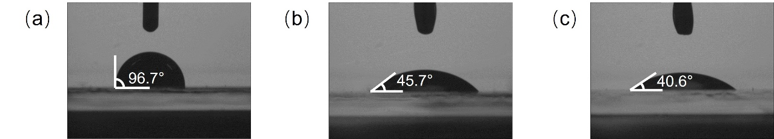
Supplementary Fig.S1 Contact angles of modified PEDOT:PSS spread on 66-PTB:IEICO-4F blend layer (a) PEDOT:PSS Al 4083 (b) PEDOT:PSS Al 4083:0.3wt% FS-31 (c) PEDOT:PSS Al 4083:IPA: 0.3wt% FS-31

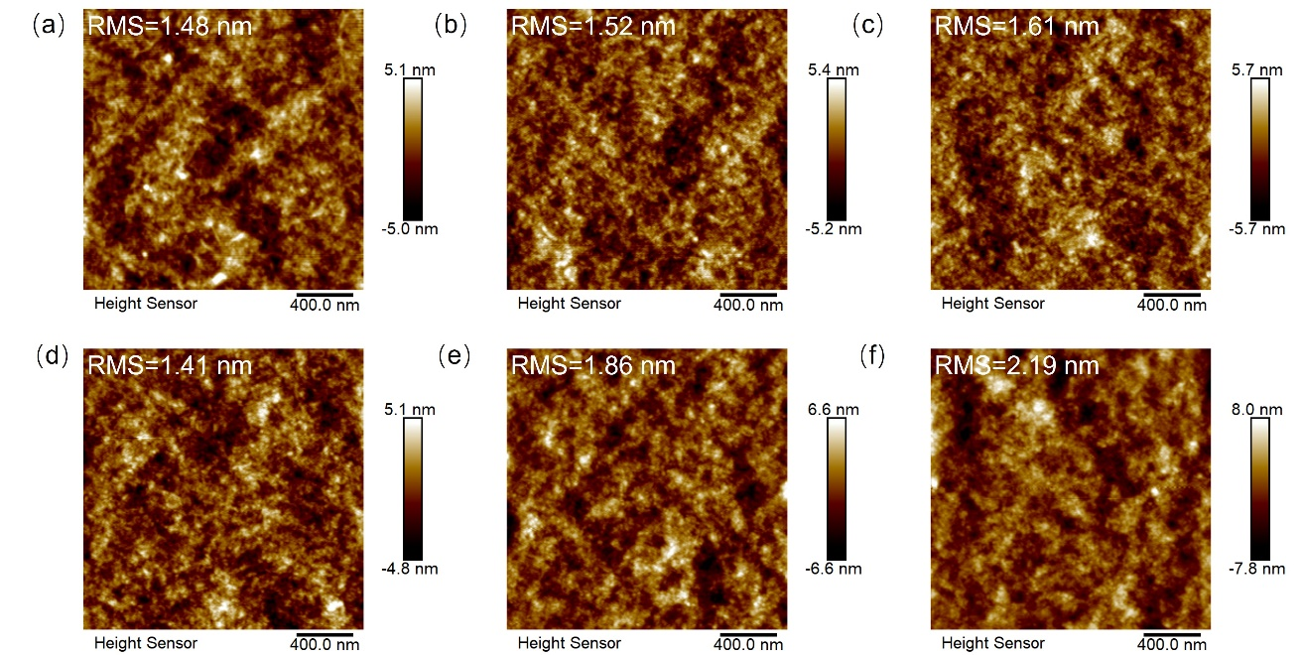
Supplementary Fig.S2 AFM height images of modified PEDOT:PSS spread on 66-PTB:IEICO-4F blend layer (a) PEDOT:PSS Al 4083:0.3wt% FS-31 (b) PEDOT:PSS Al 4083:0.6wt% FS-31 (c) PEDOT:PSS Al 4083:1wt% FS-31 (d) PEDOT:PSS Al 4083:IPA: 0.3wt% FS-31 (e) PEDOT:PSS Al 4083:IPA: 0.6wt% FS-31 (f) PEDOT:PSS Al 4083:IPA: 1wt% FS-31

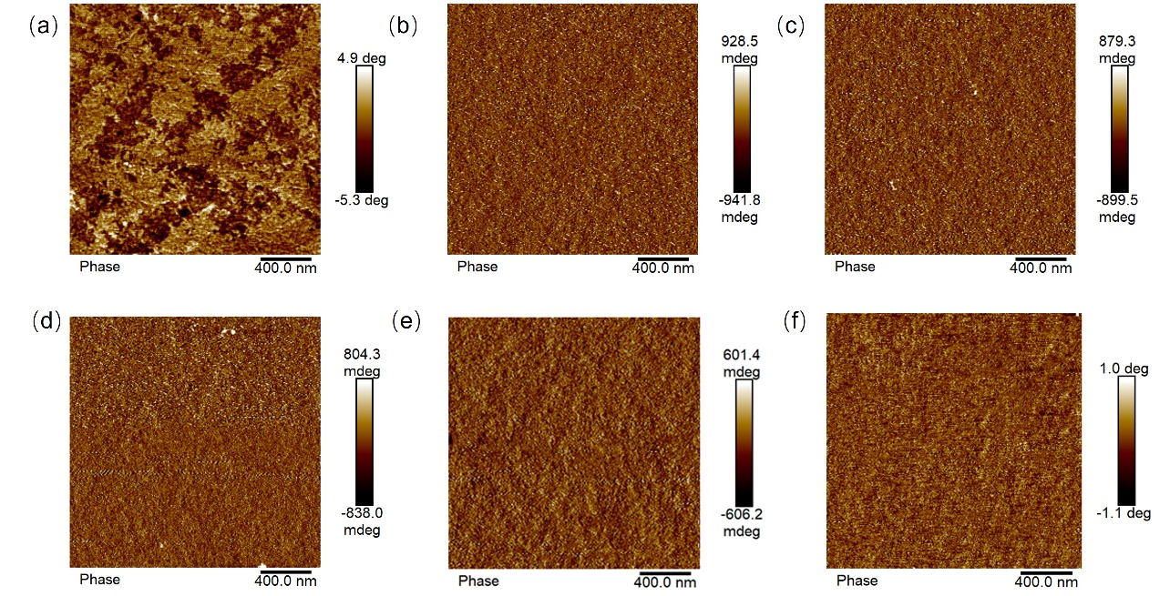
Supplementary Fig.S3 AFM phase images of modified PEDOT:PSS spread on 66-PTB:IEICO-4F blend layer (a) PEDOT:PSS Al 4083:0.3wt% FS-31 (b) PEDOT:PSS Al 4083:0.6wt% FS-31 (c) PEDOT:PSS Al 4083:1wt% FS-31 (d) PEDOT:PSS Al 4083:IPA: 0.3wt% FS-31 (e) PEDOT:PSS Al 4083:IPA: 0.6wt% FS-31 (f) PEDOT:PSS Al 4083:IPA: 1wt% FS-31

Supplementary Table S1 Summary of wettability data

 | PEDOT:PSS Al 4083 | PEDOT:PSS Al 4083:  0.3wt% FS-31 | PEDOT:PSS Al 4083: IPA: 0.3wt% FS-31
Contact angle (°) | 95.7 | 45.7 | 40.6
RMS (nm) | - | 1.48 | 1.41

Performance of NIR detection unit (IDU)
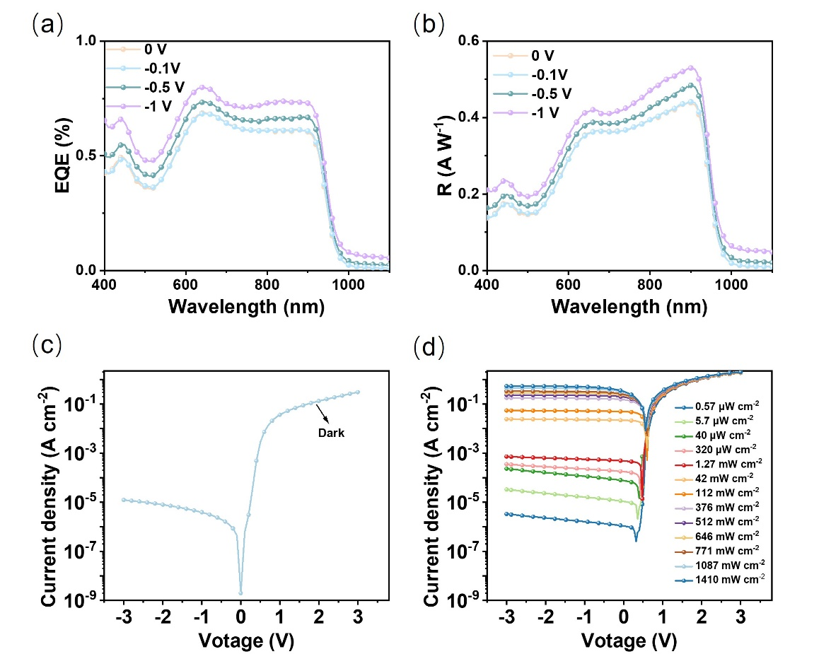
Supplementary Fig.S4 Performance of NIR detection unit (IDU) (a) external quantum efficiency (EQE), and (b) responsivity (R) of IDU at different bias. (c) dark current and (d) photocurrent of IDU under different light power.

Performance of upconversion devices with/without electron-blocking layers (EBL)
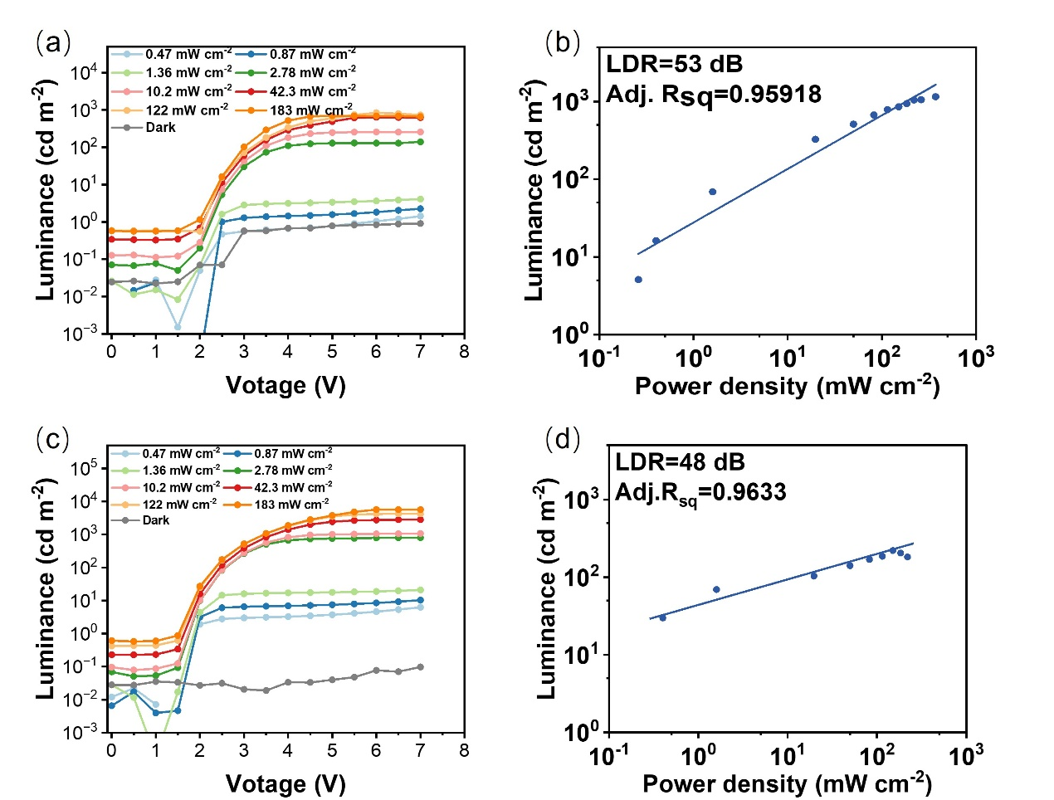
Supplementary Fig.S5 (a) Luminance-voltage curves of UCDs with EBL under different NIR light power (b) Luminance linear dynamic range (L-LDR) of UCDs with EBL (c) Luminance-voltage curves of UCDs without EBL under different NIR light power (d) Luminance linear dynamic range (L-LDR) of UCDs without EBL

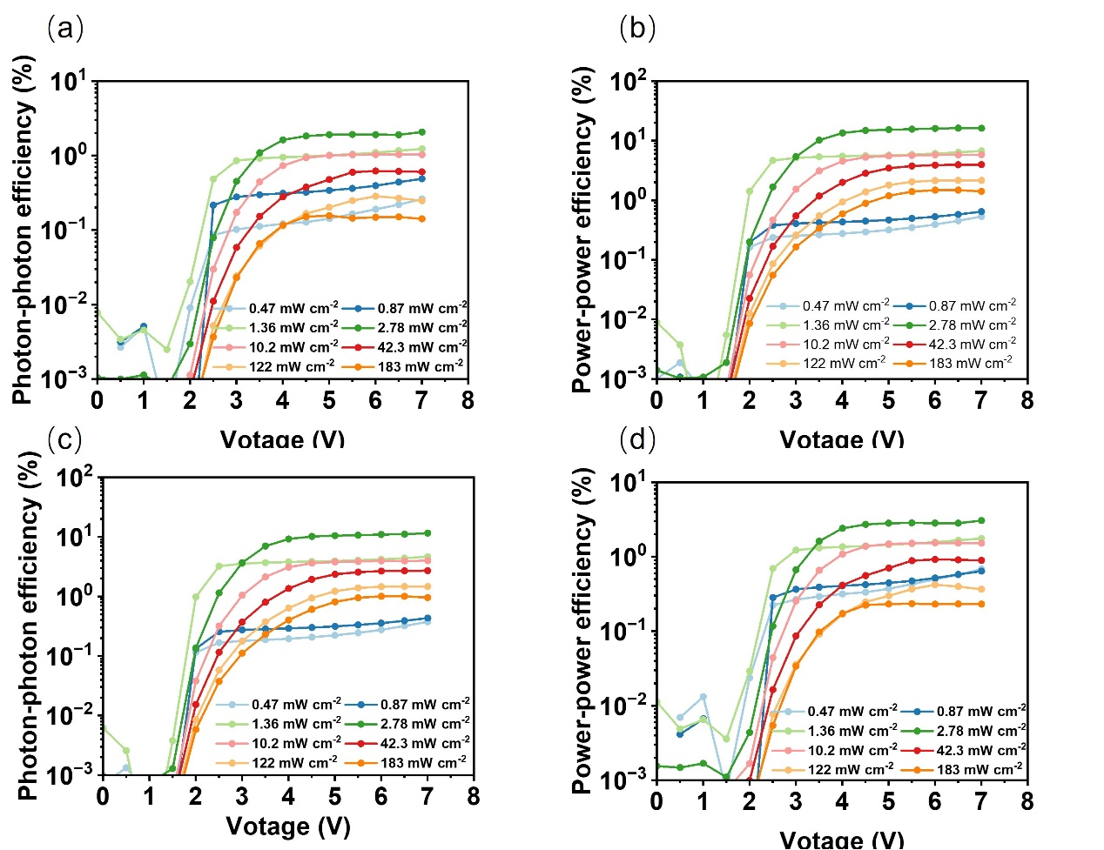
Supplementary Fig.S6 (a) Photon-photon efficiency-voltage curves and (b) power-power efficiency-voltage of UCDs with EBL under different NIR light power (c) Photon-photon efficiency-voltage curves and (d) power-power efficiency-voltage of UCDs without EBL under different NIR light power

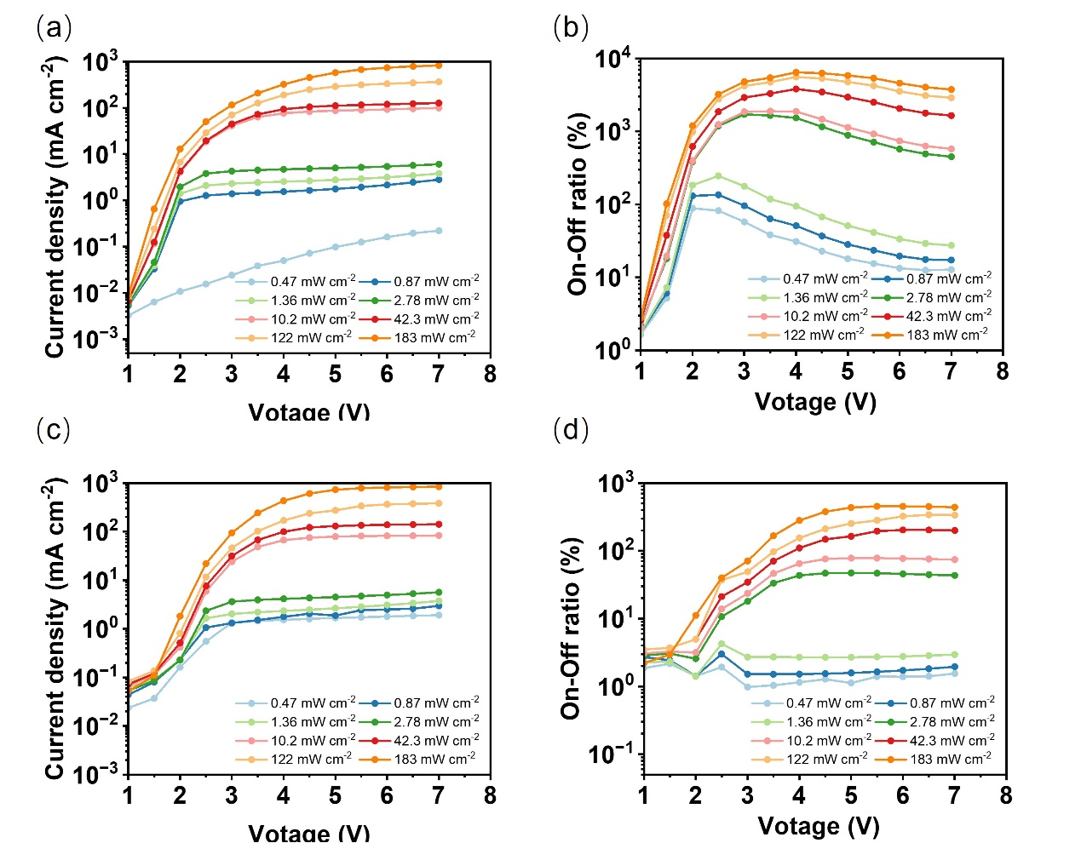
Supplementary Fig.S7 (a) Current density-voltage curves and (b) On-off ratio of UCDs with EBL under different NIR light power (c) Current density-voltage curves and (d) On-off ratio of UCDs without EBL under different NIR light power

Test system for upconversion performance of UCDs

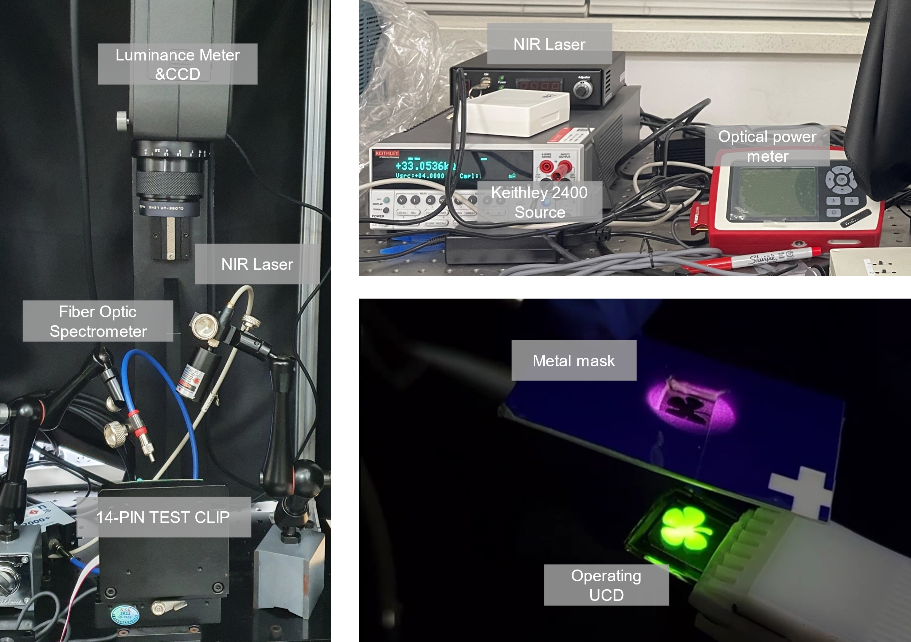
Supplementary Fig.S8 Test system for upconversion performance of UCDs and an operating UCD under an 808 nm NIR (42 mW cm⁻²) through a butterfly mask

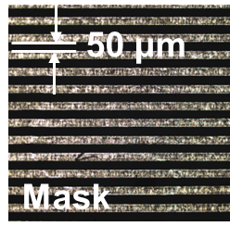
Supplementary Fig.S9 CLSM picture of photo mask for monitoring NIR imaging resolution

Performance of 66-PTB:IEICO-4F based OPVs with different hole transport layer

Supplementary Table S2 Performance of 66-PTB:IEICO-4F based OPVs with different HTL
Active layer | HTL | Device struceture | V_{oc} (V) | J_{sc} (mA cm⁻²) | FF | PCE(%)
66PTB:  IEICO-4F | MoO₃³ | Inverted | 0.62 | 18.53 | 0.58 | 6.72
66PTB:  IEICO-4F | PEDOT:PSS Al 4083 | Inverted | 0.53 | 17.84 | 0.54 | 5.12
66PTB:  IEICO-4F | PEDOT:PSS HTL Solar | Inverted | 0.58 | 19.08 | 0.52 | 5.75
66PTB:  IEICO-4F | PEDOT:PSS Al4083: IPA: 0.3 wt% Triton X-100 | Inverted | 0.60 | 19.02 | 0.54 | 6.12
66PTB:  IEICO-4F | PEDOT:PSS Al 4083: IPA: 0.3 wt% FS-31 | Inverted | 0.62 | 21.92 | 0.59 | 8.02
66PTB:  IEICO-4F | PEDOT:PSS Al 4083 | Conventional | 0.61 | 20.61 | 0.66 | 8.27

Performance summary of reported NIR UCDs and our UCDs

Supplementary Table S3 Performance summary of reported NIR UCDs and our UCDs

Incident/emergent light (nm) | NIR detection unit | Visible emission unit | Process method | Maximum Lumiance (cd/m²) | V_{on} (V) | L-LDR | P-p efficiency (%) | Ref.
1600/525 | PbS QD | CdSe/ZnS QD | S+S | 10³ | 2.5 @ 0.1 cd m⁻² | 60 | 6.5 | 4
1064/524 | PTB7-Th:IEICO-4F:PCBM71 | CBP:Ir(ppy)₂(acac) | S+V | 10⁴ | 1.6 @ 0.1 cd m | 84.4 | 12.9 | 5
1310/524 | PTB7-Th:IEICO-4F:COTIC-4F | CBP:Ir(ppy)₂(acac) | S+V | 10⁴ | 2.5 @ 0.1 cd m⁻² | 72 | 12 | 6
~1000/Yellow | SQ-880:PCBM | SY | S+S | 760 | - | - | 1.6 | 7
850/520 | DPP–DTT: COi8DFIC | CsPbBr₃ | S+S | ~300 | 4 @ 1 cd m⁻² | 13.8 | 1.7 | 8
1200/520 | PTQ:PCBM71 | Alq₃ | S+V | 10² | 3 @ 0.1 cd m⁻² | - | 0.6 | 9
1400/512 | DPP-DTT:SWIR | CsPbBr₃ | S+S | ＜10² | 7 @ 2 cd m⁻² | 19.8 | 0.1 | 10
950/Green | PDPP3T:PC₆₁BM | Be(pp)₂:Ir(ppy)₂(acac) | S+V | 1504 | 4.5 @ 1 cd m⁻² | 66.0 | 29.6(a) | 11
Incident/emergent light (nm) | NIR detection unit | Visible emission unit | Process method | Maximum Lumiance (cd/m²) | V_{on} (V) | L-LDR | P-p efficiency (%) | Ref.
1040/Green | PbS | TCTA:Ir(ppy)₃ | S+V | 10² | 8.2 @ 1 cd m⁻² | - | 1597^{(b)} | 12
808/509 | PbPc:C₆₀ | 2PXZ-OXD | V+V | 32935 | 2.4 @ 1 cd m⁻² | - | 256^{(c)} | 13
780/520 | ClAlPc | BCzPh:CN-T2T: Ir(ppy)₂(acac) | V+V | 1622 | 1.7 @ 1 cd m⁻² | 35.0 | 25.52 | 14
980/535 | 66-PTB:IEICO-4F | F8BT | S+S | 5500 | 1.2 @ 1 cd m⁻² | 53 | 11.9 | This work
S: solution processing V: Vacuum processing
(a) Tandem OLED-based visible emission unit
(b) Organic field effect transistor-based NIR detect unit
(c) Organic photomultiplier-based NIR detect unit

Reference.

1 Wei, Q. et al. A near-infrared polymer enables over 50% transmittance in semi-transparent organic solar cells. J. Mater. Chem. C 10, 5887-5895, (2022).
2 Vella, J. H. et al. Broadband infrared photodetection using a narrow bandgap conjugated polymer. Sci. Adv. 7, eabg2418 (2021).
3 Li, B. et al. Room-Temperature, Solution-Processed MoOx Thin Film as a Hole Extraction Layer to Substitute PEDOT/PSS in Polymer Solar Cells. ACS Photonics 1, 87-90, (2014).
4 Zhou, W. et al. Solution-processed upconversion photodetectors based on quantum dots. Nat. Electron. 3, 251-258, (2020).
5 Du, X. et al. Efficient Organic Upconversion Devices for Low Energy Consumption and High-Quality Noninvasive Imaging. Adv. Mater. e2102812, (2021).
6 Zhang, Y. et al. High-performance organic upconversion device with 12% photon to photon conversion efficiency at 980 nm and bio-imaging application in near-infrared region. Opt. Express 30, 16644-16654 (2022).
7 Strassel, K. et al. Solution-Processed Organic Optical Upconversion Device. ACS Appl. Mater. Interfaces 11, 23428-23435, (2019).
8 Li, N. et al. NIR to Visible Light Upconversion Devices Comprising an NIR Charge Generation Layer and a Perovskite Emitter. Adv. Opt. Mater. 6, 1801084 (2018).
9 Li, N. et al. Organic Upconversion Imager with Dual Electronic and Optical Readouts for Shortwave Infrared Light Detection. Adv. Func. Mater. 31, 2100565 (2021).
10 Li, N. et al. SWIR Photodetection and Visualization Realized by Incorporating an Organic SWIR Sensitive Bulk Heterojunction. Adv. Sci. 7, 2000444 (2020).
11 Yang, D. et al. Near infrared to visible light organic up-conversion devices with photon-to-photon conversion efficiency approaching 30%. Mater. Horizons 5, 874-882, (2018).
12 Yu, H. et al. High-gain infrared-to-visible upconversion light-emitting phototransistors. Nat. Photonics 10, 129-134, (2016).
13 Song, Q. et al. Organic Upconversion Display with an over 100% Photon-to-photon Upconversion Efficiency and a Simple Pixelless Device Structure. J. Phys. Chem. Lett. 9, 6818-6824, (2018).
14 Shih, C.-J. et al. Transparent organic upconversion device targeting high- grade infrared visual image. Nano Energy 86, 106043 (2021).

