Supplementary materials
The prevention process of anammox inhibited by nitrite: cannot by change the external conditions, turning inward to enhance the antifragility of anammox bacteria
Beiying Liª, Conghe Liuª, Run Sua, Yan Weiª , Bin Ma^{a,}∗
a Key Laboratory of Agro-Forestry Environmental Processes and Ecological Regulation of Hainan Province, School of Ecology and Environment, Hainan University, Haikou 570228, China

Corresponding authors
Email addresses: mabin@hainanu.edu.cn (B. Ma)

The following are included as supporting information for this paper:
Number of pages: 5
Number of figures: 2
Number of tables: 1

S1. Nitrite treatment concentrations in the side-stream unit
One-tenth of the sludge was exposed to nitrite in the side-stream unit each time, and ten days for each operation of the unit. To avoid the complete loss of anammox bacteria activity in the side-stream unit, the operation time of the side-stream unit was set to 8 h. After nitrite exposure, the sludge was returned to mix with the remaining sludge in UASB2 reactor, and operated at the normal influent concentration for 16 h. The nitrogen removal rate (NRR) of the UASB2 reactor was measured after 16 h operation. Compared to the previous day, the nitrite concentration on the subsequent day increased by10 mg·L⁻¹ if the NRR of the reactor did not decrease after nitrite exposure. A total of three operations of the side-stream treatment unit.

S2. Nitrite treatment concentrations in the side-stream unit
Table S1. Variation of nitrite concentration in the side-stream unit.

Phase | Days | nitrite concentration in the side-stream unit of UASB2 (mg·L⁻¹) | nitrite concentration in the side-stream unit of UASB3  (mg·L⁻¹)
II | 1 | 30 | 30
II | 2 | 35 | 40
II | 3 | 30 | 30
II | 4 | 35 | 30
II | 5 | 30 | 30
II | 6 | 30 | 40
II | 7 | 30 | 30
II | 8 | 30 | 30
II | 9 | 30 | 30
II | 10 | 30 | 30
IV | 1 | 30 | 30
IV | 2 | 30 | 30
IV | 3 | 30 | 30
IV | 4 | 30 | 30
IV | 5 | 35 | 40
IV | 6 | 35 | 50
IV | 7 | 35 | 60
IV | 8 | 40 | 60
IV | 9 | 40 | 70
IV | 10 | 45 | 70
IV | 1 | 30 | 30
IV | 2 | 30 | 30
IV | 3 | 35 | 40
IV | 4 | 40 | 50
IV | 5 | 45 | 60
IV | 6 | 50 | 70
IV | 7 | 55 | 80
IV | 8 | 60 | 90
IV | 9 | 65 | 100
IV | 10 | 60 | 100

S2. Performance of UASB1 reactors

Figure S1. Reactor performances of the UASB1 reactor: (a) influent TN concentrations and NLR; (b) effluent TN concentrations and NRR; (c) effluent nitrite concentrations, FNA and TN removal rate..

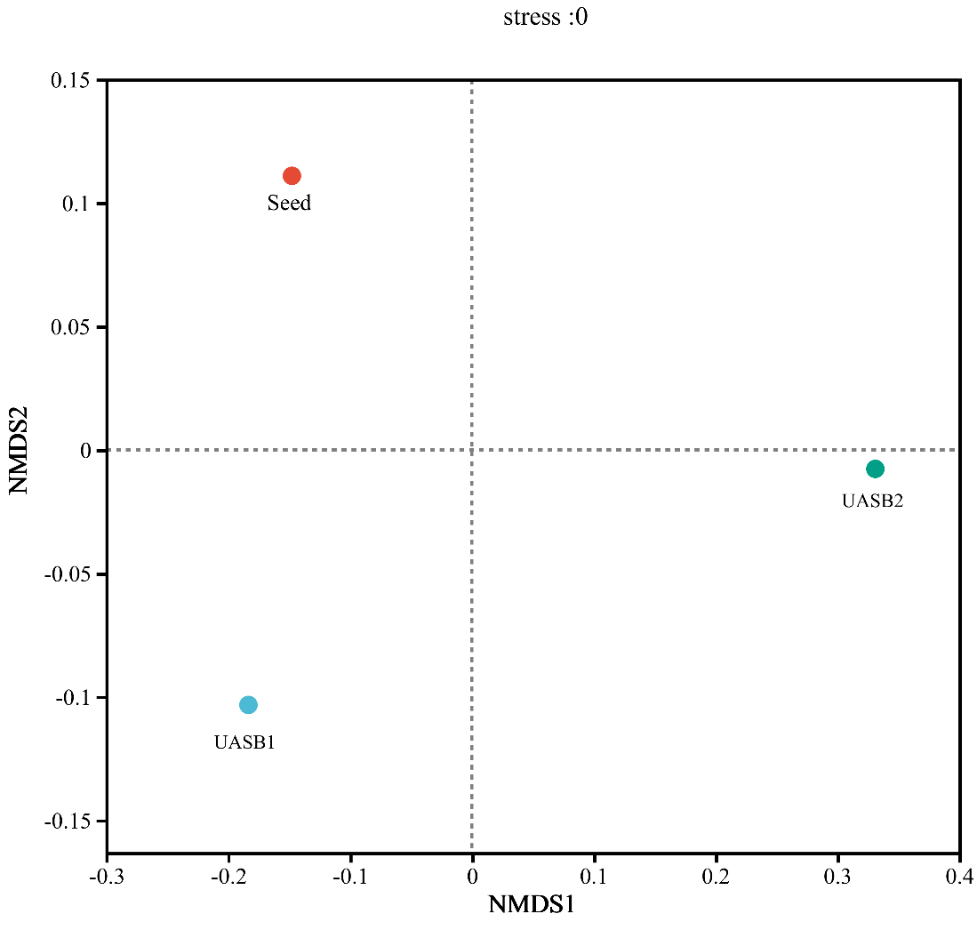
S3. The beta diversity of bacterial communities based on NMDS

Figure S2. Microbial community variation driven by nitrite exposure was shown NMDS plot. Each sample is shown by a different marker and color.

