Supplementary Information

Unusual d-electron heavy-fermion behaviour in f-electron ferromagnetic antiperovskite Gd₃SnC

Joonho Bang^{1‡}, Jongho Park^{1‡}, Kimoon Lee², Minsoo Kim^{3,4}, Wonshik Kyung^{3,4}, Jonathan D. Denlinger⁵, Yeongkwan Kim^{6,7}, Young Hee Lee^{1,8}, Changyoung Kim^{3,4,*}, and Sung Wng Kim^{1,8,*}

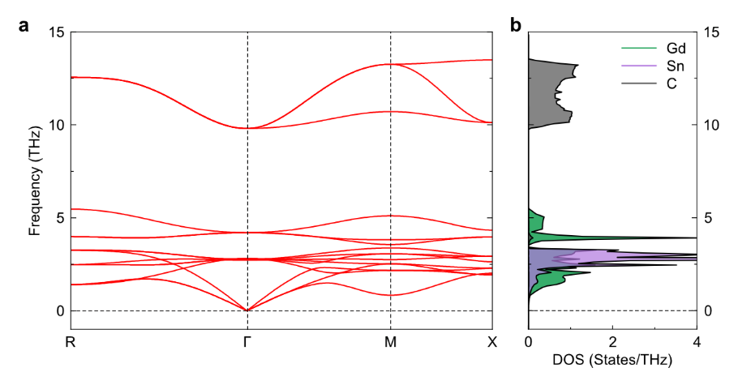
Supplementary Fig. 1 | Calculated phonon band structure and DOS for Gd₃SnC. a, Phonon band along R−Γ−M−X direction. b, Partial phonon DOS.
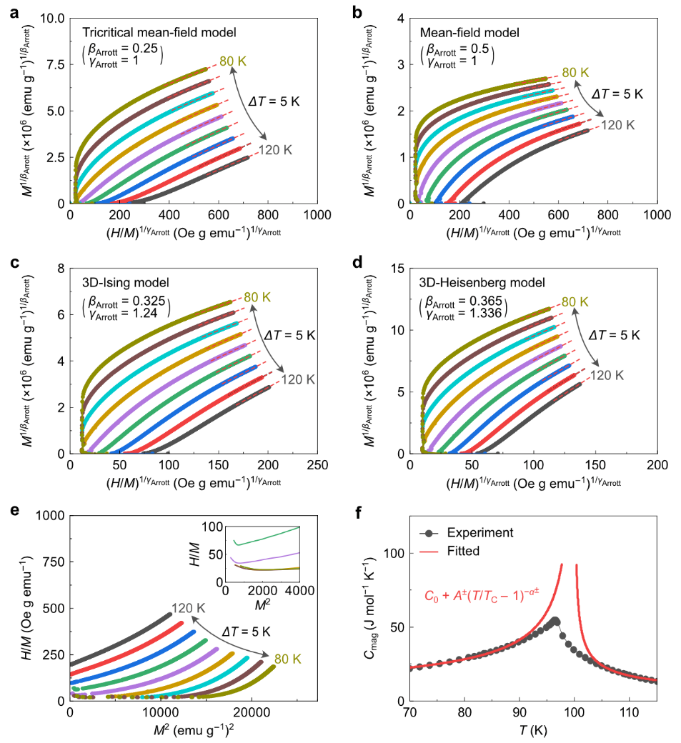
Supplementary Fig. 2 | Tricritical behaviour of Gd₃SnC antiperovskite. a–d, Modified Arrott plots for the tricritical mean-field model (β_{Arrott} = 0.25, γ_{Arrott} = 1) (a), mean-field model (β_{Arrott} = 0.5, γ_{Arrott} = 1) (b), 3D-Ising model (β_{Arrott} = 0.325, γ_{Arrott} = 1) (c), and 3D-Heisenberg model (β_{Arrott} = 0.365, γ_{Arrott} = 1.336) (d). e, H/M versus M ² curves for various T around the T_{C}. The inset is an enlarged view of low-M ² region. f, T-dependent C_{mag} and data fitting using C_{mag} (T) = C₀ + A±(T/T_{C} − 1)^{−α±}, where C₀, A, and α are constant, critical amplitude, and critical exponent, respectively. ± indicates above and below the T_{C}.

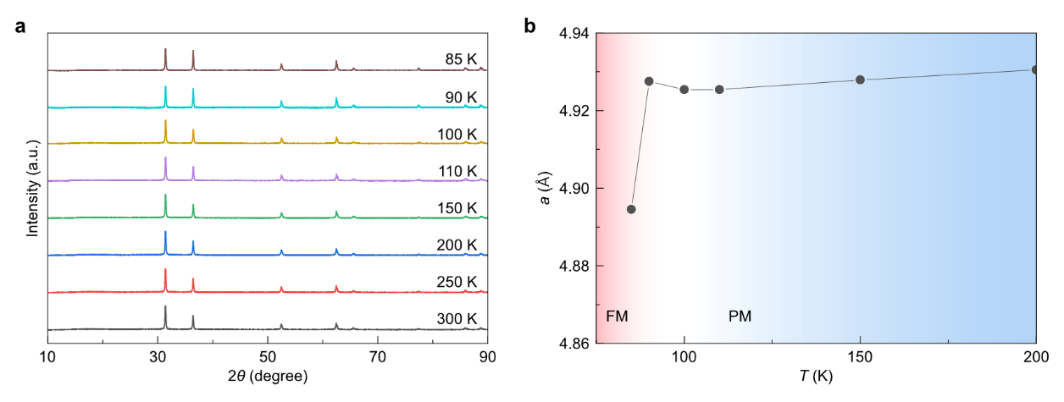
Supplementary Fig. 3 | Temperature-dependent powder XRD results of Gd₃SnC. a, Low-T XRD patterns in the temperature range between 85 and 300 K. b, T-dependent lattice constant a obtained from the XRD peak position.

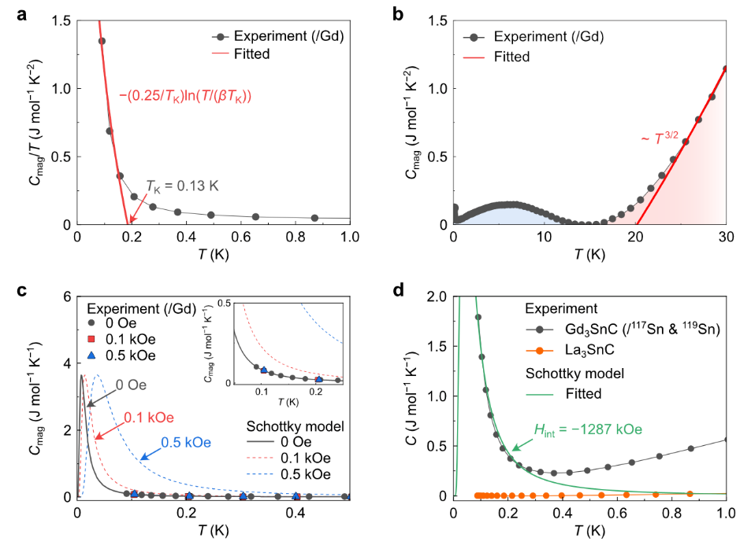
Supplementary Fig. 4 | Temperature-dependent magnetic contribution to the heat capacity for Gd₃SnC antiperovskite. a, Determination of the T_{K} using the equation of C_{mag}/T = −(0.25/T_{K})ln(T/(βT_{K})) (Ref. Seaman, C. L. et al. Evidence for non-Fermi liquid behaviour in the Kondo alloy Y_{1−x}U_{x}Pd₃. Phys. Rev. Lett. 67, 2882–2885 (1991).), where β = 2.25 is obtained from the phonon background term βT ³ (inset of Fig. 3a). b, C_{mag} versus T curve. Blue and red areas represent the ΔS responsible for the singlet formation and FM ordering, respectively. Red curve is a fit of the FM contribution (C_{mag} ~ T ^{3/2}). c, C_{mag} versus T curves under the different H. Dashed curves are the results of the Schottky model calculations for the electron spins of Gd. There is no H-driven C_{mag} shift ruling out the possibility of the Schottky anomaly due to the electron spins of Gd. d, Comparison of C_{mag} versus T curves between experimental data and the calculated data using the Schottky anomaly model for the nuclear spins of ¹¹⁷Sn and ¹¹⁹Sn. The fitting result shows that the required internal field is about −1287 kOe.
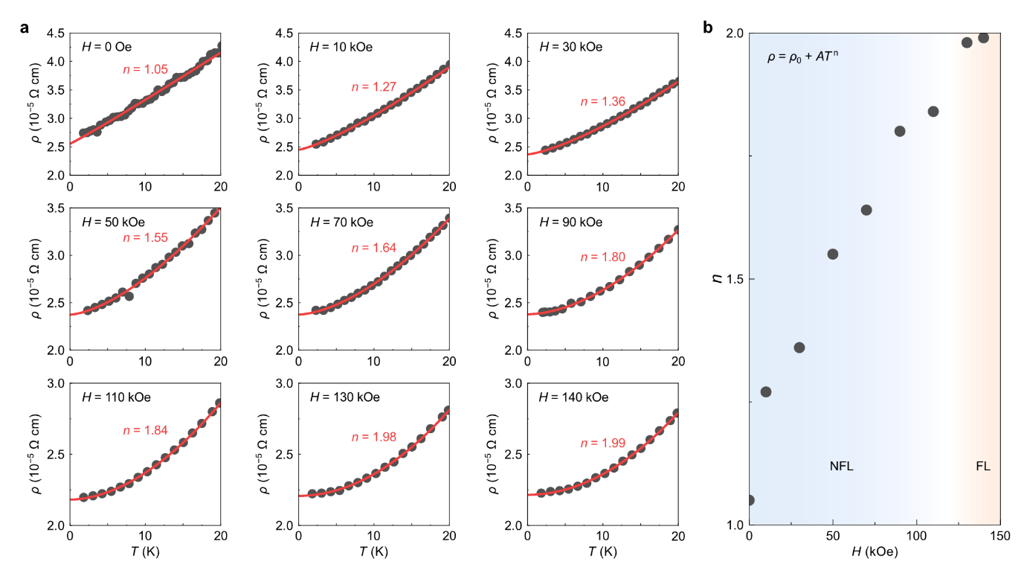
Supplementary Fig. 5 | Crossover from non-Fermi-liquid (NFL) to Fermi-liquid (FL) behaviour driven by an external magnetic field. a, ρ(T) in the low-T region under different applied H. Red curves are a single power-law fit ρ = ρ₀ + AT ^{n} of the data, where ρ₀ is the residual resistivity and A is a constant. b, The field-dependent n value. Blue and red coloured backgrounds represent NFL and FL regions.
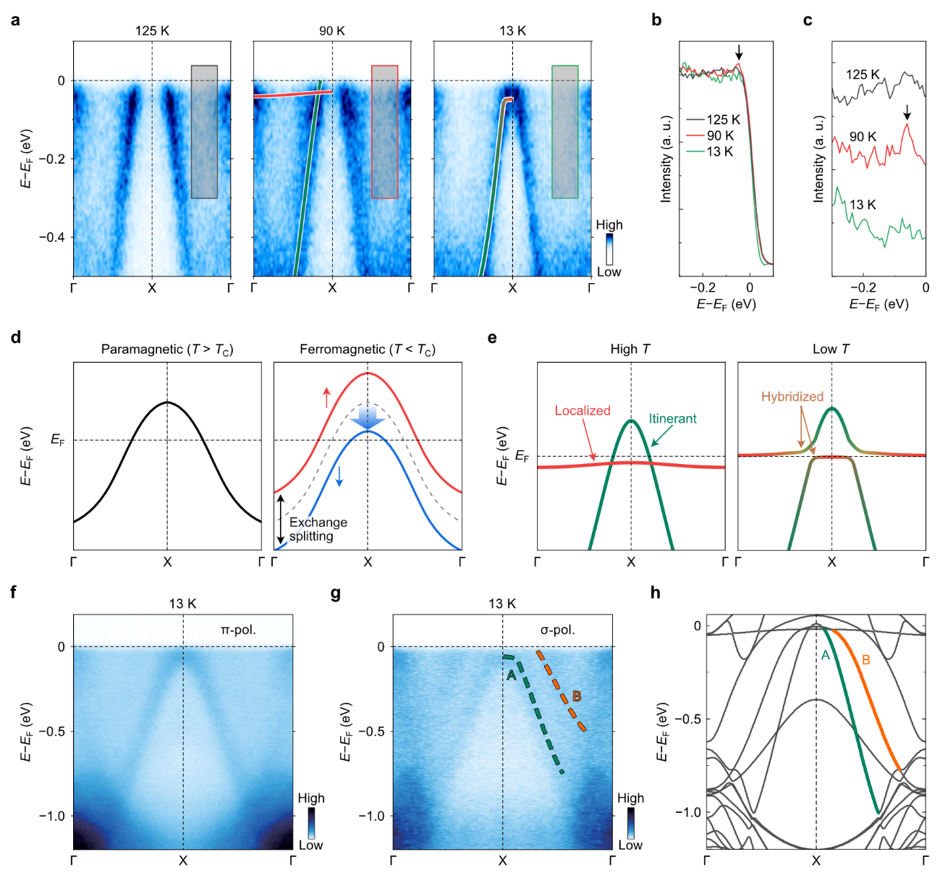
Supplementary Fig. 6 | Electronic band structures. a, ARPES spectra along the Γ–X–Γ direction at various T. b–c, EDCs near E_{F}. Each EDC is a momentum integrated spectrum from the grey area in a. c, EDCs are divided by the Fermi-Dirac distribution for better visualization of the flat band peak. d, Schematic illustration of the exchange splitting of the fast-dispersing band near T_{C}. e, Schematic illustration of band hybridization between the fast-dispersing band (green colour) and weakly dispersing band (red colour) at the low-T region. f–g, Wide energy range ARPES data along the Γ–X–Γ direction at 13 K obtained with linear horizontal (π) and vertical (σ) polarizations, respectively. h, Calculated band structure along the Γ–X–Γ direction. Two observed bands near E_{F} (labeled as A and B) are well reproduced by the calculated band structure.
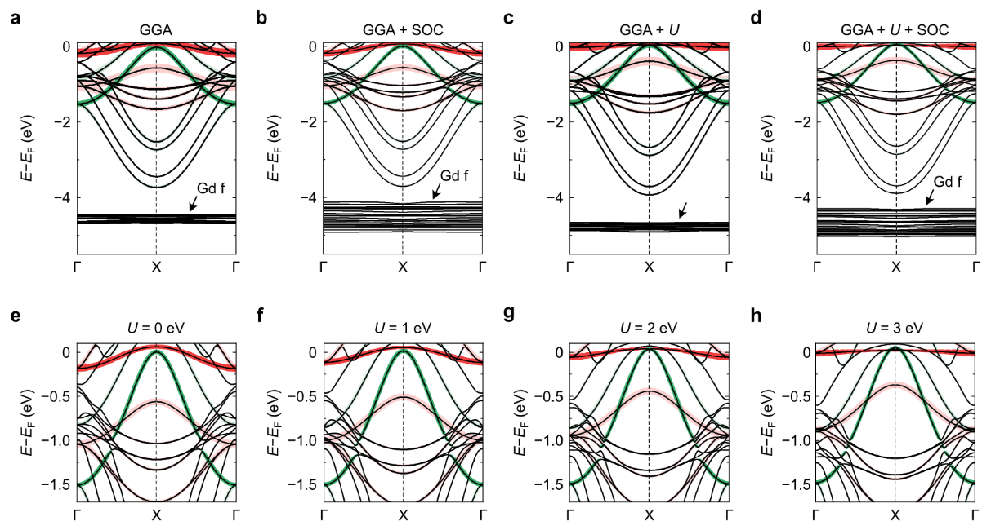
Supplementary Fig. 7 | Calculated electronic structure of Gd₃SnC. a–d, The band structure calculated by GGA (a), GGA+SOC (b), GGA+U (c), and GGA+U+SOC (d) methods. Red and green colours represent the t_{2g} and e_{g} contributions of Gd 5d-orbitals, respectively. e–h, The band structure calculated by GGA+U+SOC method with different U values.

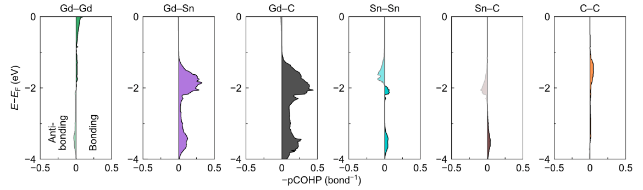
Supplementary Fig. 8 | Calculated COHP for antiperovskite Gd₃SnC. pCOHP for various bonds between constituent elements in Gd₃SnC.
Supplementary Table 1 | Lattice parameters of antiperovskite Gd₃SnC and La₃SnC from Rietveld refinement of XRD data.
System | Gd₃SnC | La₃SnC
Space group | Pm$\overline{3}$m | Pm$\overline{3}$m
Lattice parameter (Å) | a = 4.92895(7)  d(Gd–Gd) = 3.48529(6)  d(Gd–Sn) = 3.48529(6)  d(Gd–C) = 2.46447(4) | a = 5.1351(14)  d(La–La) = 3.6311(10)  d(La–Sn) = 2.5675(8)  d(La–C) = 3.6311(10)
Atomic position | Gd (0, 0.5, 0.5)  Sn (0, 0, 0)  C (0.5, 0.5, 0.5) | La (0, 0.5, 0.5)  Sn (0, 0, 0)  C (0.5, 0.5, 0.5)
V (Å) | 119.74660 | 135.40873
Z | 1 | 1
R_{wp} | 7.72 | 15.60
Goodness of fit | 2.1 | 4.32

Supplementary Table 2 | List of −ICOHP values and bond lengths for various chemical bonds.
Bond | −ICOHP (spin-up)  (eV/bond) | −ICOHP (spin-down)  (eV/bond) | Bond length  (Calc., Å) | Bond length  (Exp., Å)
Gd–Gd | 0.52 | 0.45 | 3.50 | 3.49
Gd–Sn | 0.59 | 0.61 | 3.50 | 3.49
Gd–C | 1.43 | 1.53 | 2.47 | 2.46
Sn–Sn | 0.02 | 0.01 | 4.95 | 4.93
Sn–C | 0.01 | 0.01 | 4.29 | 4.27
C–C | 0.06 | 0.06 | 4.95 | 4.93

