Supplementary figures and tables
Table S1. Information of cell lines used in the study.
Status | Cell line | Sex | Age | Ethnicity
Healthy | NUIGi049-A (ALSH47C1) | 66 | Female | Caucasian
Sporadic ALS | NUIGi050-A (ALS53C5) | 60 | Male | Caucasian
Sporadic ALS | NUIGi051-A (ALS57C1) | 56 | Female | Caucasian

Figure S1.
Figure S1. MN differentiation and characterization following a previously published protocol. (A) Representative images of suspension culture on day 13 and day 18 of differentiation. (B) Representative double staining of OCT4/SOX2, indicating the silence of iPSC pluripotent marker, OCT4 on day 6 of differentiation. (C) Representative double staining of MN markers, ISL1/MNX1 from multiple iPSC lines on day 18 of differentiation (D) Representative double staining of MN mature marker, CHAT from multiple iPSC lines on day 28 of differentiation. (E) The efficiency of ISL⁺ and MNX1⁺ MNs on day 18 and CHAT⁺ mature MNs on day 28. MNP differentiation on day 12. Scale bar 100µM.

Figure S2.
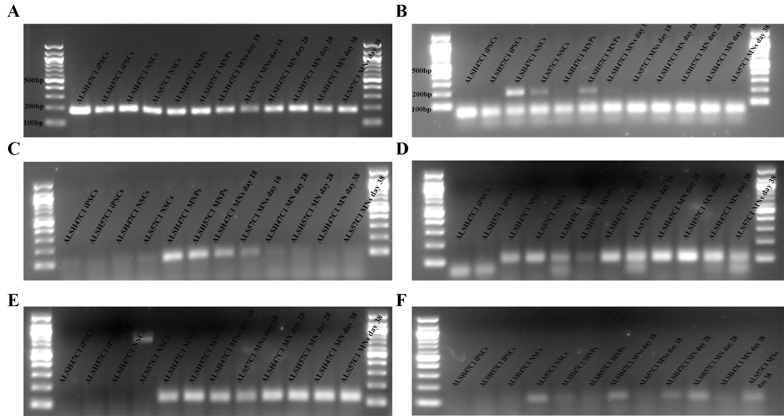
Figure S2. Full-length gels of the RT-PCR images in Figure 1. (A: GAPDH; B: PAX6; C: OLIG2; D: ISL1; E: MNX1; F: CHAT.)

Figure S3.

Figure S3. Longitudinal MEA recording of each cell line during D18 to D48 of sMNs plated on POM or PEI. (A) The number of Active Electrodes, (B) Mean firing rate (Hz), (C) Network burst Frequency and (D) Synchrony index of each cell line involved in the electrophysiological comparison. The total number of wells of each cell line were: ALSH47C1 POM (dark) n=4, ALS53C5 POM (grey) n=8, and ALS57C1 POM (light grey) n=4, ALSH47C1 PEI (dark red) n=16, ALS53C5 PEI (red) n=14, and ALS57C1 PEI (pink) n=15.

