Supplementary material

BITE FORCE CALCULATION
Material characterisation
The rubber sample was modelled as a visco-hyperelastic material with a near incompressible material response. The material properties of the rubber sample were derived experimentally following the authors previously published protocol. The hyperelastic response was modelled using the phenomenological Ogden model, with the strain energy density function defined as:
$W(λ_{1},λ_{2},λ_{3})= \sum_{i=1}^{N}{\frac{μ_{i}}{α_{i}}(λ_{1}^{α_{i}}+λ_{2}^{α_{i}}+λ_{3}^{α_{i}}-3)}$ (1)
Where N = 1, $λ_{i}$ are the principle stretch ratios and $µ_{i}$ and $α_{i}$ are the phenomenological material constants (4.60 × ${10}^{5}$ and 2.09 Pa, respectively) obtained using least squares optimisation on experimentally measured stress-strain curves ($R^{2}$ = 0.9985) (Figure S1a). The viscoelastic material response was modelled as a second order Prony series, with relaxation modulus given by:
$g_{R}\left(t\right)=1- \sum_{i=1}^{N}{g_{i}(1-\exp\left(\frac{-t}{τ_{i}}\right))}$ (2)
Where N = 2, $t$ is time, and $g_{i}$ and $τ_{i}$ are the phenomenological material constants (first order: $6.30 × {10}^{-2}$ and 0.99 s, second order: $5.58 × {10}^{-2}$ and 0.19 s, respectively) obtained using least squares optimisation on experimentally measured stress-relaxation curves ($R^{2}= 0.9994$) (Figure S1b).

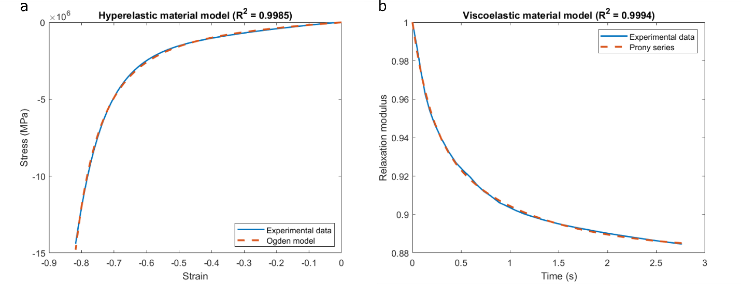
Figure S1: Material model fit to experimental data. (a) Hyperelastic material response, Ogden model (N=1) fit to average experimentally measured stress-strain data. (b) Viscoelastic material response, Prony series (N=2) fit to average experimentally measured stress-relaxation data.
Mass scaling
Mass scaling was applied to the simulations to reduce the computation time. To assess whether this addition still led to a meaningful solution the maximum ratio of kinetic energy to internal energy was calculated as a percentage for all simulations to ensure that inertial forces remained insignificant throughout the simulations. The mean ratio of kinetic energy to internal energy is $7.79×{10}^{-5}$ ± $1.60{×10}^{-4}$ %. All values remained below the accepted 2%.

MUSCULOSKELETAL MODELLING
The effect of modelling the masseter and temporalis muscles with full capacity was investigated through a sensitivity analysis. For one total unilateral TMJR patient musculoskeletal models were setup with the maximum isometric forces of the ipsilateral anterior temporalis, posterior temporalis, superficial masseter, deep anterior masseter and deep posterior masseter muscles modelled as 50%, 60%, 70%, 80%, 90% and 100% of their full capacity. The ipsilateral inferior lateral pterygoid and superior lateral pterygoid remained removed from the model, and the applied bite force remained the same. As the ipsilateral masseter and temporalis strength is decreased there is higher influence from the contralateral superficial masseter and the ipsilateral medial pterygoid muscles (Figure S2). This resulted in higher compressive and tensile TMJ loading during ipsilateral molar biting for weakened masseter and temporalis muscles (Figure S3). There is no available literature directly compares EMG activity od the temporalis and masseter muscles of TMJR patients to healthy controls. However, studies comparing contralateral to ipsilateral muscle function of unilateral total TMJR patients found operated to non-operated muscle force ratios of 0.97 and 0.89 for the masseter and temporalis, respectively, 12 months after surgery (Raustia et al. 1997). Therefore, it is reasonable to assume that the temporalis and masseter muscles of the unilateral total TMJ replacement patients in this study were operating between 90% to 100% of their full capacity.

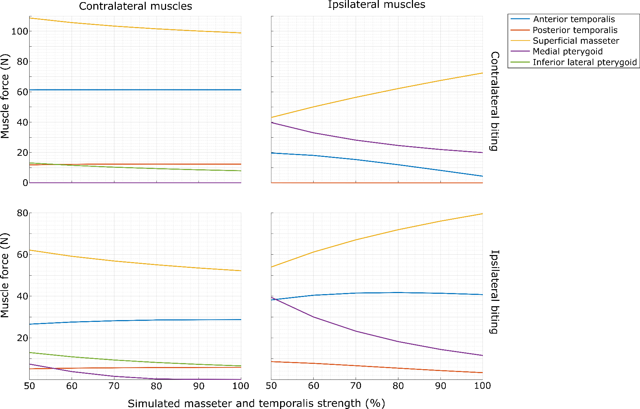
Figure S2: Resultant muscle forces for the anterior temporalis, posterior temporalis, superficial masseter, medial pterygoid and inferior lateral pterygoid muscles when the maximum isometric force of the temporalis and masseter sub-regions are modelled as 50%, 60%, 70%, 80%, 90% and 100% of their full capacity.
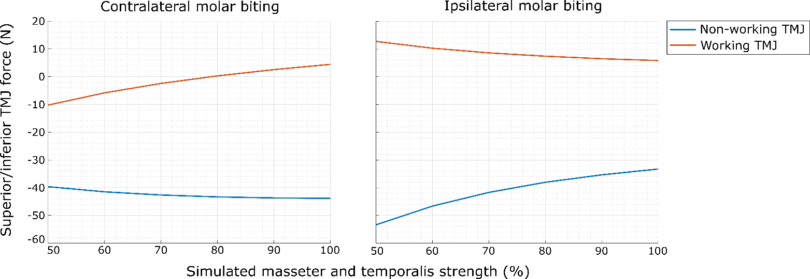
Figure S3: TMJ loading when the maximum isometric force of the temporalis and masseter sub-regions are modelled as 50%, 60%, 70%, 80%, 90% and 100% of their full capacity.

BIBLIOGRAPHY
Raustia AM, Oikarinen KS, Pernu H (1997) Changes in electrical activity of masseter and temporal muscles after temporomandibular joint surgery: A one-year follow up. Int J Oral Maxillofac Surg 26:253–257

