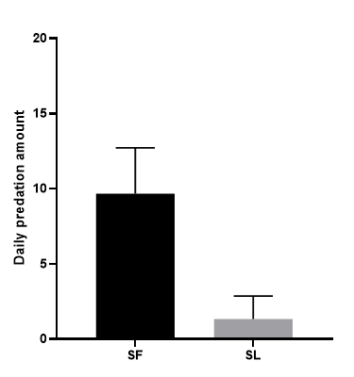
Fig. S1. Two-way predation between Spodoptera frugiperda and Spodoptera litura under greenhouse conditions. SF:The daily predation of the 4th instar S. frugiperda on the3rd instar S. litura. SL:The daily predation of the 4th instar S. litura on the3rd instar S. frugiperda.

