Supplementary Materials for
FAM3A plays a key role in protecting against tubular cell pyroptosis and acute kidney injury

Xiaolong Li^{1#}, Feifei Yuan^{1#}, Ying Tang^{2#}, Jun Ai^{1#}, Jinhua Miao¹, Wenting Ye¹, Shan Zhou¹, Qinyu Wu¹, Xiaoxu Wang¹, Dan Xu¹, Jiemei Li¹, Jiewu Huang¹, Qiurong Chen¹, Weiwei Shen¹, Youhua Liu¹, Fan Fan Hou¹, Lili Zhou^{1*}

¹State Key Laboratory of Organ Failure Research, National Clinical Research Center of Kidney Disease, Guangdong Provincial Clinical Research Center for Kidney Disease, Guangdong Provincial Key Laboratory of Nephrology, Division of Nephrology, Nanfang Hospital, Southern Medical University, Guangzhou, China; ²Department of Nephrology, The Third Affiliated Hospital of Southern Medical University, Guangzhou, China.

Correspondence to: Lili Zhou, jinli730@smu.edu.cn

This file includes:
Supplementary Figure S1 to S12
Supplementary Tables S1 to S3
Supplementary References

Supplementary Figures

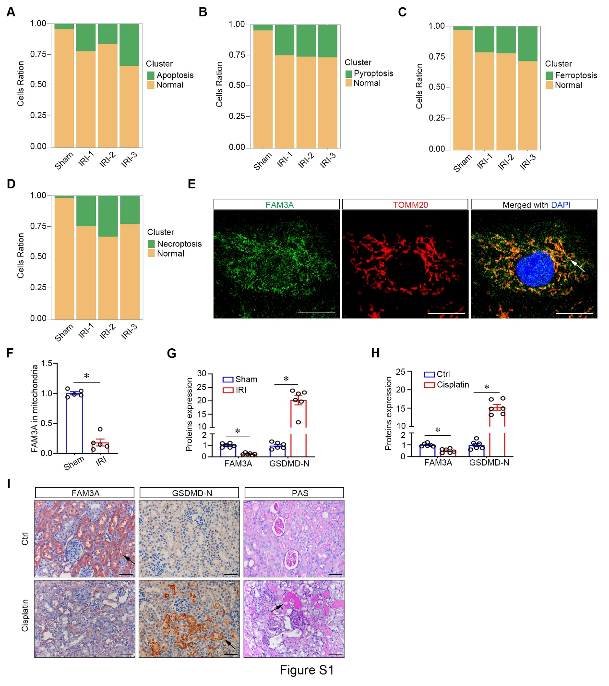
Figure S1. FAM3A is located in mitochondria and downregulated in AKI. (A-D) Cells ratio of apoptotic, pyroptotic, ferroptotic, and necroptotic tubular cells in different groups as indicated. (E) Representative micrographs show immunofluorescent co-staining of FAM3A with TOMM20 in HKC-8 cells. Arrow indicates co-staining area. Scale bar, 10μm. (F) Quantitative determination of FAM3A levels in the mitochondria of sham and IRI kidneys (normalized by VDAC). *P< 0.05 versus Sham (n=5). (G) Quantification of FAM3A and GSDMD-N in sham and IRI kidneys. *P< 0.05 versus Sham (n=5). (H) Quantification of FAM3A and GSDMD-N in control and cisplatin-AKI kidneys. *P< 0.05 versus controls (n=5). (I) Representative images of PAS, FAM3A and GSDMD-N immunohistochemical staining in normal and cisplatin-AKI kidneys. Arrows indicate the injured tubules or the positive staining. Scale bar, 50μm.

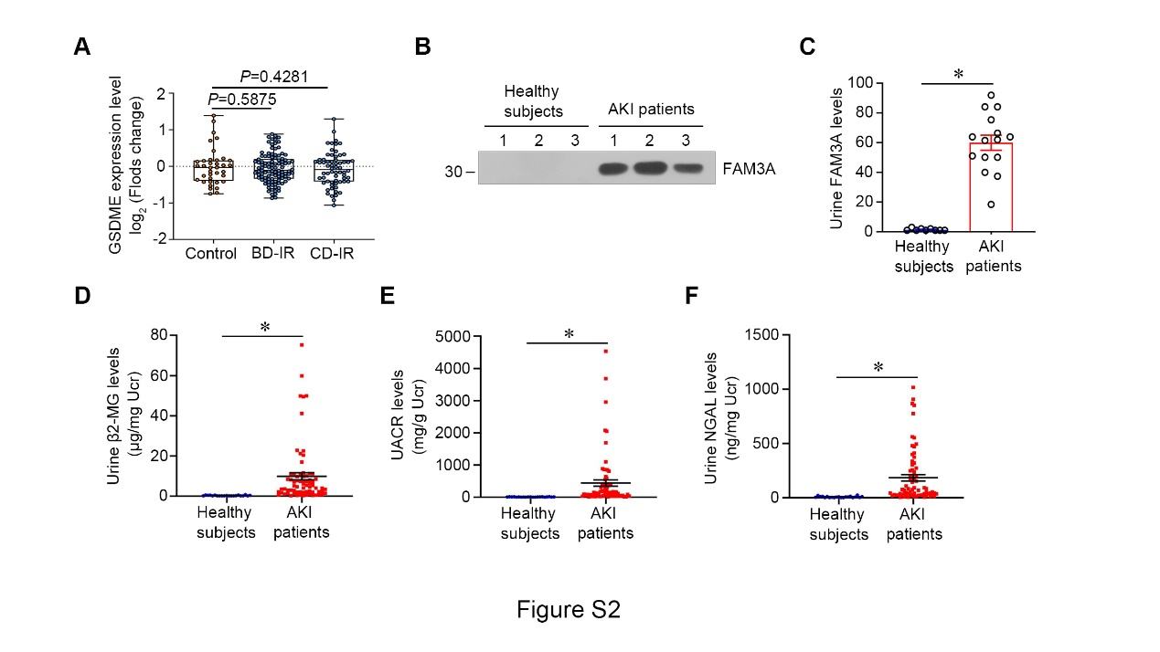
Figure S2. Urine test data of AKI patients. (A) The related levels of GSDME in kidneys from different groups as indicated. n=37 controls, n=105 BD-IR, n=64 CD-IR. (B) Representative western blotting shows the protein levels of FAM3A in urines from healthy and AKI patients. (C) Quantitation of the protein levels of FAM3A in different groups. n=9 healthy samples, n=15 AKI urine samples. *P< 0.05 versus healthy subjects. (D-F) The levels of β2-MG, UACR and NGAL in urine from healthy subjects and AKI patients. *P< 0.05 versus healthy subjects. n=21 healthy subjects, n=71 AKI patients.

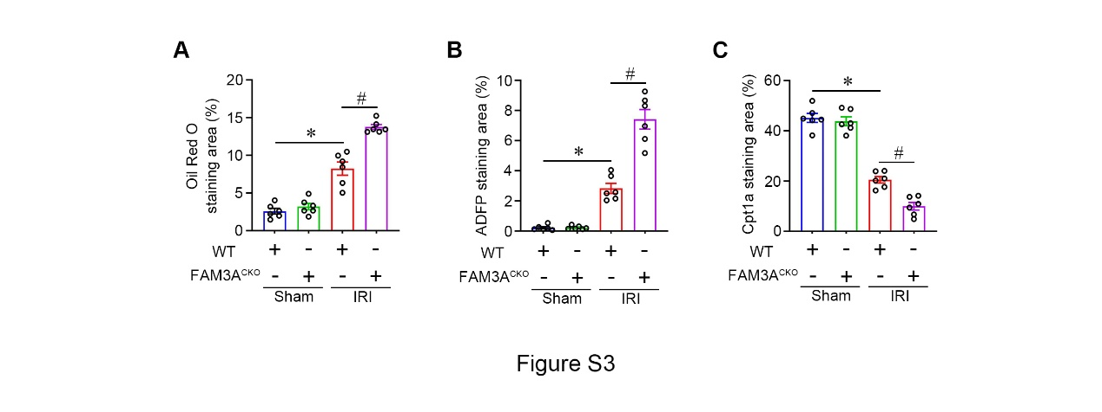
Figure S3. Knockout of FAM3A leads to mitochondrial dysfunction. (A-C) Quantitative determination of Oil red O, ADFP staining area, and Cpt1a staining fluorescence intensity in different groups. *P< 0.05 versus WT controls, #P< 0.05 versus WT-IRI mice (n=6).

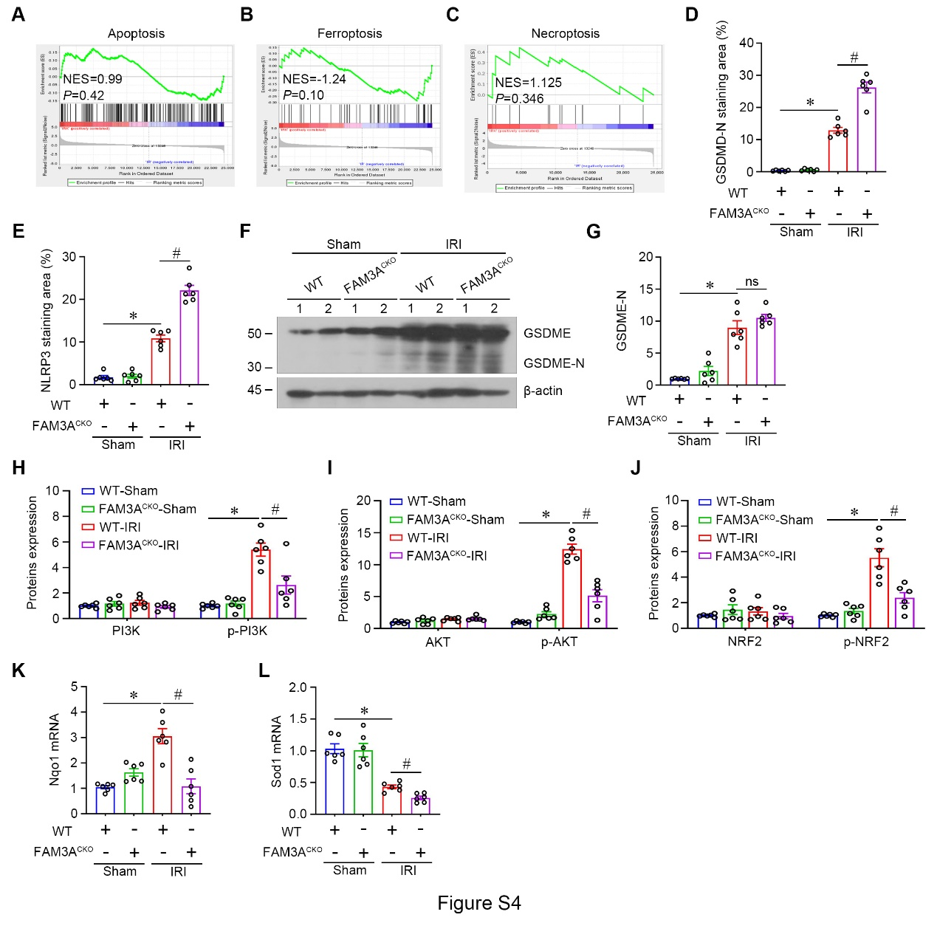
Figure S4. Knockout of FAM3A accelerates pyroptosis via PI3K/AKT/NRF2 pathway. (A-C) GSEA shows the enrichment of apoptosis, ferroptosis, and necroptosis in WT and FAM3A^{CKO} mice after IRI surgery (n=3 per group). (D-E) Quantitative determination of GSDMD-N and NLRP3 staining positive area in different groups. *P< 0.05 versus WT controls, #P< 0.05 versus WT-IRI mice (n=6). (F) Representative western blotting shows the protein levels of GSDME. (G) Quantitation of the levels of GSDME-N in different groups. *P< 0.05 versus WT controls, ns, no significant difference. (n=6). (H-J) Quantitative proteins expression of p-PI3K, PI3K, p-AKT, AKT, p-NRF2, and NRF2. *P< 0.05 versus WT controls, #P< 0.05 versus WT-IRI mice (n=6). (K-L) qPCR analyses show the expression of Nqo1 and Sod1 in the kidneys from different groups as indicated. *P< 0.05 versus WT controls, #P< 0.05 versus WT-IRI mice (n=6).

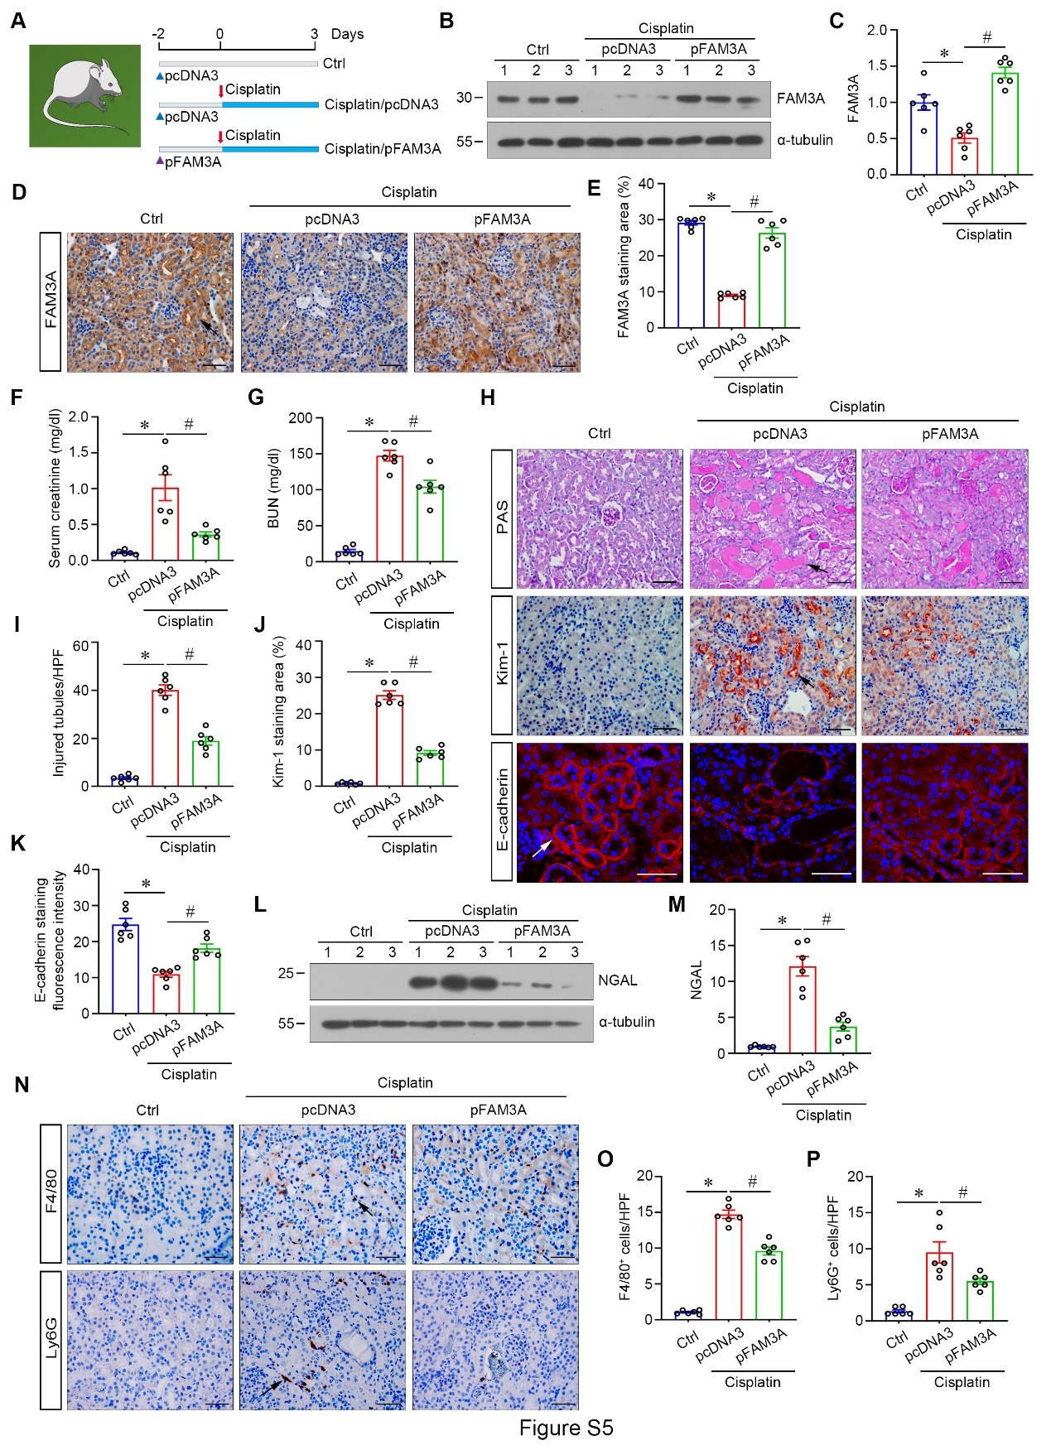
Figure S5. FAM3A overexpression improves cisplatin nephrotoxicity. (A) Experimental design of cisplatin AKI model in different groups of mice. (B) Representative western blot shows the protein levels of FAM3A in different groups as indicated. (C) Quantitative determination of FAM3A expression in different groups. *P< 0.05 versus controls, #P< 0.05 versus pcDNA3-cisplatin group (n=6). (D) Representative image of FAM3A immunohistochemical staining. Arrows indicate positive staining. Scale bar, 50μm. (E) Quantitation of FAM3A staining area in different groups. *P< 0.05 versus controls, #P< 0.05 versus pcDNA3-cisplatin group (n=6). (F-G) Serum creatinine and BUN level in different groups as indicated. *P< 0.05 versus controls, #P< 0.05 versus pcDNA3-cisplatin group (n=6). (H) Representative images of PAS, immunofluorescent and immunohistochemical staining show injured tubules, Kim-1, and E-cadherin expression in different groups. Arrows indicate the injured tubules or the positive staining. Scale bar, 50μm. (I-K) Quantitation of injured tubules ratio per HPF, Kim-1 staining positive area, and E-cadherin staining fluorescence intensity of kidneys from different groups. *P< 0.05 versus controls, #P< 0.05 versus pcDNA3-cisplatin group (n=6). (L) Representative western blot shows the protein levels of NGAL. (M) Graphic presentation shows the relative NGAL protein abundance in different groups as indicated. *P< 0.05 versus controls, #P< 0.05 versus pcDNA3-cisplatin group (n=6). (N) Representative micrographs of immunohistochemical staining for the macrophage marker F4/80, or neutrophile marker Ly6G. Arrows indicate the positive staining cell. Scale bar, 50μm. (O-P) Quantitation of the number of F4/80⁺ and Ly6G⁺ cells per HPF. *P< 0.05 versus controls, #P< 0.05 versus pcDNA3-cisplatin group (n=6).

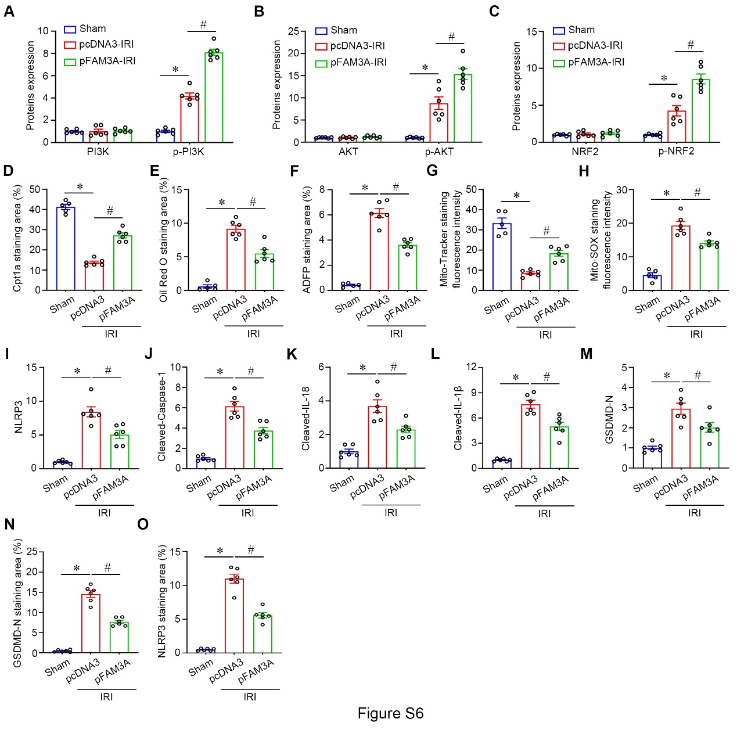
Figure S6. FAM3A overexpression improves mitochondrial dysfunction and pyroptosis by activating PI3K/AKT/NRF2 axis in AKI. (A-C) Quantitative proteins expression of p-PI3K, PI3K, p-AKT, AKT, p-NRF2, and NRF2. *P< 0.05 versus controls, #P< 0.05 versus pcDNA3-IRI group (n=6). (D-H) Quantitative determination of Oil red O, ADFP and Cpt1a staining area, Mito-Tracker and Mito-SOX staining fluorescence intensity in different groups. *P< 0.05 versus controls, #P< 0.05 versus pcDNA3-IRI group (n=5-6). (I-M) Quantitation of the protein levels of NLRP3, Cleaved-caspase-1, Cleaved-IL-18, Cleaved-IL-1β, and GSDMD-N in different groups. *P< 0.05 versus controls, #P< 0.05 versus pcDNA3-IRI group (n=6). (N-O) Quantitative determination of GSDMD-N and NLRP3 staining positive area in different groups as indicated. *P< 0.05 versus controls, #P< 0.05 versus pcDNA3-IRI group (n=5-6).

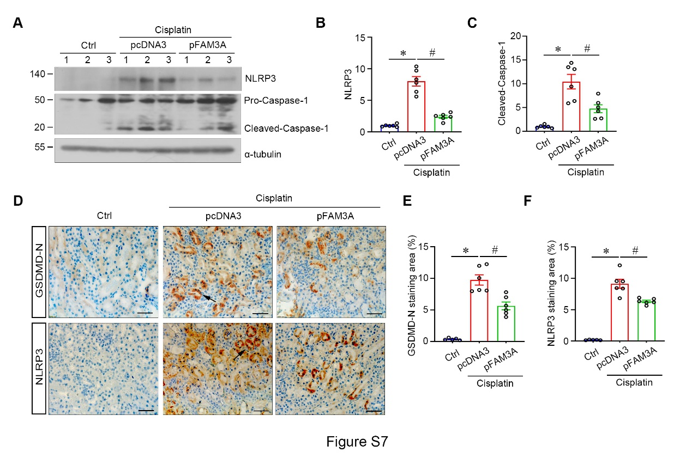
Figure S7. FAM3A overexpression alleviated pyroptosis in cisplatin AKI. (A) Representative western blotting shows the protein levels of renal NLRP3, Pro-caspase-1, and Cleaved-Caspase-1 in different groups as indicated. (B-C) Quantitation of the protein levels of NLRP3, and Cleaved-Caspase-1 in different groups. *P< 0.05 versus controls, #P< 0.05 versus pcDNA3-cisplatin group (n=6). (D) Representative micrographs of immunohistochemical staining show the abundance of GSDMD-N and NLRP3. Arrows indicate positive staining. Scale bar, 50μm. (E-F) Quantitative determination of GSDMD-N and NLRP3 staining positive area in different groups as indicated. *P< 0.05 versus controls, #P< 0.05 versus pcDNA3-cisplatin group (n=5-6).

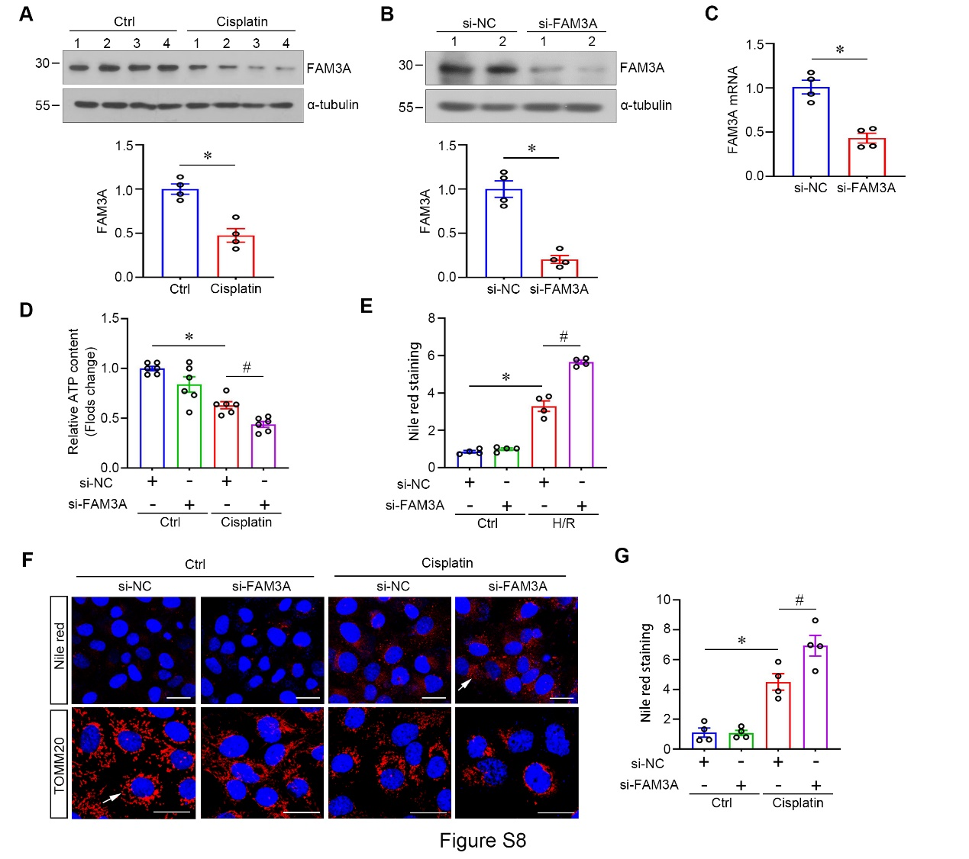
Figure S8. Down-regulation of FAM3A facilitated mitochondrial dysfunction after treatment with H/R or cisplatin. (A) Western blotting and quantitation show the expression of FAM3A in HKC-8 after cisplatin treatment. *P< 0.05 versus control group, (n=4). (B) Western blot shows that FAM3A is knocked-down in HKC-8 after transfection with si-FAM3A. *P< 0.05 versus controls, (n=4). (C) qPCR analysis confirms the effect of si-FAM3A in down-regulating FAM3A mRNA. *P< 0.05 versus controls, (n=4). (D) Graphic presentation shows the relative ATP content in HKC-8 from different groups as indicated. *P< 0.05 versus negative controls, #P< 0.05 versus the cell treatment with cisplatin (n=6). (E) Graphic presentation shows the Nile red staining in different groups as indicated. *P< 0.05 versus controls, #P< 0.05 versus the cell received si-NC and H/R (n=4). (F) Representative micrographs of Nile red and TOMM20 immunofluorescent staining exhibit lipid accumulation and mitochondria in HKC-8. Arrows indicate positive staining. Scale bar, 50μm (upper) or 20μm (under). (G) Graphic presentation shows the Nile red staining in different groups. *P< 0.05 versus controls, #P< 0.05 versus the cell received si-NC and cisplatin (n=4).

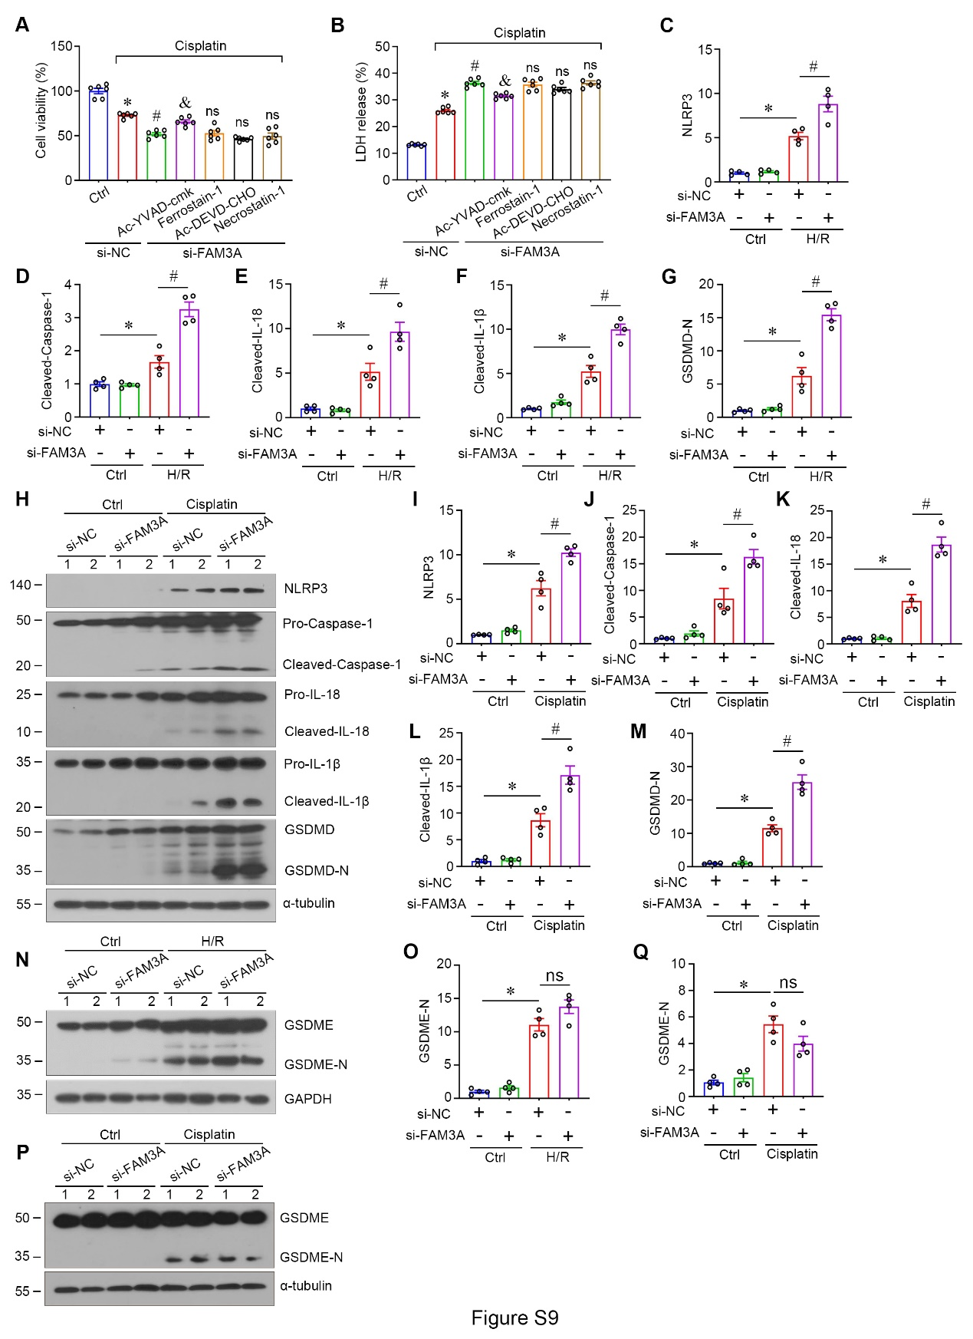
Figure S9. Knocking down of FAM3A aggravates cisplatin-induced pyroptosis. (A) Graphic presentation shows the viability of cells from different groups as indicated. *P< 0.05 versus controls, #P< 0.05 versus the cell treated with si-NC and cisplatin, &P< 0.05 versus the cell treated with si-FAM3A and cisplatin (n=6). ns, no significant difference. (B) Graphic presentation shows the cell LDH release ratio in different groups as indicated. *P< 0.05 versus controls, #P< 0.05 versus the cell treated with si-NC and cisplatin, &P< 0.05 versus the cell treated with si-FAM3A and cisplatin (n=6). ns, no significant difference. (C-G) Quantitation of NLRP3, Cleaved-Caspase-1, Cleaved-IL-18, Cleaved-IL-1β, and GSDMD-N in HKC-8 cells stimulation with H/R. *P< 0.05 versus controls, #P< 0.05 versus the cell received si-NC and H/R (n=4). (H) Representative western blotting shows the protein levels of NLRP3, Pro-caspase-1, Cleaved-caspase-1, Pro-IL-18, Cleaved-IL-18, Pro-IL-1β, Cleaved-IL-1β, GSDMD, and GSDMD-N in different groups as indicated. (I-M) Quantitation of the protein expression showed in (H). *P< 0.05 versus controls, #P< 0.05 versus the cell received si-NC and cisplatin (n=4). (N) Representative western blot shows the protein expression of GSDME and GSDME-N in HKC-8 treated with H/R. (O) Quantitation of the GSDME-N level. *P< 0.05 versus controls (n=4). ns, no significant difference. (P) Representative western blot shows the protein expression of GSDME and GSDME-N in HKC-8 treated with cisplatin. (Q) Quantitation of the expression of GSDME-N. *P< 0.05 versus controls (n=4). ns, no significant difference.

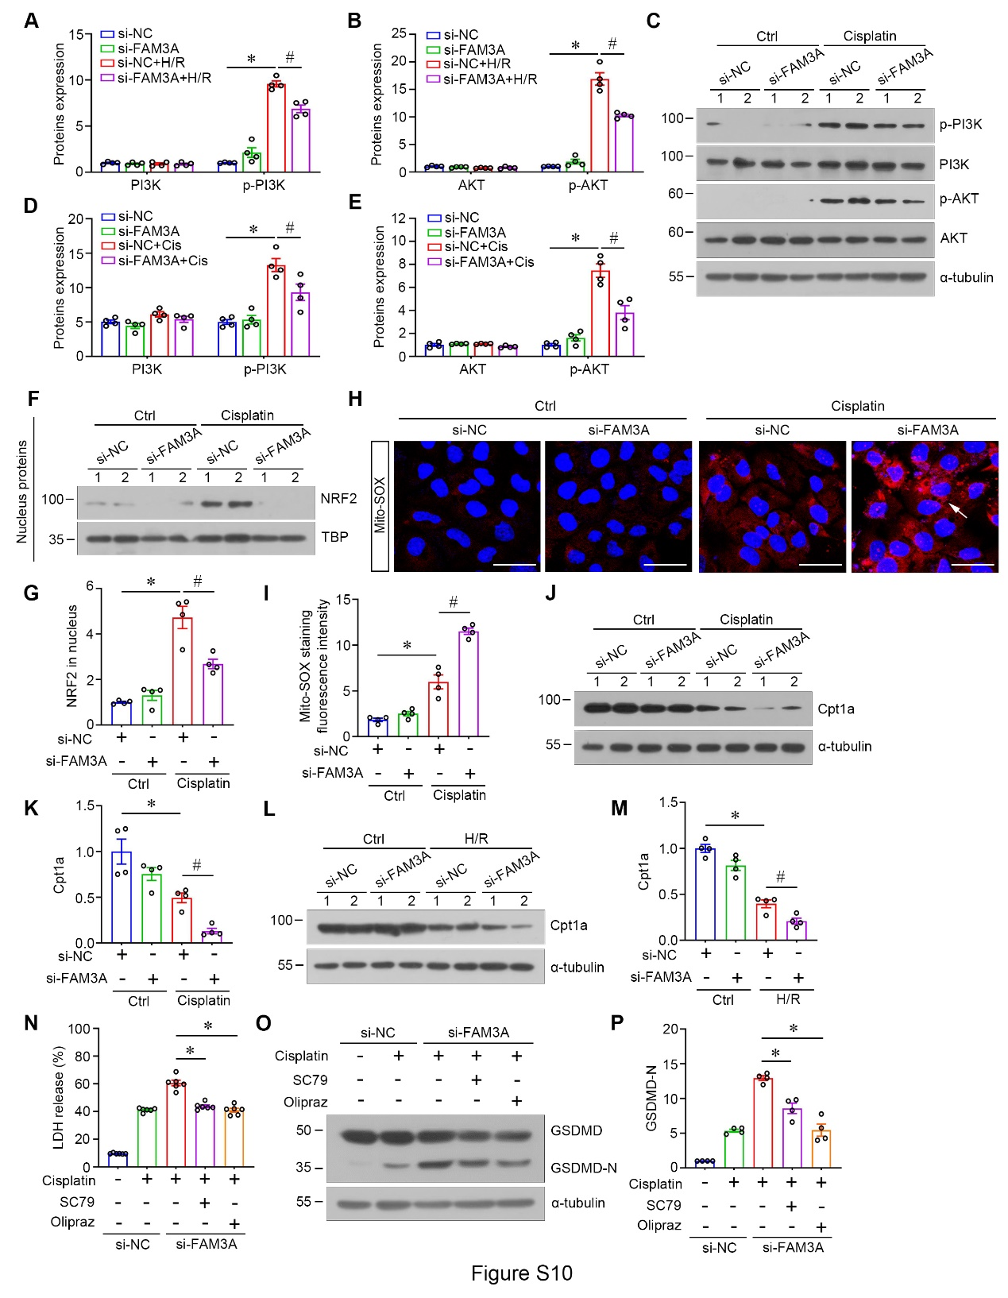
Figure S10. Knocking down of FAM3A inhibits PI3K/AKT/NRF2 signaling. (A-B) Quantitation of the level of PI3K, p-PI3K, AKT, p-AKT in cells stimulation with H/R. *P< 0.05 versus controls, #P< 0.05 versus the cell received si-NC and H/R (n=4). (C) Representative western blot shows the protein levels of p-PI3K, PI3K, p-AKT, and AKT in different groups as indicated. (D-E) Quantitation of the expression of the proteins showed in (C). *P< 0.05 versus controls, #P< 0.05 versus the cell received si-NC and cisplatin (n=4). (F) Western blot shows the accumulation of NRF2 in nucleus. (G) Graphic presentation shows the relative NRF2 protein abundance. Data were normalized by TBP. *P< 0.05 versus controls, #P< 0.05 versus the cell received si-NC and cisplatin (n=4). (H) Representative image of Mito-SOX red staining in the HKC-8 from different groups as indicated. Arrows indicate positive staining. Scale bar, 50μm. (I) Quantitation of Mito-SOX red staining fluorescence intensity of HKC-8 from different groups as indicated. *P< 0.05 versus controls, #P< 0.05 versus the cell received si-NC and cisplatin (n=4). (J-K) Western blotting and quantitation show the expression of Cpt1a in HKC-8 after cisplatin treatment. *P< 0.05 versus controls, #P< 0.05 versus the cell received si-NC and cisplatin (n=4). (L-M) Western blotting and quantitation show the expression of Cpt1a in different groups. *P< 0.05 versus controls, #P< 0.05 versus the cell received si-NC and H/R (n=4). (N) Graphic presentation shows the cell LDH release ratio in different groups as indicated. *P< 0.05 versus the cell received si-FAM3A and cisplatin (n=6). (O-P) Western blotting and quantitation show the expression of GSDMD and GSDMD-N in different groups as indicated. *P< 0.05 versus the cell received si-FAM3A and cisplatin (n=4).


Figure S11. Gene type of NRF2^{KO} mice. Mice were PCR-genotyped by using specific primers for NRF2-KO and WT. Mice carrying NRF2-KO but not WT were considered NRF2^{KO}.

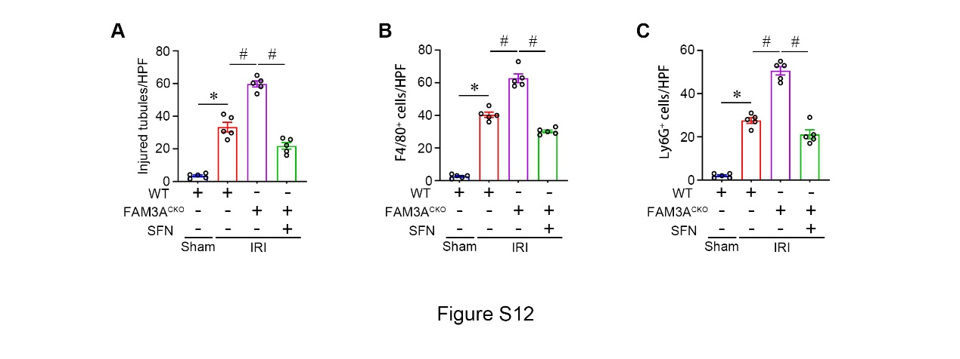
Figure S12. Treatment with NRF2 activator improves AKI. (A-C) Quantitative determination of injured tubules ratio per HPF, the number of F4/80⁺ and Ly6G⁺ cells per HPF. *P< 0.05 versus FAM3A^{CKO} IRI mice (n=5).

Supplementary Tables
Table S1. Primers were used in this study.
Gene | Froward Primers (5′-3′) | Reverse Primers (5′-3′)
Primers used for genotyping
FAM3A^{flox} | CTTATCTATCTGTAAAGACCCTGTT | GACCTAGGGACTCCAAGAATTAGAT
Ggt1-Cre | CATCACATCAGGCACCCCAGAA | GAACATCTTCAGGTTCTGCGGGA
NRF2-KO | GAAGCATTATCATTTGGTGGGAAC | TGCACCAGAGTTCAAAGGTAGC
NRF2-WT | GAAGCATTATCATTTGGTGGGAAC | TGTCTGCCATGAACCCTGTCTC
Primers used for RT-PCR (mouse)
TOMM20 | TCTTCCGCCACCAGTGTTC | CAGCCAAGCTCTGAGCACT
mt-cytb | CCCACCCCATATTAAACCCC | GAGGTATGAAGGAAAGGTATAAGGG
TFAM | CACCCAGATGCAAAACTTTCAG | CTGCTCTTTATACTTGCTCACAG
Nqo1 | CTGGTTTGAGAGAGTGCTCGT | GAGAGTACATGGAGCCGCTAC
Sod1 | CAGGATTAACTGAAGGCCAGC | AAATGAGGTCCTGCACTGGTA
Cpt1a | CAAGGTCTTCTCGGGTCGAAA | CACTGCAATTTGGGTCCAAGG
Acox1 | AACTTCCTCACTCGAAGCCAG | AAGGTCCAAAGGCTCAGGATG
P2y1 | CCTGCTATGACACCACGTCCAA | AGCGGAGAGTTGTCCAGGTCAT
β-actin | AGGCATCCTCACCCTGAAGTA | CACACGCAGCTCATTGTAGA
Primers used for RT-PCR (human)
FAM3A | CTGGTGTTCGTGGCATCCT | GGCCAGCCTTCGTACTTGT
β-actin | CTCACCATGGATGATGATATCGC | AGGAATCCTTCTGACCCATGC

Table S2. Characteristics of healthy subjects and AKI patients.
Characteristics | AKI (71) | No-AKI (21)
Age, yr | 56±2.055 | 36.6±2.63
Men, n (%) | 41 (57.74%) | 10 (47.62%)
Preexisting clinical conditions, n (%)
CKD | 32 (45.07%) | 0 (0.0)
Hypertension | 29 (40.84%) | 0 (0.0)
Diabetes | 16 (22.53%) | 0 (0.0)
Renal function
Serum creatinine (µmol/L) | 186.3±15.12 | 73.57±3.752
UACR (mg/g Ucr) | 441.4±98.31 | 8.831±1.129
β2-MG (µg/mg Ucr) | 9.909±1.772 | 0.183±0.00

Table S3. Genes used for FAM3A network analysis¹⁻²⁰.
 | Genes Name | References
Upstream signal of FAM3A | Stat3; Hoxa13; Snhg8; Hnf4a; Nfe2; Pparg; Cebpb | 1; 2; 3; 4; 5; 6
Downstream signal of FAM3A | P2ry1; Atp5b; Creb; Foxd3; Eif5; Atp5a1; Atp5c1; Atp5d; Atp5g; Atpaf1; Calm1; Foxa2; Cpt2; Adipor1; Ampk; P2rx7; Foxa2; Pdx1; Ep2; Chop; Wnt; Mtor; Mapk1; Hsf1; Mapk2; Camk1; Vegfa; Gsk3b; Akt; Pi3k | 1; 5; 6; 8; 9; 10; 11; 12; 13; 14; 15; 16; 17
PI3K/AKT regulated cell death | Pten; Nlrp3; Nek7; Casp1; Gsdma; Gsdme; Il-1b; Il-18; Bad; Bcl2; Casp9; Bax; Mcl2; Gpx4; Acsl4; Gsk3b; Nrf2 | 18; 19; 20

References
1 Chen, Z. et al. Repurposing Doxepin to Ameliorate Steatosis and Hyperglycemia by Activating FAM3A Signaling Pathway. Diabetes 69, 1126-1139, doi:10.2337/db19-1038 (2020).
2 Kang, T. et al. Transcriptional regulation analysis of FAM3A gene and its effect on adipocyte differentiation. Gene 595, 92-98, doi:10.1016/j.gene.2016.09.038 (2016).
3 Liu, J. et al. Mechanism of Snhg8/miR-384/Hoxa13/FAM3A axis regulating neuronal apoptosis in ischemic mice model. Cell Death Dis 10, 441, doi:10.1038/s41419-019-1631-0 (2019).
4 Sala, D. et al. The Stat3-Fam3a axis promotes muscle stem cell myogenic lineage progression by inducing mitochondrial respiration. Nat Commun 10, 1796, doi:10.1038/s41467-019-09746-1 (2019).
5 Xiang, R. et al. VSMC-Specific Deletion of FAM3A Attenuated Ang II-Promoted Hypertension and Cardiovascular Hypertrophy. Circ Res 126, 1746-1759, doi:10.1161/CIRCRESAHA.119.315558 (2020).
6 Yang, W. et al. NFE2 Induces miR-423-5p to Promote Gluconeogenesis and Hyperglycemia by Repressing the Hepatic FAM3A-ATP-Akt Pathway. Diabetes 66, 1819-1832, doi:10.2337/db16-1172 (2017).
7 Jia, S. et al. FAM3A promotes vascular smooth muscle cell proliferation and migration and exacerbates neointima formation in rat artery after balloon injury. J Mol Cell Cardiol 74, 173-182, doi:10.1016/j.yjmcc.2014.05.011 (2014).
8 Lee, J. et al. Dulaglutide Ameliorates Palmitic Acid-Induced Hepatic Steatosis by Activating FAM3A Signaling Pathway. Endocrinol Metab (Seoul) 37, 74-83, doi:10.3803/EnM.2021.1293 (2022).
9 Liu, X. et al. Imipramine activates FAM3A-FOXA2-CPT2 pathway to ameliorate hepatic steatosis. Metabolism 136, 155292, doi:10.1016/j.metabol.2022.155292 (2022).
10 Song, Q. et al. FAM3A Ameliorates Brain Impairment Induced by Hypoxia-Ischemia in Neonatal Rat. Cell Mol Neurobiol 43, 251-264, doi:10.1007/s10571-021-01172-6 (2023).
11 Song, Q., Gou, W. L. & Zhang, R. FAM3A attenuates ER stress-induced mitochondrial dysfunction and apoptosis via CHOP-Wnt pathway. Neurochem Int 94, 82-89, doi:10.1016/j.neuint.2016.02.010 (2016).
12 Wang, C. et al. FAM3A activates PI3K p110alpha/Akt signaling to ameliorate hepatic gluconeogenesis and lipogenesis. Hepatology 59, 1779-1790, doi:10.1002/hep.26945 (2014).
13 Xu, W., Liang, M., Zhang, Y., Huang, K. & Wang, C. Endothelial FAM3A positively regulates post-ischaemic angiogenesis. EBioMedicine 43, 32-42, doi:10.1016/j.ebiom.2019.03.038 (2019).
14 Yan, H. et al. Intracellular ATP Signaling Contributes to FAM3A-Induced PDX1 Upregulation in Pancreatic Beta Cells. Exp Clin Endocrinol Diabetes 130, 498-508, doi:10.1055/a-1608-0607 (2022).
15 Yan, H. et al. FAM3A maintains metabolic homeostasis by interacting with F1-ATP synthase to regulate the activity and assembly of ATP synthase. Metabolism 139, 155372, doi:10.1016/j.metabol.2022.155372 (2023).
16 Yan, S., Jiang, C., Li, H., Li, D. & Dong, W. FAM3A protects chondrocytes against interleukin-1beta-induced apoptosis through regulating PI3K/Akt/mTOR pathway. Biochem Biophys Res Commun 516, 209-214, doi:10.1016/j.bbrc.2019.06.016 (2019).
17 Yang, W. et al. FAM3A plays crucial roles in controlling PDX1 and insulin expressions in pancreatic beta cells. FASEB J 34, 3915-3931, doi:10.1096/fj.201902368RR (2020).
18 Zhou, B. H. et al. PI3K/AKT signaling pathway involvement in fluoride-induced apoptosis in C2C12 cells. Chemosphere 199, 297-302, doi:10.1016/j.chemosphere.2018.02.057 (2018).
19 Li, X. et al. Pretreatment with Roxadustat (FG-4592) Attenuates Folic Acid-Induced Kidney Injury through Antiferroptosis via Akt/GSK-3beta/Nrf2 Pathway. Oxid Med Cell Longev 2020, 6286984, doi:10.1155/2020/6286984 (2020).
20 Zhang, C. et al. Cadmium and molybdenum co-induce pyroptosis via ROS/PTEN/PI3K/AKT axis in duck renal tubular epithelial cells. Environ Pollut 272, 116403, doi:10.1016/j.envpol.2020.116403 (2021).

