Table S1: The summary fitting of 2,4-D degradation in the PCP
Source | Sequential p-value | Lack of Fit p-value | Adjusted R² | Predicted R²
Linear | 0/1521 | < 0.0001 | 0/1042 | -0/1548
2FI | 0/0029 | < 0.0001 | 0/5477 | 0/5247
Quadratic | < 0.0001 | 0/0994 | 0/9865 | 0/9637 | Suggested
Cubic | 0/6602 | 0/0290 | 0/9843 | 0/5860 | Aliased

Table S2: The ANOVA result for the quadratic model of the PCP in 2,4-D degradation
Source | Sum of Squares | df | Mean Square | F-value | p-value
Model | 1190/63 | 14 | 85/04 | 152/27 | < 0.0001 | significant
A-pH | 97/61 | 1 | 97/61 | 174/77 | < 0.0001
B-2,4 D Con | 98/42 | 1 | 98/42 | 176/21 | < 0.0001
C-Catalist | 40/56 | 1 | 40/56 | 72/62 | < 0.0001
D-Reaction Time | 36/51 | 1 | 36/51 | 65/37 | < 0.0001
AB | 0/2025 | 1 | 0/2025 | 0/3626 | 0/5561
AC | 21/16 | 1 | 21/16 | 37/89 | < 0.0001
AD | 132/25 | 1 | 132/25 | 236/79 | < 0.0001
BC | 308/00 | 1 | 308/00 | 551/48 | < 0.0001
BD | 68/06 | 1 | 68/06 | 121/87 | < 0.0001
CD | 40/96 | 1 | 40/96 | 73/34 | < 0.0001
A² | 220/19 | 1 | 220/19 | 394/25 | < 0.0001
B² | 3/20 | 1 | 3/20 | 5/73 | 0/0302
C² | 136/81 | 1 | 136/81 | 244/96 | < 0.0001
D² | 26/52 | 1 | 26/52 | 47/49 | < 0.0001
Residual | 8/38 | 15 | 0/5585
Lack of Fit | 7/28 | 10 | 0/7277 | 3/31 | 0/0994 | not significant
Pure Error | 1/10 | 5 | 0/2200
Cor Total | 1199/01 | 29

Fig. S1: The kinetics for the degradation of 2,4-D in the PCP (pH = 6.5, RT = 60 min, 2,4-D concentration=50,75, and 100 mg/L, light intensity=30 mW/cm³, and catalyst dose = 16.5 mg/L)
Table S3: The kinetic constants for the degradation of 2,4-D in the PCP
2,4-D Concentration (mg/L) | K×10 ⁻²(min⁻¹) | R²
50 | 2.0 | 0.96
75 | 12.0 | 0.98
100 | 3.0 | 0.95

Fig. 2S: The synergistic effect of different mechanisms in the PCP (pH = 6.5, RT = 60 min, 2,4-D concentration=50 mg/L, light intensity=30 mW/cm³, and catalyst dose = 16.5 mg/L)

Fig. 3S: The reusability of the catalyst in the sixth consecutive PCP (pH = 6.5, RT = 60 min, 2,4-D concentration=50 mg/L, light intensity=30 mW/cm³, and catalyst dose = 16.5 mg/L)
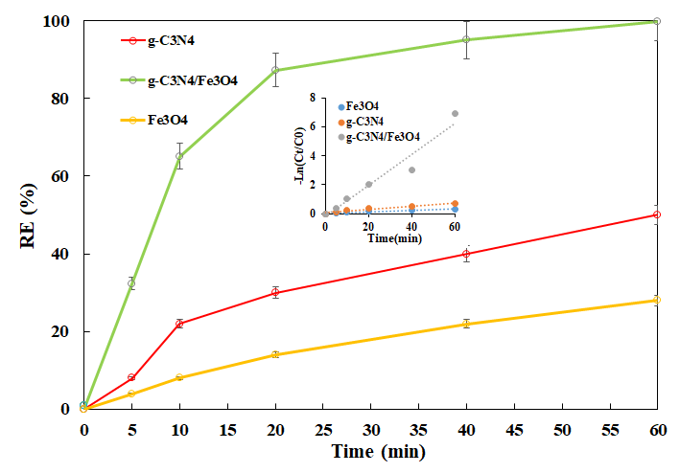
Fig. 4S: The performance of the PCP in the presence of individual component of catalyst (pH = 6.5, RT = 60 min, 2,4-D concentration=50 mg/L, light intensity=30 mW/cm³, and catalyst dose = 16.5 mg/L)

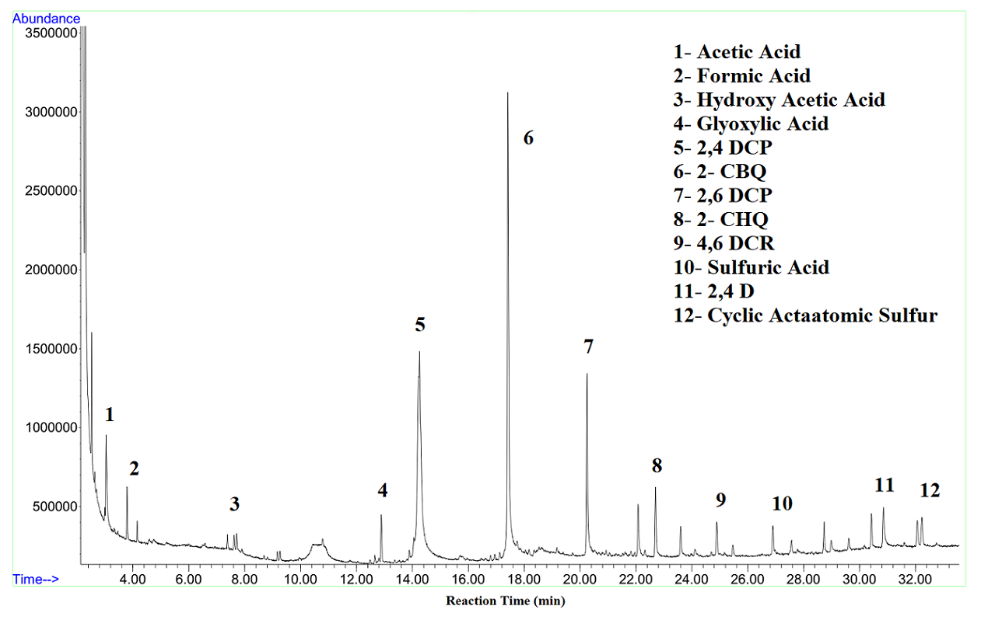
Fig. 5S: The analysis of the produced intermediates during 2, 4-D degradation via GC–MS (pH = 6.5, RT = 60 min, 2,4-D concentration=50 mg/L, light intensity=30 mW/cm³, and catalyst dose = 16.5 mg/L)

