Fluorocarbon-driven pore size reduction in polyurethane foams: an effect of improved bubble entrainment
Martin Hamann¹, Guillaume Cotte-Carluer¹, Sébastien Andrieux¹, Daniel Telkemeyer², Meik Ranft³, Markus Schütte², Wiebke Drenckhan¹
¹CNRS-UPR 22, Institut Charles Sadron, Université de Strasbourg, 67200 Strasbourg, France
²BASF Polyurethanes GmbH, 49448 Lemförde, Germany
³BASF SE, 67056 Ludwigshafen am Rhein, Germany

Supporting Information

Characterization of bubbly A-components (premixes) via transmitted light microscopy

  - Experimental details
Directly after the bubble generation step, three or four drops of the fresh premix were collected in the center of a microscope slide (70 x 26 mm). Both ends of this microscope slide were equipped with one layer of adhesive tape (Tesafilm Classic, thickness = 44 µm). Then, the microscope slide was covered by a second microscope slide of the same size. Due to the presence of the adhesive tape layer on the bottom slide, a thin slit of 44 µm thickness filled with the fresh premix sample was formed in-between the two microscope slides (see Figure S1). This slit hindered superposition of multiple bubble layers which would otherwise complicate automatic image analysis.
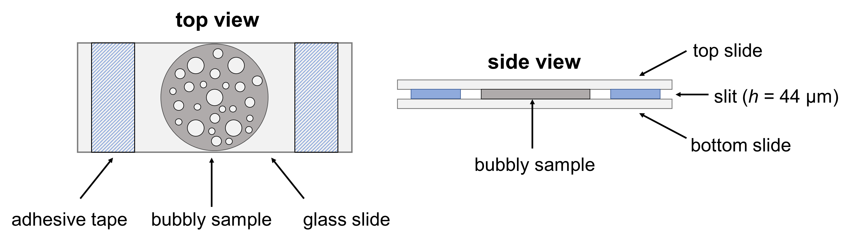
Figure S1: Microscope slide setup used for the observation of bubbly polyol-based A-components (premix) in transmitted light mode

All microscopic observations were conducted using a Keyence VHX 2000 numerical microscope in transmitted light mode. To ensure fast and continuous image acquisition, videos of the samples were recorded for 600 s instead of single images, as the lowest rate of automatic single image acquisition was 5 seconds per image. All videos were recorded using a resolution of 1600 x 1200 pixels at a framerate of 15 fps. Using VLC Player, the recorded videos were then converted to single images such that one image for every second of the observation was generated.

Image analysis
All images were analyzed using the image analysis software ImageJ by National Institute of Health. For each image the same treatment was used to extract the number of bubbles and the mean radius. First, the images were binarized (8 bit). Next, the images were thresholded using Otsu’s method. Then, the scale was set to translate pixel units into micrometer. Moreover, a window within the image in which bubbles were supposed to be considered was defined. Eventually, the “analyze particles” function of ImageJ was used for detecting the number of bubbles and the area of each bubble (see Figure S2).
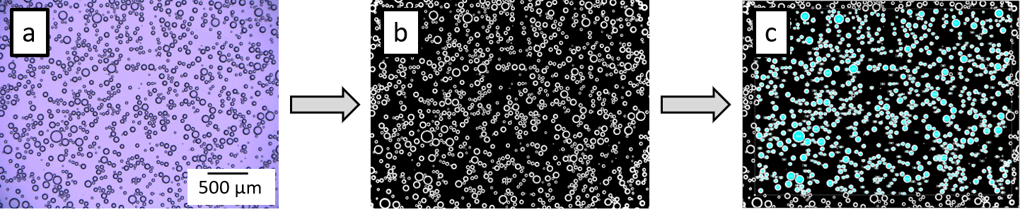
Figure S2: Overview of the treatment of the microscope images: a) Raw image obtained from the microscope. b) Image after binarization and thresholding. c) Output of the particle analysis function of ImageJ.

A macro that automated all the mentioned processing steps was generated and is supplied in the following:
run("8-bit");
folder="C:/Target_folder_path/" ;
Incomplete_name=getTitle();
name=Incomplete_name+".xls";
path=folder+name;
setAutoThreshold("Otsu dark");
//run("Threshold...");
//setThreshold(139, 255);
setOption("BlackBackground", false);
run("Convert to Mask");
//setTool("rectangle");
makeRectangle(68, 44, 1490, 1082);
run("Set Scale...", "distance=0.4653 known=1 pixel=1 unit=µm global");
run("Analyze Particles...", "size=30-Infinity circularity=0.60-1.00 show=[Overlay Masks] display exclude clear");
saveAs("Results", path);
Lastly, table calculations were used to convert the measured bubble areas into bubble radii. For air bubbles with a radius greater than half the slit thickness (r > 22 µm) the observed bubble radius had to be corrected since the observed air bubble was not spherical but had a “pancake shape” (which was approximated by a cylindrical shape) due to being confined between the two glass slides. The correction included calculating the volume of the observed cylindrical bubble and extracting the radius of a spherical bubble of equal volume.
 | $$r_{s}={\left(\frac{3}{4}h\right)}^{\frac{1}{3}}⋅{r_{c}}^{\frac{2}{3}}$$ | [1]

With r_{s} being the diameter of a spherical bubble of equal volume to the observed cylindrical bubble, h the slit thickness (44 µm) and r_{c} the radius of the observed cylindrical bubble. Furthermore, the bubble count in the observed window was translated into a volumetric bubble density by dividing the bubble count by the volume of the observation window (V_{window} = 0.33 mm³).

  - Microscopy of dispersed FC droplets
Having seen a pronounced turbidity when preparing FC-containing premixes and knowing that FCs are notoriously insoluble in most other liquid phases, we tried to use transmitted light microscopy to visualize the FC droplets and to assess their size. For this purpose, we zoomed into some of the premix samples that we used to study the temporal decay of the bubble density in the premix directly after its generation (see Section 2 of this supporting information). Figure S3 shows a micrograph of an FC-containing bubbly premix obtained using a magnification of 1000x.

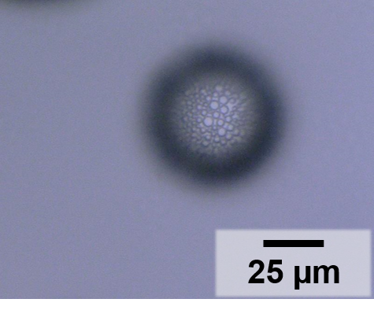
Figure S3: High-magnification (1000x) transmitted light micrograph of an FC-containing bubbly premix.

We observed that the FC droplets preferably accumulate at the bottom of the slit in between the two microscopic carrier slides shown in Figure S1. As can be taken from Figure S3, we found that the FC-droplets have a characteristic radius between 1 and 3 µm and are therefore very small with respect to the air bubbles (⟨r_{b}⟩ = 10 – 15 µm). Although we managed to visualize the FC droplets, we emphasize that, due to their small characteristic size, other means of investigation such as light scattering techniques would be much more appropriate to characterize the FC droplets in more detail.

Microscopic analysis of bubble aging in the premix
To monitor the decay of the air bubble density n_{pre} in the premix due to bubble aging, transmitted light micrographs corresponding to t = [0, 5, 10, 15, 20, 25, 30, 40, 50, 100, 150, 200, 250, 300, 350, 400, 450, 500, 550, and 600] s were picked and evaluated for every experiments conducted using different cycle numbers N_{c} = [1, 2, 5, 10, 30, 50] both in absence and presence of the FC. In this context, Figure S4a and b show the evolution of the air bubble density as a function of time, while Figure S4c and d show the evolution of the corresponding mean bubble radii ⟨r_{b}⟩.
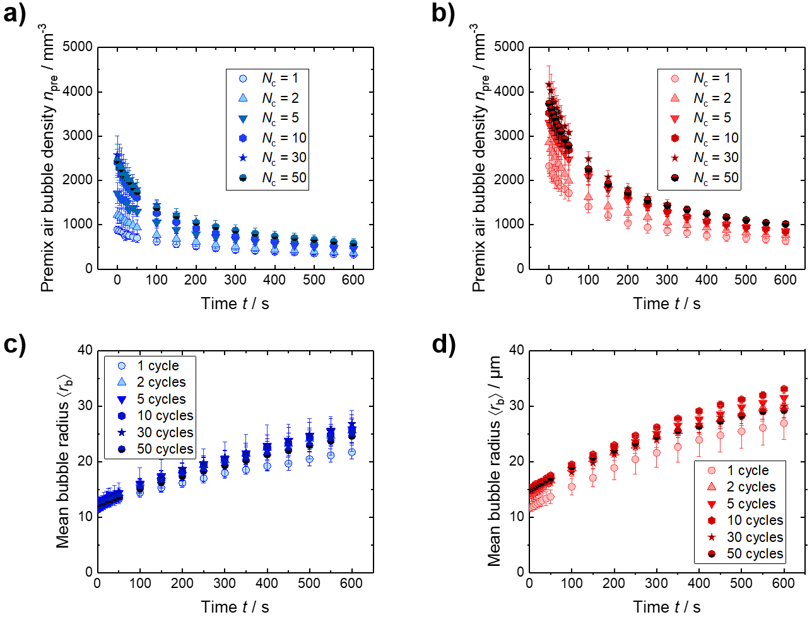
Figure S4:Temporal evolution of the premix air bubble density n_{pre} for premixes generated a) without and b) with the fluorocarbon (FC) perfluoro(4-methylpent-2ene) using different numbers of mixing cycles N_{c} in a double-syringe mixing machine. Mean air bubble radius of the air bubbles in c) absence and d) presence of the FC in the premix.

As can be taken from Figure S4a and b, the premix air bubble density n_{pre} decreases over the period of the microscopic observation with a pronounced decrease at the beginning of the observation irrespective of the absence or presence of the FC. At the same time, Figure S4c and d show the mean air bubble radius ⟨r_{b}⟩ grows continuously during the observation for both formulations with and without FC. This demonstrates unambiguously that bubble aging is taking place in the premix and that the presence of the FC does not noticeably retard bubble aging as often stated.
For the sake of the comparability of the results shown in Figure S4, Figure S5a shows the temporal evolution of the normalized bubble density, i.e., how the bubble density n_{pre} changes with respect to the initial bubble density n_{pre,0}. Furthermore, the evolution of the normalized mean bubble radius ⟨r_{b}⟩ / ⟨r_{b,0}⟩ is shown in Figure S5. Note that for reasons of clarity, only the results of the experiments conducted with N_{c} = 50 are shown in Figure S5.

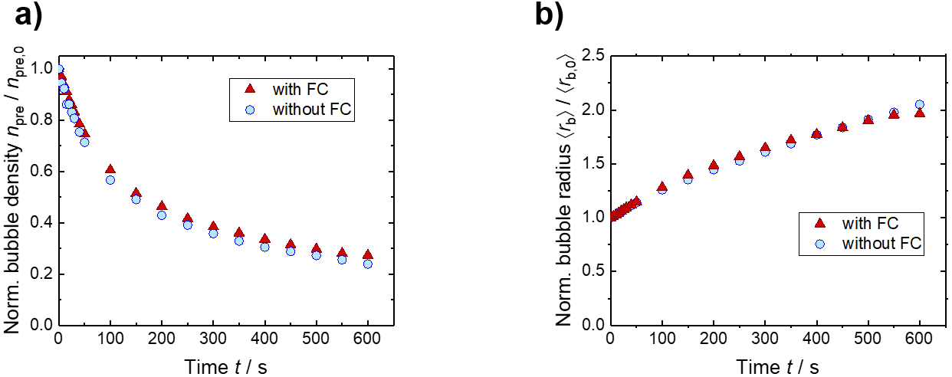
Figure S5:Temporal evolution of a) the normalized air bubble density n_{pre} / n_{pre,0} and b) the normalized mean bubble radius ⟨r_{b}⟩ / ⟨r_{b,0}⟩ premixes generated using 50 double-syringe mixing cycles for formulations with and without the FC.

Figure S5a reveals that the relative decay of the bubble density proceeds equally fast for formulations with and without the FC. As is shown in Figure S5, the same holds true for the growth of the entrapped air bubbles undergoing bubble aging. This finding emphasizes that bubble aging is not only not stopped in the presence of the FC – in fact it is not even noticeably decelerated.

