A: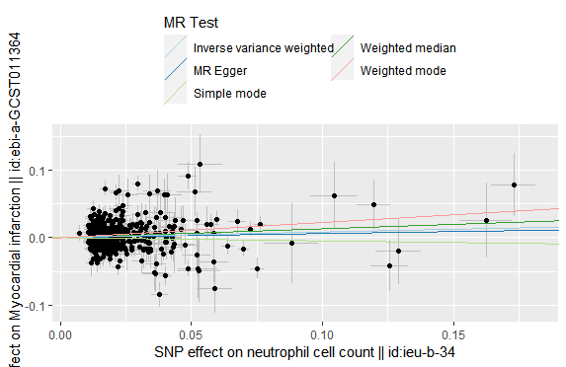
B:
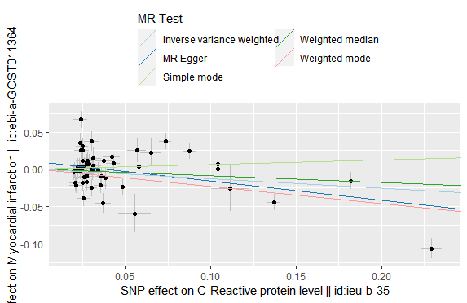
Supplementary Figure S1. Scatter plot of the association of inflammatory factors with myocardial infarction. A: neutrophil cell count; B: C-Reactive protein level.
The plot displays each SNP as a black dot, with its estimate on inflammatory factors and risk of myocardial infarction indicated by standard error bars. The slopes of the lines represent causal estimates obtained using various methods. SNP refers to single nucleotide polymorphism.

A:
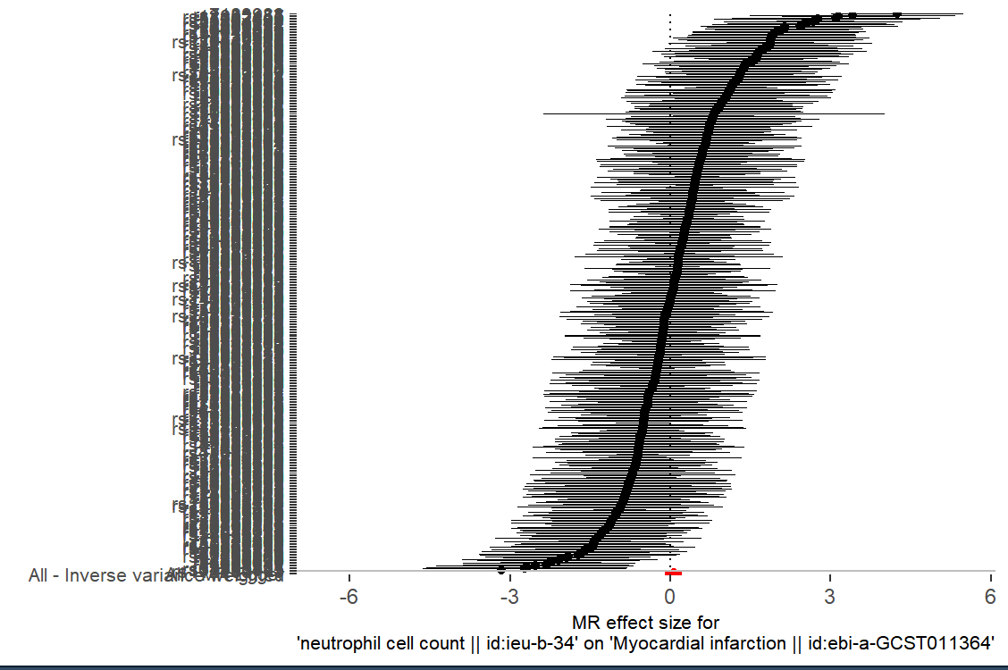
B:
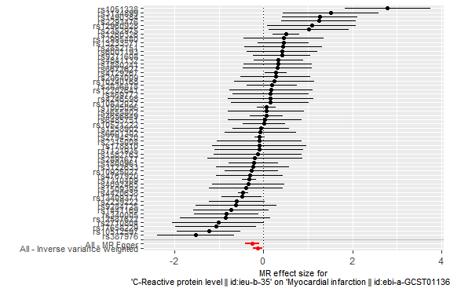
Supplementary Figure S2. Forest plot of the association of flammatory factors with myocardial infarction. A: neutrophil cell count; B: C-Reactive protein level.
The dot and bar indicate the causal estimate of flammatory factors on risks of myocardial infarction.

A:
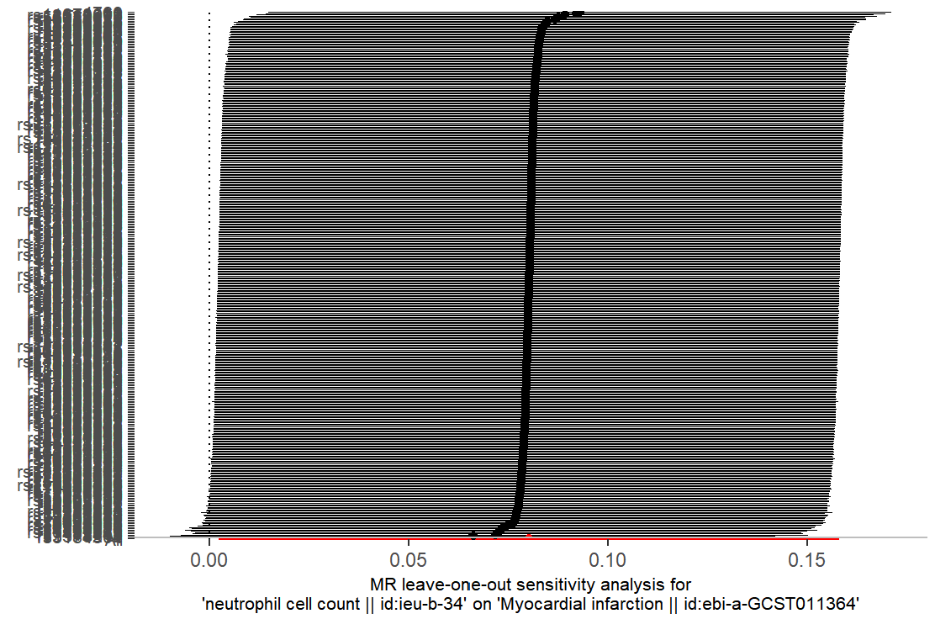
B:
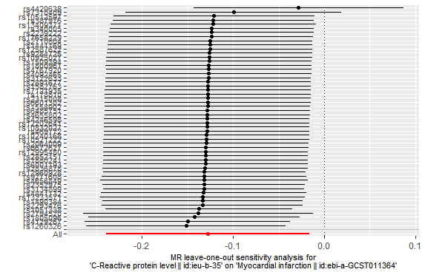
Supplementary Figure S3. Leave-one-out sensitivity analysis of the association of inflammatory factors with myocardial infarction. A: neutrophil cell count; B: C-Reactive protein level.
The dot and bar indicate the estimates and 95% confidence interval when the specific single
nucleotide polymorphism is removed.

A:
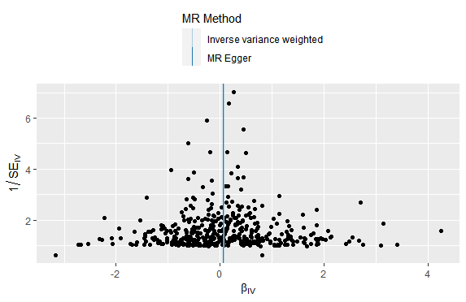
B:
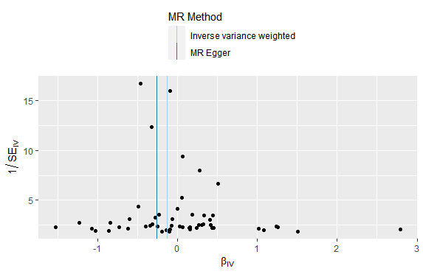
Supplementary Figure S4. Funnel plot of the association of inflammatory factors with myocardial infarction. A: neutrophil cell count; B: C-Reactive protein level.
Each black dot indicates a single nucleotide polymorphism

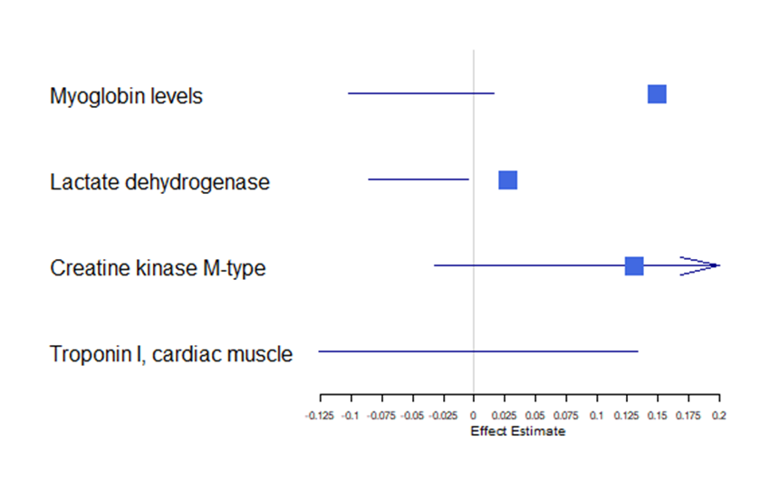
Supplementary Figure S6 Forest plot of effect estimates for the association between neutrophil cell count and myocardial infarction

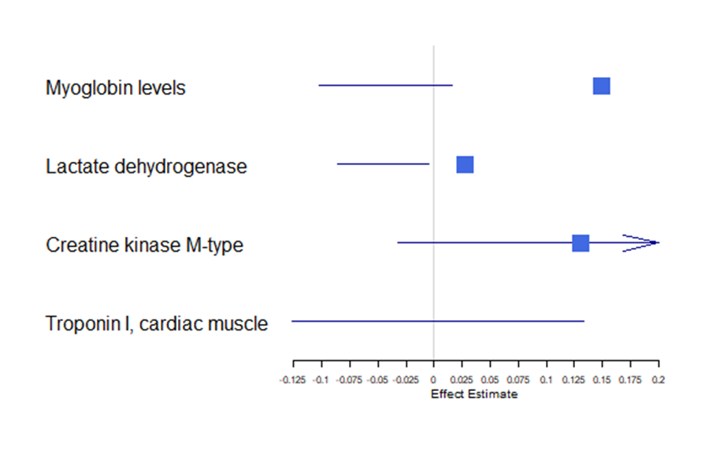
Supplementary Figure S7 Forest plot of effect estimates for the association between C-reactive protein level and myocardial infarction.

