Supplementary Information
Response of distinct soil types to cyanobacterial biofertilizer inoculation
Babanpreet Kour ¹, Preeti Sharma ^{1,2}, Ramya S ¹, Sandeep Gawdiya ³, Sudheer K ¹, Balasubramanian Ramakrishnan ^{1, *}
¹Division of Microbiology, ICAR-Indian Agricultural Research Institute, New Delhi, India.

² University Institute of Engineering & Technology, Kurukshetra University, Kurukshetra, Haryana, India.
³ Division of Agronomy, ICAR-Indian Agricultural Research Institute, New Delhi, India.

*Address for correspondence:
Dr. B. Ramakrishnan
Division of Microbiology
ICAR-Indian Agricultural Research Institute
New Delhi, India
Mobile: +91 7838222671
E-mail: ramakrishnanbala@yahoo.com/b.ramakrishnan@icar.gov.in

Supplementary Table S1. Primers and thermal cycling conditions for PCR reactions
Target gene | Primer | Primer sequence (5’ to 3’) | Reaction conditions  (ºC) | Amplified fragment  (bp) | References
Total bacteria | Eub338  Eub518 | ACTCCTACGGGAGGCAGCAG  ATTACCGCGGCTGCTGG | 10 min of 95ºC, 35 cycles consisting of 10s at 95ºC, 15s at 53ºC, and 40s at 72ºC | 200 | Feirer et al. (2005)
Total archaea | ARCH-mix1369F  Prok-1541R | 1:1 mixture of Arch1-1369F & Arch2-1369F  Arch1-1369F:CGGTGAATACGTCCCTGC,  and Arch2-1369F: CGGTGAATATGCCCCTGC;  AAGGAGGTGATCC RGCCGCA | 10 min of 95ºC, 40 cycles consisting of 10s at 95ºC, 15s at 55ºC, and 25s at 72ºC | 172 | Suzuki et al. (2000)
Cyanobacteria | Cya 359F  Cya 781R_{a}  & Cya 781R_{b} | GGG GAA TYT TCC GCA ATG GG  GAC TAC TGG GGT ATC TAA TCC CAT T  GAC TAC AGG GGT ATC TAA TCC CTT T | 10 min of 95ºC, 40 cycles consisting of 10s at 95ºC, 10s at 60ºC, and 25s at 72ºC | 450 | Nubel et al. (1997)
Cyanophage | CPS1  CPS8 | GTA GWA TTT TCT ACA TTG AYG TTG  G AAA TAY TTD CCA ACA WAT GGA | 10 min of 95ºC, 35 cycles consisting of 60s at 94ºC, 60s at 55ºC, and 60s at 72ºC | 600 | Wang et al. (2011)
nifH | nifH-F  nifH-R | TGCGAYCCSAARGCBGACTC  ATSGCCATCATYTCRCCGGA | 10 min of 95ºC, 40 cycles consisting of 10s at 95ºC, 15s at 55ºC, and 40s at 72ºC | 227 | Poly et al. (2001)
Bacterial amoA | amoA-1F  amoA-2R | GGGGTTTCTACTGGTGGT  CCCCTCKGSAAAGCCTTCTTC | 10 min of 95ºC, 40 cycles consisting of 10s at 95ºC, 15s at 53ºC, and 40s at 72ºC | 491 | Rotthauwe et al. (1997)
Archaeal amoA | CrenamoA-23f^{d} CrenamoA-616r^{d} | ATGGTCTGGCTWAGACG  GCCATCCATCTGTATGTCCA | 10 min of 95ºC, 40 cycles consisting of 10s at 95ºC, 15s at 58ºC, and 40s at 72ºC | 592 | Tourna et al. (2008)
nirK | nirK-1F  nirK-3R | GG(A/C)ATGGT(G/T)CC(C/G)TGGCA  GAACTTGCCGGT(A/C/G)G(C/T)CCAGAC | 10 min of 95ºC, 40 cycles consisting of 10s at 95ºC, 15s at 45ºC, and 30s at 72ºC | 392 | Braker et al. (1998)
nirS | nirS-1F  nirS-6R | CCTA(C/T)TGGCCGCC(A/G)CA(A/G)T  GCCGCCGTC(A/G)TG(A/C/G)AGGAA | 10 min of 95ºC, 40 cycles consisting of 10s at 95ºC, 15s at 45ºC, and 40s at 72ºC | 256 | Braker et al. (1998)
narG | narG-1960m2f  narG-2050m2R | TA(CT)GT(GC)GGGCAGGA(AG)AAACTG  CGTAGAAGAAGCTGGTGCTGTT | 10 min of 95ºC, 40 cycles consisting of 10s at 95ºC, 30s at 60ºC, and 40s at 72ºC | 110 | López-Gutiérrez et al. (2004)
nosZ | nosZ-1F  nosZ-1R | WCSYTGTTCMTCGACAGCCAG  ATGTCGATCARCTGVKCRTTYTC | 10 min of 95ºC, 40 cycles consisting of 10s at 95ºC, 15s at 60ºC, and 30s at 72ºC | 259 | Henry et al. (2006)

Legends for Supplementary figures
Supplementary Figure S1.
Effect of cyanobacterial inoculation on the abundance of archaeal 16S rRNA gene copies in soils incubated under the light-dark or continuous dark cycles on (a) 15 DAI on the left axis (b) 30 DAI on the right axis. Vertical bars represent the mean copy number of genes after 15 DAI, while vertical boxes show abundances after 30 DAI (n=3). Error bars represent the standard error ± 0.05 for individual variables. (IARI-Indian Agricultural Research Institute; SUB-Subsurface; KUT-Kuttanad; RAJ-Rajasthan; ADU-Aduthurai; UMI-Umiam; & KAR-Karnal given on the x-axis).
Supplementary Figure S2.
Total bacterial 16S rRNA gene copies as influenced by cyanobacterial inoculation in distinct soil types, incubated under the light-dark or continuous dark cycles on (a) 15 DAI on the left axis (b) 30 DAI on the right axis. Vertical bars represent the mean copy number of genes after 15 DAI, while vertical boxes show abundances after 30 DAI (n=3). Error bars represent the standard error ± 0.05 for individual variables. (IARI-Indian Agricultural Research Institute; SUB-Subsurface; KUT-Kuttanad; RAJ-Rajasthan; ADU-Aduthurai; UMI-Umiam; & KAR-Karnal given on the x-axis).
Supplementary Figure S3. Abundance of (a) archaeal amoA and (b) bacterial amoA gene copies in soils without or with cyanobacterial inoculant, incubated under the light-dark or continuous dark cycles on 15 DAI and 30 DAI. Each bubble represents the mean copy number of genes (n=3) (IARI-Indian Agricultural Research Institute; SUB-Subsurface; KUT-Kuttanad; RAJ-Rajasthan; ADU-Aduthurai; UMI-Umiam; & KAR-Karnal given on the y-axis)
Supplementary Figure S4. Gene copies of (a) nirS, (b) nirK, (c) narG, and (d) nosZ in soils without or with cyanobacterial inoculant, incubated under light-dark (left) or continuous dark (right) cycles on 15 DAI and 30 DAI. The height of nodes indicates the absolute abundances of individual genes (n=3), and the links represent the gene copies in source soils. Different colors present different soil types. Different alphabets (Tukey’s HSD) are significantly different (p<0.05) between the treatments. (IARI-Indian Agricultural Research Institute; SUB-Subsurface; KUT-Kuttanad; RAJ-Rajasthan; ADU-Aduthurai; UMI-Umiam; & KAR-Karnal).

Supplementary Figure S1

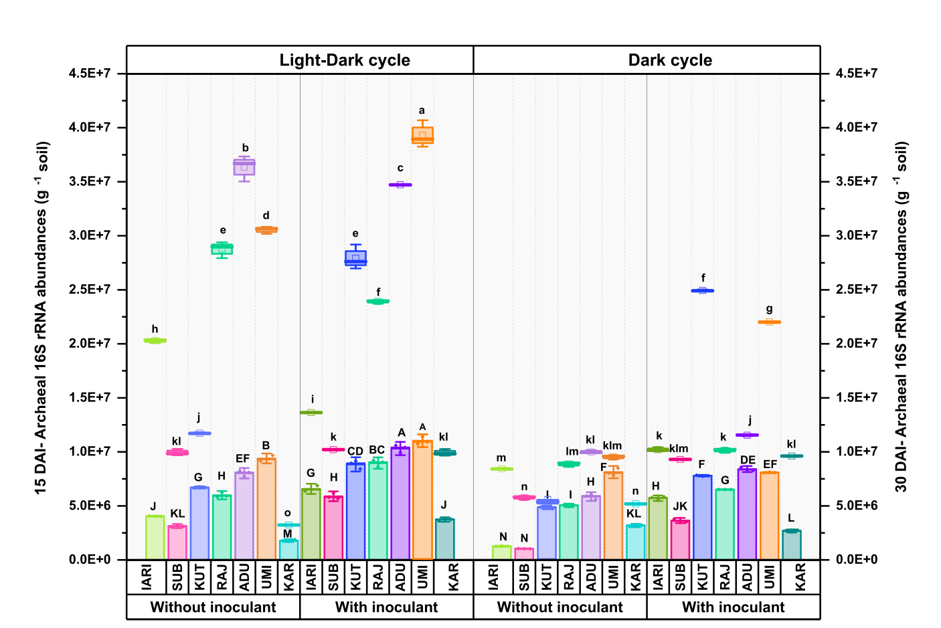

Supplementary Figure S2

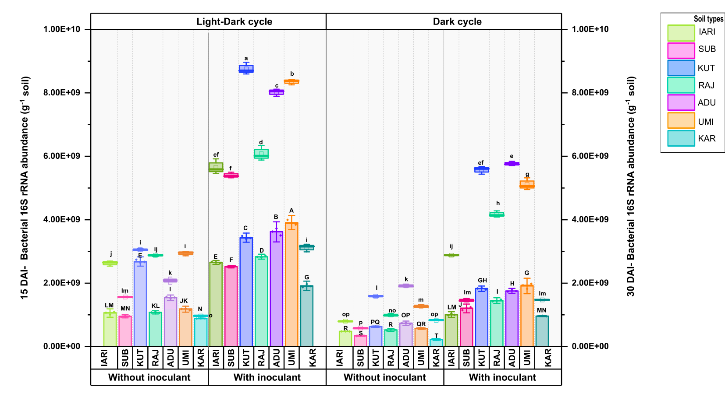

Supplementary Figure S3 (a)

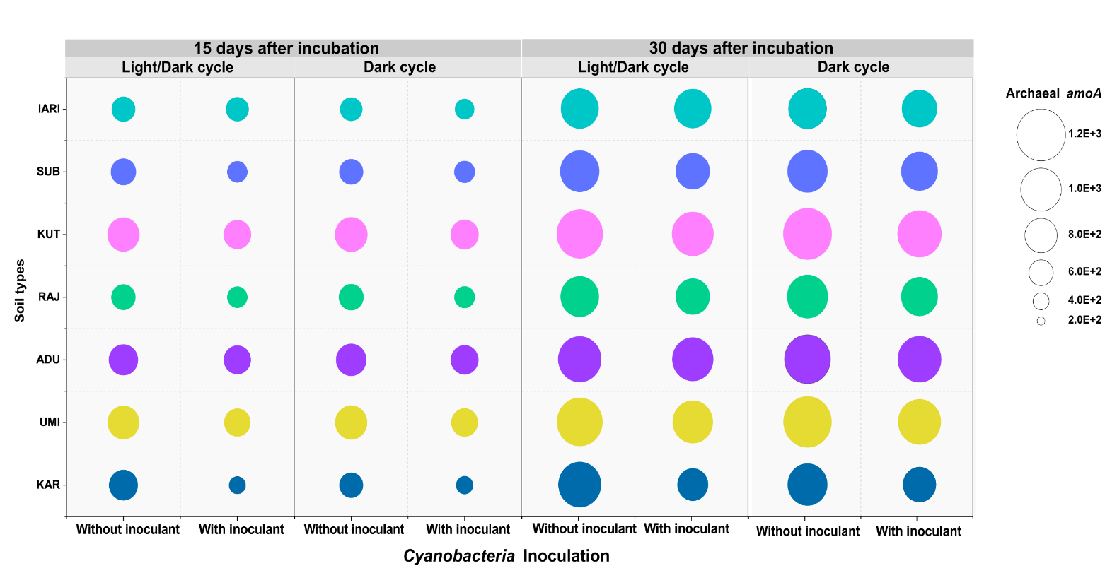

Supplementary Figure S3 (b)

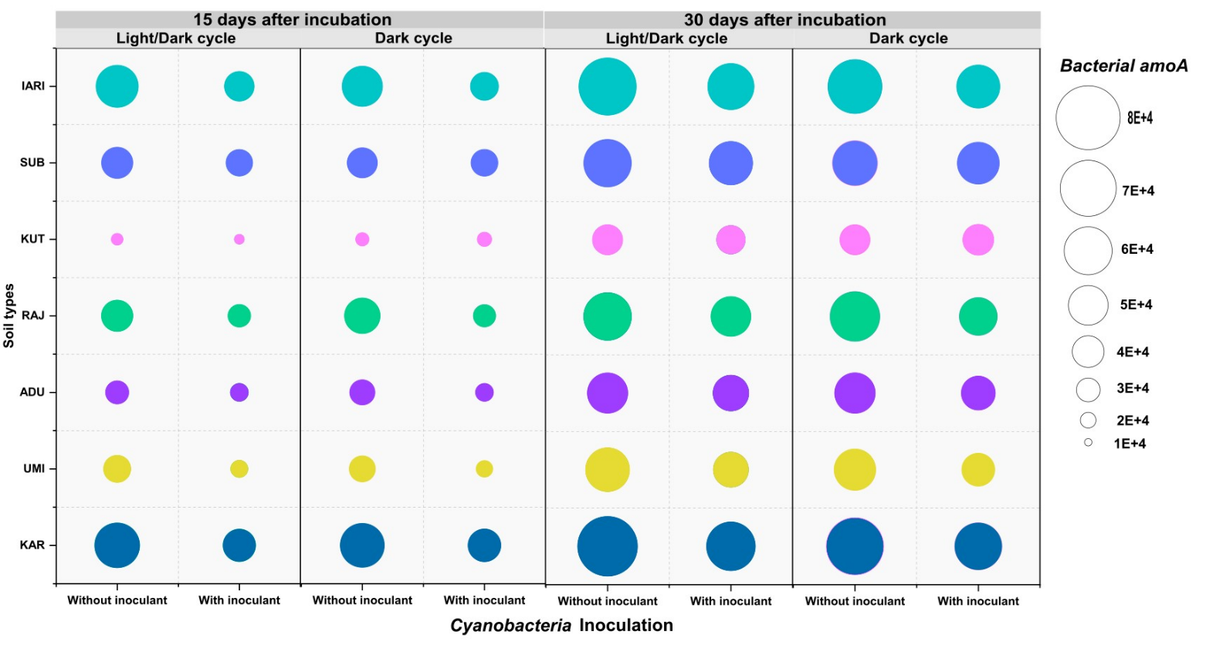

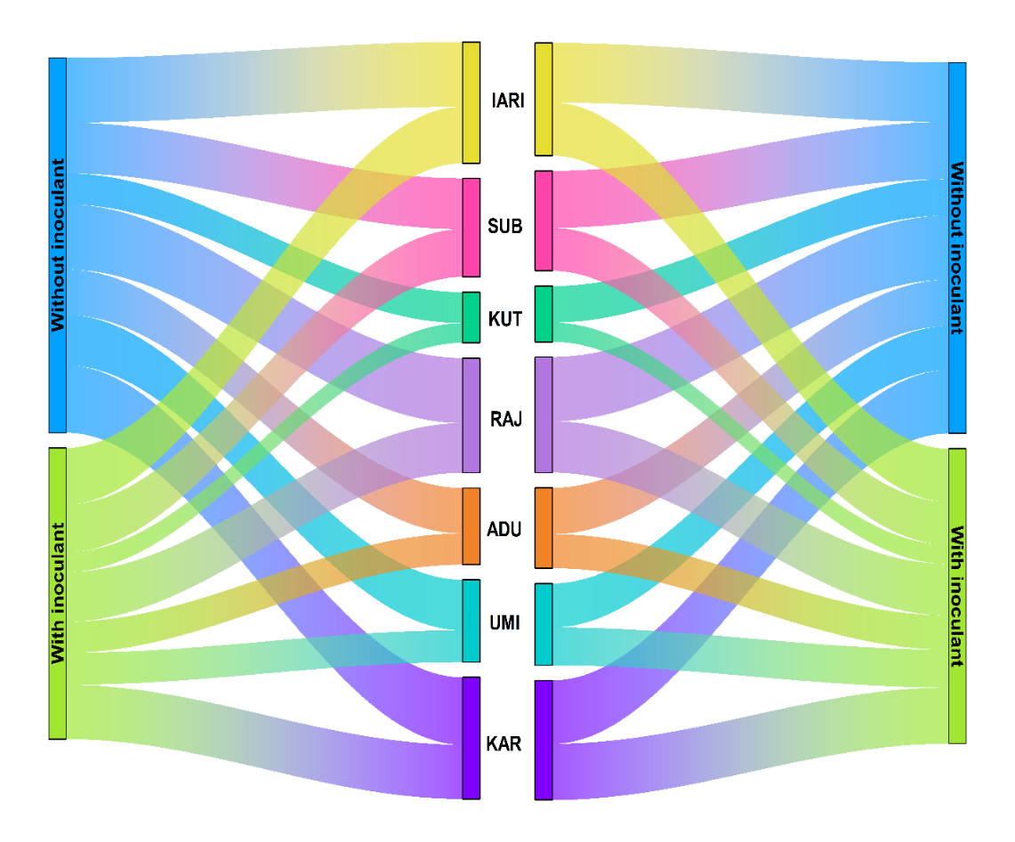
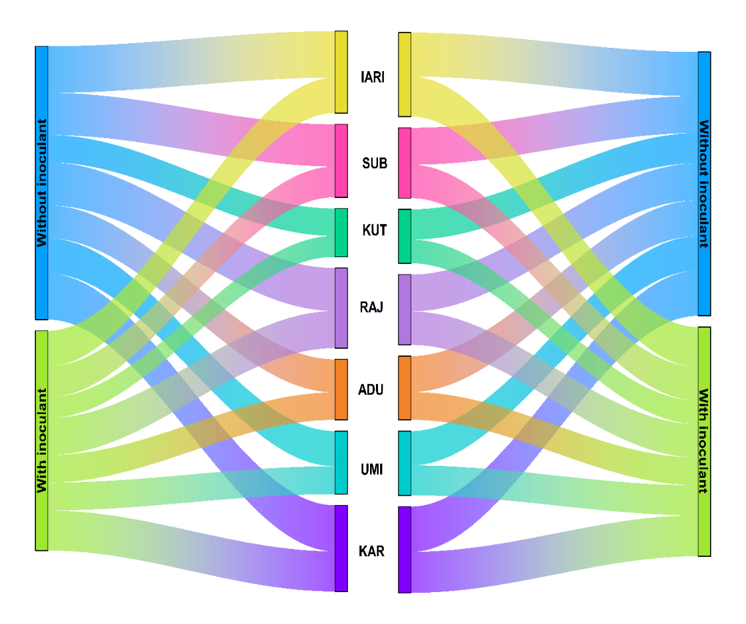
Supplementary Figure S4 (a)
Light-Dark cycle
Dark cycle
Relative abundance of nirS (g⁻¹ soil) after 15 days of incubation
Relative abundance of nirS (g⁻¹ soil) after 30 days of incubation
Light-Dark cycle
Dark cycle
B
BC
A
A
BC
C
CD
CD
DE
E
F
FG
FG
GH
HI
HI
HI
HI
IJ
JK
K
KL
L
M
M
M
N
N
CD
EF
MN
B
IJ
C
FGH
A
BC
O
KL
FG
A
MN
B
FG
LM
JK
O
FG
JK
DE
LM
GHI
HIJ
B
D
N

Supplementary Figure S4 (b)

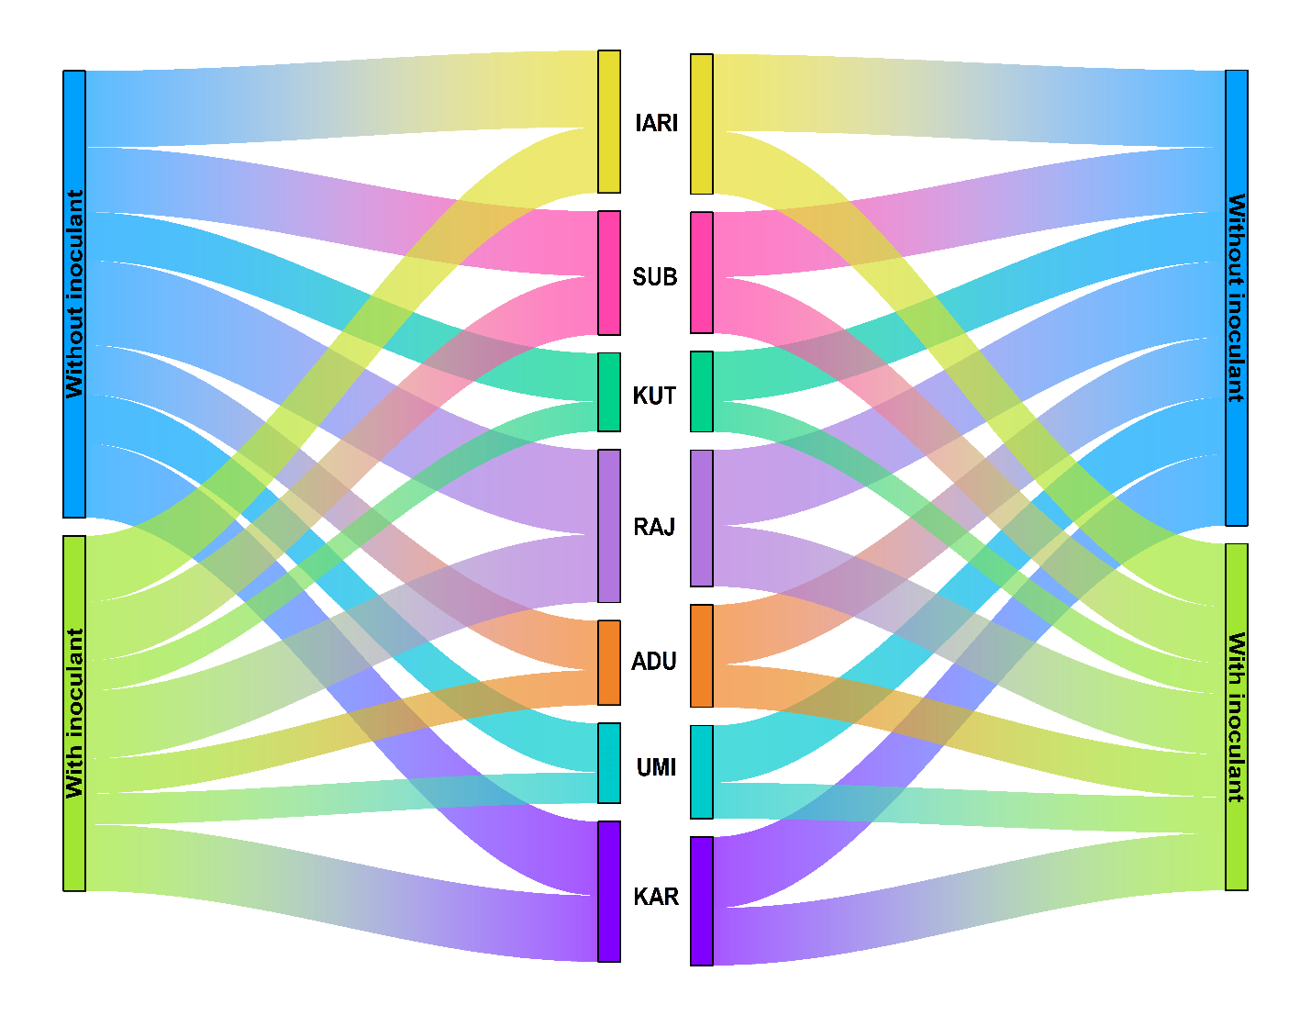
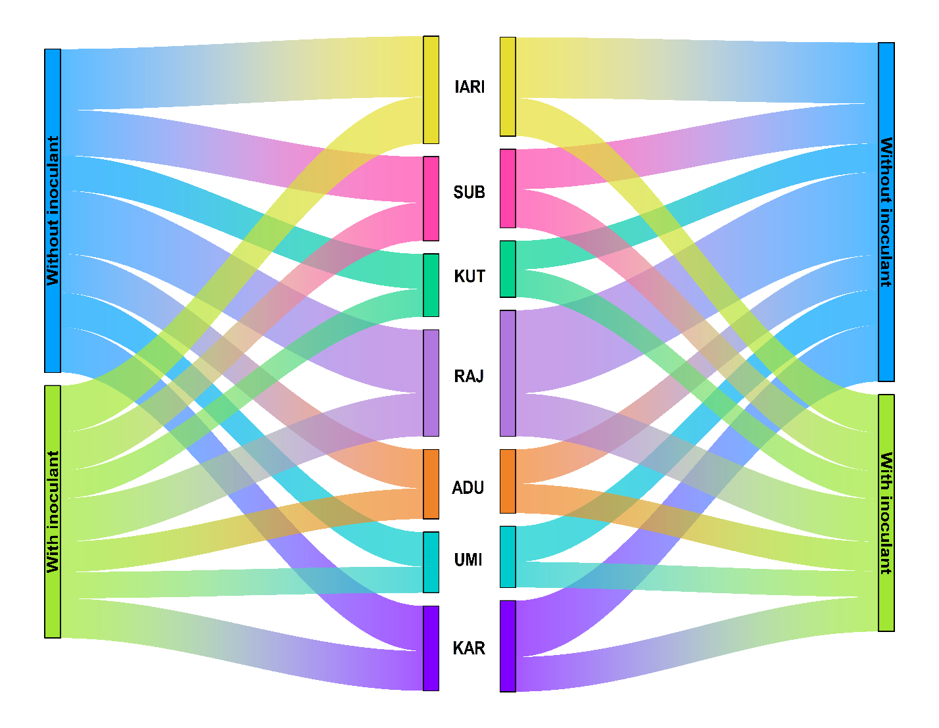
Relative abundance of nirK (g⁻¹ soil) after 15 days of incubation
Light-Dark cycle
Dark cycle
Relative abundance of nirK (g⁻¹ soil) after 30 days of incubation
Dark cycle
Light-Dark cycle
E
LM
I
KL
A
DE
M
M
H
I
H
EF
BC
I
M
H
K
J
GH
FGH
BC
LM
CD
I
EFG
EFG
B
H
GH
N
K
GHI
B
EF
MN
D
DE
L
HIJ
D
B
K
JK
IJK
N
LM
K
DE
A
LMN
C
LM
FG
M
GHI
GH

Supplementary Figure S4 (c)

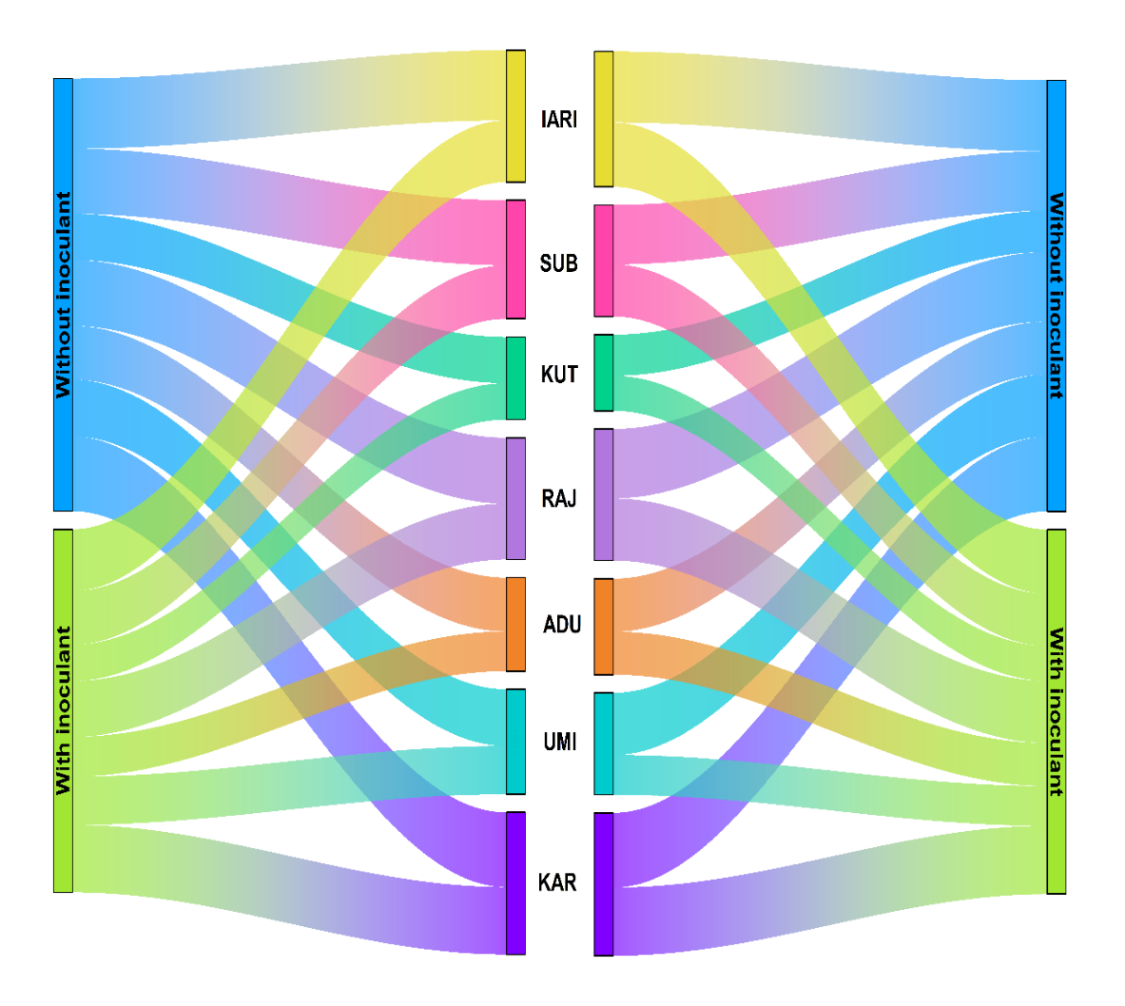
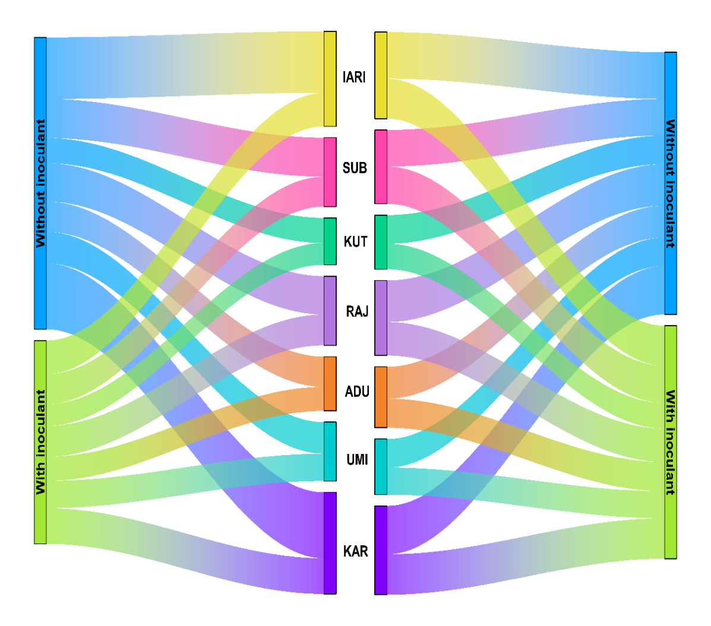
Relative abundance of narG (g⁻¹ soil) after 15 days of incubation
Light-Dark cycle
Dark cycle
Relative abundance of narG (g⁻¹ soil) after 30 days of incubation
Light-Dark cycle
Dark cycle
EFG
KLM
HIJ
NOP
DE
IJ
P
D
A
J
JK
GHI
B
MNO
DE
MNO
MNO
LM
JKL
IJ
DE
OP
C
MN
GH
DEF
C
FG
BC
I
GH
J
CD
GH
J
CDE
A
H
H
EF
B
I
EF
GH
J
J
I
GH
DE
K
BC
J
H
FG
CDE
I

Supplementary Figure S4 (d)

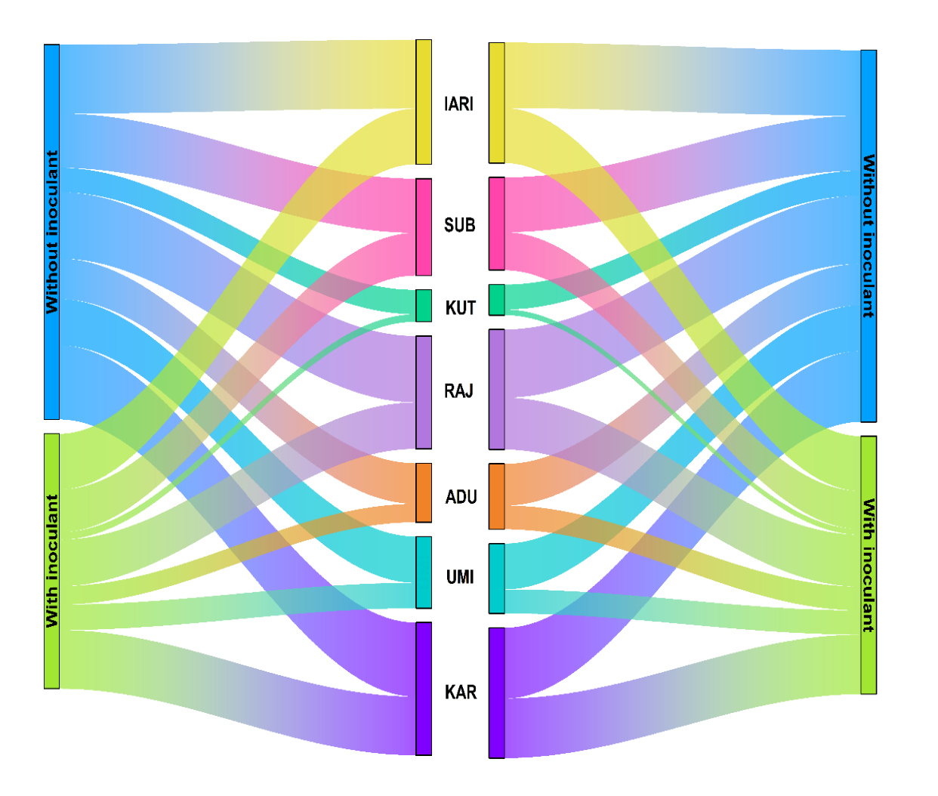
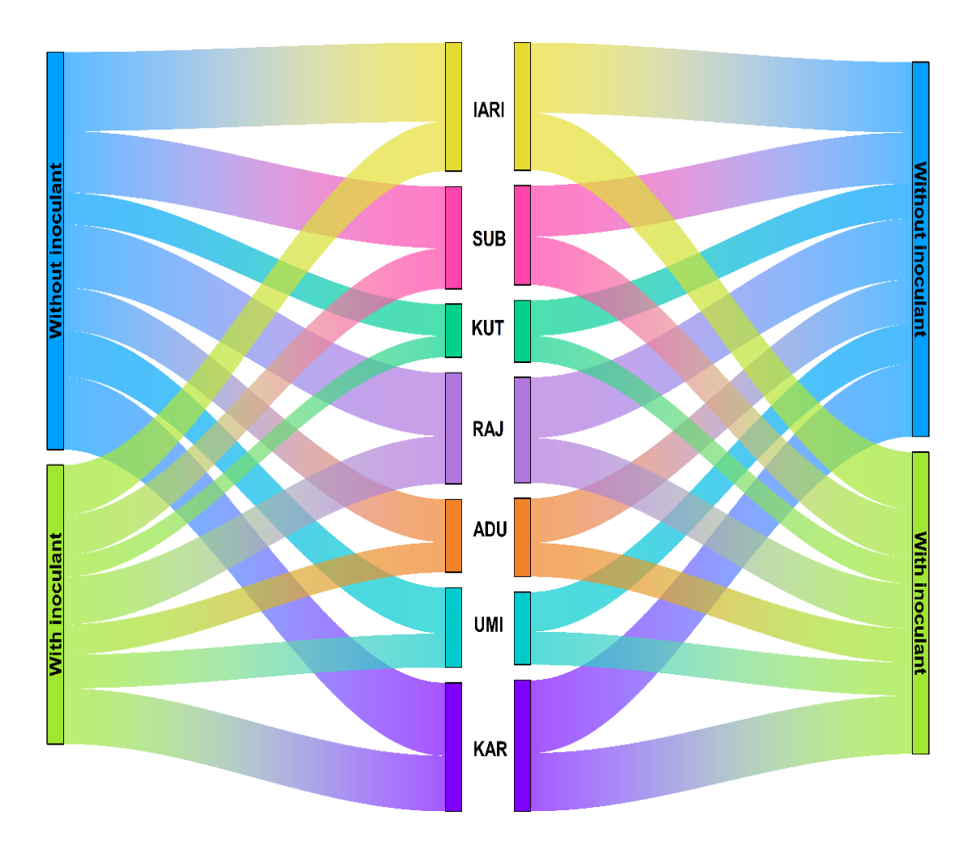
Relative abundance of nosZ (g⁻¹ soil) after 15 days of incubation
Dark cycle
Light-Dark cycle
Light-Dark cycle
Dark cycle
Relative abundance of nosZ (g⁻¹ soil) after 30 days of incubation
D
J
HI
JK
C
FG
L
C
B
FGH
GH
E
A
J
DE
MNO
J
J
FGH
IJ
CD
KL
D
IJ
E
DEF
D
FG
DE
K
GH
L
C
GH
M
F
A
IJ
HIJ
EF
BC
K
D
G
K
LM
HI
F
DE
M
A
K
EF
EF
BC
J

References

Braker G, Fesefeldt A, Witzel KP (1998) Development of PCR primer systems for amplification of nitrite reductase genes (nirK and nirS) to detect denitrifying bacteria in environmental samples. Appl Environ Microbiol 64:3769-3775
Feirer N, Jackson JA, Vilgalys R, Jackson RB (2005) Assessment of soil microbial community structure by use of taxon-specific quantitative PCR assays. Appl Environ Microbiol 71:4117-4120
Henry S, Bru D, Stres B, Hallet S, Philippot L (2006) Quantitative detection of the nosZ gene, encoding nitrous oxide reductase, and comparison of the abundances of 16S rRNA, narG, nirK, and nosZ genes in soils. Appl Environ Microbiol 72:5181-5189
López-Gutiérrez JC, Henry S, Hallet S, Martin-Laurent F, Catroux G, Philippot L (2004) Quantification of a novel group of nitrate-reducing bacteria in the environment by real-time PCR. J Microbiol Methods 57:399-407
Nübel U, Garcia-Pichel F, Muyzer G (1997) PCR primers to amplify 16S rRNA genes from cyanobacteria. Appl Environ Microbiol 63:3327-3332
Poly F, Monrozier LJ, Bally R (2001) Improvement in the RFLP procedure for studying the diversity of nifH genes in communities of nitrogen fixers in soil. Res Microbiol 152:95-103
Rotthauwe JH, Witzel KP, Liesack W (1997) The ammonia monooxygenase structural gene amoA as a functional marker: molecular fine-scale analysis of natural ammonia-oxidizing populations. Appl Environ Microbiol 63:4704-4712
Suzuki MT, Taylor LT, DeLong EF (2000) Quantitative analysis of small-subunit rRNA genes in mixed microbial populations via 5′-nuclease assays. Appl Environ Microbiol 66:4605-4614
Tourna M, Freitag TE, Nicol GW, Prosser JI (2008) Growth, activity and temperature responses of ammonia‐oxidizing archaea and bacteria in soil microcosms. Environ Microbiol 10:1357-1364
Wang G, Asakawa S, Kimura M (2011) Spatial and temporal changes of cyanophage communities in paddy field soils as revealed by the capsid assembly protein gene g20. FEMS Microbiol Ecol 76:352-359

