Supplementary Information for
Extreme electron-blocking interface for garnet-based solid-state lithium-metal batteries with superior long lifespan

Chang Zhang¹, Jiameng Yu¹, Yinjie Lv¹, Yue Zhang¹, Tianyi Gao¹, Yuxi He¹, Xin Chen¹, Yi Yu^{1,2} and Wei Liu^{1,2,3}*

¹School of Physical Science and Technology, ShanghaiTech University, Shanghai 201210, China
²Shanghai Key Laboratory of High-resolution Electron Microscopy, ShanghaiTech University; Shanghai, 201210, China
³Key Laboratory of Advanced Energy Materials Chemistry (Ministry of Education), Nankai University, Tianjin, 300071, China

* Corresponding author. E-mail: liuwei1@shanghaitech.edu.cn

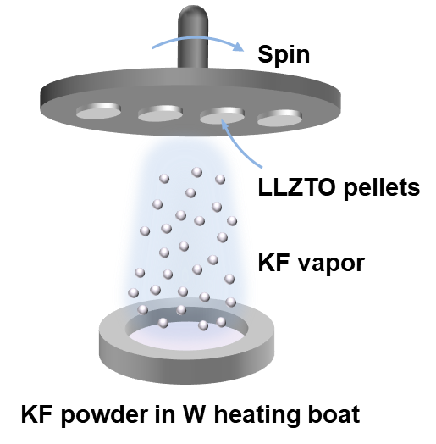
Figure S1. Schematic illustration of KF buffer layer deposition process by vacuum thermal evaporation.

Figure S2. XRD patterns of (a) prepared LLZTO powder, LLZTO pellet and LLZTO-KF pellet.

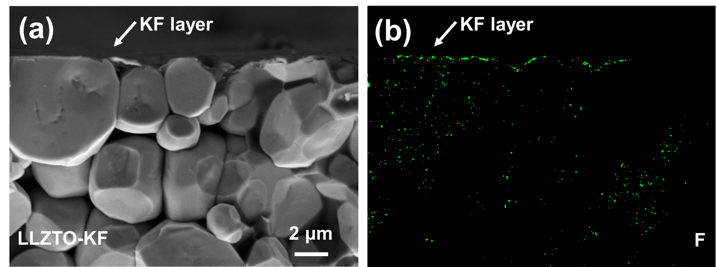
Figure S3. (a), Cross-sectional SEM image of LLZTO-KF. (b), Corresponding EDS mappings of F elements.

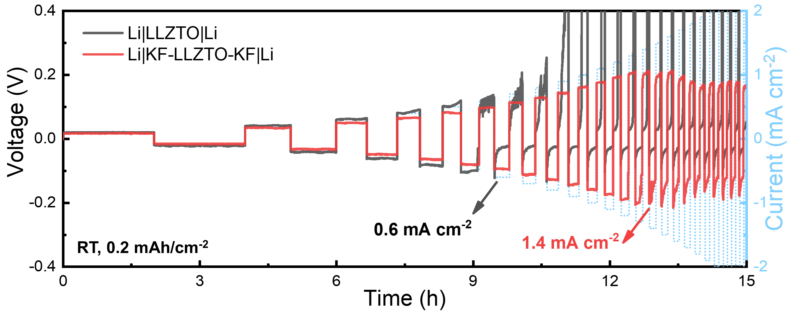
Figure S4. CCD profiles of Li|KF-LLZTO-KF|Li and Li|LLZTO|Li symmetric cells of capacity-constant mode at RT.

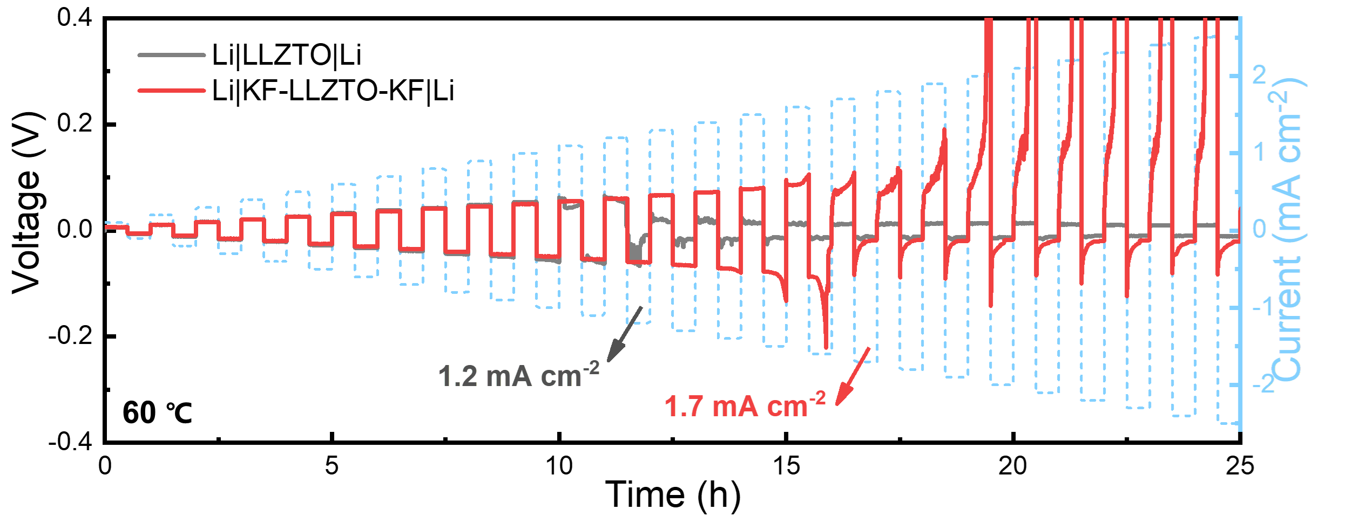
Figure S5. CCD profiles of Li|KF-LLZTO-KF|Li and Li|LLZTO|Li symmetric cells of time-constant mode at 60 °C.

Figure S6. EIS curves of Li|KF-LLZTO-IL|NCM cells with different ionic liquids at RT.

Figure S7. EIS curves of Li|KF-LLZTO-IL|NCM cells with 2 M Li-TFSI in various ionic liquids at RT.
v
Figure S8. EIS curves of Li|KF-LLZTO-IL|NCM cells with 1 M Li-TFSI in PP13-TFSI ionic liquid at RT.

Figure S9. EIS curves of Li|KF-LLZTO-LE|NCM cells at RT. LE is liquid electrolyte, 1 M LiPF₆ in EC/DMC (v/v=1:1) with 2%VC.

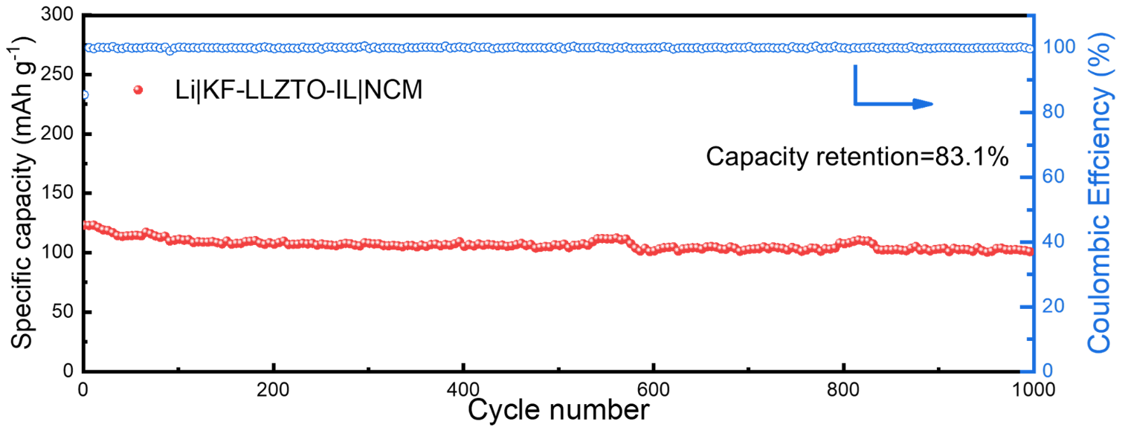
Figure S10. Long cycle performance of Li|KF-LLZTO-IL|NCM cells at 1C, RT.

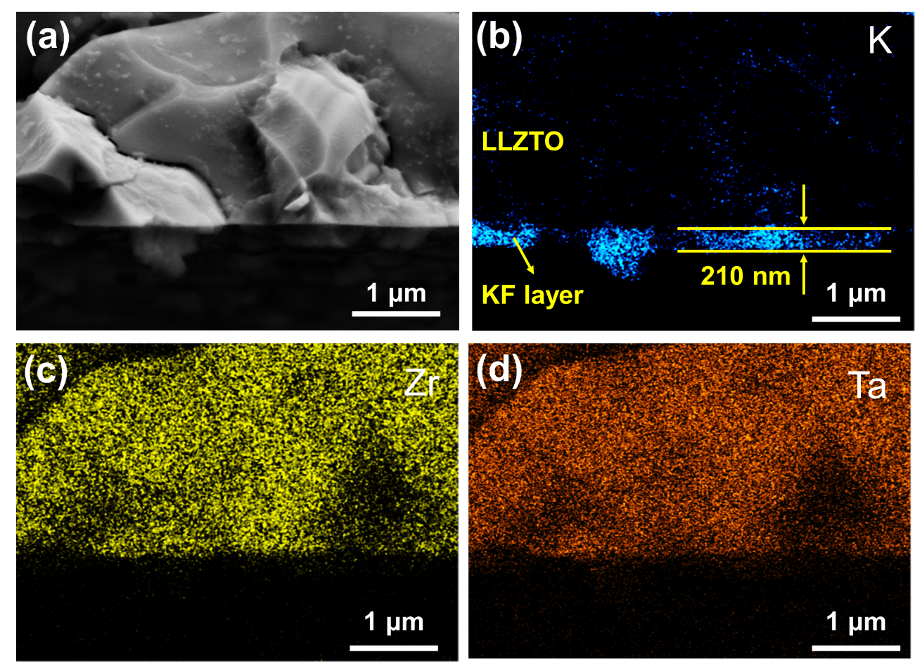
Figure S11. Morphology and corresponding EDS mapping of LLZTO-KF pellet. (a), SEM image of LLZTO pellet with excess KF layer. (b) Corresponding EDS mappings of K, Zr and Ta elements.

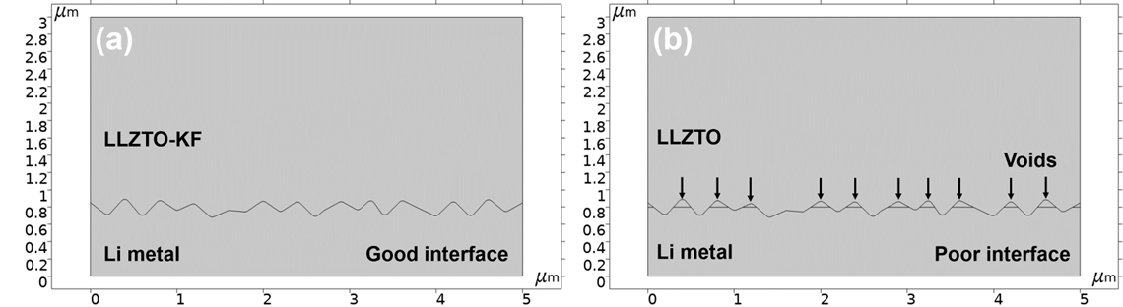
Figure S12. Simulation cell geometry in COMSOL for LLZO-KF|Li interface (a) and LLZO|Li interface (b).

Table S1. Electronic conductivity comparation chart of our work with other literature reports.
Solid state electrolyte | Modified methods | Electronic conductivity (S cm⁻¹) | Reference
Al-doped Li₇La₃Zr₂O₁₂ | SPS | 6.4×10^{–8} | ^{[1]}
Li₇La_{2.75}Ca_{0.25}Zr_{1.65}Nb_{0.25}Co_{0.1}O₁₂ | Doping | 6×10⁻⁸ | ^{[2]}
Li₇La_{2.75}Ca_{0.25}Zr_{1.75}Nb_{0.25}O₁₂ | Doping | 3.59×10⁻⁸ | ^{[3]}
Li_{6.2}La₃(Zr_{0.2}Hf_{0.2}Ti_{0.2}Nb_{0.2}Ta_{0.2})_{0.2}O₁₂ | Doping | 2.33×10^{–8} | ^{[4]}
Al-doped Li₇La₃Zr₂O₁₂ | Hot press | 2×10⁻⁸ | ^{[5]}
Li_{6.5}La₃Zr_{1.5}Ta_{0.5}O₁₂ | Rapid sintering | 1.2×10⁻⁸ | ^{[6]}
(Li_{6.7}La₃Zr_{1.7}Ta_{0.3}O₁₂ | Doping | 5.4×10⁻⁹ | ^{[7]}
Li_{6.4}La₃Zr_{1.4}Ta_{0.6}O₁₂ | Ag-LiF | 5.0×10⁻⁹ | ^{[8]}
Li_{6.4}La₃Zr_{1.4}Ta_{0.6}O₁₂ | AlN sinter additive | 2.6×10⁻⁹ | ^{[9]}
Li_{6.4}Ga_{0.2}La₃Zr₂O₁₂ | Doping | 5×10⁻¹⁰ | ^{[10]}
Li_{6.4}La₃Zr_{1.4}Ta_{0.6}O₁₂ | KF layer | 1.8×10⁻¹⁰ | This work

Table S2. Critical current density (CCD), area specific resistance (ASR) and cycling life of the reported Li|LLZO|Li symmetrical cells with different interface layers at RT (25 °C) or other temperatures.
Various LLZO solid state electrolytes | Interface layer | CCD  (mA cm⁻²) | ASR  (Ω cm²) | Cycle life  (mA cm⁻²@h) | Year ^{[Ref.]}
Li_{5.9}Al_{0.2}La₃Zr_{1.75}W_{0.25}O₁₂ | Drawing graphite | N/A | 25 | 0.3@1000 | 2018^{[11]}
Li_{6.5}La₃Zr_{1.5}Ta_{0.5}O₁₂ | Li-C composite | 1.0 | 11 | 0.3@250 | 2019^{[12]}
Li_{6.4}La₃Zr_{1.4}Ta_{0.6}O₁₂ | Cu₃N film | 1.2 | 83.4 | 0.1@1000 | 2020^{[13]}
Li_{6.5}La₃Zr_{1.5}Ta_{0.5}O₁₂ | Li-gC₃N₄ composite | 1.5 | 11 | 0.3@300 | 2020^{[14]}
Li_{6.5}La₃Zr_{1.5}Ta_{0.5}O₁₂ | liquid metal painting | 1.7 | 19.5 | 0.2@2000 (RT) | 2020^{[15]}
Li_{6.4}La₃Zr_{1.4}Ta_{0.6}O₁₂ | PAA | 54.5 | 1.2 | 0.2@1000  1@400 | 2021^{[16]}
Li_{6.4}La₃Zr_{1.4}Ta_{0.6}O₁₂ | 3D Li–Zn alloy | 2 | 1.9 | 0.1@1000  0.5@300 | 2021^{[17]}
Li_{6.4}La₃Zr_{1.4}Ta_{0.6}O₁₂ | LiF | 0.75 | 12.7 | 0.2@1500  0.4@300 | 2021^{[18]}
Li_{6.75}La₃Zr_{1.75}Ta_{0.25}O₁₂ | MgF₂ | 0.65 | 25 | 0.3@1000 | 2022^{[19]}
Li_{6.4}La₃Zr_{1.4}Ta_{0.6}O₁₂ | Li_{x}C₆ | N/A | 26.2 | 0.3@900 | 2022^{[20]}
Li_{6.5}La₃Zr_{1.5}Ta_{0.5}O₁₂ | Al₂O₃ | 1.0 | 16.8 | 0.3@1000 | 2022^{[21]}
Li_{6.75}La₃Za_{1.75}Ta_{0.25}O₁₂ | LiF/Li-Mxene | 1.5 | 5 | 0.3@600 | 2022^{[22]}
Li_{6.75}La₃Za_{1.75}Ta_{0.25}O₁₂ | Li₂S/Li_{x}Sn | 0.5 | 47 | 0.2@1000 | 2022^{[23]}
Li_{6.4}La₃Zr_{1.4}Ta_{0.6}O₁₂ | Ag-LiF | 0.75 | 5.8 | 0.2@600  0.5@130 | 2022^{[8]}
Li_{6.4}La₃Zr_{1.4}Ta_{0.6}O₁₂ | Li₃PO₄ | 0.8 (30 °C) | 13(30 °C) | 0.1@1000 (30 °C)  0.4@200 (30 °C) | 2022^{[24]}
Li_{6.4}La₃Zr_{1.4}Ta_{0.6}O₁₂ | AlN | 0.76 | 1 | 0.2@500 | 2022^{[9]}
Li_{6.4}La₃Zr_{1.4}Ta_{0.6}O₁₂ | KF | 1.0 (time mode)  1.4 (capacity mode) | 5.9 | 0.2@3000  0.5@350 | This work

Table S3. The interface impedance values of Li|KF-LLZTO|NCM cells with various ionic liquids and liquid electrolyte.
 | 0.3 M  PY14 | 0.2 M  PP13 | 0.2 M  C₄mim | 1 M  PP13 | 1 M  C₄mim | 2 M  PP13 | 2 M  C₄mim | 1 M  LE
Interface impedance (Ω cm²) | 1720 | 1150 | 710 | 143 | 76 | 520 | 170 | 340

Table S4. Cycle performance comparation chart of our work with other literature reports.
Cathode | Modifications | C-Rate | Cycle numbers | Retention  (%) | Average coulombic efficiency (%) | Voltage range (V) | Ref.
LiFePO₄ | 10 μL commercial liquid electrolyte | 1C | 900 | 85.4 | 99.98 | 2-4 | ^{[25]}
LiNi_{0.8}Co_{0.1}Mn_{0.1}O₂ | 10 μL commercial liquid electrolyte | 0.5C | 200 | 89 | 99.95 | 3-4.3 | ^{[25]}
LiNi_{0.8}Co_{0.1}Mn_{0.1}O₂ | 7 μL liquid electrolyte, 1 M LiPF₆ in EC/DEC | 0.2C | 50 | 87.7 | 99.74 | 2.7-4.3 | ^{[26]}
LiFePO₄ | 7 μL liquid electrolyte, 1 M LiPF₆ in EC/DEC | 1C | 835 | 80.6 | 99.97 | 2.5-4 | ^{[26]}
LiFePO₄ | 7 μL SN+LiTFSI | 0.5C | 400 | 80.4 | 99.95 | 2.5-4 | ^{[26]}
LiNi_{0.8}Co_{0.1}Mn_{0.1}O₂ | 7 μL SN+LiTFSI | 0.2C | 100 | 80.4 | 99.78 | 2.7-4.3 | ^{[26]}
LiNi_{0.83}Co_{0.11}Mn_{0.06}O₂ | N/A | 0.2C | 140 | 72.1 | 99.77 | 2.7-4.3 | ^{[27]}
LiNi_{1/3}Co_{1/3}Mn_{1/3}O₂ | ionic liquid, 2 M  LiFSI in Pyr13FSI | 0.5C | 1700 | ~91 | 99.99 | 2.8-4.2 | ^{[8]}
LiFePO₄ | 10 μL liquid electrolyte, 1 M LiFP₆ in EC/DME/EMC | 0.2C | 80 | 95 | 99.94 | 2.5-4 | ^{[28]}
LiFePO₄ | 6 μL liquid electrolyte, 1 M LiFP₆ in EC/DEC | 0.1C | 100 | 90.4 | 99.90 | 2-4.2 | ^{[23]}
LiFePO₄ | 3 μL ionic liquid, 0.3M LiTFSI in PY14TFSI | 0.1C | 500 | ~75 | 99.94 | 2.5-4 | ^{[21]}
LiNi_{0.83}Co_{0.11}Mn_{0.06}O₂ | 3 μL ionic liquid, 0.3M LiTFSI in PY14TFSI | 0.2C | 100 | 90.2 | 99.90 | 3-4.3 | ^{[21]}
LiNi_{0.83}Co_{0.11}Mn_{0.06}O₂ | liquid electrolyte | 0.2C | 100 | 75.9 | 99.72 | 3-4.3 | ^{[21]}
LiFePO₄ | 3 μL liquid electrolyte, 1 M LiFP₆ in EC/DME/EMC | 0.1C | 300 | 83 | 99.94 | 2.5-4.2 | ^{[20]}
LiFePO₄ | 6 μL SN+LiTFSI | 0.3C | 100 | 75.9 | 99.72 | 2.5-4.2 | ^{[19]}
LiFePO₄ | 6 μL SN+LiTFSI | 0.1C | 100 | 98.3 | 99.98 | 2.5-4.2 | ^{[19]}
LiFePO₄ | 10 μL liquid electrolyte, 1 M LiPF₆ in EC/DEC | 0.5C | 100 | 94 | 99.94 | 2.5-4.2 | ^{[22]}
LiNi_{0.5}Co_{0.3}Mn_{0.2}O₂ | 15 μL liquid electrolyte | 1C | 300 | 85.5 | 99.95 | 2.8-4.3 | ^{[29]}
LiNi_{0.5}Co_{0.3}Mn_{0.2}O₂ | 15 μL liquid electrolyte | 2C | 200 | 80% | 97.61 | 2.8-4.3 | ^{[29]}
LiNi_{0.6}Co_{0.2}Mn_{0.2}O₂ | 10 μL liquid electrolyte, 1 M LiPF₆ in EC/DMC | 0.2C | 100 | 88.43 | 99.88 | 2.8-4.5 | ^{[30]}
LiFePO₄ | 3 μL ionic liquid, 0.2 M LiTFSI in PP13-TFSI | 0.1C  (30 °C) | 150 | 81 | 99.86 | 3-4.2 | ^{[24]}
LiNi_{0.8}Co_{0.1}Mn_{0.1}O₂ | 3 μL ionic liquid, 1 M LiTFSI in C₄mim-TFSI | 0.2C | 270 | 82.8 | 99.93 | 2.8-4.3 | This work
LiNi_{0.8}Co_{0.1}Mn_{0.1}O₂ | 3 μL ionic liquid, 1 M LiTFSI in C₄mim-TFSI | 1C | 1000 | 83.1 | 99.98 | 2.8-4.3 | This work
LiNi_{0.8}Co_{0.1}Mn_{0.1}O₂ | 3 μL ionic liquid, 1 M LiTFSI in C₄mim-TFSI | 2C | 3000 | 72.1 | 99.99 | 2.8-4.3 | This work

Reference
[1] Y. Zhu, J. Zhang, W. Li, Y. Zeng, W. Wang, Z. Yin, B. Hao, Q. Meng, Y. Xue, J. Yang, and S. Li, Journal of Alloys and Compounds 2023 967.
[2] A. J. Samson;K. Hofstetter;E. Wachsman;V. Thangadurai, Journal of the Electrochemical Society 2018 165, A2303-A2311.
[3] Y. L. Song;L. Y. Yang;W. G. Zhao;Z. J. Wang;Y. Zhao;Z. Q. Wang;Q. H. Zhao;H. Liu;F. Pan, Advanced Energy Materials 2019 9.
[4] S. X. Han;Z. Q. Wang;Y. Ma;Y. Miao;X. M. Wang;Y. Wang;Y. Z. Wang, Journal of Advanced Ceramics 2023 12, 1201-1213.
[5] E. Rangasamy;J. Wolfenstine;J. Sakamoto, Solid State Ionics 2012 206, 28-32.
[6] L. Yang;Q. S. Dai;L. Liu;D. S. Shao;K. L. Luo;S. Jamil;H. Liu;Z. G. Luo;B. B. Chang;X. Y. Wang, Ceramics International 2020 46, 10917-10924.
[7] M. Y. Yi;T. Liu;X. N. Wang;J. Y. Li;C. Wang;Y. C. Mo, Ceramics International 2019 45, 786-792.
[8] S. Lee;K. S. Lee;S. Kim;K. Yoon;S. Han;M. H. Lee;Y. Ko;J. H. Noh;W. Kim;K. Kang, Science Advances 2022 8.
[9] C. Zhang, X. C. Hu, Z. W. Nie, C. Wu, N. Zheng, S. J. Chen, Y. H. Yang, R. Wei, J. M. Yu, N. Yang, Y. Yu, and W. Liu, Journal of Advanced Ceramics 2022 11, 1530-1541.
[10] M. Philipp;B. Gadermaier;P. Posch;I. Hanzu;S. Ganschow;M. Meven;D. Rettenwander;G. J. Redhammer;H. M. R. Wilkening, Advanced Materials Interfaces 2020 7.
[11] Y. J. Shao, H. C. Wang, Z. L. Gong, D. W. Wang, B. Z. Zheng, J. P. Zhu, Y. X. Lu, Y. S. Hu, X. X. Guo, H. Li, X. J. Huang, Y. Yang, C. W. Nan, and L. Q. Chen, Acs Energy Letters 2018 3, 1212-1218.
[12] J. Duan;W. Y. Wu;A. M. Nolan;T. R. Wang;J. Y. Wen;C. C. Hu;Y. F. Mo;W. Luo;Y. H. Huang, Advanced Materials 2019 31.
[13] H. Y. Huo;Y. Chen;R. Y. Li;N. Zhao;J. Luo;J. G. P. da Silva;R. Mucke;P. Kaghazchi;X. X. Guo;X. L. Sun, Energy & Environmental Science 2020 13, 127-134.
[14] Y. Huang;B. Chen;J. Duan;F. Yang;T. R. Wang;Z. F. Wang;W. J. Yang;C. C. Hu;W. Luo;Y. H. Huang, Angewandte Chemie-International Edition 2020 59, 3699-3704.
[15] J. W. Meng;Y. Zhang;X. J. Zhou;M. Lei;C. L. Li, Nature Communications 2020 11.
[16] H. Y. Huo, J. Gao, N. Zhao, D. X. Zhang, N. G. Holmes, X. N. Li, Y. P. Sun, J. M. Fu, R. Y. Li, X. X. Guo, and X. L. Sun, Nature Communications 2021 12.
[17] Z. P. Wan;K. Shi;Y. F. Huang;L. Yang;Q. B. Yun;L. K. Chen;F. Z. Ren;F. Y. Kang;Y. B. He, Journal of Power Sources 2021 505.
[18] S. J. Tang;G. W. Chen;F. C. Ren;H. C. Wang;W. Yang;C. X. Zheng;Z. L. Gong;Y. Yang, Journal of Materials Chemistry A 2021 9, 3576-3583.
[19] J. L. Jiang;Y. H. Ou;S. Y. Lu;C. Shen;B. B. Li;X. Y. Liu;Y. Jiang;B. Zhao;J. J. Zhang, Energy Storage Materials 2022 50, 810-818.
[20] C. Cui;Q. Ye;C. Zeng;S. H. Wang;X. W. Xu;T. Y. Zhai;H. Q. Li, Energy Storage Materials 2022 45, 814-820.
[21] S. J. Guo, Y. T. Li, B. Li, N. S. Grundish, A. M. Cao, Y. G. Sun, Y. S. Xu, Y. L. M. Ji, Y. Qiao, Q. H. Zhang, F. Q. Meng, Z. H. Zhao, D. Wang, X. Zhang, L. Gu, X. Q. Yu, and L. J. Wan, Journal of the American Chemical Society 2022 144, 2179-2188.
[22] J. Y. Wen;L. Q. Huang;Y. Huang;W. Luo;H. Y. Huo;Z. F. Wang;X. Y. Zheng;Z. Y. Wen;Y. H. Huang, Energy Storage Materials 2022 45, 934-940.
[23] B. Zhao;W. C. Ma;B. B. Li;X. T. Hu;S. Y. Lu;X. Y. Liu;Y. Jiang;J. J. Zhang, Nano Energy 2022 91.
[24] Z. Bi;Q. Sun;M. Jia;M. Zuo;N. Zhao;X. Guo, Advanced Functional Materials 2022 32.
[25] B. Chen;J. Zhang;T. Zhang;R. Wang;J. Zheng;Y. Zhai;X. Liu, Advanced Science 2023 10, 2207056.
[26] G. J. Lu;W. Liu;Z. G. Yang;Y. M. Wang;W. K. Zheng;R. R. Deng;R. H. Wang;L. Lu;C. H. Xu, Advanced Functional Materials 2023.
[27] W. J. Ji, B. Luo, Q. Wang, G. H. Yu, Z. H. Liu, Z. W. Zhao, R. R. Zhao, S. B. Wang, X. W. Wang, B. Zhang, J. F. Zhang, F. Hou, and J. Liang, Advanced Energy Materials 2023 13.
[28] J. X. Zhang;C. H. Wang;M. T. Zheng;M. H. Ye;H. Y. Zhai;J. Li;G. J. Tan;X. F. Tang;X. L. Sun, Nano Energy 2022 102.
[29] T. R. Wang, J. Duan, B. Zhang, W. Luo, X. Ji, H. H. Xu, Y. Huang, L. Q. Huang, Z. Y. Song, J. Y. Wen, C. S. Wang, Y. H. Huang, and J. B. Goodenough, Energy & Environmental Science 2022 15, 1325-1333.
[30] C. J. Zheng;J. M. Su;Z. Song;T. P. Xiu;J. Jin;M. E. Badding;Z. Y. Wen, Materials Today Energy 2022 27.

