Table 1 Primers for qRT-PCR
Genes | Forward | Reveise
E-cadherin | GAGTGCCAACTGGACCATTC | ACCCACCTCTAAGGCCATCT
N-cadherin | GTGCATGAAGGACAGCCTCT | TCTCACGGCATACACCATGC
Vimentin | ACGTCTTGACCTTGAACGCA | TCTTGGCAGCCACACTTTCA
Slug | TGTGACAAGGAATATGTGAGCC | TGAGCCCTCAGATTTGACCTG
Twist | GTCCGCAGTCTTACGAGGAG | GCTTGAGGGTCTGAATCTTGCT
MBIP | CATACGGACCACAGACTAGACC | ATGTCTCTTGGCACTGGACCAC
GAPDH | GAAGGTGAAGGTCGGAGTC | GAAGATGGTGATGGGATTTC

Figure Legends:
Fig.S1. Prognostic analysis of ESCC patients using Kaplan-Maier curves based on risk score models including gender, age, drinking, smoking, grade, tumor location, T stage and N stage.
Fig.S2. Correlation analysis of mRNA expression between MBIP and EMT mark genes in 179 ESCC patients from GSE53625 database (https://www.ncbi.nlm.nih.gov/geo/query/acc.cgi?acc=GSE53625).

Fig.S1.
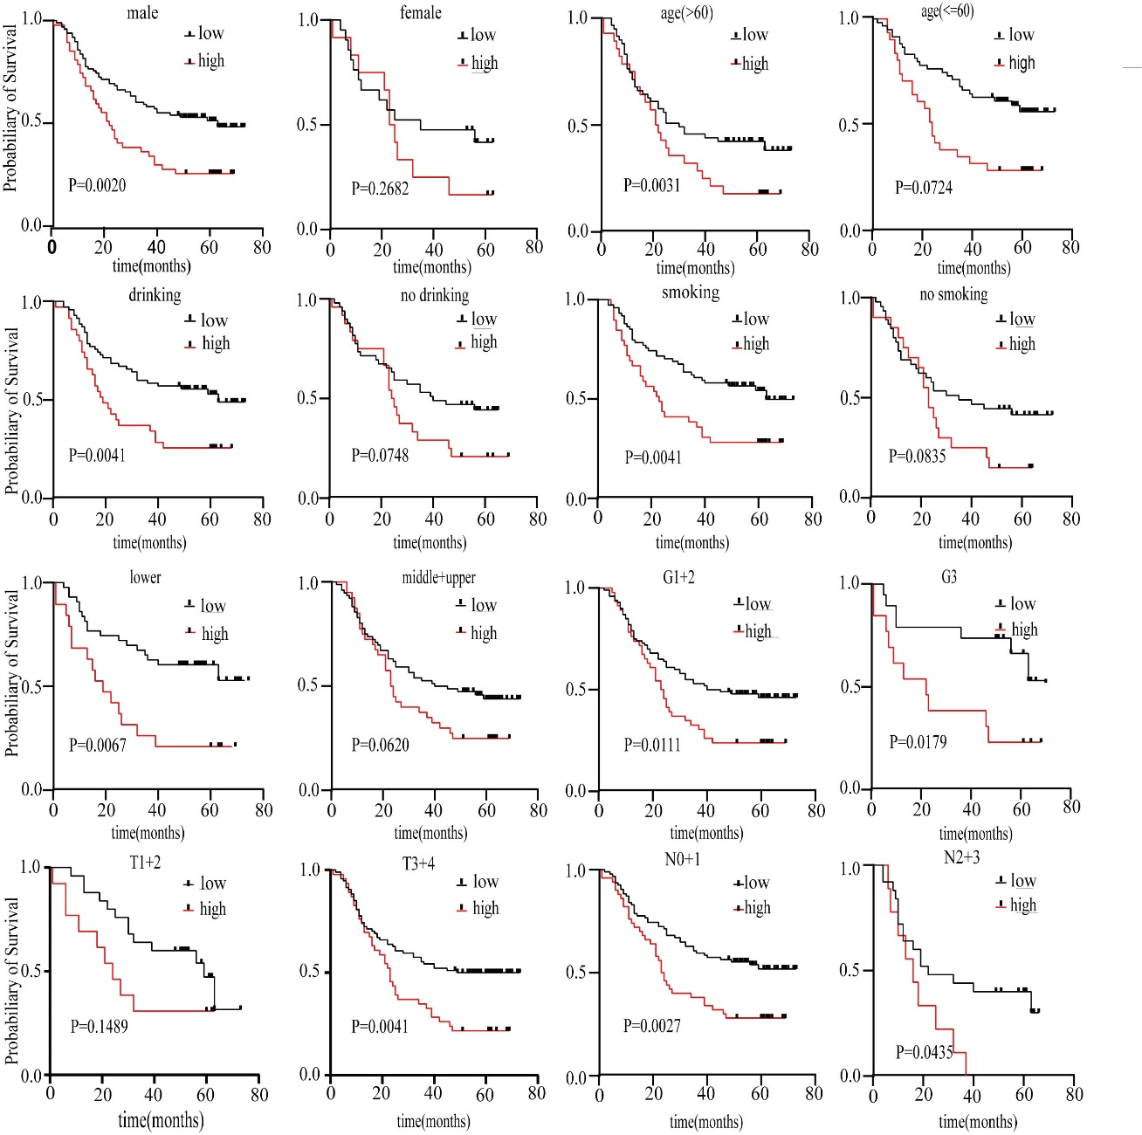
Fig.S2.
