Title: Carthamus tinctorius L. genome sequence provides insights into synthesis of unsaturated fatty acids

Authors: Yuanyuan Dong^{1, #}, Xiaojie Wang^{2, #}, Yuanxin Wang¹, Xiuming Liu¹, Na Yao¹, Yang Jing¹, Linna Du¹, Xiaowei Li¹, Nan Wang¹, Weican Liu¹, Fawei Wang¹, Xiaokun Li², Haiyan Li^{3,*}

¹ Engineering Research Center of Bioreactor and Pharmaceutical Development, Ministry of Education, College of Life Sciences, Jilin Agricultural University, Changchun 130118, China.
² School of Pharmaceutical Science, Key Laboratory of Biotechnology and Pharmaceutical Engineering of Zhejiang Province, Wenzhou Medical University, Wenzhou 325035, China.
³ College of Tropical Crops, Hainan University, Haikou 570228, China.
# These authors contributed equally to this work.
* Corresponding authors:
* Haiyan Li, hyli99@163.com

Authors’ email addresses:
Yuanyuan Dong, yuanyuand@jlau.edu.cn;
Xiaojie Wang, 18858811123@126.com;
Xinyuan Wang, 2755276161@qq.com;
XIumin Liu, xiuming1211@163.com;
Na Yao, yaona801103@aliyun.com;
Jing Yang, yangjing5122010@163.com;
Linna Du, dulinna0918@163.com;
Xiaowei Li, xiaoweili1206@163.com;
Nan Wang, wangnanlunwen@126.com;
Weican Liu, liuweican602@163.com;
Fawei Wang, fw-1980@163.com;
Xiaokun Li, xiaokunli@163.net.

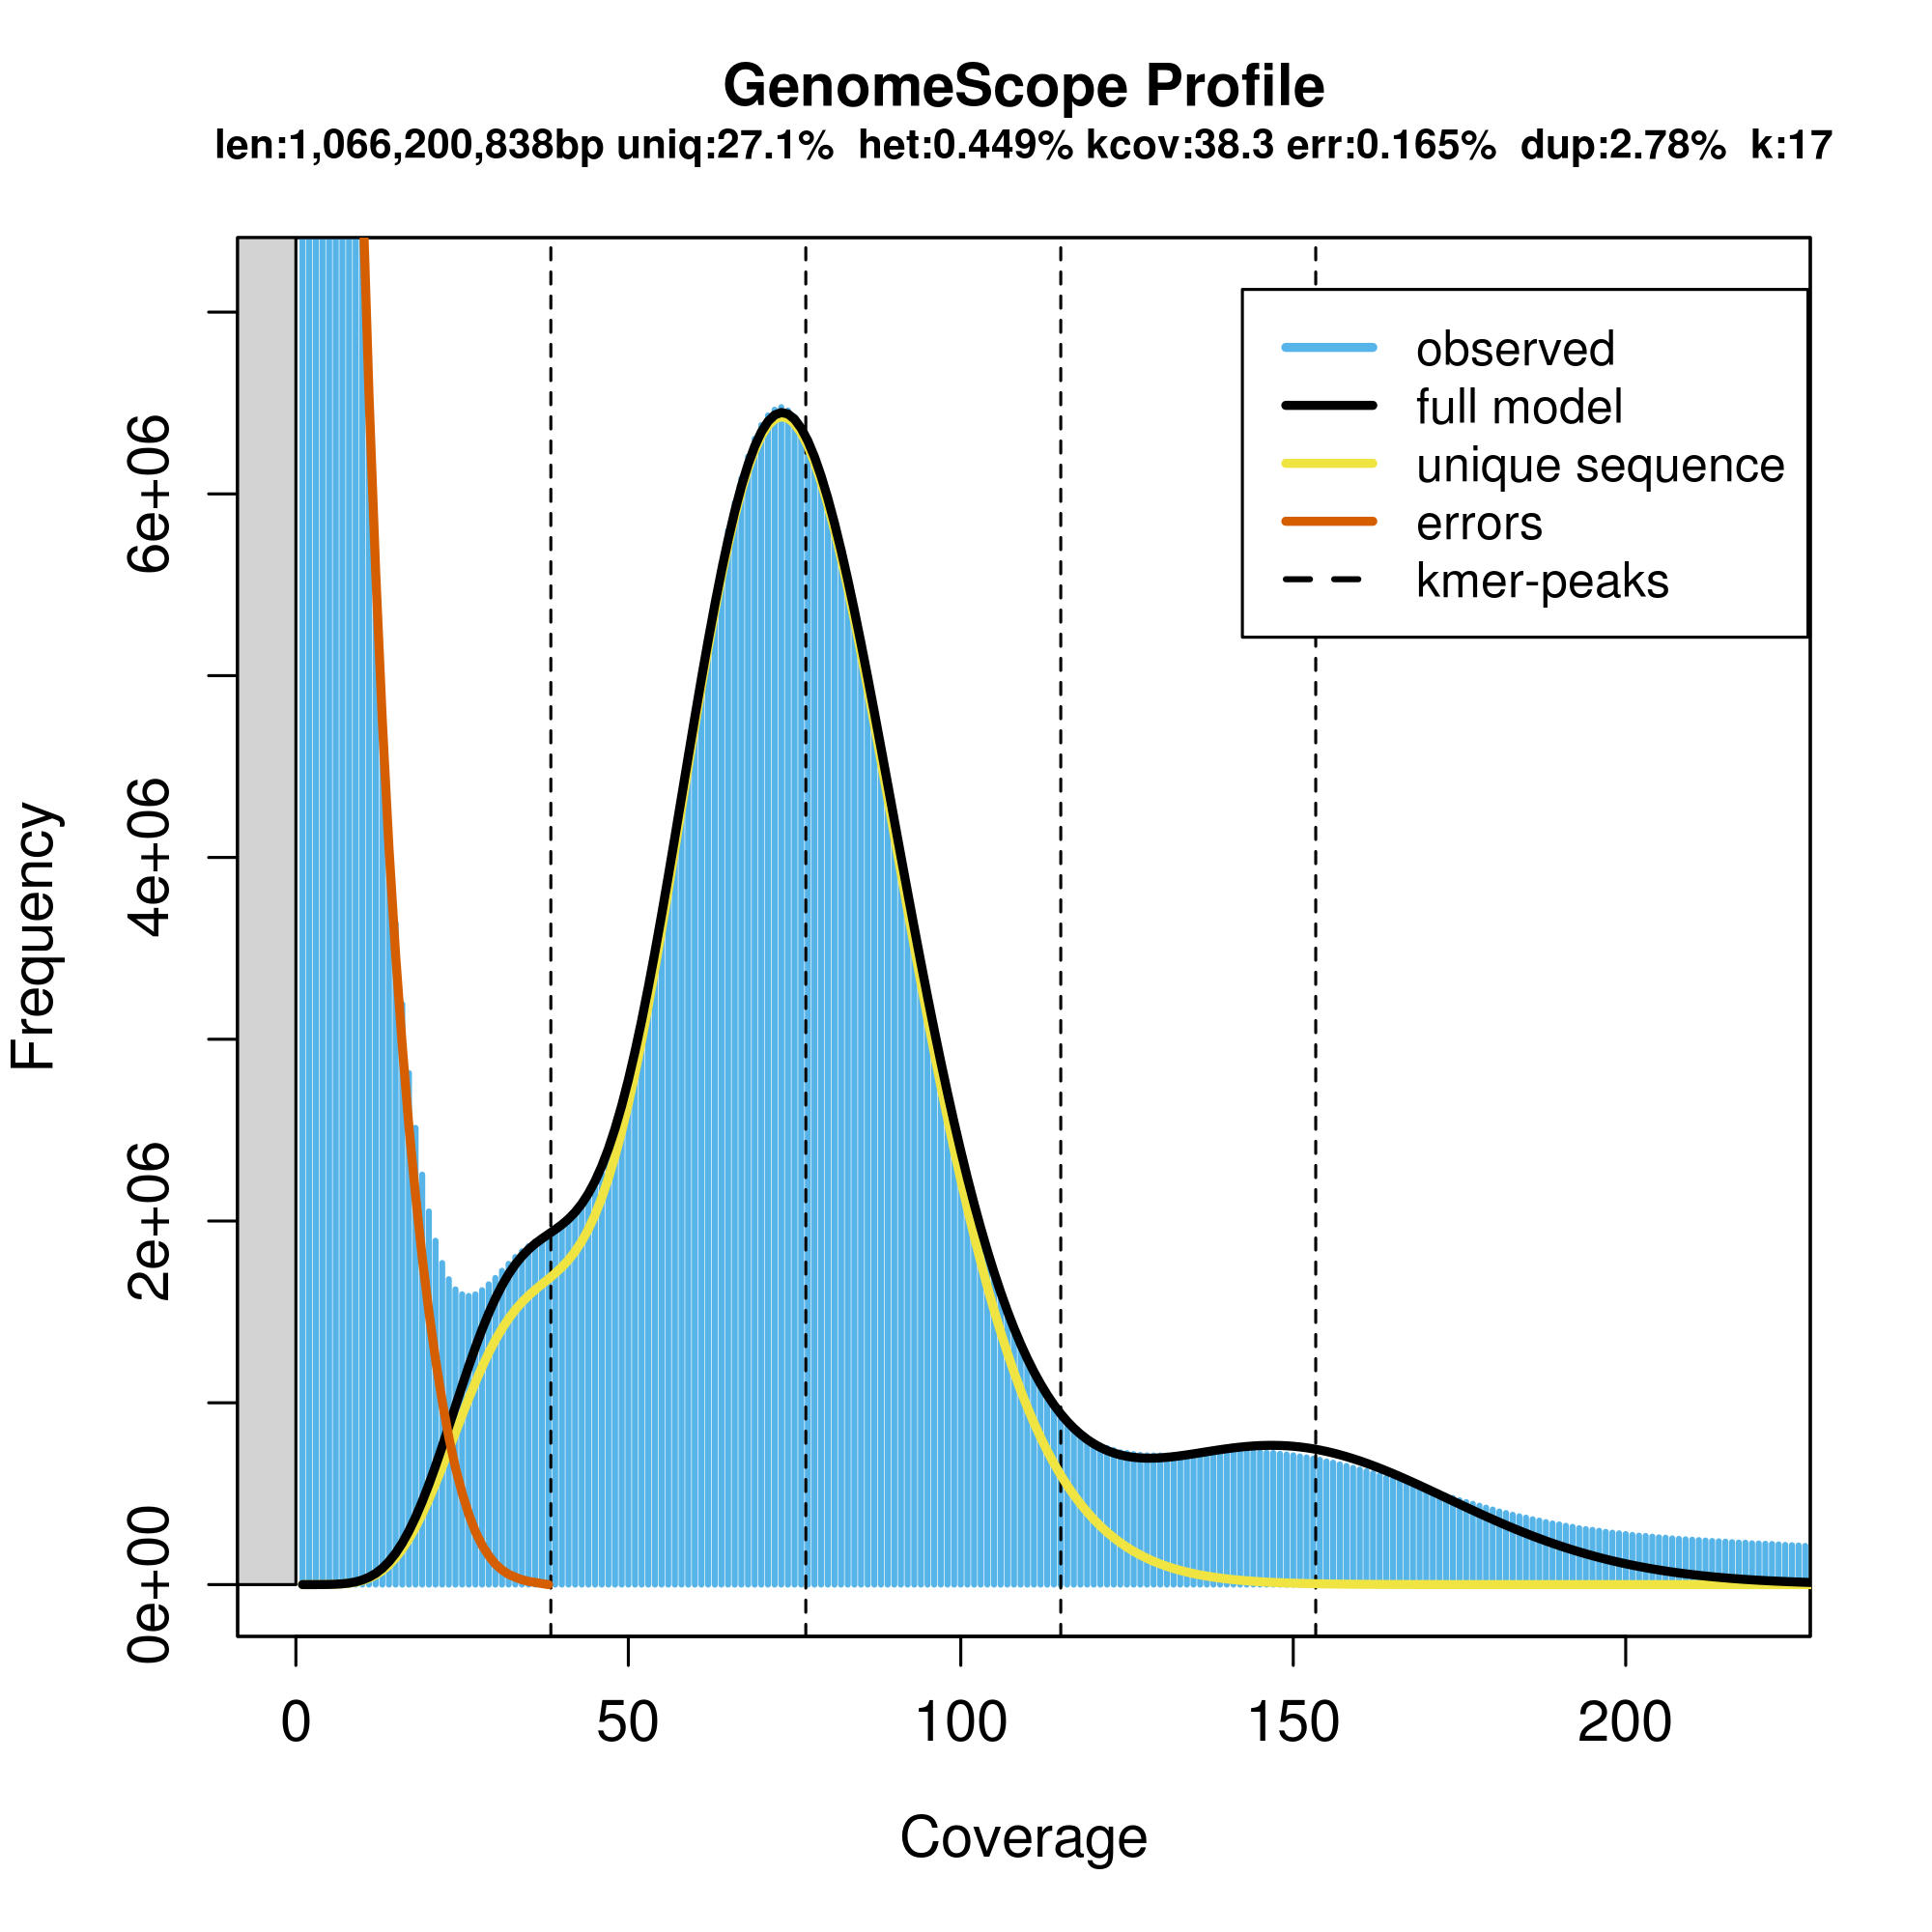
Figure S1. 17-mer profile plot of the Carthamus tinctorius L. pair-end library

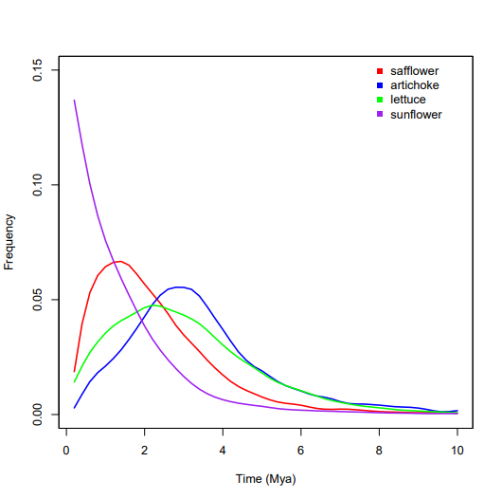
Figure S2. Estimate of LTR insertion time

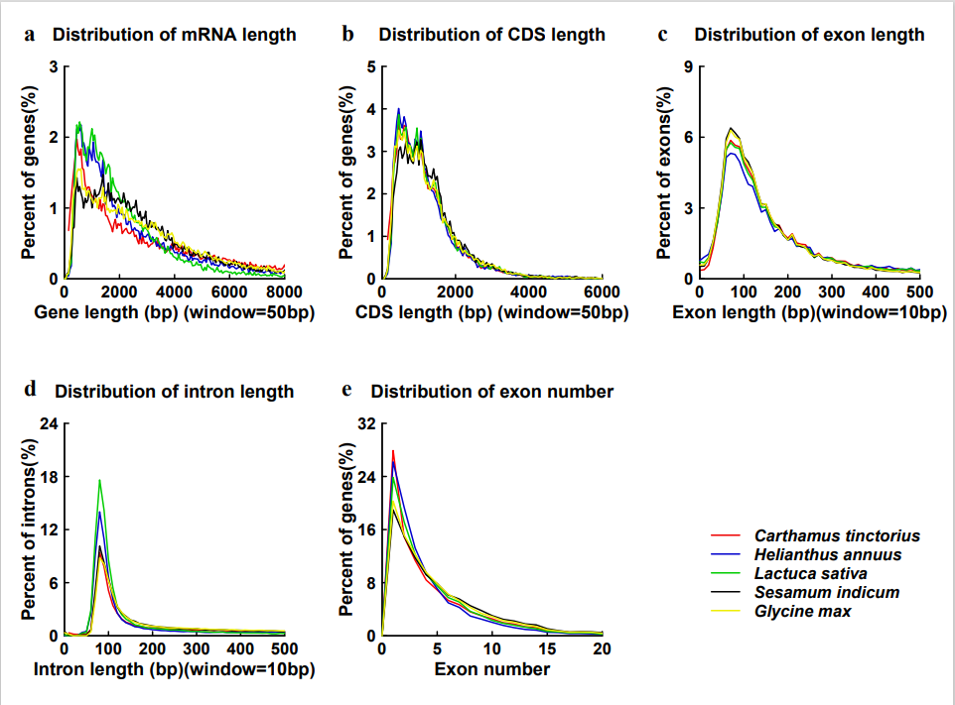\
Figure S3. Distribution of (a) mRNA length, (b) CDS length, (c) exon length, (d) intron length and (e) exon number of protein coding genes in safflower and related species.

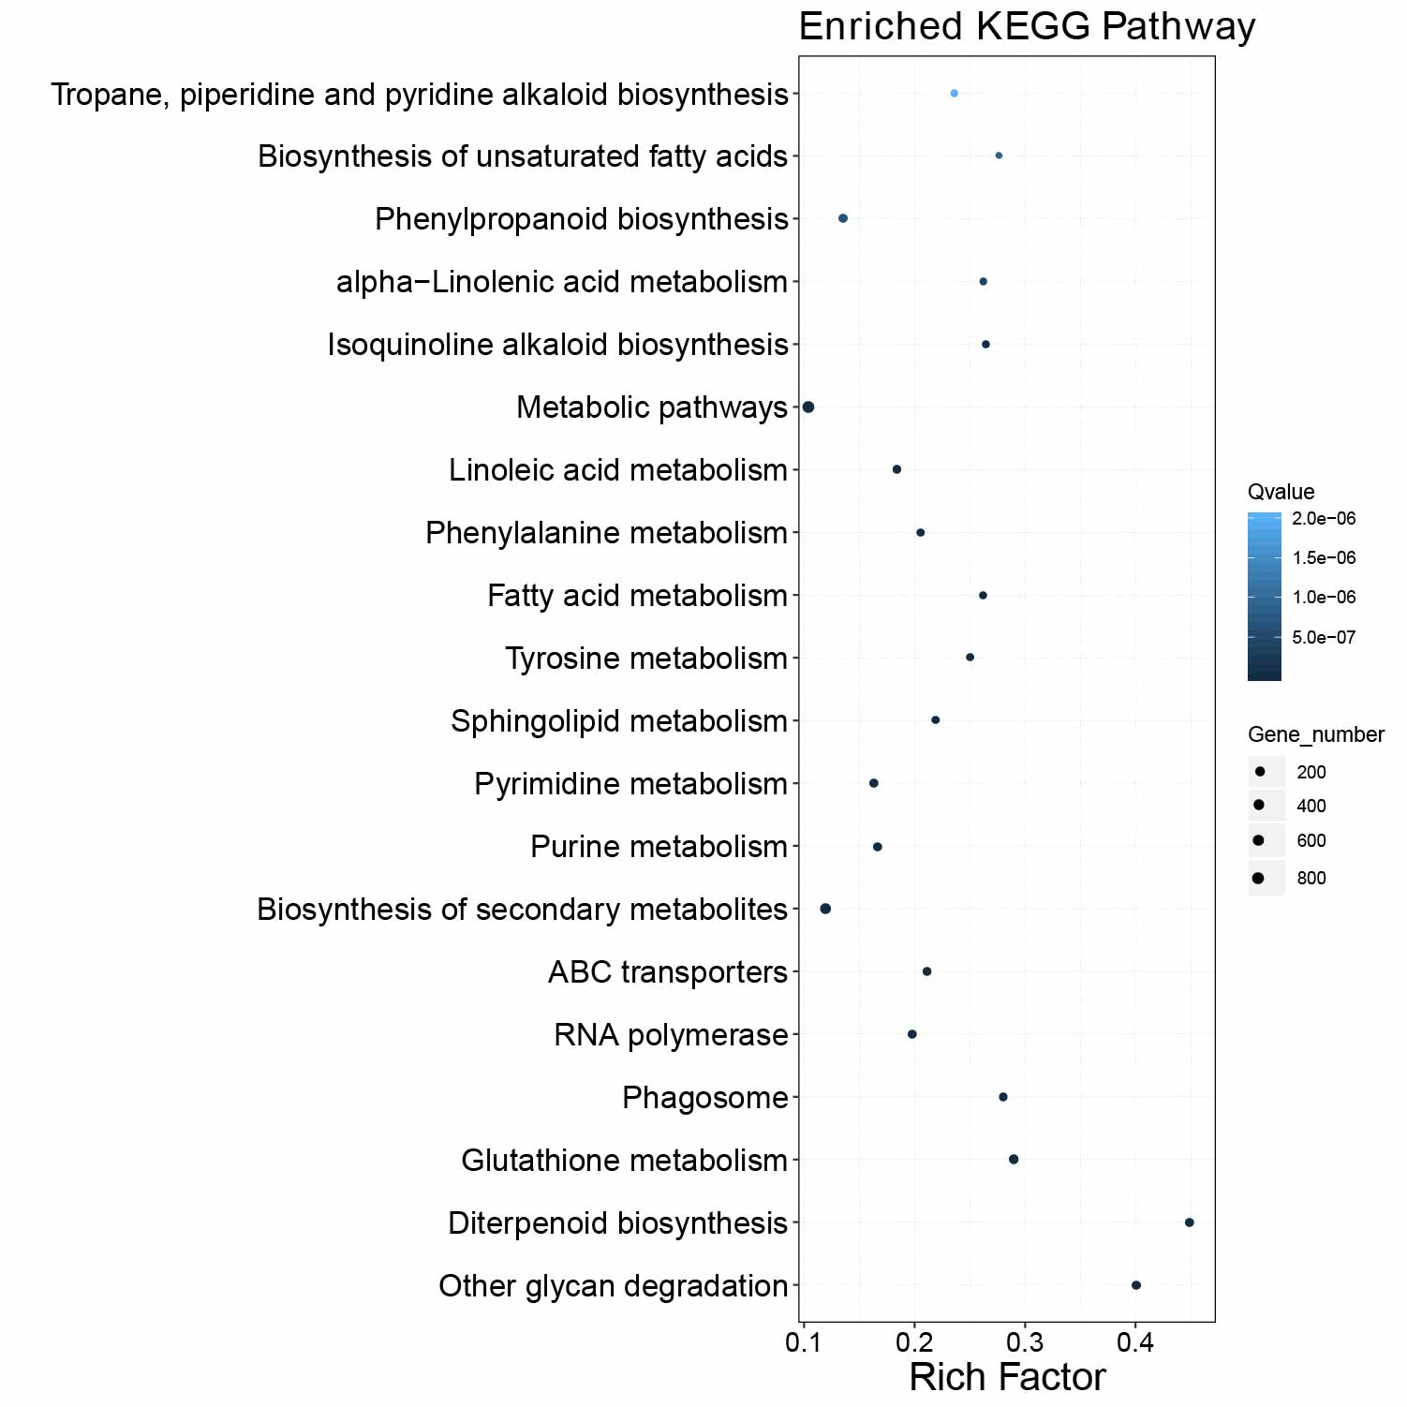
Figure S4. KEGG pathway enrichment of significant expanded gene families

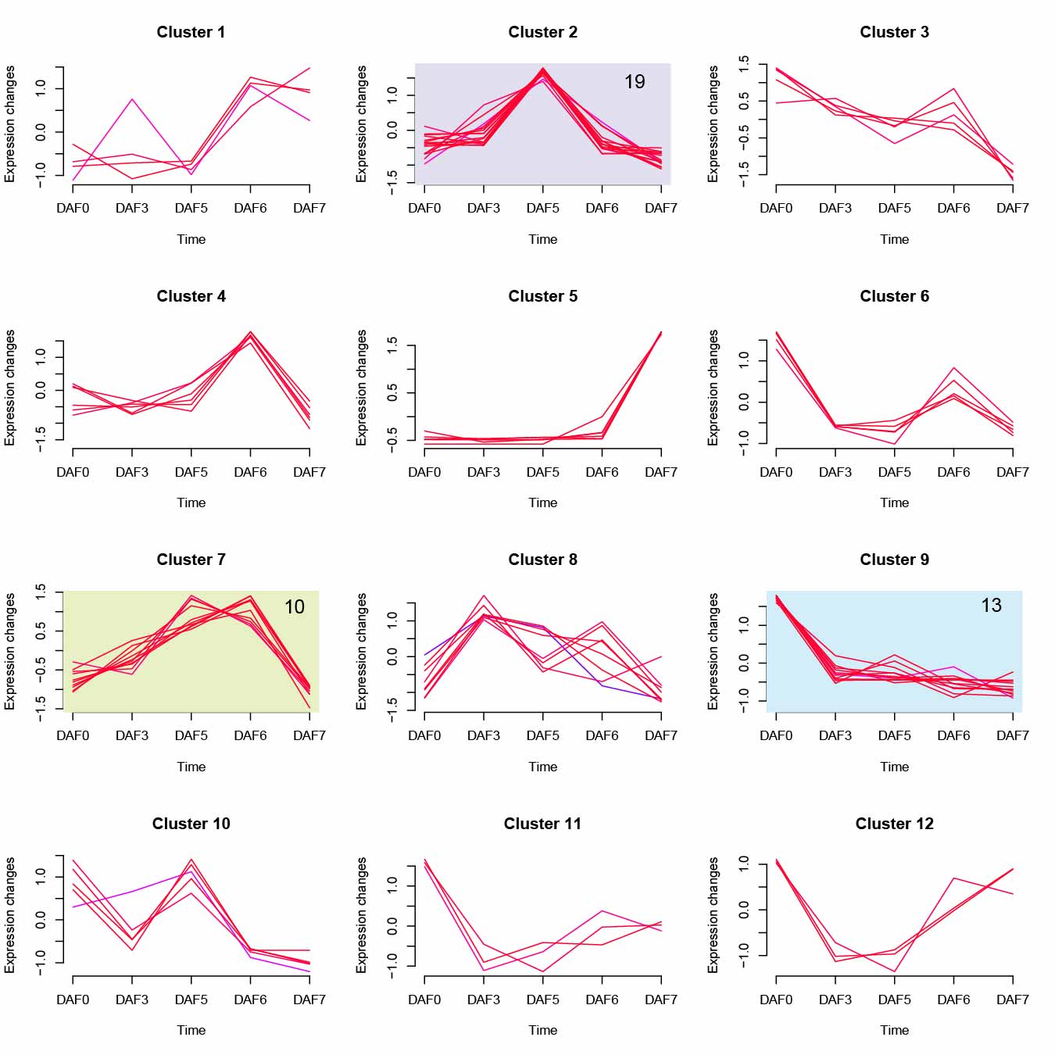
Figure S5. Expression patterns of safflower unsaturated fatty acids biosynthesis genes during seed development.

Table S1. Statistics of safflower genome assembly and annotation
Assembly size (Mb) | 1,061.1
Number of contigs | 452
Contig N50 (Mb) | 8.8
Number of scaffolds | 114
Scaffold N50 (Mb) | 87.1
Number of pseudochromosomes | 12
Percent anchored to pseudochromosomes (%) | 98.82
GC content (%) | 38.37
Complete BUSCOs (%) | 90.3
Fragment BUSCOs (%) | 2.4
Missing BUSCOs (%) | 7.3
Repeat sequences (%) | 63.4%
Protein coding genes | 32,379

Table S2. Genes in biosynthesis of unsaturated fatty acids pathway
Gene_ID | ko | definition
Cti_chr10_00912 | K00059 | 3-oxoacyl-[acyl-carrier protein] reductase [EC:1.1.1.100]
Cti_chr3_02146 | K00059 | 3-oxoacyl-[acyl-carrier protein] reductase [EC:1.1.1.100]
Cti_chr4_00272 | K00059 | 3-oxoacyl-[acyl-carrier protein] reductase [EC:1.1.1.100]
Cti_chr7_00820 | K00059 | 3-oxoacyl-[acyl-carrier protein] reductase [EC:1.1.1.100]
Cti_chr8_00170 | K00059 | 3-oxoacyl-[acyl-carrier protein] reductase [EC:1.1.1.100]
Cti_chr8_00199 | K00059 | 3-oxoacyl-[acyl-carrier protein] reductase [EC:1.1.1.100]
Cti_chr9_01668 | K00059 | 3-oxoacyl-[acyl-carrier protein] reductase [EC:1.1.1.100]
Cti_chr9_01669 | K00059 | 3-oxoacyl-[acyl-carrier protein] reductase [EC:1.1.1.100]
Cti_chr9_01670 | K00059 | 3-oxoacyl-[acyl-carrier protein] reductase [EC:1.1.1.100]
Cti_chr9_01671 | K00059 | 3-oxoacyl-[acyl-carrier protein] reductase [EC:1.1.1.100]
Cti_scaffold74_00139 | K00059 | 3-oxoacyl-[acyl-carrier protein] reductase [EC:1.1.1.100]
Cti_scaffold74_00214 | K00059 | 3-oxoacyl-[acyl-carrier protein] reductase [EC:1.1.1.100]
Cti_scaffold74_00367 | K00059 | 3-oxoacyl-[acyl-carrier protein] reductase [EC:1.1.1.100]
Cti_chr10_00706 | K00232 | acyl-CoA oxidase [EC:1.3.3.6]
Cti_chr10_01035 | K00232 | acyl-CoA oxidase [EC:1.3.3.6]
Cti_chr10_01515 | K00232 | acyl-CoA oxidase [EC:1.3.3.6]
Cti_chr10_01517 | K00232 | acyl-CoA oxidase [EC:1.3.3.6]
Cti_chr1_00646 | K00232 | acyl-CoA oxidase [EC:1.3.3.6]
Cti_chr11_00263 | K00232 | acyl-CoA oxidase [EC:1.3.3.6]
Cti_chr2_00135 | K00232 | acyl-CoA oxidase [EC:1.3.3.6]
Cti_chr2_01685 | K00232 | acyl-CoA oxidase [EC:1.3.3.6]
Cti_chr2_02588 | K00232 | acyl-CoA oxidase [EC:1.3.3.6]
Cti_chr3_00737 | K00232 | acyl-CoA oxidase [EC:1.3.3.6]
Cti_chr3_01554 | K00232 | acyl-CoA oxidase [EC:1.3.3.6]
Cti_chr3_02109 | K00232 | acyl-CoA oxidase [EC:1.3.3.6]
Cti_chr4_01345 | K00232 | acyl-CoA oxidase [EC:1.3.3.6]
Cti_chr4_01347 | K00232 | acyl-CoA oxidase [EC:1.3.3.6]
Cti_chr5_00227 | K00232 | acyl-CoA oxidase [EC:1.3.3.6]
Cti_chr7_00010 | K00232 | acyl-CoA oxidase [EC:1.3.3.6]
Cti_chr8_00111 | K00232 | acyl-CoA oxidase [EC:1.3.3.6]
Cti_chr8_00256 | K00232 | acyl-CoA oxidase [EC:1.3.3.6]
Cti_chr8_00487 | K00232 | acyl-CoA oxidase [EC:1.3.3.6]
Cti_chr8_00775 | K00232 | acyl-CoA oxidase [EC:1.3.3.6]
Cti_chr9_00572 | K00232 | acyl-CoA oxidase [EC:1.3.3.6]
Cti_chr9_00871 | K00232 | acyl-CoA oxidase [EC:1.3.3.6]
Cti_chr9_01446 | K00232 | acyl-CoA oxidase [EC:1.3.3.6]
Cti_chr9_02046 | K00232 | acyl-CoA oxidase [EC:1.3.3.6]
Cti_chr7_01048 | K01062 | platelet-activating factor acetylhydrolase [EC:3.1.1.47]
Cti_chr5_02083 | K01068 | acyl-coenzyme A thioesterase 1/2/4 [EC:3.1.2.2]
Cti_chr5_02084 | K01068 | acyl-coenzyme A thioesterase 1/2/4 [EC:3.1.2.2]
Cti_chr1_03864 | K03921 | acyl-[acyl-carrier-protein] desaturase [EC:1.14.19.2 1.14.19.11 1.14.19.26]
Cti_chr2_02009 | K03921 | acyl-[acyl-carrier-protein] desaturase [EC:1.14.19.2 1.14.19.11 1.14.19.26]
Cti_chr2_02013 | K03921 | acyl-[acyl-carrier-protein] desaturase [EC:1.14.19.2 1.14.19.11 1.14.19.26]
Cti_chr5_00769 | K03921 | acyl-[acyl-carrier-protein] desaturase [EC:1.14.19.2 1.14.19.11 1.14.19.26]
Cti_chr10_00049 | K07513 | acetyl-CoA acyltransferase 1 [EC:2.3.1.16]
Cti_chr11_01169 | K07513 | acetyl-CoA acyltransferase 1 [EC:2.3.1.16]
Cti_chr8_00645 | K07513 | acetyl-CoA acyltransferase 1 [EC:2.3.1.16]
Cti_chr10_02151 | K10249 | elongation of very long chain fatty acids protein 4 [EC:2.3.1.199]
Cti_chr10_02148 | K10251 | 17beta-estradiol 17-dehydrogenase/very-long-chain 3-oxoacyl-CoA reductase [EC:1.1.1.62 1.1.1.330]
Cti_chr4_00901 | K10251 | 17beta-estradiol 17-dehydrogenase/very-long-chain 3-oxoacyl-CoA reductase [EC:1.1.1.62 1.1.1.330]
Cti_chr4_00902 | K10251 | 17beta-estradiol 17-dehydrogenase/very-long-chain 3-oxoacyl-CoA reductase [EC:1.1.1.62 1.1.1.330]
Cti_chr6_02134 | K10251 | 17beta-estradiol 17-dehydrogenase/very-long-chain 3-oxoacyl-CoA reductase [EC:1.1.1.62 1.1.1.330]
Cti_chr10_00208 | K10256 | omega-6 fatty acid desaturase/acyl-lipid omega-6 desaturase (Delta-12 desaturase) [EC:1.14.19.6 1.14.19.22]
Cti_chr1_00586 | K10256 | omega-6 fatty acid desaturase/acyl-lipid omega-6 desaturase (Delta-12 desaturase) [EC:1.14.19.6 1.14.19.22]
Cti_chr11_01893 | K10256 | omega-6 fatty acid desaturase/acyl-lipid omega-6 desaturase (Delta-12 desaturase) [EC:1.14.19.6 1.14.19.22]
Cti_chr11_01894 | K10256 | omega-6 fatty acid desaturase/acyl-lipid omega-6 desaturase (Delta-12 desaturase) [EC:1.14.19.6 1.14.19.22]
Cti_chr11_01895 | K10256 | omega-6 fatty acid desaturase/acyl-lipid omega-6 desaturase (Delta-12 desaturase) [EC:1.14.19.6 1.14.19.22]
Cti_chr11_01896 | K10256 | omega-6 fatty acid desaturase/acyl-lipid omega-6 desaturase (Delta-12 desaturase) [EC:1.14.19.6 1.14.19.22]
Cti_chr11_01897 | K10256 | omega-6 fatty acid desaturase/acyl-lipid omega-6 desaturase (Delta-12 desaturase) [EC:1.14.19.6 1.14.19.22]
Cti_chr11_01898 | K10256 | omega-6 fatty acid desaturase/acyl-lipid omega-6 desaturase (Delta-12 desaturase) [EC:1.14.19.6 1.14.19.22]
Cti_chr11_01899 | K10256 | omega-6 fatty acid desaturase/acyl-lipid omega-6 desaturase (Delta-12 desaturase) [EC:1.14.19.6 1.14.19.22]
Cti_chr11_01900 | K10256 | omega-6 fatty acid desaturase/acyl-lipid omega-6 desaturase (Delta-12 desaturase) [EC:1.14.19.6 1.14.19.22]
Cti_chr11_01901 | K10256 | omega-6 fatty acid desaturase/acyl-lipid omega-6 desaturase (Delta-12 desaturase) [EC:1.14.19.6 1.14.19.22]
Cti_chr3_02111 | K10256 | omega-6 fatty acid desaturase/acyl-lipid omega-6 desaturase (Delta-12 desaturase) [EC:1.14.19.6 1.14.19.22]
Cti_chr3_02112 | K10256 | omega-6 fatty acid desaturase/acyl-lipid omega-6 desaturase (Delta-12 desaturase) [EC:1.14.19.6 1.14.19.22]
Cti_chr4_00382 | K10256 | omega-6 fatty acid desaturase/acyl-lipid omega-6 desaturase (Delta-12 desaturase) [EC:1.14.19.6 1.14.19.22]
Cti_chr7_00474 | K10256 | omega-6 fatty acid desaturase/acyl-lipid omega-6 desaturase (Delta-12 desaturase) [EC:1.14.19.6 1.14.19.22]
Cti_chr7_00475 | K10256 | omega-6 fatty acid desaturase/acyl-lipid omega-6 desaturase (Delta-12 desaturase) [EC:1.14.19.6 1.14.19.22]
Cti_chr7_00477 | K10256 | omega-6 fatty acid desaturase/acyl-lipid omega-6 desaturase (Delta-12 desaturase) [EC:1.14.19.6 1.14.19.22]
Cti_chr8_00311 | K10256 | omega-6 fatty acid desaturase/acyl-lipid omega-6 desaturase (Delta-12 desaturase) [EC:1.14.19.6 1.14.19.22]
Cti_chr9_01616 | K10256 | omega-6 fatty acid desaturase/acyl-lipid omega-6 desaturase (Delta-12 desaturase) [EC:1.14.19.6 1.14.19.22]
Cti_chr9_01617 | K10256 | omega-6 fatty acid desaturase/acyl-lipid omega-6 desaturase (Delta-12 desaturase) [EC:1.14.19.6 1.14.19.22]
Cti_chr9_01618 | K10256 | omega-6 fatty acid desaturase/acyl-lipid omega-6 desaturase (Delta-12 desaturase) [EC:1.14.19.6 1.14.19.22]
Cti_chr9_01619 | K10256 | omega-6 fatty acid desaturase/acyl-lipid omega-6 desaturase (Delta-12 desaturase) [EC:1.14.19.6 1.14.19.22]
Cti_chr9_01620 | K10256 | omega-6 fatty acid desaturase/acyl-lipid omega-6 desaturase (Delta-12 desaturase) [EC:1.14.19.6 1.14.19.22]
Cti_chr9_01622 | K10256 | omega-6 fatty acid desaturase/acyl-lipid omega-6 desaturase (Delta-12 desaturase) [EC:1.14.19.6 1.14.19.22]
Cti_chr9_01623 | K10256 | omega-6 fatty acid desaturase/acyl-lipid omega-6 desaturase (Delta-12 desaturase) [EC:1.14.19.6 1.14.19.22]
Cti_chr9_01625 | K10256 | omega-6 fatty acid desaturase/acyl-lipid omega-6 desaturase (Delta-12 desaturase) [EC:1.14.19.6 1.14.19.22]
Cti_chr9_01626 | K10256 | omega-6 fatty acid desaturase/acyl-lipid omega-6 desaturase (Delta-12 desaturase) [EC:1.14.19.6 1.14.19.22]
Cti_chr9_01627 | K10256 | omega-6 fatty acid desaturase/acyl-lipid omega-6 desaturase (Delta-12 desaturase) [EC:1.14.19.6 1.14.19.22]
Cti_chr9_01634 | K10256 | omega-6 fatty acid desaturase/acyl-lipid omega-6 desaturase (Delta-12 desaturase) [EC:1.14.19.6 1.14.19.22]
Cti_chr1_00501 | K10258 | very-long-chain enoyl-CoA reductase [EC:1.3.1.93]
Cti_chr1_00784 | K10258 | very-long-chain enoyl-CoA reductase [EC:1.3.1.93]
Cti_chr1_00785 | K10258 | very-long-chain enoyl-CoA reductase [EC:1.3.1.93]
Cti_chr1_01059 | K10258 | very-long-chain enoyl-CoA reductase [EC:1.3.1.93]
Cti_chr11_01509 | K10258 | very-long-chain enoyl-CoA reductase [EC:1.3.1.93]
Cti_chr11_01732 | K10258 | very-long-chain enoyl-CoA reductase [EC:1.3.1.93]
Cti_chr11_01733 | K10258 | very-long-chain enoyl-CoA reductase [EC:1.3.1.93]
Cti_chr8_02329 | K10258 | very-long-chain enoyl-CoA reductase [EC:1.3.1.93]
Cti_chr8_02330 | K10258 | very-long-chain enoyl-CoA reductase [EC:1.3.1.93]
Cti_chr12_01111 | K10703 | very-long-chain (3R)-3-hydroxyacyl-CoA dehydratase [EC:4.2.1.134]
Cti_chr9_01554 | K10703 | very-long-chain (3R)-3-hydroxyacyl-CoA dehydratase [EC:4.2.1.134]
Cti_chr3_02029 | K11147 | dehydrogenase/reductase SDR family member 4 [EC:1.1.-.-]
Cti_chr3_02144 | K11147 | dehydrogenase/reductase SDR family member 4 [EC:1.1.-.-]
Cti_chr9_00599 | K11147 | dehydrogenase/reductase SDR family member 4 [EC:1.1.-.-]
Cti_chr12_01704 | K18643 | katanin p80 WD40 repeat-containing subunit B1

Table S3. SAD, FAD6 and FAD2 genes in safflower genome
Name | Gene_ID
SAD | Cti_chr5_00769
SAD | Cti_chr1_03864
SAD | Cti_chr2_02009
SAD | Cti_chr2_02013
FAD6 | Cti_chr3_02287
FAD2 | Cti_chr4_00382
FAD2 | Cti_chr10_00208
FAD2 | Cti_chr8_00311
FAD2 | Cti_chr1_00586
FAD2 | Cti_chr7_00477
FAD2 | Cti_chr7_00475
FAD2 | Cti_chr7_00474
FAD2 | Cti_chr9_01616
FAD2 | Cti_chr9_01617
FAD2 | Cti_chr9_01618
FAD2 | Cti_chr9_01619
FAD2 | Cti_chr9_01620
FAD2 | Cti_chr9_01622
FAD2 | Cti_chr9_01623
FAD2 | Cti_chr9_01625
FAD2 | Cti_chr9_01626
FAD2 | Cti_chr9_01627
FAD2 | Cti_chr9_01634
FAD2 | Cti_chr11_01901
FAD2 | Cti_chr11_01900
FAD2 | Cti_chr11_01899
FAD2 | Cti_chr11_01898
FAD2 | Cti_chr11_01897
FAD2 | Cti_chr11_01896
FAD2 | Cti_chr11_01895
FAD2 | Cti_chr11_01894
FAD2 | Cti_chr11_01893
FAD2 | Cti_chr3_02111
FAD2 | Cti_chr3_02112

