Supplementary Figure 2 Copy number variants sequencing

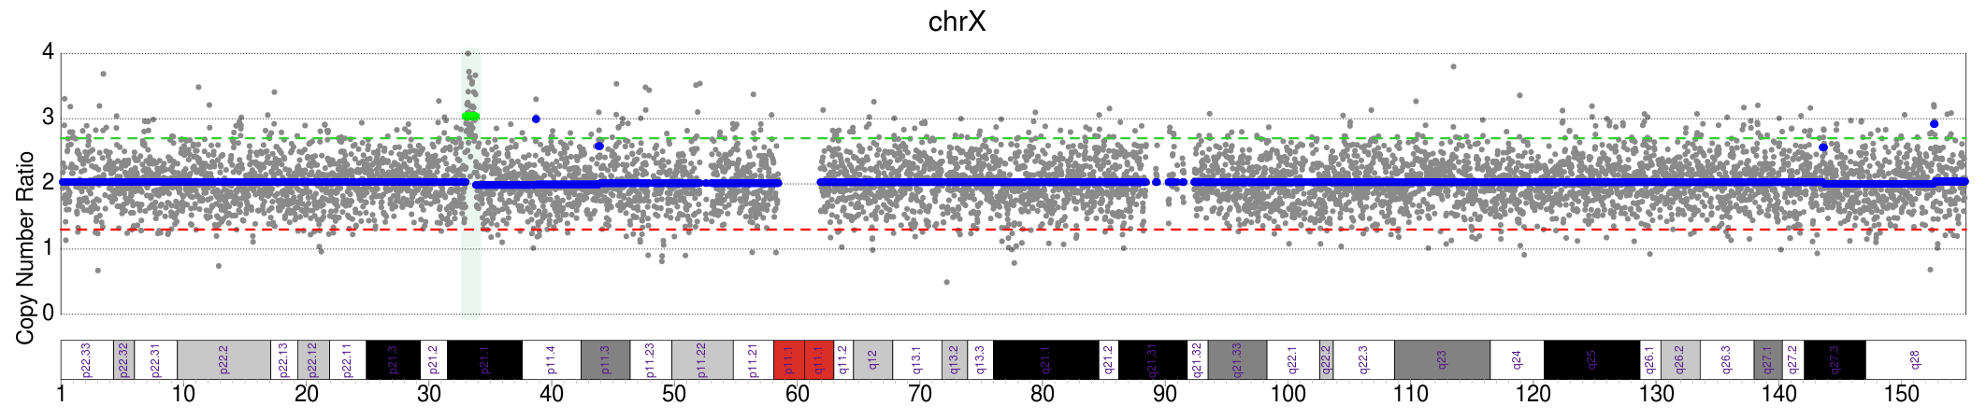
II4 in Pedigree 1: seq[GRCh37] dup(X)(p21.1) chrX:g.33020001_33840000dup

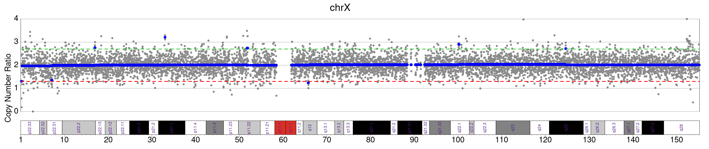
II2 in Pedigree 2: The size of the duplication segment identified by LRS(ChrX:32,999,023-33,070,000) was smaller than the resolution (100kb CNV-Seq)

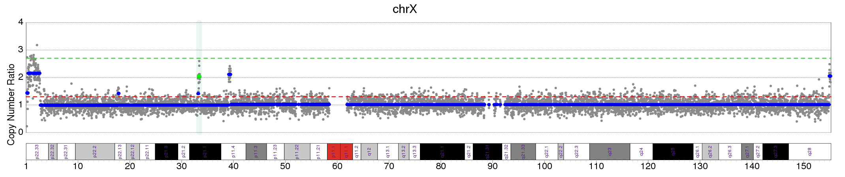
II1 in Pedigree 3: seq[GRCh37] dup(X)(p21.1) chrX:g.33280001_33540000dup, seq[GRCh37] dup(X)(p11.4) chrX:g.39080001_39480000dup.
The size of the third duplication segment identified by LRS(ChrX:33,154,320-33,202,989) was smaller than the resolution (100kb CNV-Seq).

