Supplemental Information
Supplementary Table 1: Full Coded Comments by Domain
Pre-Curriculum
Domain | Code
Self-efficacy | 'For people who have a lot of experience with science, I think I can show the purpose and show them science. For people who have less scientific experience, I think it would be harder to show them my experience of science' (Monastic Scholar 1)  'Right now I don't do it but being around it I think I can' (Monastic Scholar 1)  'When I have doubts or hypotheses, I want to share them with scientists' (Monastic Scholar 2)  'I think if we have more knowledge, we can more confidently give suggestions. If less, less confident. I think it is based on background knowledge'(Monastic Scholar 2)  'Confidence comes from information and so I feel like I can get more confidence once I have the information but right now I do not' (Monastic Scholar 2)  'I am confident in finding a research lab so I can feel very confident about doing these things' (Monastic Scholar 2)  'I have confidence because there is no direct answer'(Monastic Scholar 3)  'I feel like I can get more confidence to understand what I know, but right now I don't have confidence' (Monastic Scholar 3.  'If its a general scientific paper, I feel like I would have some confidence, If it is a journal then I think I would be less confident' (Monastic Scholar 4)  'after a few sessions maybe I would be more confident' (Monastic Scholar 4)  'In that case, I feel some confidence in critiquing those scientists' (Monastic Scholar 5)  'Currently, I am not very confident but later maybe' (Monastic Scholar 5)  'I am fully confident that even though it is a new thing for us and I am fully confident that I can do it' (Monastic Scholar 6)  'When I research the scientists I understand very well about it so I can explain it to other people. Its not for any subject' (Monastic Scholar 7)
Knowledge | 'Actually I have not much knowledge about scientists. After I know more about the body then I can begin to ask more questions' (Monastic Scholar 3)  'Because I have no background in science' (Monastic Scholar 3)  ' if I am critiquing somebody who has very little scientific background I may be able to give some background, but if it is somebody who is a lot, its better to keep quiet' (Monastic Scholar 4)  ' However, I currently do not know how the research is done' (Monastic Scholar 4)  'I would need too high of a level of education or how to use the equipment' (Monastic Scholar 5)  'I have a little bit of confidence if I have knowledge on the specific subject such as certain neuroscience subjects' (Monastic Scholar 5)  'I ask several questions with the mentors and the professor, but thats just for my knowledge and to answer my doubt. However, that doesn't have anything to do with an experiment' (Monastic Scholar 5)  'This is my first time to take research sessions so I have no idea what to do and how to do' (Monastic Scholar 5)  'But I don't know about these things as much so I chose 2' (Monastic Scholar 7)
Future Applications/Drive | 'I am also inspired by surroundings where we can see lots of scientists' (Monastic Scholar 2)  'I think that it is not relevant to become a biological scientist or a physical scientist. However, for a psychological scientist, I have considered becoming one because they deal with brain and mental states' (Monastic Scholar 2)  'I am so curious to learn more about science I don't need to feel embarrassed when we don't know something' (Monastic Scholar 2)  'So this is part of my commitment to get rid of my doubt and do science' (Monastic Scholar 3)  'Especially we don't the opportunity to do research on specific objects and I am excited to be here' (Monastic Scholar 5)
Belonging | 'If I just came from the monastery, if I was in the monastery I would say I wouldn't feel like I'm part of a scientific community because it's mostly theoretical and I wouldn't say that I was a scientist. But now that I am here, I feel like I am more part of a scientific community but still not completely feel because I am still lacking in some ways of how scientific communities think' (Monastic Scholar 4).  'I would love to be a scientist but I don’t think I am' (Monastic Scholar 5)  'For me, I never think that I am going to become a scientist because scientists spend their life studying external objects' (Monastic Scholar 5)  'I would love to be a scientist but for me, I don't consider myself a scientist' (Monastic Scholar 5)  'Before I came to Emory I didn't feel like I was part of a scientific community but when I saw a lot of students wearing those lab coats I felt like I was in the community' (Monastic Scholar 6)

Post-Curriculum

Code Domain
Self-efficacy | 'I am a little bit better but I am not fully confident in being able with everything in the scientific method' (Monastic Scholar 1)  'I am more confident about this one. If I read about scientific paper, I can learn about what they are doing and how they are doing it' (Monastic Scholar 1)  'That's why I am totally satisfied and confident in participating with a lab. (Monastic Scholar 2)  'I now feel more confident in investigating now only based on faith but also using the scientific method. So that's why I feel more confident' (Monastic Scholar 2)  'There are some things that can be answered in our life using the scientific method, but in general, I am not very confident' (Monastic Scholar 4)  'Right now as I am, I am not comfortable being able to criticise those papers.If the scientific paper is some science journal, if there is some obvious things that are incorrect, I may be able to offer some thoughts' (Monastic Scholar 4)  'I remember this question from the first meeting. I think that I gave a 3 so I feel more confident than the last time. I am quite confident about that now' (Monastic Scholar 4)  'For those theories I have some confidence and being able to comment on those. And in some specific topics I am very confident I can provide feedback' (Monastic Scholar 5)  'So there are some questions I am very confident in asking to some researchers' (Monastic Scholar 5)  'I think I may be able to criticise some scientific ideas if they run opposite to what is understood and provide feedback' (Monastic Scholar 7)  'That is why I am very confident to ask them meaningful questions' (Monastic Scholar 7)
Knowledge | 'In a scientific paper, scientists write down their own viewpoints. They are written also with what they did and write through the experiment and what they found out through research. So what based on what I saw in paper, then I can make aware of something' (Monastic Scholar 1)  'Because there are some things that they may not understand about the scientific method and mistakes in their research that I could help provide feedback for' (Monastic Scholar 1)  'So we can apply all the scientific methods in our life and no matter what job or where you are we can apply the scientific method' (Monastic Scholar 2)  'I put it in the middle. There are two reasons: One is that I am very willing to apply the scientific method in my life. Why I didn't put a 5 is because now I consider myself a scientist with a lack of knowledge' (Monastic Scholar 2)  'Currently, I don't think I have the knowledge to make the appropriate comment. There is two things: emotionally, I can make the comment but I don't have the knowledge' (Monastic Scholar 2)  'I really think it is dependent on your background knowledge. So if you have the background it is easier to know more' (Monastic Scholar 2)  'The questions you have asked are dependent on what we think from your questions. If I read the basic fundamental things from a scientific paper, then I can understand. If I look at some research papers, they are very hard and difficult. I could not explain to others because I have trouble. If I have trouble, then how could I explain it to others? Till now I was only thinking about papers in English. If they were written in Tibetan then I could explain them' (Monastic Scholar 2)  'Until participating in Emory, I never learned these subjects. With you guys, I learned a lot of things I never heard about' (Monastic Scholar 2)  'Because I think scientists are more experienced and know research to other things. So I have to know more experience about it' (Monastic Scholar 3)  'If I have the knowledge and it does not align with my view, then I have some confidence. However, if I do not have specific knowledge, then I do not have confidence. But when I do have the knowledge, I am confident that I can give thoughts that are against my view' (Monastic Scholar 3)  'If I know about the question then maybe I could get the question but I don't know a lot of questions' (Monastic Scholar 3)  'I do not know if these things can be answered with the scientific method. I also do not know if all of these things are repeatable' (Monastic Scholar 4)  'In some articles from scientific journals, I could gain main points from what is being said' (Monastic Scholar 4)  'As per my experience, there are some conditions that I have to answer to the subjective experience meaning mental conditions, which cannot be answered through the scientific method' (Monastic Scholar 5)  'There are some questions that I am not sure that they could be answered experimentally. There are lots of questions about microorganisms and the science and research are still going on' (Monastic Scholar 5)  'From the level of the paper, I can explain what the paper tried to say about their ideas and learn from their research. But it is very hard to accurately explain their ideas' (Monastic Scholar 5)  ' It is very helpful for me to do the research and take the research sessions' (Monastic Scholar 5)  ' I don't like math and math doesn't like me. In lab, we need lots of math for the materials. The second thing is that I am not good with memorization so ' (Monastic Scholar 6)  'However, there are many subjects I do not understand as well that I would not be able to provide feedback on. But if I do have experience, I will be able to provide feedback' (Monastic Scholar 7)  'Its right that we need a lot of knowledge to have the courage to criticise other scientific papers' (Monastic Scholar 6).
Future Applications/Drive | 'Your courage while teaching us encouraged me to learn more about labs and other sources.. Each and everyone are all excited to learn new things that they have never touched' (Monastic Scholar 2)  'I am very confident on the lab research because I love to research. I am very happy to do research in the lab and that's why I'm very confident and am very excited to do research and gained a lot of techniques. If I do research I get new information which is exciting' (Monastic Scholar 1)  ' I feel more confident because I love to do investigations using reason and doing deep investigation which is the nature of the scientific method so I feel more confident' (Monastic Scholar 2)  'I am planning to study more on those things in my future time' (Monastic Scholar 2)  'I think it is also very related to Buddhist philosophy and highly applicable to our life' (Monastic Scholar 2)  'However, in the future, once I increase my information and become like you guys (the mentors) then I can put 5' (Monastic Scholar 2)  'In the future maybe I can but that would need to be back by other data and proofs' (Monastic Scholar 4)  'So for that those there are several questions like the positive and some ethics, ethics that the through traditional religions, theory or experience. And I think however a combination of these two can answer every problem in our life' (Monastic Scholar 5)  'I think I was born for research, experiment and investigations' (Monastic Scholar 5)  'For me at Emory, it is important to do research because we go through class but not only to listen to what theory and lecture says but to do the lab and makes me excited to focus on research' (Monastic Scholar 5)  'However, I am going on the first definition but I still have to continue and go further. I am confident I am a scientist but can go further' (Monastic Scholar 6)  'However, to go to that level, I have to study more. Studying means a lot of practice. I can do such a thing. I don't have a specific reason as to why I can do it, but I know that I can improve and give comments in the future. I have the curiosity to comment' (Monastic Scholar 6)  'The meaningful questions are important for myself and many people and are about being happy, being productive in society and I am often concerned with this question' (Monastic Scholar 7)
Belonging | 'because I don't consider myself a scientist' (Monastic Scholar 3)  'I am totally aware I am surrounded by the scientific community. I am surrounded by science students and professors learning science so I feel like I am part of the community. Yeah, I am very confident that I’m part of the scientific community' (Monastic Scholar 6)  'For me, I define scientists as the one who study science. That is what we are here for and that is what we are doing. There is another definition for scientists who study a lot of science and are professional and know a lot' (Monastic Scholar 6)

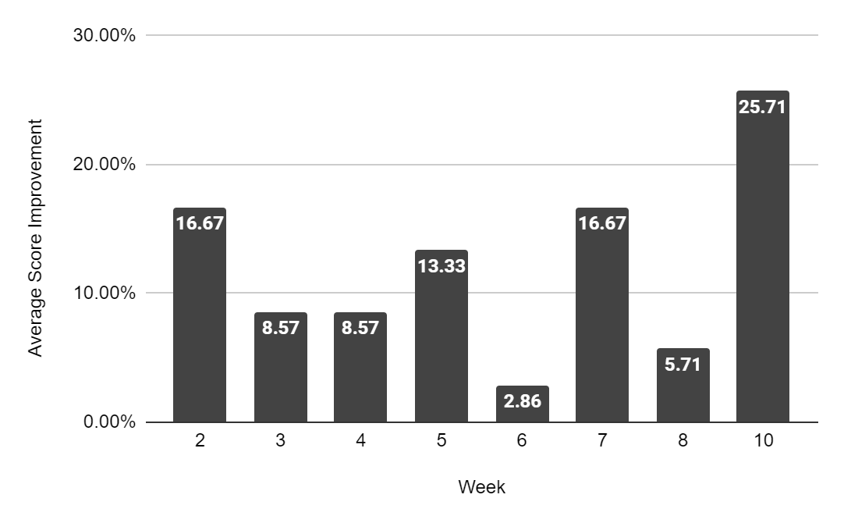
Figure 1: Average Improvement on Weekly Quizzes. Average post-lesson score subtracted from pre-lesson score. n=7

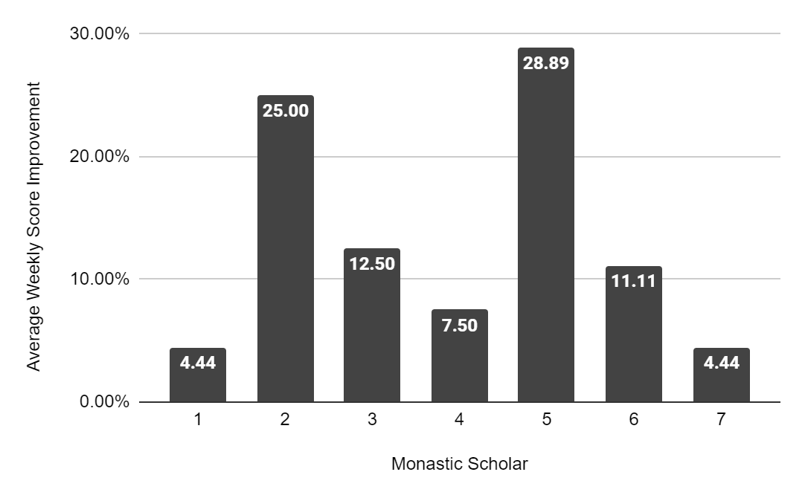
Figure 2: Average Weekly Improvement per Monastic Scholar. Each Monastic Scholar’s average post-lesson score subtracted from their average pre-lesson score.

