Supplementary Data
Accumulation of n-3 DPA in a novel isolate of the marine ichthyosporean Sphaeroforma arctica
Qiang (Wilson) Yan¹, Yingchun Liu¹, Christa Barrett¹, Kelly Ryan¹, Daniel Seeler¹, Oliver May², Ross Zirkle^{1,*}
¹ dsm-firmenich Science and Research, Columbia, Maryland, United States of America
* Corresponding authors
² dsm-firmenich Science and Research, Biotechnology, Kaiseraugst, Switzerland

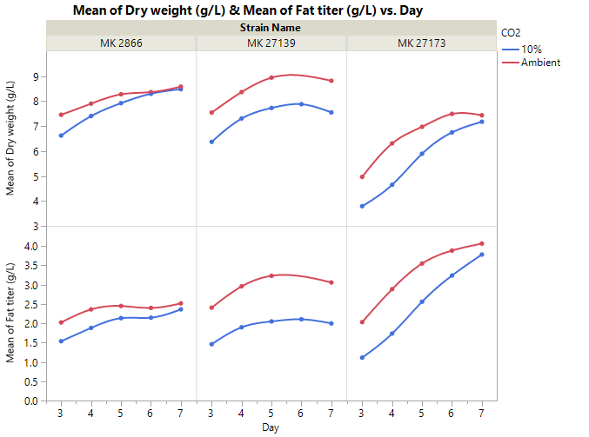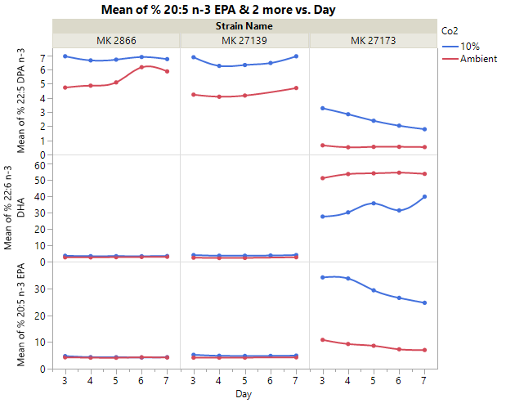
Figure S1. Effect of supplement CO2 on biomass, total fatty acid (left) and n-3 DPA (right) production. Cells MK2866, MK27139 and MK27173 were grown for 7 days at 22.5C with ambient CO2 or 10% CO2.

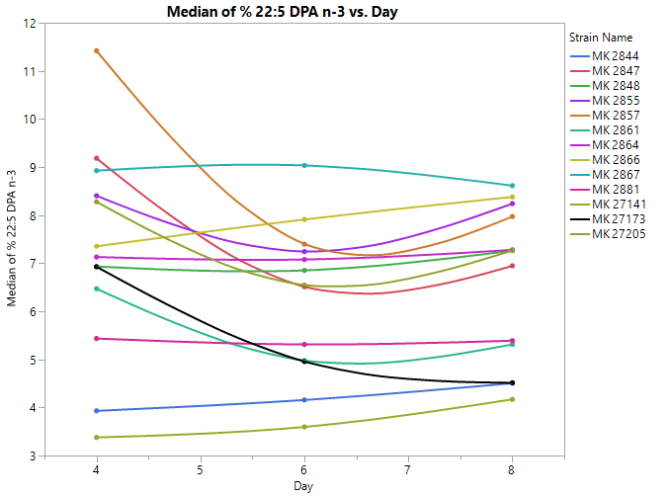
Figure S2. Second round screening of 30 selected strains from DSM Culture Collection to evaluate n-3 DPA content. Cells were grown in sterile 250 mL baffled Erlenmeyer flasks containing 50 mL of sterile 2X SDFM-O medium. The cultures were grown for 96-240 hrs at 22.5°C using a 2.5 cm orbital shaker rotating at 200 r.p.m. in a 10% CO₂ incubator.

