Supplemental Materials

Supplemental Methods
CMR Radiomics
CMR Radiomics were computed given the CMR images and the corresponding segmentations from the right atrial (RA) and left atrial (LA) from long axis in end-diastole and from the right ventricle (RV) and left ventricular cavities including left ventricle (LV) and left ventricular myocardium (MYO) from short-axis in end-diastole and end-systole. The segmentations were performed using two different techniques for long and short axis.
In short axis, the first 5,000 UK Biobank CMR scans stored as CMR DICOM® (Digital Imaging and Communications in Medicine) images were manually segmented by expert cardiologists using Cardiac MRI and CT Software (CVI42 from Circle). A fully automated image analysis pipeline publicly available was used to propagate the contours of the remaining data [36]. The resulting segmentations were exported into a single xml file containing the CVI42 contour points defined with a different label for each ROI. An in-house software was developed to convert each contour into a binary mask in a readable format [37].
In order to obtain the contouring of the atrial ROIs in the long axis view, an automatic segmentation model based on a U-Net architecture was implemented [38]. Automated bi-atrial segmentation combination was performed by a fully convolutional neural network adapted from the U-net architecture. The network was trained on the manually annotated 5,065 UK Biobank CMR studies segmented by eight analysts in two core laboratories using cvi42 software. These manual ground-truth CMR studies were visually quality assessed by the analyst at the time of manual segmentation. 153 out of a total of 5,065 manual annotated studies were excluded due to poor image quality. The main reasons for exclusion were incomplete coverage of the ventricles, blurred image due to electrocardiography mistriggering and miscellaneous causes including motion artefacts due to poor breath-hold. The trained neural network produced segmentation masks with averages Dice metrics of 0.95 and 0.96 for the LA cavity and RA respectively in 4-chamber view.
The open-source library PyRadiomics (version 2.2.0) written in python was used to extract the radiomics features. A harmonization of the CMR images was first performed by using histogram matching with respect to a randomly selected reference image. A fixed binwidth of 25 intensity values was used for grey level discretisation for intensity and texture-based radiomics features. All radiomics features were extracted resulting in 13 shape, 18 first-order, and 75 textural features for each ROI. In long axis, one 3D shape feature, flatness, was discarded as resulted in zero. The texture features were extracted using five different matrices: gray-level co-occurrence matrix (GLCM, 24 features), graylevel run-length matrix (GLRLM, 16 features), gray-level size-zone matrix (GLSZM,
16 features), neighboring gray tone difference matrix (NGTDM, 5 features), and gray-level dependence matrix (GLDM, 14 features). A total of 210 atrial radiomics features in long axis were computed where each ROI contained the same number of features of each type (ROI shape n=24, ROI first-order n=36, ROI texture n=150). Additionally, 636 radiomics features were also extracted in short axis (ROI shape n=26, ROI first-order n=36, ROI texture n=150).

Supplemental Results

Feature importance in the cardiac age model
We used SHAP method to identify the most informative predictive features, the principal components (PCs) contributing to the model in each study cohort based on their SHAP value. We observed that (Supplemental Figure 2) PC1, PC3 and PC14 were on the top of the list in each of the three cohorts. The order of the rest is relatively similar in the three cohorts due to that the weights of the PCs are calculated from the training data.
As the PCs are not interpretable, we retained the weights of the original features in the first three informative PCs (Supplemental Table 4). We then analyzed these most contributing features to modeling the heart age based on their value and direction of association with estimated cardiac age in each group.

Supplemental Tables
Supplemental Table 1: Approach to ascertainment of cardiac diseases. UK Biobank field ID for ICD10: 41270; ICD9: 41271; self-reported: 20002.
Code | Condition | Variable
410 | Acute myocardial infarction | ICD9
411 | Other acute and subacute forms of ischaemic heart disease | ICD9
412 | Old myocardial infarction | ICD9
I45.3 | Trifascicular block | ICD10
I50.0 | Congestive heart failure | ICD10
I50.1 | Left ventricular failure | ICD10
I50.9 | Heart failure, unspecified | ICD10
410 | Acute myocardial infarction | ICD10
411 | Other acute and subacute forms of ischaemic heart disease | ICD10
412 | Old myocardial infarction | ICD10
I42 | Cardiomyopathy | ICD10
I43 | Cardiomyopathy in diseases classified elsewhere | ICD10
I11 | Hypertensive heart disease | ICD10
I13 | Hypertensive heart and renal disease | ICD10
I35 | Non-rheumatic aortic valve disorders | ICD10
I36 | Non-rheumatic tricuspid valve disorders | ICD10
I37 | Pulmonary valve disorders | ICD10
I38 | Endocarditis, valve unspecified | ICD10
I20 | I20 Angina pectoris | ICD10
I21 | I21 Acute myocardial infarction | ICD10
I22 | I22 Subsequent myocardial infarction | ICD10
I23 | I23 Certain current complications following acute myocardial infarction | ICD10
I24 | I24 Other acute ischaemic heart diseases | ICD10
I25 | I25 Chronic ischaemic heart disease | ICD10
I34.0 | I34.0 Mitral (valve) insufficiency | ICD10
I34.2 | I34.2 Nonrheumatic mitral (valve) stenosis | ICD10
I34.8 | I34.8 Other nonrheumatic mitral valve disorders | ICD10
I34.9 | I34.9 Nonrheumatic mitral valve disorder, unspecified | ICD10
I35.0 | I35.0 Aortic (valve) stenosis | ICD10
I35.1 | I35.1 Aortic (valve) insufficiency | ICD10
I35.2 | I35.2 Aortic (valve) stenosis with insufficiency | ICD10
I35.8 | I35.8 Other aortic valve disorders | ICD10

I35.9 | I35.9 Aortic valve disorder, unspecified | ICD10
I36.0 | I36.0 Nonrheumatic tricuspid (valve) stenosis | ICD10
I36.1 | I36.1 Nonrheumatic tricuspid (valve) insufficiency | ICD10
I36.8 | I36.8 Other nonrheumatic tricuspid valve disorders | ICD10
I36.9 | I36.9 Nonrheumatic tricuspid valve disorder, unspecified | ICD10
I37.0 | I37.0 Pulmonary valve stenosis | ICD10
I37.1 | I37.1 Pulmonary valve insufficiency | ICD10
I37.2 | I37.2 Pulmonary valve stenosis with insufficiency | ICD10
I37.8 | I37.8 Other pulmonary valve disorders | ICD10
I37.9 | I37.9 Pulmonary valve disorder, unspecified | ICD10
I38 E | I38 Endocarditis, valve unspecified | ICD10
I39.0 | I39.0 Mitral valve disorders in diseases classified elsewhere | ICD10
I39.1 | I39.1 Aortic valve disorders in diseases classified elsewhere | ICD10
I39.3 | I39.3 Pulmonary valve disorders in diseases classified elsewhere | ICD10
I39.4 | I39.4 Multiple valve disorders in diseases classified elsewhere | ICD10
I39.8 | I39.8 Endocarditis, valve unspecified, in diseases classified elsewhere | ICD10
I05 | I05 Rheumatic mitral valve diseases | ICD10
I06 | I06 Rheumatic aortic valve diseases | ICD10
I07 | I07 Rheumatic tricuspid valve diseases | ICD10
I08 | I08 Multiple valve diseases | ICD10
I42.0 | I42.0 Dilated cardiomyopathy | ICD10
I42.1 | I42.1 Obstructive hypertrophic cardiomyopathy | ICD10
I42.2 | I42.2 Other hypertrophic cardiomyopathy | ICD10
I42.5 | I42.5 Other restrictive cardiomyopathy | ICD10
I42.6 | I42.6 Alcoholic cardiomyopathy | ICD10
I42.7 | I42.7 Cardiomyopathy due to drugs and other external agents | ICD10
I42.8 | I42.8 Other cardiomyopathies | ICD10
I42.9 | I42.9 Cardiomyopathy, unspecified | ICD10
I43.0 | I43.0 Cardiomyopathy in infectious and parasitic diseases classified elsewhere | ICD10
I43.1 | I43.1 Cardiomyopathy in metabolic diseases | ICD10
I43.2 | I43.2 Cardiomyopathy in nutritional diseases | ICD10
I43.8 | I43.8 Cardiomyopathy in other diseases classified elsewhere | ICD10
I11.0 | I11.0 Hypertensive heart disease with (congestive) heart failure | ICD10
I11.9 | I11.9 Hypertensive heart disease without (congestive) heart failure | ICD10
I13.0 | I13.0 Hypertensive heart and renal disease with (congestive) heart failure | ICD10
I13.1 | I13.1 Hypertensive heart and renal disease with renal failure | ICD10

I13.2 | I13.2 Hypertensive heart and renal disease with both (congestive) heart failure and renal failure | ICD10
I13.9 | I13.9 Hypertensive heart and renal disease, unspecified | ICD10
I44.1 | I44.1 Atrioventricular block, second degree | ICD10
I44.2 | I44.2 Atrioventricular block, complete | ICD10
I45.6 | I45.6 Preexcitation syndrome | ICD10
I46.0 | I46.0 Cardiac arrest with successful resuscitation | ICD10
I46.1 | I46.1 Sudden cardiac death, so described | ICD10
I46.9 | I46.9 Cardiac arrest, unspecified | ICD10
I47.0 | I47.0 Reentry ventricular arrhythmia | ICD10
I47.1 | I47.1 Supraventricular tachycardia | ICD10
I47.2 | I47.2 Ventricular tachycardia | ICD10
I47.9 | I47.9 Paroxysmal tachycardia, unspecified | ICD10
I48.0 | I48.0 Paroxysmal atrial fibrillation | ICD10
I48.1 | I48.1 Persistent atrial fibrillation | ICD10
I48.2 | I48.2 Chronic atrial fibrillation | ICD10
I48.3 | I48.3 Typical atrial flutter | ICD10
I48.4 | I48.4 Atypical atrial flutter | ICD10
I48.9 | I48.9 Atrial fibrillation and atrial flutter, unspecified | ICD10
I49.0 | I49.0 Ventricular fibrillation and flutter | ICD10
I49.5 | I49.5 Sick sinus syndrome | ICD10
1074 | Angina (data field 20002) | self-reported
1075 | heart attack/myocardial infarction (data field 20002) | self-reported
1489 | Mitral stenosis (data field 20002) | self-reported
1584 | mitral valve disease | self-reported
1587 | aortic regurgitation / incompetence | self-reported
1490 | aortic stenosis | self-reported
1586 | aortic valve disease | self-reported
1585 | mitral regurgitation / incompetence | self-reported
1078 | heart valve problem/heart murmur | self-reported
1585 | Mitral regurgitation / incompetence (data field 20002) | self-reported
1586 | Aortic valve disease (data field 20002) | self-reported
1490 | Aortic stenosis (data field 20002) | self-reported
1587 | Aortic regurgitation / incompetence (data field 20002) | self-reported
1079 | Cardiomyopathy (data field 20002) | self-reported
1588 | Hypertrophic cardiomyopathy (data field 20002) | self-reported
1076 | Heart failure/pulmonary odema (data field 20002) | self-reported

1485 | irregular heart beat | self-reported
1077 | heart arrhythmia | self-reported
1486 | Sick sinus syndrome (data field 20002) | self-reported
1487 | SVT/ supraventricular tachycardia (data field 20002) | self-reported
1471 | Atrial fibrillation (data field 20002) | self-reported
1483 | Atrial flutter (data field 20002) | self-reported
42000 | Date of myocardial infarction | Algorithmicallydefined outcomes
131354 | Date I50 first reported (heart failure) | First occurrence
131338 | Date I42 first reported (cardiomyopathy) | First occurrence
131340 | Date I43 first reported (cardiomyopathy in diseases classified elsewhere) | First occurrence
131288 | Date I11 first reported (hypertensive heart disease) | First occurrence
131292 | Date I13 first reported (hypertensive heart and renal disease) | First occurrence
131322 | Non-rheumatic mitral valve disorders | First occurrence
131324 | Non-rheumatic aortic valve disorders | First occurrence
131326 | Non-rheumatic tricuspid valve disorders | First occurrence
131328 | Pulmonary valve disorders | First occurrence
131330 | Endocarditis, valve unspecified | First occurrence
131332 | Endocarditis and heart valve disorders in diseases classified elsewhere | First occurrence
131276 | Rheumatic mitral valve diseases | First occurrence
131278 | Rheumatic aortic valve diseases | First occurrence
131280 | Rheumatic tricuspid valve diseases | First occurrence
131282 | Multiple valve diseases | First occurrence
131298 | Acute myocardial infarction | First occurrence
131300 | Subsequent myocardial infarction | First occurrence
131302 | Certain current complications following acute myocardial infarction | First occurrence
131296 | Angina pectoris | First occurrence
131304 | Other acute ischaemic heart diseases | First occurrence
131306 | Chronic ischaemic heart disease | First occurrence
131346 | Cardiac arrest | First occurrence
131348 | Paroxysmal tachycardia | First occurrence
131350 | Atrial fibrillation and flutter | First occurrence
131368 | Date I64 first reported (stroke, not specified as hemorrhage or infarction) | First occurrence
131366 | Cerebral infarction | First occurrence
131362 | Intracerebral hemorrhage | First occurrence
131364 | Other nontraumatic intracranial hemorrhage | First occurrence

Supplemental Table 2: Approach to ascertainment of Ischemic heart disease and Cardiac arrhythmia. UK Biobank field ID for ICD10: 41270; ICD9: 41271; self-reported: 20002.
Code | Condition | Variable
Ischemic heart disease
410 | Acute myocardial infarction | ICD9
411 | Other acute and subacute forms of ischaemic heart disease | ICD9
412 | Old myocardial infarction | ICD9
I21 | Acute myocardial infarction | ICD10
I22 | Subsequent myocardial infarction | ICD10
I23 | Certain current complications following acute myocardial infarction | ICD10
1075 | Heart attack/myocardial infarction | self-reported
1074 | Angina | self-reported
I20 | Angina pectoris | ICD10
I24 | Other acute ischaemic heart diseases | ICD10
I25 | Chronic ischaemic heart disease | ICD10
131296 | Angina pectoris | First occurrence
131304 | Other acute ischaemic heart diseases | First occurrence
131306 | Chronic ischaemic heart disease | First occurrence
131298 | Acute myocardial infarction | First occurrence
131300 | Subsequent myocardial infarction | First occurrence
131302 | Certain current complications following acute myocardial infarction | First occurrence
3627 | Age angina diagnosed | Diagnosed by doctor
42000 | Date of myocardial infarction | Algorithmicallydefined outcomes
Cardiac arrhythmia
1471 | Atrial fibrillation | self-reported
1486 | Sick sinus syndrome | self-reported
1487 | SVT / supraventricular tachycardia | self-reported
1483 | Atrial flutter | self-reported
1077 | Heart arrhythmia | self-reported
1485 | Irregular heart beat | self-reported
I44.1 | Atrioventricular block, second degree | ICD10
I44.2 | Atrioventricular block, complete | ICD10
I45.3 | Trifascicular block | ICD10
I45.6 | Preexcitation syndrome | ICD10
I46.0 | Cardiac arrest with successful resuscitation | ICD10
I46.1 | Sudden cardiac death, so described | ICD10
I46.9 | Cardiac arrest, unspecified | ICD10
I47.0 | Re-entry ventricular arrhythmia | ICD10
I47.1 | Supraventricular tachycardia | ICD10
I47.2 | Ventricular tachycardia | ICD10
I47.9 | Paroxysmal tachycardia, unspecified | ICD10
I48.3 | Typical atrial flutter | ICD10
I48.4 | Atypical atrial flutter | ICD10
I49.0 | Ventricular fibrillation and flutter | ICD10
I48.0 | Paroxysmal atrial fibrillation | ICD10
I48.1 | Persistent atrial fibrillation | ICD10
I48.2 | Chronic atrial fibrillation | ICD10
I48.9 | Atrial fibrillation and atrial flutter, unspecified | ICD10
I49.5 | Sick sinus syndrome | ICD10
131346 | Cardiac arrest | First occurrence
131348 | Paroxysmal tachycardia | First occurrence
131350 | Atrial fibrillation and flutter | First occurrence

Supplemental Table 3: Approach to ascertainment of vascular risk factors. UK Biobank field ID for ICD10: 41270; ICD9: 41271; self-reported: 20002.
Code | Condition | Variable
Diabetes
1 | Diabetes diagnosed by doctor | Diagnosed by doctor  (Field ID 2443)
2976 | Age diabetes diagnosed | Age diagnosed by doctor
1220 | Diabetes | Self-report
1222 | Type 1 diabetes | Self-report
1223 | Type 2 diabetes | Self-report
E10 | Insulin-dependent diabetes mellitus | ICD10
E11 | Non-insulin-dependent diabetes mellitus | ICD10
E13 | Other specified diabetes mellitus | ICD10
E14 | Unspecified diabetes mellitus | ICD10
G590 | Diabetic mononeuropathy | ICD10
G632 | Diabetic polyneuropathy | ICD10
H280 | Diabetic cataract | ICD10
H360 | Diabetic retinopathy | ICD10
M142 | Diabetic arthropathy | ICD10
N083 | Glomerular disorders in diabetes mellitus | ICD10
O240 | Pre-existing diabetes mellitus, insulin-dependent | ICD10
O241 | Pre-existing diabetes mellitus, noninsulin-dependent | ICD10
O243 | Pre-existing diabetes mellitus, unspecified | ICD10
O244 | Diabetes mellitus arising in pregnancy | ICD10
O249 | Diabetes mellitus in pregnancy, unspecified | ICD10
Y423 | Insulin and oral hypoglycaemic [antidiabetic] drugs | ICD10
130706 | Date E10 first reported (insulin-dependent diabetes mellitus) | First occurrences
130708 | Date E11 first reported (non-insulin-dependent diabetes mellitus)  Endocrine, nutritional and metabolic diseases | First occurrences
130712 | Date E13 first reported (other specified diabetes mellitus)  Endocrine, nutritional and metabolic diseases | First occurrences
130714 | Date E14 first reported (unspecified diabetes mellitus)  Endocrine, nutritional and metabolic diseases | First occurrences
3 | Medication for cholesterol, blood pressure, diabetes, or take exogenous hormones Medication | Medications (6153)
3 | Medication for cholesterol, blood pressure or diabetes | Medications (6177)
250 | Diabetes mellitus | ICD9

30750 | Blood Biochemistry (Glycated haemoglobin (HbA1c) HbA1c >48 | Blood biochemistry  Biomarkers
Hypercholesterolaemia
E780 | Pure hypercholesterolaemia | ICD10
E782 | Mixed hyperlipidaemia | ICD10
E783 | Hyperchylomicronaemia | ICD10
E784 | Other hyperlipidaemia | ICD10
E785 | Hyperlipidaemia, unspecified | ICD10
130814 | Date E78 first reported (disorders of lipoprotein metabolism and other lipidaemias) | First occurrences
1 | Medication for cholesterol, blood pressure, diabetes, or take exogenous hormones Medication | Medications (6153)
1 | Medication for cholesterol, blood pressure or diabetes | Medications (6177)
Hypertension
1065 | Hypertension | Self-report
1072 | Essential hypertension | Self-report
I10 | Essential (primary) hypertension | ICD10
2 | Medication for cholesterol, blood pressure, diabetes, or take exogenous hormones Medication | Medications (6153)
2 | Medication for cholesterol, blood pressure or diabetes | Medications (6177)
131286 | Date I10 first reported (essential (primary) hypertension)  Circulatory system disorders | First occurrences
4 | Vascular/heart problems diagnosed by doctor Medical conditions | Diagnosed by doctor  (Field ID 6150)
2966 | Age high blood pressure diagnosed Medical conditions | Age diagnosed by doctor
Smoking
1 +2 Status smoking 20116
Waist to hip ratio
 | Waist_circumference (WC), cm | 48
 | Hip_circumference (HC), cm | 48
Derived (48, 49) | Waist-to-Hip ratio (WHR) | Formula (WC/HC)

Supplemental Table 4: The weights of the first 10 influential features in 3 PCs.
PC1 |  | PC3 |  | PC14
Volume_RV_ED | -0.075 | QRS_Balance_aVF | -0.105 | RA_shape_Sphericity_ED | -0.111
GrayLevelNonUniformity_gldm_MYO_ED | -0.075 | QRS_Area_aVF | -0.103 | RA_shape_SurfaceVolumeRatio_ED | -0.108
ZoneVariance_glszm_MYO_ED | -0.072 | QRS_Balance_II | -0.098 | RA_ngtdm_Strength_ED | -0.091
LargeAreaEmphasis_glszm_MYO_ED | -0.071 | QRS_Balance_III | -0.096 | RA_glszm_ZonePercentage_ED | -0.090
Energy_LV_ED | -0.070 | QRS_Area_III | -0.095 | RA_gldm_SmallDependenceEmphasis_ED | -0.089
SurfaceAreatoVolumeRatio_LV_ED | 0.066 | Max_S_Ampl_III | 0.082 | RA_shape_MeshVolume_ED | 0.124
Coarseness_ngtdm_RV_ED | 0.066 | S_Duration_aVF | 0.081 | RA_shape_VoxelVolume_ED | 0.124
SurfaceAreatoVolumeRatio_LV_ES | 0.064 | S_PeakAmpl_aVF | 0.079 | RA_shape_SurfaceArea_ED | 0.124
Coarseness_ngtdm_LV_ED | 0.064 | S_PeakAmpl_III | 0.078 | RA_shape_MinorAxisLength_ED | 0.121
DifferenceAverage_glcm_MYO_ED | 0.062 | S_Area_III | 0.077 | RA_firstorder_Energy_ED | 0.119

Supplemental Figures
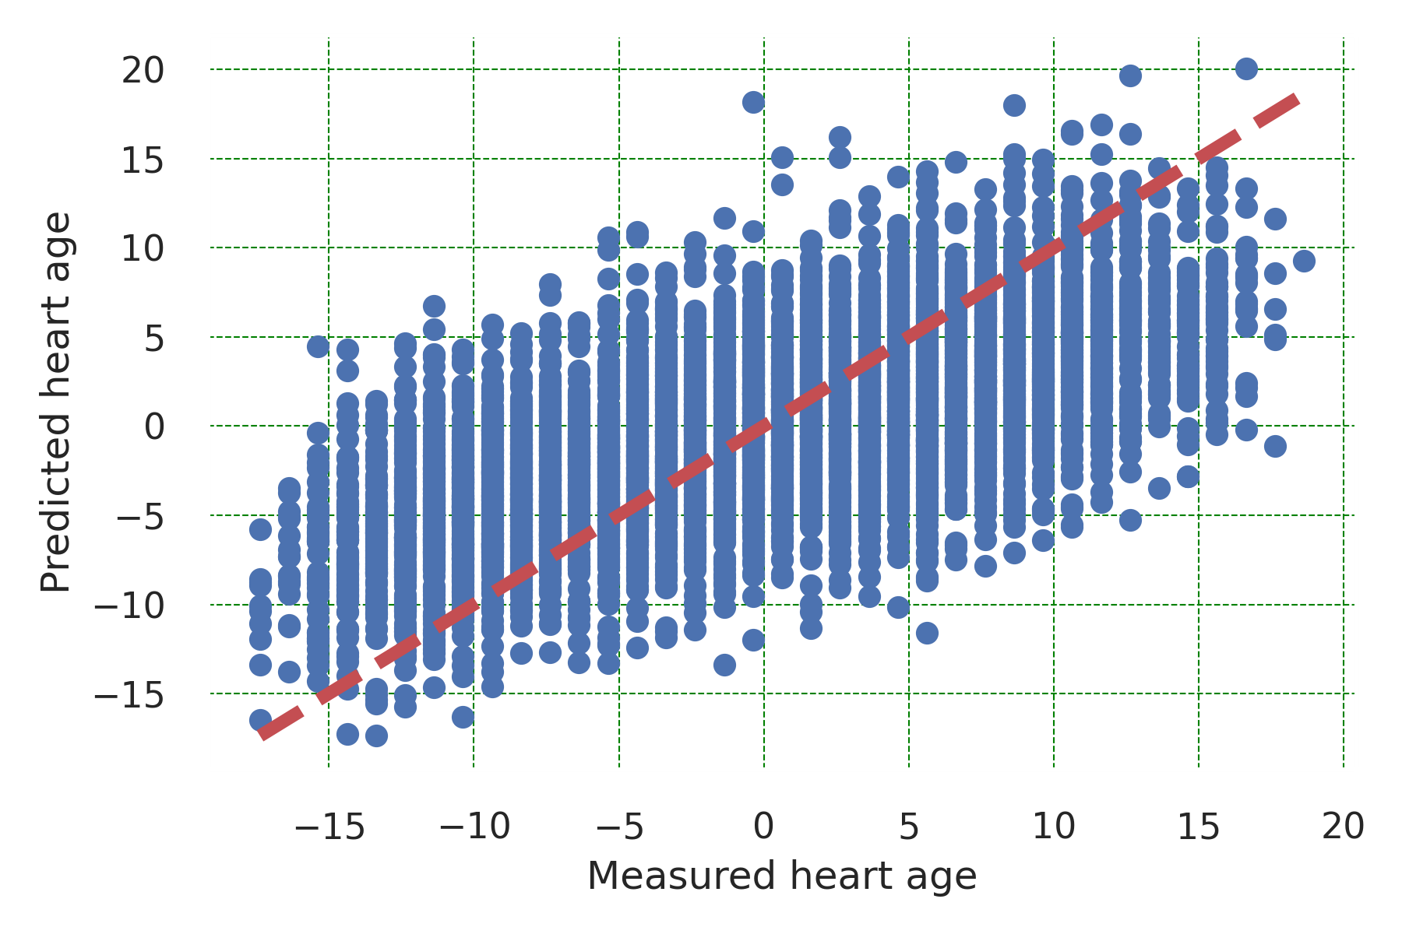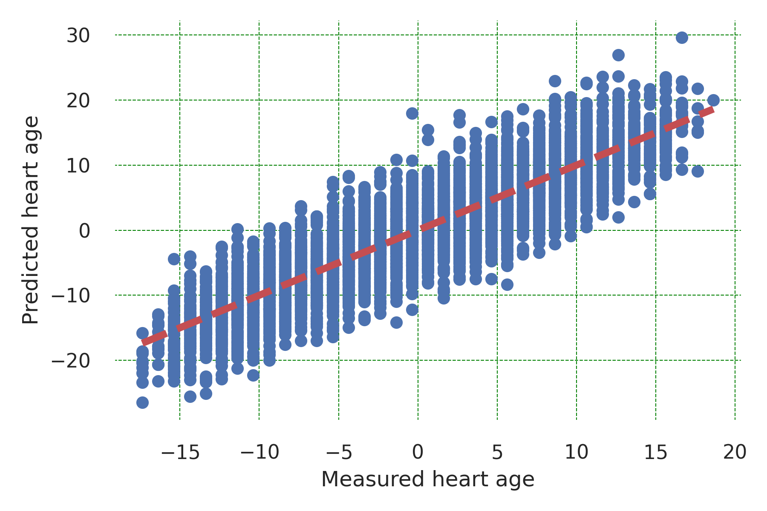
(a) Before (test) (b) After (test)
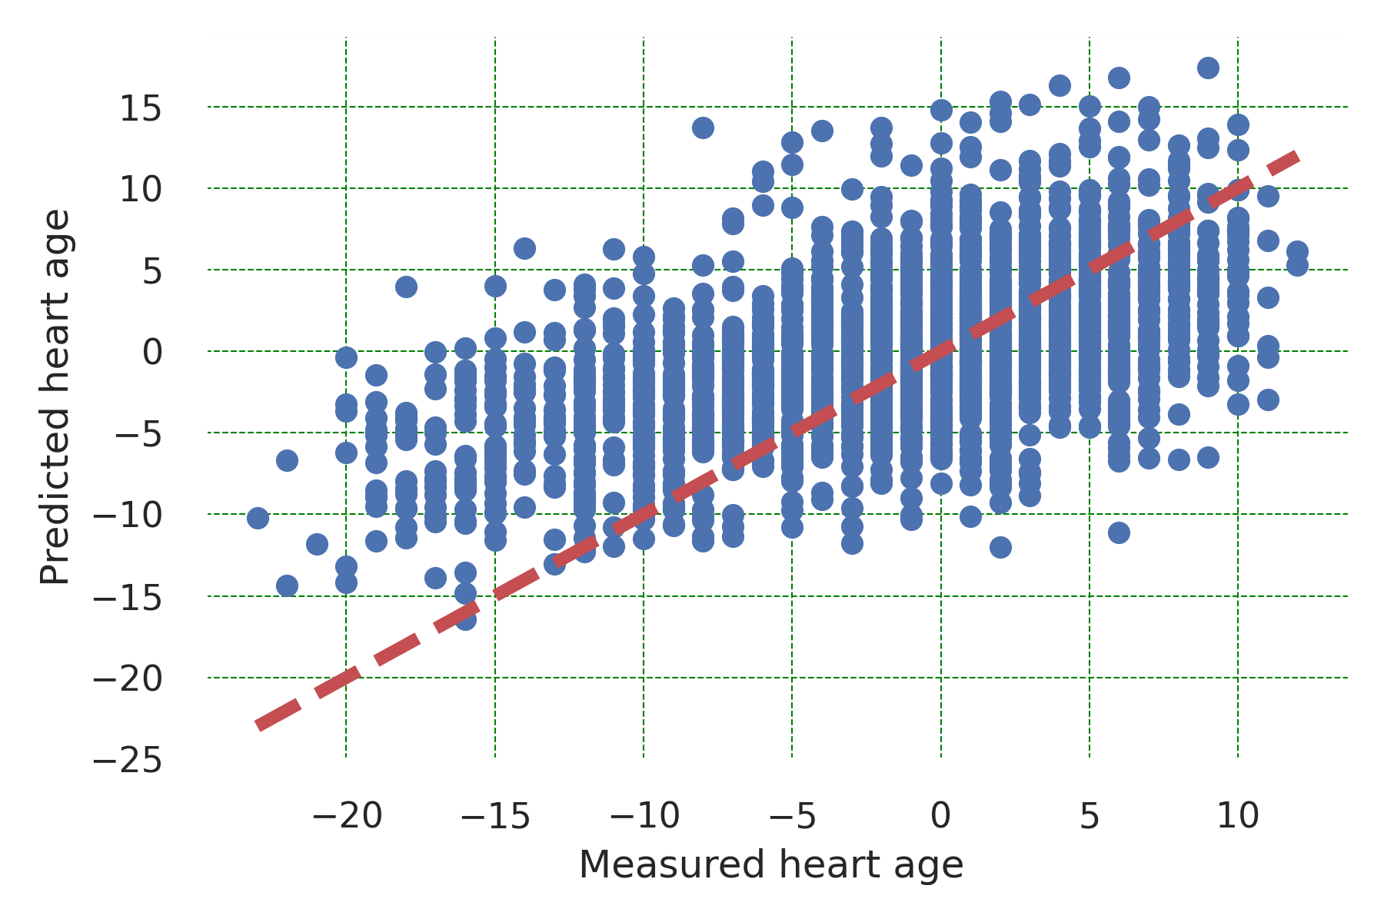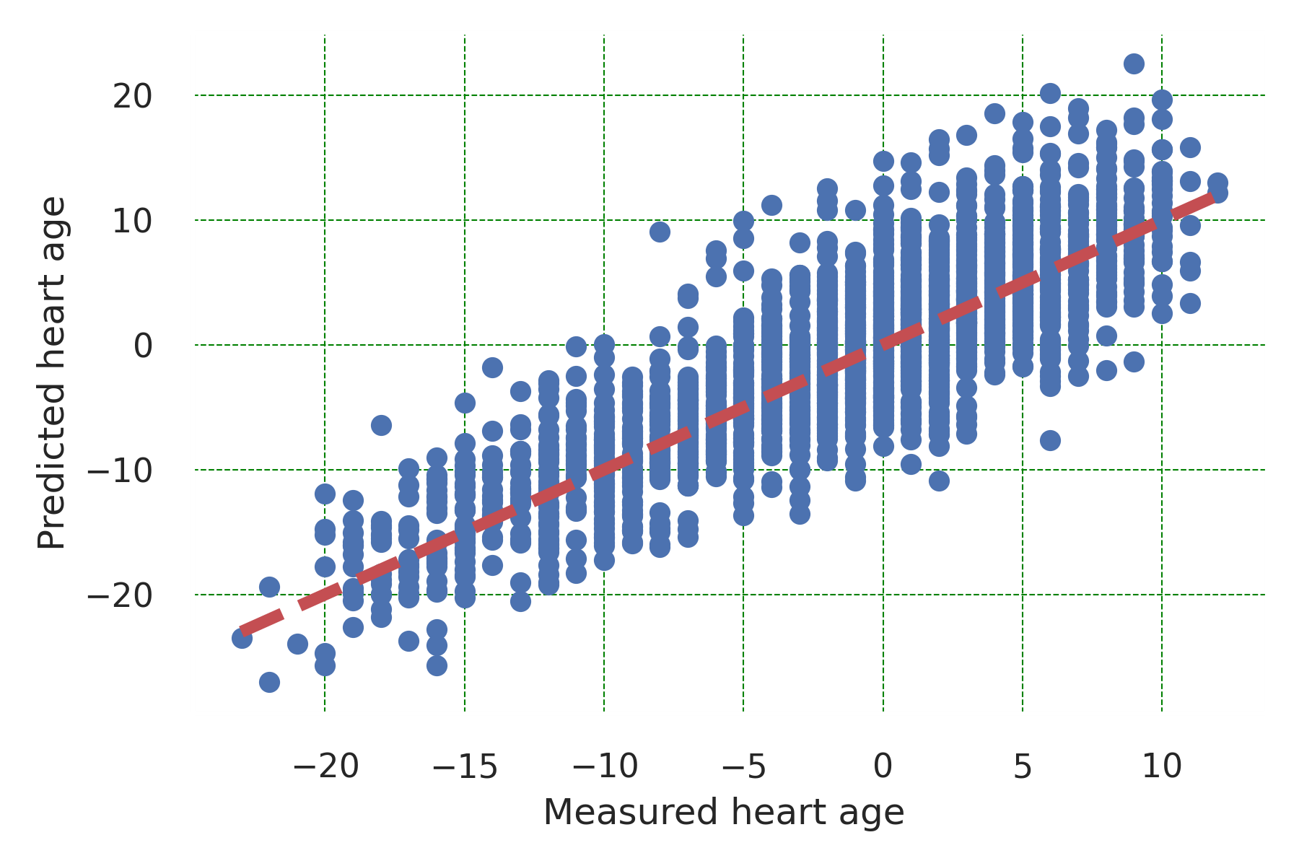
(c) Before (IHD) (d) After (IHD)
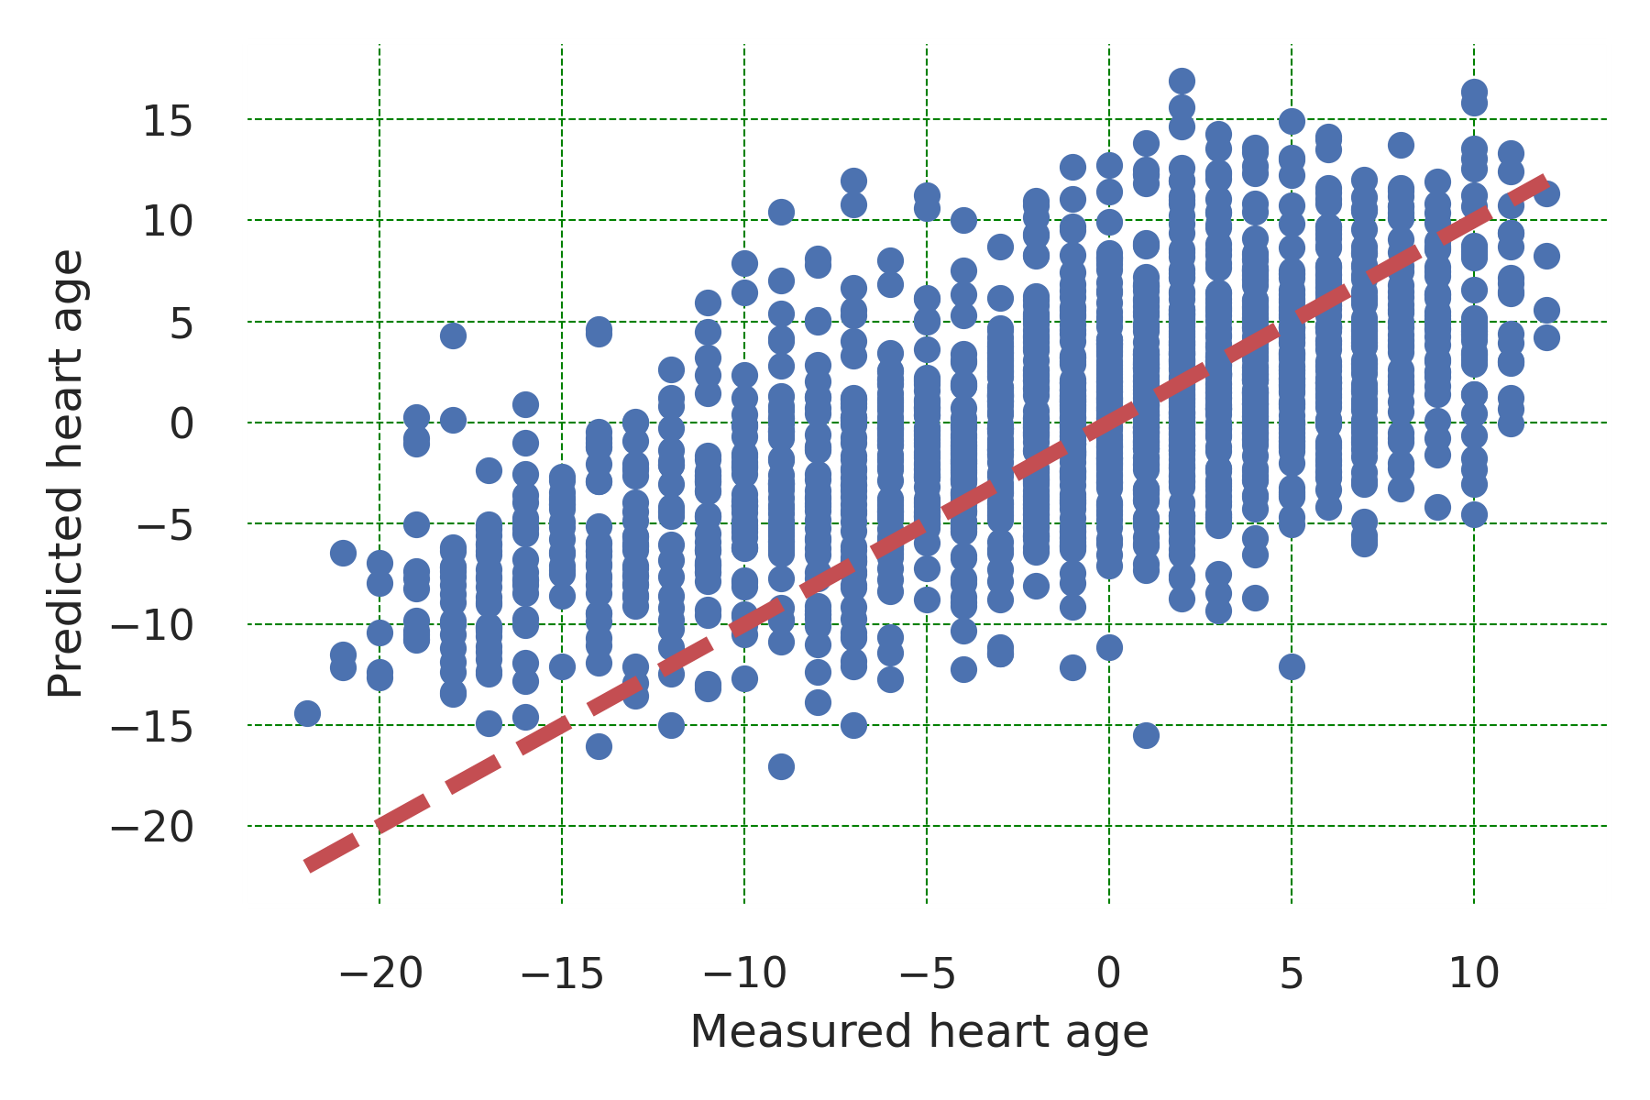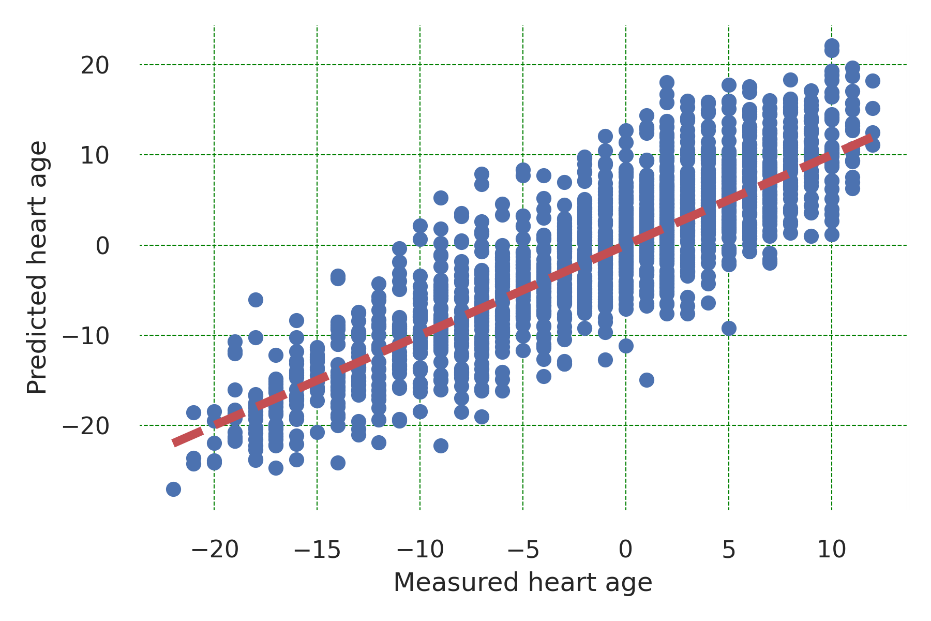
(e) Before (Cardiac arrhythmia) (f) After (Cardiac arrhythmia)
Supplemental Figure 1: Correlation between predicted and measured heart age before and after correction for each of the three cohorts. Before indicates before applying the bias correction method while after refers to after applying the correction. IHD: Ischemic heart disease.

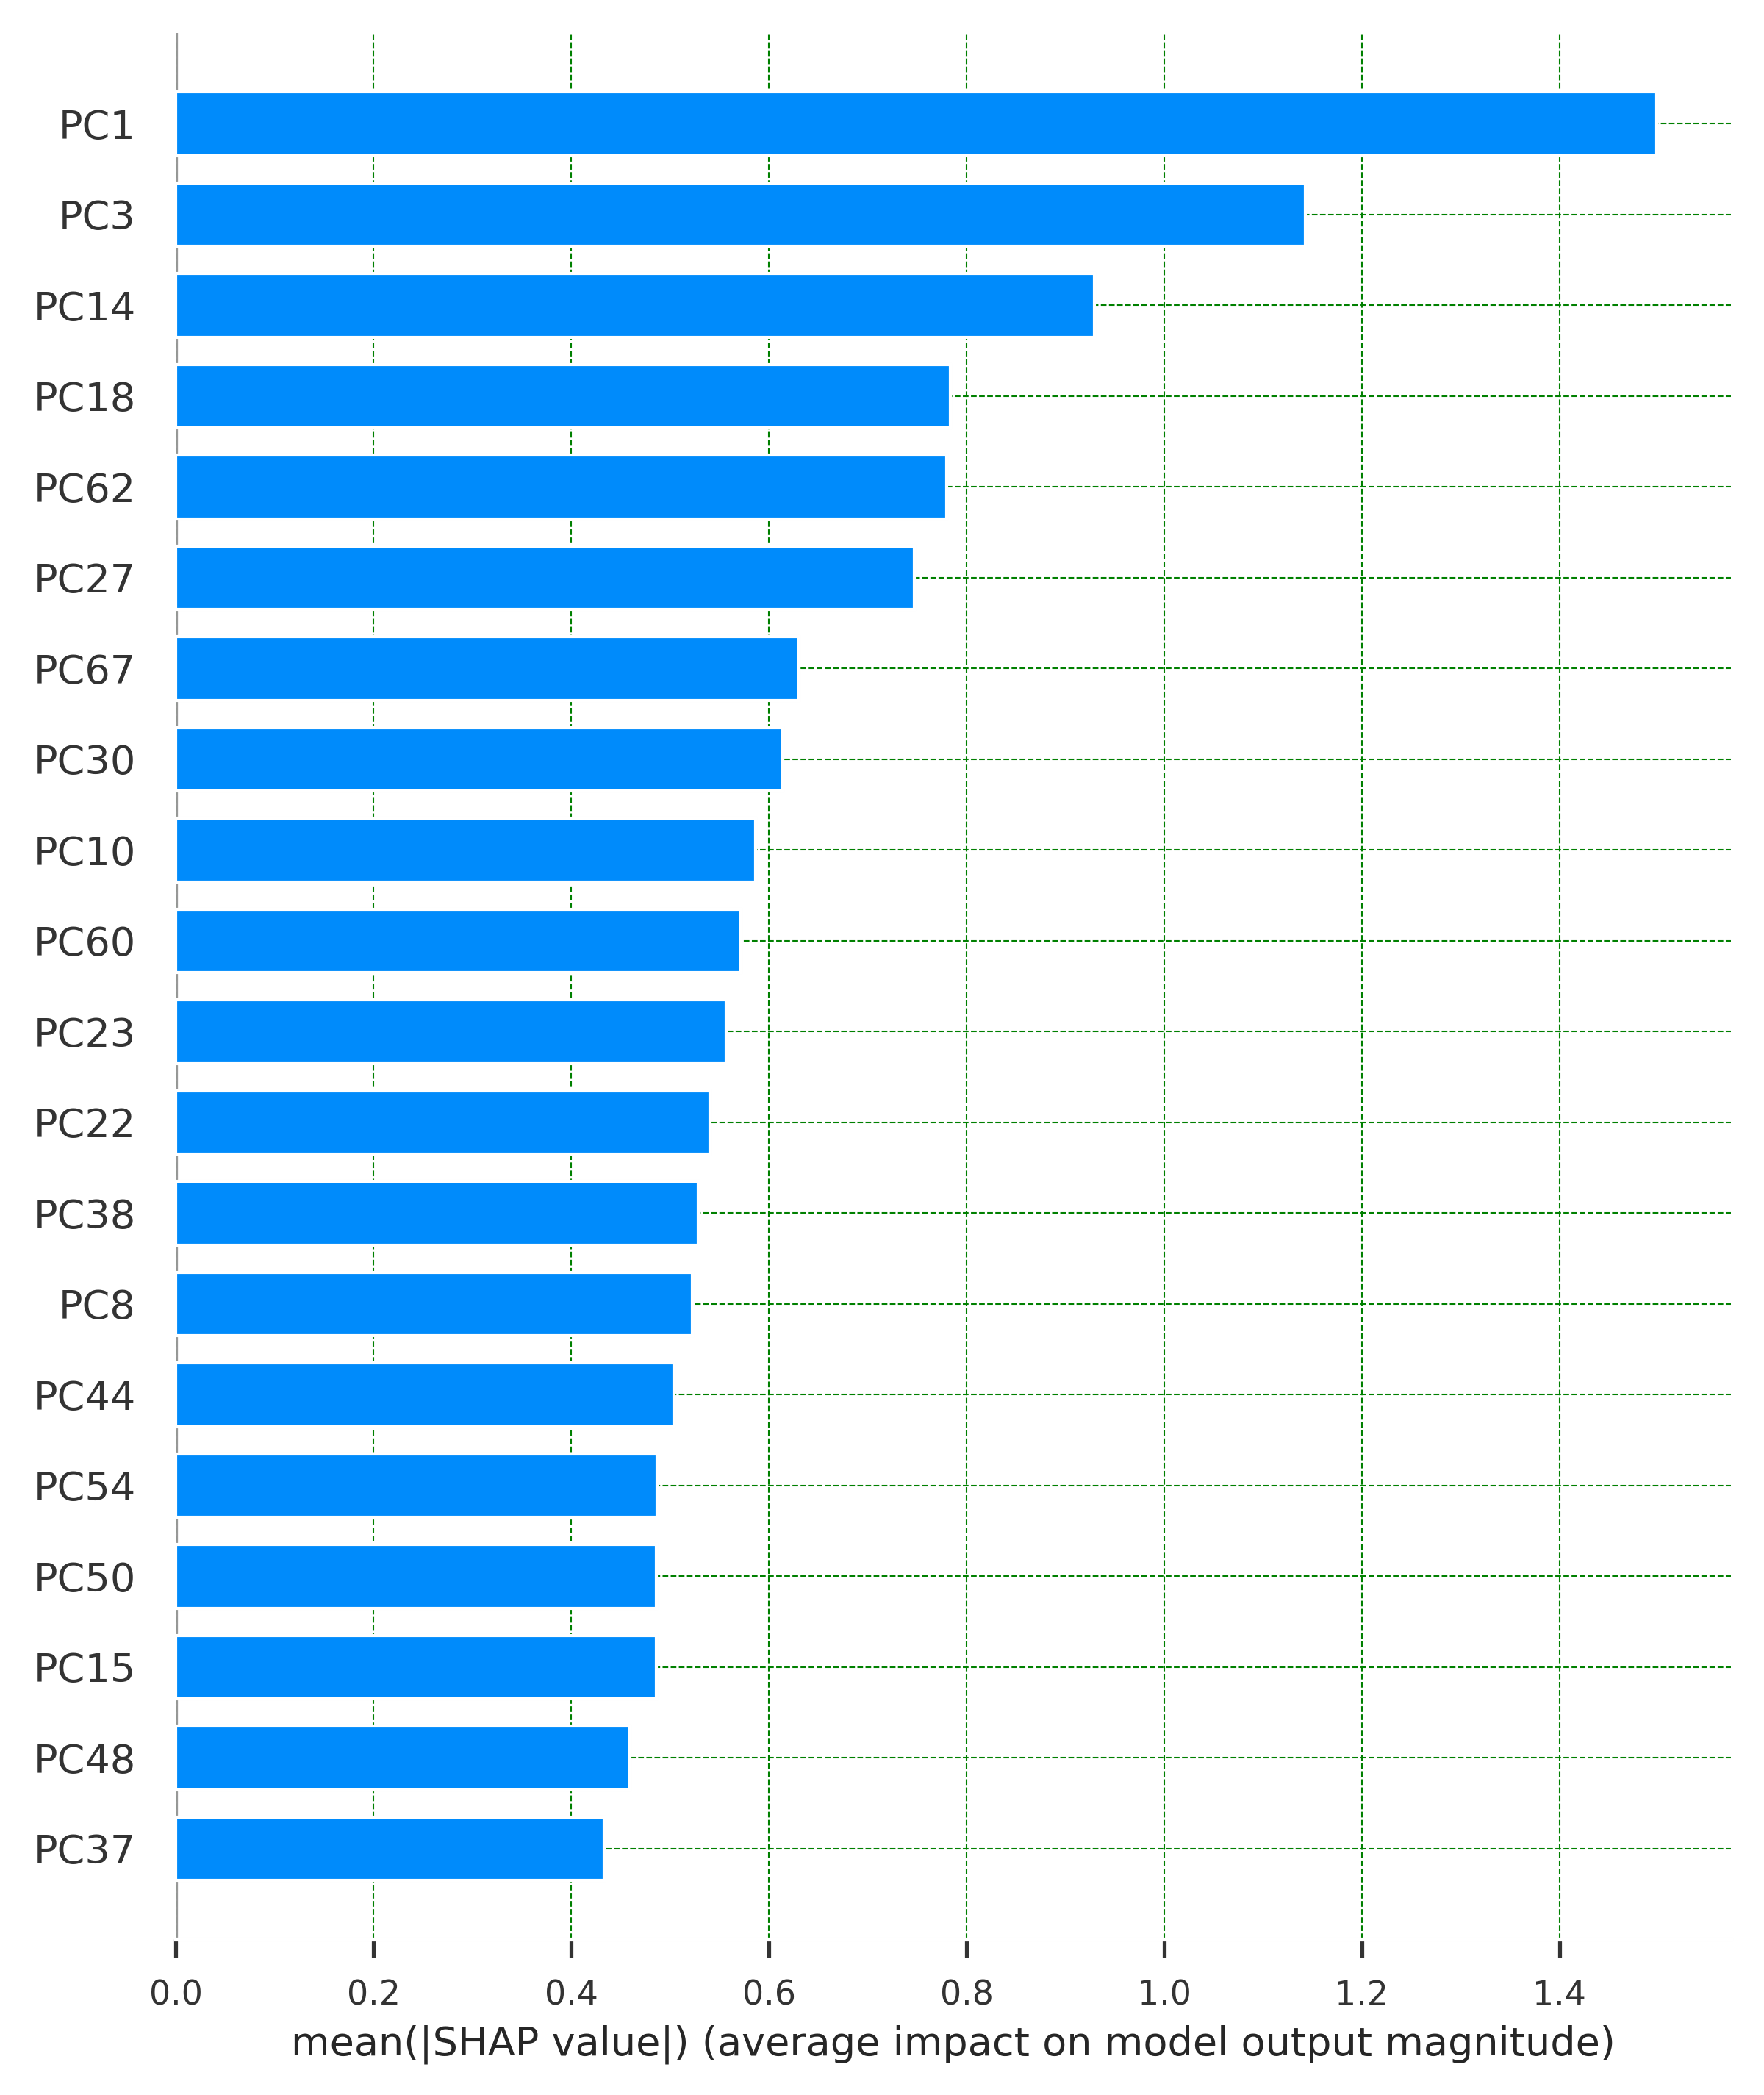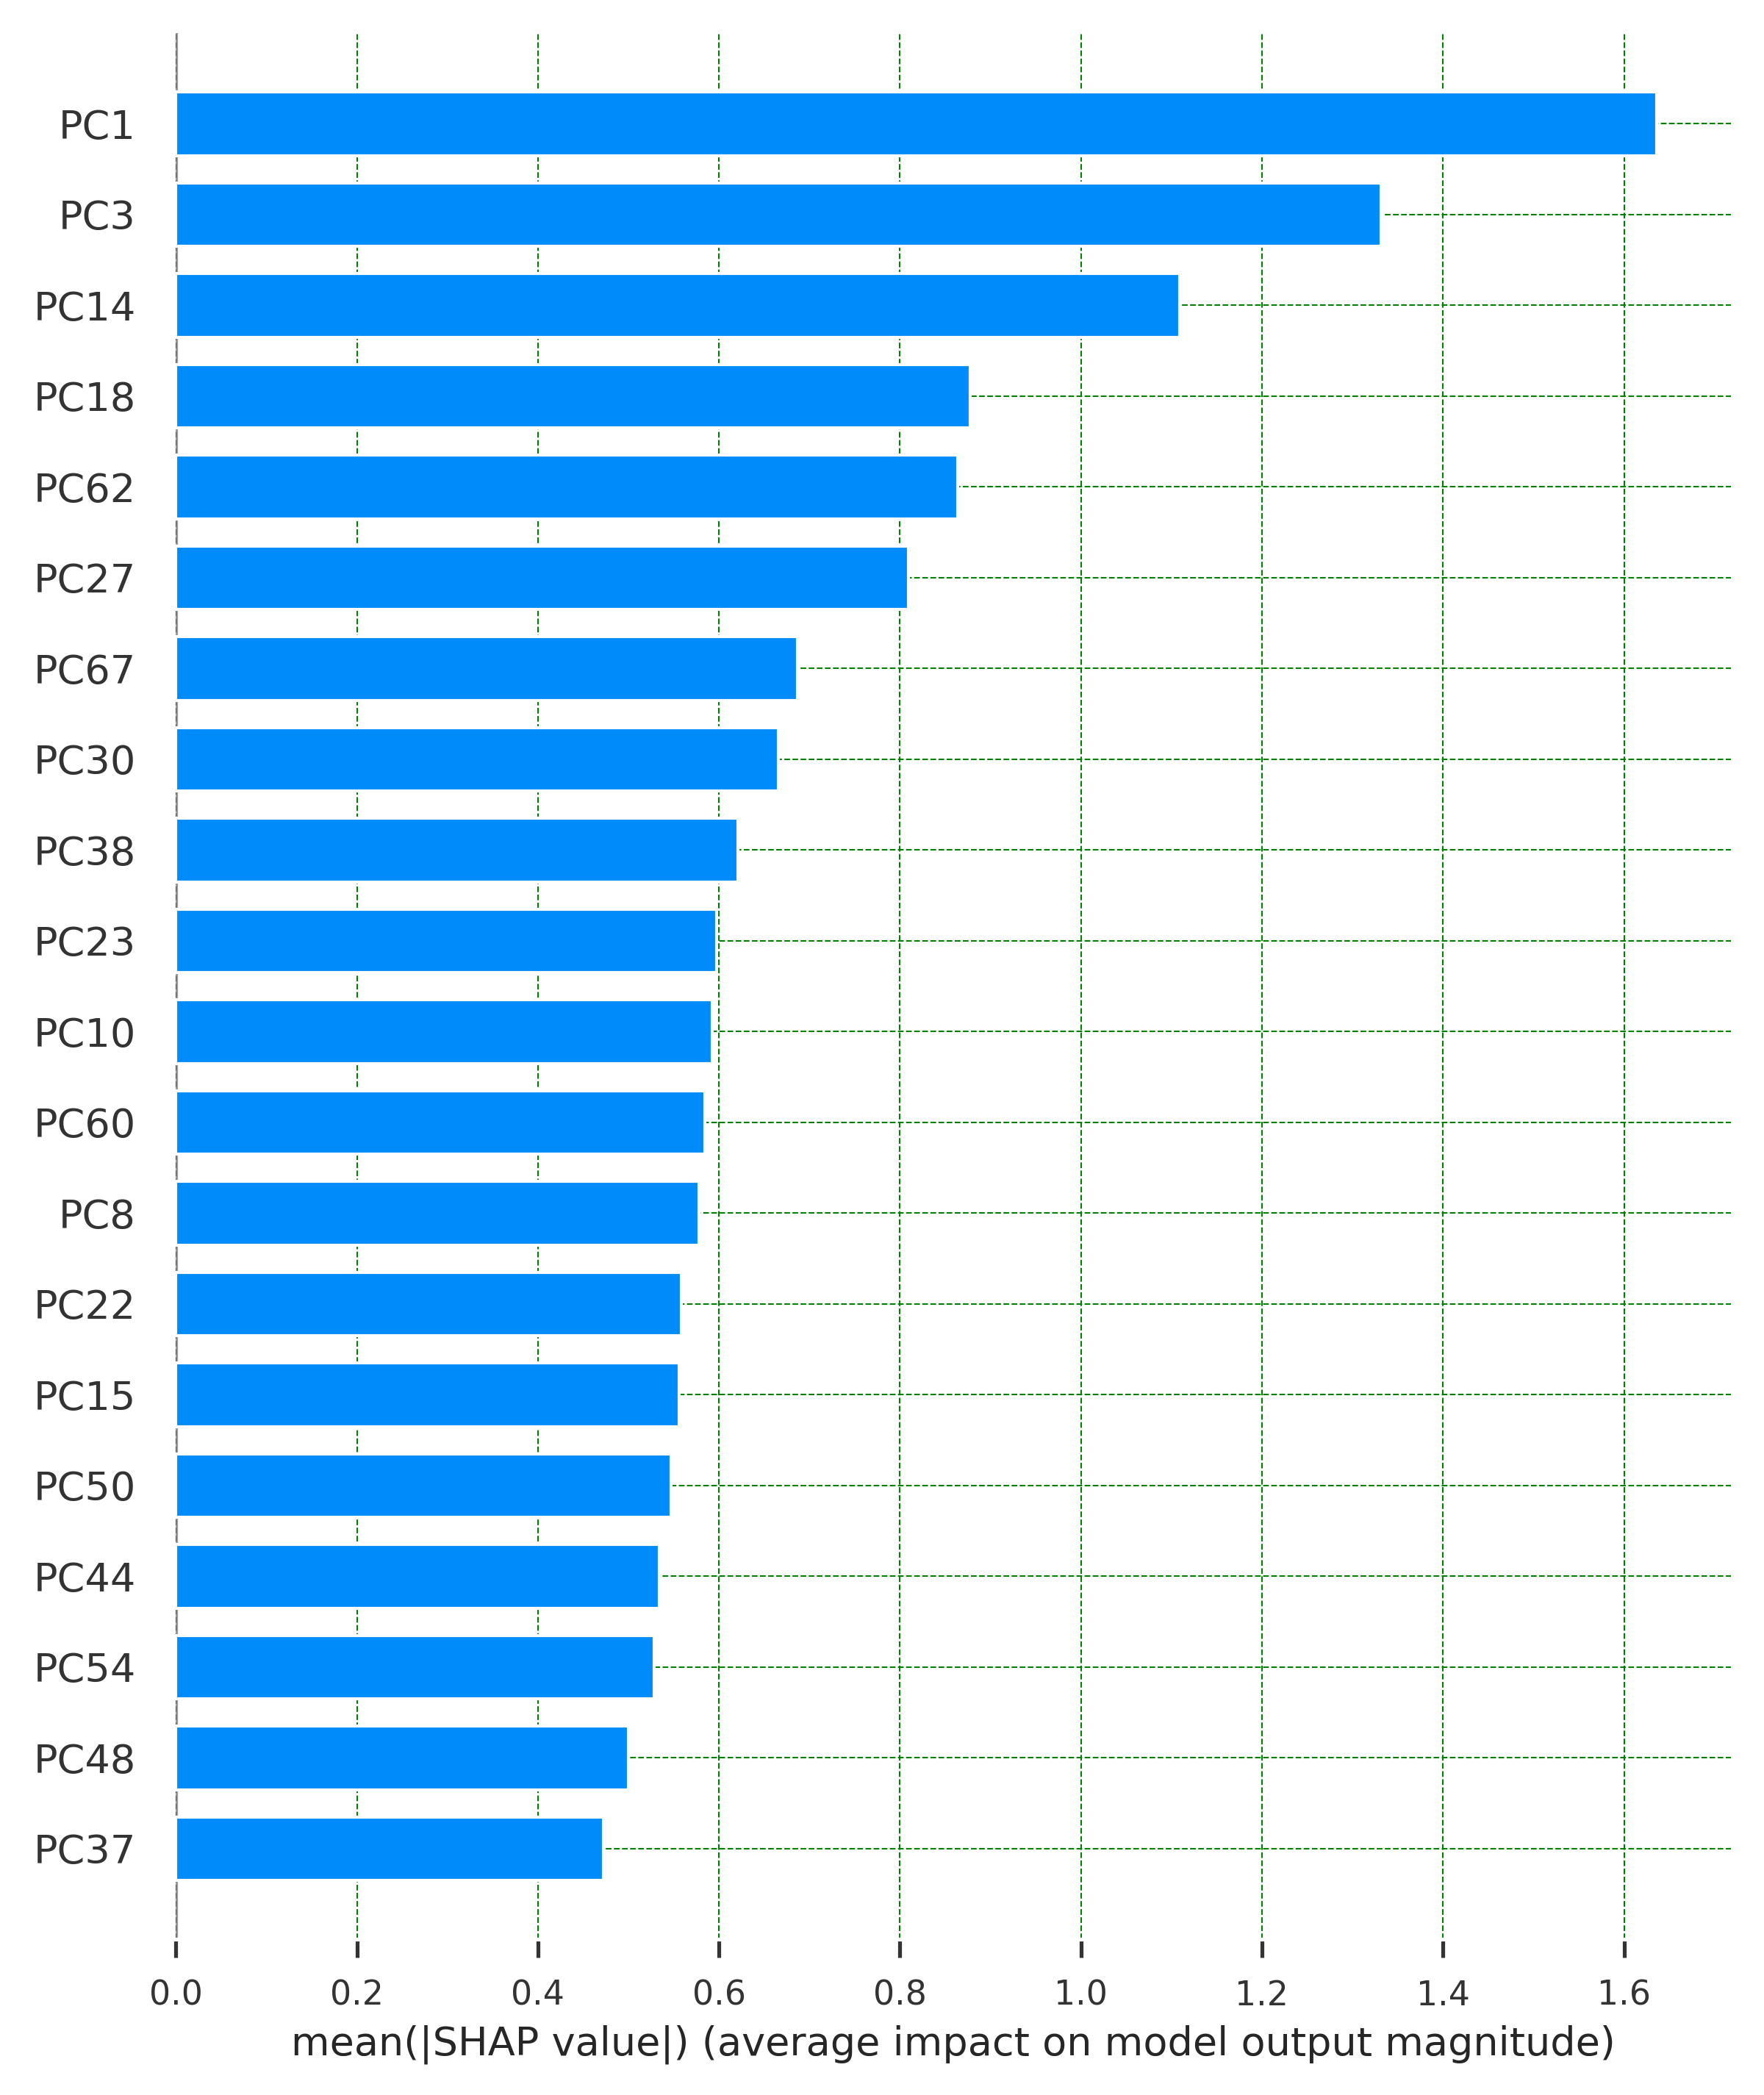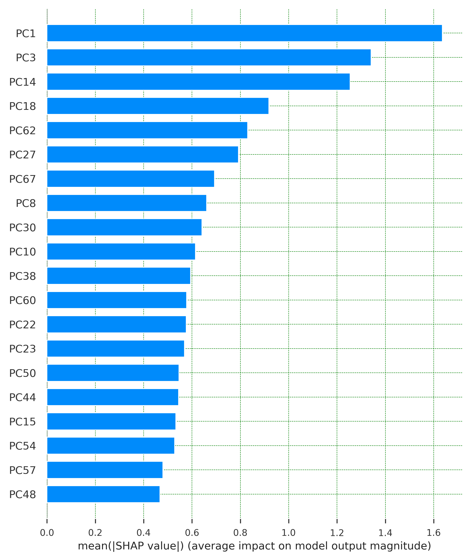
(g) Test (h) IHD (i) Cardiac arrhythmia
Supplemental Figure 2: Informative predictors (PCs) produced by SHAP for each cohort based on SHAP method. IHD: Ischemic heart disease.

