Fig S1: (a-b) Infected onion plants, (c-d) close view of purple blotch symptoms.
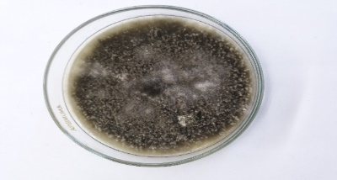
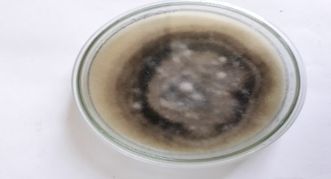
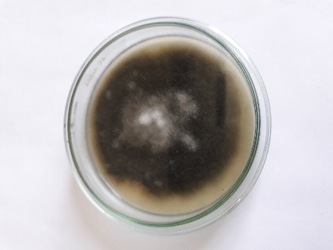
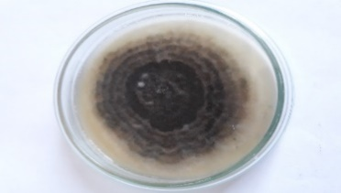
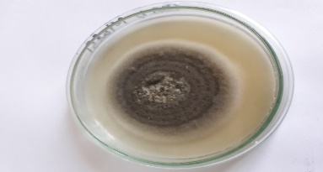
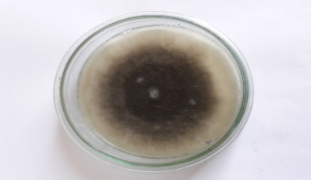
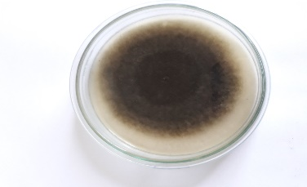
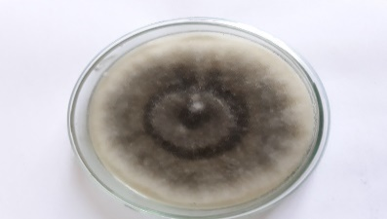
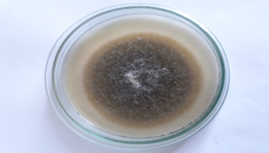
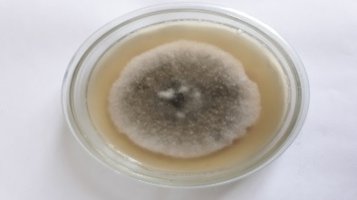
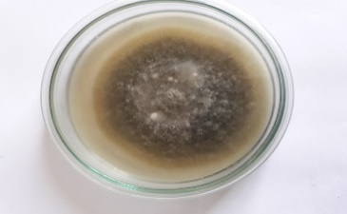
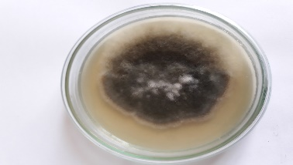
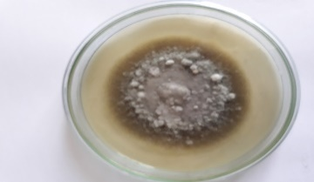
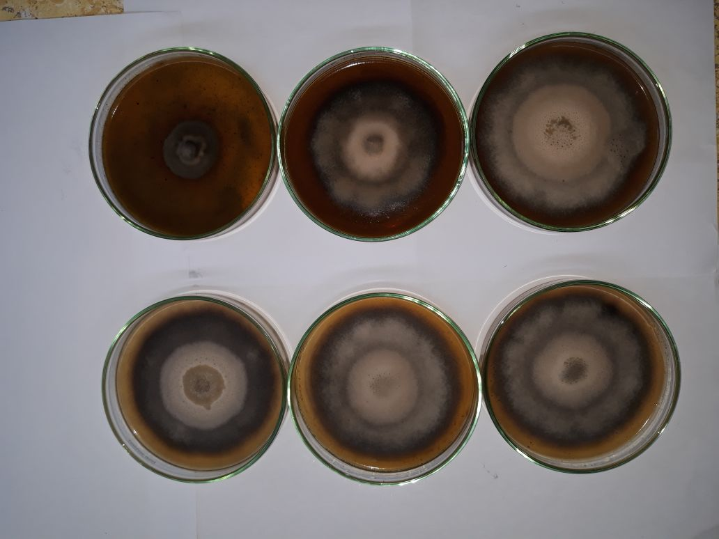
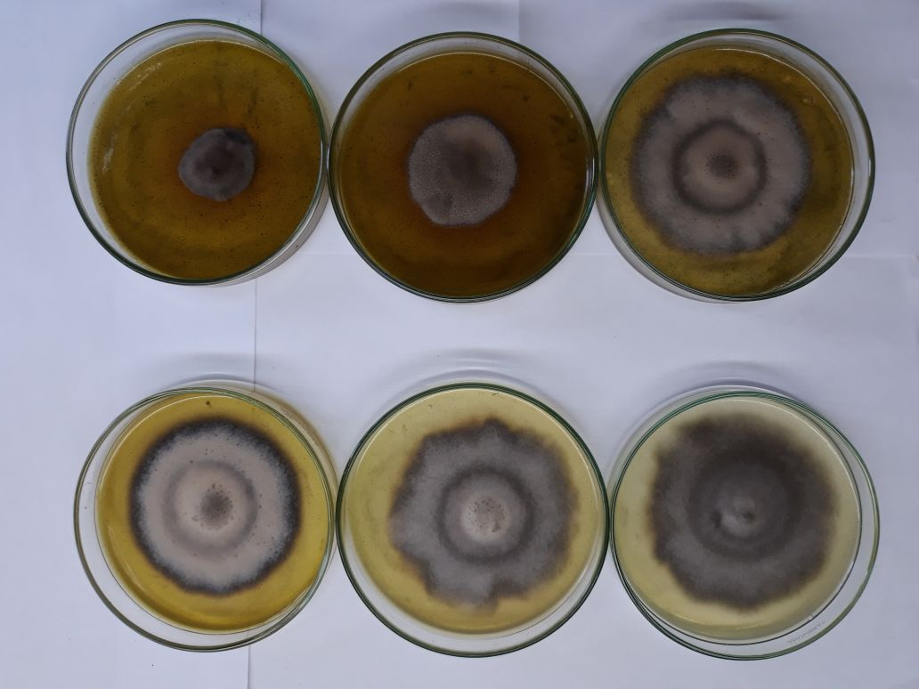
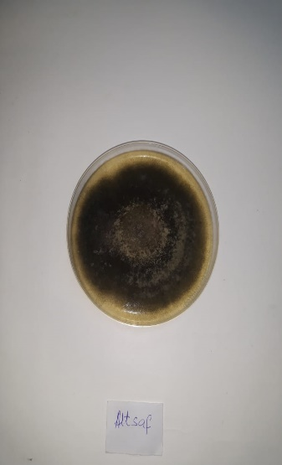
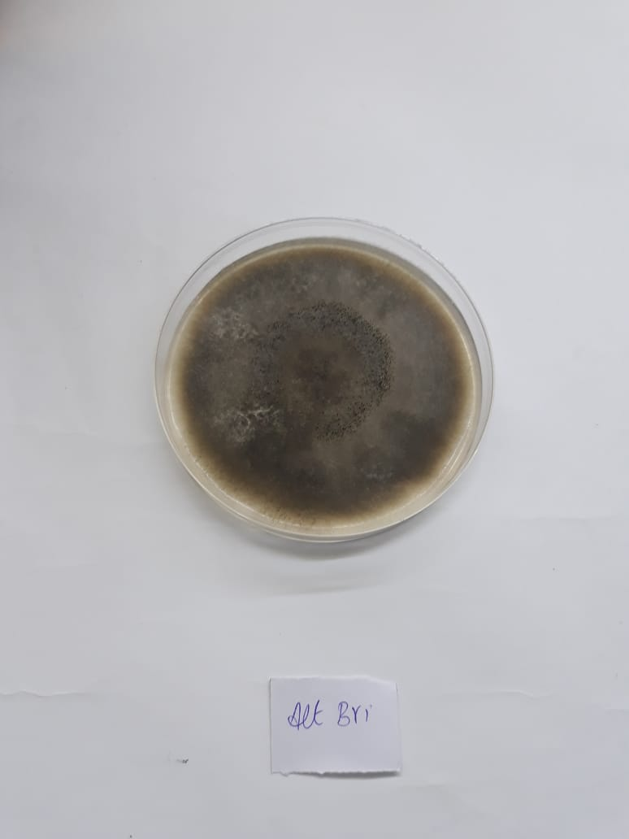
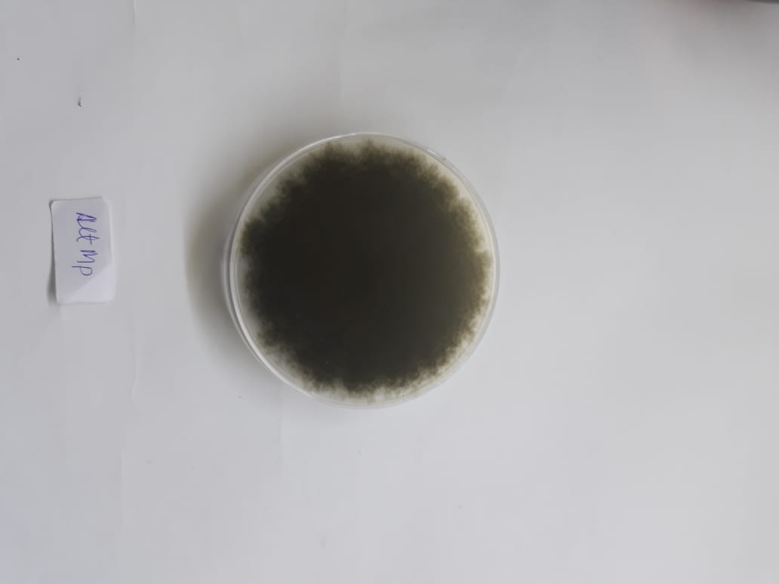
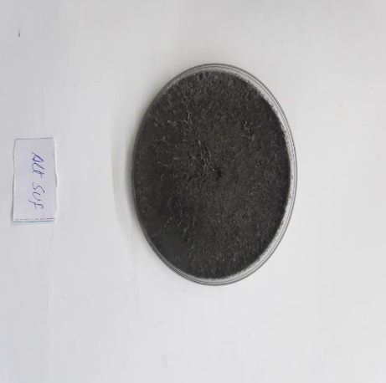
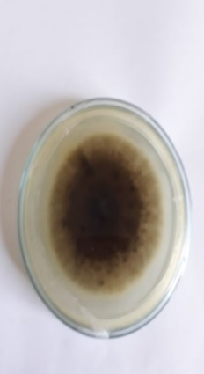
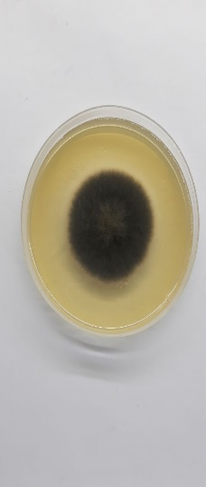
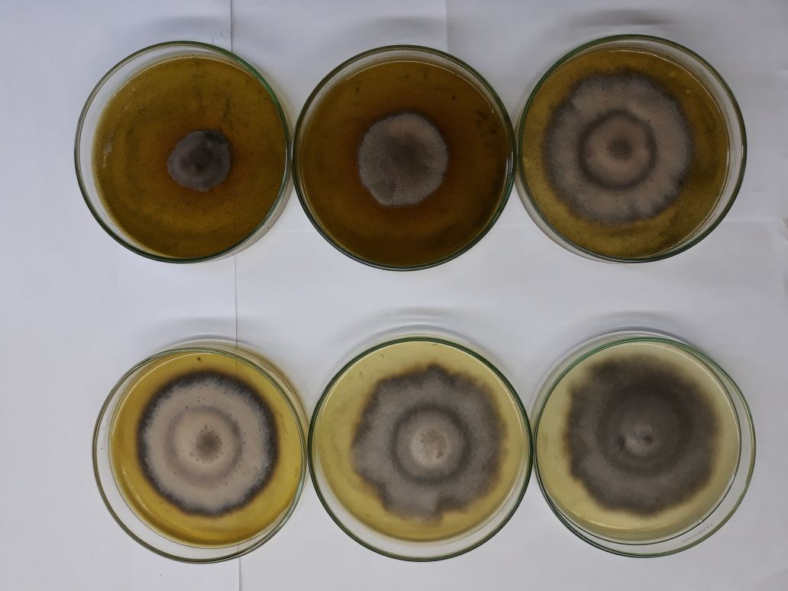
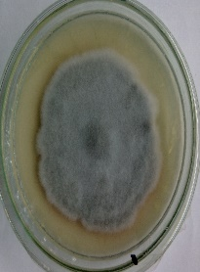
a
b
c
e
d
f
g
h
j
i
l
m
k
o
p
n
q
s
r
t
u
v
w
x

Fig S2: Isolates of different Alternaria spp. (a-l) Alternaria tenuissima, (m-r) A. alternata (s-x) A. arborescence.

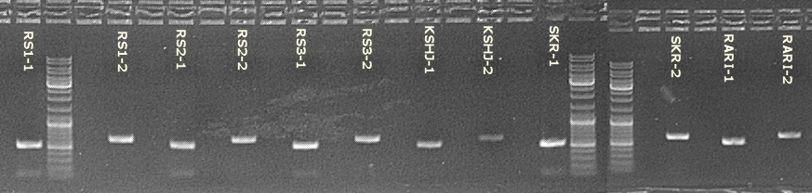
500bp
1000bp
5000bp
(a)
(b)

Fig S3: (a): PCR amplification products with ITS1 and ITS4 on 1% agarose gel electrophoresis with ladder. (b): PCR amplification products with gpd1/gpd2 and Alt F/Alt R on 1% agarose gel electrophoresis with 1kb ladder. RS1-1, RS2-1, RS3-1, SKR-1, KSHJ-1, RARI-1 indicates PCR amplification products with specific primers Alt F/Alt R while RS1-2, RS2-2, RS3-2, SKR-2, KSHJ-2, RARI-2 represents PCR amplification products with primer pairs gpd1/gpd2.
Fig S4: Phylogenetic trees with three primers set (a) ITS1 and ITS4 (b) gpd1/gpd2 (c)
Alt F/Alt R. The bootstrap support values have 1000 replicates.

Fig. S5: Pathogenecity test with different isolates, A: Uninoculated, B: MLP, C: RS1, D: KSHJ, E: MOG, F:HMW, G: RS3,H:BZU, I: SKR,:J: BH, K: RARI.

Fig S6: Pictorial representation of antifungal activity of sub-fractions of methanolic extract of D. stramonium.

Fig S7: Chromatogram of n-butanol fraction of methanolic leaf extract of D. stramonium.
Fig S8: Structures of biologically active compounds identified from butanol sub-fraction of methanolic leaf extract of Datura stramonium through GC-MS analysis.

