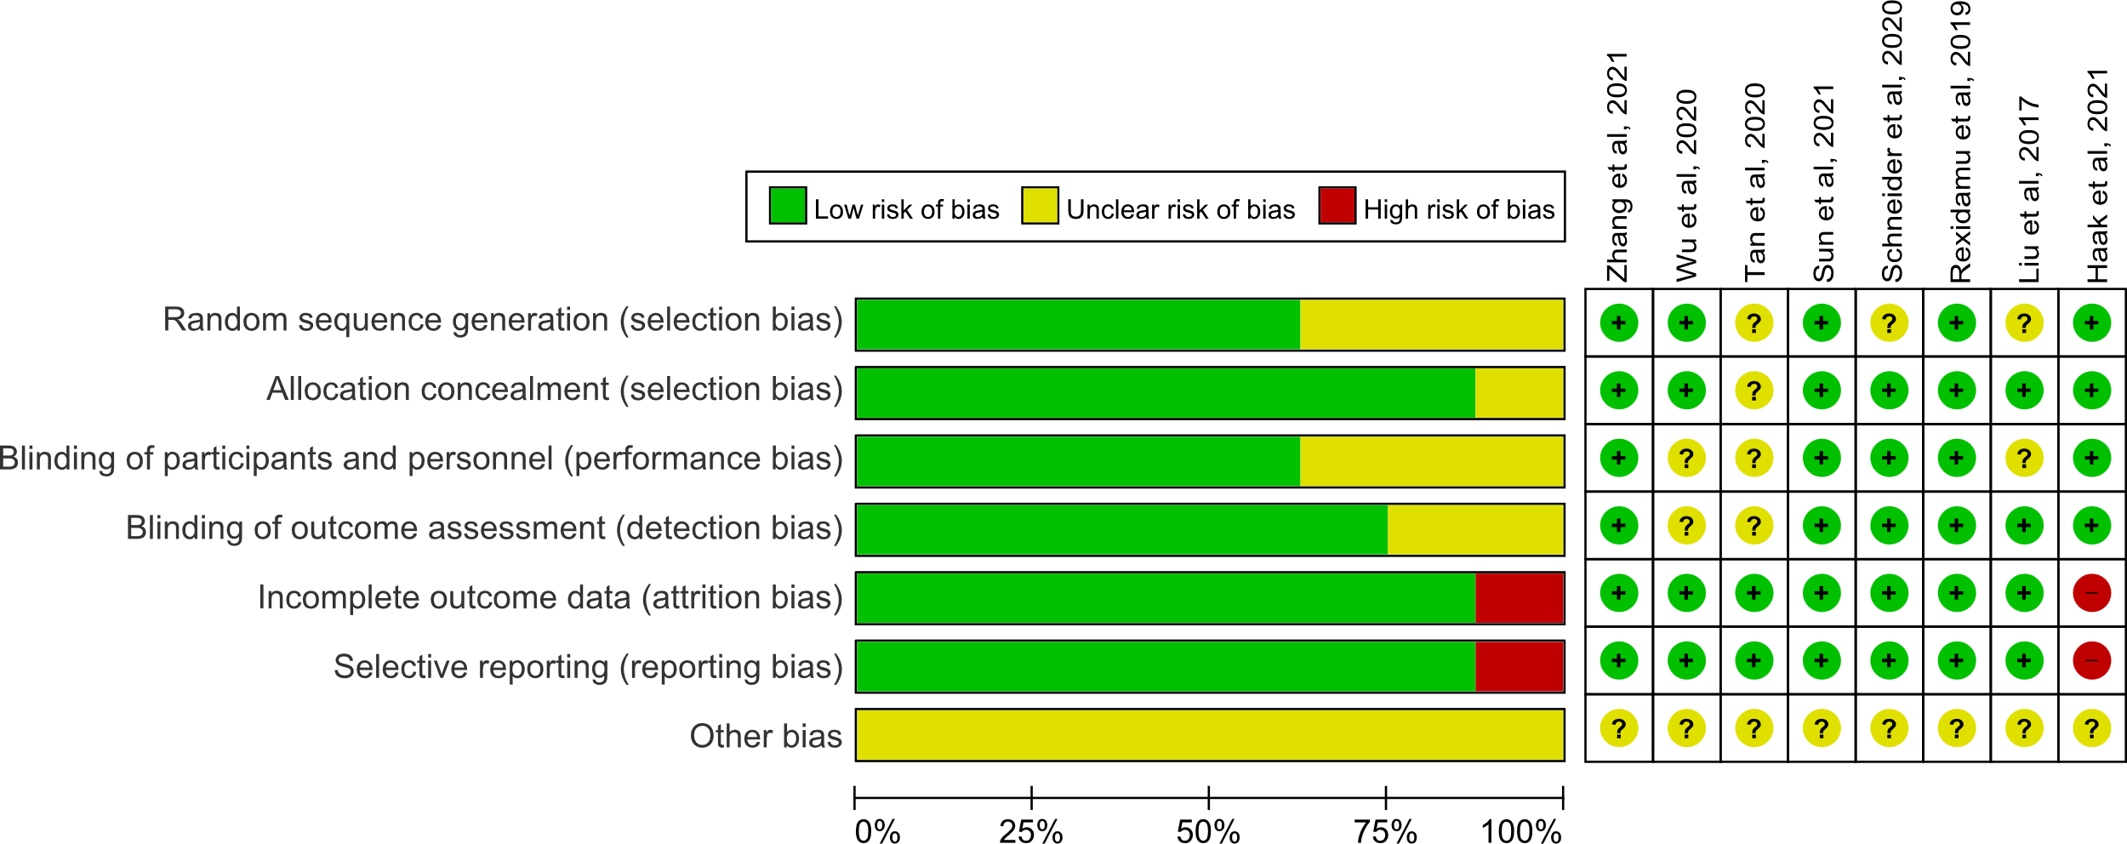
Figure S1. Quality assessment of the included studies for meta-analysis. The evidence levels of identified studies were assessed according to the criteria by the Centre for Evidence-Based Medicine in Oxford, UK [20].

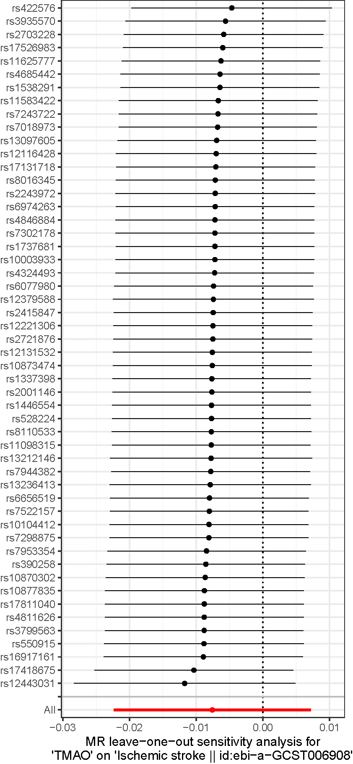
Figure S2. Leave-one-out analysis indicated that no single SNP was driving the association of MR analysis.
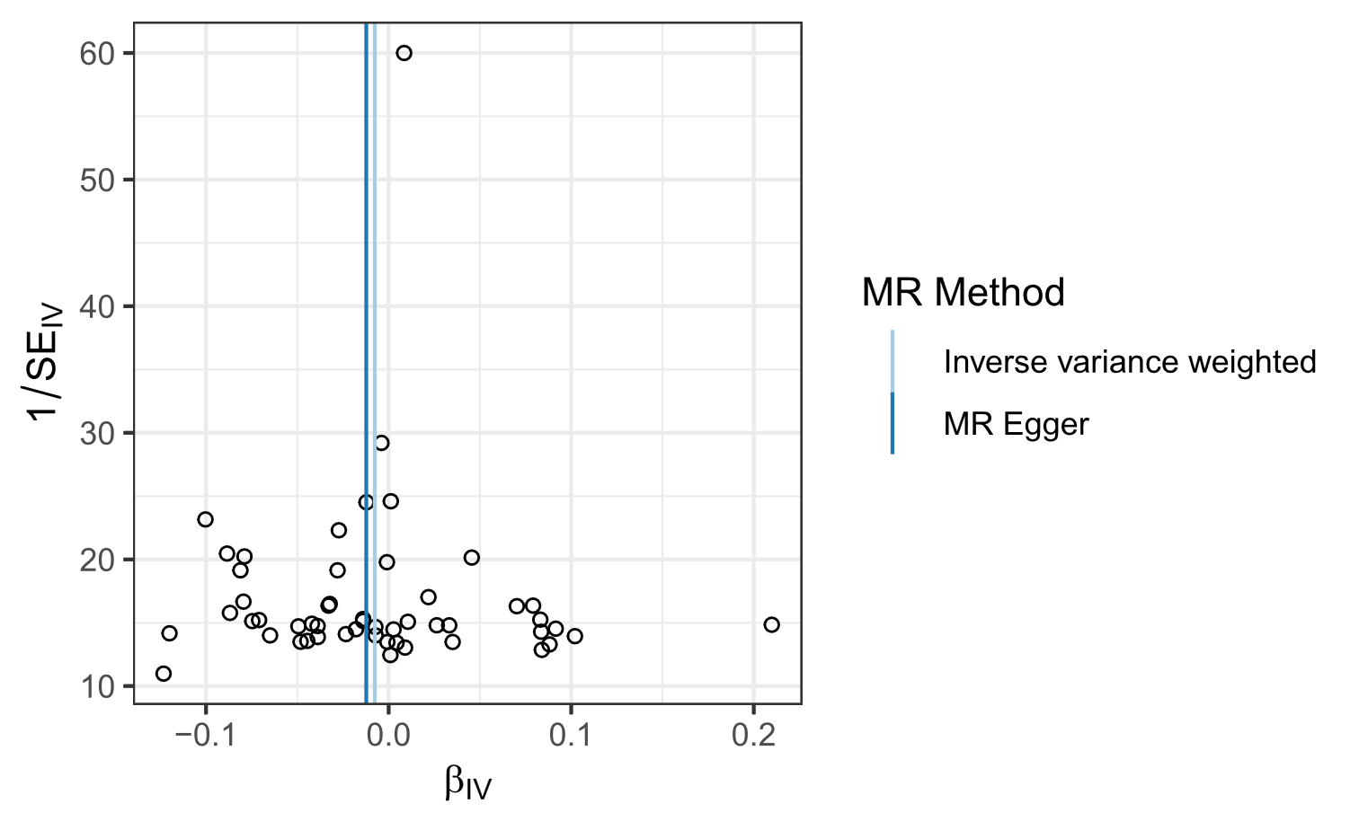
Figure S3. The funnel plot for visually inspection for horizontal pleiotropy of MR analysis.

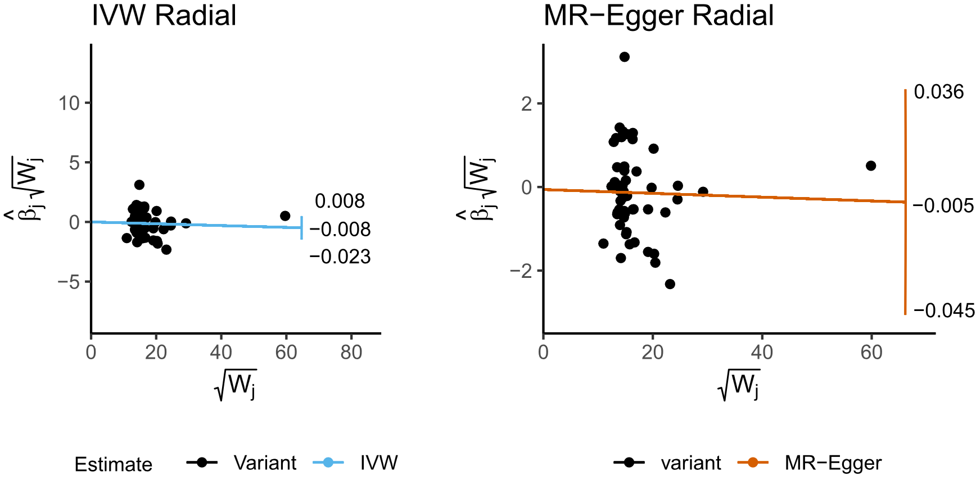
Figure S4. The Radial plots for classification of outliers in the SNPs.

