Supplementary Information
Paradigm shift for platinum oxidation below fuel cell open-circuit voltage
Carlos A. Campos-Roldán ¹, Amir Gasmi ¹, Morgane Stodel ², Isaac Martens ³, Jean-Sébastien Filhol ¹, Jakub Drnec ³, Pierre-Yves Blanchard ¹, Sara Cavaliere ¹, Deborah Jones ¹ and Raphaël Chattot ^{1, *}

¹ ICGM, Univ. Montpellier, CNRS, ENSCM, 34095 Montpellier Cedex 5, France
² CIRIMAT, Université Toulouse 3 Paul Sabatier, Toulouse INP, CNRS, Université de Toulouse, 118 Route de Narbonne, 31062 Toulouse cedex 9 - France
³ ESRF, The European Synchrotron Radiation Facility, 71 Avenue des Martyrs, CS40220, 38043 Grenoble Cedex 9, France

*e-mail: (RC) raphael.chattot@umontpellier.fr

METHODS
Materials. Commercial membrane electrode assemblies (MEAs) were purchased from Fuel Cell Store and used in PEMFC without further treatment. The 5-layer, 4.84 cm², MEAs were composed of a 60 wt.% carbon-supported Pt/C catalyst loaded at 0.5 mg_{Pt} cm⁻² for both anode and cathode, a 50.8 µm thick Nafion® NRE-212 membrane, and woven carbon cloth with microporous layer as gas diffusion layers. A 40 wt.% carbon-supported Pt/C was purchased from Johnson Matthey (JM) and used in thin-film electrochemical flow cell without any further treatment.
X-ray transparent fuel cell operation. The MEA was mounted in a house-made X-ray transparent fuel cell largely described in previous contributions ^{1–4} and pictured in Picture S1.a. The cell was operated at 80 °C with H₂/O₂ or H₂/N₂ at anode/cathode, 65 °C dewpoint (52 % relative humidity) and 100 mbar backpressure. After a break-in procedure consisting in a 1 h voltage hold at 0.60 V in H₂/O_{2,} the cathode was purged with N₂ to both fix and minimize ohmic voltage losses. The cell voltage was controlled by a SP-240 potentiostat (Biologic) equipped with a 4 A booster. Prior to any cyclic voltammetry experiment, the high frequency resistance (200 kHz) was measured by means of potentio electrochemical impedance spectroscopy (PEIS), and the potential of the working electrode was dynamically compensated for 85 % of the ohmic losses.
Conventional fuel cell operation. The MEA was mounted in a commercial single-cell PEMFC casing (Scribner) and operated at 80 °C with H₂/Air or H₂/O₂ at anode/cathode, 80 °C dewpoint (100 % relative humidity) and 500 mbar backpressure with a house-made test bench. The cell voltage was controlled by a SP-150 potentiostat (Biologic) equipped with a 20 A booster. The break-in procedure was conducted in H₂/Air (313/496 sccm) and consisted of potential cycles between the open circuit voltage (OCV, 10 s), a 100 mV s⁻¹ potential sweep from the OCV to 0.10 V, followed by 1 min hold at 0.10 V. The cycles were repeated for a total duration of 1 h. The oxidant gas was then turned to O₂ and polarization curve was recorded using the staircase potentio electrochemical impedance spectroscopy with a total of 14 potential steps (3 min hold) between the OCV and 0.10 V. The high frequency resistances measured at the end of all steps was used to later correct the potential values from the ohmic losses. Cyclic voltammogram of the cathode catalyst and cell performance are displayed in Figure S3.
X-ray transparent thin-film electrochemical flow cell operation. 10 µL of an ink suspension composed of 5 mg of 40 wt.% Pt/C catalyst (JM), 3600 µL of 18.2 MΩ ultra-pure water (Millipore), 1446 µL of isopropanol and 20 µL of 5 wt.% Nafion solution (Electrochem. Inc.) were deposited on a 0.196 cm² glassy carbon substrate thus reaching a Pt loading of 20 ${μg}_{Pt} {cm}^{-2}$. The sample was mounted in a 3-electrode flow cell described in previous contributions ^{5,6} and pictured in Picture S1.b. A Pt wire was used as counter electrode and a commercial Ag/AgCl electrode (ET072, eDAQ) as reference electrode. The cell was fed with 0.10 M HClO₄, (Suprapur®, Merck) at a rate of 20 mL min⁻¹ using a peristaltic pump. The electrochemistry was controlled by a SP-300 potentiostat (Biologic). The catalyst was first conditioned using 50 cycles between 0.05 and 1.23 V vs. RHE at 500 mV s⁻¹. The temperature of the room was regulated at 25 ºC.
Stroboscopic operando synchrotron wide-angle X-ray scattering (WAXS) measurements. Synchrotron WAXS measurements were performed at ID31 beamline of the European Synchrotron Radiation facility (ESRF) in Grenoble, France. The high energy X-ray beam (77 keV) was focused on the sample through the cells in grazing incidence configuration, and the scattered signal was collected using a Dectris Pilatus CdTe 2M detector. The energy, detector distance and tilts were calibrated using a standard CeO₂ powder and the 2D diffraction patterns were reduced to the presented 1D curves using the pyFAI software package ⁷. For a fair comparison between cyclic voltammetry experiments recorded at different potential sweep rates, the chosen temporal resolution for the reconstructed WAXS patterns was kept constant at ca. 1/60th of the cycle period T. The WAXS measurements were performed on stable cyclic voltammograms.
Rietveld refinement of the WAXS patterns. Rietveld refinement of the WAXS patterns was performed to extract the phase structure, crystallite size and lattice parameter using the Fm3m structure of Pt and the Fullprof software. The instrumental resolution function was determined by the refinement of a CeO₂ standard sample. Thomson-Cox-Hastings profile function was adopted ⁸. The background of patterns was described by an interpolated set of points with refinable intensities.
First-order rate constant determination. The lattice constant and scattered intensity variations during potential steps were fitted using a linear combination of exponential functions of the type:
$$y=y_{0}+A_{1}e^{-(x-x_{0})/t_{1}}+A_{2}e^{-(x-x_{0})/t_{2}}$$
where $y_{0}$ and $x_{0}$ are the fitted boundary conditions, $A_{1}$ and$A_{2}$ the fitted amplitude variations, and $t_{1}$ and $t_{2}$ are the fitted first-order time constants. The two exponential functions were found necessary to capture the oxidation process while only one was sufficient to capture the reduction. More details and numerical values of the fitted parameters can be found in Figure S6 and Table S1.
Electrochemical on-line inductively coupled plasma mass spectrometry. A commercial electrochemical flow cell (BASi, MF-1092, cross-flow cell) was used. The flow cell consists in two glassy carbon disk (3 mm) aligned in series, which are embedded into PEEK material. The first disk was used as counter electrode, and the working electrode is in the direction of the electrolyte flow. 3.4 µL of an ink suspension composed of 5.4 mg of 40 wt.% Pt/C catalyst (JM), 1800 µL of 18.2 MΩ ultra-pure water (Millipore), 723 µL of isopropanol and 29 µL of 5 wt.% Nafion solution (Electrochem. Inc.) were deposited on the 0.071 cm² glassy carbon substrate thus reaching a Pt loading of 20 ${μg}_{Pt} {cm}^{-2}$. An Ag/AgCl reference electrode was used. The cell was fed with aqueous electrolyte at a rate of 400 µL min⁻¹ using a peristaltic pump. The electrochemistry was controlled by a SP-300 potentiostat (Biologic). The electrolyte was either 0.10 M HClO₄, (99.999 % trace metal basis, Merck) at room temperature (26 ºC), 1.0 M HClO₄ at room temperature (28 ºC) or 1.0 M HClO₄ at 60 ºC (temperature at the cell outlet). In this last case, the electrolyte was heated prior entering the electrochemical cell (see Picture S2). The potential shift of the Ag/AgCl reference electrode with temperature was calibrated in situ by measuring the open circuit voltage of the Pt/C working electrode after hydrogen evolution in the cell. The flow cell was connected to an Agilent 7900 ICP-MS equipped with a Micromist/Scott nebulizer. The ¹⁹⁵Pt metal ions were detected with 0.1 s integration time per point. Before each measurement, calibration curves were carried out using daily prepared standard solutions of ¹⁹⁵Pt (0, 10, 100, 1000 and 10000 ppt). The catalyst was conditioned also using 50 cycles between 0.05 and 1.23 V vs. RHE at 500 mV s⁻¹. The associated Pt electrochemical surface area used for normalization of the ICP-MS data was measured separately using the CO_{ads} stripping technique.
Computational details. Periodic DFT calculations were performed using the Vienna Ab Initio Simulation Package (VASP) ^{9,10} within the generalized gradient approximation (GGA) using PBE ¹¹ functional for exchange and correlation potential and projector augmented wave pseudopotentials (PAW) ¹² with a cut-off energy of 450 eV. 201 Pt atoms truncated-octahedral clusters were computed with up to 192 hydrogen atom and 120 oxygen atoms adsorbed on their facets. H atoms were adsorbed on all hcp sites of the {111} facets and on all residual bridge sites of both edges sites and {110} facets. O atoms were adsorbed on the most stable fcc sites of the {111} facets and 4 more O atoms were adsorbed on the {100} ones converging into a threefold-like site. They were set in 2.8x2.8x2.8 nm³ cubic unit cell. The intermolecular facet distances between periodic surfaces were larger than 9 Å. Gamma point calculations were used and structural relaxations were performed on all atoms. The residual forces after structural relaxation were lower than 0.01 eV/Å. Simulated diffraction patterns were obtained by Diamond code.

Supplementary Picture S1: Setups for operando high energy X-ray scattering experiments. a) X-ray transparent PEMFC and b) thin-film electrochemical flow cell.

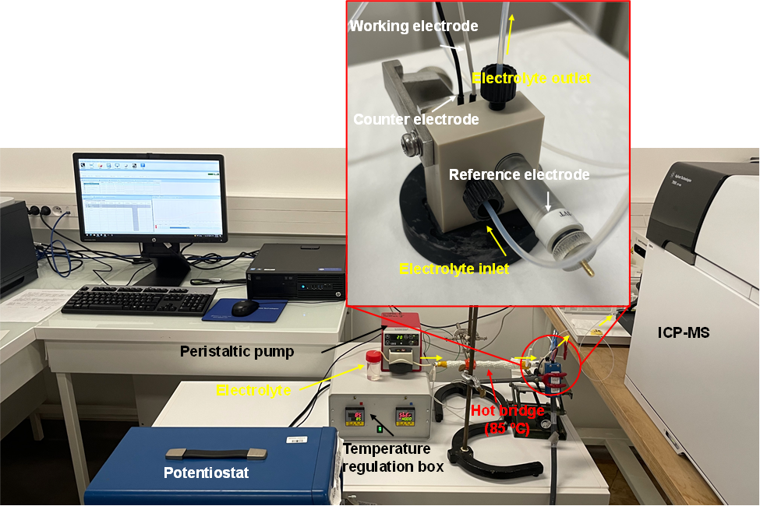
Supplementary Picture S2: Setup for the electrochemical on-line ICP-MS experiment at controlled temperature
Supplementary Figure S1: Effect of the used WAXS data processing on the refinement of Pt/C structural parameters during cyclic voltammetry at 1000 mV s⁻¹. a) example of raw vs. reconstructed patterns, refined b) lattice constant and c) scale factor from raw patterns, refined d) lattice constant and e) scale factor from reconstructed patterns using similar refinement model.

Supplementary Figure S2: calculated vs. observed diffraction patterns of Pt nanoparticles covered with adsorbed hydrogen or oxygen. a) calculated patterns b) recorded patterns, Pt-201 model of nanoparticle covered with c) oxygen, d) free of adsorbate and e) covered with hydrogen.
Supplementary Figure S3: MEA performance in PEMFC. a) cyclic voltammogram recorded at 50 mV s⁻¹ in H₂/N_{2.} b) current density (left axis, solid markers) and power density (right axis, hollow markers) recorded during polarization curve in H₂/O₂ after 3 min stabilization per point. The cell operated at 80 °C with 313/496 sccm at anode/cathode, 80 °C dewpoint (100 % relative humidity) and 500 mbar backpressure with a house-made test bench. In b), the markers and error bars correspond to the average and standard deviation values, respectively, of two independent measurements.

Supplementary Figure S4: Fits associated to the surface crystallinity loss or recovery during oxidation and reduction in both PEMFC and thin-film electrochemical cells.
Supplementary Figure S5: Estimation of the double-layer capacitance C_{DL} from linear regression of double-layer currents measured at E = 0.40 V vs. RHE at different potential sweep rates for a) the thin-film flow cell and b) the PEMFC.

Supplementary Figure S6: Reconstructed cyclic voltammograms during (ultra-fast) operando WAXS measurements in PEMFC. The error bars represent the standard deviations associated to the averaged values during cycle merging.

Supplementary Figure S7: Reconstructed cyclic voltammograms during (ultra-fast) operando WAXS measurements in thin-film flow cell. The error bars represent the standard deviations associated to the averaged values during cycle merging.

Supplementary Figure S8: Outpacing Pt oxidation in thin-film catalyst layer during accelerated stress tests. a) Reconstructions of the applied potential cycle profiles between 0.60 and 1.0 V vs. RHE: 3 s – 3 s square wave and triangular waves at 5, 10, 100, 500 and 1000 mV s⁻¹, b) lattice constant variations and c) surface-fraction-normalized scattering intensity variations as a function of the percentage fraction of cycle duration. d) Kernel density estimations of the lattice constant distributions during each potential cycle profile. c) Maximum of surface crystallinity loss induced by a single potential cycle of each profile (cycle depth) and f) amount of surface crystallinity loss induced by each potential cycle profile (cycle efficiency). The voltage was dynamically corrected by the cell high frequency resistance.

Supplementary Table S1: Results from the fits associated to the surface crystallinity loss or recovery during oxidation and reduction in both PEMFC and thin-film electrochemical cells
 | y₀  (a.u.) | x₀  (s) | A₁  (a.u.) | t₁  (s) | A₂  (a.u.) | t₂  (s)
Oxidation  PEMFC 80 ºC | -48 ± 0 | 1.304 ± 0 | 28 ± 2.4 | 0.30 ± 0.05 | 24.7 ± 2.4 | 3.56 ± 0.62
Reduction  PEMFC 80 ºC | 0.02 ± 0.4 | 4.24 ± 0 | -37.9 ± 1.4 | 0.31 ± 0.02 | n.a. | n.a.
Oxidation  0.1 M HClO₄ 25 ºC | -6 ± 0 | 1.509 ± 0 | 4.4 ± 0.3 | 0.08 ± 0.012 | 1.90 ± 0.22 | 1.16 ± 0.15
Reduction  0.1 M HClO₄ 25 ºC | 0.09 ± 0.06 | 4.45 ± 0 | -6 ± 0.27 | 0.13 ± 0.013 | n.a. | n.a.

Supplementary Table S2: Estimation of the ‘RC’ time constant for the two electrochemical cells. C_{DL} is estimated from linear regression of the capacitive current at 0.4 V vs. RHE at different sweep rates and R_{s} from electrochemical impedance spectroscopy.
 | C_{DL} | R_{s} | ‘RC’ constant
PEMFC | 510 mC | 0.6 Ω | 306 ms
Thin-film flow cell | 303 µC | 24 Ω | 7.3 ms
REFERENCES
1. Martens, I. et al. X-ray transparent proton-exchange membrane fuel cell design for in situ wide and small angle scattering tomography. J. Power Sources 437, 226906 (2019).
2. Martens, I. et al. Imaging Heterogeneous Electrocatalyst Stability and Decoupling Degradation Mechanisms in Operating Hydrogen Fuel Cells. ACS Energy Lett. 6, 2742–2749 (2021).
3. Martens, I., Chattot, R. & Drnec, J. Decoupling catalyst aggregation, ripening, and coalescence processes inside operating fuel cells. J. Power Sources 521, 230851 (2022).
4. Chattot, R. et al. Beware of cyclic voltammetry! Measurement artefact in accelerated stress test of fuel cell cathode revealed by operando X-ray diffraction. J. Power Sources 555, 232345 (2023).
5. Chattot, R. et al. Electrochemical Strain Dynamics in Noble Metal Nanocatalysts. J. Am. Chem. Soc. 143, 17068–17078 (2021).
6. Chattot, R. et al. Break-In Bad: On the Conditioning of Fuel Cell Nanoalloy Catalysts. ACS Catal. 12, 15675–15685 (2022).
7. Ashiotis, G. et al. The fast azimuthal integration Python library: PyFAI. J. Appl. Crystallogr. 48, 510–519 (2015).
8. Thompson, P., Cox, D. E. & Hastings, J. B. Rietveld Refinement of Debye-Scherrer Synchrotron X-ray Data from A1203. J. Appl. Crystallogr. 20, 79–83 (1987).
9. Kresse, G. & Furthmüller, J. Efficiency of ab-initio total energy calculations for metals and semiconductors using a plane-wave basis set. Comput. Mater. Sci. 6, 15–50 (1996).
10. Kresse, G. & Furthmüller, J. Efficient iterative schemes for ab initio total-energy calculations using a plane-wave basis set. Phys. Rev. B 54, 11169–11186 (1996).
11. Perdew, J. P., Burke, K., Ernzerhof, M. & Ernzerhof, M. Generalized gradient approximation made simple. Phys. Rev. Lett. 77, 3865 (1996).
12. Kresse, G. & Joubert, D. From ultrasoft pseudopotentials to the projector augmented-wave method. Phys. Rev. B 59, 1758–1775 (1999).

