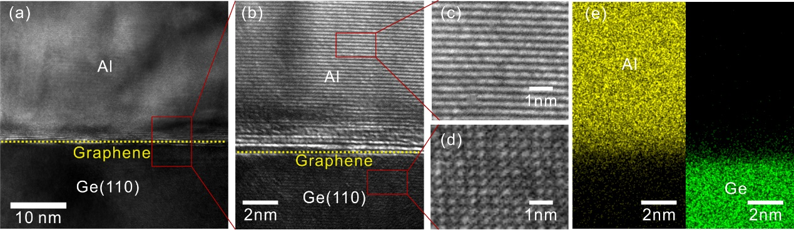
Extended Data Figure 1. Remote epitaxial single-crystalline Al (110) on Gr/Ge (110) substrate. (a) Cross-sectional HRTEM image of Al/Gr/Ge (110) interface. (b) Magnified cross-sectional HRTEM of Al/Gr/Ge (110) interface from the red boxes in (a). (c) and (d) Magnified cross-sectional HRTEM of single-crystalline Al (110) and single-crystalline Ge (110) remote epitaxial template from the red boxes in (b), respectively. (e) EDS mapping images of Al/Gr/Ge interface. Notably, Al is slight oxidation at the Al/Gr/Ge interface due to the exposure of the TEM cross-section sample to air.

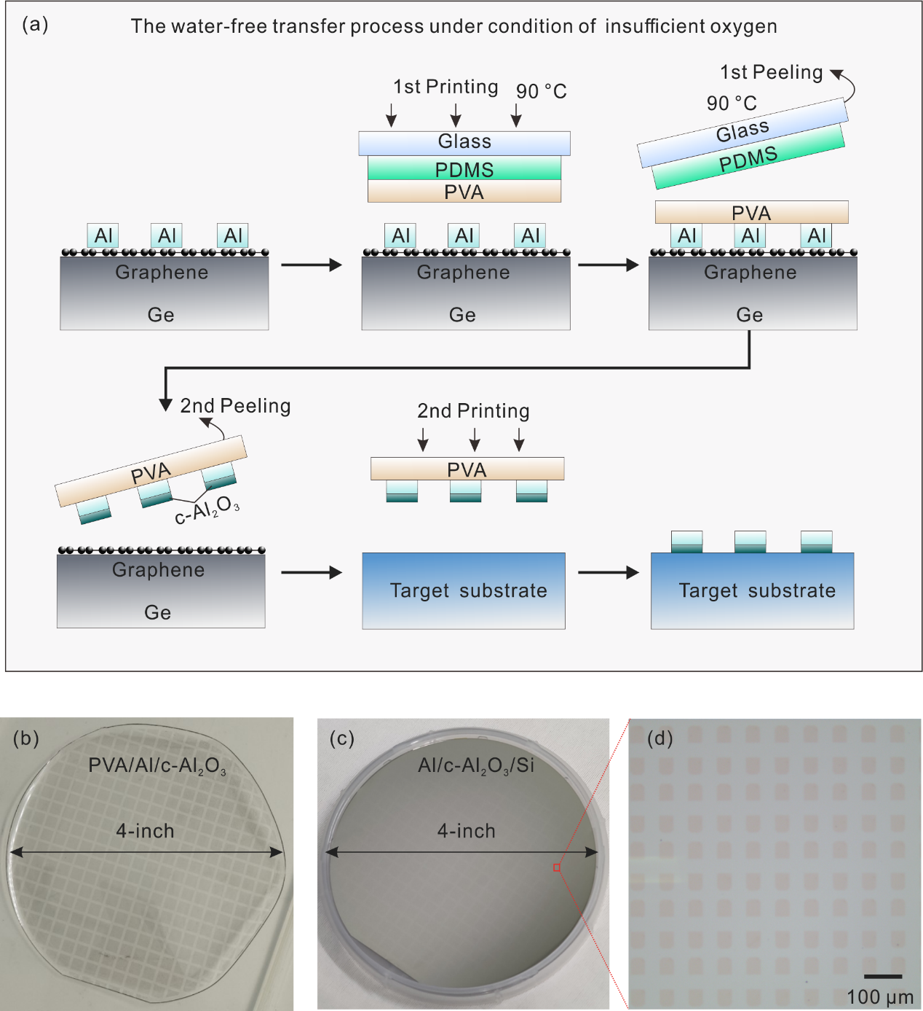
Extended Data Figure 2. Schematic and optical images of the graphene-assisted Al/c-Al₂O₃ water-free transfer printing process. (a) Schematic of the water-free transfer process of Al/c-Al₂O₃ patterns under an oxygen-deficient environment in a glovebox. The process starts with a clean CVD Gr/Ge substrate; followed by defining Al patterns by electron beam lithography (EBL)/photolithography, depositing Al by electron beam evaporation and lifting off; first printing dry PVA film on Al patterns using a PDMS stamp at 90℃; second peeling off Al patterns from Gr/Ge substrate using dry PVA film at room temperature in a glovebox; second transferring and printing PVA/Al/c-Al₂O₃ on target substrate using a PDMS stamp at 90℃; finally, the PVA film is dissolved by dimethyl sulfoxide (DMSO). (b) Optical image of Al/c-Al₂O₃ patterns transferred onto a 4-inch PVA film. (c) Optical image of Al/c-Al₂O₃ patterns transferred onto a 4-inch Si wafer. (d) Magnified optical image of Al/c-Al₂O₃ patterns from the red box in (c).

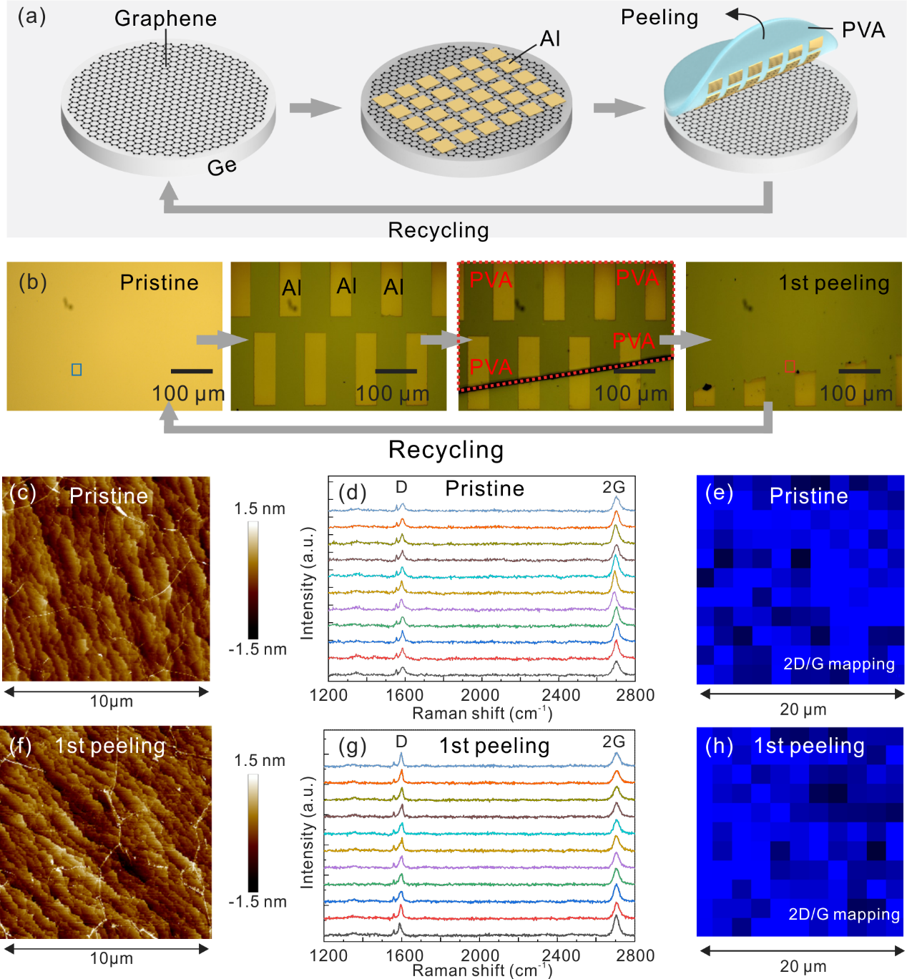
Extended Data Figure 3. The reuse of Gr/Ge template substrate. (a) and (b) Schematic and optical images of reusing Gr/Ge template substrate for Al/c-Al₂O₃ patterns transfer. (c) AFM image of pristine Gr/Ge substrate with a surface roughness of 0.261nm from the blue box in (b). (d) and (e) Raman line mapping and area mapping of pristine Gr/Ge substrate. (f) AFM image of Gr/Ge substrate from the red box in (b) after first peeling with the surface roughness of 0.299nm. (g) and (h) Raman line mapping and area mapping of Gr/Ge substrate from the red box in (b) after first peeling. It is demonstrated that the graphene can be retained on Ge substrate almost undamaged after first peeling, which makes it possible to reuse the Gr/Ge wafer.

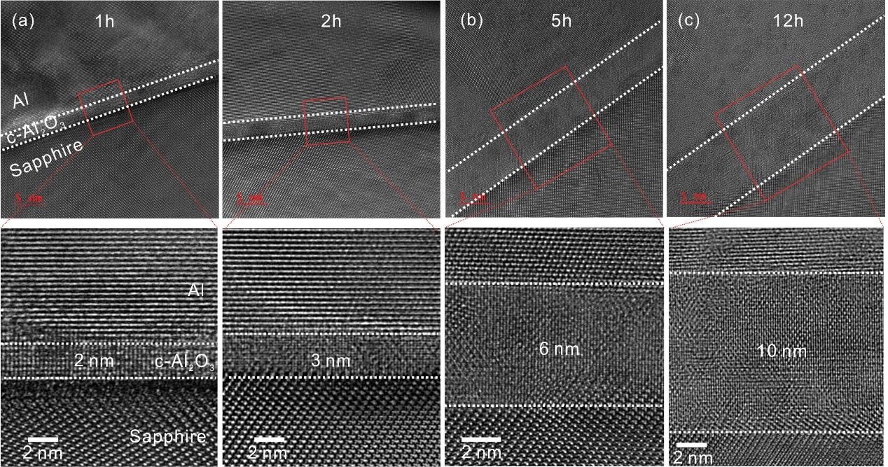
Extended Data Figure 4. Cross-sectional HRTEM images of vdW-transferred Al/c-Al₂O₃ with different thickness on the sapphire substrate. (a)-(c) The cross-sectional HRTEM images and corresponding enlarged images from the red box of 2nm, 3nm, 6nm, and 10nm c-Al₂O₃ by exposing Al to an oxygen-deficient environment for 1h, 2h, 5h, and 12h, respectively.

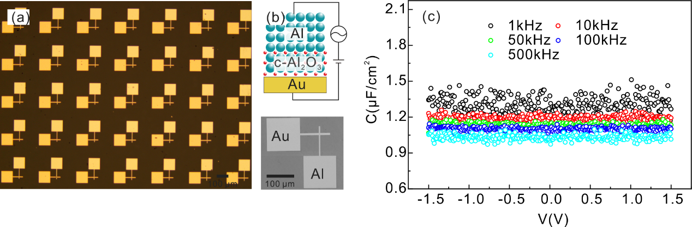
Extended Data Figure 5. Dielectric properties of vdW-transferred Al/c-Al₂O₃ gate stacks (a) and (b) The optical and SEM image of the MIM device array on the sapphire substrate. (c) Voltage-dependent capacitance density (C-V) for MIM device of c-Al₂O₃ under different frequencies.

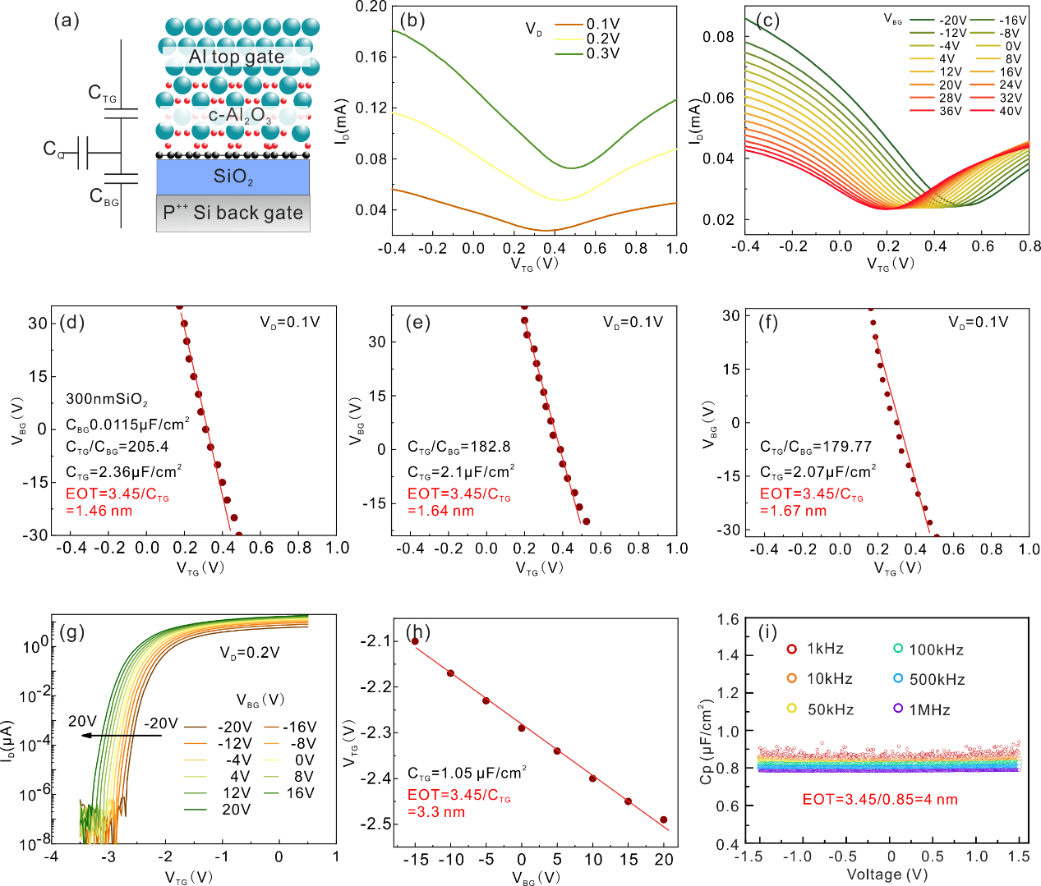
Extended Data Figure 6. Double-gate measurement to extract EOT. (a) A schematic of the double-gate graphene transistor model. C_{TG} is the top gate capacitance of c-Al₂O₃, C_{BG} (0.0115 μF cm⁻²) is the back gate capacitance of 300 nm SiO₂, C_{Q} is the quantum capacitance of graphene. (b)-(c) Transfer curves of a typical top gate graphene transistor with 2-nm-thick c-Al₂O₃ as gate dielectrics and corresponding transfer curves under different V_{BG} from -20V to 40V, V_{D} = 0.1V. (d)-(f) Dirac point voltage (V_{TG, Dirac}) versus V_{BG} in top gate graphene transistors. From the linear fitting, EOT of 1.46 nm, 1.64 nm, and 1.67 nm are obtained respectively. (g)-(h) Transfer curves of a top gate MoS₂ transistor with 6-nm-thick c-Al₂O₃ as gate dielectrics under different V_{BG} and corresponding liner fitting of threshold voltage versus V_{BG}, EOT of 3.3nm is obtained. The SS remains unchanged in (g), indicating excellent device stability and interface quality. (i) C-V characteristics for MIM devices with 10 nm c-Al₂O₃ under different frequencies, EOT of 4nm is obtained.

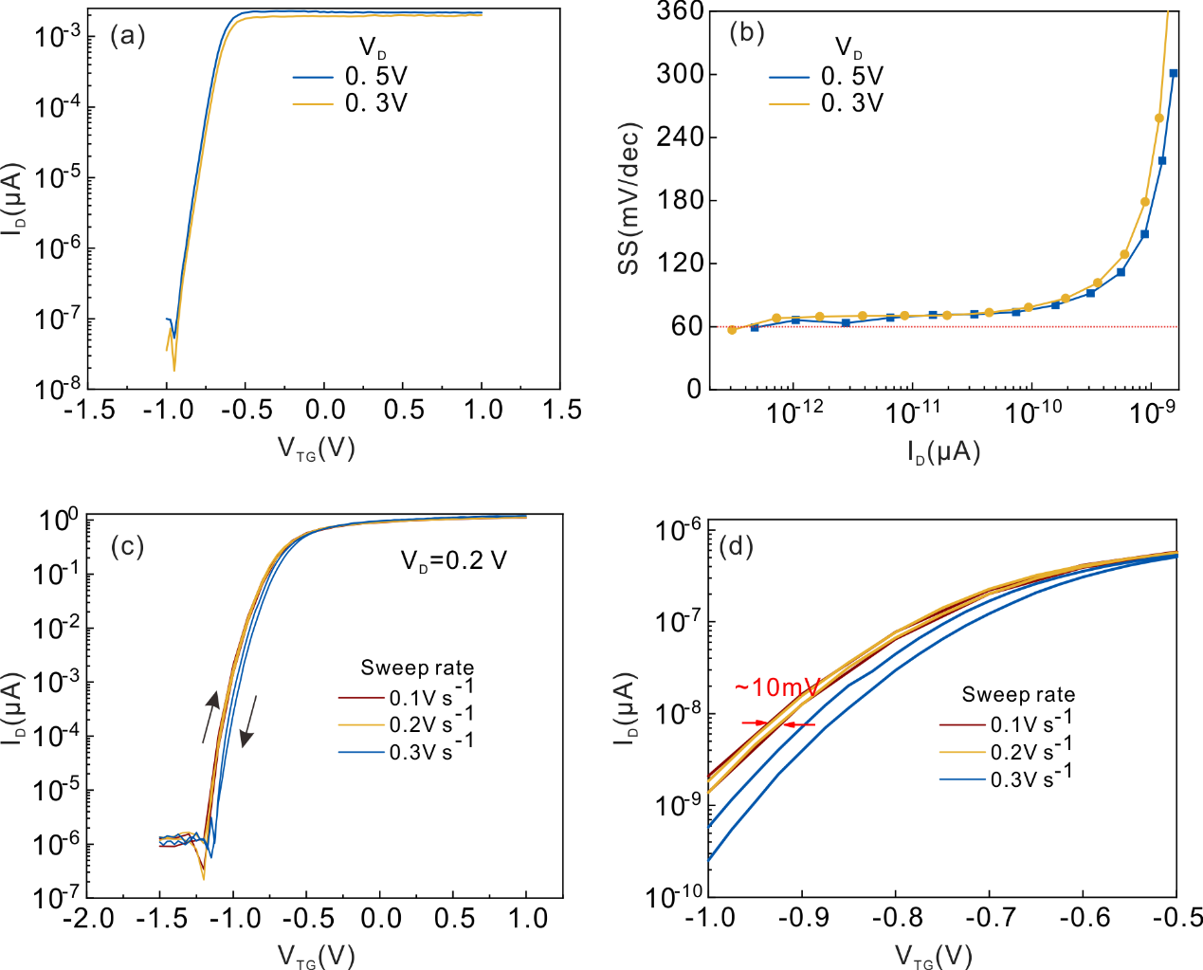
Extended Data Figure 7. SS distribution and hysteresis of vdW-transferred c-Al₂O₃ top-gate MoS₂ transistors. (a) Transfer curves of top-gate MoS₂ transistor. (b) SS distribution as a function of channel current in (a). The dashed line represents the thermal limit of SS at room temperature (60 mV/dec). (c) The double-sweep transfer curves with different gate-voltage sweeping speeds of another top-gate MoS₂ transistor, V_{D}=0.2V. (d) Enlarged double-sweep transfer curves in (c), indicating a hysteresis of ~10 mV.

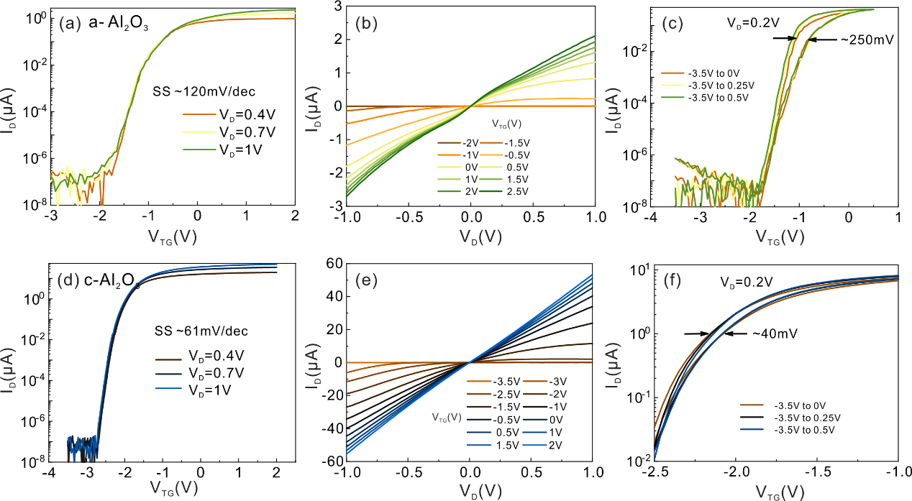
Extended Data Figure 8. Electrical performance of a-Al₂O₃ and c-Al₂O₃ top-gate MoS₂ transistors. (a) and (b) Transfer and output curves of ALD a-Al₂O₃ top-gate MoS₂ transistors. (c) The double-sweep transfer curves with different gate-voltage ranges of ALD a-Al₂O₃ top-gate MoS₂ transistors. (d) and (e) Transfer and output curves of vdW-transferred c-Al₂O₃ top-gate MoS₂ transistors. (f) Enlarged double-sweep transfer curves with different gate-voltage ranges of vdW-transferred c-Al₂O₃ top-gate MoS₂ transistors. The top-gate MoS₂ transistors with vdW-transferred c-Al₂O₃ dielectric and Au contracts show a larger higher on/off ratio (1.05 × 10⁸), smaller subthreshold swing (SS ≈ 61 mV/dec) and hysteresis (40mV). By contrast, the devices with ALD a-Al₂O₃ and deposited Au contacts show a notably smaller on/off ratio (1.4× 10⁷), larger SS (120 mV/dec), and hysteresis (250 mV).

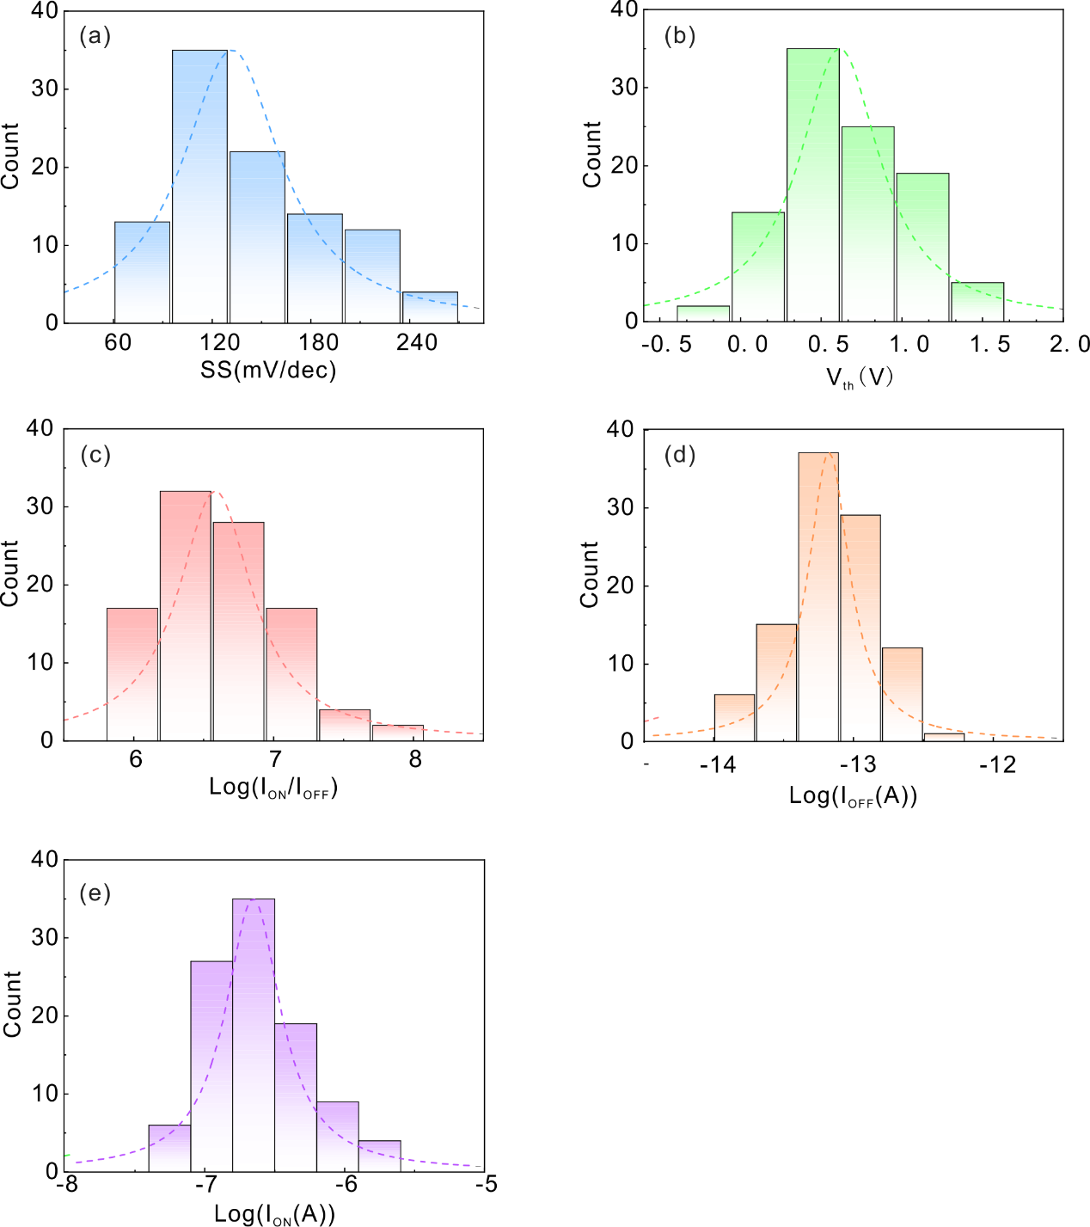
Extended Data Figure 9. Electrical performance of CVD-MoS₂ transistor array. Histogram and Lorentz's distribution fits of (a) subthreshold swing SS, (b) threshold voltage, V_{th}, (c) on/off ratio I_{ON}/I_{OFF}, (d) off-state current I_{OFF,} and (e) on-state current I_{ON} extracted from the transfer curves of 100 devices. According to Lorentz distribution fittings, the statistical results of SS, V_{th}, I_{ON}/I_{OFF}, I_{OFF}, and I_{ON} show centralized distributions with average values of 121.8 mV/dec, 0.63 V, 3.2 × 10⁶, 7× 10⁻¹⁴ A, 2× 10⁷ A, respectively. The electrical performance and uniformity of MoS₂ transistors can be further improved by using single crystalline CVD MoS₂ wafer in the future.

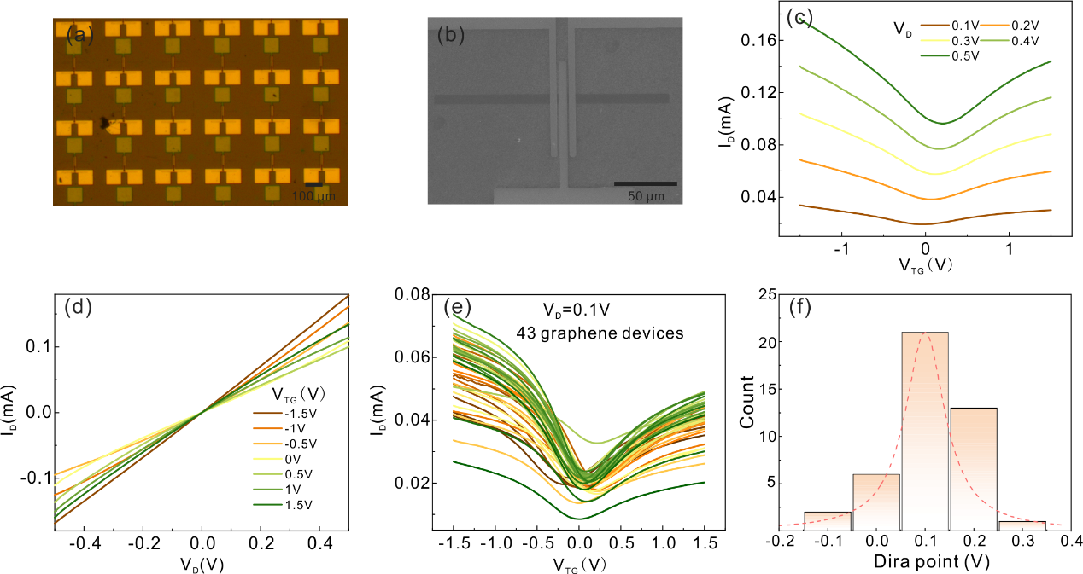
Extended Data Figure 10. Electrical performance of CVD-grown graphene transistor array. (a) Optical image of the top-gate graphene transistor array with vdW-transferred c-Al₂O₃ dielectric and Au contracts. (b) SEM image of a single graphene transistor in (a). (c) and (d) Transfer and output curves of a typical graphene transistor. (e) Transfer curves of 43 graphene transistors in the array, V_{D}=0.1V. (f) Histogram and Lorentz's distribution fits of Dirac point voltage, the Dirac point voltage shows centralized distribution with average values of 0.13V.

