Supplementary information to ZnFe₂O₄ Nanoparticles for Gas-Sensing Applications: Monitoring of Structural Parameters while Exposing the Ferrite in Gas Atmospheres
Zeyad M. Abdulhamid¹, Aasif A. Dabbawala², Thomas Delclos³, Rainer Straubinger⁴, Magnus Rueping⁵, Kyriaki Polychronopoulou², Dalaver H. Anjum^{1,*}
¹Department of Physics, Khalifa University of Science and Technology, Abu Dhabi 127788, United Arab Emirates; Center for Catalysis and Separations (CeCaS Center), Khalifa University of Science and Technology, Abu Dhabi 127788, United Arab Emirates.
²Department of Mechanical Engineering, Khalifa University of Science and Technology, Abu Dhabi 127788, United Arab Emirates; Center for Catalysis and Separations (CeCaS Center), Khalifa University of Science and Technology, Abu Dhabi 127788, United Arab Emirates.
³Manager, Materials, and Surface Core Labs, Khalifa University of Science and Technology, Abu Dhabi 127788, United Arab Emirates
⁴Core Technology Platforms Operations, New York University, Abu Dhabi 129188, United Arab Emirates.
⁵KAUST Catalysis Center (KCC), King Abdullah University of Science and Technology, Thuwal 23955-6900, Saudi Arabia.
*Corresponding author email: dalaver.anjum@ku.ac.ae
Figure S1 Variation of lattice parameter with cos²θ/sinθ, and Williamson-Hall plots of (a)ZFO-1, (b) ZFO-2, (c) ZFO-3, and (d) ZFO-4, respectively.

Figure S2 TEM-EDS elemental analysis of ZnFe₂O₄ derived from (a) ZFO-2, (b) ZFO-3, and (c) ZFO-4.
Figure S3 XPS survey of the ZnFe₂O₄ derived from (a) ZFO-1, (b) ZFO-2, (c) ZFO-3, and (d) ZFO-4.
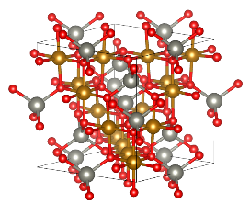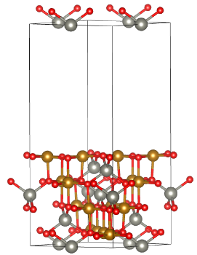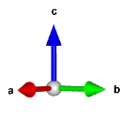
(b)
(a)
Figure S4 Unit cell of ZnFe₂O₄ (a) without and (b) with (001) surface termination.

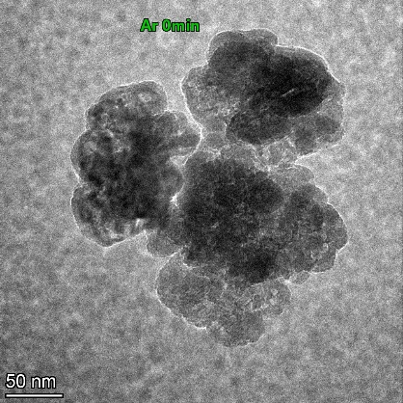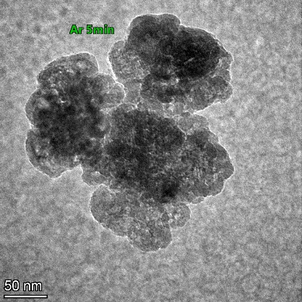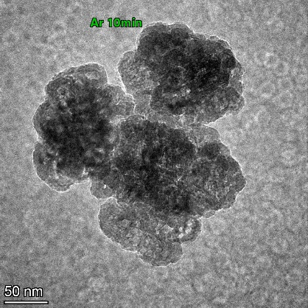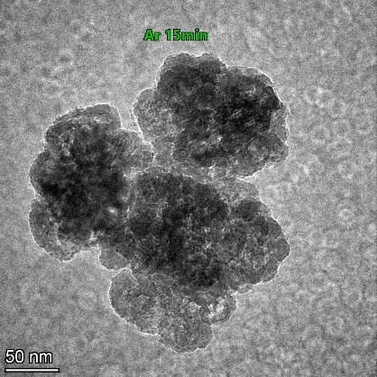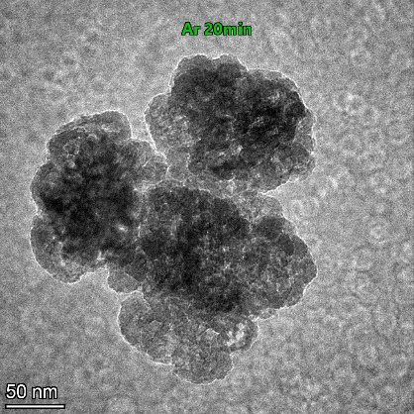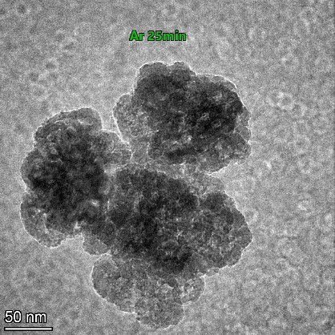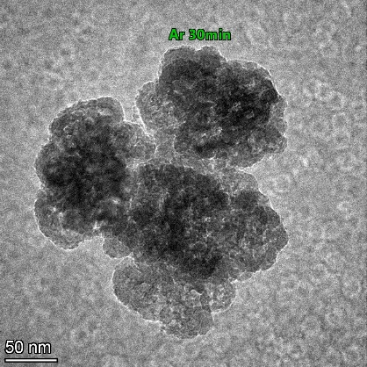
(a)
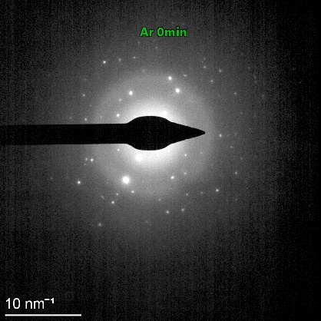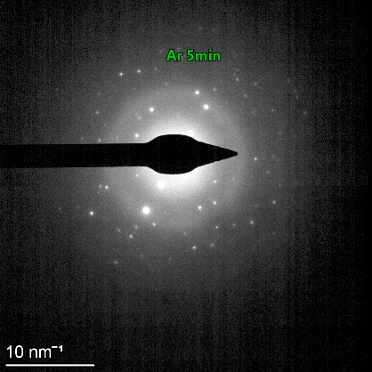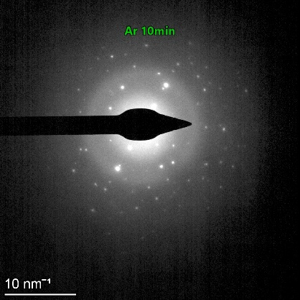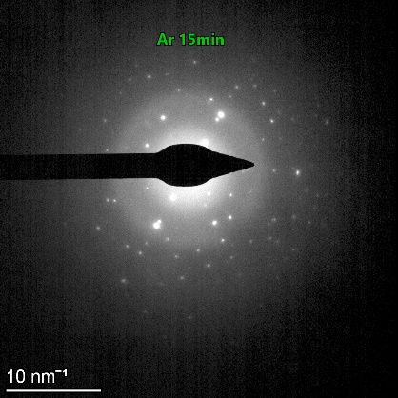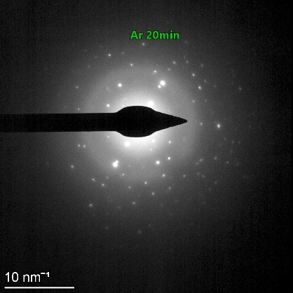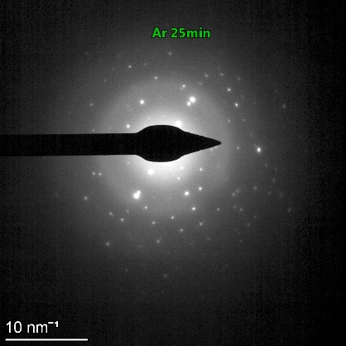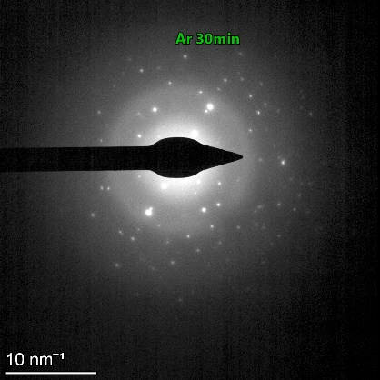
(b)
Figure S5 (a) TEM images and (b)SAED of ZFO-3 during purging Argon gas for 30 minutes at 300 ºC.
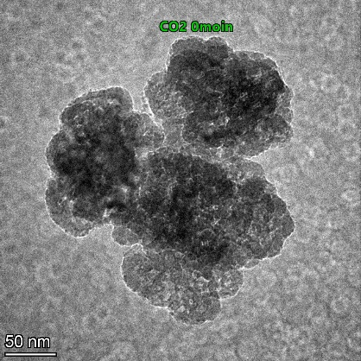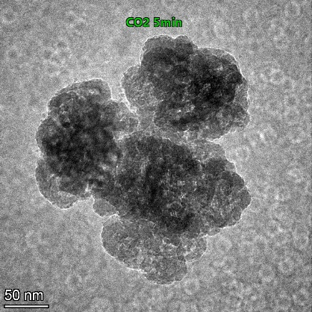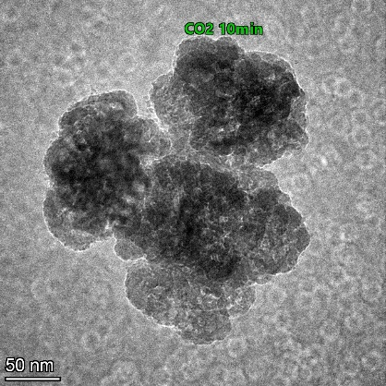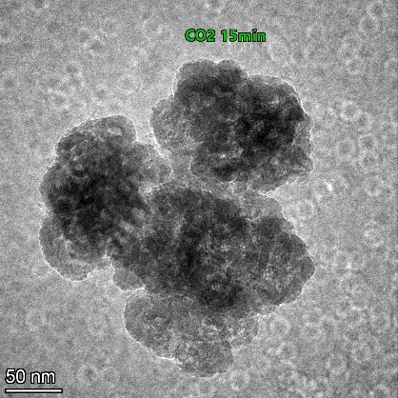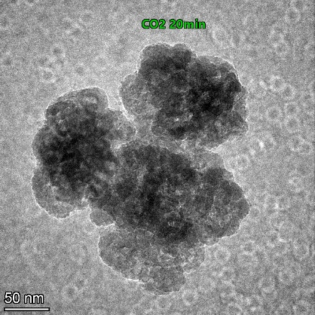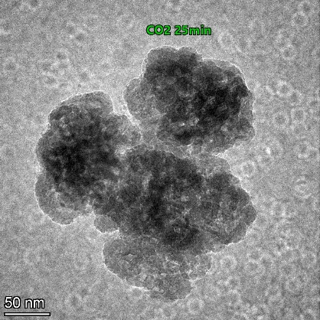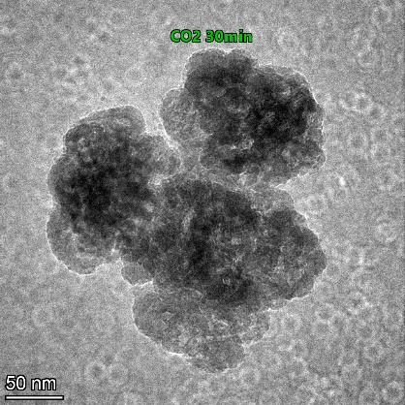
(a)
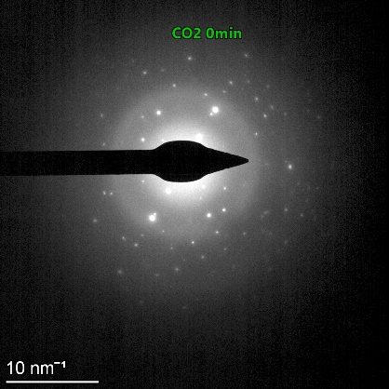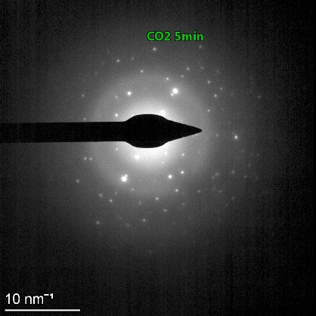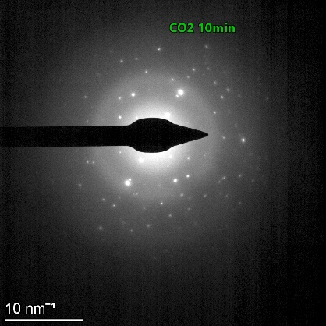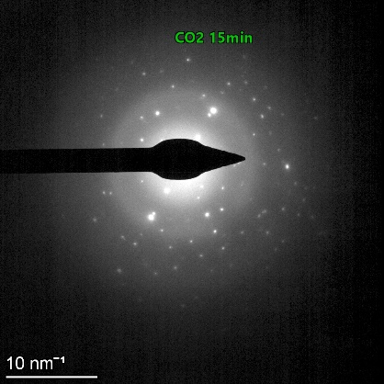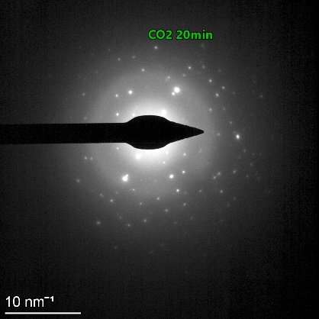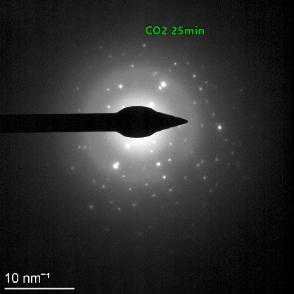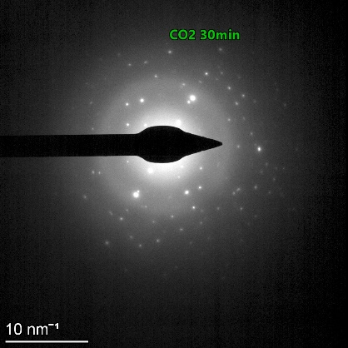
(b)
Figure S6 (a) TEM images and (b)SAED of ZFO-3 during purging CO2 gas for 30 minutes at 300 ºC.
Table S1 TEM-EDS and EELS elemental composition of ZnFe₂O₄ NPs.
Elements | Atomic Percent
Elements | ZFO-2 |  | ZFO-3 |  | ZFO-4
Elements | EDS-TEM | EELS | EDS-TEM | EELS | EDS-TEM | EELS
Zn | 11.13 | 11.3 | 7 | 7.1 | 4.11 | 4.8
Fe | 42.20 | 46.3 | 26.27 | 29.4 | 26.07 | 35.3
O | 46.67 | 42.4 | 66.72 | 64 | 69.81 | 60

