Supplementary Figures
Suppl. Figure1
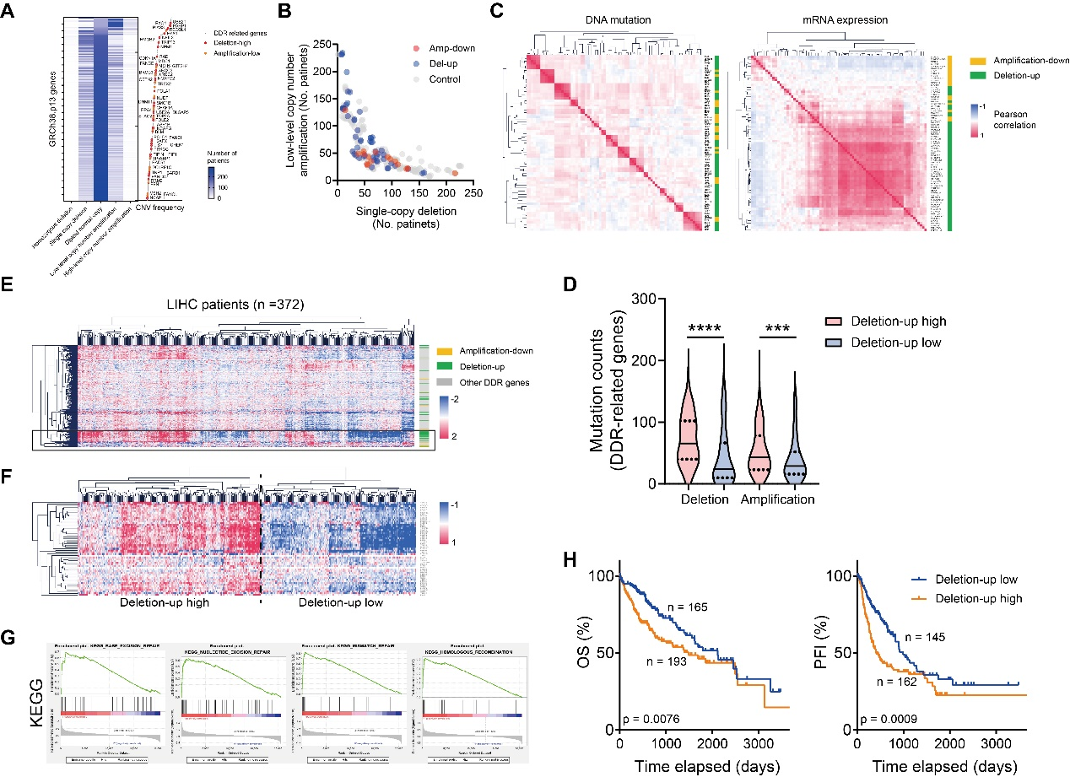
(A-B) Dot plot showing the distribution of SNV levels in HCC patients (A) and deletion-up genes (B).
(C) Heatmap showing the DNA levels (the left panel) and mRNA expression levels (the right panel) correlation between DNA damage repair-related genes.
(D) Violin plot showing the mutation counts of DDR-related genes in HCC patients.
(E-F) Heatmap showing the expression pattern of all DDR genes (E) and deletion-up genes (F) in the TCGA LIHC database.
(G) GSEA analysis results showing the enrichment of DDR pathways in patients overexpressing deletion-up genes.
(H) Kaplan-Meier analysis showing the unfavorable prognosis of HCC patients with different levels of deletion-up genes.

Suppl. Figure2
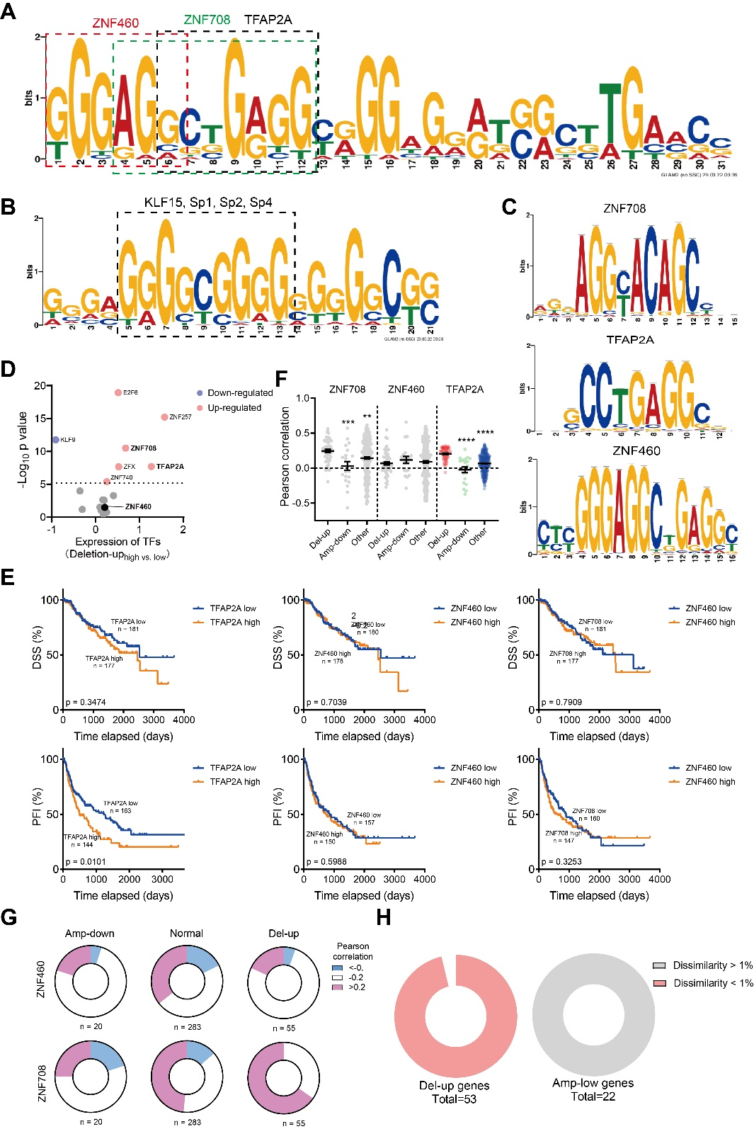
(A-B) Top mutual motifs found with the MEME website in deletion-up/amplification genes (A) or amplification-down (B) genes.
(C) Binding motifs of ZNF708, TFAP2A, and ZNF460.
(D) Expression levels of different transcription factors in the TCGA LIHC database.
(E) Kaplan-Meier analysis comparing the prognosis of patients with different ZNF708, TFAP2A, and ZNF460 levels.
(F) Dot plot showing the expression levels of ZNF708, TFAP2A and ZNF460 in HCC patients with different CNV levels.
(G) Pie chart showing the percent of genes whose expression correlated with ZNF708, TFAP2A, and ZNF460 in the TCGA LIHC database.
(H) Pie chart showing the TFAP2A binding prediction results on the promoter regions of deletion-up genes or amplification-down genes.

Suppl. Figure 3
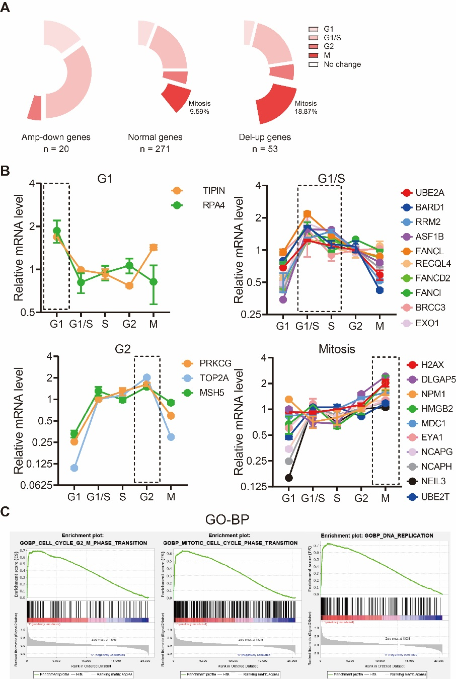

(A-B) Pie chart(A) and dot plot (B) showing the expression peaks of deletion-up/amplification-down genes at different cell phases.
(C) GSEA assay results showing the enrichment of G2/M phases in patients expressing high levels of deletion-up genes.

Suppl. Figure 4
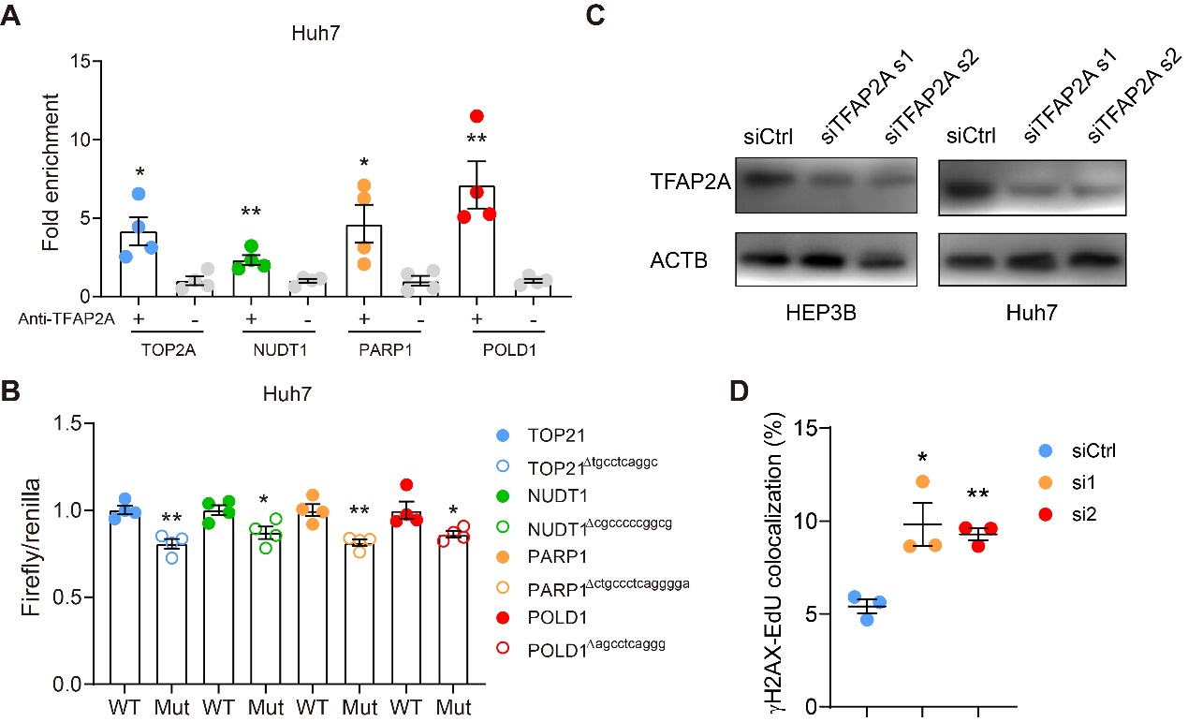
(A) Quantification of ChIP-qPCR results, showing the binding of TFAP2A on the promoter regions of TOP2A, PARP1, POLD1 and NUDT1 in Huh7 cells.
(B) Dual luciferase assay results showing the suppressed transcription activity after mutation of the TFAP2A binding domains in Huh7 cells.
(C) Immunoblots showing the siTFAP2A efficacy in HEP3B and Huh7 cells.
(D) Quantification of immunofluorescence results in TFAP2A-depleted Huh7 cells. γH2AX-EdU colocalization was quantified with Cellprofiler.

Suppl. Figure 5
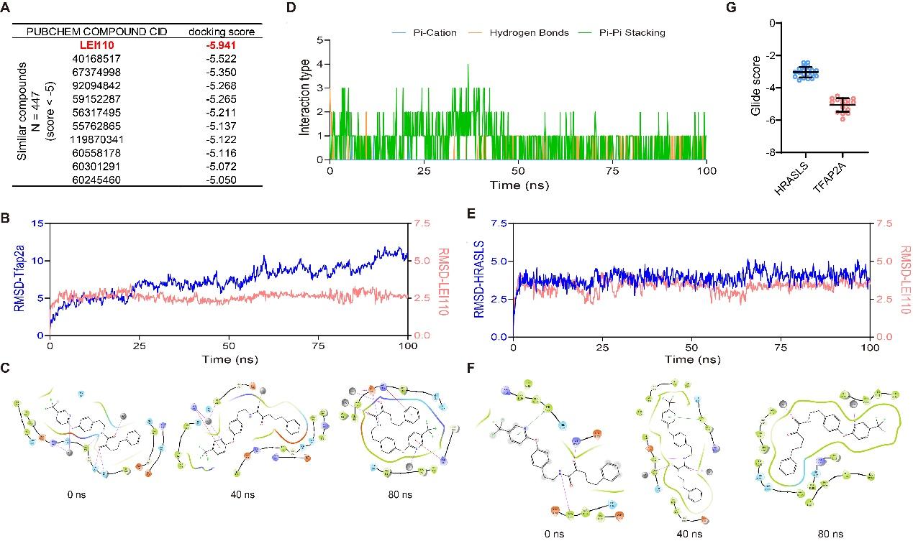
(A) Docking results of LEI110 and its analogs with TFAP2A in Schrodinger.
(B-C) Molecular dynamic simulation results showing the stabilization of TFAP2A with LEI110.
(D) Quantification of interaction types between LEI110 and TFAP2A in the molecular dynamics simulations.
(E-F) Molecular dynamic simulation results showing very weak stabilization of HRASLS by LEI110.
(G) Quantification of Glide score showing the binding affinity (kcal/mol) between HRSLS-LEI110 and TFAP2A-LEI110. The top 20 poses were included for each group.

Suppl. Figure 6
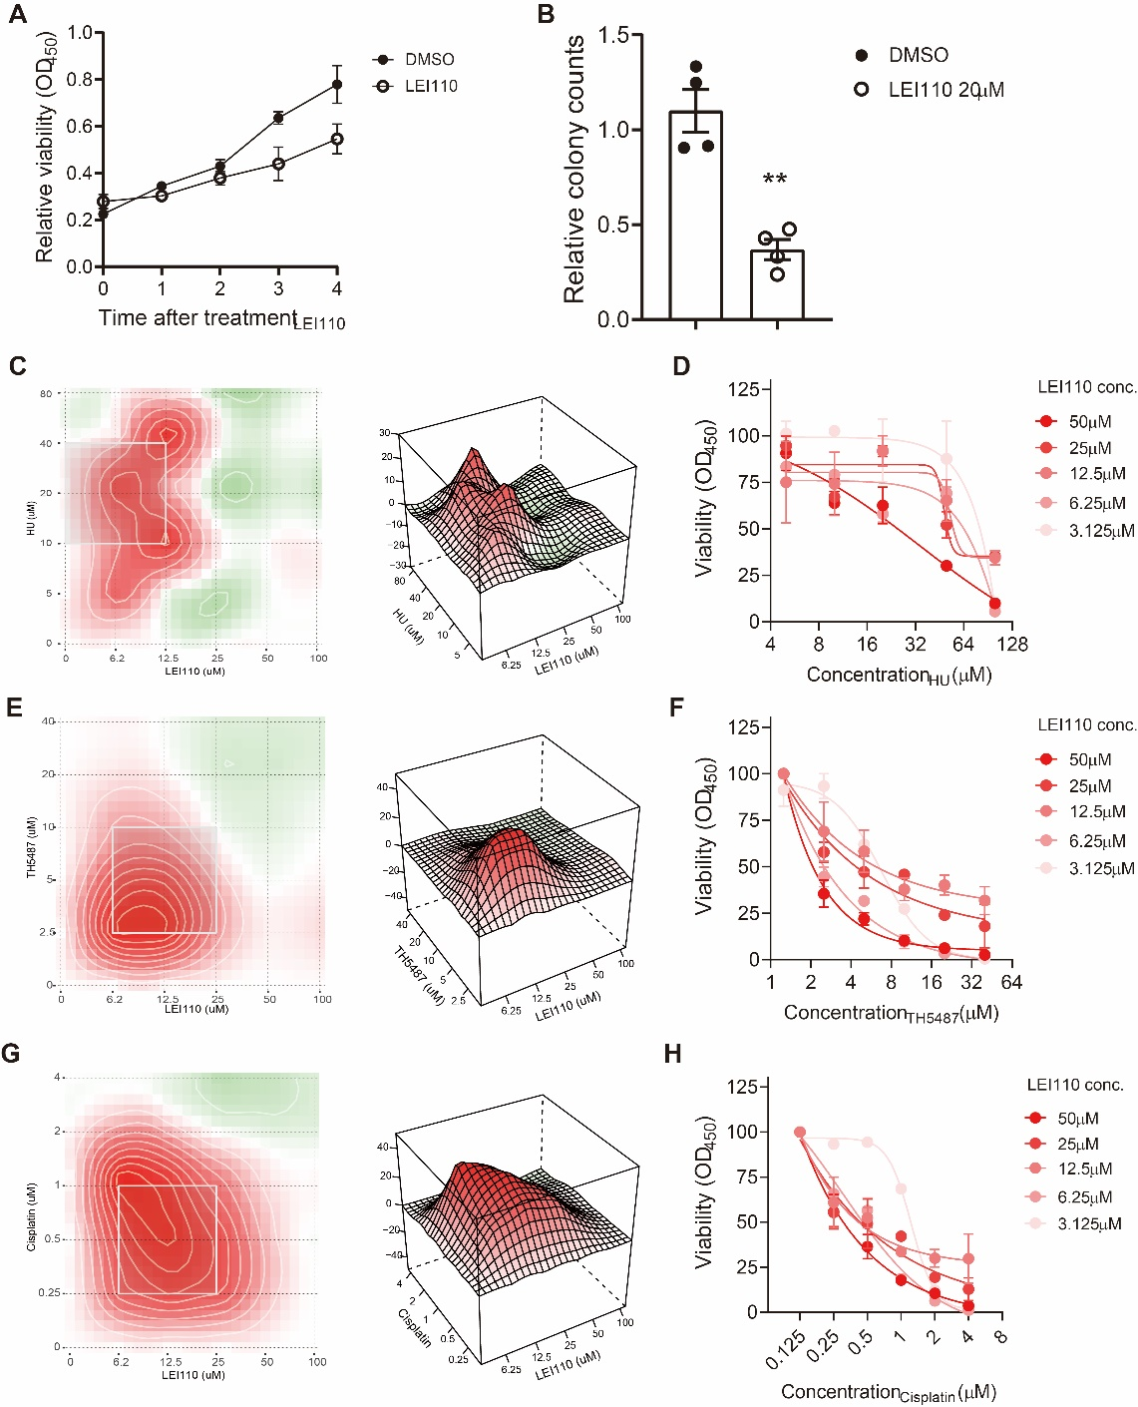
(A) Dot plot showing the suppressed proliferation of Huh7 cells by LEI110.
(B) Quantification of the clonogenic ability of Huh7 cells after LEI110 treatment (20μM).
(C-H) Synergy plot (C, E, G) and viability assay results (D, F, H) showing the sensitization of HCC cells towards different DNA damage-inducing reagents.

