Supplementary material
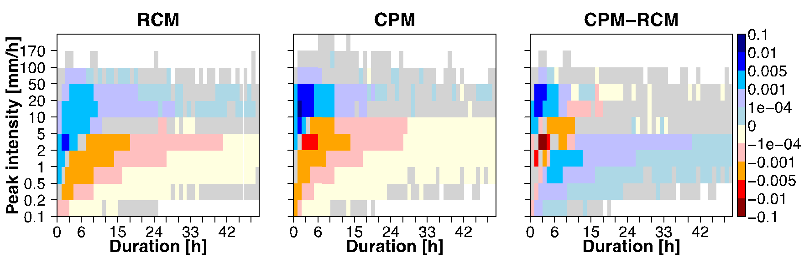
Figure S1: ﻿Future summer change in the contribution to the total precipitation as a function of the peak precipitation intensity and duration of precipitation event, where an event is defined as a continuous period of precipitation exceeding 0.1 mm/hr, for the ensemble mean of RCM (left), CPM (middle) and CPM‐RCM difference (right). Fractional contribution is given by (joint probability of a given amount‐duration bin) × (mean bin precipitation amount) / (total precipitation over all bins), pooling all land points over the domain. Future changes or differences that are not significant at the 5% level are masked in grey.

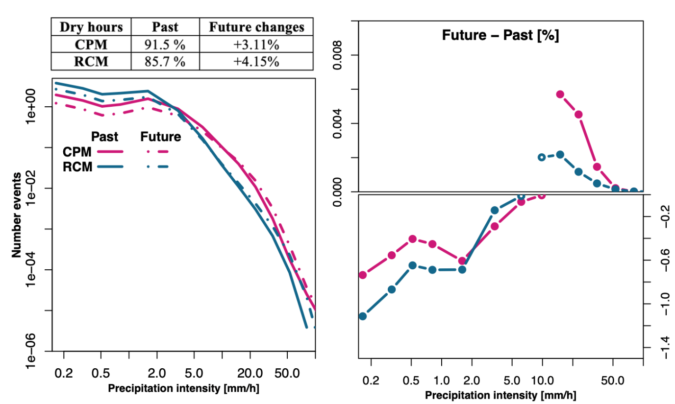
Figure S2: The left panel shows the number of events in summer for the bin intensities identified in Figure 1 for the CPM (purple) and RCM (petroleum) ensemble mean for the past and future times slices (solid and dashed lines respectively). The right panel shows the difference between future and past as a percentage of all hours. The changes significant at the 95th level are indicated by solid dots. Note the logarithmic x axis for both plots and the different y axes for right panel top and bottom. The table shows the percentage of dry hours in the past and the future changes across all bins for both CPM and RCM ensembles.

Figure S3: Uncertainty spread for the fractional contribution of Figure 2 in the past (left) and in the future changes (right). Uncertainty spreads, calculated as the difference between the 97.5th and the 2.5th quantile of the bootstrapped ensemble, is here divided by the ensemble mean to highlight the tail of the distribution, but the findings do not change considering simply the uncertainty spread. Respectively for RCM and CPM ensemble, the spread in total uncertainty (TU) is shown black and grey; in the model uncertainties (MU) in blue and red; in the median of the single-model natural variability (SM-NV) in light and dark grey dashed line. Additionally for the past time slice (left), the 95th confidence interval of the SM-NV is shown as a band in dark and light grey for RCM and CPM ensemble. Note that the SM-NV uncertainty appears as a large band because it includes the SM-NV of each model (see Methods for further details). Both panels refer to the summer season and the statistics are calculated when at least 50% of the models have events in the bin.
Figure S4: As Figure 3, but for the reduced ensemble CMCC, CNRM, THE, FZJ-IDL, ICTP, MOHC.

Figure S5: As Figure 3, but for the reduced ensemble CMCC, HCLIM, KIT, FZJ-IDL, ICTP, MOHC.

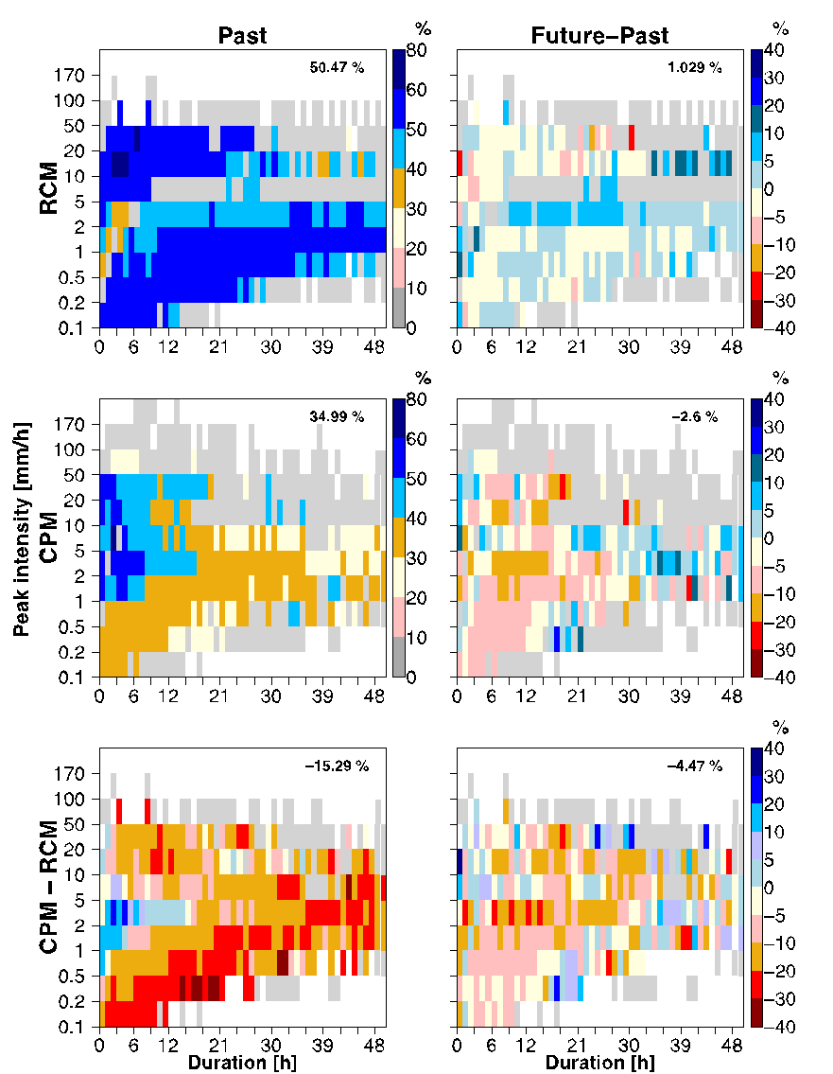
Figure S6: As Figure 4, but for the following subset of models: CMCC, CNRM, ETH, FZJ-IDL, ICTP, MOHC.
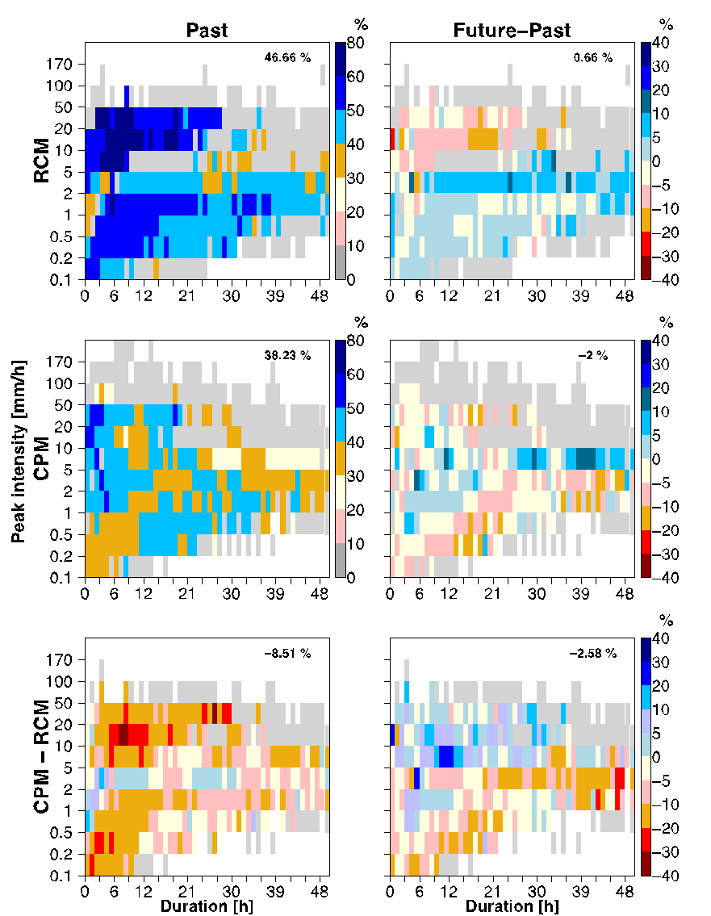
Figure S7: As Figure 4, but for the following subset of models: CMCC, HCLIM, KIT, FZJ-IDL, ICTP, MOHC.

Tests were performed calculating the total uncertainty by randomly selecting 9000 times both years and models (e.g. an hypothetical bootstrap surrogates would be composed by: 1st year from the 8th Ensemble Member (EM), 2nd year form the 1st EM, 3rd year from the 9th EM, 4th year from the 8th EM, 5th year from the 3rd EM, 6th year from the 5th EM, 7th year from the 7th EM, 8th year from the 7th EM, 9th year from the 2nd EM, 10th year from the 4th EM). While the spread in model uncertainty remains unchanged (by design), the spread in the total uncertainty (TU_test) substantially reduces compared to previously calculate TU. The new methodology, in fact, underestimates the interannual natural variability and thus the total uncertainties. Nevertheless, the final message, i.e. the CPMs reduce the model uncertainty contribution to the total uncertainty, does not change, but actually becomes even clearer. The model uncertainty explains 75% and 92% of the TU_test respectively in CPM and RCM, while the SM-NV explain 49% and 20% respectively (not shown). Figure S8 shows that this method leads to an enhanced widespread reduction in model uncertainty contribution to total uncertainty between CPM and RCM of around 40%.

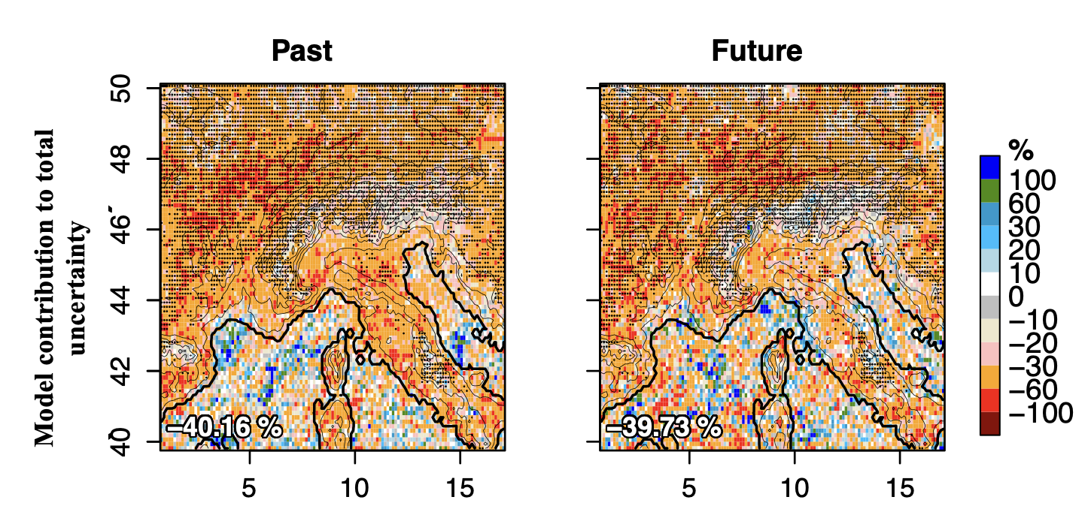
Figure S8: As for Figure 6 bottom, but with TU_test.

