Supplementary materials

Figure S1.
Model 1 - The Hypothesized Model.
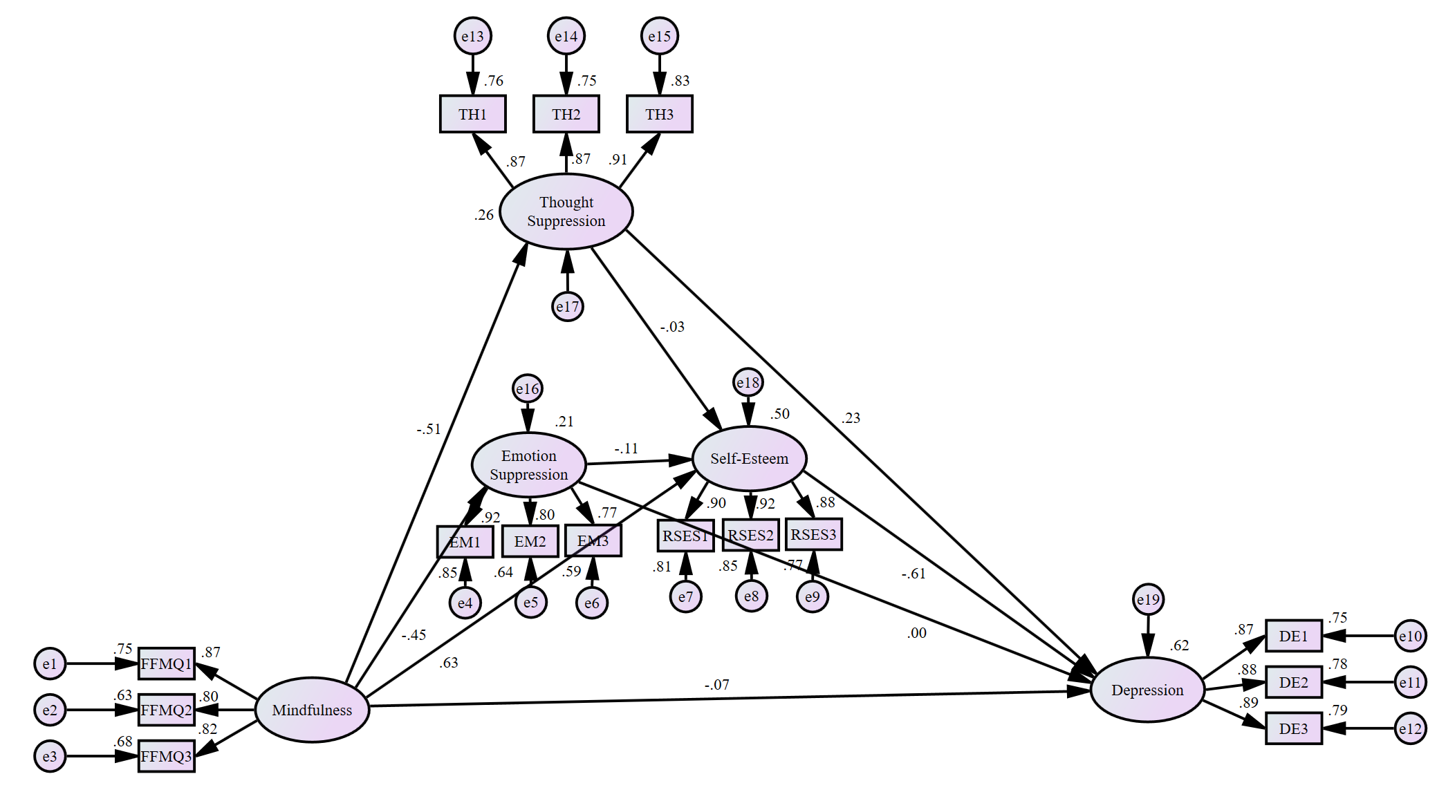

Figure S2.
Model 2 – The Model after Eliminating the Three Insignificant Paths.
