Supplementary Information

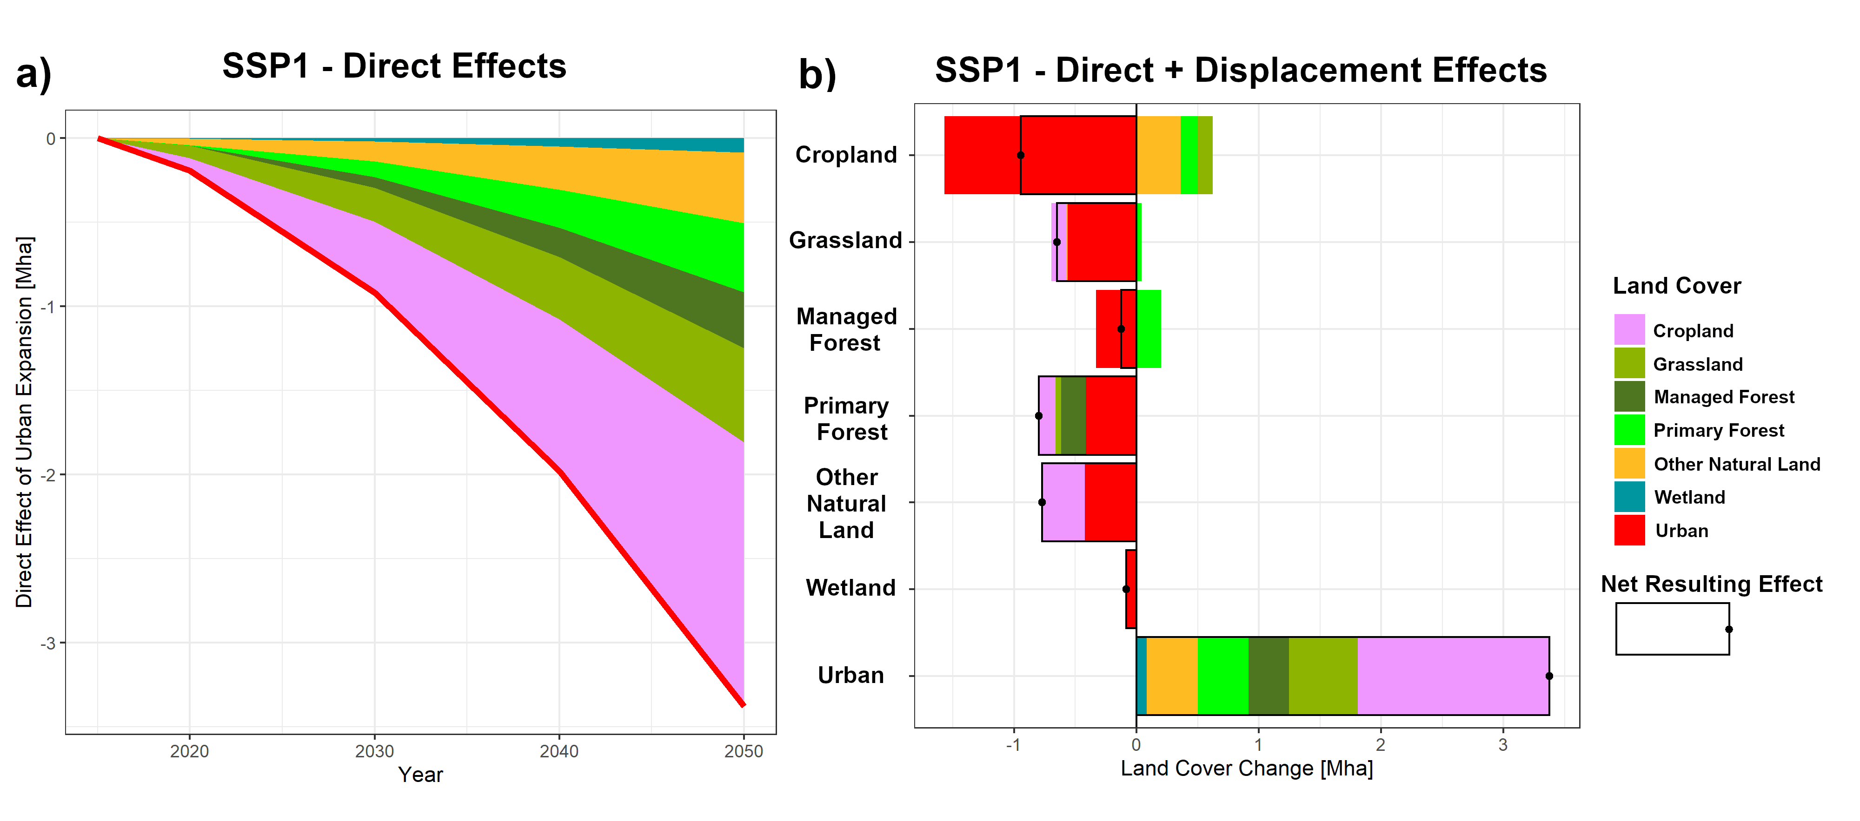
Supplementary Figure 1: Land Cover Changes [Mha] induced by urbanization on the African continent by 2050 under SSP1-Sustainability. a) Only considering direct effects of urban expansion. b) also considering land use displacement effects.
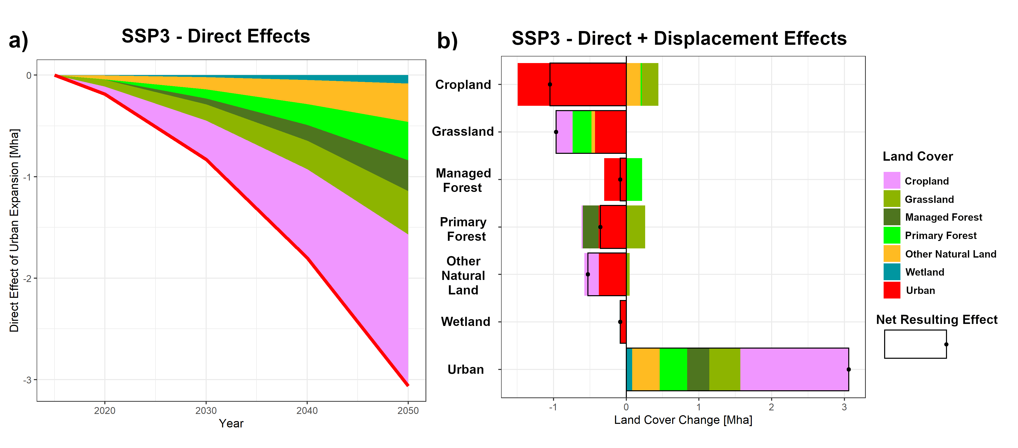
Supplementary Figure 2: Land Cover Changes [Mha] induced by urbanization on the African continent by 2050 under SSP3-Regional Rivalry. a) Only considering direct effects of urban expansion. b) also considering land use displacement effects.

Supplementary Table 1: Direct and Net Total (Direct + Displacement) land use change induced by African urbanization (in Mha) under different Shared Socioeconomic Pathways (SSP) by 2050.
Africa - 2050 |  | Direct Effects  (Mha) |  |  | Direct Effect + Displacement Effects (Mha)
 |  | SSP1 | SSP2 | SSP3 | SSP1 | SSP2 | SSP3
 | Cropland | -1.57 | -1.65 | -1.49 | -0.95 | -0.73 | -1.05
 | Grassland | -0.56 | -0.42 | -0.43 | -0.65 | -0.43 | -0.96
 | Managed Forest | -0.33 | -0.33 | -0.30 | -0.13 | -0.05 | -0.08
 | Primary Forest | -0.41 | -0.39 | -0.38 | -0.80 | -0.98 | -0.38
 | Other Natural Land | -0.42 | -0.40 | -0.38 | -0.77 | -1.00 | -0.53
 | Wetland | -0.08 | -0.09 | -0.08 | -0.08 | -0.09 | -0.08
 | Urban | +3.38 | +3.28 | +3.07 | +3.38 | +3.28 | +3.07

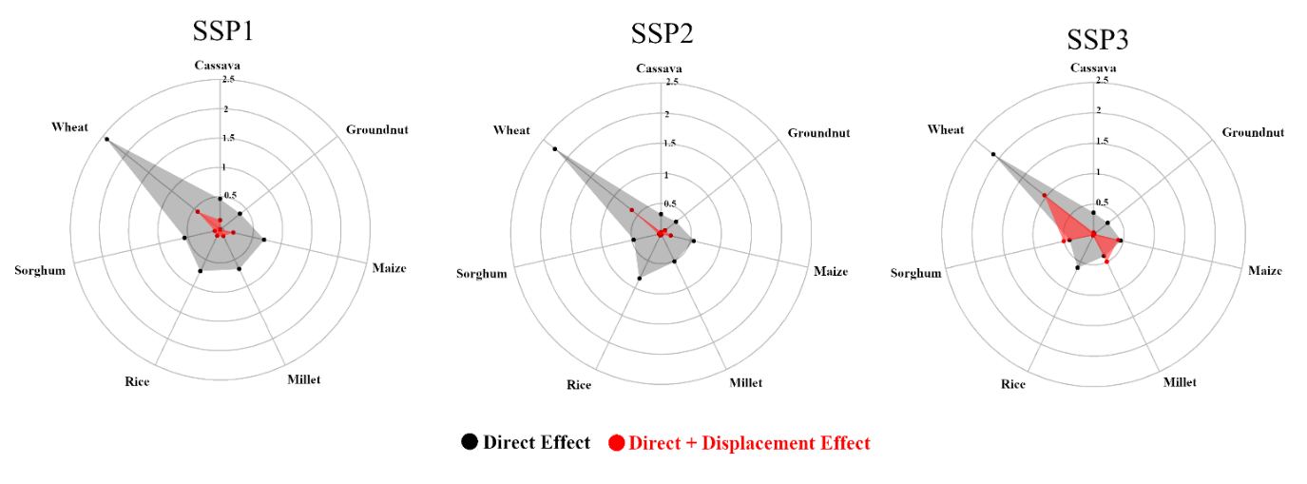
Supplementary Figure 3: Expected production losses [in %] for key staple crops in Africa following different Shared Socioeconomic Pathways (SSP) when only accounting for direct urban expansion effects (black) or when also accounting for displacement effects (red) at the continental scale. See Methods for the calculation of the production losses

Observed Increase in Rice Demand
For both Eastern and Western African regions (EAC and ECOWAS), we observe a similar ratio of urban over rural per capita rice consumption of around 1.50 based on estimates from the available LSMS household surveys (Supplementary Figure 4). Although our analysis also includes information on Ethiopia (rural demand < urban demand) and Malawi (rural demand > urban demand), data from other countries is not available to represent their respective regions – thereby questioning the representativeness of these regions (see Supplementary Table 2 for more information on the surveys included). For the other regions, no observed data was available and the continental average was considered (see Methods)
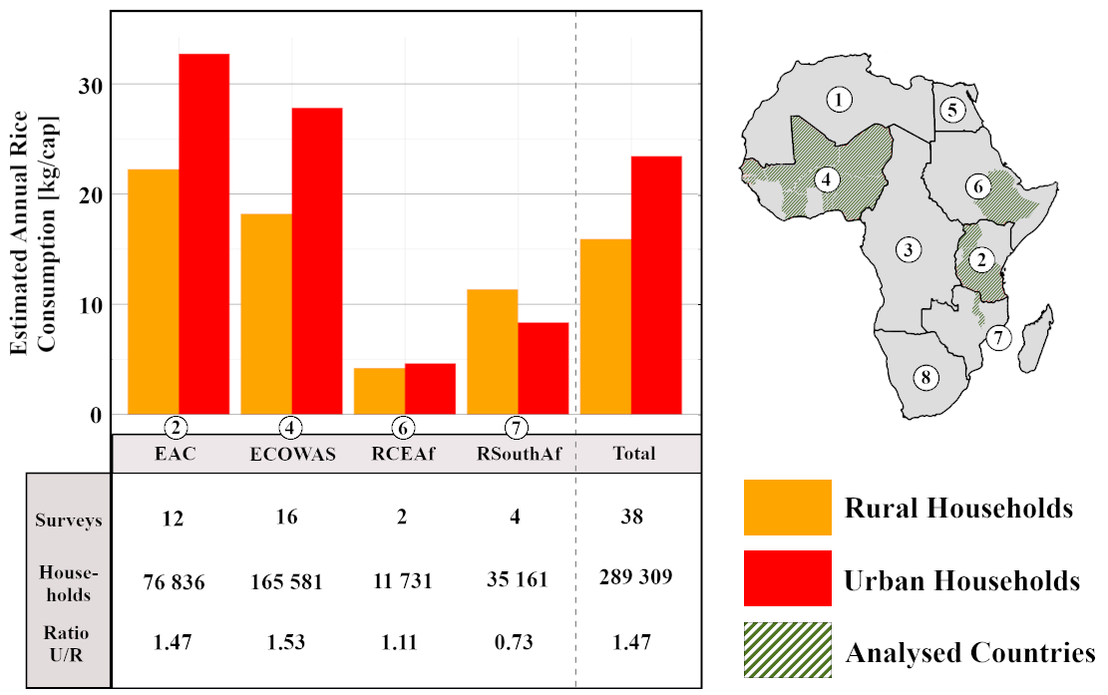
Supplementary Figure 4: Estimated Annual rice consumption (in kg/cap) for rural (orange) and urban (red) households in the LSMS household surveys for the selected countries (see Supplementary Table 2). For each region aggregated following Janssens et al., (2022), the number of surveys, total number of households, and the ratio between estimated urban and rural consumption is provided (urban/rural). For the calculation of the estimated annual rice consumption, see Methods. The total is the average of all surveys weighted on the countries’ population.

Supplementary Table 2: Overview of the household surveys available on the World Bank’s LSMS data catalog for Africa. For each available survey, we provide further information on whether this survey was included in our analysis (green= included, yellow = partially included, orange = excluded). If the survey was not (fully) included in our analysis, a reason as to why is also provided.
 | Survey included in analysis |  |  | Survey partly included in analysis* |  |  | Survey excluded from analysis*
Region |  | Country | Survey |  |  | *Reason
②-EAC |  | Tanzania | National Panel Survey 2019-2020 – Extended panel with Sex Disaggregated Data
 |  | Tanzania | National Panel Survey 2014-2015, Wave 4 – Extended Panel
 |  | Tanzania | National Panel Survey 2012-2013, Wave 3
 |  | Tanzania | National Panel Survey 2010-2011, Wave 2
 |  | Tanzania | National Panel Survey 2008-2009, Wave 1
 |  | Tanzania | High Frequency Welfare Monitoring Phone Survey 2021 |  |  | Does not report on rice consumption
 |  | Tanzania | National Panel Survey Wave 4 – Feed the Future Interim Supplemental Survey 2016 |  |  | Does not disaggregate to rice consumption
 |  | Tanzania | Measuring Living Standards within Cities, Dar es Salaam 2014-2015 |  |  | Only considers an urban environment
 |  | Tanzania | National Panel Survey 2014-2015, Wave 4 |  |  | Duplicate data with the extended version
 |  | Tanzania | Kagera Health and Development Survey 2010, Wave 6 |  |  | Only covers the Kagera region
 |  | Tanzania | National Panel Survey 2008-2015, Uniform Panel Dataset |  |  | Duplicates to the used waves
 |  | Tanzania | Kagera Health and Development Survey 2004 (Wave 5 Panel) |  |  | Only covers the Kagera region
 |  | Tanzania | Human Resource Development Survey 1993 |  |  | Data prior to 2000
 |  | Tanzania | Kagera Health and Development Survey 1991-1994 (Wave 1 to 4 Panel) |  |  | Data prior to 2000
 |  | Uganda | National Panel Survey 2019-2020
 |  | Uganda | Uganda National Panel Survey 2018-2019
 |  | Uganda | National Panel Survey 2015-2016
 |  | Uganda | National Panel Survey 2013-2014
 |  | Uganda | National Panel Survey 2011-2012, Wave III
 |  | Uganda | National Panel Survey 2010-2011
 |  | Uganda | National Panel Survey 2005-2009
 |  | Uganda | High-Frequency Phone Survey 2020-2023 |  |  | Does not report on rice consumption
 |  | Uganda | High-Frequency Phone Survey on COVID-19 2020-2021 – World Bank LSMS Harmonized Dataset |  |  | Does not report on rice consumption
ECOWAS-④ |  | Benin | Enquete Harmonisée sur le Conditions de Vie des Ménages 2018-2019
 |  | Burkina Faso | Enquete Harmonisée sur le Conditions de Vie des Ménages 2018-2019
 |  | Burkina Faso | Enquete Multisectorielle Continue 2014 |  |  | Only the first passage is used as the others did not report on quantity consumed
 |  | Côte d’Ivoire | Enquete Harmonisee sur le Conditions de Vie des Menages 2018-2019
 |  | Côte d’Ivoire | Enquete Permanente Aupres des Menages 1988-1989 (Wave 4 Panel) |  |  | Survey prior to 2000
 |  | Côte d’Ivoire | Enquete Permanente Aupres des Menages 1987-1988 (Wave 3 Panel) |  |  | Survey prior to 2000
 |  | Côte d’Ivoire | Enquete Permanente Aupres des Menages 1986-1987 (Wave 2 Panel) |  |  | Survey prior to 2000
 |  | Côte d’Ivoire | Enquete Permanente Aupres des Menages 1985-1986 (Wave 1 Panel) |  |  | Survey prior to 2000
 |  | Gambia | Integrated Household Survey 2015
 |  | Gambia | Integrated Household Survey 2010
 |  | Ghana | Socioeconomic Panel Survey 2009-2010 |  |  | Provided quantity units are not convertible to kg
 |  | Ghana | Living Standards Survey IV 1998-1999 |  |  | Survey prior to 2000
 |  | Ghana | Living Standards Survey III 1991 |  |  | Survey prior to 2000
 |  | Ghana | Living Standards Survey II 1988-1989 |  |  | Survey prior to 2000
 |  | Ghana | Living Standards Survey I 1987-1988 |  |  | Survey prior to 2000
 |  | Guinea-Bissau | Inquerito Harmonizado sobre as Conficöes de vide dos Agreagados Familiares 2018-2019
 |  | Liberia | National Household Forest Survey 2018-2019 |  |  | Only considers rice consumption from autoconsumption
 |  | Mali | Enquete Harmonisee sur le Conditions de Vie des Menages 2018-2019
 |  | Mali | COVID-19 Panel Phone Survey of Households 2020 |  |  | Does not report on rice consumption
 |  | Mali | Enquete Agricole de Conjoncture Integreee aux Conditions de Vie des Menages 2017 |  |  | Does not report on rice consumption
 |  | Mali | Enquete Agricole de Conjoncture Integree 2014 |  |  | Does not report on rice consumption
 |  | Niger | Enquete Harmonisee sur le Conditions de Vie des Menages 2018-2019
 |  | Niger | National Survey on Household Living Conditions and Agriculture 2014, Wave 2 Panel Data
 |  | Niger | National Survey on Household Living Conditions and Agriculture 2011 |  |  | Passage 2 not taken into account as it did not disaggregate between rural and urban
 |  | Nigeria | General Household Survey, Panel 2018-2019, Wave 4
 |  | Nigeria | Living Standards Survey 2018-2019
 |  | Nigeria | General Households Survey Panel 2015-2016, Wave 3
 |  | Nigeria | General Households Survey Panel 2012-2013, Wave 2
 |  | Nigeria | General Households Survey Panel 2010-2011, Wave 1
 |  | Nigeria | National Longitudinal Phone Survey 2021-2022 |  |  | Does not report on rice consumption
 |  | Nigeria | COVID-19 National Longitudinal Phone Survey 2020-2021 |  |  | Does not report on rice consumption
 |  | Nigeria | COVID-19 National Longitudinal Phone Survey 2020 – World Bank LSMS Harmonized Dataset |  |  | Does not report on rice consumption
 |  | Nigeria | General Household Survey Panel, Farm Area Measurement Validation Study 2013 |  |  | Does not report on rice consumption
 |  | Senegal | Enquete Harmonisee sur le Conditions de Vie des Menages 2018-2019
 |  | Togo | Enquete Harmonisee sur le Conditions de Vie des Menages 2018-2019
RCEAf-⑥ |  | Ethiopia | Socioeconomic Survey 2018-2019
 |  | Ethiopia | Socioeconomic Survey 2015-2016
 |  | Ethiopia | COVID-19 High Frequency Phone Survey of Households 2020 |  |  | Does not report on rice consumption
 |  | Ethiopia | COVID-19 High Frequency Phone Surveys of Households 2020 – World Bank LSMS Harmonized Dataset |  |  | Does not report on rice consumption disaggregated from other food
 |  | Ethiopia | Land and Soil Experimental Research 2013 |  |  | Does not report on rice consumption
 |  | Ethiopia | Socioeconomic Survey 2013-2014 |  |  | Does not report on rice consumption disaggregated from other cereals
 |  | Ethiopia | Rural Socioeconomic Survey 2011-2012 |  |  | Only considers rural households
RSouthAf-⑦ |  | Malawi | Fifth Integrated Household Survey 2019-2020
 |  | Malawi | Fourth Integrated Household Survey 2016-2017
 |  | Malawi | Third Integrated Household Survey 2010-2011
 |  | Malawi | Second Integrated Household Survey 2004-2005
 |  | Malawi | Integrated Household Panel Survey 2010-2013 (Short-Term Panel) |  |  | Duplicate data as the integrated household surveys
 |  | Malawi | Integrated Household Panel Survey 2010-2013-2016 (Long-Term Panel) |  |  | Duplicate data as the integrated household surveys
 |  | Malawi | Integrated Household Panel Survey 2010-2013-2016-2019 (Long-Term Panel) |  |  | Duplicate data as the integrated household surveys
 |  | Malawi | High-Frequency Phone Survey 2020-2022 |  |  | Does not report on rice consumption
 |  | Malawi | High-Frequency Phone Survey on COVID-19 – World Bank LSMs Harmonised Dataset |  |  | Does not report on rice consumption
SACU-⑧ |  | South-Africa | Integrated Household Survey 1993 |  |  | Data prior to 2000

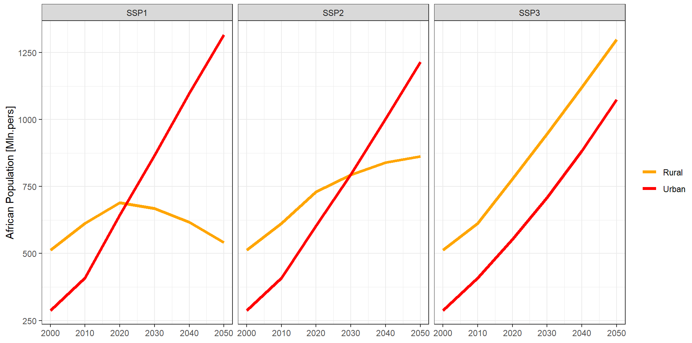
Supplementary Figure 5: Rural (orange) and urban (red) population projections for Africa under SSP1-sustainability (left), SSP2-Middle of the Road (middle), and SSP3-Regional Rivalry (right). Projections are based on Jiang & O’Neill (2017).

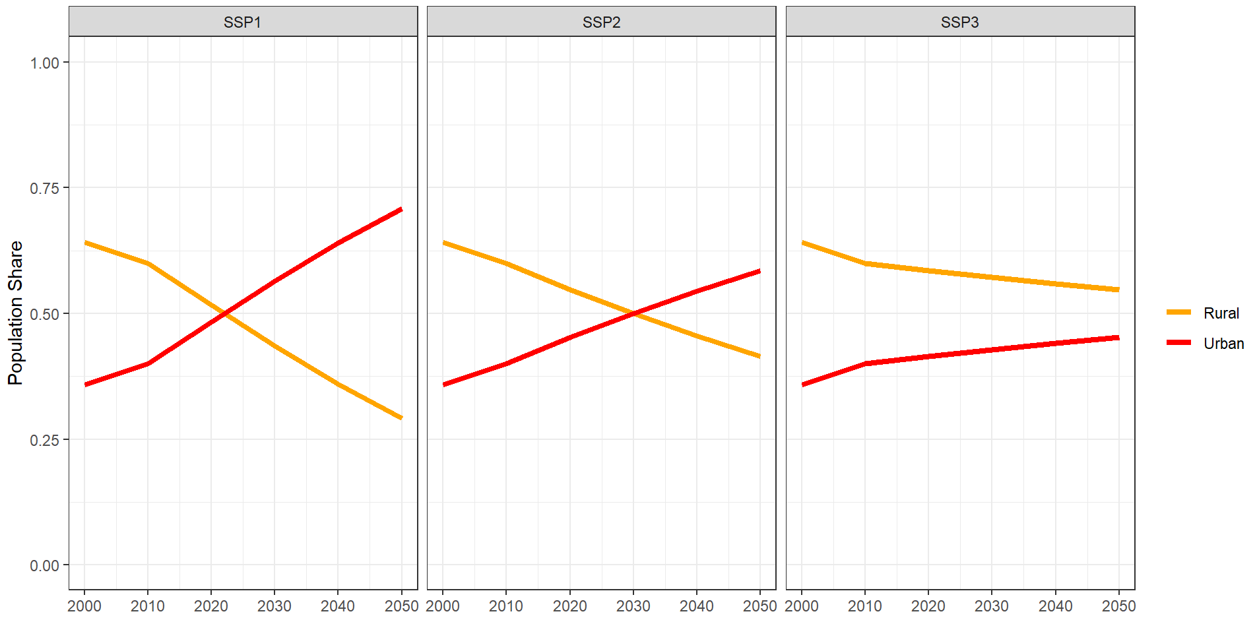
Supplementary Figure 6: Rural (orange) and urban (red) population share for Africa under SSP1-Sustainability (left), SSP2-Middle of the Road (middle), and SSP3-Regional Rivalry (right). Projections are based on Jiang & O’Neill (2017).

Supplementary Table 3: Net total urban effect per African region for the different SSP-scenarios on rice production in Mt and in percentage.
Rice Production [Mt] |  | SSP1 | SSP2 | SSP3
① | AMU | <0.01 | +0.02  (+12.0%) | +0.02  (+0.7%)
② | EAC | +1.10  (+16.2%) | +0.65  (+10.1%) | +0.29  (+4.3%)
③ | ECCAS | +0.77  (+17.6%) | +0.50  (+11.9%) | +0.20  (+4.8%)
④ | ECOWAS | +4.99  (+9.3%) | +5.72  (+10.7%) | +3.03  (+5.2%)
⑤ | Egypt | +0.70  (+9.0%) | +0.54  (+7.0%) | +0.07  (+1.0%)
⑥ | RCEAf | +0.03  (+7.9%) | <0.01 | <0.01
⑦ | RSouthAf | -1.03  (-8.5%) | -0.74  (-6.5%) | -0.32  (-2.7%)
⑧ | SACU | <0.01 | <0.01 | <0.01
 | Total | +6.55  (+7.7%) | +6.69  (+8.0%) | +3.30  (+3.7%)

Supplementary Table 4: Net total urban effect per African region for the different SSP-scenarios on total rice demand in Mt and percentage.
Rice Demand [Mt] |  | SSP1 | SSP2 | SSP3
① | AMU | +0.05  (+8.4%) | +0.04  (+5.9%) | +0.03  (+3.9%)
② | EAC | +1.23  (+15.6%) | +0.76  (+10.1%) | +0.37  (+4.7%)
③ | ECCAS | +0.81  (+15.2%) | +0.53  (+4.6%) | +0.24  (+4.8%)
④ | ECOWAS | +7.06  (+11.3%) | +6.89  (+11.2%) | +3.91  (+5.8%)
⑤ | Egypt | +0.73  (+11.6%) | +0.55  (+7.8%) | +0.08  (+1.2%)
⑥ | RCEAf | +0.05  (+4.1%) | +0.03  (+2.4%) | +0.01  (+0.9%)
⑦ | RSouthAf | -1.20  (-10.1%) | -0.77  (-6.5%) | -0.35  (-2.8%)
⑧ | SACU | +0.20  (+11.0%) | +0.14  (+7.9%) | +0.07  (+4.1%)
 | Total | +8.93  (+9.2%) | +8.18  (+8.4%) | +4.35  (+4.2%)

Supplementary Table 5: Net total urban effect per African region for the different SSP-scenarios on net rice trade (Mt). Net Trade is defined as export-import. Net importing regions are visualized in blue, net exporting regions are visualized in orange. A positive value for a net importing region represents a region that is becoming lesser dependent on imports and vice versa for a negative value. A positive value for a net exporting region represents a region that is increasing in exports, and vice versa for a negative value.
Rice Net Trade [Mt] |  | SSP1 | SSP2 | SSP3
① | AMU | -0.05 | -0.03 | -0.01
② | EAC | -0.13 | -0.11 | -0.08
③ | ECCAS | -0.04 | -0.03 | -0.03
④ | ECOWAS | -2.07 | -1.17 | -0.88
⑤ | Egypt | -0.03 | -0.01 | -0.01
⑥ | RCEAf | -0.02 | -0.03 | -0.01
⑦ | RSouthAf | +0.17 | +0.02 | +0.02
⑧ | SACU | -0.20 | -0.14 | -0.07
 | Total | -2.38 | -1.49 | -1.05

Supplementary Table 6: Net total urban effect per African region for the different SSP-scenarios on total land cover under “Other natural land” (Mha).
Other Natural Lands [Mha] |  | SSP1 | SSP2 | SSP3
① | AMU | <0.01 | -0.05 | -0.06
② | EAC | -0.02 | -0.14 | +0.04
③ | ECCAS | <0.01 | <0.01 | <0.01
④ | ECOWAS | -0.87 | -2.08 | -0.93
⑤ | Egypt | <0.01 | <0.01 | <0.01
⑥ | RCEAf | <0.01 | <0.01 | <0.01
⑦ | RSouthAf | <0.01 | <0.01 | <0.01
⑧ | SACU | <0.01 | <0.01 | <0.01
 | Total | -0.89 | -2.27 | -0.96

Supplementary Table 7: Net total urban effect per African region for the different SSP-scenarios on total land cover under primary forest (Mha).
Primary Forest [Mha] |  | SSP1 | SSP2 | SSP3
① | AMU | -0.01 | -0.01 | -0.01
② | EAC | -0.12 | -0.22 | -0.05
③ | ECCAS | -0.48 | -0.42 | -0.26
④ | ECOWAS | -0.46 | -0.41 | -0.31
⑤ | Egypt | / | / | /
⑥ | RCEAf | <0.01 | <0.01 | <0.01
⑦ | RSouthAf | -0.15 | -0.29 | +0.01
⑧ | SACU | -0.02 | -0.02 | -0.02
 | Total | -1.23 | -1.37 | -0.63

Supplementary Table 8: Net total urban effect per African region for the different SSP-scenarios on agricultural methane emissions from rice (R), enteric fermentation (E), and manure management (M) in Mt CO₂ eq. /yr.
CH₄-emission |  | SSP1 |  |  | SSP2 |  |  | SSP3
 |  | R | E | M | R | E | M | R | E | M
① | AMU | <0.01 | -0.03 | <0.01 | +0.01 | -0.03 | <0.01 | +0.02 | -0.05 | <0.01
② | EAC | +1.55 | -0.14 | -0.02 | +1.00 | -0.11 | <0.01 | +0.76 | <0.01 | -0.01
③ | ECCAS | +2.05 | -0.01 | <0.01 | +1.54 | -0.02 | <0.01 | +0.70 | <0.01 | <0.01
④ | ECOWAS | +8.26 | +0.16 | -0.11 | +10.82 | -0.44 | +0.09 | +6.97 | -0.16 | -0.01
⑤ | Egypt | +0.35 | <0.01 | <0.01 | +0.33 | <0.01 | <0.01 | +0.04 | <0.01 | <0.01
⑥ | RCEAf | +0.03 | -0.05 | <0.01 | <0.01 | -0.01 | <0.01 | +0.01 | -0.05 | <0.01
⑦ | RSouthAf | -1.20 | -0.02 | <0.01 | -0.99 | +0.03 | <0.01 | -0.45 | <0.01 | <0.01
⑧ | SACU | <0.01 | -0.01 | <0.01 | <0.01 | -0.01 | <0.01 | <0.01 | -0.02 | <0.01
 | Continental CH₄ | +11.04 | -0.10 | -0.13 | +12.70 | -0.58 | +0.09 | +8.04 | -0.28 | -0.03
 | Total CH₄ | +10.81 |  |  | +12.21 |  |  | +7.74

Supplementary Table 9: Net total urban effect per African region for the different SSP-scenarios on agricultural water use for rice (R) or other crops (O) in km³.
Agricultural  Water Use [km³] |  | SSP1 |  | SSP2 |  | SSP3
 |  | R | O | R | O | R | O
① | AMU | <0.01 | <0.01 | +0.04 | -0.44 | -0.03 | +0.34
② | EAC | +0.43 | -0.11 | +0.04 | +0.16 | <0.01 | <0.01
③ | ECCAS | <0.01 | <0.01 | <0.01 | <0.01 | <0.01 | <0.01
④ | ECOWAS | +2.70 | -0.88 | +0.04 | -0.04 | +1.75 | -1.75
⑤ | Egypt | +0.82 | -1.20 | +0.83 | -1.50 | +0.10 | -2.03
⑥ | RCEAf | +0.17 | +0.19 | <0.01 | -0.87 | +0.03 | -0.03
⑦ | RSouthAf | -1.81 | +1.41 | -1.43 | +0.68 | -1.59 | +1.64
⑧ | SACU | / | -0.08 | / | -0.02 | / | <0.01
 | Continental Water Use | +2.31 | -0.66 | -0.47 | -2.03 | -0.27 | -1.84
 | Total African Water Use | +1.65 |  | -2.50 |  | -1.57
 | Global Water Use | +2.17 | -2.58 | +1.77 | -3.58 | +1.81 | -3.53

