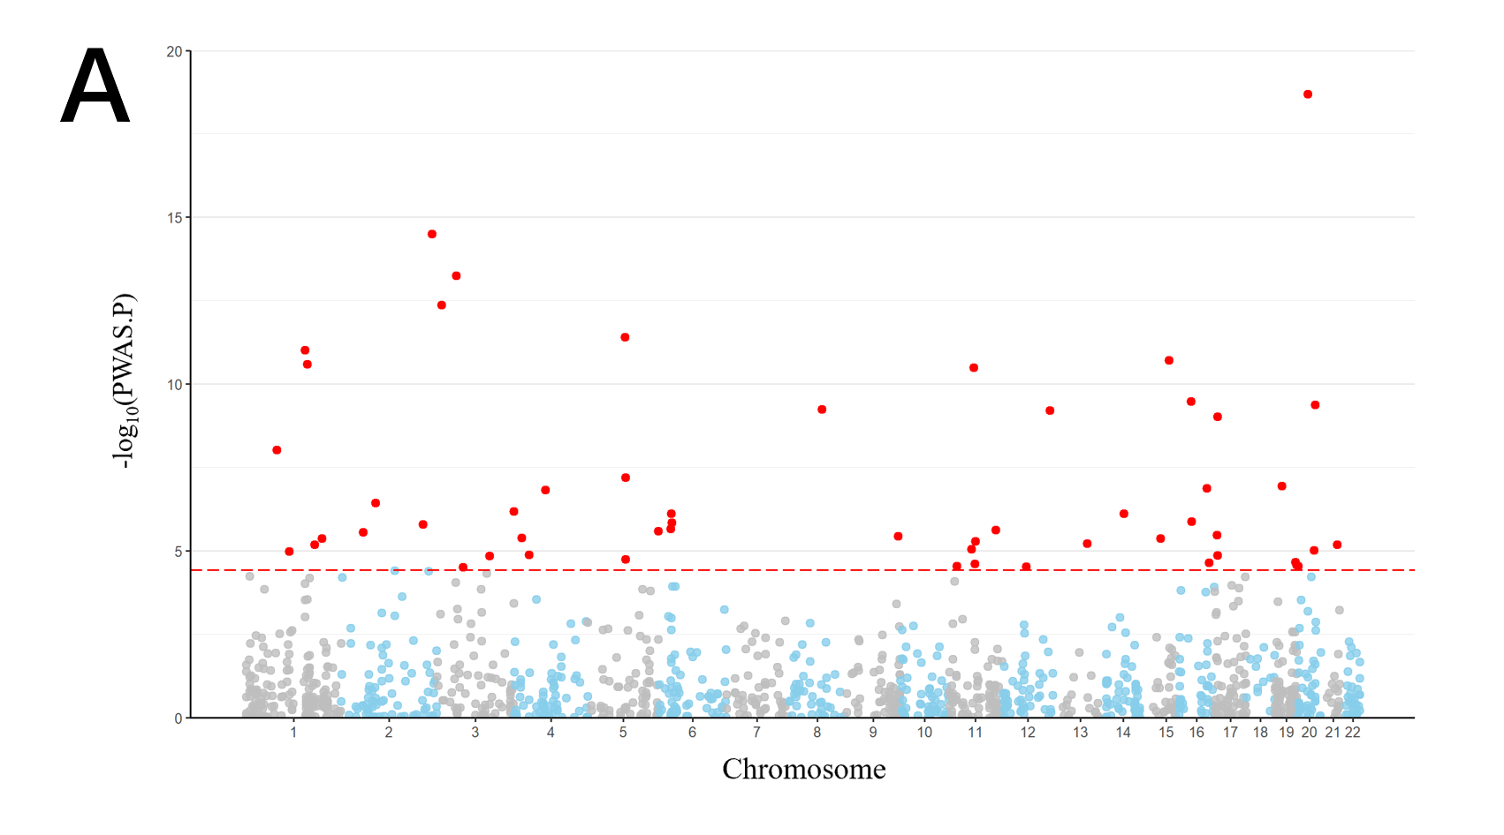

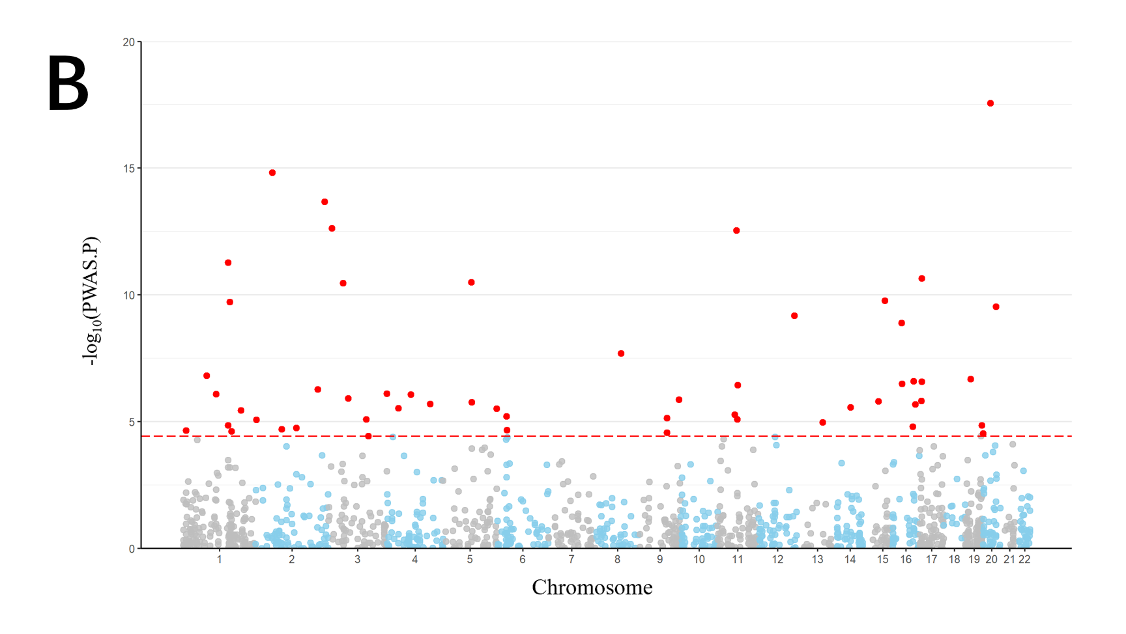
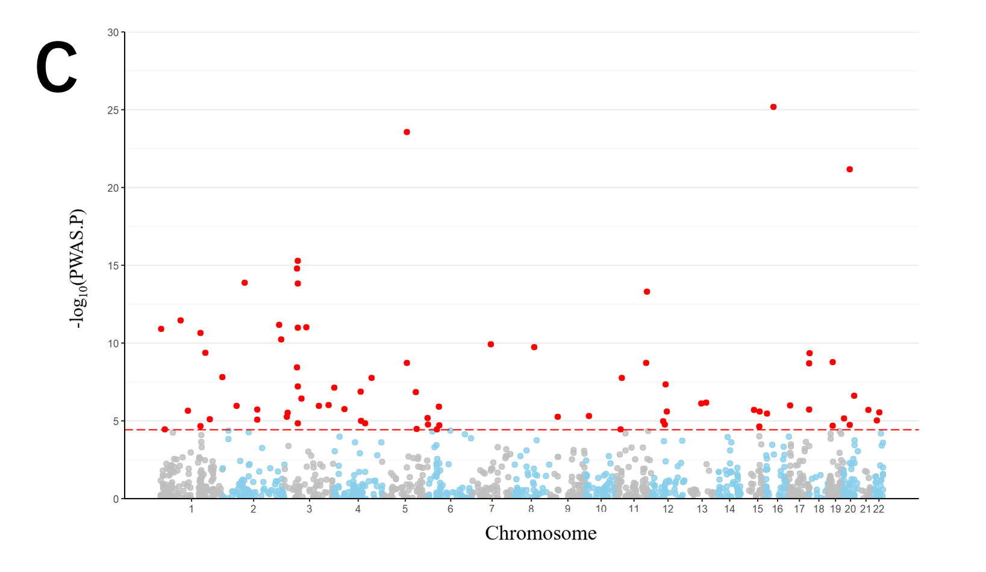

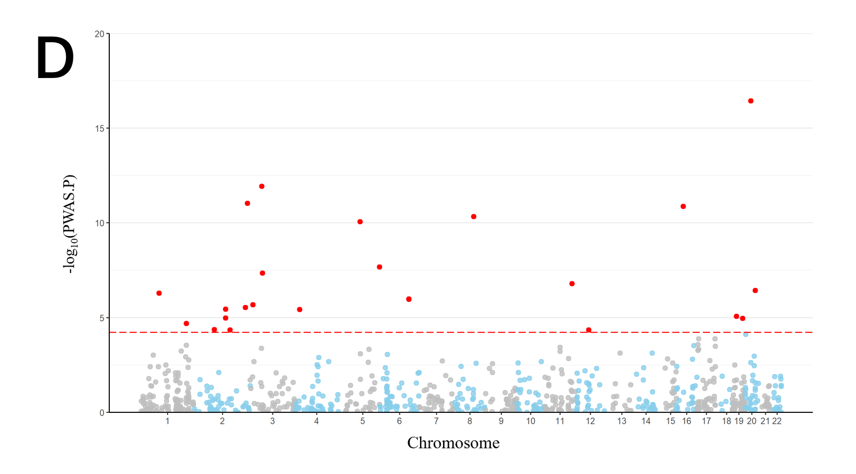
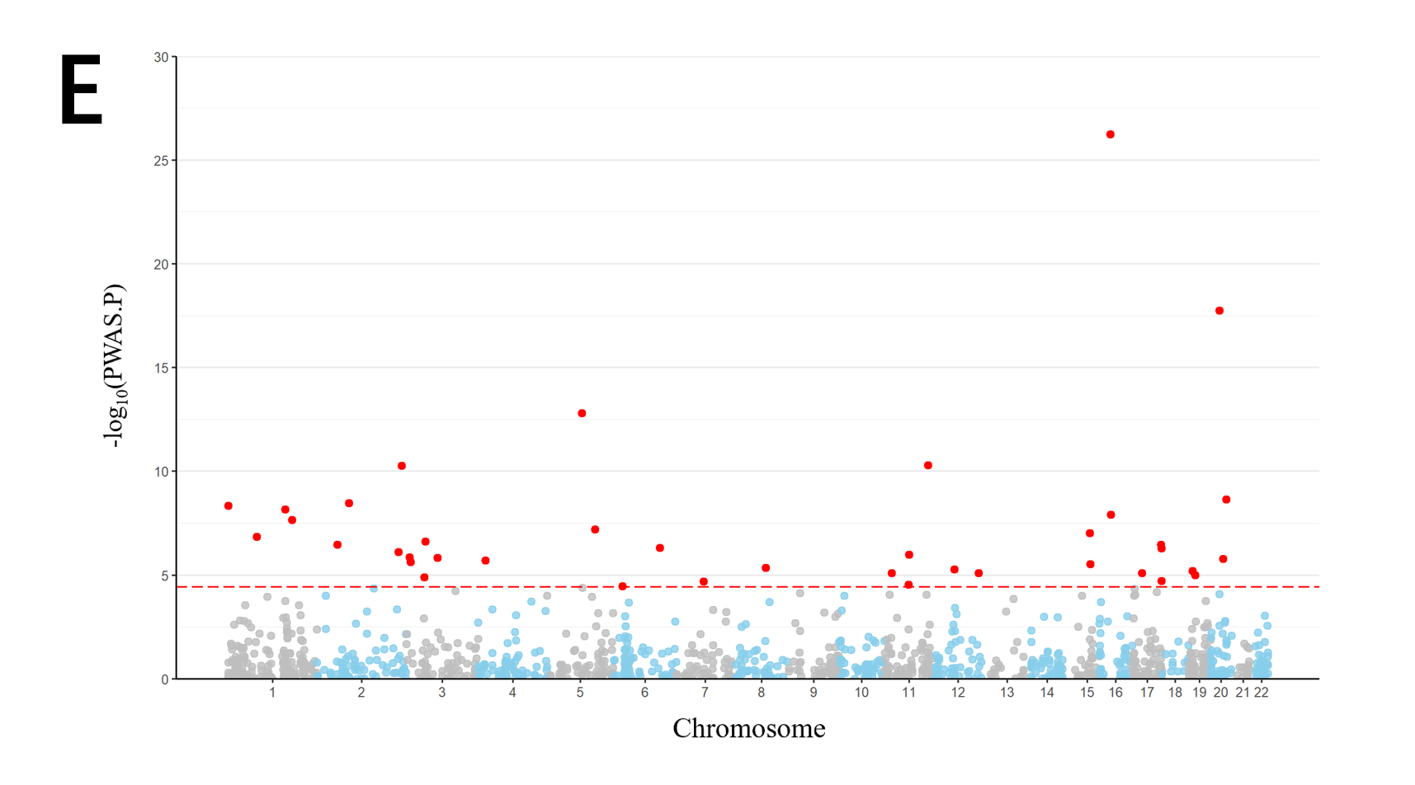

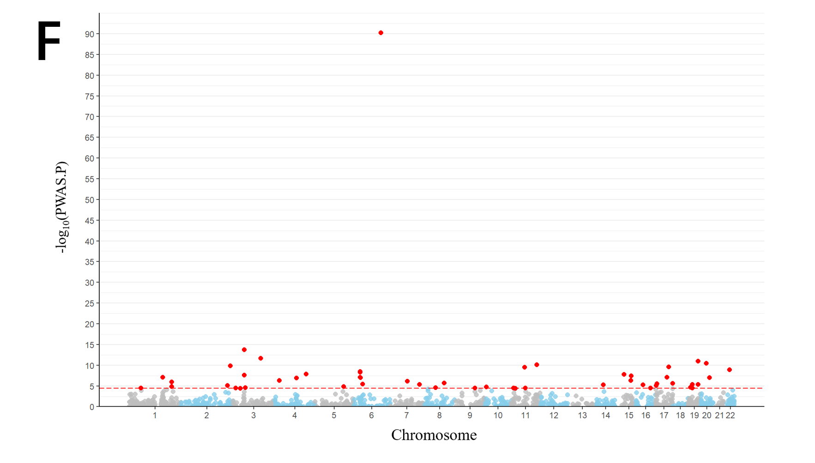
Figure 1．Manhattan plots for the six obesity-related traits PWASs in the ARIC human plasma proteomes. (A) Manhattan plot for PWAS integrating the GWAS of body fat percentage (N = 452,264) with ARIC proteomes (N = 7213). (B) Manhattan plot for PWAS integrating the GWAS of trunk fat percentage (N = 452,264) with ARIC proteomes (N = 7213). (C) Manhattan plot for PWAS integrating the GWAS of BMI (N = 806,834) with ARIC proteomes (N = 7213). (D) Manhattan plot for PWAS integrating the GWAS of VAT (N = 325,153) with ARIC proteomes (N = 7213). (E) Manhattan plot for PWAS integrating the GWAS of WC (N = 452,264) with ARIC proteomes (N = 7213). (F) Manhattan plot for PWAS integrating the GWAS of WHR (N = 697,734) with ARIC proteomes (N = 7213). Each dot on the x-axis represents a gene, and the association strength on the y-axis represents the -log10(p) of PWAS. PWAS significance level was set at p < 0.05/number of genes analyzed. GWAS, genome-wide association study PWAS, proteome-wide association study; ARIC, Atherosclerosis Risk in Communities.

