Supplementary materials

Effects of a live vs heat-inactivated probiotic in preterm infants- a pilot randomized trial

Gayatri Athalye-Jape, Meera Esvaran, Sanjay Patole, Elizabeth Nathan, Dorota Doherty, Edric Sim, Lakshmi Chandrasekaran, Chooi Kok, Stephan Schuster, Patricia Conway

Index Page
Supplementary Methods 2
Supplementary Table 1………………………………………………………………………………………………………………………..7
Fig S1 8
Fig S2 9
References 10

Supplementary Methods
Carmine red dye administration and measurement of intestinal transit time (ITT)
1g of 50% carmine red powder (50g of carmine red in 100g of sample, hence 125 mg of carmine red in 0.25g of powder) was weighed on digital scales using hand hygiene and sterile precautions throughout. This was added to 10ml of sterile water till powder dissolved completely. 1.25 ml of this solution (osmolality 190mosm/L) was administered to infant via naso or orogastric tube in week 3-4 post probiotic supplementation and when infant was on 15ml 2-3 hourly feeds. Time of administration was noted (A) and all subsequent nappies were checked for passage of dye. Time when carmine was first seen in stools was noted (B). This gave an estimate of ITT (A-B).^{1,2}
Sugar absorption test (SAT)
Intestinal permeability (IP) was measured by sugar absorption test. 2ml/kg of lactulose (250mg/5ml) and mannitol (100mg/5ml) solution was administered to infants in week 1 (after 48 hours of life post commencement of enteral feeds) for a baseline IP (SAT1) and after 3rd week of supplementation (between day 28-30 of life) for post supplementation IP (SAT2). Urine collection was commenced for 6 hrs following administration. As a preservative, 0.1 ml of 20% chlorohexidine digluconate was added to urine. Lactulose and mannitol concentrations (mmol/mol creatinine) were planned to be measured using gas chromatography and lactulose/mannitol ratio was planned to be calculated. Strict hand hygiene protocols were followed throughout.^{3,4}
Faecal sample collection
Two stool samples were collected in sterile containers from each participating infant; first sample (T1) was collected as soon as possible after birth/admission (week 1). The second sample (T2) was collected between 21-28 days of life (week 3-4). All samples were labelled and stored at -80⁰C. After completing recruitment, samples were shipped on dry ice (carbon dioxide) to the University of New South Wales (Sydney, Australia), for microbial analysis.
Calprotectin concentrations
Calprotectin concentrations were quantified using diluted faecal samples using the PhiCal ELISA kit (CalPro, USA) as per the manufacturers’ instructions.
Quantification of SCFA
SCFA from faecal samples were extracted and analysed as previously described.⁵ Acetic acid, propionic acid, isobutyric acid, butyric acid, isovaleric acid, 4-methyl valeric acid (internal standard, IS), ethyl acetate and meta-phosphoric acid were purchased from Merck (Singapore) for use as standards. Briefly, samples were acidified and stored frozen until being extracted and analysed with an added internal standard. An Agilent GC-MS system (Agilent Technologies 7890B-5977B Bundle with Stainless Steel Source) and an HP-FFAP capillary column (30 m×0.250 mm ×0.25 μm; Agilent). The calibration graphs were constructed by plotting the relative response (ratio of peak area of SCFA/peak area of IS) versus relative concentration for each SCFA. The final concentrations were expressed as microgram of SCFA per gram wet weight faecal sample. All the analyses were performed in duplicate. Wilcoxon rank analysis was performed to compare SCFA concentrations between different groups.
Linearity and sensitivity
A stock solution containing the mixture of standards (20mM final concentration each) in ethyl acetate was diluted to obtain a calibration curve ranging from 2 to 15 000 μM. IS was added to each diluted standards mixture (500 μM final concentration). The calibration graphs were constructed by plotting the ratio of peak area SCFA/peak area IS vs. concentration for each individual SCFA. By normalizing the peak area to that of the IS, the variability in the extraction step and the instrument response was corrected (in particular, the injection volume variability and the MS response). Each point of the calibration graph corresponds to the mean value from independent replicate injections. The limits of detection (LOD) and quantification (LOQ) of the individual analytes were obtained by injecting successively more diluted standard solutions and were calculated according to the International Union of Pure and Applied Chemistry method based on a signal-to-noise ratio (S/N) of 3 for the LOD and of 10 for the LOQ.
DNA extraction
DNA was extracted from thawed stool samples (0.3g) using the Qiagen Powersoil kit (cat# 1288-100; Hilden, Germany). Samples were subjected to physical lysis in a bead-beater (TissuerLyzer11, Qiagen) for 3min at 30Hz. DNA was eluted in molecular grade water and stored at -80⁰C.
PCR amplification and 16s rRNA gene sequencing
Genomic DNA was submitted to the Ramaciotti Centre for Genomics (University of New South Wales, Sydney, Australia) for library preparation and sequencing on the Illumina MiSeq platform using the MiSeq Kit v3 (2x300 cycles) using V3-V4 primers.⁶
Library preparation
Library preparation was performed according to Illumina’s TruSeq Nano DNA Sample Preparation protocol. The samples were sheared on a Covaris E220 to ~450bp, following the manufacturer’s recommendation, and uniquely tagged with one of Illumina’s TruSeq HT DNA dual barcode combination to enable sample pooling for sequencing. Finished libraries were quantitated using Promega's QuantiFluor dsDNA assay and the average library size was determined on an Agilent Tapestation 4200. Library concentrations were then normalized to 4nM and validated by qPCR on a QuantStudio-3 real-time PCR system (Applied Biosystems), using the Kapa library quantification kit for Illumina platforms (Kapa Biosystems). The libraries were then pooled at equimolar concentrations and sequenced on the Illumina HiSeq2500 platform at a read-length of 250bp paired-end.
16S rRNA gene sequence analysis
16S rRNA sequence data were quality filtered and trimmed using TRIMMOMATIC VERSION 0.36 truncating reads if the quality was below 12 in a sliding window of 4bp. USEARCH version 10.0.240 was used to merge, and quality filter sequencing reads between 350 and 500 nucleotides.⁶ Only unique sequences that appeared more than 9 times were retained. Processed reads were then concatenated and clustered into operational taxonomic units (OUT) at 97% sequence similarity using UPARSE. Chimeras were removed de novo in reference mode using UCHIME together with the SILVA SSURef NR99 database (version 132) and OTU sequences were identified taxonomically using BLASTN alignments against the SILVA database.⁷
For alpha diversity measures, each sample was subsampled 100 times to a count of 20000 counts per sample and the average was taken. OTU richness and diversity indices; Simpson, Shannon, ACE and Chao1 were calculated in R (version 3.6.0) using the vegan package. Relative abundance analysis at Phylum, Family, Genus and Species levels were carried out using phyloseq package in R.⁶ Data were visualized using ggplot2⁷ and ggpubr packages.⁸
For beta diversity analysis, data were square root transformed. A phylogenetic tree for diversity computations was calculated with FastTree (version 2.1.10). Weighted unifrac distances were calculated and visualized on a principal coordinate analysis plot.
Shotgun metagenomic analysis
Quality of the sequencing reads were checked using FastQC (version 0.11.9). Cutadapt (version 2.10) was used for quality filtering of the raw reads to remove adapters and low-quality bases using -e 0.1, --minimum-length 30 as parameters. Bowtie2 (version 2.3.5.1) was used for mapping the trimmed reads with the reference database, GRCH38 to remove human host reads using “–un-conc”, “–very-sensitive-local” as parameters.^{9,10}
Taxonomic profiling
Kaiju classifier (version 1.7.2) was used for taxonomic classification of metagenomic reads. The database index is created from the reference database, nr_euk (2020-05-25) downloaded from the source. MEGAN6 was used for calculating the normalized read counts of bacteria at species level. The read counts for each taxon are the number of reads covered by the clade rooted to this taxon.
Statistical analysis
All data analyses were conducted with R version 3.6.0. For microbial richness, linear mixed model effects (LME) test (MASS, lme4 and lmerTest packages) was used to identify if there were statistical differences between the groups over time as well as between the groups at the two time points. In our model, subject ID was a random factor, whilst time and treatment were used as fixed factors. Post-hoc pairwise comparisons between the groups were performed using Tukey’s HSD method to adjust for multiple comparisons.
Taxa enriched between the groups over time were identified at phylum, family, genus and species levels using the Analysis of Composition of Microbiomes (ANCOM; v2.1).⁶ In this study ANCOM v2.1 code was used which allows for analysis of longitudinal samples and can be adjusted for confounding variables (birth weight and gestation age). Cut-off level of ‘detected 0.7’ was used to accept taxa as significantly enriched across groups and time. To identify differences between the groups at timepoints, Wilcoxon Rank Sum Test with Benjamini-Hochberg correction to adjust for multiple testing was used.⁹⁻¹²
For beta diversity, PERMANOVA with 999 permutations was implemented to check if community structures differed between the groups at the two time points followed by pairwise adonis test for comparisons between the groups.⁶ P values were adjusted for multiple testing using the Benjamini-Hochberg correction.¹³
For all analyses, an adjusted P value <0.05 was considered statistically significant.

Composition of heat-inactivated probiotic (HP by heating for 100º C for 15 minutes)
Total cell count (aerobic) | Not detected (<10/g)
Bifidobacteria counts (anaerobic) | Not detected (<10/g)
Fungi cell counts | Not detected (<10/g)
Yeast cell counts | Not detected (<10/g)
Staphylococcous aureus | Negative/ 0.01 g
Total coliforms | Negative/ 0.2 g
Bacillus cereus | Not detected (<0.3 g)
C. sakazakii | Negative/ 50g
Salmonella | Negative/25g

Supplementary Table 1: Secondary outcomes in infants with gestation <28 weeks
 | Live probiotic,  n=15 | Heat-inactivated probiotic,  n=14 | p-value
Intestinal transit time (h)  Pr_{n=11}, Pa_{n=10} | 20.6 (18.0-25.0) | 15.4 (10.0-26.3) | 0.282
All-cause mortality | 1 (6.7%) | 1 (7.1%) | 1.000
Time to full feeds# (150ml/kg/day) (d) | 9 (6-12) | 9 (6-9) | 0.323
TPN duration# (d) | 8 (7-11) | 10 (8-11) | 0.213
Length of hospital stay# (d) | 100 (71-120) | 96 (91-123) | 0.538
Late onset sepsis
Suspected | 9 (60.0%) | 10 (71.4%) | 0.700
Confirmed | 2 (13.3%) | 1 (7.1%) | 1.000
Data represent median, interquartile range, or number (%), unless otherwise stated.
# Data represent median and 25th-75th percentile Kaplan-Meier survival estimates.

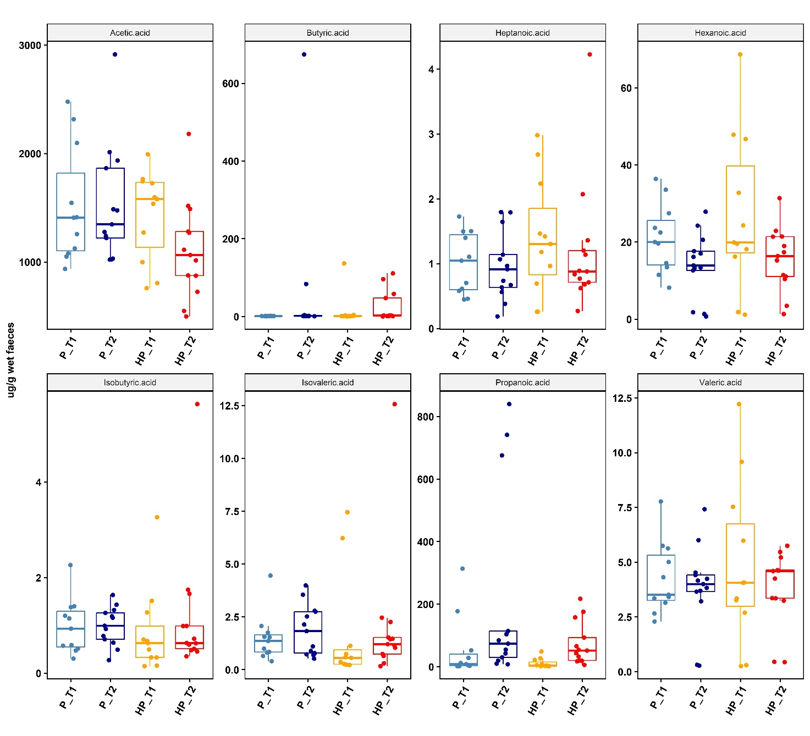
FigS1: SCFA (ug/g wet faeces) in extreme preterm subgroup
Acetic, Butyric, Heptanoic, Hexanoic, Isobutyric, Isovaleric Propionic and Valeric acid. Box shows first and third interquartile range; the line, median and the dots represent an individual sample. Differences between groups and over time was evaluated using linear mixed model test where time and probiotic supplements were fixed factors and Subject ID was the random factor. Tukey’s HSD method was used to adjust for multiple comparisons.

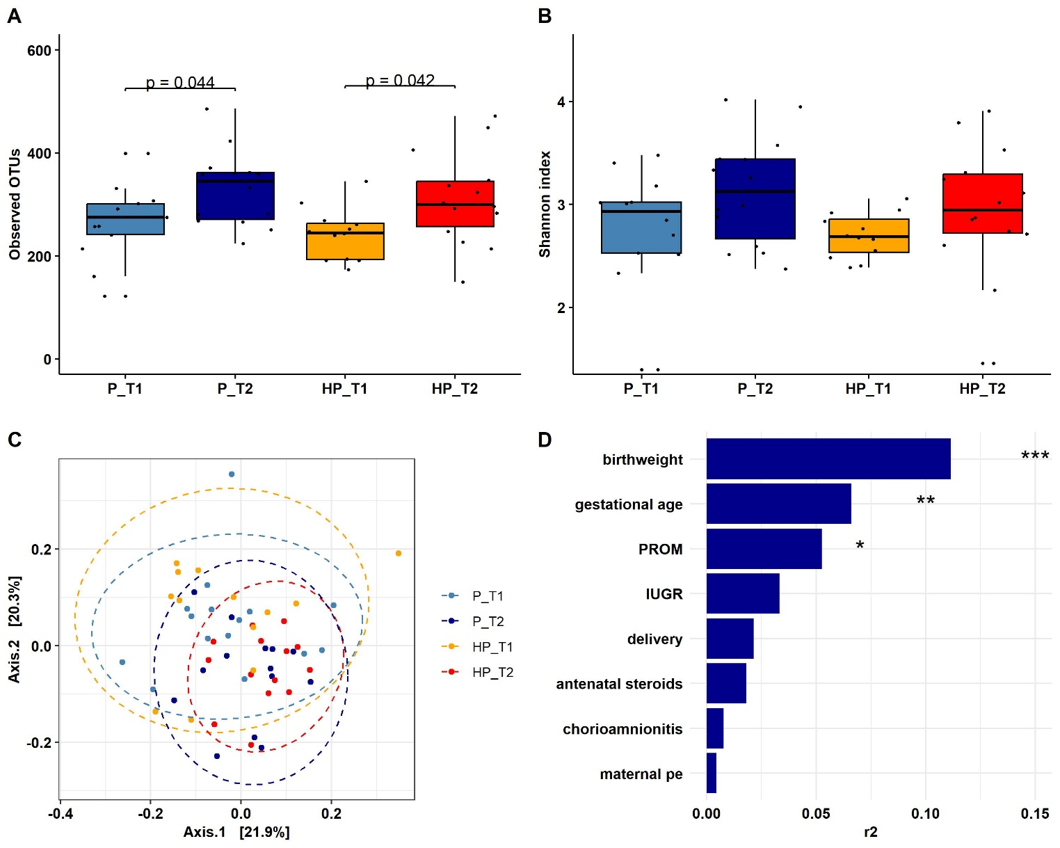
Fig S2: Alpha and beta diversity measures in extreme preterm subgroup
(A) observed OTUs and (B) diversity measure Shannon. (C) Principal coordinate analysis (PCoA) based on weighted unifrac distances. Each sample is depicted as a dot. Differences in the community structures by group and time was checked by PERMANOVA and pairwise adonis test for pair-wise comparisons between the groups. (D) Host factors and their effect sizes on beta diversity. Microbiota covariates were identified using the envfit function (vegan). Bonferroni-Holm was used to adjust for multiple comparison. Significant differences are indicated by * P <0.05, ** <0.01, *** <0.001.

References
1. Costalos C, Gounaris A, Varhalama E, Kokori F, Alexiou N, Kolovou E. Erythromycin as a prokinetic agent in preterm infants. J Pediatr Gastroenterol Nutr. 2002 Jan;34(1):23-5
2. Athalye-Jape G, Esvaran M, Patole S, Simmer K, Nathan E, Doherty D, Keil A, Rao S, Chen L, Chandrasekaran L, Kok C, Schuster S, Conway P. Effect of single versus multistrain probiotic in extremely preterm infants: a randomised trial. BMJ Open Gastroenterol. 2022 Feb;9(1):e000811.
3. van Elburg RM, Fetter WPF, Bunkers CM, et al. Intestinal permeability in premature infants. Arch Dis Child Fetal Neonatal 2003;88:F52–5
4. van Elburg RM, Uil JJ, Kokke FTM, et al. Repeatability of the sugar absorption test, using lactulose and mannitol, for measuring intestinal permeability for sugars. J Pediatr Gastroenterol Nutr 1995;20:184–8.
5. Klindworth A, Pruesse E, Schweer T, et al. Evaluation of general 16S ribosomal RNA gene PCR primers for classical and next-generation sequencing-based diversity studies. Nucleic Acids Res 2013; 41(1): e1.
6. Wu D, Chen L, Teh J, Sim E, Schlundt J, Conway PL. Honeys with anti-inflammatory capacity can alter the elderly gut microbiota in an ex vivo gut model. Food Chem. 2022 Oct 30;392:133229.
7. Edgar RC. Search and clustering orders of magnitude faster than BLAST. Bioinformatics 2010; 26(19): 2460-1.
8. Quast C, Pruesse E, Yilmaz P, et al. The SILVA ribosomal RNA gene database project: improved data processing and web-based tools. Nucleic Acids Res 2013; 41: D590-6.
9. McMurdie PJ, Holmes S. phyloseq: An R Package for Reproducible Interactive Analysis and Graphics of Microbiome Census Data. PLoS One 2013; 8(4): e61217.
10. Wickham H. ggplot2: Elegant Graphics for Data Analysis. Springer-Verlag New York, 2016
11. Alboukadel Kassambara (2020). ggpubr: 'ggplot2' Based Publication Ready Plots. R package version 0.4.0. https://CRAN.R-project.org/package=ggpubr.
12. Mandal S, Van Treuren W, White RA, Eggesbo M, Knight R, Peddada SD. Analysis of composition of microbiomes: a novel method for studying microbial composition. Microb Ecol Health Dis 2015; 26: 27663.
13. Bernd and Franziska Wemheuer. Running pairwise.adonis.version 0.1.0.2018

