Manuscript for Advanced Composites and Hybrid Materials
Supplementary Information
In situ polymerization of hydrogel electrolyte on electrode enabling the flexible all-hydrogel supercapacitors with low-temperature adaptability
Yijing Zhang^{1,2}, Yue Sun^{1,2}, Jingya Nan^{1,}*, Fusheng Yang¹, Zihao Wang¹, Yuxi Li¹, Chuchu Wang¹, Fuxiang Chu^{1,2}, Yupeng Liu^{1,2,}*, and Chunpeng Wang^{1,2,}*
¹Institute of Chemical Industry of Forest Products, Chinese Academy of Forestry; Key Laboratory of Biomass Energy and Material, Jiangsu Province, Nanjing, Jiangsu 210042, China.
²Co-Innovation Center of Efficient Processing and Utilization of Forest Resources, Nanjing Forestry University, Nanjing, Jiangsu 210037, China.
*Corresponding author. E-mail: Jingya Nan, nanjingya@icifp.cn; E-mail: Yupeng Liu, liuyupeng@icifp.cn; E-mail: Chunpeng Wang, wangchunpeng@icifp.cn
Yijing Zhang and Yue Sun are contributed equally to this work.
This file includes:
Supporting Fig.S1 to S14 and Table S1 to S4
Description of Supporting Movies
Supporting References

Table of Contents
Supporting Figures and Tables 3
Fig.S1 DLS analysis of the lignin and Ag-Lignin dispersion. 3
Fig.S2 Pure-shear test for measuring the fracture energy of hydrogel matrix. 4
Fig.S3 Adhesive property of the hydrogel matrix. 5
Fig.S4 Tensile properties of hydrogel electrolytes with different AAm:HAp mass ratios. 6
Fig.S5 Fracture energy of hydrogel matrices with different AAm: HAp mass ratios. 7
Fig.S6 Scanning electron microscope (SEM) images of the PAAm-HAp/CNTs-PPy hydrogel electrode and the PAAm-HAp/ZnCl₂ hydrogel electrolyte. 8
Fig.S7 The interfacial adhesion test of the all-hydrogel supercapacitors. 9
Fig.S8 Raman fitting curves for different ZnCl₂ concentration (0~15 m). 10
Fig.S9 The radial distribution function (RDF) and the corresponding average coordination number (N) for 7.5 m and 15 m ZnCl₂ electrolytes. 11
Fig.S10 The tensile cycles test of the hydrogel electrolyte at the temperature of 20~−60 °C. 12
Fig.S11 The low-temperature fatigue resistance of the all-hydrogel supercapacitor. 13
Fig.S12 Electrochemical performance of all-hydrogel supercapacitors at −50 °C. 14
Fig.S13 Electrochemical impedance analysis of all-hydrogel supercapacitors at temperatures ranging from 20 to −50 °C. 15
Fig.S14 Optical images of the all-hydrogel supercapacitor. 16
Fig.S15 Tensile cycling tests of all-hydrogel supercapacitors at 20% strain. 17
Table S1. Comparison of the low-temperature adhesion performance of our hydrogel electrolyte with previously-reported anti-freezing hydrogels. 18
Table S2. Ionic conductivity of hydrogel electrolytes with different concentrations of ZnCl₂ in the temperature range of 20~–60 °C 19
Table S3. Fitting equivalent circuit results of the all-hydrogel supercapacitor in the temperature range of 20~–50 °C 20
Table S4. Comparison of electrochemical performance of our all-hydrogel supercapacitor with previously-reported flexible hydrogel-based energy storage devices 21
Description of Supporting Movies 23
Supporting References 24

Supporting Figures and Tables

Fig.S1 DLS analysis of the lignin and Ag-Lignin dispersion. Size distribution of a lignin dispersion and b Ag-Lignin dispersion. The DLS analysis determines an average size of Ag-Lignin NPs to be ~390 nm, which can be attributed to the fact that the introduction of Ag atoms benefits the stabilization between lignin clusters.

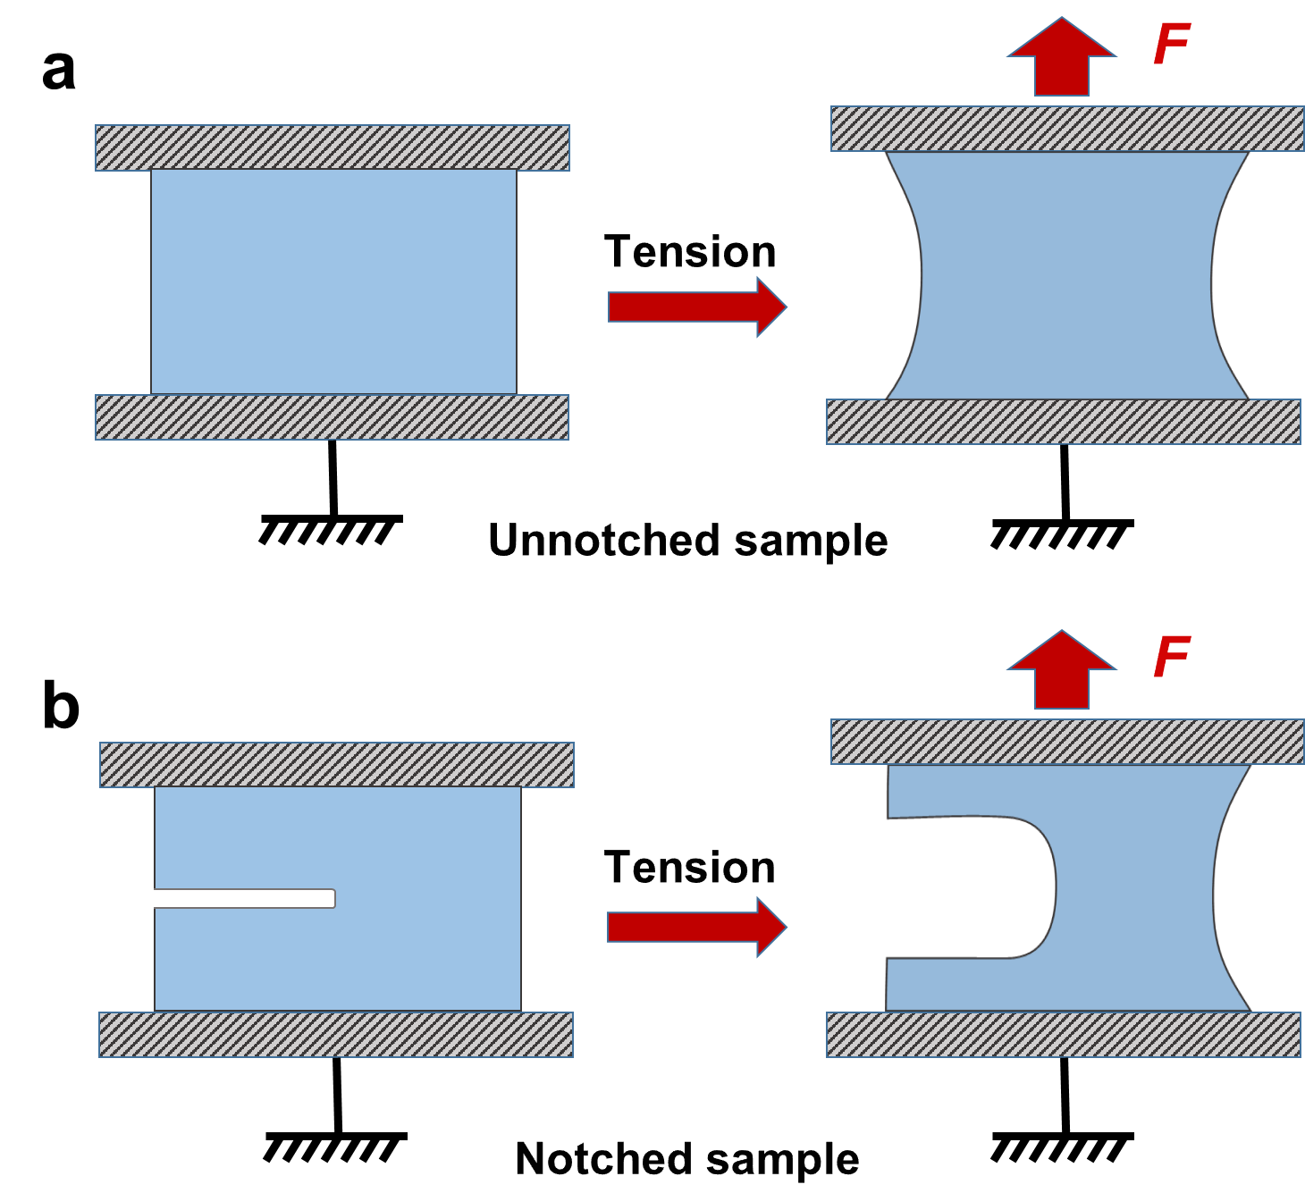

Fig.S2 Pure-shear test for measuring the fracture energy of hydrogel matrix. Schematics of the pure-shear test for the a unnotched sample and b notched sample. c Force versus distance curves for the unnotched (blue line) and notched (red line) hydrogel samples for the fracture energy calculation. The red area is the work U(L_{c}) done by the tensile force to the unnotched sample at L_{c}. L_{c} indicates the critical distance between clamps at which the notched sample starts to propagate the crack.

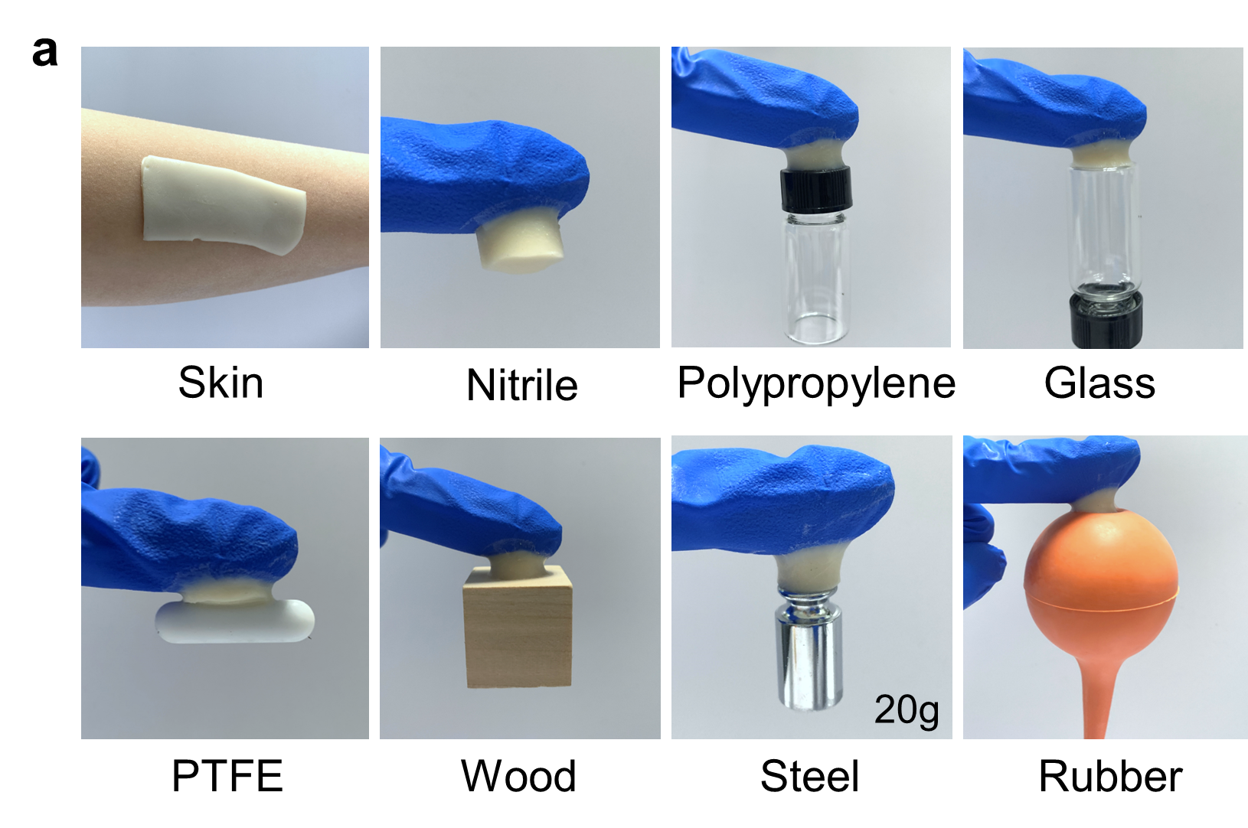
Fig.S3 Adhesive property of the hydrogel matrix. The fabricated hydrogel matrix can adhere to various materials, such as skin tissue, nitrile, glass, PP, PTFE, wood, steel and rubber. The catechol groups of Ag-lignin NPs allow the hydrogel matrix to adhere to various substrates via covalent bonds (Schiff base, Michael addition reactions) and noncovalent bonds (Hydrogen bonding, π-π stacking, Metal coordination).

Fig.S4 Tensile properties of hydrogel electrolytes with different AAm:HAp mass ratios.
a The Young's modulus, fracture stress and fracture strain for hydrogel electrolytes with different AAm: HAp mass ratios; b Values of dissipated energy and dissipation rate corresponding to tension-release curves at 100% tensile strain; c Comparison of the fracture energy of hydrogels with various AAm: HAp mass ratios.

Fig.S5 Fracture energy of hydrogel matrices with different AAm: HAp mass ratios. a Fracture energy curve of hydrogel with AAm: HAp =1:0; b Fracture energy curve of hydrogel with AAm: HAp =1:0.1; c Fracture energy curve of hydrogel with AAm: HAp =1:0.2; d Fracture energy curve of hydrogel with AAm: HAp =1:0.5.

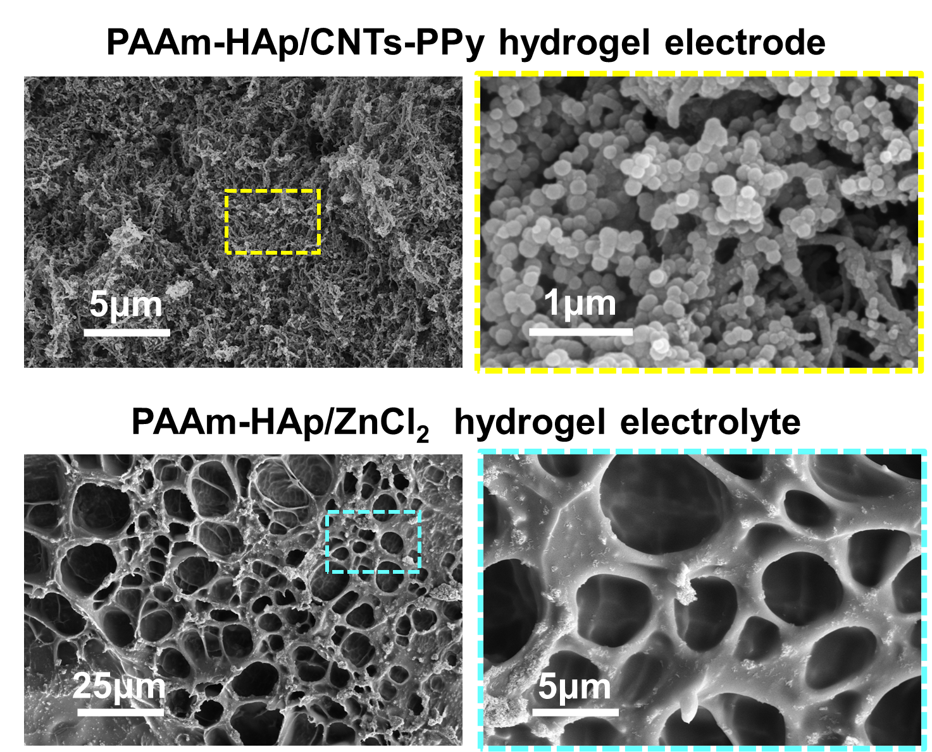
Fig.S6 Scanning electron microscope (SEM) images of the PAAm-HAp/CNTs-PPy hydrogel electrode and the PAAm-HAp/ZnCl₂ hydrogel electrolyte. After the PPy and CNTs incorporation, the hydrogel maintains the interconnected network structure and the CNTs and PPy nanoparticles are coated on the wall of the compartment, which offers great advantages on the diffusion of electrolyte and ions transfer in the electrochemical process; The PAAm-HAp/ZnCl₂ hydrogel electrolyte maintains a network structure in which the ions can be rapidly transported between the pores.

Fig.S7 The interfacial adhesion test of the all-hydrogel supercapacitors. Interfacial toughness and shear strength of three all-hydrogel supercapacitors, including the supercapacitor with direct stacking, the supercapacitor with semi-dehydration & stacking, and the supercapacitor with in situ-polymerization.

Fig.S8 Raman fitting curves for different ZnCl₂ concentration (0~15 m). With the addition of ZnCl₂, the strong and weak hydrogen bonds decrease while increasing the non-hydrogen bonds.

Fig.S9 The radial distribution function (RDF) and the corresponding average coordination number (N) for 7.5 m and 15 m ZnCl₂ electrolytes. a The radial distribution function (RDF) and the corresponding average coordination number (N) for 15 m; b the corresponding average coordination number (N) for 7.5 m and 15 m ZnCl₂ electrolyte.

Fig.S10 The tensile cycles test of the hydrogel electrolyte at the temperature of 20~−60 °C. Tension-release hysteresis loops of hydrogel electrolyte with 7.5 m ZnCl₂ at 100% tensile strain at a 20, b −20, c −40, and d −60 °C; e Maximum stress, plastic deformation, and resilience of the hydrogel electrolyte in 100 tensile cycles at 100% strain;

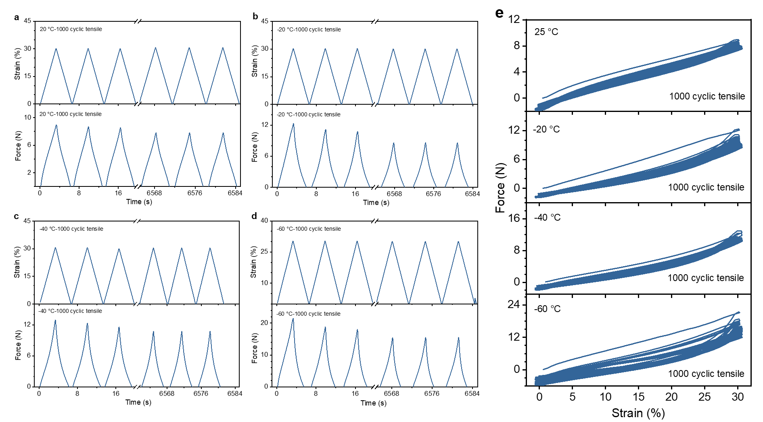
Fig.S11 The low-temperature fatigue resistance of the all-hydrogel supercapacitor. Time-force and time-strain curves of 30% strain 1000 times for the device at a 20, b −20, c −40, and d −60 °C. e Force-strain curves at 20, −20, −40, and −60 °C. f Maximum stress, plastic deformation, resilience of all−hydrogel supercapacitor in 1000 tensile cycles at 30% strain.

Fig.S12 Electrochemical performance of all-hydrogel supercapacitor at −50 °C. GCD curve of the device at a current density between 0.15 and 0.25 mA cm⁻² at −50 °C, the device can run well and deliver the specific capacitance of 37 mF cm⁻² with 0.15 mA cm⁻².

Fig.S13 Electrochemical impedance analysis of all-hydrogel supercapacitor at temperatures ranging from 20 to −50 °C. a Comparison of the internal resistance (R_{s}) and charge-transfer resistance (R_{ct}) of all-hydrogel supercapacitors at different temperatures. These values were obtained by fitting the EIS plots in Fig.4c; b The linear fit of ln (1/R_{ct}) to 1000/T shows that the electrode/electrolyte interface of the supercapacitor remains stable at low temperatures; c Linear fitting between the real impedance (Z') and the inverse square root of angular frequency (ω_{1/2}, ω=2πf) at different temperatures; d Warburg factors (σ_{w}) at different temperatures. Values of σ_{w} correspond to the slope of fitted lines in c; e Linear fitting between ln (D_{Zn2+}) and 1000/T. The diffusion coefficients of Zn²⁺ (D_{Zn2+}) at different temperatures are calculated on the basis of Warburg diffusion area. Linear relationship between ln (D_{Zn2+}) and 1000/T obeys Arrhenius’ law and reflects the effective diffusion of Zn²⁺ in the hydrogel electrode at low temperatures between 20 and −40 °C.

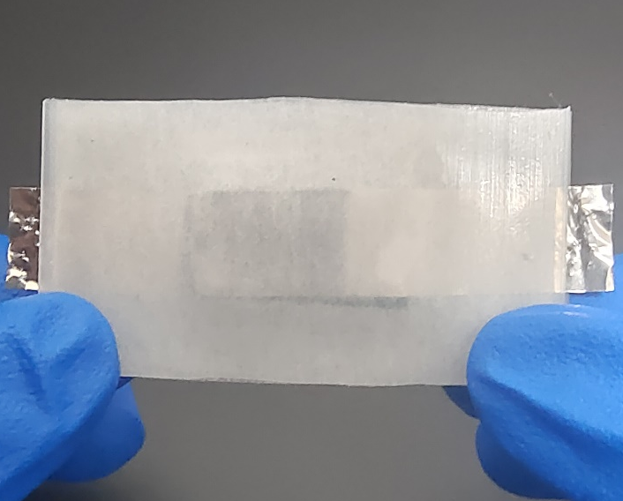
Fig.S14 Optical image of the all-hydrogel supercapacitor. The device is an integrated device with two Pt current collectors and an all-hydrogel supercapacitor (30 mm broad × 15 mm high) encapsulated in silicone rubber.

Fig.S15 Tensile cycling tests of all-hydrogel supercapacitor at 20% strain. Force and strain versus time curves for all-hydrogel supercapacitor subjected to 2000 tensile cycles at a 20, b −20, and c −40 °C, respectively.

Table S1. Comparison of the low-temperature adhesion performance of our hydrogel electrolyte with previously-reported anti-freezing hydrogels.
Material | Adhesion mechanism | Adhesion  substrate | Interfacial toughness  (J/m²) | Shear strength  (kPa)
PAAm-co-PUH hydrogel[1] | Physical interaction | Skin | 160 | ——
PEGDA/TA hydrogel[2] | Physical interaction | Skin | —— | ~55
PAAM-SC-CC hydrogel[3] | Physical interaction | Aluminum | 56.9 | ——
PC/GO/Met hydrogel[4] | Physical interaction | Tissue | —— | 18
PACG-COS-J Hydrogel[5] | Physical interaction | Hydrogel | ~170 | ——
PAM/PDA/XL-MSN hydrogel[6] | Physical interaction | Skin | ~150 | 13.5
p(Cro-co-AAm)-crosslinked hydrogel[7] | Physical interaction | Glass | ~410 | ——
PAACP hydrogel[8] | Covalent anchorage | Skin | ~790 | ——
PAAm/CMC/PPy hydrogel[9] | Physical interaction | Aluminum | 330 | ——
Gel–CS hydrogel[10] | Covalent anchorage | Skin | ~120 | 30.64
PVA/P(AM-AMPS) hydrogel[11] | Physical interaction | Glass | —— | ~15
PVA-FT hydrogel[12] | Physical interaction | Skin | —— | 18.7
rGO-PVA-PAA-NHS hydrogel[13] | Covalent anchorage | Skin | 270 | 60
PAAm-HAp  hydrogel [This work] | Topological entanglement | Hydrogel | 639.14 | 54.43

Table S2. Ionic conductivity of hydrogel electrolytes with different concentrations of ZnCl₂ in the temperature range of 20~–60 °C
Temperature (°C) | Ionic conductivities (mS cm⁻¹)
Temperature (°C) | 0 | 2 | 5 | 7.5 | 10 | 15
20 | 2.65 | 58.44 | 57.70 | 36.48 | 28.20 | 17.60
0 | 1.71 | 46.85 | 31.82 | 21.58 | 17.02 | 9.07
−10 | 1.33×10⁻⁴ | 10.06 | 21.32 | 11.40 | 7.15 | 4.09
−20 | 2.55×10⁻⁵ | 5.87×10⁻¹ | 11.31 | 7.32 | 4.28 | 2.15
−30 | 7.73×10⁻⁶ | 7.37×10⁻² | 5.41 | 4.09 | 3.39 | 1.81
−40 | 1.47×10⁻⁶ | 2.92×10⁻³ | 8.63×10⁻¹ | 1.88 | 1.06 | 6.02×10⁻¹
−50 | 4.23×10⁻⁷ | 2.55×10⁻⁴ | 2.34×10⁻¹ | 8.87×10⁻¹ | 4.08×10⁻¹ | 3.05×10⁻¹
−60 | 6.65×10⁻⁸ | 1.27×10⁻⁵ | 2.29×10⁻² | 2.92×10⁻¹ | 1.16×10⁻¹ | 7.42×10⁻²

Table S3. Fitting equivalent circuit results of the all-hydrogel supercapacitor in the temperature range of 20~–50 °C
Temperature(°C) | Equivalent circuit | Rs (Ω) | Rct (Ω) | D_{Zn2+}
20 | 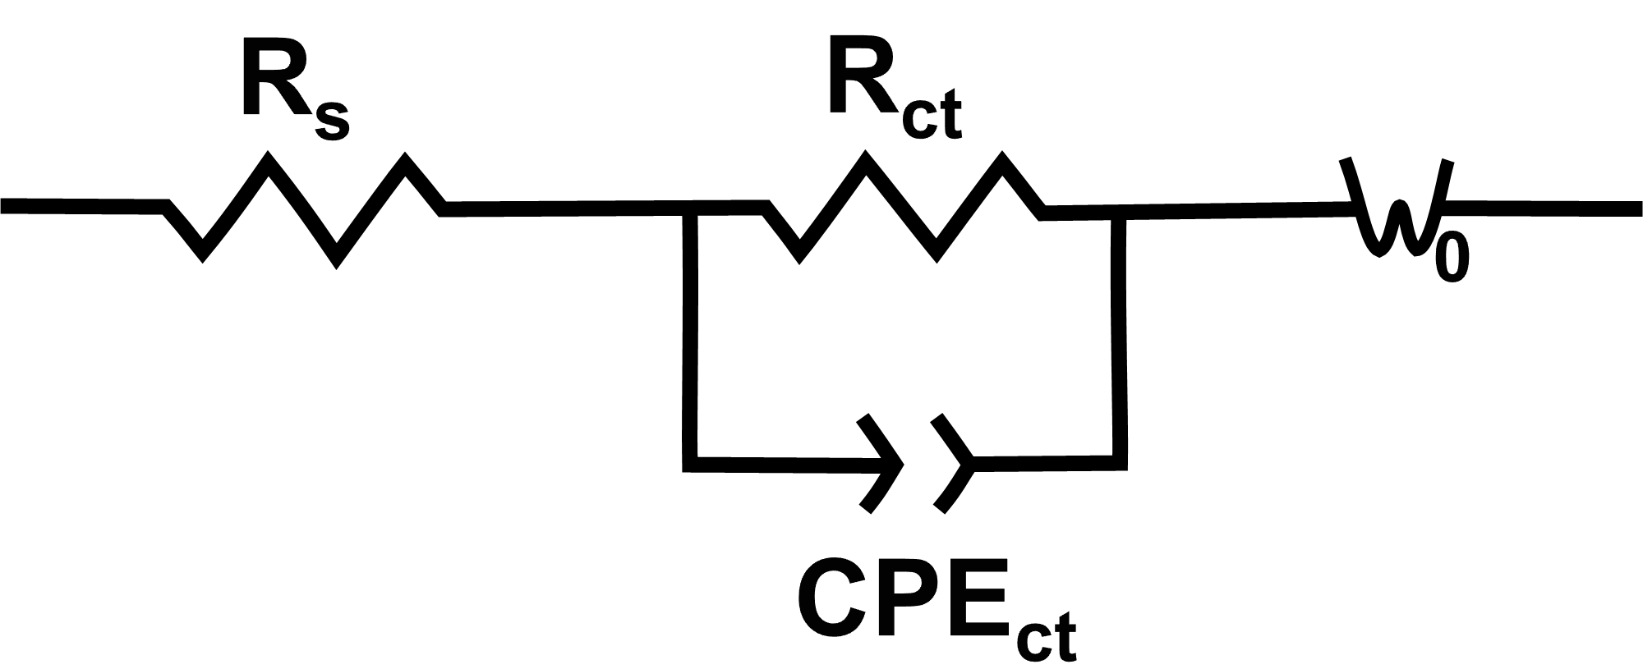 | 3.01 | 2.90 | 6.02×10⁻¹³
0 |  | 4.76 | 4.38 | 4.48×10⁻¹³
−10 |  | 9.43 | 8.70 | 3.31×10⁻¹³
−20 |  | 13.89 | 14.38 | 2.06×10⁻¹³
−30 |  | 22.12 | 26.07 | 7.61×10⁻¹⁴
−40 |  | 48.31 | 60.69 | 5.85×10⁻¹⁴
−50 |  | 119.4 | 147.0 | 2.10×10⁻¹⁴

Table S4. Comparison of electrochemical performance of our all-hydrogel supercapacitor with previously-reported flexible hydrogel-based energy storage devices
Device configuration  (Negative electrode||  positive electrode) | Electrolyte | Freezing tolerance | Cycle life | Max. energy @ power | Energy @ max. power | Capacitance retention under deformation
PEDOT:PSS || PEDOT:PSS[14] | PVA/ H₃PO₄ gel | — | 75% over 2000 cycles at 25 °C | 15.73 μWh cm⁻² @ 398.79 μW cm⁻² | 12.27 μWh cm⁻²  @1998.7 μW cm⁻² | No noticeable change under 1000 90°-bending cycles at 25 °C
DAPPy || DAPPy[15] | SA/ Na₂B₄O₇ hydrogel | — | 80% over 2000 cycles at 25 °C | 52.18 μWh cm⁻² @  800 μW cm⁻² | 28.27 μWh cm⁻²  @2400 μW cm⁻² | No noticeable change under weight and 60~180°-bending at 25 °C
PANI/RGO || PANI/RGO[16] | PVA/H₂SO₄ hydrogel | — | 86% over 17000 cycles at 25 °C | 8.80 mWh cm⁻³ @  30.77 mW cm⁻³ | — | 101% under 1000 stretching at 25 °C
PANi || PANi[17] | PVA/H₂SO₄ | — | 78.2% over 5000 cycles at 25 °C | 11.20 Wh kg⁻¹ @  49.89 W kg⁻¹ | 8.86 Wh kg⁻¹ @  399.70 W kg⁻¹ | negligible changes under bending angles of 150° at 25 °C
PANI || PANI[18] | p(AA-PEGMA)/PEG | –25°C | 91.6% over 3000 cycles at 25 °C | — | — | 91.8% under 1000 bending 180° cycles at 25 °C
PPy || PPy[19] | PAA-β-CD hydrogel | –20°C | 80.5% over 4000 cycles at 25 °C | 0.082 mWh cm⁻³ @  0.25 W cm⁻³ | 0.049 mWh cm⁻³ @ 0.47 W cm⁻³ | 86.8% under 2000 bending 180° cycles at 25 °C
PANI || PANI[20] | PVA-CPBA-Ca hydrogel | — | 87% over 3000 cycles at 25 °C | 7.8 Wh kg⁻¹ @  200 W kg⁻¹ | 5.9 Wh kg⁻¹ @  3200 W kg⁻¹ | 90.6% under 60% compression strains at 25 °C
PANI || PANI[21] | PAA/H₂SO₄ | — | 95% over 10000 cycles at 25 °C | 22 μW h cm⁻² @  150 μW cm⁻² | 11.5 μW h cm⁻²  @1500 μW cm⁻² | 76% under 100 stretching cycles at 100% strain at 25 °C
PrGO/ Co(NO₃)₂ ||  PrGO- Co(NO₃)₂[22] | PAAm/PrGO | — | 91.3% over 1000 cycles at 25 °C | — | — | well-maintained under 100%~300% tensile states at 25 °C
PPy || PPy[23] | PVA/H₂SO₄ | –20 °C | 84% over 1000 cycles at 25 °C | 62.1 µWh cm⁻² @ 0.57 mW cm⁻² | 35.3µWh cm⁻²  @1.67 mW cm⁻² | 96% after 100% strain, 81% after 500 stretching-releasing cycles at 25 °C
ACP || ACP[24] | P(NaSS-co-DMAEA-Q)/H₃PO₄ Zwitterionic Hydrogel | –10 °C | 90% over 1000 cycles at –10°C | 5.6 μWh cm⁻² @  0.1 mW cm⁻² | — | above 90% after bending angles (30~150◦) at 25 °C
PPy || PPy[25] | PAAm/MMT | –30 °C | 81.8% over 1000 cycles at –10°C | 9.4 μWh cm⁻² @  319.5 μW cm⁻² | — | 92.5% after 500 twist-releasing  67% after 500 100% stretch-releasing
PPy || PPy[26] | PVA/gelatin | –25 °C | 87% over 2000 cycles at –25 °C | — | — | negligible changes under bending angles of 0~180° at 25 °C
PPy/CNTs || PPy/CNTs[This work] | PAAm/ZnCl₂ | –40 °C | 98.4% over 5000 cycles at –40 °C | 11.3 mWh cm⁻² @  85.1 mW cm⁻²  at –40 °C | 1.04 mWh cm⁻² @  143.4 mW cm⁻² | 106.1% after 2000 tensile cycles at 20 °C  107.2% after 2000 tensile cycles at –40 °C

Description of Supporting Movies
Movie S1: Demonstration for testing processes of mechanical and capacitive behaviors of the all-hydrogel supercapacitor under 20% cyclic tensions at 20 °C.
Movie S2: Demonstration for testing processes of mechanical and capacitive behaviors of the all-hydrogel supercapacitor under 20% cyclic tensions at −20 °C.
Movie S3: Demonstration for testing processes of mechanical and capacitive behaviors of the all-hydrogel supercapacitor under 20% cyclic tensions at −40 °C.

Supporting References
1. Fan X, Zhou W, Chen Y, Yan L, Fang Y, Liu H (2020). An antifreezing/antiheating hydrogel containing catechol derivative urushiol for strong wet adhesion to various substrates. ACS Appl Mater Interfaces 12:32031-32040. https://doi.org/:10.1021/acsami.0c09917
2. Chen K, Lin Q, Wang L, Zhuang Z, Zhang Y, Huang D, Wang H (2021). An all-in-one tannic acid-containing hydrogel adhesive with high toughness, notch insensitivity, self-healability, tailorable topography, and strong, instant, and on-demand underwater adhesion. ACS Appl Mater Interfaces 13:9748-9761. https://doi.org/:10.1021/acsami.1c00637
3. Wang G, Zhang Q, Wang Q, Zhou L, Gao G (2021). Bio-based hydrogel transducer for measuring human motion with stable adhesion and ultrahigh toughness. ACS Appl Mater Interfaces 13:24173-24182. https://doi.org/:10.1021/acsami.1c05098
4. Liang Y, Li M, Yang Y, Qiao L, Xu H, Guo B (2022). Ph/glucose dual responsive metformin release hydrogel dressings with adhesion and self-healing via dual-dynamic bonding for athletic diabetic foot wound healing. ACS Nano 16:3194-3207. https://doi.org/:10.1021/acsnano.1c11040
5. Cui C, Wu T, Chen X, Liu Y, Li Y, Xu Z, Fan C, Liu W (2020). A janus hydrogel wet adhesive for internal tissue repair and anti-postoperative adhesion. Adv Funct Mater 30. https://doi.org/:10.1002/adfm.202005689
6. Jung H, Kim MK, Lee JY, Choi SW, Kim J (2020). Adhesive hydrogel patch with enhanced strength and adhesiveness to skin for transdermal drug delivery. Adv Funct Mater 30:2004407. https://doi.org/:10.1002/adfm.202004407
7. Chen J, Wang D, Wang LH, Liu W, Chiu A, Shariati K, Liu Q, Wang X, Zhong Z, Webb J, Schwartz RE, Bouklas N, Ma M (2020). An adhesive hydrogel with "load-sharing" effect as tissue bandages for drug and cell delivery. Adv Mater 32:e2001628. https://doi.org/:10.1002/adma.202001628
8. Tian G, Yang D, Liang C, Liu Y, Chen J, Zhao Q, Tang S, Huang J, Xu P, Liu Z, Qi D (2023). A nonswelling hydrogel with regenerable high wet tissue adhesion for bioelectronics. Adv Mater 35:e2212302. https://doi.org/:10.1002/adma.202212302
9. Cheng Y, Ren X, Duan L, Gao G (2020). Transparent and adhesive carboxymethyl cellulose/polypyrrole hydrogel electrode for flexible supercapacitor. J Mater Chem C 8:8234-8242. https://doi.org/:doi.org/10.1039/D0TC01039A
10. Zhou L, Dai C, Fan L, Jiang Y, Liu C, Zhou Z, Guan P, Tian Y, Xing J, Li X, Luo Y, Yu P, Ning C, Tan G (2021). Injectable self-healing natural biopolymer-based hydrogel adhesive with thermoresponsive reversible adhesion for minimally invasive surgery. Adv Funct Mater 31:2007457. https://doi.org/:10.1002/adfm.202007457
11. Chen G, Hu O, Lu J, Gu J, Chen K, Huang J, Hou L, Jiang X (2021). Highly flexible and adhesive poly(vinyl alcohol)/poly(acrylic amide-co-2-acrylamido-2-methylpropane sulfonic acid)/glycerin hydrogel electrolyte for stretchable and resumable supercapacitor. Chem Eng J 425:131505. https://doi.org/:10.1016/j.cej.2021.131505
12. Wang Q, Pan X, Guo J, Huang L, Chen L, Ma X, Cao S, Ni Y (2021). Lignin and cellulose derivatives-induced hydrogel with asymmetrical adhesion, strength, and electriferous properties for wearable bioelectrodes and self-powered sensors. Chem Eng J 414:128903. https://doi.org/:10.1016/j.cej.2021.128903
13. Deng J, Yuk H, Wu J, Varela CE, Chen X, Roche ET, Guo CF, Zhao X (2021). Electrical bioadhesive interface for bioelectronics. Nat Mater 20:229-236. https://doi.org/:10.1038/s41563-020-00814-2
14. Cheng T, Wang F, Zhang Y-Z, Li L, Gao S-Y, Yang X-L, Wang S, Chen P-F, Lai W-Y (2022). 3d printable conductive polymer hydrogels with ultra-high conductivity and superior stretchability for free-standing elastic all-gel supercapacitors. Chem Eng J 450:1385-8947. https://doi.org/:10.1016/j.cej.2022.138311
15. Li Y, Liu X, Gong Q, Xia Z, Yang Y, Chen C, Qian C (2021). Facile preparation of stretchable and self-healable conductive hydrogels based on sodium alginate/polypyrrole nanofibers for use in flexible supercapacitor and strain sensors. Int J Biol Macromol 172:41-54. https://doi.org/:10.1016/j.ijbiomac.2021.01.017
16. Li P, Jin Z, Peng L, Zhao F, Xiao D, Jin Y, Yu G (2018). Stretchable all-gel-state fiber-shaped supercapacitors enabled by macromolecularly interconnected 3d graphene/nanostructured conductive polymer hydrogels. Adv Mater 30:e1800124. https://doi.org/:10.1002/adma.201800124
17. Yang Z, Shi D, Dong W, Chen M (2020). Self-standing hydrogels composed of conducting polymers for all-hydrogel-state supercapacitors. Chem-Eur J 26:1846-1855. https://doi.org/:10.1002/chem.201904357
18. Chen Y, Ren H, Rong D, Huang Y, He S, Rong Q (2023). Stretchable all-in-one supercapacitor enabled by poly(ethylene glycol)-based hydrogel electrolyte with low-temperature tolerance. Polymer 270:125796. https://doi.org/:10.1016/j.polymer.2023.125796
19. Mo F, Li Q, Liang G, Zhao Y, Wang D, Huang Y, Wei J, Zhi C (2021). A self-healing crease-free supramolecular all-polymer supercapacitor. Adv Sci 8:2100072. https://doi.org/:10.1002/advs.202100072
20. Zou Y, Chen C, Sun Y, Gan S, Dong L, Zhao J, Rong J (2021). Flexible, all-hydrogel supercapacitor with self-healing ability. Chem Eng J 418:128616. https://doi.org/:10.1016/j.cej.2021.128616
21. Shi Y, Zhang Y, Jia L, Zhang Q, Xu X (2018). Stretchable and self-healing integrated all-gel-state supercapacitors enabled by a notch-insensitive supramolecular hydrogel electrolyte. ACS Appl Mater Interfaces 10:36028-36036. https://doi.org/:10.1021/acsami.8b13947
22. Jiang L, Li Y, Zou F, Gan D, Gao M, Yuan L, Zhang Q, Lu X (2023). Highly self-adhesive, compressible, stretchable, all hydrogel-based supercapacitor for wearable/portable electronics. Mater Today Phys 33:e101046. https://doi.org/:10.1016/j.mtphys.2023.101046
23. Chen F, Chen Q, Song Q, Lu H, Ma M (2019). Strong and stretchable polypyrrole hydrogels with biphase microstructure as electrodes for substrate‐free stretchable supercapacitors. Adv Mater Interfaces:1900133. https://doi.org/:10.1002/admi.201900133
24. Li X, Wang Y, Li D, Shen C, Chen M, Long S, Huang Y (2022). Tough, flexible, and durable all-polyampholyte hydrogel supercapacitor. Polym Test 115:107720. https://doi.org/:10.1016/j.polymertesting.2022.107720
25. Hu Q, Cui S, Sun K, Shi X, Zhang M, Peng H, Ma G (2022). An antifreezing and thermally stable hydrogel electrolyte for high-performance all-in-one flexible supercapacitor. J Energy Storage 50:104231. https://doi.org/:10.1016/j.est.2022.104231
26. Liu C, Zeng B, Jiang L, Wu Y, Wang Y, Wang J, Wu Q, Sun X (2023). Tough and self-healable double-network hydrogel for environmentally resistant all-in-one supercapacitors and strain sensors. Chem Eng J 460:141787. https://doi.org/:10.1016/j.cej.2023.141787

