Supporting Information

A pyrrolo[3,2-b]pyrrole derivative used for one- and two-component radical photoinitiators for photopolymerization under 405 nm
Congcong Liu¹, Yuanyuan Xu ^{1,2}, Yukun Liu ¹, Yu Chen ¹, * Xiaoyuan Zhang ¹, Jinghan Li ¹, Ying Ma ¹, Yaolong Li ³, Song Xue¹
^{1.}Tianjin Key Laboratory of Organic Solar Cells and Photochemical Conversion, School of Chemistry and Chemical Engineering, Tianjin University of Technology, Tianjin 300384, People’s Republic of Chin
^{2.} School of Materials Science and Engineering, Tianjin University of Technology, Tianjin 300384, People’s Republic of China
^{3.} Tianjin Dage Technology Co., Ltd., Tianjin 301700, People’s Republic of China

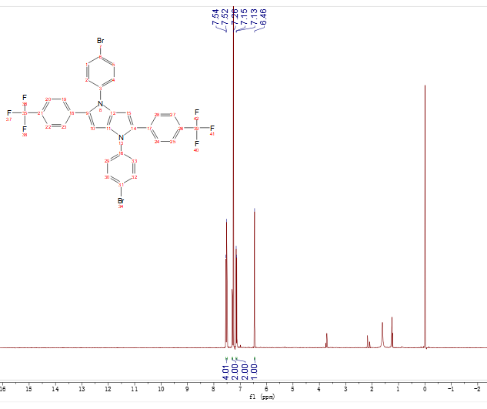
(a)
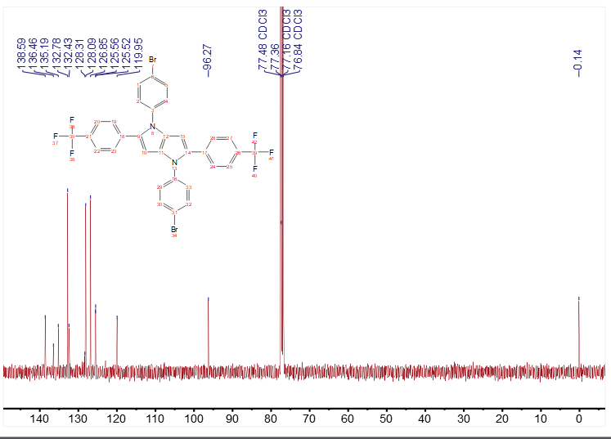
(b)
Fig. S1 ¹H and ¹³C NMR spectra of PyBF in CDCl₃.

Fig. S2 Emission spectra and CV curves of PyBF and TPO in dichloromethane.

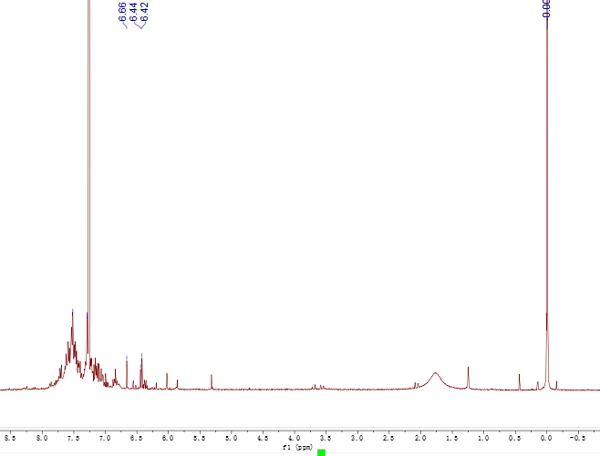
Fig. S3 ¹H NMR spectra of PyBF in CDCl₃ after irradiation for 480s.
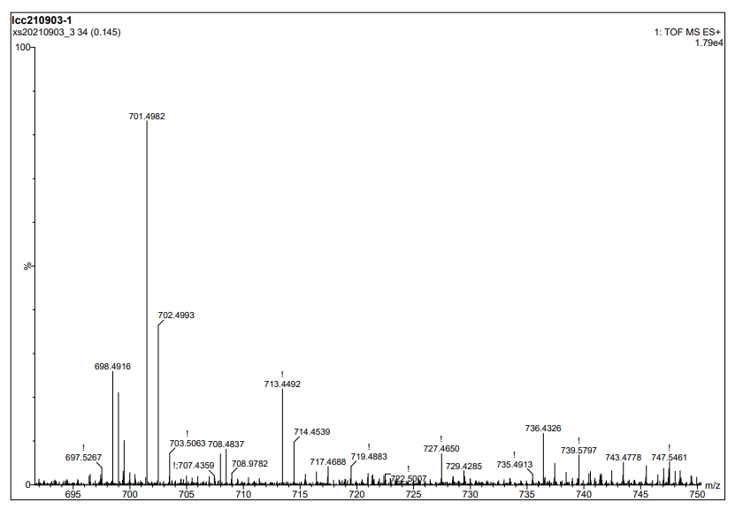
(a)
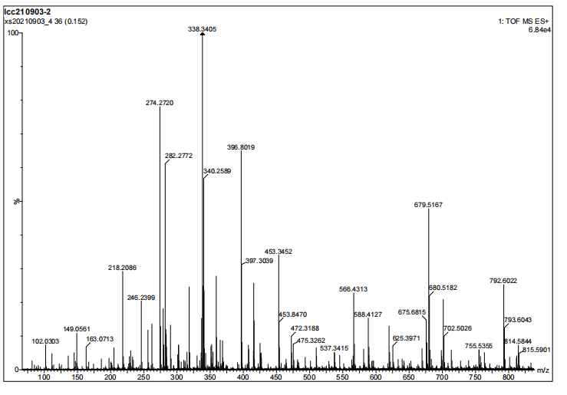
(b)
Fig. S4 Comparison of mass spectra before and after spectra after irradiation for 480 s.

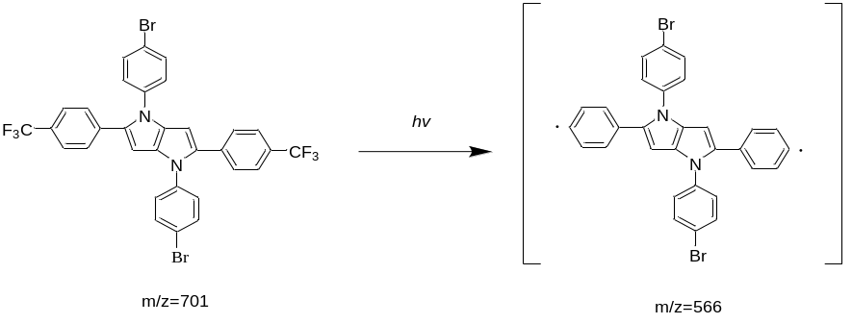
Fig. S5 Schematic diagram of photolysis mechanism for PyBF.

