Supplementary Information

Figure S1. Alternative pathway for UDP-GlcNAc synthesis. Schematic depicting an alternative pathway other than an existing canonical pathway for UDP-GlcNAc synthesis. Here, GlcNAc will enter the cell through SugI, a sugar transporter than will be phosphorylated by Rv0650, a sugar kinase and converted into GlcNac-6P which either can directly enter into canonical pathway or acted upon by some unknown enzyme which convert it into GlcNac-1P that can enter into last step of the canonical pathway.
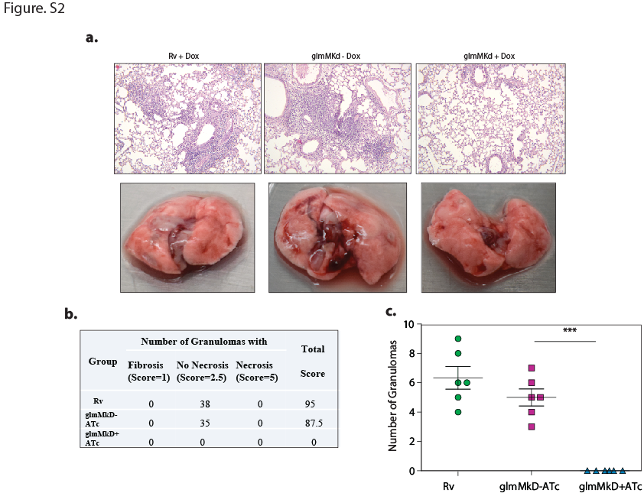
Figure S2. Effects of GlmM_{Kd} on Gross pathology and histopathology of mice. a. Upper panel exhibit hematoxylin and eosin stained photomicrograph of lungs from Rv, RvGlmM_{Kd} – and + Dox. While the lower panel shows the overall pathology of lungs illustrates robust Mtb infection in Rv, RvGlmM_{Kd} – Dox compared to RvGlmM_{Kd} + Dox. b-c. Quantification of number of granulomas and total score in each set of mice. Data is representation of two independent experiments with 6 mice in each group.
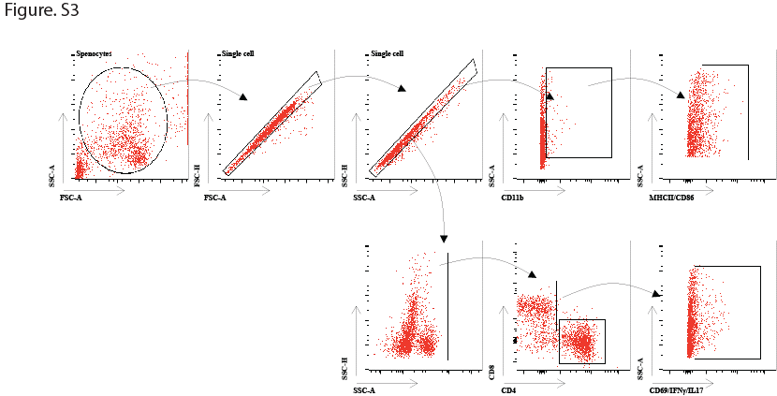
Figure S3. Gating strategy used in FACS analysis.
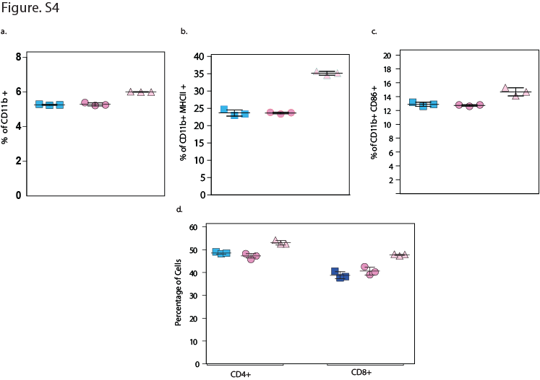
Figure S4. GlmM depeletion induces immune response. FACS data to show the percentage of total (a)CD11b⁺cells (b) CD11b⁺MHCII⁺(c) CD11b⁺Cd86⁺ (d) CD4⁺ and CD8⁺ T cells in the spleen of different groups of mice infected with the H37Rv and RvGlmM_{kD} (-Dox and +Dox).

