Figure S5:

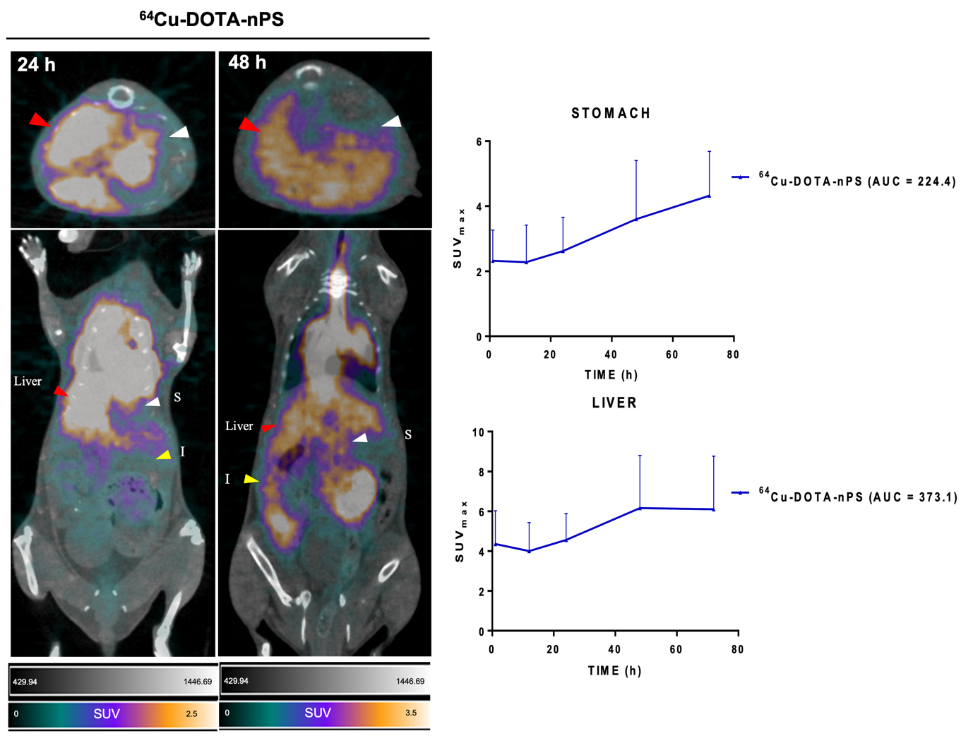

Fig. S5. The [⁶⁴Cu]Cu-DOTA-nPS PET images showing stomach and liver uptake. The 24 h and 48 h images showed highest liver uptake in nPS group. The images were marked with arrows pointing to organs; red arrow-liver, white arrow-stomach, yellow arrow-intestines. SUV graph was obtained from Fig. 3.

